TDetect - Fraud & Anomaly Investigation Copilot
An AI-assisted fraud investigation tool built on Snowflake's AI Data Cloud, for the Snowflake CoCo CLI Hackathon (GCC Edition). TDetect helps a fraud analyst move from "here's a flagged transaction" to "here's the evidence, here's what similar cases looked like, here's a recommendation" - with a human making every final decision.
Built as a portfolio project to demonstrate Snowflake + AI product design, not a production fraud system. See Limitations below.

What it does
- Risk scoring - 5 explainable, rule-based signals (unusual amount, new device, unusual location, high transaction velocity, unusual merchant) combine into a transparent 0-100 risk score.
- AI copilot - ask "why was this flagged?" in plain English; answers are grounded strictly in the transaction's actual data, with the raw evidence shown alongside so nothing has to be taken on faith.
- Natural-language queries - ask things like "show me all critical transactions from new devices" across the whole dataset; the app converts it to SQL, shows the generated query, and runs it read-only with a safety check.
- Similar-case lookup - surfaces past transactions with the same signal pattern.
- Human-in-the-loop decisions - Confirm Fraud / Mark Legitimate / Escalate, logged to a permanent, append-only audit trail. The AI never closes a case on its own.
- Two views - an Analyst view for case-by-case investigation, and a Manager view with rolled-up metrics.

Screenshots
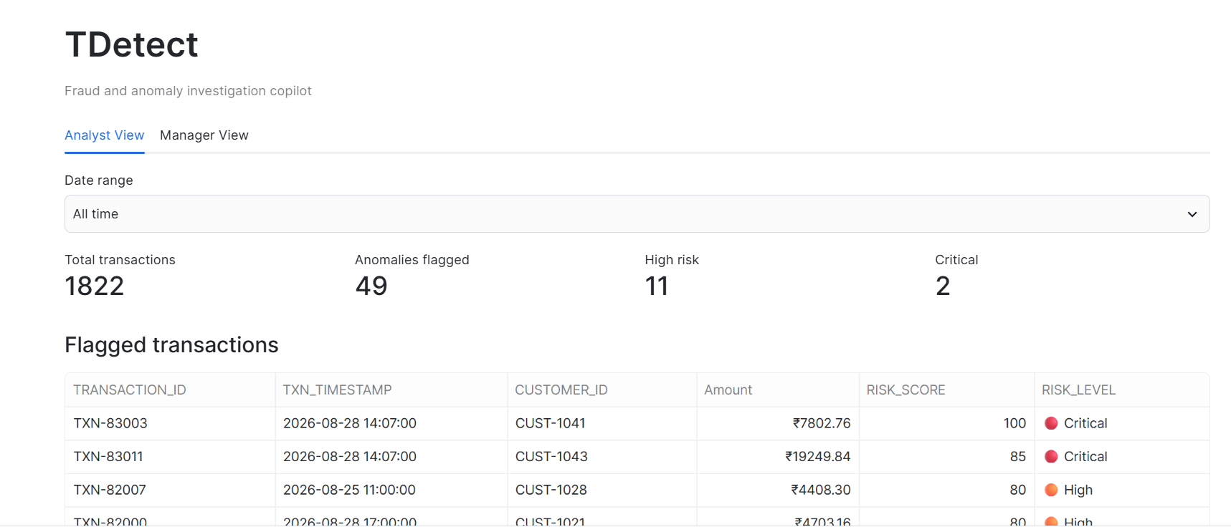

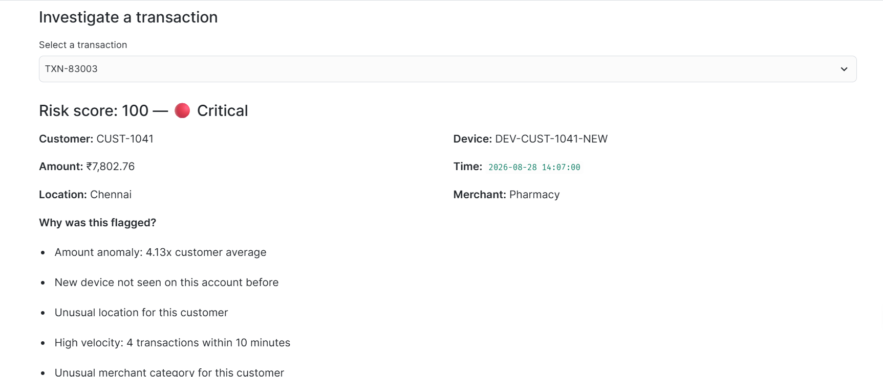

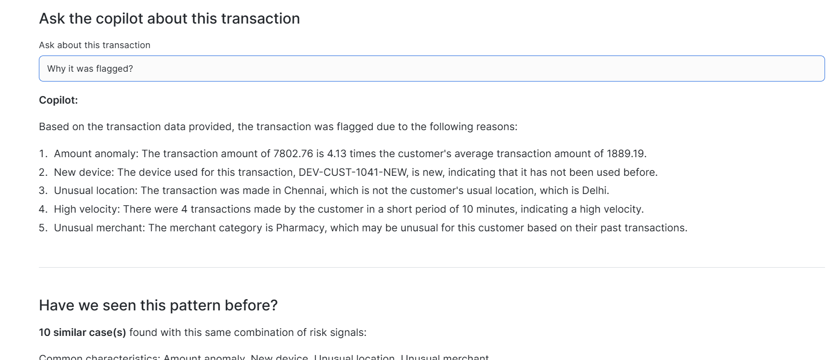

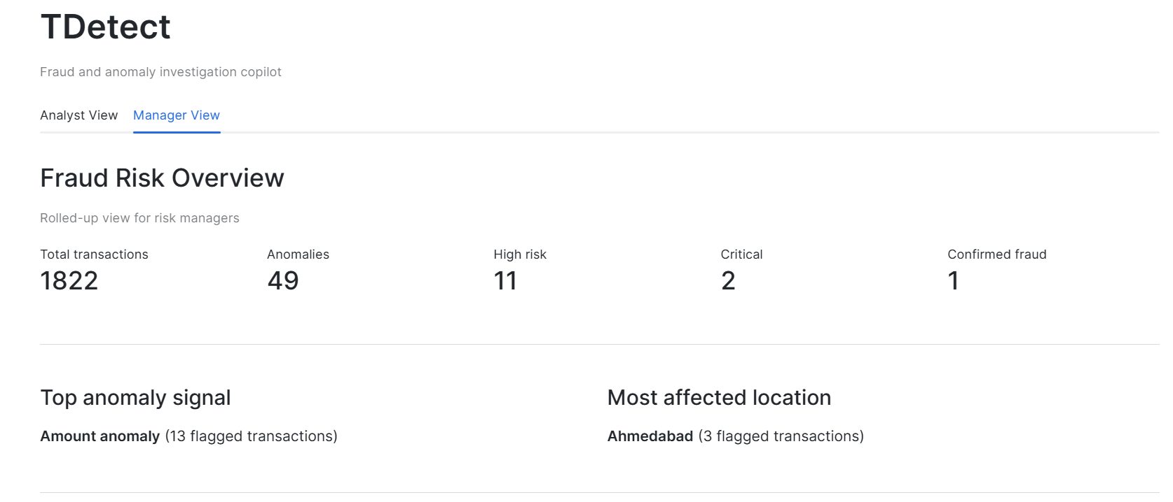

Tech stack
Layer | Tool
Data warehouse | Snowflake (RAW → ANALYTICS → CASES schemas)
Risk scoring | SQL views (rule-based, no ML model)
AI / LLM | Snowflake Cortex (CORTEX.COMPLETE, llama3.1-8b)
Application | Streamlit in Snowflake
Data | Synthetic transaction dataset (50 customers, ~1,800 transactions)

Project structure
tdetect/
├── app/
│ └── tdetect_dashboard.py # Streamlit app (Analyst + Manager views)
├── sql/
│ ├── 01_setup_and_cleaning.sql # Schema, raw load, cleaning
│ ├── 02_customer_behavior.sql # Customer baseline aggregates
│ ├── 03_anomaly_features.sql # 5 risk signals (view)
│ ├── 04_risk_scores.sql # Weighted scoring + risk level (view)
│ └── 05_fraud_cases.sql # Human decision / audit trail table
├── data/
│ └── synthetic_transactions.csv
├── docs/
│ ├── PRODUCT_DEFINITION.md
│ ├── DECISION_LOG.md
│ ├── METRICS_AND_RESPONSIBLE_AI.md
│ ├── TEST_CASES.md
│ └── CASE_STUDY.md # Full PM case study
└── README.md

How to run it
- Create a Snowflake account (a free trial works - this project used the $400 trial credit).
- Run the SQL scripts in sql/ in order, in a Snowsight worksheet, to set up the schema and load the data.
- In Snowsight, go to Apps → Streamlit App, create a new app in the ANALYTICS schema, and paste in app/tdetect_dashboard.py.
- Click Run.

Architecture
Synthetic transaction data
↓
Snowflake (RAW → ANALYTICS → CASES)
↓
Risk engine (5 rule-based signals → weighted 0–100 score)
↓
AI layer (Snowflake Cortex - grounded explanation + NL-to-SQL)
↓
Streamlit app (Analyst View + Manager View)
↓
Human decision (Confirm Fraud / Mark Legitimate / Escalate)
↓
Audit trail (feeds back into future calibration)

A few notable decisions
- Rule-based scoring, not a trained ML model - no validated fraud-labeled dataset existed; an explainable v1 was judged more honest than a misleading model trained on synthetic labels.
- Caught and fixed a data-leakage bug (twice) - customer "normal" baselines were briefly being computed from data that included the anomaly being evaluated, silently masking it.
- AI-generated SQL is never trusted blindly - every generated query is shown to the user and checked against a blocklist before running; the analyst's original question is also pre-screened for destructive language.
Full reasoning for every decision, including alternatives considered and why they were rejected, is in Decision Log file. The full product case study - problem, users, architecture, AI design, metrics, responsible AI, and roadmap - is in Case study.

Limitations
- This is a prototype built on synthetic data, not a production fraud system.
- Risk scoring is rule-based, not machine-learned - see the decision log for why, and the roadmap for the intended upgrade path.
- Natural-language querying is scoped to one table and SELECT-only by design, not a general-purpose database assistant.
- A few SQL queries use string interpolation for prototype simplicity; a production version would use parameterized queries throughout.

Demo

https://youtu.be/JJ8N95TMt7o

Author
Built by Ritika Singh for the Snowflake CoCo CLI Hackathon (GCC Edition).

