TITLE:
Predicting the mushroom as deadly/safe using classification algorithms

PROBLEM STATEMENT:

Mushroom Data Analysis: Use mushroom consisting of different features affecting the quality of mushrooms. Predict accordingly whether the mushrooms are deadly or safe.
Make use of at least two classification algorithms and provide comparative analysis.

OBJECTIVE:

- To learn different classification algorithms.
- To implement classification algorithms.
- Analyze and compare various techniques.

OUTCOMES:

We will be able to learn:
- Different classification models in ML.
- Implementation of classification models.
- Analyze and compare these models.

SOFTWARE AND HARDWARE REQUIREMENTS:

- OS (Windows 10/ Ubuntu 64-bit)
- Python Scikit libraries/ RStudio with R libraries
- RAM- 4GB
- HDD- 500GB

CONCEPTS RELATED THEORY:

1. WHAT IS CLASSIFICATION?

We use the training dataset to get better boundary conditions which could be used to determine each target class. Once the boundary conditions are determined, the next task is to predict the target class. The whole process is known as classification.

Target class examples:
- Analysis of the customer data to predict whether he will buy computer
- accessories ​ (Target class: Yes or No)
- Classifying fruits from features like color, taste, size, weight ​ (Target classes:
- Apple, Orange, Cherry, Banana)
- Gender classification from hair length ​ (Target classes: Male or Female)

2. APPLICATIONS OF CLASSIFICATION ALGORITHM

- Email spam classification
- Bank customers loan pay willingness prediction.
- Cancer tumor cell identification.
- Sentiment analysis
- Drugs classification
- Facial keypoints detection
- Pedestrian detection in an automotive car driving.

3. TYPES OF CLASSIFICATION ALGORITHMS

Classification Algorithms could be broadly classified as the following:

- Linear Classifiers
○ Logistic regression
○ Naive Bayes classifier
○ Fisher’s linear discriminant
- Support vector machines
○ Least squares support vector machines
- Quadratic classifiers
- Kernel estimation
○ k-nearest neighbor
- Decision trees
○ Random forests
- Neural networks
- Learning vector quantization

LOGISTIC REGRESSION

- We use logistic regression for the binary classification of data-points. We perform categorical classification such that an output belongs to either of the two classes (1 or 0).
- For example –we can predict whether it will rain today or not, based on the current weather conditions.
- Two of the important parts of logistic regression are Hypothesis and Sigmoid Curve. With the help of this hypothesis, we can derive the likelihood of the event.
- The data generated from this hypothesis can fit into the log function that creates an S-shaped curve known as “sigmoid”. Using this log function, we can further predict the category of class.

We can represent the Sigmoid as follows:
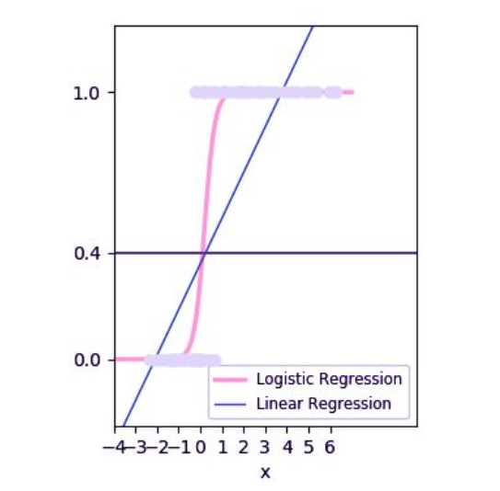

The produced graph is through this logistic function:

1 / (1 + e^-x)

The ‘e’ in the above equation represents the S-shaped curve that has values between 0 and 1.
We write the equation for logistic regression as follows:

y = e^(b0 + b1*x) / (1 + e^(b0 + b1*x))

In the above equation, b0 and b1 are the two coefficients of the input x. We estimate these two
coefficients using “maximum likelihood estimation”.

NAIVE BAYES CLASSIFICATION

Naive Bayes is one of the powerful machine learning algorithms that is used for
classification. It is an extension of the Bayes theorem wherein each feature assumes
independence. It is used for a variety of tasks such as spam filtering and other areas of text
classification.Naive Bayes algorithm is useful for:
- Naive Bayes is an easy and quick way to predict the class of the dataset. Using this, one can perform a multi-class prediction.
- When the assumption of independence is valid, Naive Bayes is much more capable than the other algorithms like logistic regression. Furthermore, you will require less training data.

This is a classification technique based on an assumption of independence between predictors or what’s known as Bayes’ theorem .In simple terms, a Naive Bayes classifier assumes that the presence of a particular feature in a class is unrelated to the presence of any other feature.

For example, a fruit may be considered to be an apple if it is red, round, and about 3 inches in
diameter. Even if these features depend on each other or upon the existence of the other
features, a Naive Bayes Classifier would consider all of these properties to independently
contribute to the probability that this fruit is an apple.

To build a Bayesian model is simple and particularly functional in case of enormous data sets.
Along with simplicity, Naive Bayes is known to outperform sophisticated classification methods
as well.

Bayes theorem provides a way of calculating posterior probability P(c|x) from P(c), P(x) and
P(x|c). The expression for Posterior Probability is as follows.
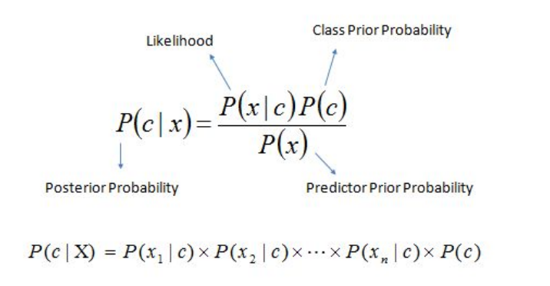

Here,
- P ( c | x ) is the posterior probability of class(target ) given predictor (attribute) .
- P ( c ) is the prior probability of class .
- P ( x | c ) is the likelihood which is the probability of predictor given class .
- P ( x ) is the prior probability of predictor.

Drawbacks:
- If the categorical variable belongs to a category that wasn’t followed up in the training
- set, then the model will give it a probability of 0 which will inhibit it from making any
- prediction.
- Naive Bayes assumes independence between its features. In real life, it is difficult to
- gather data that involves completely independent features.

TEST CASES AND ANALYSIS:

Input ->
mushroom.csv
Output->

1.) Logistic Regression:
a.) Accuracy Score: 0.9057
b.) Confusion Matrix: [ [2849, 102],
[434, 2301] ]
c.) Average accuracy: 0.9057
d.) Standard deviation: 0.0098
2.) Naive Bayes:
a.) Accuracy Score: 0.8966
b.) Confusion Matrix: [ [1215, 42],
[210, 971] ]
c.) Average accuracy: 0.8995
d.) Standard deviation: 0.0098

CONCLUSION:
We have successfully implemented classification algorithms to determine whether
mushrooms will be deadly or safe to consume. The classification algorithms were
analysed and compared to determine the best one and the results generated have been
reported.

