Rangriti Fashion for Every Festivity

# 1. Introduction

Rangriti is a popular Indian ethnic wear brand offering vibrant, trendy, and affordable clothing. Known for blending traditional aesthetics with contemporary designs, Rangriti caters to modern Indian consumers, delivering stylish apparel at accessible prices.

History:

* Founded in 2015, Rangriti was created as a sub-brand of BIBA, with the mission to provide affordable ethnic wear with modern, trendy designs.
* The brand combines vibrant colors and traditional styles to create unique, contemporary ethnic wear, catering to a broad demographic across India.
* Rangriti’s focus is on delivering quality ethnic wear at accessible prices, ensuring that a larger customer base can enjoy stylish clothing without breaking the bank.

# 2. About the Store

Observations during the visit:

* Products Available: Rangriti offers a variety of ethnic wear including kurtis,

palazzos, dresses, dupattas, and more.

* Store Layout: The store is organized into different sections for new arrivals, seasonal collections, and sale items.
* Ambiance: The store is clean and welcoming, though it could be more modern to attract younger customers.
* Staffing: The store had only one staff member present, leading to delays in customer service during busy hours.
* Customer Experience: While the staff member was friendly, delays in service were noted during peak hours.

# 3. Store Operational Processes

## 1. Store Setup and Maintenance

* Location: Rangriti stores are strategically placed in high-footfall areas, such as malls and shopping districts, to maximize customer visits.
* Cleanliness and Ambiance: Regular cleaning is maintained, ensuring a pleasant shopping experience. The lighting and background music create an inviting atmosphere.
* USP in Operations:  
   Rangriti’s affordable pricing is a key USP, making it the preferred choice for customers seeking stylish ethnic wear at competitive prices.

## 2. Inventory Management

* Stock Levels: Inventory is managed centrally and replenished regularly to ensure stock availability in stores.
* Tracking System: The store uses a barcode system for easy inventory tracking and efficient billing.
* Demand Forecasting: Historical sales data is analyzed to forecast demand, ensuring that popular products are restocked in a timely manner.

## 3. Pricing Strategies

* Competitive Pricing: Rangriti focuses on offering affordable ethnic wear, with products like kurtis starting from ₹500.
* Price Segmentation: The product range is divided into multiple price segments, catering to casual wear, office wear, and festive collections.
* Seasonal Discounts and Offers: The store offers regular discounts during festive seasons and end-of-season sales to attract price-sensitive customers.
* Value-for-Money Focus: Rangriti’s USP is delivering quality products at affordable prices, making ethnic wear accessible to a wider customer base, especially middle-income groups.

## 4. Customer Service

* Personalized Assistance: Store staff provide personalized help to customers, assisting with size selection, styles, and outfit suggestions.
* Trial Rooms: Customers can try on clothes in trial rooms to ensure the fit before purchasing.
* Efficient Billing: The store utilizes Point-of-Sale (POS) systems for quick billing and smooth checkout.

## 5. Marketing and Promotions

* In-Store Promotions: Rangriti uses visually attractive displays and banners to showcase new arrivals and ongoing offers.
* - Digital Presence: The brand's digital marketing is limited but could be further developed to engage younger customers online.
* Promotional Campaigns: The store runs seasonal promotions like the 'End of Season Sale' to boost foot traffic and clear inventory.
* USP in Promotions: The brand’s unique selling point in promotions lies in affordable ethnic wear with trendy designs, which is showcased through in-store promotions and social media marketing.

# 4. Problems Identified

* Limited Staffing: Only one staff member is present in the store, resulting in delays in customer service, especially during busy hours.
* Stock Replenishment Delays: Some popular items were out of stock, leading to customer dissatisfaction and missed sales opportunities.
* Weak Digital Marketing: Rangriti’s online presence could be strengthened to reach younger, tech-savvy customers who prefer shopping online.
* Ambiance Needs Enhancement: While the store is clean and well-lit, it lacks engaging decor that would appeal to the younger, trend-focused crowd.
* . Pricing Transparency: While Rangriti offers affordable pricing, the display of discounts and offers could be clearer to avoid confusion during promotional periods.

# 5. Recommendations

* Increase Staffing: Hire additional staff to manage customer service, inventory, and billing, particularly during busy periods.
* Improve Inventory Management: Implement AI-powered tools for demand forecasting and inventory management to prevent stockouts and overstocking
* . Strengthen Digital Marketing Efforts: Launch targeted campaigns on social media platforms like Instagram and Facebook, with influencer partnerships to reach younger audiences.
* Enhance Store Ambiance: Modernize the store’s design to create an Instagram-worthy shopping experience for younger customers.
* Clarify Pricing and Offers: Ensure discounts and offers are clearly visible to customers to encourage immediate purchases.

# 6. Conclusion

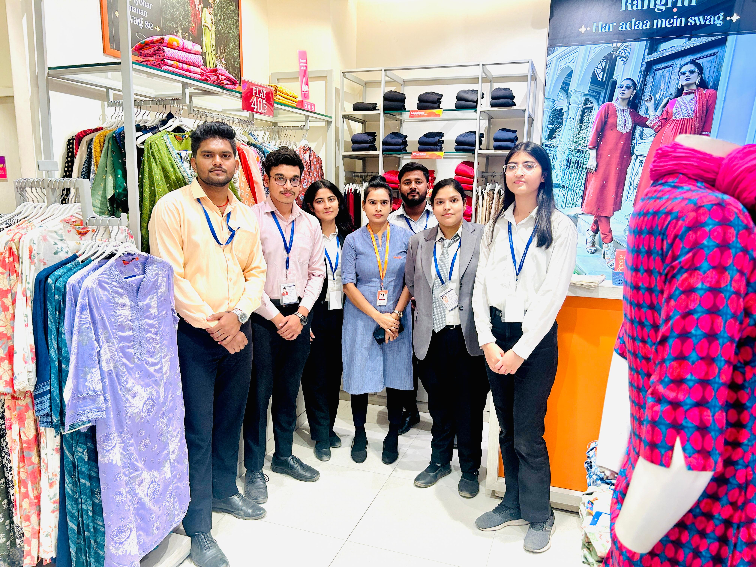Rangriti’s combination of affordable, trendy ethnic wear positions it as a strong player in the market. However, by addressing key operational challenges like staffing, digital marketing, and inventory management, Rangriti can enhance customer experience and increase sales. Improving store ambiance, marketing strategies, and pricing clarity will help solidify its presence in the competitive ethnic wear market.