Automation Test Report - BlazeDemo Flight Booking Project
Prepared By: Ritika Agrawal
Framework: Selenium + Java + TestNG + Maven + Page Object Model (POM)
Project Type: Web Automation Testing
Github link----https://github.com/ritika2004/Wipro2026

1. Project Overview
This project automates the BlazeDemo Flight Booking application using Selenium WebDriver, Java, TestNG, Maven, and the Page Object Model design pattern. The framework supports data-driven testing through Excel, screenshot capturing, reporting, and validation of the end-to-end booking workflow.

2. Technologies Used
- Java
- Selenium WebDriver
- TestNG
- Maven
- Apache POI (Excel Handling)
- Page Object Model (POM)
- Git & GitHub
- Jenkins (CI/CD)
- Docker

3. Framework Structure
Base Package
Pages Package
Utilities Package
Testcases Package
Listeners Package
Excel Test Data
Screenshots Folder

4. Automated Test Flow
- Launch BlazeDemo Application
- Search Flights (Boston → London)
- Select Flight
- Enter Passenger Details
- Complete Flight Purchase
- Validate Confirmation Page
- Capture Screenshots
- Write Results into Excel

5. Test Execution Summary
Test Data | Passenger | Status | Result
Row 1 | Ritika | PASS | Booking Successful
Row 2 | Yashi | PASS | Booking Successful
Row 3 | Navya | PASS | Booking Successful
Total Test Cases Executed : 3
Passed : 3
Failed : 0
Skipped : 0
Pass Percentage : 100%

6. Execution Log Highlights
Searching Flights → Selecting Flight → Filling Purchase Details → Final Confirmation Page → Writing Excel Data → Test Completed Successfully

7. Defects Identified During Testing
- Name field accepts special characters.
- City and State fields can be left blank.
- Invalid month values are accepted.
- Credit card validation is weak.
- Confirmation page data mismatch issue observed during validation testing.
- Registration functionality not working.
- Login functionality not working.

8. Defects Reports and Screenshots
- Defect –1
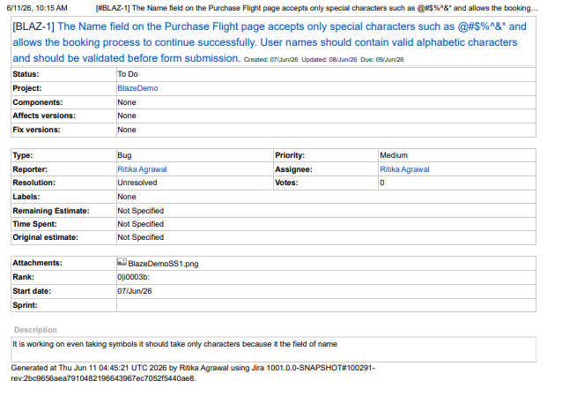
- Defect—2
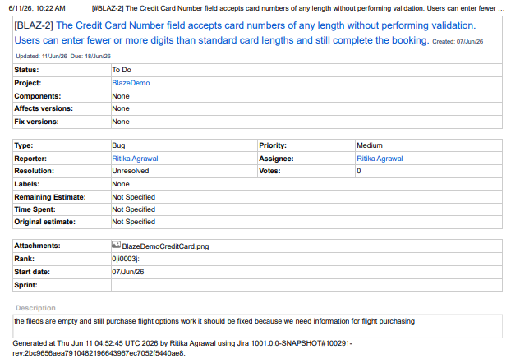
- Defect—3
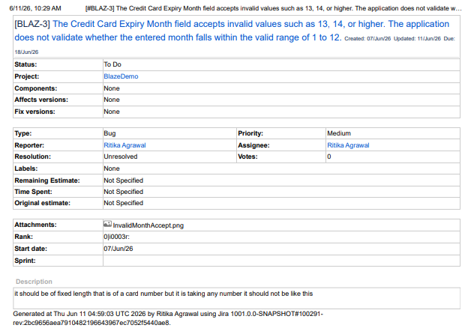
- Defect—4
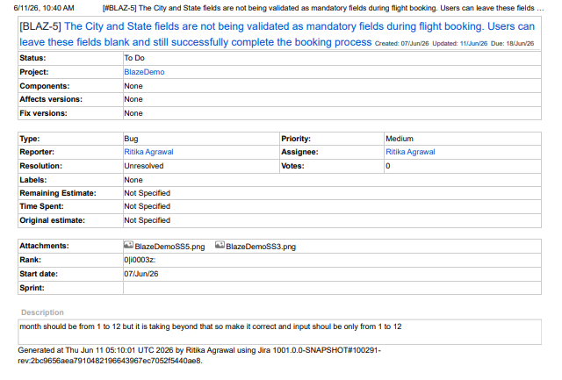
- Defect--5
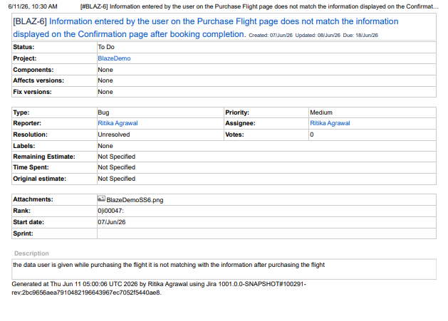
- Defect—6
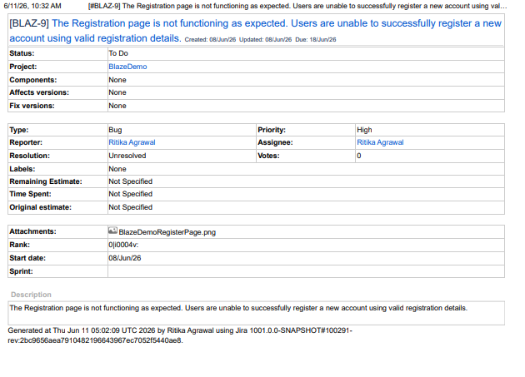
- Defect—7
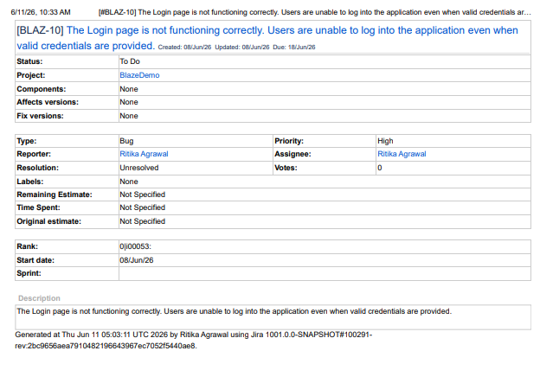
- Defects Summary
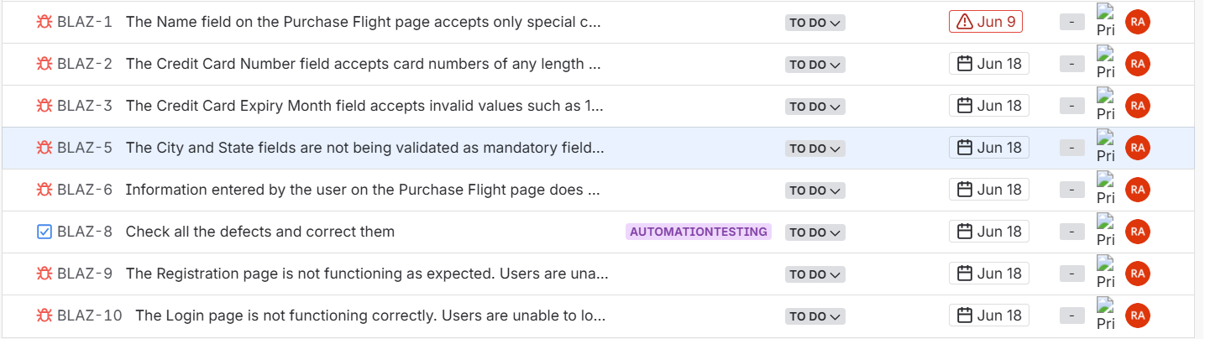

9. Project link & Screenshots & Evidence
Screenshots are captured automatically during execution and stored in the screenshots folder.

Command –mvn clean test
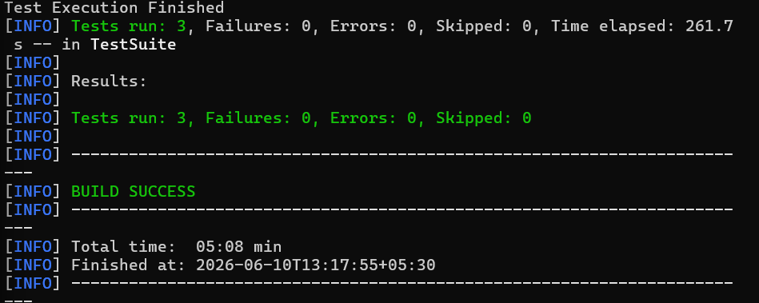
Docker build in command prompt
Command – docker run –rm blazedemo-automation
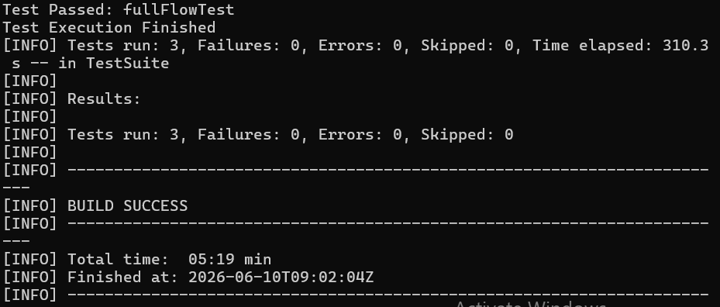

9. CI/CD & Containerization
The project is prepared for Jenkins integration and Docker execution. Maven commands can be executed through Jenkins jobs and Docker containers.
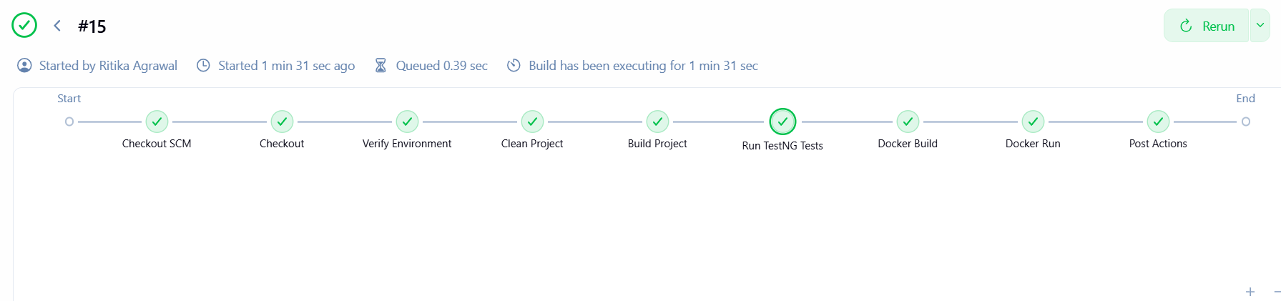

10. Conclusion
The BlazeDemo Flight Booking Automation Framework executed successfully. All three data-driven test scenarios passed successfully with a 100% pass rate. The framework demonstrates automated flight search, booking validation, screenshot capture, Excel integration, and scalable automation architecture using Selenium and TestNG.

