Bluestock Mutual Fund Analytics Capstone
End-to-End Mutual Fund Analytics using Python & Power BI

Final Project Report
Prepared By: Ritika Prakash
Business Analytics Intern
Submitted To
Bluestock Fintech

Tools & Technologies
- Python
- Pandas
- NumPy
- Matplotlib
- Plotly
- SciPy
- SQLite
- Power BI
- Git & GitHub

1. Introduction
The Indian mutual fund industry has witnessed significant growth over the last few years due to increasing financial awareness, digital investment platforms, and systematic investment plans (SIPs). With a large volume of schemes, transactions, and investor data, extracting meaningful insights requires an effective analytics solution.
This project presents an end-to-end Mutual Fund Analytics solution developed using Python and Power BI. The project begins with data collection and ETL (Extract, Transform, Load) processes, where multiple datasets were cleaned, validated, and transformed into analysis-ready data. Exploratory Data Analysis (EDA) was then performed to identify market trends, investor behaviour, fund performance, and category-wise investment patterns.
Financial performance metrics such as Daily Returns, CAGR, Sharpe Ratio, Sortino Ratio, Alpha, Beta, Maximum Drawdown, and Fund Score were calculated to evaluate the performance of mutual fund schemes. Advanced analytics techniques including Historical Value at Risk (VaR), Conditional Value at Risk (CVaR), Rolling Sharpe Ratio, Investor Cohort Analysis, SIP Continuity Analysis, and Sector Concentration Analysis were also implemented.
Finally, an interactive Power BI dashboard consisting of Industry Overview, Fund Performance, Investor Analytics, and SIP & Market Trends was developed to provide business users with meaningful insights for investment analysis and decision-making.
The project demonstrates how data analytics can be used to convert raw financial data into actionable business intelligence for investors, fund managers, and financial institutions.
1.1 Background
Mutual funds are one of the most popular investment instruments in India. They allow investors to pool their money into professionally managed portfolios consisting of equities, debt securities, government bonds, and other financial instruments. The growth of digital investment platforms and increasing financial awareness has significantly increased the number of investors participating in mutual fund investments.
The Indian mutual fund industry has experienced rapid growth in Assets Under Management (AUM), Systematic Investment Plan (SIP) contributions, and investor folios over recent years. With thousands of schemes and millions of transactions generated every month, financial organizations require advanced analytics solutions to monitor performance, identify investment trends, and improve customer engagement.
Analytics enables fund houses to evaluate fund performance, measure investment risk, understand investor behaviour, and make data-driven business decisions. This project focuses on building a complete analytics pipeline that transforms raw mutual fund data into meaningful business insights through Python and Power BI.

1.2 Problem Statement
The mutual fund industry generates a large amount of financial and transactional data every day. However, raw data alone cannot support effective investment decisions. There is a need for an integrated analytics solution that can clean, process, analyze, and visualize data in a meaningful way.
The objective of this project is to build an end-to-end Mutual Fund Analytics System capable of performing financial analysis, investor analysis, and dashboard reporting using Python and Power BI.

1.3 Project Objectives
The primary objectives of this project are:
- To collect and clean mutual fund datasets from multiple sources.
- To design an ETL pipeline for data preprocessing.
- To perform Exploratory Data Analysis (EDA) for identifying trends and patterns.
- To calculate financial performance metrics such as CAGR, Sharpe Ratio, Sortino Ratio, Alpha, Beta, and Maximum Drawdown.
- To perform advanced analytics including VaR, CVaR, Rolling Sharpe Ratio, Investor Cohort Analysis, SIP Continuity Analysis, and Sector Concentration Analysis.
- To build an interactive Power BI dashboard for business users.
- To generate meaningful insights and business recommendations.

1.4 Scope of the Project
The scope of this project includes the complete analytics lifecycle from raw data processing to business dashboard development. The project covers mutual fund scheme information, NAV history, investor transactions, monthly SIP inflows, industry folios, category inflows, portfolio holdings, and fund performance metrics.
The project focuses on descriptive analytics, diagnostic analytics, and financial performance analysis rather than predictive modelling.

2. Data Sources

The project uses multiple datasets representing different aspects of the mutual fund industry.
Fund Master Dataset
This dataset contains the basic information about each mutual fund scheme including AMFI code, scheme name, fund house, investment category, and investment plan. It acts as the master reference table for all other datasets.
NAV History Dataset
The NAV History dataset stores the historical Net Asset Value of all mutual fund schemes between 2022 and 2026. This dataset is used for return calculations, trend analysis, volatility measurement, and performance evaluation.
AUM Dataset
The Assets Under Management (AUM) dataset contains yearly AUM values for various fund houses. It is used to compare market share and identify leading asset management companies.
Monthly SIP Dataset
This dataset contains monthly Systematic Investment Plan (SIP) inflows along with active SIP accounts and year-on-year growth percentages. It is used to analyze investment behaviour over time.
Category Inflow Dataset
The category inflow dataset contains monthly net inflows for different mutual fund categories such as Large Cap, Mid Cap, Small Cap, ELSS, Liquid Funds, and Sectoral Funds. This dataset helps identify investor preferences across categories.
Industry Folio Dataset
The folio dataset records the number of investor folios across different fund categories. It is used to measure investor participation and market growth.
Investor Transaction Dataset
The investor transaction dataset contains transaction-level information including investor ID, transaction type, amount invested, state, city tier, gender, age group, payment mode, and KYC status. This dataset supports investor analytics and behavioural analysis.
Portfolio Holdings Dataset
The portfolio holdings dataset includes sector allocation and stock-level holdings for each mutual fund scheme. It is used to calculate portfolio concentration using the Herfindahl-Hirschman Index (HHI).

3. ETL Process

Raw CSV
↓
Python ETL
↓
Processed Data
↓
Analytics
↓
Power BI Dashboard
The ETL (Extract, Transform, Load) process forms the foundation of this project. Multiple raw datasets were collected and processed using Python to create analysis-ready datasets.
During the extraction stage, CSV datasets containing mutual fund information, NAV history, investor transactions, SIP inflows, portfolio holdings, and industry statistics were imported using the Pandas library.
During the transformation stage, missing values were handled, duplicate records were removed, inconsistent column names were standardized, data types were converted, and invalid records were filtered. Date columns were converted into datetime format, numerical columns were cleaned, and new calculated columns were created wherever required.
After transformation, processed datasets were stored in the Processed Data folder for further analysis. These cleaned datasets were then used for Exploratory Data Analysis, financial performance analysis, advanced analytics, and dashboard development.
The ETL pipeline ensured data quality, consistency, and reliability before performing any analytical operations.

4.Exploratory Data Analysis
Exploratory Data Analysis (EDA) was performed to understand the structure of the mutual fund dataset and identify meaningful trends before conducting financial analysis. Various visualization techniques were used to analyze Assets Under Management (AUM), Net Asset Value (NAV), SIP inflows, investor demographics, fund category performance, portfolio allocation, and industry growth. The analysis helped identify investment patterns, fund performance trends, and investor behaviour.

4.1 NAV Trend Analysis
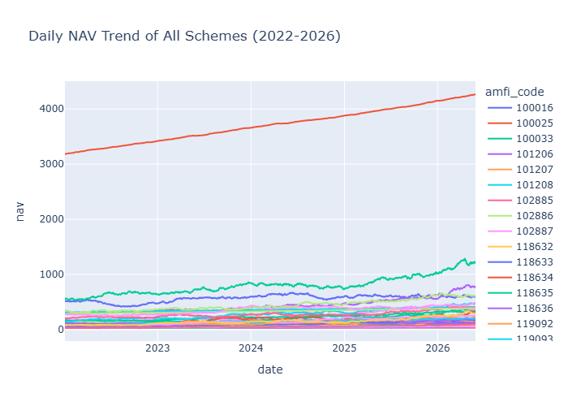
The daily Net Asset Value (NAV) of all selected mutual fund schemes was analyzed for the period 2022–2026. The objective was to observe long-term price movements, identify periods of market growth, and evaluate the stability of different schemes.
The visualization indicates that most equity-oriented mutual funds experienced consistent NAV growth over the observed period. A strong upward trend was visible during the 2023 market recovery, while moderate corrections were observed during 2024 due to changing market conditions. Despite short-term fluctuations, most schemes maintained positive long-term growth.
Business Insight
- Most mutual funds generated positive long-term NAV appreciation.
- Market corrections had only temporary effects on long-term growth.
- Equity funds remained strong wealth creators over the investment horizon.

4.2 Assets Under Management (AUM) Growth Analysis
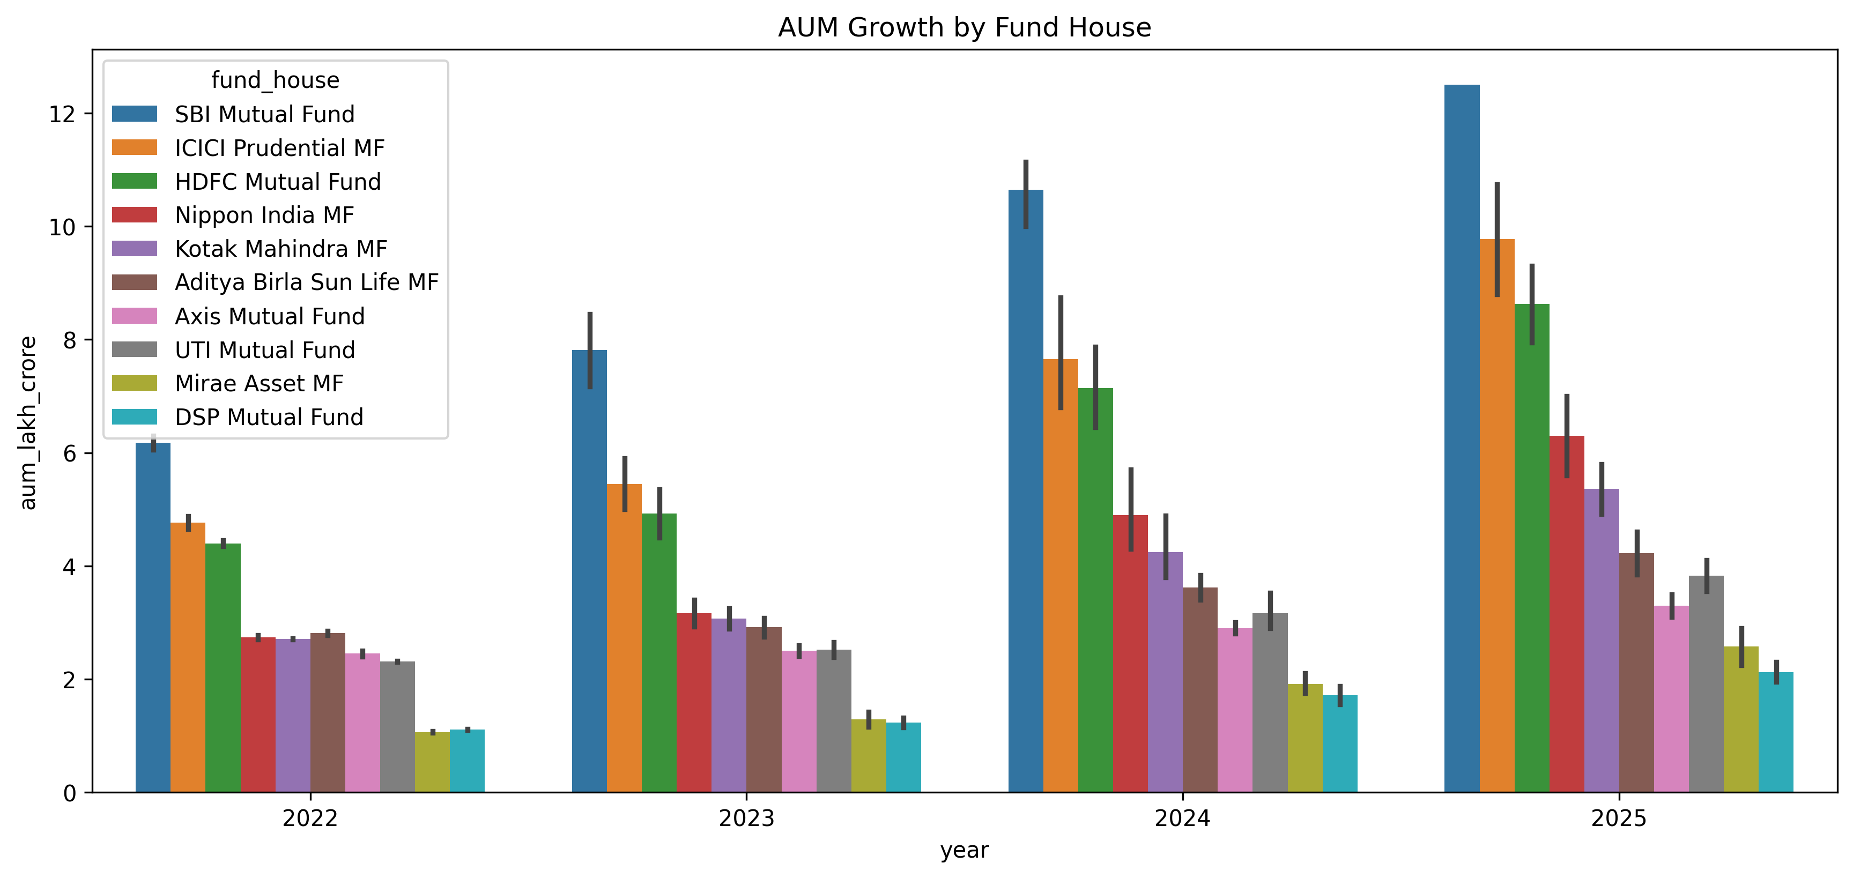
Assets Under Management (AUM) represent the total value of investments managed by Asset Management Companies (AMCs). A grouped bar chart was created to compare yearly AUM growth across major fund houses from 2022 to 2025.
The analysis showed steady industry growth with SBI Mutual Fund maintaining the highest AUM throughout the study period. Other major fund houses such as ICICI Prudential, HDFC Mutual Fund, Axis Mutual Fund, and Nippon India Mutual Fund also demonstrated significant growth in managed assets.
Business Insight
- SBI Mutual Fund remained the market leader in terms of AUM.
- Consistent AUM growth indicates increasing investor confidence.
- Large AMCs continue to dominate the Indian mutual fund market.

4.3 Monthly SIP Inflow Analysis

Systematic Investment Plans (SIPs) have become one of the primary investment methods for retail investors. Monthly SIP inflows from January 2022 to December 2025 were analyzed using a time-series visualization.
The results showed a continuous increase in SIP contributions over time, reaching an all-time high during December 2025. The increasing trend indicates growing financial awareness and long-term investment discipline among investors.
Business Insight
- SIP investments have grown consistently over the last four years.
- Investors increasingly prefer disciplined monthly investing.
- Higher SIP inflows contribute to stable long-term industry growth.

4.4 Category-wise Net Inflow Analysis
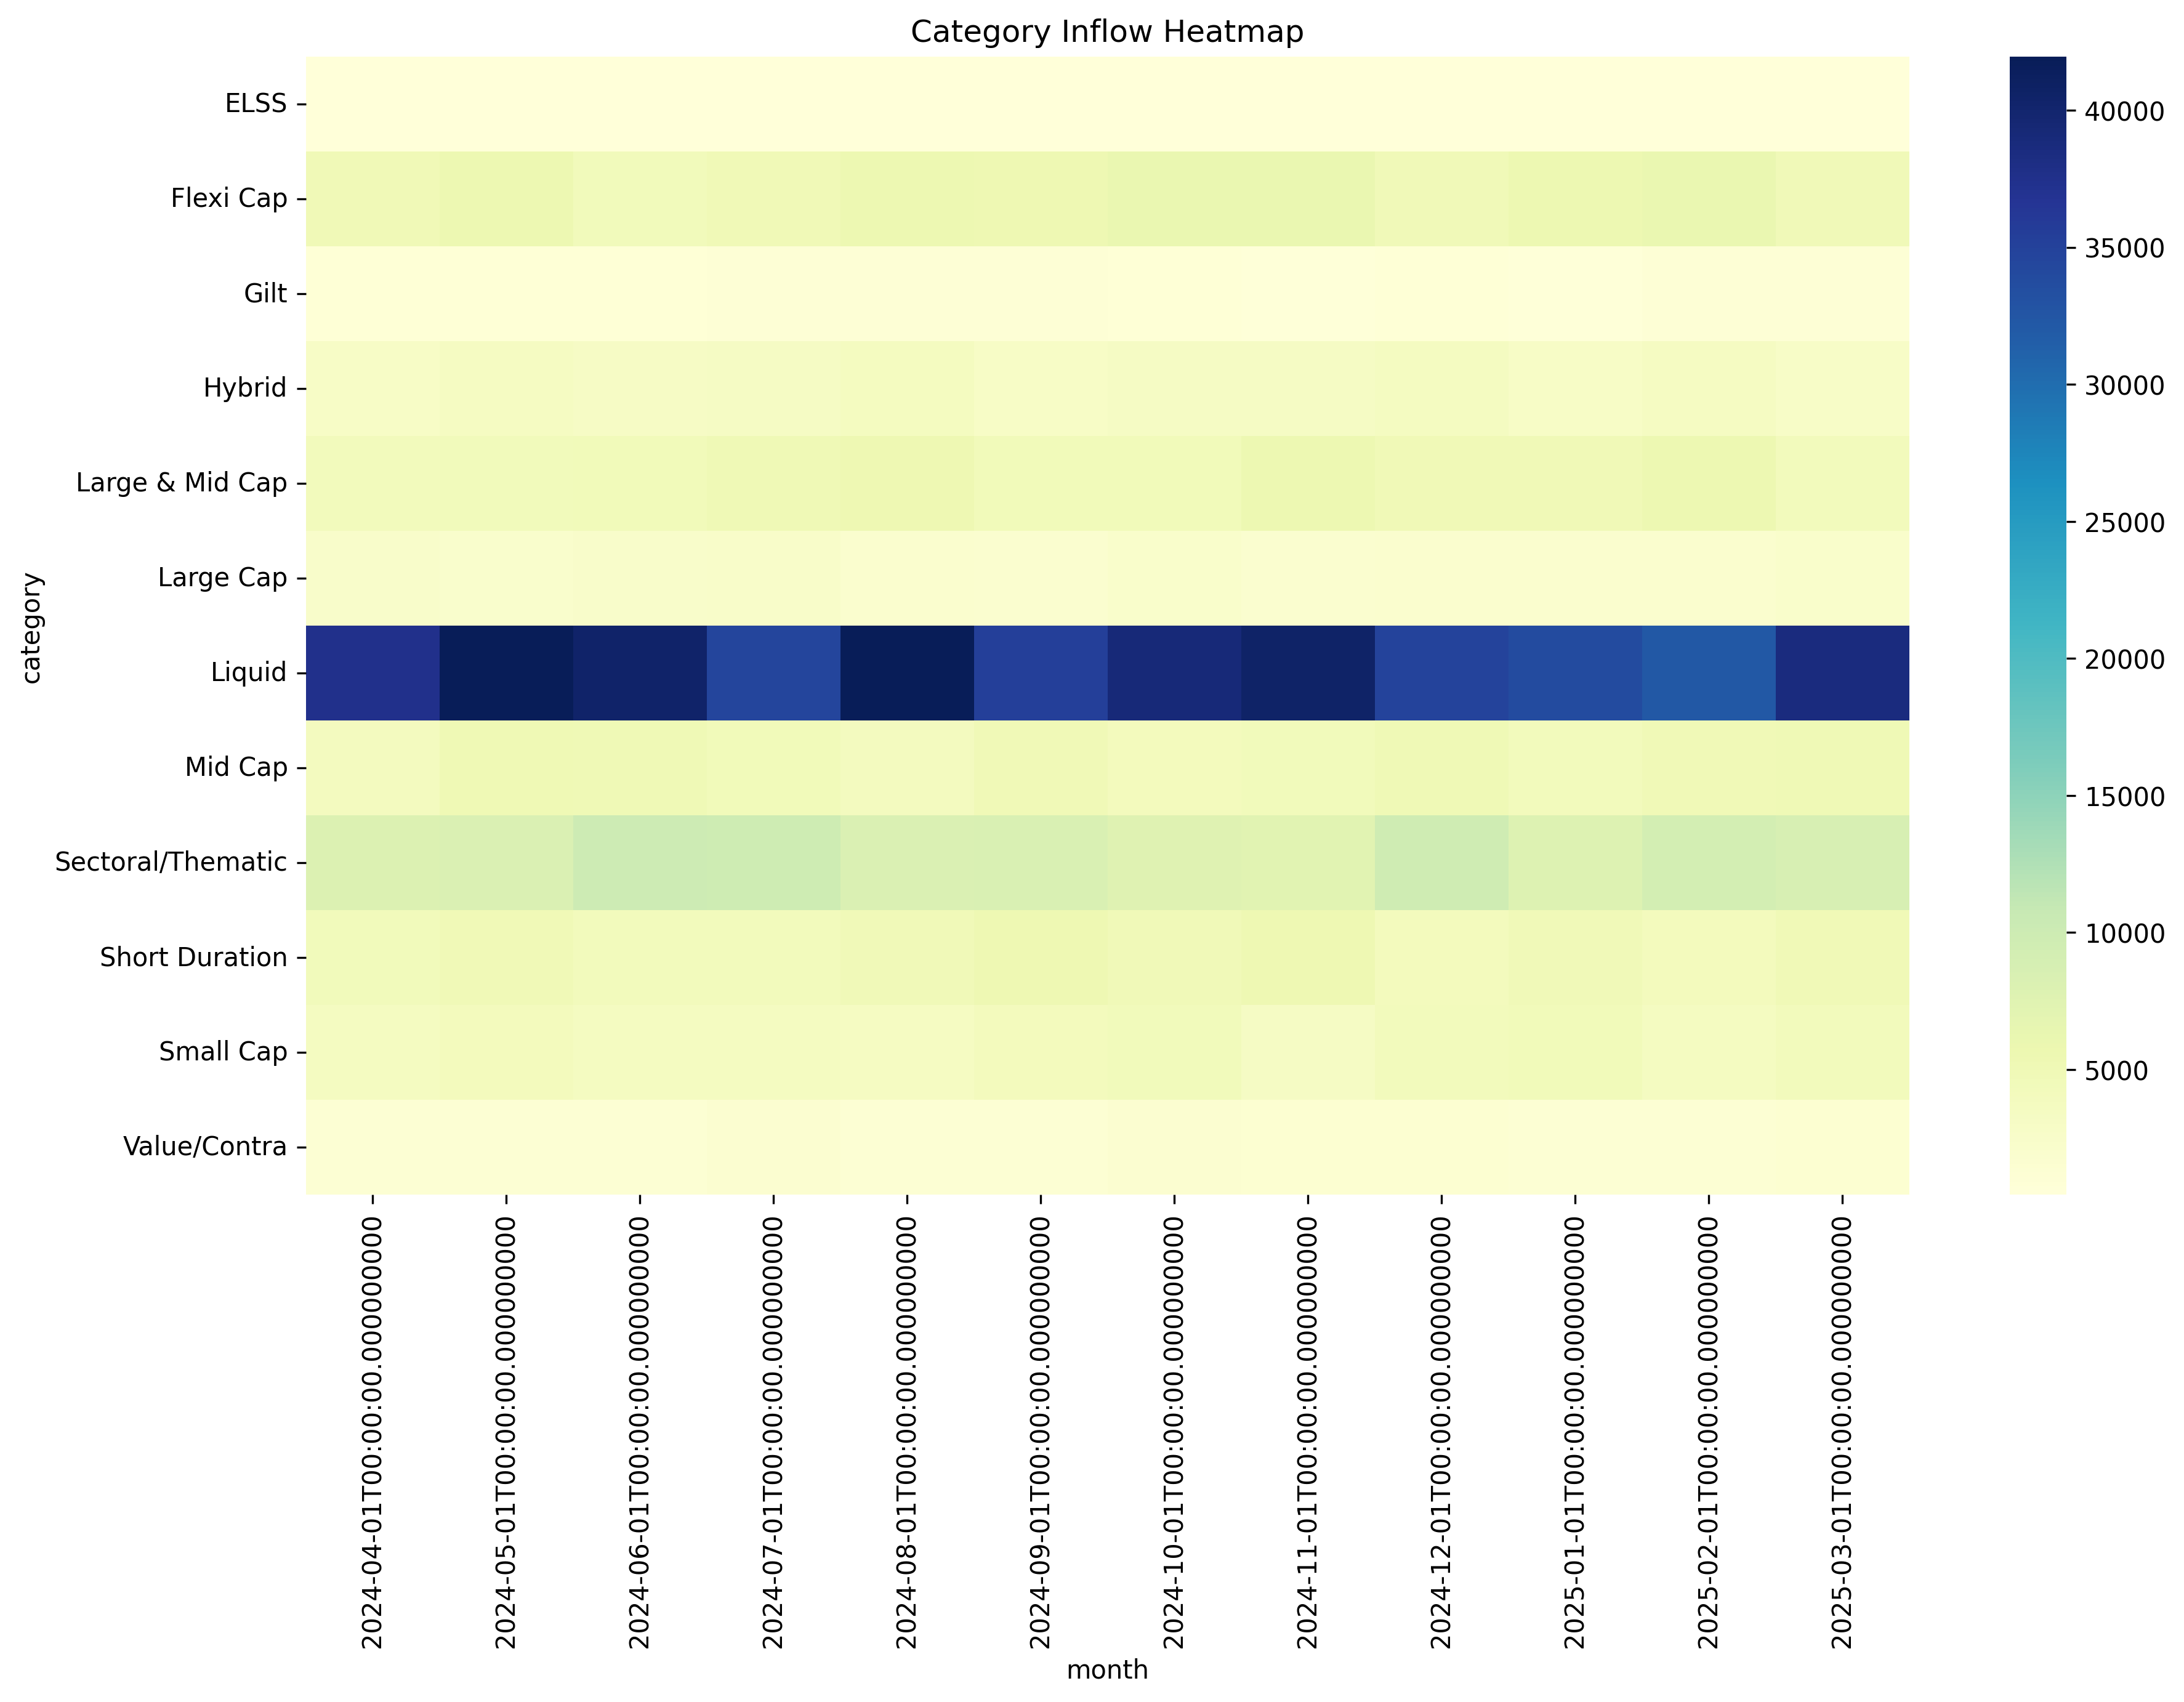
Monthly net inflows were analyzed across different mutual fund categories including Large Cap, Mid Cap, Small Cap, ELSS, Liquid Funds, Hybrid Funds, and Sectoral Funds.
The heatmap clearly indicates that Liquid Funds attracted the highest inflows during multiple months, followed by Sectoral/Thematic and Large & Mid Cap funds. ELSS and Value Funds received comparatively lower inflows.
Business Insight
- Liquid Funds remained the most preferred category.
- Sector-specific funds attracted strong investor interest during bullish markets.
- Investors diversified across multiple categories instead of concentrating in a single segment.

4.5 Investor Age Group Analysis
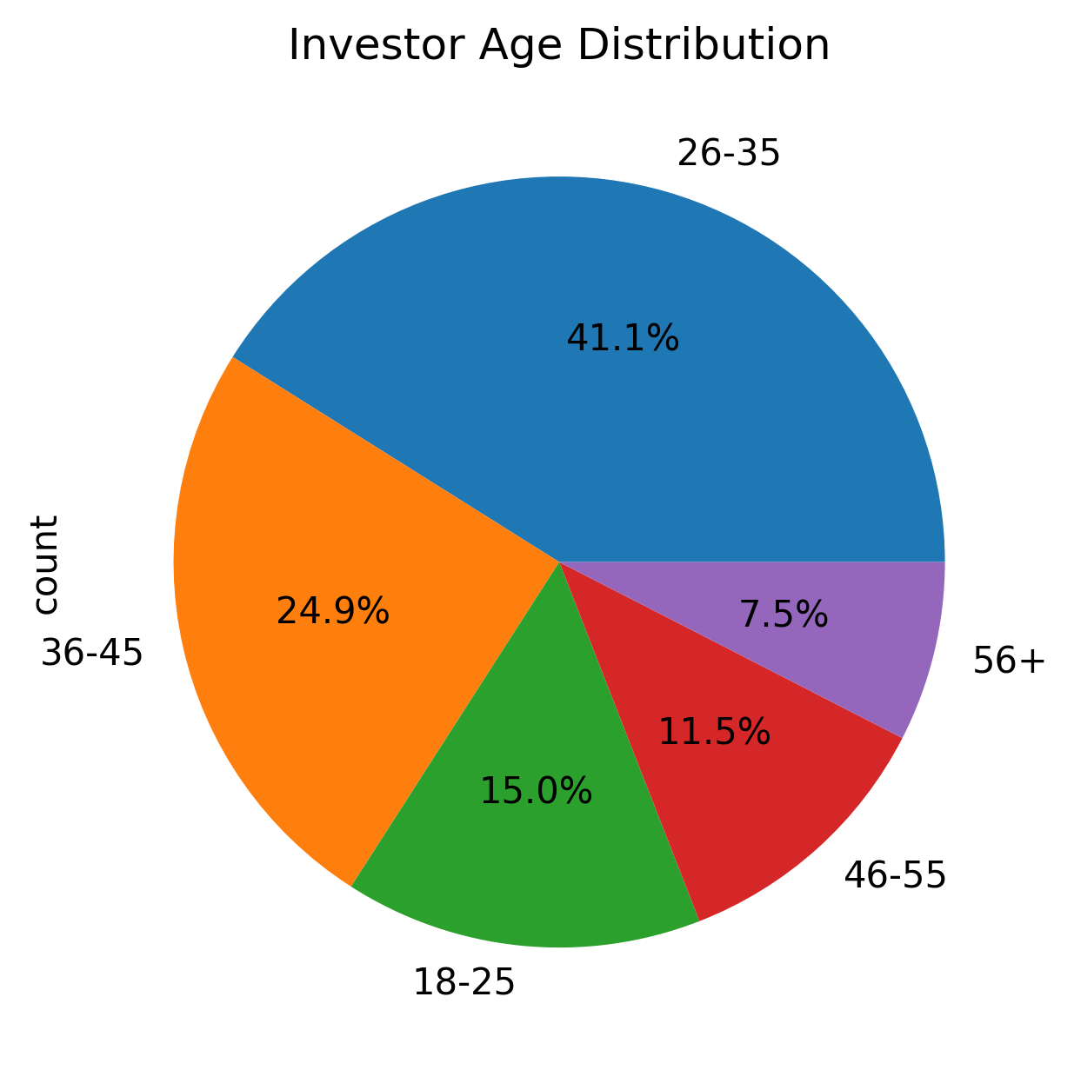
Investor demographics were analyzed to understand participation across different age groups. The analysis indicates that investors between 26–35 years formed the largest investment group, followed by investors in the 36–45 age bracket.
Young professionals showed greater participation in systematic investments, reflecting increasing financial literacy among the working population.
Business Insight
- Investors aged 26–35 contribute the largest share of investments.
- Young investors are adopting long-term wealth creation strategies.
- Financial institutions should design products targeting young professionals.

4.6 Gender Distribution Analysis
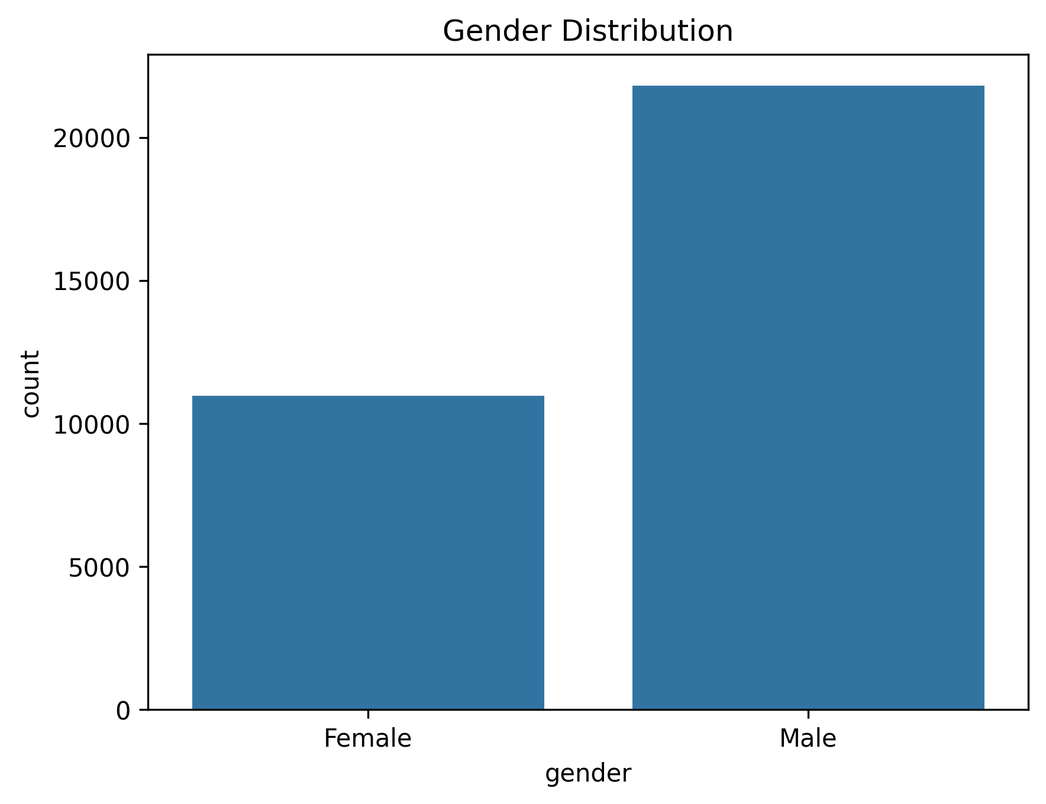
Investor participation was analyzed based on gender.
The results indicate that male investors contributed a larger share of investments compared to female investors. However, female participation continues to grow, reflecting increasing financial independence and awareness.
Business Insight
- Male investors currently dominate investment activity.
- Female investor participation presents a significant growth opportunity.
- Gender-focused financial awareness programs may increase market participation.

4.7 Industry Folio Growth Analysis
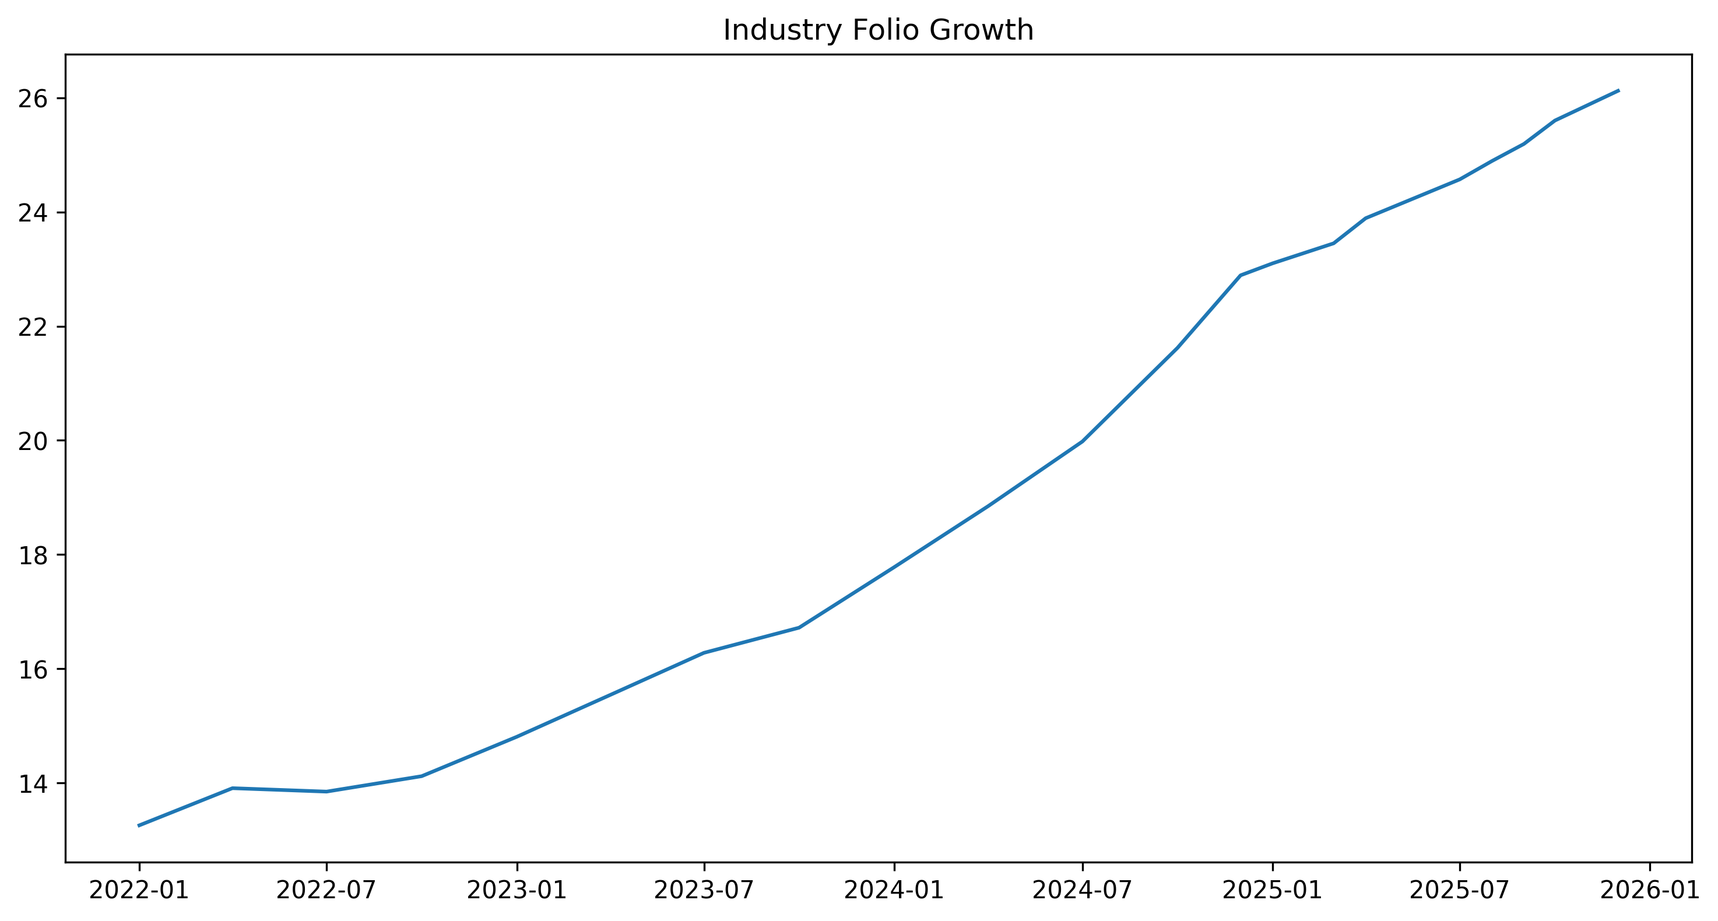
Investor folios represent the number of mutual fund accounts maintained across the industry. Folio growth between 2022 and 2025 was analyzed to measure industry expansion.
The analysis revealed that total folios increased steadily during the study period, indicating continuous addition of new investors into the mutual fund ecosystem.
Business Insight
- Rising folio counts demonstrate increasing retail participation.
- Industry expansion is driven by digital investment platforms.
- Higher folio growth reflects growing investor confidence.

4.8 Correlation Analysis

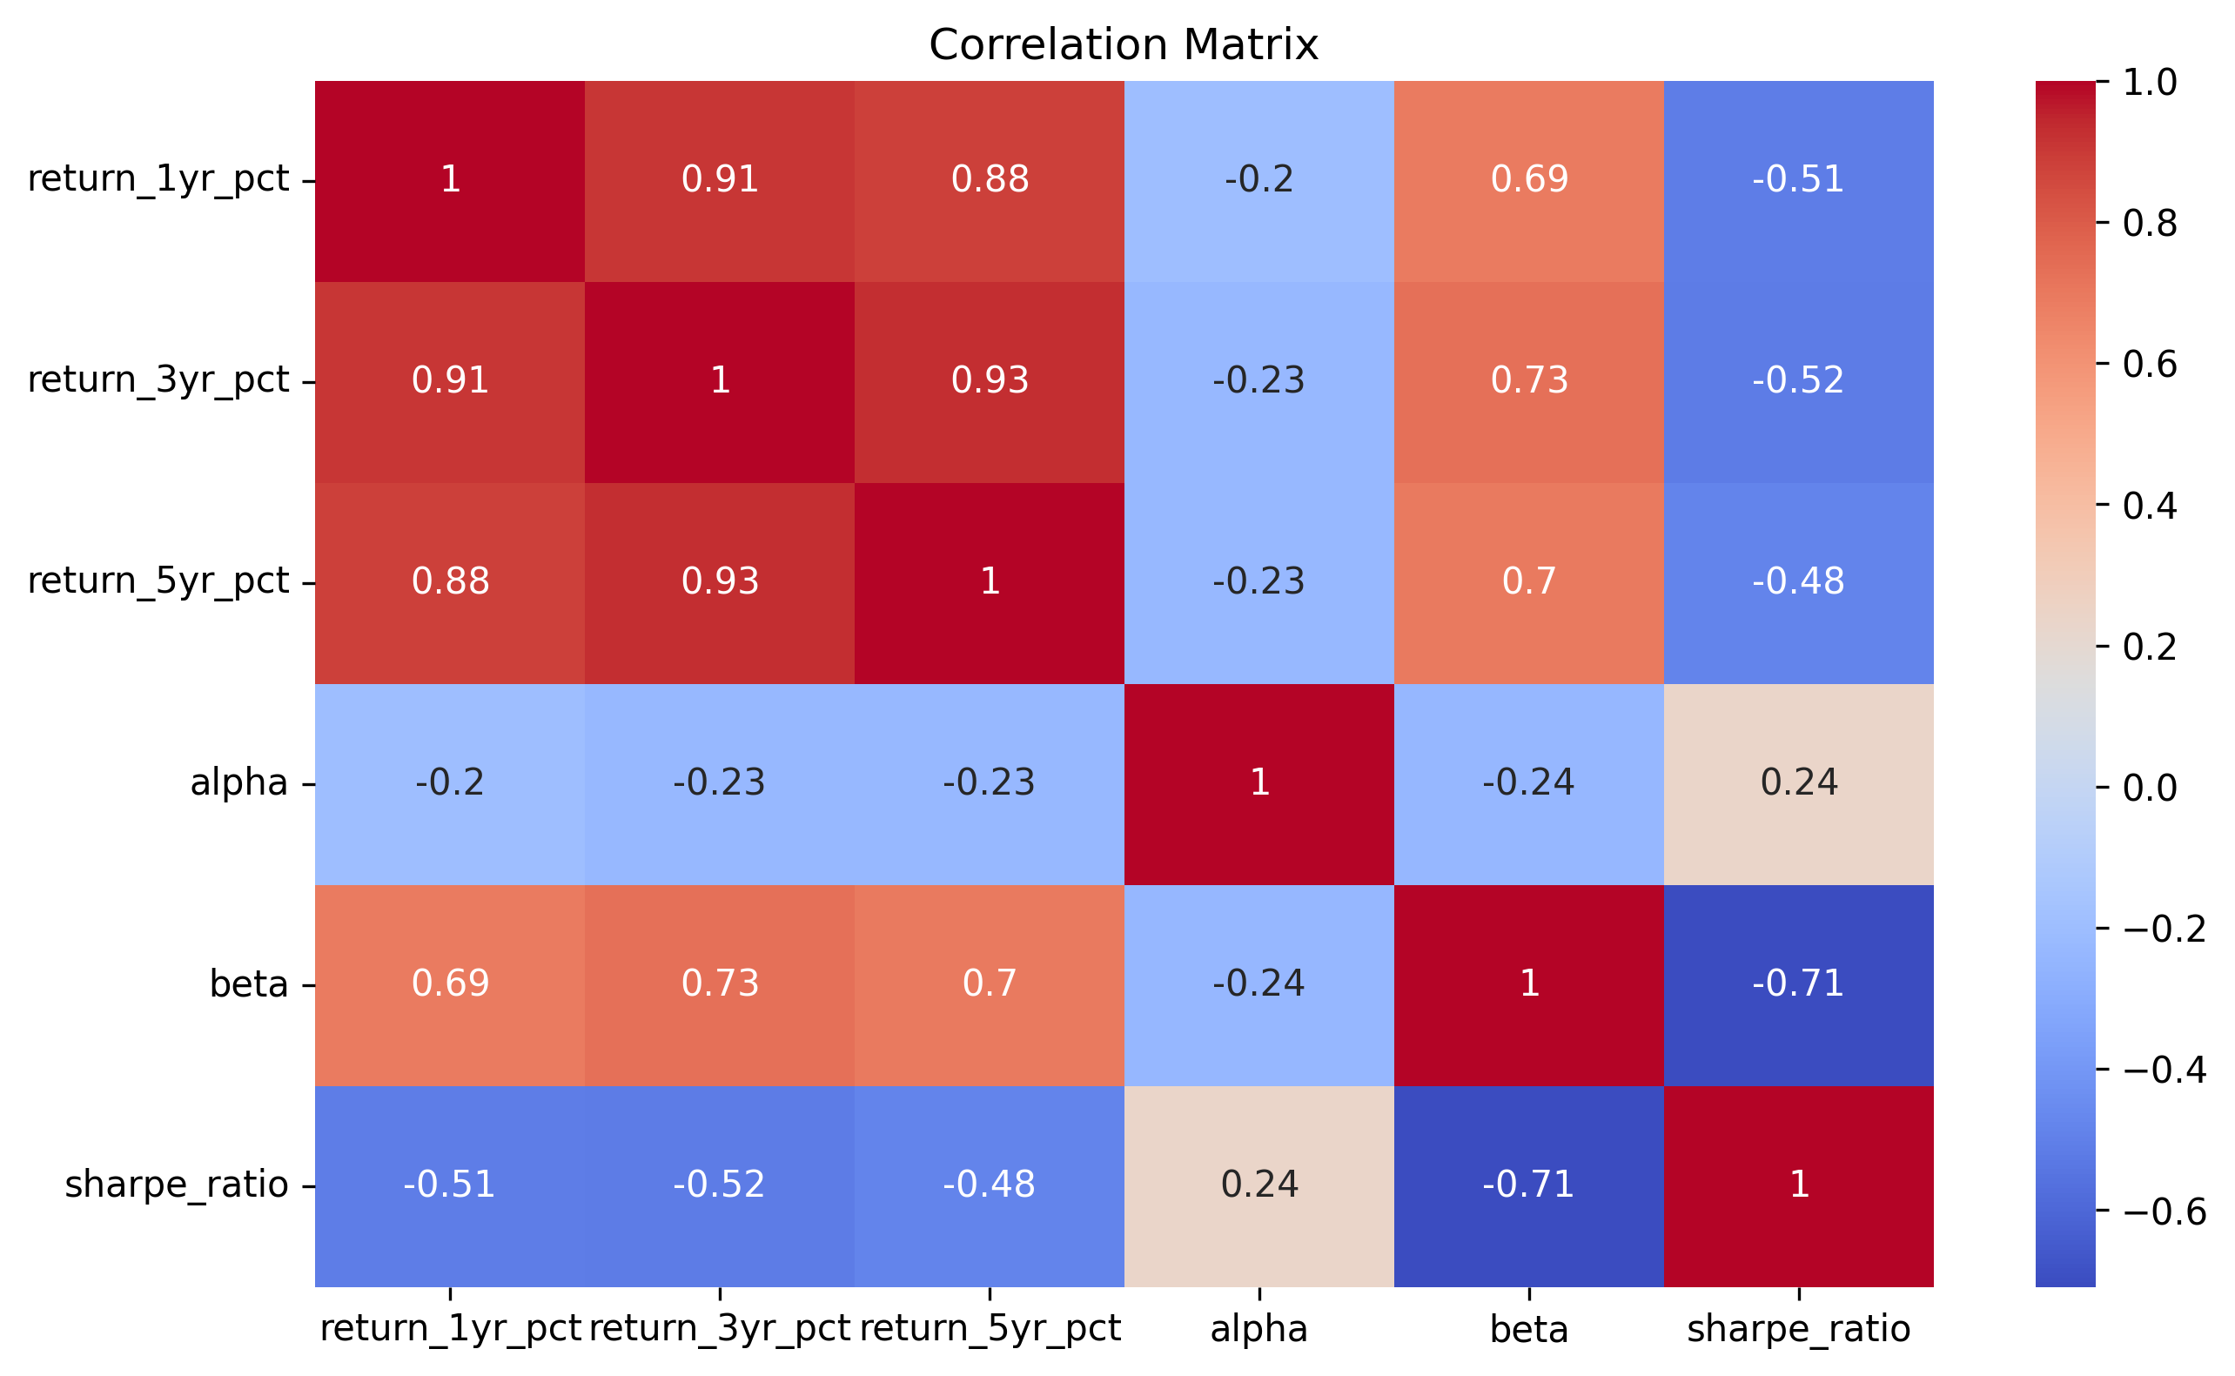
Correlation analysis was performed on selected mutual fund returns to evaluate relationships between different schemes.
The correlation matrix indicated that funds within similar investment categories exhibited strong positive correlations, while diversified funds showed relatively lower correlation.
Business Insight
- Diversification reduces portfolio concentration risk.
- Similar category funds often move together during market fluctuations.
- Investors should diversify across categories instead of selecting highly correlated funds.

Key EDA Findings
The exploratory analysis generated the following important insights:
- Industry Assets Under Management increased consistently between 2022 and 2025.
- SBI Mutual Fund maintained the highest AUM among all Asset Management Companies.
- Monthly SIP inflows showed continuous growth, indicating increasing retail participation.
- Liquid Funds received the highest category-wise inflows during the study period.
- Investors aged 26–35 represented the largest investment segment.
- Male investors contributed a larger proportion of total investments.
- Industry folio counts increased significantly, reflecting growth in the mutual fund industry.
- Equity-oriented funds demonstrated stable long-term NAV growth.
- Fund returns within similar categories showed strong positive correlation.
- Diversified investment strategies provide better risk management than concentrated portfolios.

5: Performance Analytics
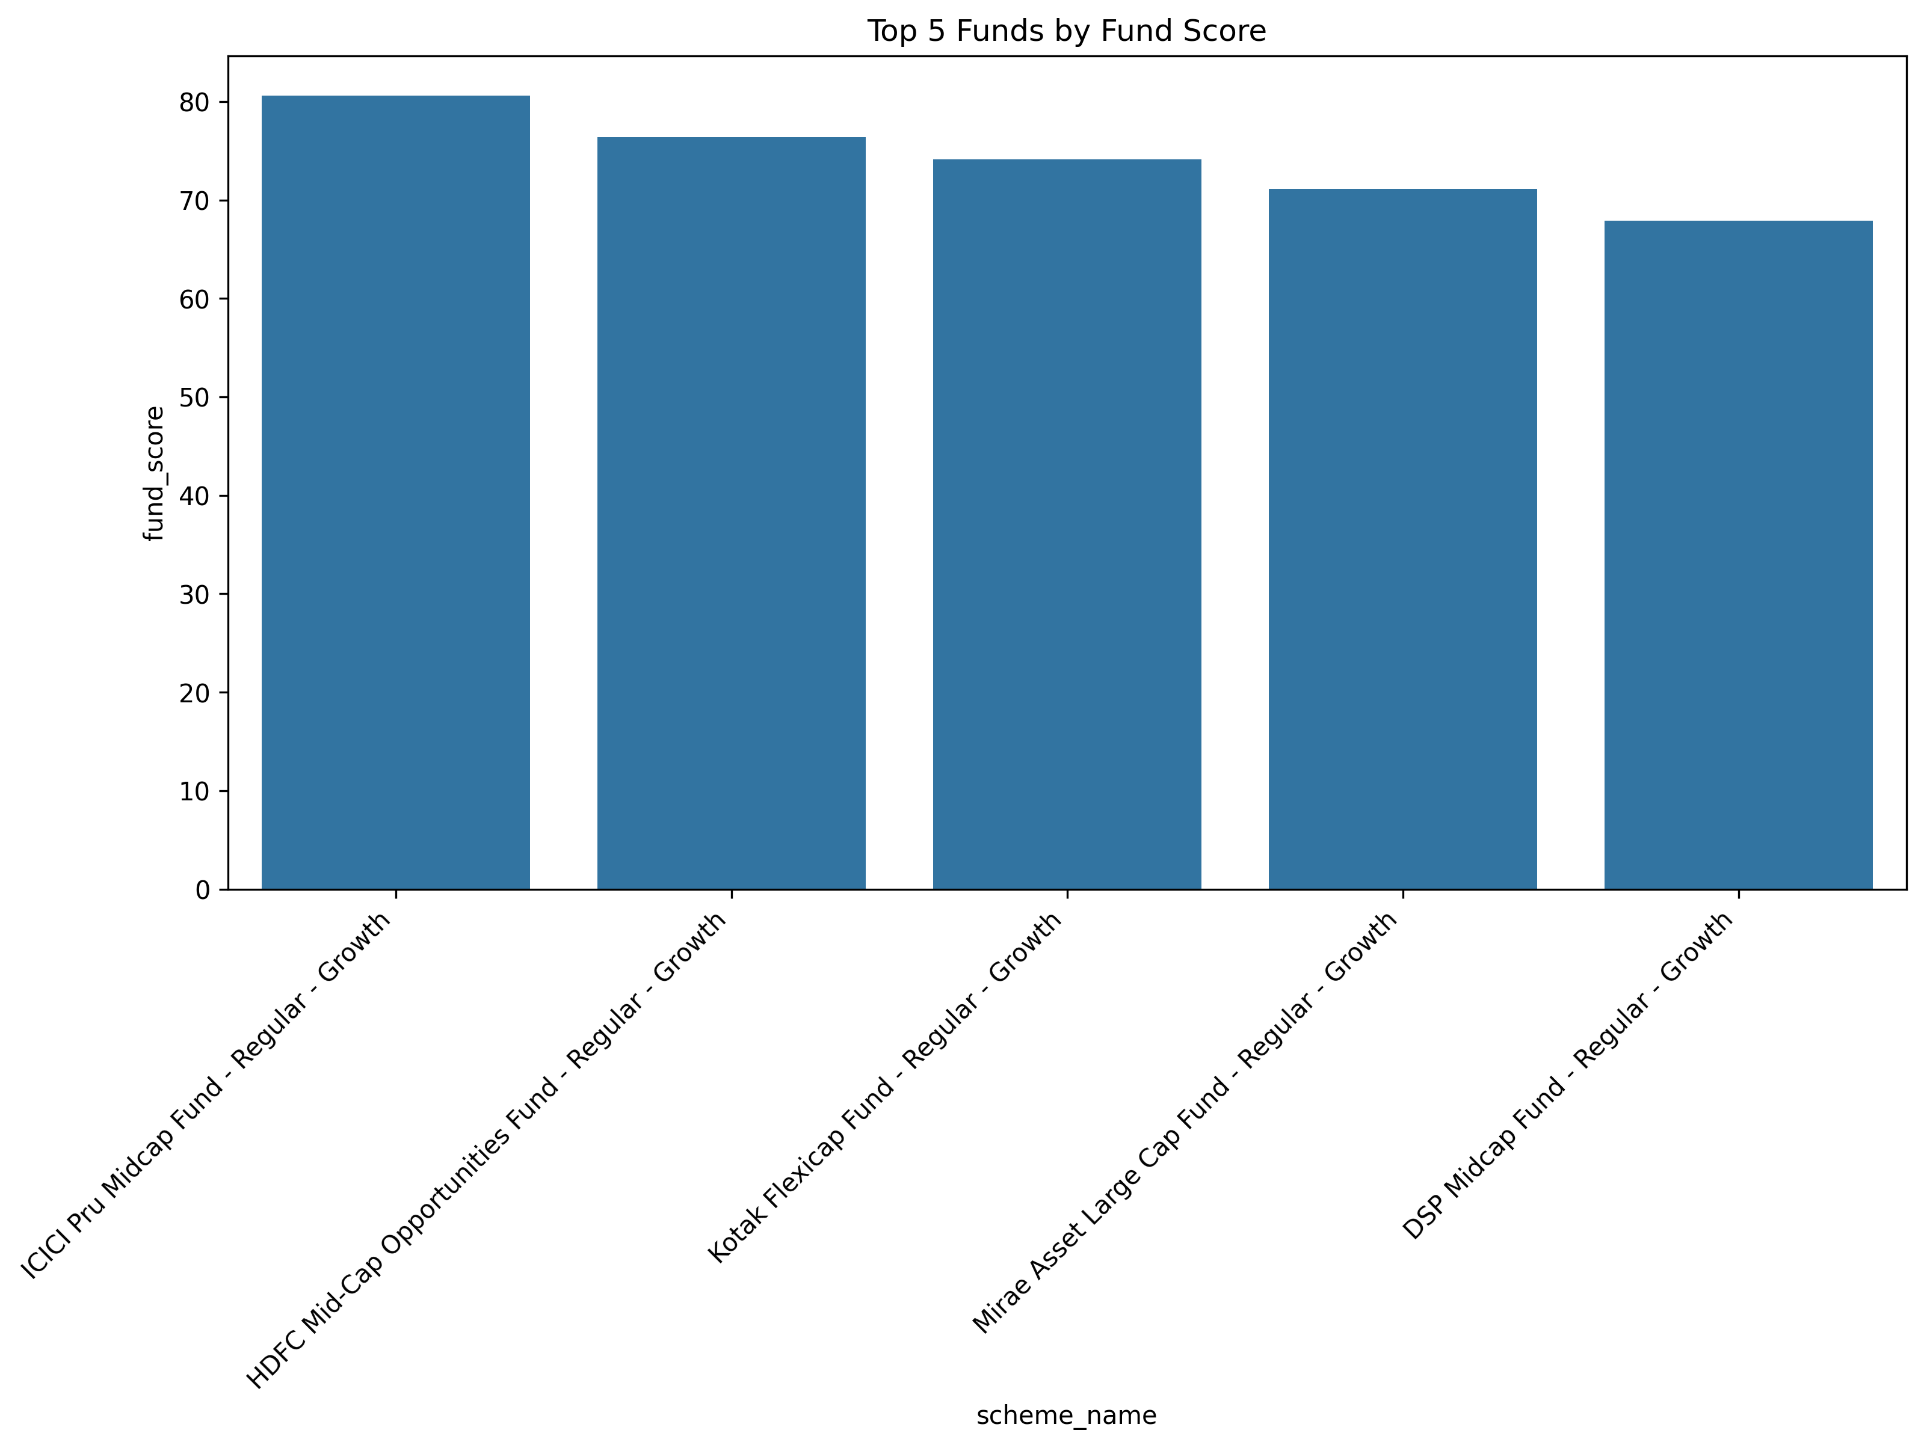
Performance analytics was conducted to evaluate the financial performance and risk characteristics of each mutual fund scheme. Multiple risk-adjusted performance indicators were calculated using historical NAV data to provide a comprehensive assessment of investment quality.
The analysis included Daily Returns, Compound Annual Growth Rate (CAGR), Sharpe Ratio, Sortino Ratio, Alpha, Beta, Maximum Drawdown, Benchmark Comparison, and a Composite Fund Score. These metrics enable investors to compare mutual funds not only based on returns but also on the level of risk undertaken to achieve those returns.

6: Advanced Analytics

6.1 Historical Value at Risk (VaR)
Value at Risk (VaR) is a statistical measure used to estimate the maximum expected loss that a mutual fund may experience over a specific period at a given confidence level. In this project, Historical VaR at a 95% confidence level was calculated using the 5th percentile of daily return distributions for all selected mutual fund schemes.
The analysis helped identify funds with relatively higher downside risk during adverse market conditions. Funds with more negative VaR values were considered riskier, while funds with smaller negative values indicated better downside protection.
Business Insight
- Funds with higher negative VaR values have greater downside risk.
- Conservative investors should prefer funds with lower VaR values.
- VaR helps investors understand potential short-term losses before investing.

6.2 Conditional Value at Risk (CVaR)
Conditional Value at Risk (CVaR), also known as Expected Shortfall, measures the average loss beyond the VaR threshold. While VaR estimates the minimum expected loss at a confidence level, CVaR provides information about the severity of losses during extreme market conditions.
The analysis showed that some equity-oriented funds experienced significantly larger tail risks compared to debt and hybrid funds.
Business Insight
- CVaR provides a better understanding of extreme market losses.
- Funds with high CVaR values require stronger risk management.
- Investors should consider both VaR and CVaR while evaluating investment risk.

6.3 Rolling 90-Day Sharpe Ratio
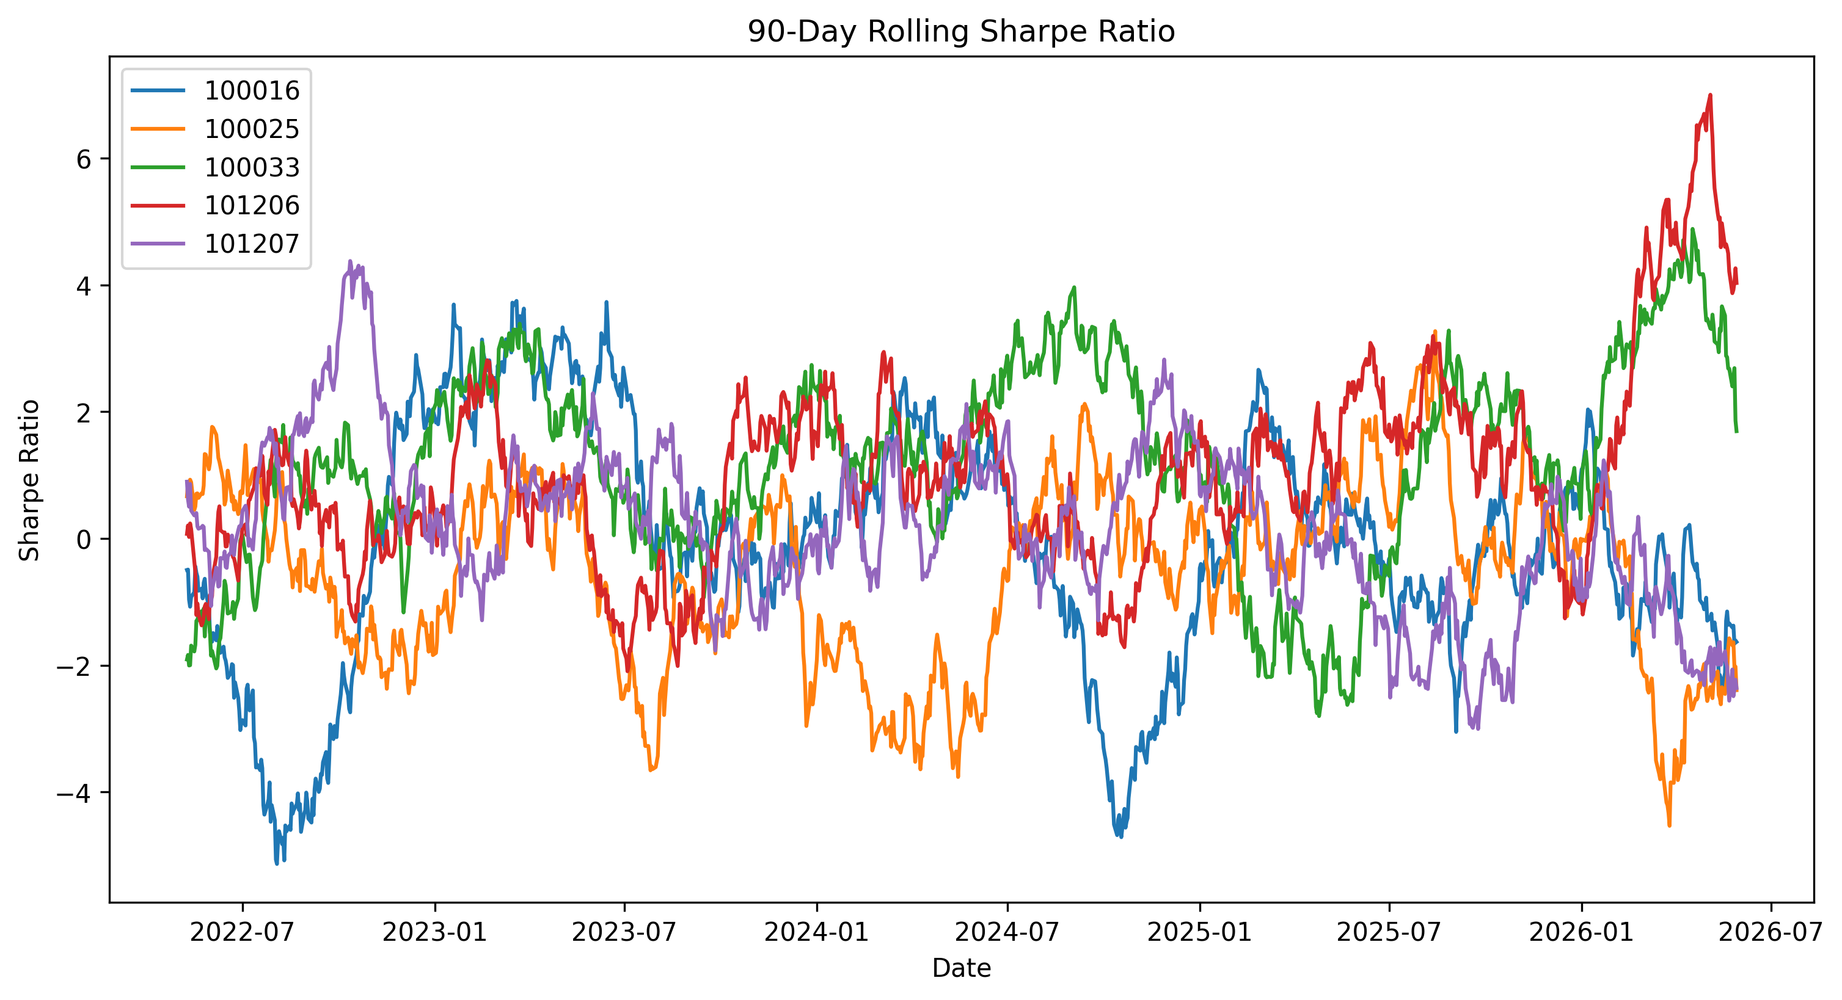
A Rolling 90-Day Sharpe Ratio was calculated to evaluate changes in risk-adjusted returns over time. Instead of calculating a single Sharpe Ratio for the complete dataset, a rolling window of ninety trading days was used to monitor performance across different market conditions.
The results indicated that Sharpe Ratios increased during strong market periods and declined during market corrections, reflecting changes in investment performance.
Business Insight
- Rolling Sharpe Ratio provides continuous performance monitoring.
- Higher Sharpe values indicate better returns relative to risk.
- Investors can identify periods of consistent fund performance.

6.4 Investor Cohort Analysis
Investor Cohort Analysis grouped investors according to the year of their first investment. The analysis compared average SIP amount, total investment value, and investment behaviour among different investor groups.
The analysis showed that recent investor cohorts invested slightly higher average SIP amounts, while older cohorts contributed larger cumulative investments due to longer investment durations.
Business Insight
- Recent investors demonstrate increasing investment confidence.
- Earlier cohorts contribute higher overall investments.
- Cohort analysis helps financial institutions understand customer behaviour.

6.5 SIP Continuity Analysis
SIP Continuity Analysis measured the average gap between consecutive SIP transactions for each investor. Investors whose average transaction gap exceeded 35 days were classified as "At Risk."
This analysis enables fund houses to identify investors who may discontinue systematic investments and design retention strategies accordingly.
Business Insight
- Regular SIP investments improve long-term wealth creation.
- Investors with irregular SIP payments require timely engagement.
- SIP continuity contributes to better customer retention.

6.6 Sector Concentration Analysis (HHI)
Sector concentration was evaluated using the Herfindahl-Hirschman Index (HHI). The HHI measures portfolio diversification by calculating the sum of squared sector weights.
Funds with higher HHI values were found to have concentrated portfolios, whereas lower HHI values indicated better diversification across multiple sectors.
Business Insight
- Diversified portfolios generally reduce investment risk.
- Highly concentrated portfolios may generate higher returns but involve greater volatility.
- HHI supports portfolio diversification decisions.

6.7 Rule-Based Fund Recommendation System
A simple recommendation system was developed using the calculated Sharpe Ratio and investor risk preference. Investors selecting Low, Moderate, or High risk profiles received recommendations for the top-performing mutual funds within the corresponding risk category.
This recommendation model demonstrates how analytical techniques can assist investors in selecting suitable mutual funds based on risk tolerance.
Business Insight
- Personalized recommendations improve investment decision-making.
- Risk-based fund selection enhances customer satisfaction.
- The recommendation engine can be further improved using machine learning algorithms.

7: Dashboard Analysis
An interactive Power BI dashboard was developed to present key insights obtained from the analysis. The dashboard consists of four pages designed to support decision-making for investors, analysts, and fund managers.
7.1 Industry Overview Dashboard
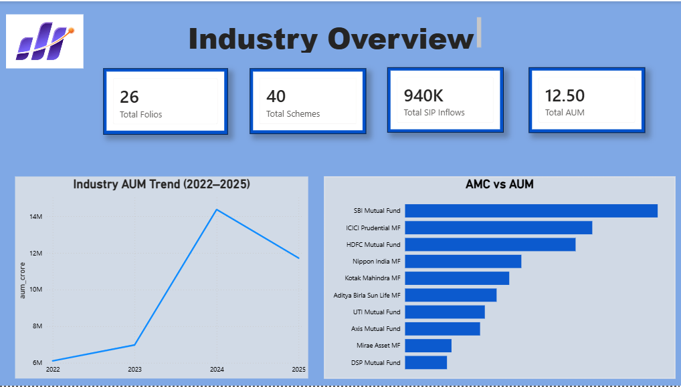
The Industry Overview dashboard provides a summary of key industry indicators, including Total Assets Under Management (AUM), Total SIP Inflows, Total Schemes, and Total Folios. It also displays the industry AUM trend from 2022 to 2025 and compares Assets Under Management across major Asset Management Companies.
The dashboard enables users to monitor industry growth and identify leading fund houses based on managed assets.

7.2 Fund Performance Dashboard
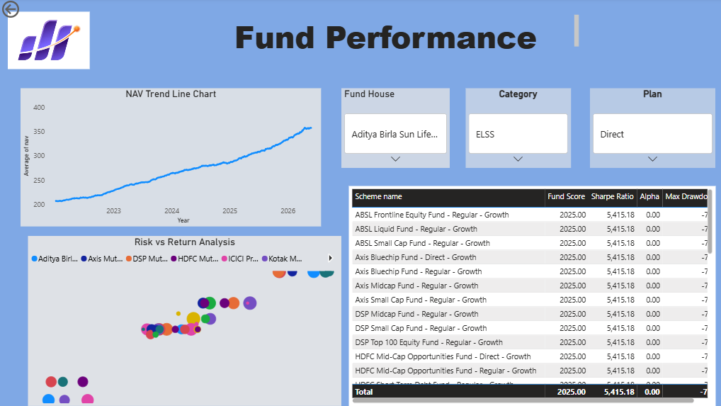
The Fund Performance dashboard compares mutual fund schemes using Risk vs Return Analysis, Fund Scorecards, and NAV Trend Analysis. Interactive slicers allow users to filter data by fund house, investment category, and investment plan.
This dashboard helps investors compare mutual funds based on both return and risk-adjusted performance.

7.3 Investor Analytics Dashboard

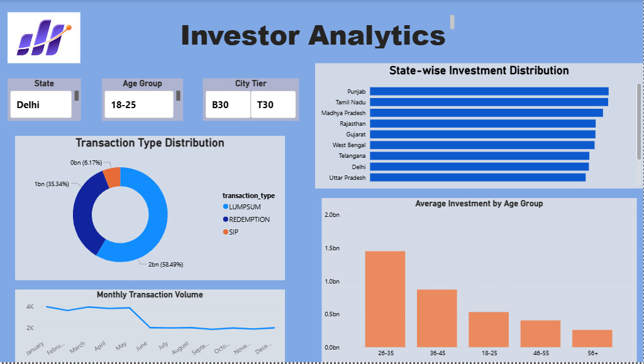
The Investor Analytics dashboard provides insights into investor demographics and transaction behaviour. It includes state-wise investment distribution, transaction type analysis, age group participation, monthly transaction trends, and interactive filters for state, age group, and city tier.
The dashboard supports customer segmentation and helps identify investor behaviour across different demographic groups.

7.4 SIP & Market Trends Dashboard

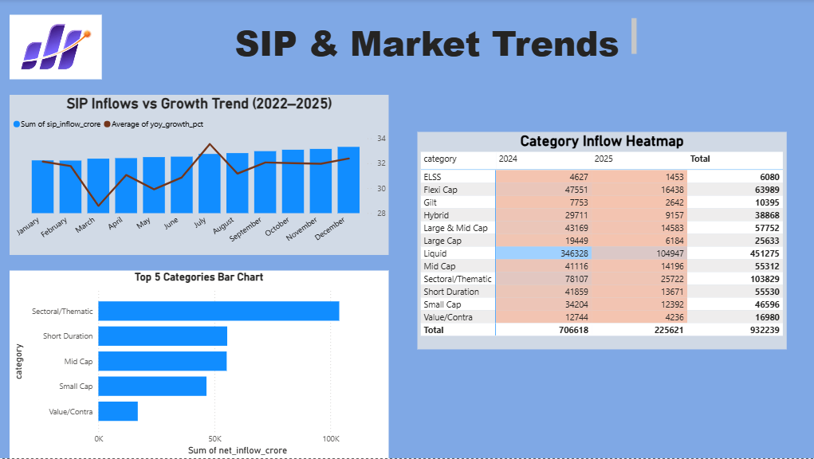
The SIP & Market Trends dashboard presents monthly SIP inflows, category-wise investment heatmaps, and top-performing mutual fund categories. It enables users to understand investment trends across different fund categories and monitor changes in investor preferences over time.
The dashboard also highlights monthly SIP growth and category-wise fund inflows, providing valuable insights into market dynamics.

8: Key Findings
The analysis of the mutual fund datasets generated several valuable insights regarding industry growth, investor behaviour, and fund performance.
8.1 Industry Growth
The Indian mutual fund industry experienced consistent growth in Assets Under Management (AUM) between 2022 and 2025. The increasing AUM indicates rising investor confidence and expanding participation in mutual fund investments.
8.2 Strong Growth in SIP Investments
Monthly Systematic Investment Plan (SIP) contributions increased steadily throughout the study period, reaching record levels during the final months of 2025. This trend reflects the growing popularity of disciplined long-term investing among retail investors.
8.3 Dominance of Large Asset Management Companies
Among all Asset Management Companies, SBI Mutual Fund consistently maintained the highest Assets Under Management, followed by ICICI Prudential Mutual Fund and HDFC Mutual Fund. These companies continue to dominate the Indian mutual fund industry.
8.4 Growth in Investor Participation
The number of investor folios increased significantly during the study period, indicating that more retail investors are participating in mutual fund investments each year.
8.5 Investor Demographics
The majority of investments were made by individuals in the 26–35 age group. This indicates that young professionals are actively participating in wealth creation through mutual fund investments.
8.6 Category-wise Investment Trends
Liquid Funds, Sectoral/Thematic Funds, and Large & Mid Cap Funds attracted the highest net inflows during the analysis period. Investors preferred diversified investment opportunities while maintaining liquidity.
8.7 Risk-adjusted Performance
Mutual fund schemes with higher Sharpe Ratios demonstrated superior risk-adjusted performance. These schemes generated higher returns relative to the amount of risk undertaken.
8.8 Portfolio Diversification
Sector concentration analysis revealed that diversified portfolios generally exhibited lower investment risk compared to highly concentrated portfolios. Funds with lower HHI values offered better diversification.
8.9 Investor Behaviour
Investor Cohort Analysis showed that recently joined investors invested slightly higher average SIP amounts, while earlier investor cohorts contributed larger cumulative investments due to longer investment durations.
8.10 Dashboard Insights
The interactive Power BI dashboard successfully consolidated financial metrics, investor behaviour, industry trends, and fund performance into a single decision-support platform. Interactive filtering enabled users to perform customized analysis efficiently.

9: Recommendations
Based on the analytical findings, the following recommendations are proposed for investors, fund managers, and financial institutions.
Recommendation 1
Asset Management Companies should continue promoting Systematic Investment Plans (SIPs) because regular investments encourage long-term wealth creation and improve investor retention.
Recommendation 2
Fund houses should closely monitor investors identified as "At Risk" through SIP Continuity Analysis and implement customer engagement strategies to reduce SIP discontinuation.
Recommendation 3
Investment decisions should not rely solely on returns. Risk-adjusted performance indicators such as Sharpe Ratio, Sortino Ratio, Alpha, and Maximum Drawdown should also be considered.
Recommendation 4
Investors should diversify investments across multiple mutual fund categories to reduce portfolio concentration risk.
Recommendation 5
Financial institutions should design investment products specifically targeting young investors aged between 26 and 35 years, as this group represents the largest investor segment.
Recommendation 6
Portfolio managers should regularly monitor Value at Risk (VaR) and Conditional Value at Risk (CVaR) to identify funds exposed to significant downside risk.
Recommendation 7
Interactive dashboards should be updated regularly using automated data pipelines to provide real-time business insights.
Recommendation 8
Machine Learning models can be integrated into the recommendation engine to provide personalized investment recommendations based on investor behaviour and financial goals.
Recommendation 9
Fund houses should encourage female investor participation through financial awareness programs and customized investment products.
Recommendation 10
Continuous monitoring of market trends, investor preferences, and fund performance should be performed to improve investment strategies and decision-making.

10: Limitations
Although the project successfully demonstrates a complete analytics workflow, certain limitations should be considered.
- The project uses sample datasets instead of live mutual fund market data.
- The analysis is based on historical information and does not predict future market performance.
- The benchmark comparison uses simplified assumptions for analytical purposes.
- Risk-free rate assumptions remain constant throughout the study.
- Market events beyond the available historical period were not considered.
- The recommendation engine is rule-based and does not use machine learning techniques.
- Portfolio optimization techniques were outside the scope of this project.

11: Future Scope
The project can be further enhanced in several ways.
- Integrate live AMFI and NSE APIs for real-time data updates.
- Implement machine learning models for mutual fund recommendation.
- Develop predictive models for NAV forecasting.
- Build portfolio optimization models using Modern Portfolio Theory.
- Deploy automated ETL pipelines using cloud platforms.
- Publish the Power BI dashboard through Power BI Service for real-time access.
- Develop a web application for investor portfolio analysis.
- Incorporate sentiment analysis using financial news and social media data.
- Add real-time market alerts and investment notifications.
- Expand the project to include international mutual fund datasets.

12: Conclusion
The Bluestock Mutual Fund Analytics Capstone successfully demonstrates the application of Data Analytics, Financial Analytics, and Business Intelligence techniques to the mutual fund industry. The project transformed raw financial datasets into meaningful business insights through a structured ETL pipeline, comprehensive exploratory analysis, advanced financial metrics, and interactive dashboard development.
The analysis highlighted significant industry growth, increasing investor participation, rising SIP investments, and strong performance among leading Asset Management Companies. Financial performance indicators such as CAGR, Sharpe Ratio, Sortino Ratio, Alpha, Beta, Maximum Drawdown, VaR, and CVaR provided deeper insights into investment quality and risk.
The Power BI dashboard effectively consolidated industry statistics, investor analytics, fund performance, and market trends into an interactive decision-support system. Overall, the project demonstrates how modern analytics tools can support investment decision-making, improve operational efficiency, and generate actionable insights for investors, fund managers, and financial institutions.

References
- Association of Mutual Funds in India (AMFI). Mutual Fund Industry Reports and Statistics.
- Securities and Exchange Board of India (SEBI). Mutual Fund Regulations and Guidelines.
- Reserve Bank of India (RBI). Financial Stability Reports.
- Morningstar India. Mutual Fund Performance Reports.
- National Stock Exchange (NSE). Market Data and Index Information.
- Microsoft Power BI Documentation.
- Python Software Foundation. Python Documentation.
- Pandas Documentation.
- NumPy Documentation.
- Matplotlib Documentation.
- Plotly Documentation.
- SciPy Documentation.

