End-Term Project Report



Faculty name: Dr. Aarti Ma’am Student name: Shreya Garg 21csu457

Ritika Gupta 21csu362

Semester: 6th

Group:FS-3

**Department of Computer Science and Engineering**

**The NorthCap University, Gurugram- 122001, India**

**Session 2023-24**

**Table of Contents**

|  |  |  |
| --- | --- | --- |
| **S.No** |  | **Page No.** |
| **1.** | **Project Description** |  |
| **2.** | **Problem Statement** |  |
| **3.** | **Analysis**  **3.1 Hardware Requirements**  **3.2 Software Requirements** |  |
| **4.** | **Design**  **4.1 Data/Input Output Description:**  **4.2 Algorithmic Approach / Algorithm / DFD / ER diagram/Program Steps** |  |
| **5.** | **Implementation and Testing (stage/module wise)** |  |
| **6.** | **Output (Screenshots)** |  |
| **7.** | **Conclusion and Future Scope** |  |

**Mental Wellness Companion**

1. **Project Description**

The Mental Wellness Companion app aims to support users in managing their mental well-being through a comprehensive set of tools. These include guided meditations, breathing exercises, mood tracking, and journaling prompts. By leveraging state management techniques and integrating with available mental health resources, the app offers personalized experiences to promote mental wellness. The app also features goal-setting and reminder functionalities to help users maintain their mental health routines.

1. **Problem Statement**

* Design a mobile application in Flutter to promote mental wellness. Offer features like guided meditations, breathing exercises, mood tracking, and journaling prompts.
* Integrate with mental health resources (if APIs are available) or provide curated content.
* Include features for setting goals, reminders, and celebrating progress.
* Utilize state management (Provider or Bloc) to personalize user experience based on mood and progress.

1. **Analysis**
   1. *Hardware Requirements*

* Smartphone or tablet running iOS or Android
* Internet connectivity for accessing curated content and mental health resources
  1. *Software Requirements*
* Flutter SDK
* Dart programming language
* Visual Studio Code
* APIs for mental health resources

1. **Design**

4.1 Data/Input Output Description

**Input:**

* User's mood data
* Journal entries
* Reminders and goals

**Output:**

* Mood tracking history
* Guided meditation and breathing exercise animations
* Journal entries list
* Reminder notifications

*4.2 Algorithmic Approach / Algorithm / DFD / ER Diagram / Program Steps*

*Algorithmic Approach:*

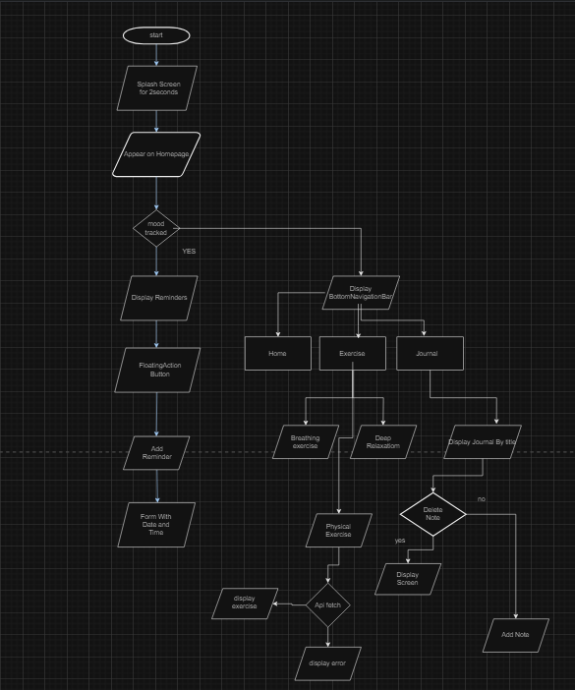

**Implementation and Testing (Stage/Module Wise)**

**Splash Screen:**

* Creating a splash screen with timestamp of 2sec and display homepage

**Home Screen:**

* Designing a home screen with mood tracking also showing mood history button and reminders
* File: home_screen.dart

**Bottom Navigation Bar:**

* Implementing navigation between screens through Bottom Navigation Bar.
* File: bottom_navigation.dart

**Mood Tracking:**

* Implementing input for mood tracking and display mood history till past month
* File: mood_tracking_screen.dart

**Journal Screen:**

* Designed a screen for journaling with a floating action button for creating new entries and jounals should be displayed as title and once clicked opens the detailed journal and delete functionality

**Add Journal Screen:**

* Allow users to add new journal notes
* File: journal_screen.dart

**Journals Screen:**

* Displaying details of individual journal notes along with add and delete functionality
* File: add_note_screen.dart and show_note_screen.dart

**Exercise Screen:**

* Implementing guided breathing exercises deep relaxation exercises and meditation
* File: breathing_screen.dart

**Reminder Screen:**

* Allowing users to view reminders along with date and time of reminder creation .
* File: reminder_screen.dart and add_reminder_screen.dart

**Output (Screenshots)**

**Home screen with mood tracking and reminders**

**Journal screen with list of topics**

**Add Note screen**

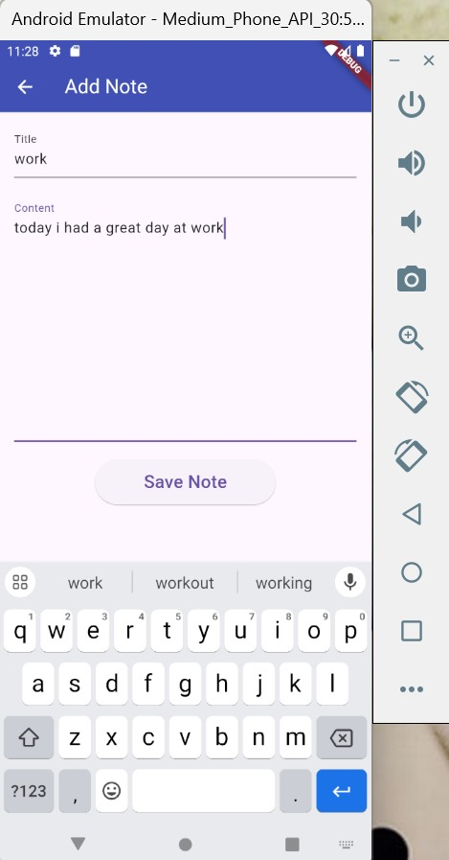

**Notes screen**

**Mood tracking screen with mood history**

**Reminder screen with upcoming reminders**

**Add Reminder screen**

**Exercise screen**

**Breathing screen with animated breathing exercise**

**Music Therapy:**

**Physical Exercise**

**Conclusion and Future Scope**

*Conclusion:*

The Mental Wellness Companion app provides a comprehensive platform for users to manage their mental well-being through various features like guided meditations, breathing exercises, mood tracking, and journaling. By leveraging Flutter's capabilities, we have created an engaging and user-friendly application that addresses the critical need for mental wellness tools.

**Future Scope:**

* Integration with more mental health resources and APIs.
* Enhanced analytics and insights based on user data to provide personalized recommendations.
* Community features for users to share their progress and support each other.
* Localization and support for multiple languages to reach a broader audience.

PROJECT LINK: https://github.com/ritika362/Mental-Wellness-Companion-App.git