ML-DevOps Integration Task

1. Create container image that’s has Python3 and Keras or numpy installed using dockerfile

2. When we launch this image, it should automatically starts train the model in the container.

3. Create a job chain of job1, job2, job3, job4 and job5 using build pipeline plugin in Jenkins

4. Job1: Pull the Github repo automatically when some developers push repo to Github.

5. Job2: By looking at the code or program file, Jenkins should automatically start the respective machine learning software installed interpreter install image container to deploy code and start training( eg. If code uses CNN, then Jenkins should start the container that has already installed all the softwares required for the cnn processing).

6. Job3: Train your model and predict accuracy or metrics.

7. Job4: if metrics accuracy is less than 80%, then tweak the machine learning model architecture.

8. Job5: Retrain the model or notify that the best model is being created

9. Create One extra job job6 for monitor: If container where app is running. fails due to any reason then this job should automatically start the container again from where the last trained model left

Solution:

Create container image that’s hasPython3 and Keras or numpy installed using dockerfile
Step 1: Create dockerfile that pulls centos from dockerhub and install keras in it.
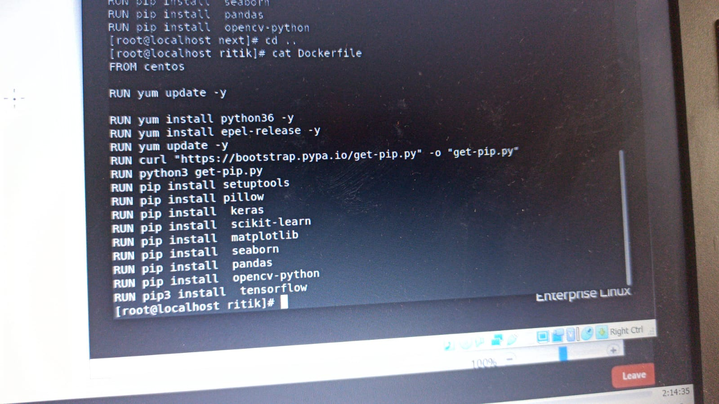

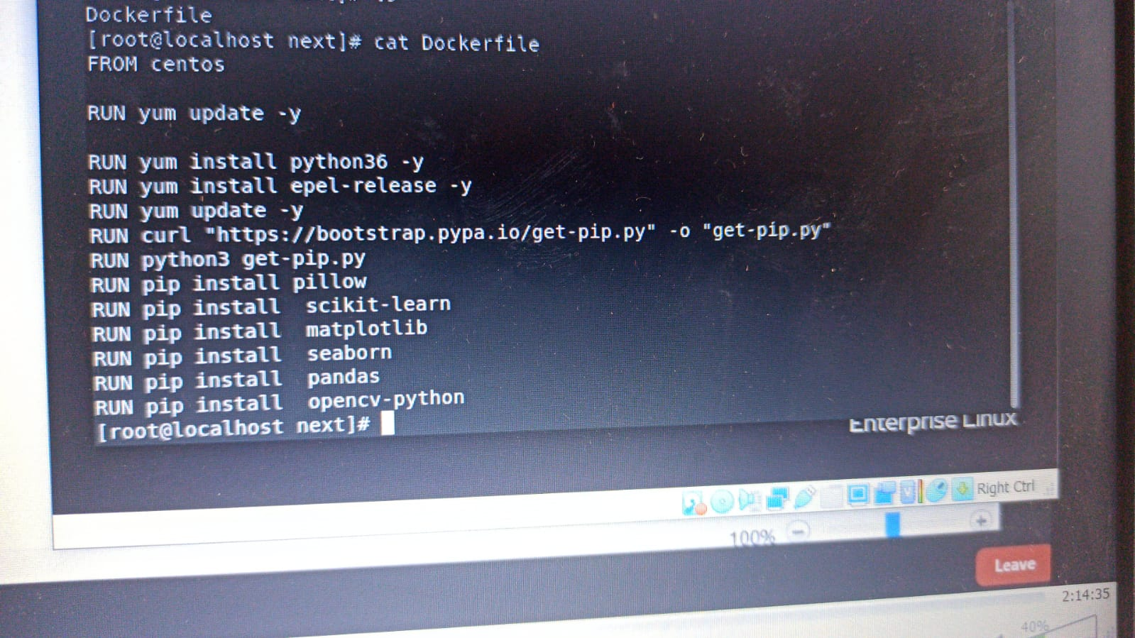
I would like to thanks Anant Jakhmola to build my dockerfile.

Create a job chain of job1, job2, job3 and job4 using build pipeline plugin in Jenkins
CREATING JOB 1:
Pull the Github repo automatically when some developers push repo to Github.

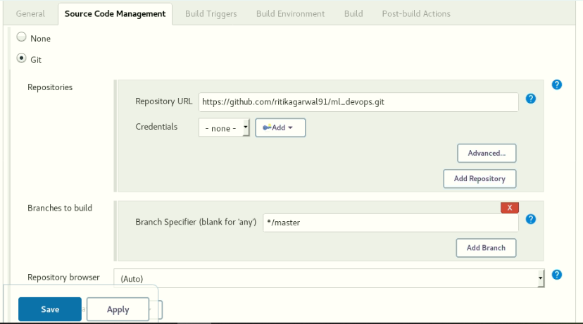
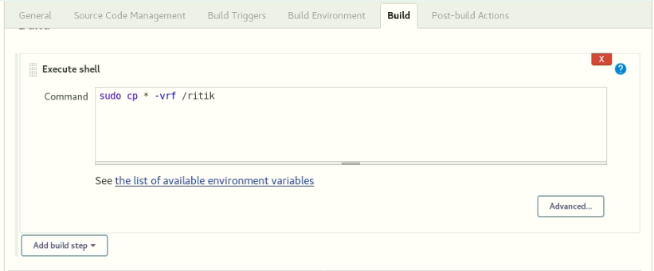

Creating job 2:
This job will trigger with job 1
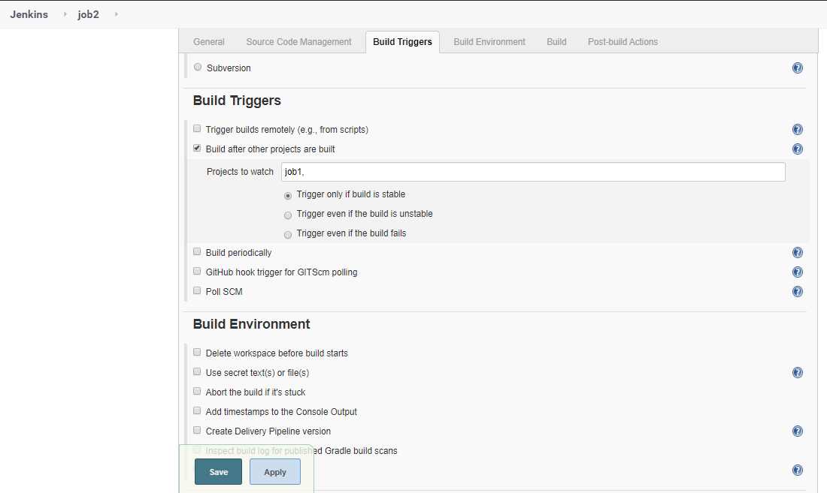
Then it will detect the type of file and will launch a container according to it and run the train.py file by creating the env using docker.

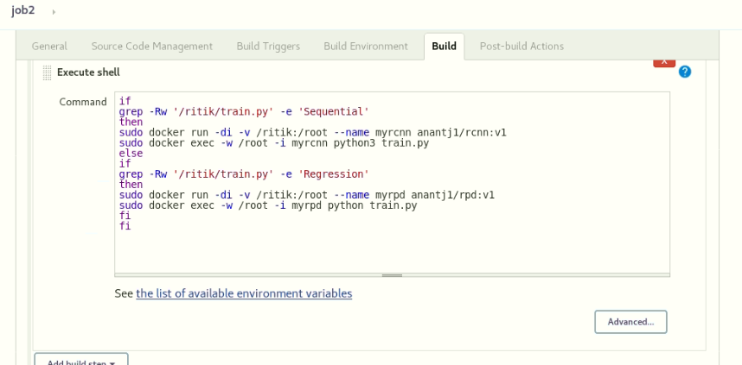
Creating job 3:
Train the model if the accuracy is above 80% then trigger job2 else run code gain by adding some layers in it. The accuracy save in Output.txt file and that file copy to the folder on redhat.
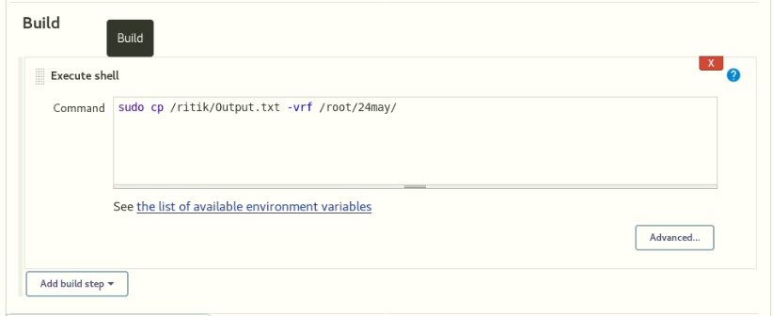
Creating job 4:
We will be sending mail to the developer for checking accuracy of the model.
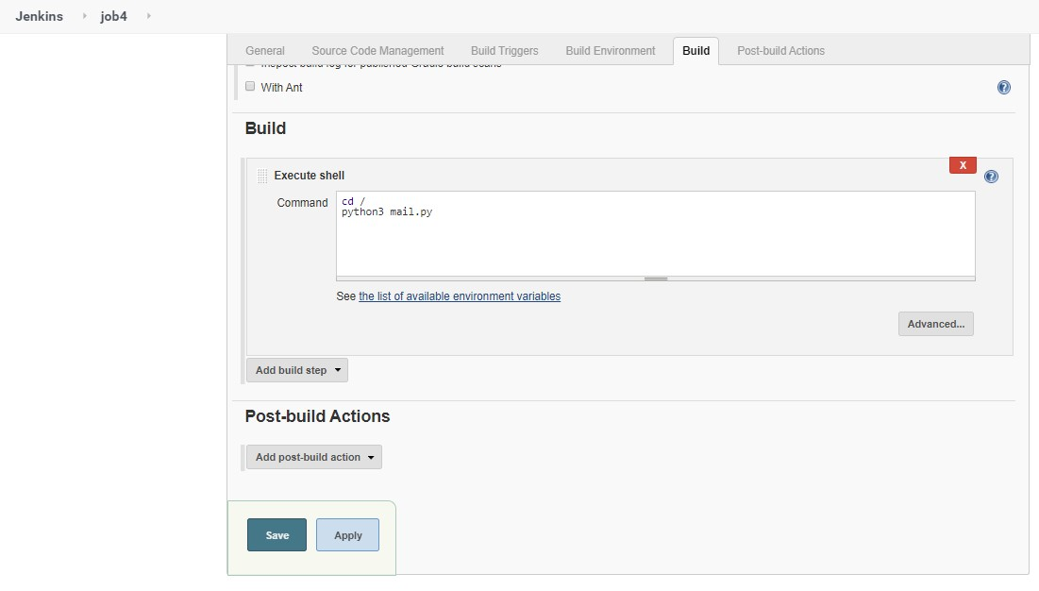

Creating job 5:
job5 for monitor : If container where app is running. fails due to any reason then this job should automatically start the container again.
