Title:
Task 1 – QA Testing Report (RealWorld Demo Application)
Prepared By:
Ritika Kumbar
Date:
01-06-2026
Application Under Test:
RealWorld Demo Web Application
Testing Type:
Functional + UI/UX Testing

2. Objective
The objective of this testing is to validate the functionality of the RealWorld Demo Application including user registration, login, article creation, editing, deletion, and logout features. The report also captures UI/UX and validation issues found during testing.

3. Test Environment
- Browser: Chrome
- Device: Laptop
- Internet: Active
- Application URL: https://demo.realworld.show/login
🔹 Test Scenario 1: User Registration (Sign Up)
Precondition: User is on Sign Up page
Steps:
- Open Sign Up page
- Enter username, email, password
- Click “Sign Up” button
Expected Result:
User should be successfully registered and redirected to login/home page.
Actual Result:
User registered successfully and redirected to home page.
Status: Pass
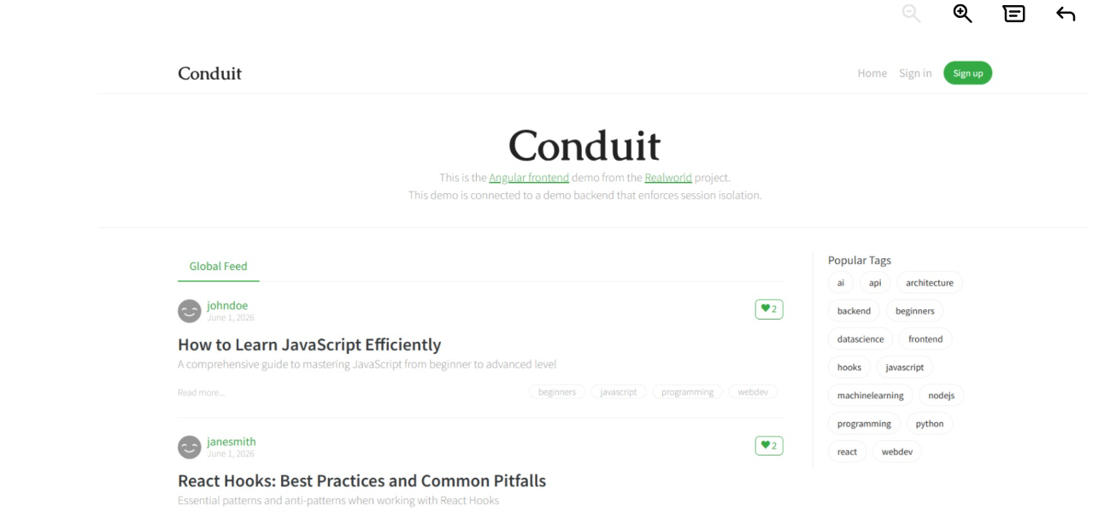

🔹 Test Scenario 2: Login with Valid Credentials
Steps:
- Open Login page
- Enter valid email
- Enter valid password
- Click “Sign In”
Expected Result:
User should login successfully and dashboard should open.
Actual Result:
User logged in successfully and dashboard is displayed.
Status: Pass
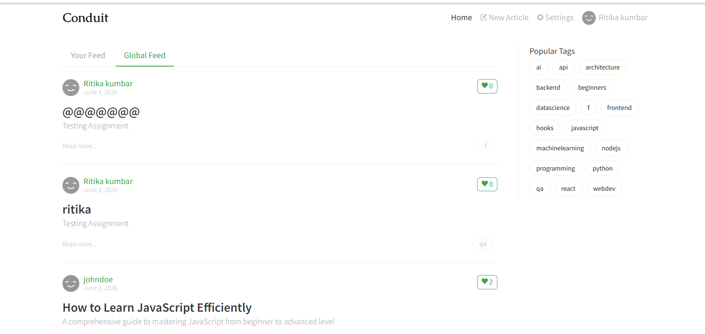
🔹 Test Scenario 3: Login with Invalid Password
Steps:
- Open Login page
- Enter valid email
- Enter wrong password
- Click “Sign In”
Expected Result:
Error message “Invalid credentials” should be displayed.
Actual Result:
Error message is displayed after submission.
Status: Pass
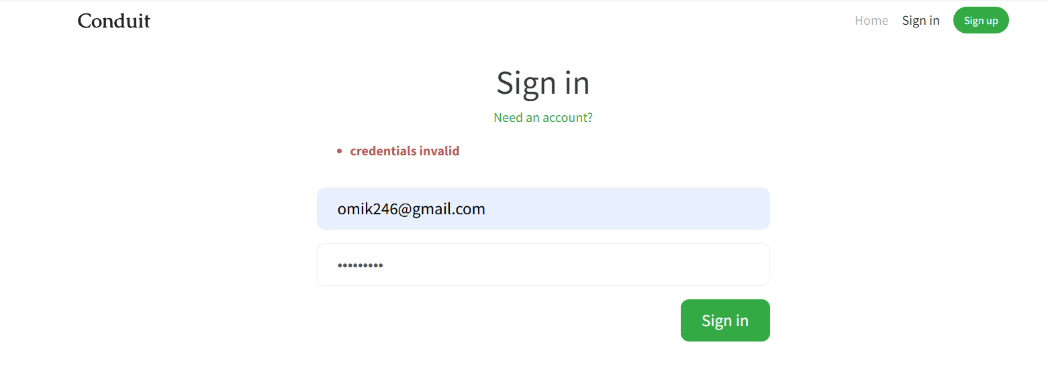

Test Scenario 4: Create Article with Empty Fields
Steps:
- Open “New Article” page
- Leave Title, Description, Body empty
- Click “Publish Article”
Expected Result:
Validation messages should appear for all required fields before submission or instantly.
Actual Result:
Validation messages appear only after clicking Publish.
Status: Fail (Bug found)
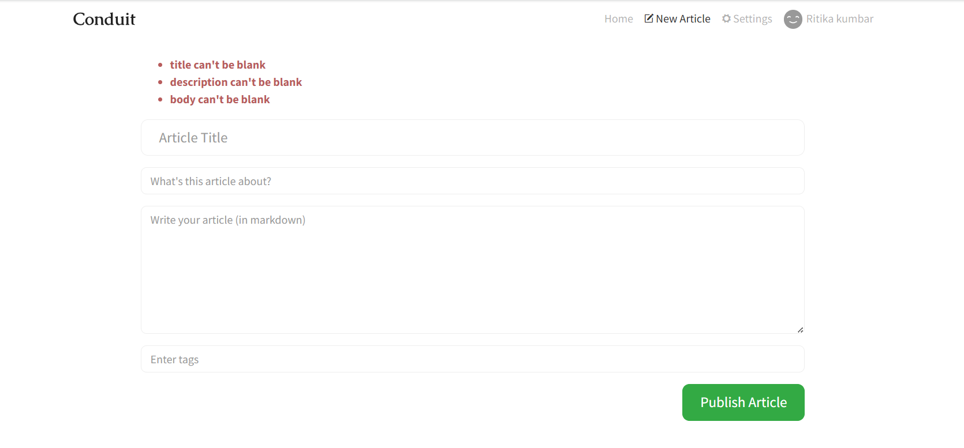
🔹 Test Scenario 5: Logout Functionality
Steps:
- Login to application
- Click on Logout button
Expected Result:
User should be logged out and redirected to login page.
Actual Result:
User successfully logged out and redirected.
Status: Pass
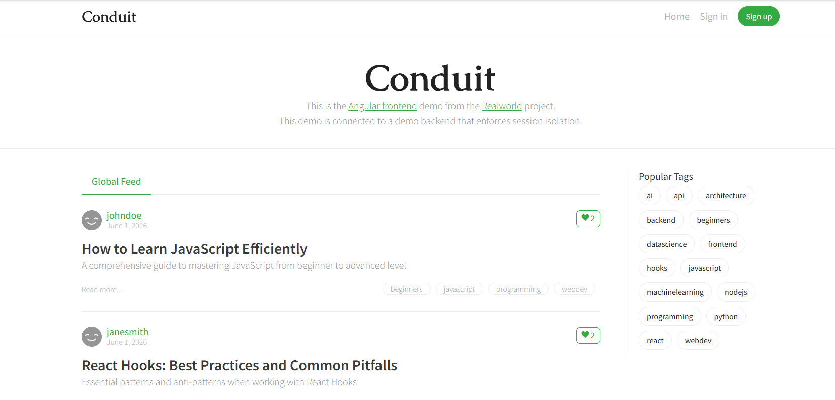

🔹 Test Scenario 7: Form Field Validation (Invalid Data Input)
Steps:
- Open Sign Up or Article form
- Enter invalid email format (e.g., abc@)
- Enter short password or invalid data
- Click submit
Expected Result:
System should show inline validation messages (e.g., “Enter valid email”).
Actual Result:
Error appears only after form submission.
Status: Fail / Partial Pass depending on app behavior
🔹 Test Scenario: Form Field Validation – Invalid Input Accepted in Sign Up
Precondition: User is on Sign Up page

Steps:
- Open Sign Up page
- Enter invalid email formats such as:
  - abc@
  - abc
  - abc123
- Enter weak/invalid password (example: 123, ac22)
- Fill all other required fields with any random values
- Click on “Sign Up” button

Expected Result:
- System should validate all input fields before submission
- Invalid email formats (like abc@, abc) should be rejected
- Password should follow validation rules (e.g., minimum length, format rules)
- “Sign Up” button should not allow submission until valid data is entered
- Proper inline error messages should be shown (field-level validation)

Actual Result:
- System is accepting invalid inputs such as abc@, abc, ac22
- User is able to click “Sign Up” button even with invalid data
- No proper validation messages are displayed before submission

Status:
❌ Fail (Functional + Validation Issue)
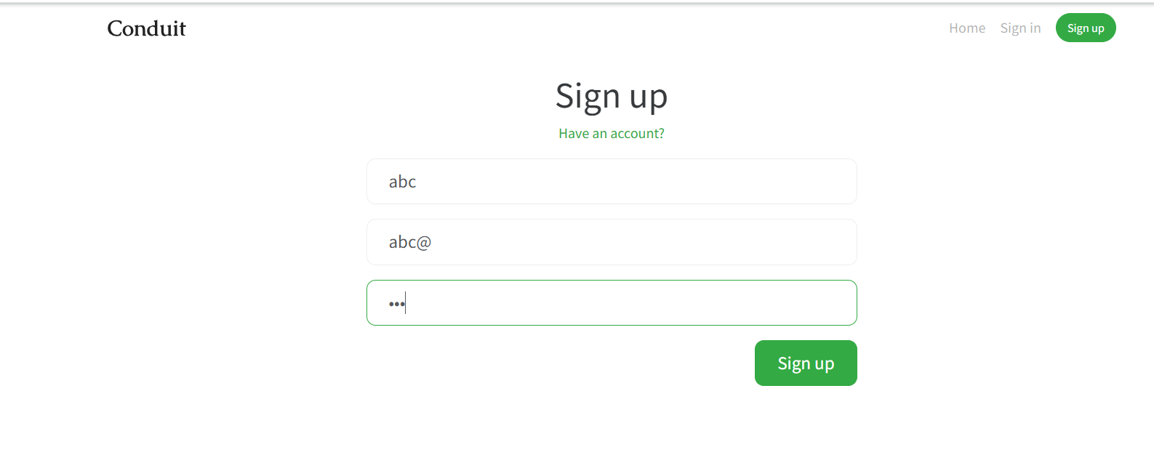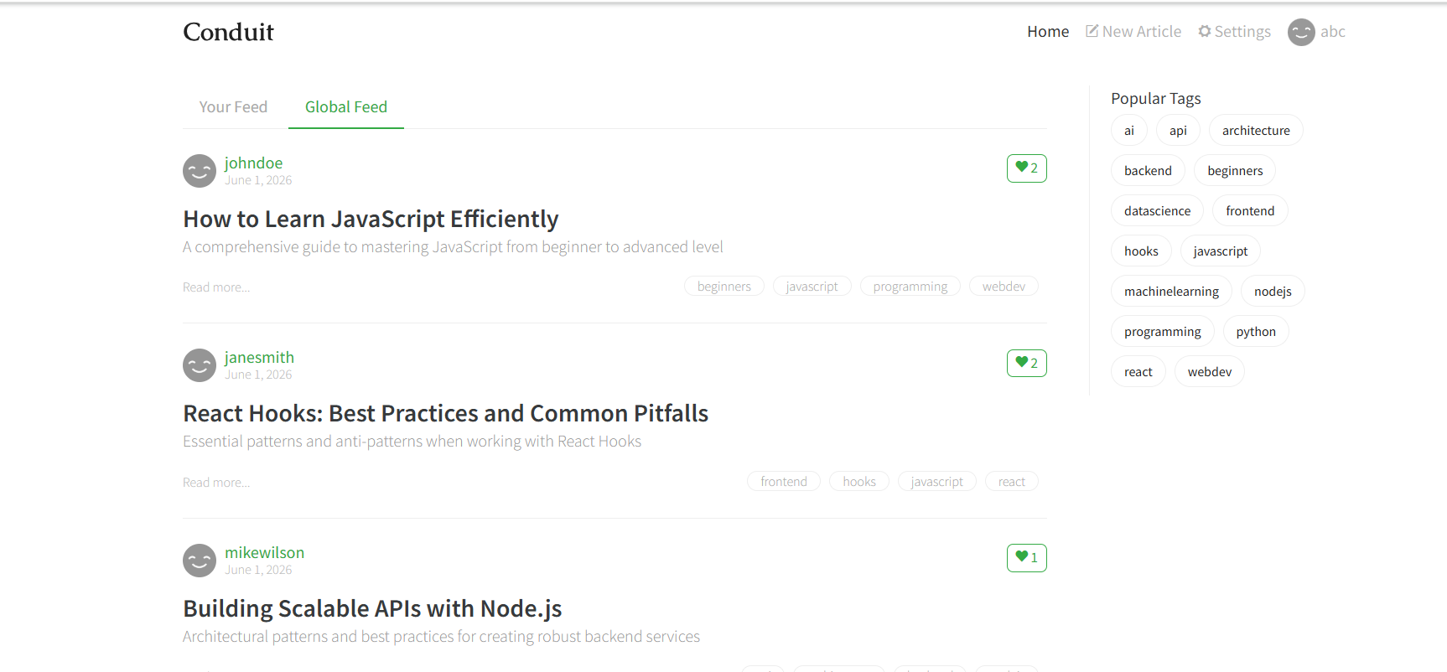

🔹 Test Scenario 9: Single Click Article Creation
Steps:
- Open “New Article” page
- Enter Title, Description, Body
- Click “Publish Article” once

Expected Result:
Article should be created only once and button should not allow multiple submissions.

Actual Result:
Article is created successfully on single click. No loading or disable button is shown.

Status:
⚠️ UX Issue
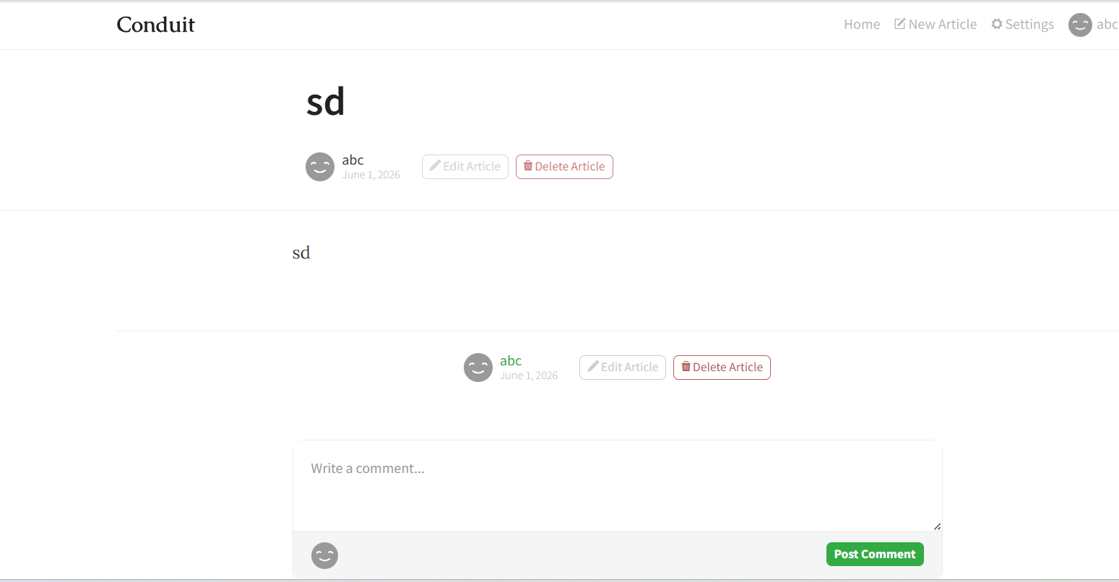

BUG-001
Title: Required field validation appears only after submission
Severity: Low
Category: Functional / UX
Steps:
- Open New Article page
- Leave all fields empty
- Click Publish Article
Expected Result:
Validation should appear before or during submission
Actual Result:
Validation appears only after clicking Publish
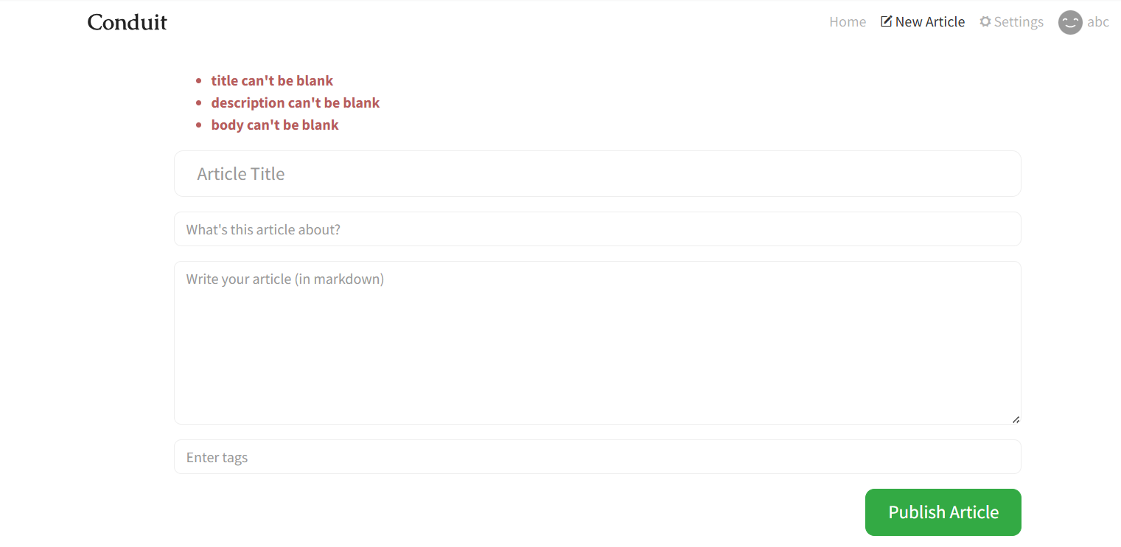
BUG-002
Title: Form accepts invalid email and weak password without validation
Severity: High
Category: Functional / Validation
Steps:
- Open Sign Up page
- Enter invalid email like abc@
- Enter weak password like 123
- Click Sign Up
Expected Result:
System should block invalid inputs
Actual Result:
System allows submission without proper validation
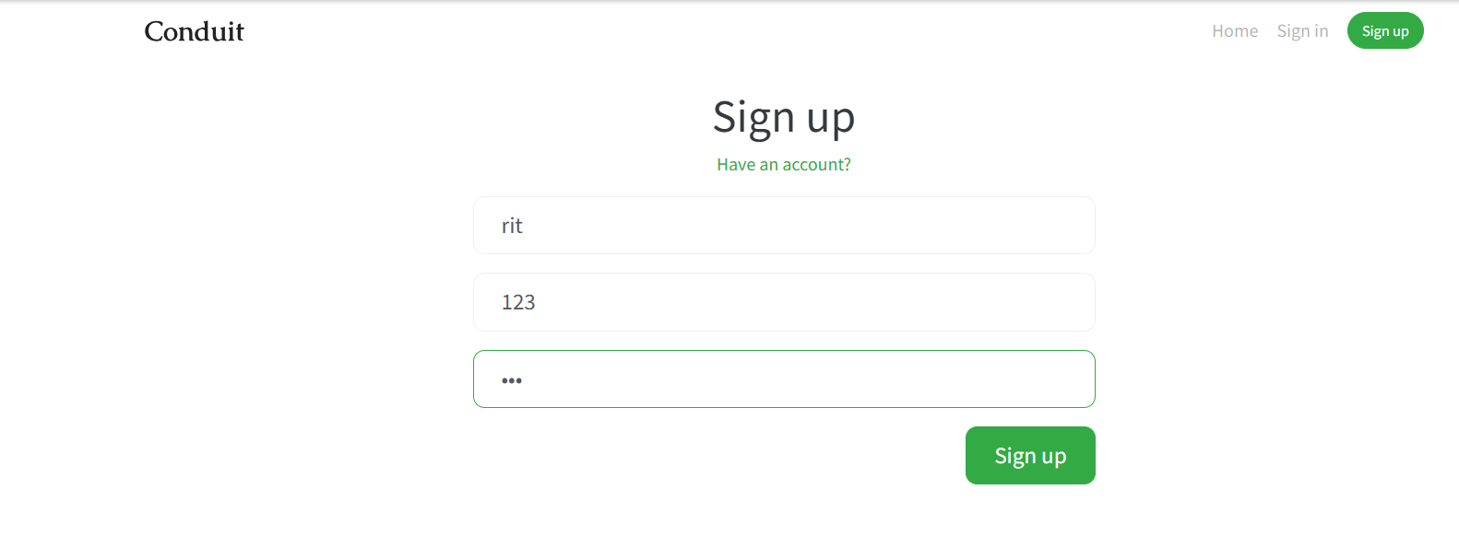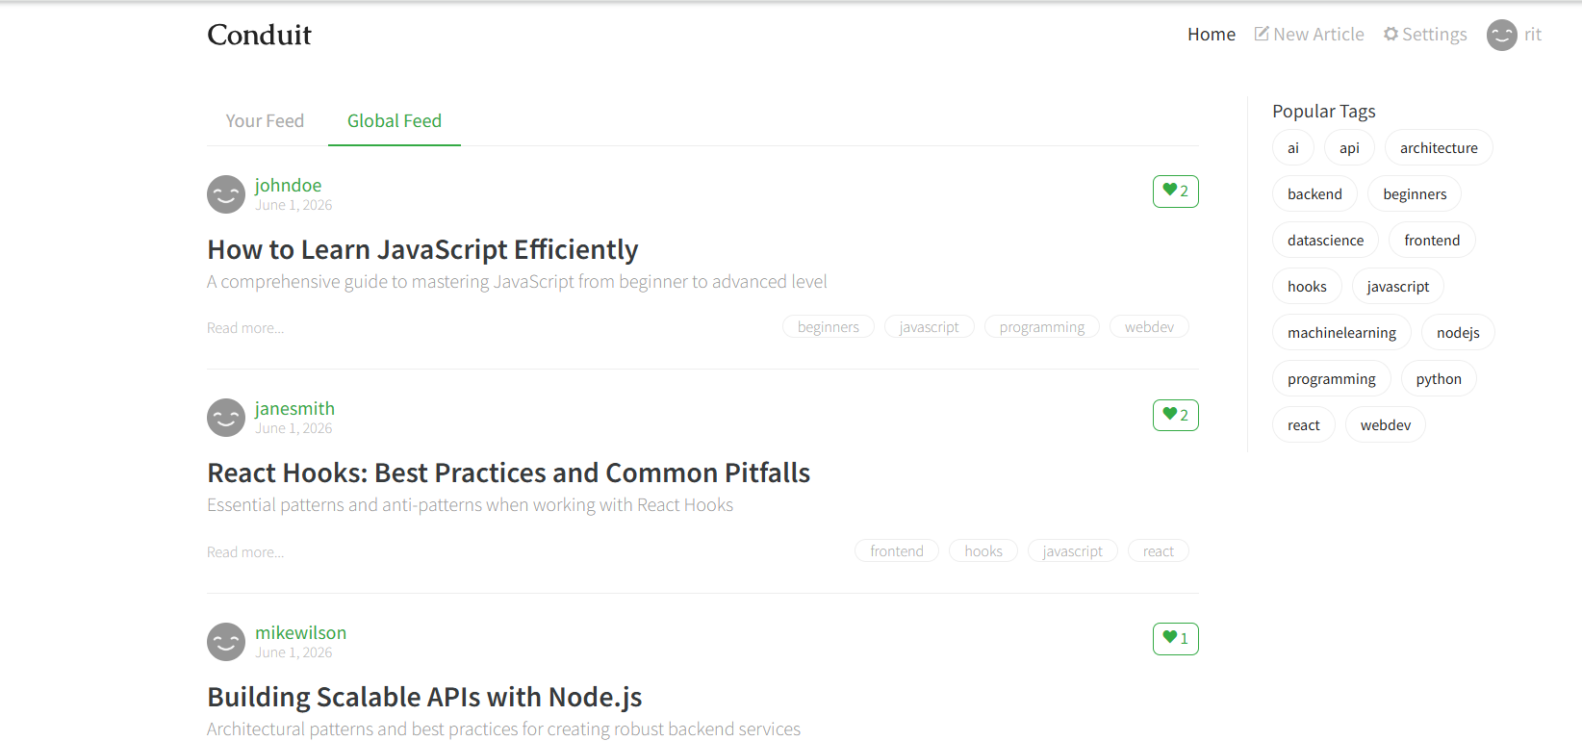

BUG-003: Error messages not shown at field level
Severity: Medium
Category: UX / Functional

🔹 What is happening?
Error messages are not shown near each input field. Instead, a general message is displayed.

🔹 Steps:
- Open New Article page
- Leave fields empty or enter wrong data
- Click create Article

🔹 Expected Result:
Each field should show its own error message (example: Email required below email box).

🔹 Actual Result:
A common or generic error message is shown instead of field-wise errors.

🔹 Why it is a problem?
User cannot easily understand which field is wrong, so it becomes confusing and slow to fix.

🔹 How to fix it?
- Add field-level validation messages
- Show error directly below each input field
- Highlight invalid fields in red
- 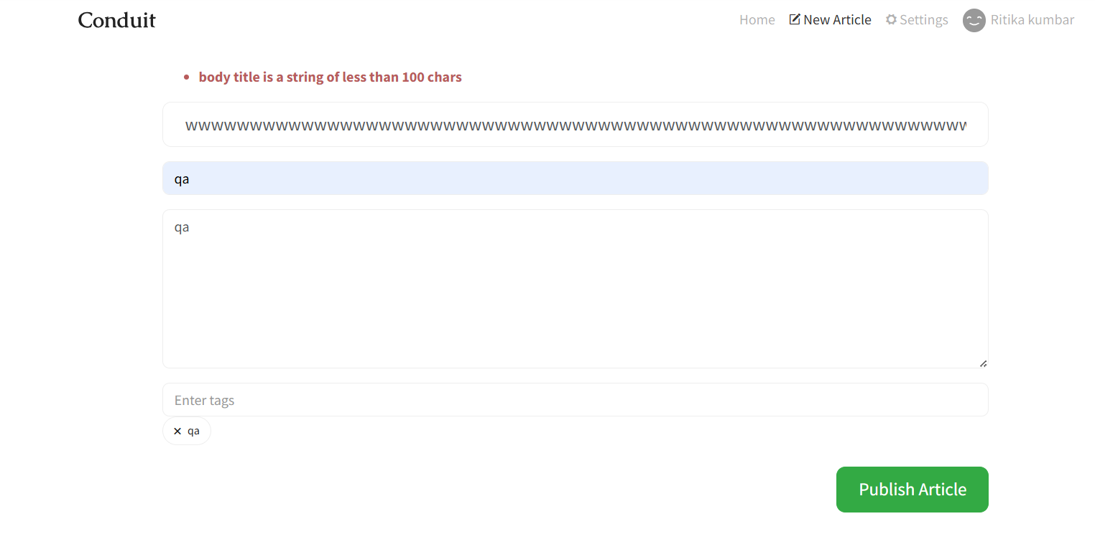

BUG-004: Tag validation rules not shown before submission
Severity: Low
Category: UX / Validation

🔹 What is happening?
While creating a new article, the system does not show any rules for Tags input field before submitting.

🔹 Steps:
- Open “New Article” page
- Enter Title, Description, Body
- Add tags (any random values)
- Click “Create Article”

🔹 Expected Result:
- System should show tag rules like:
  - Max number of tags allowed
  - Character limit per tag
- Validation should be shown before submission

🔹 Actual Result:
- No rules or guidance shown for tags
- User can enter any values without understanding limits
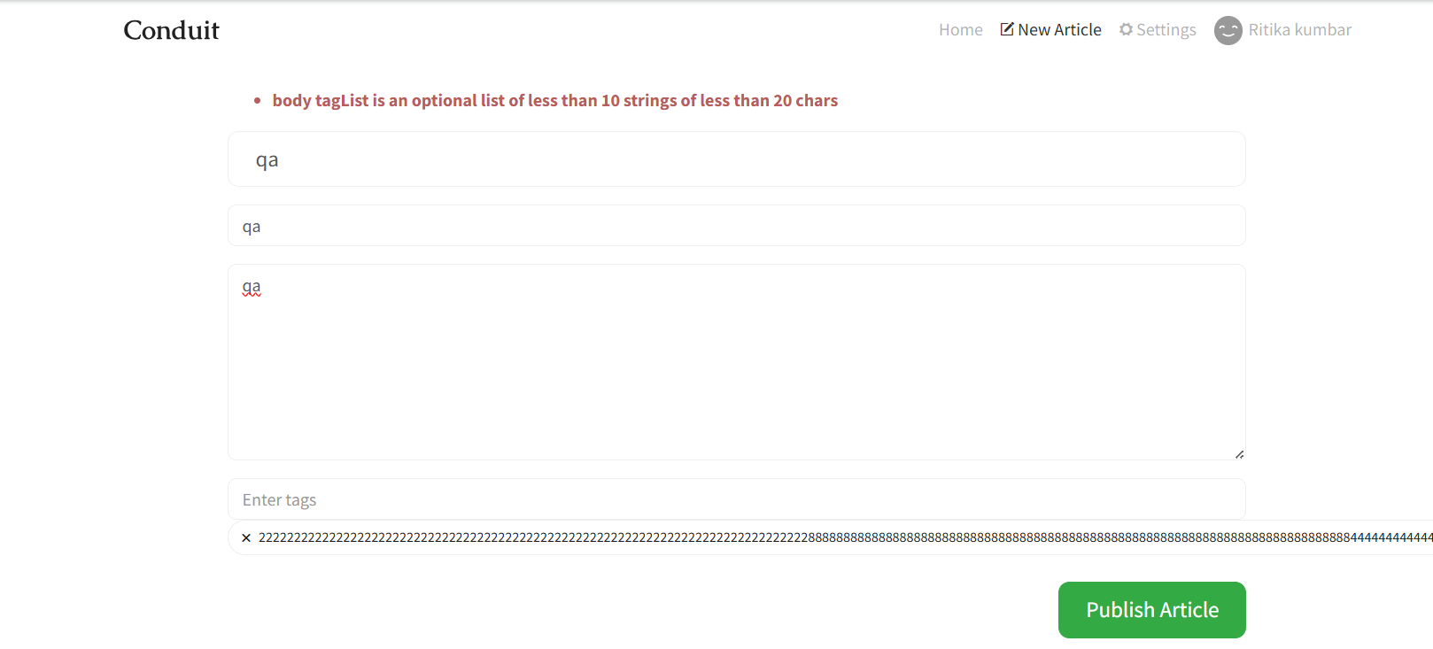
BUG-005: Missing loading state after clicking “Publish Article”
Severity: Medium
Category: UX / Functional

🔹 What is happening?
After clicking “Publish Article”, there is no loading indication shown to the user.

🔹 Steps:
- Open “New Article” page
- Enter valid Title, Description, Body
- Click “Publish Article” button

🔹 Expected Result:
- Button should show loading state (spinner / “Publishing…”)
- Button should be disabled during processing
- User should know that article is being created

🔹 Actual Result:
- No loading indicator is shown after clicking “Publish Article”
- Button remains active with no response feedback

BUG-005: Article published immediately without loading indication
Severity: Low / Medium
Category: UX / Functional

🔹 What is happening?
After clicking “Publish Article”, the article is published very quickly (within seconds) and there is no loading or processing indication shown to the user.

🔹 Steps:
- Open “New Article” page
- Enter valid Title, Description, Body
- Click “Publish Article” button

🔹 Expected Result:
- System should show loading state while processing
- Button should be disabled during submission
- User should see message like “Publishing article...” until completion

🔹 Actual Result:
- Article is published within seconds
- No loading indicator or processing message is shown
- User does not get feedback during request

🔹 Why it is a problem?
- User does 0 n000.03…ot know system is processing request
- Can cause confusion (did it click or not?)
- Poor user experience even if system is fast

🔹 How to fix it?
- Add loading spinner or “Publishing...” message
- Disable button during API call
- Show success message after completion

🔹 Status:
Open
Root Cause Analysis (RCA)
🔹 Bug: Sign Up allows registration with single character or invalid data

🔹 What is happening?
The syste
m allows users to complete Sign Up even if they enter very minimal or invalid information (like single character in fields or incorrect email format).

🔹 Why is it happening?
- Frontend validation is missing or not properly implemented
- Input field rules (like minimum length, email format) are not enforced
- Backend is not rejecting invalid or incomplete data
- No real-time validation (on typing or blur event) is implemented

🔹 How is it happening? (Flow)
- User opens Sign Up page
- Enters minimal data (e.g., “a”, “1”, invalid email)
- Clicks Sign Up button
- Request is sent to backend without proper validation
- Backend accepts data and creates account

🔹 Root Cause:
👉 Missing proper client-side + server-side validation rules for form inputs

🔹 How to fix it?
✅ Frontend Fix:
- Add validation rules:
  - Minimum length (e.g., username ≥ 3 characters)
  - Valid email format check
  - Password strength validation
- Show real-time error messages
- Disable Sign Up button until form is valid

✅ Backend Fix:
- Validate all inputs again on server side
- Reject invalid or incomplete requests
- Return proper error messages to frontend

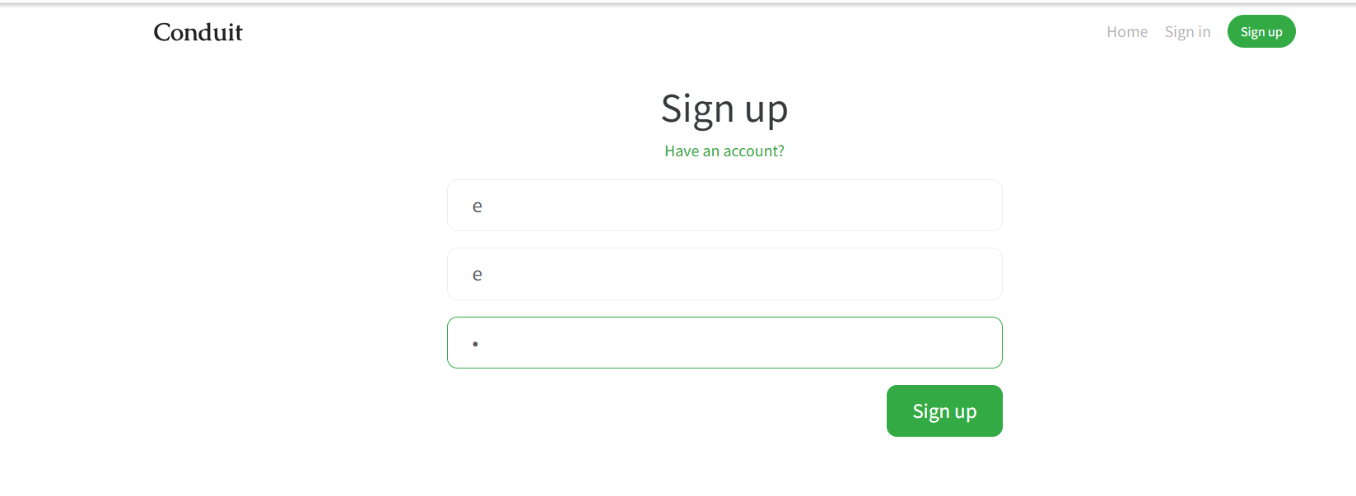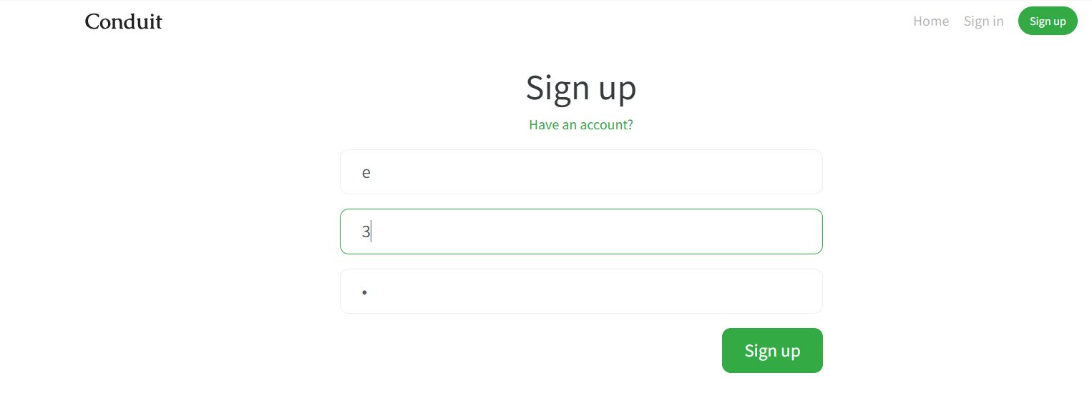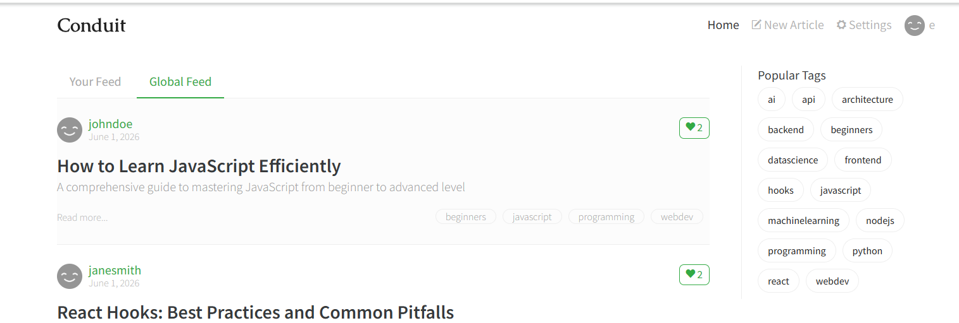

Bug table
Bug ID | Title | Severity | Category | Steps to Reproduce | Test Data | Expected Result | Actual Result | Status
BUG-001 | Required field validation shown after submission | Low | Functional / UX | Open New Article → Leave fields empty → Click Publish Article | Empty Title, Body, Description | Validation should appear before submission | Validation appears after clicking publish | Open
BUG-002 | Sign Up allows invalid/single character input | High | Functional / Validation | Open Sign Up → Enter 'a', invalid email → Click Sign Up | Username: a, Email: abc, Password: 1 | System should block invalid data | Account created with invalid data | Open
BUG-003 | Error messages not shown at field level | Medium | UX | Submit empty form in Sign Up/New Article | Empty fields | Field-wise error messages should appear | Generic or delayed error shown | Open
BUG-004 | Tag validation rules not shown | Low | UX / Validation | Open New Article → Enter tags → Submit | Random tags | Tag rules should be shown before input | No rules displayed | Open
BUG-005 | No loading state on Publish Article | Medium | UX / Functional | Click Publish Article after filling form | Valid article data | Button should show loading state | No loading indicator shown | Open

