**Test Evidence**

**Scenario1:**

Initial stock: 1 can

Input: Purchase 1 can with $2

Output: Please collect your 1 cans and remaining amount: $0.80

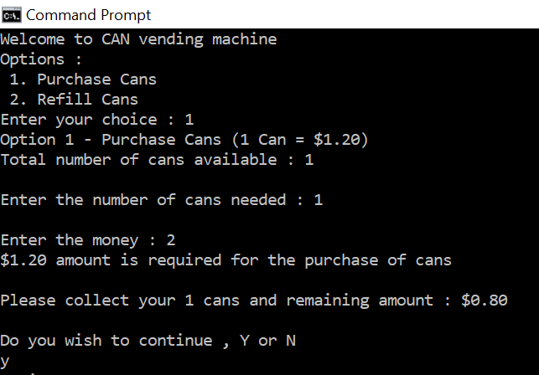

**Scenario2:**

Input: Purchase 1 can with $1

Output: Message: Insufficient Money

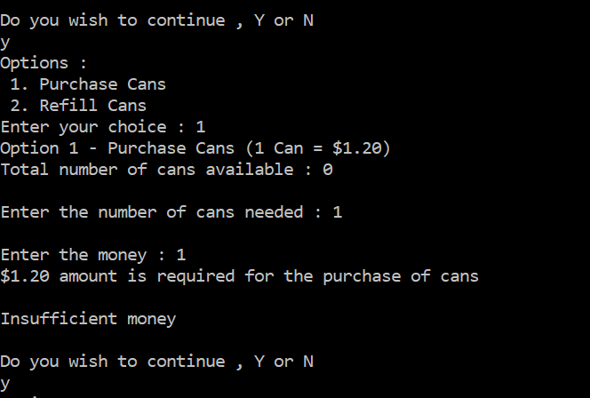

**Scenario3:**

Input: Purchase 1 can with $1.5

Output: Message: Out of Stock

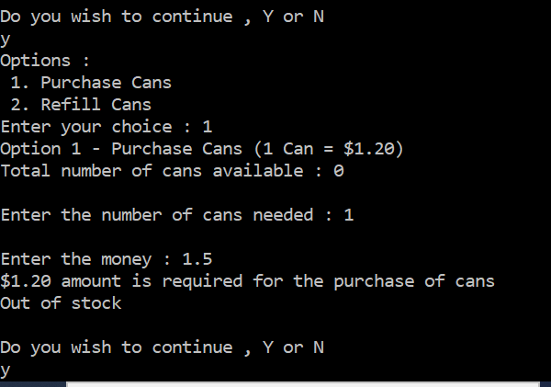

**Scenario4**:

Input: Refill 10 cans

Output: Message: 10 cans added

Total number of cans available: 10

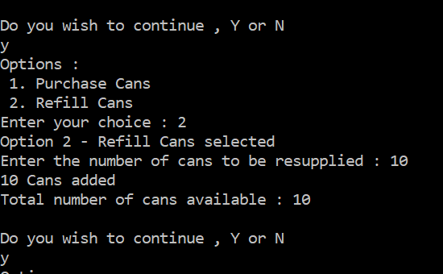

**Scenario5:**

Input: Purchase 3 cans with $5

Output: Message: Please collect your 3 cans and remaining amount: $1.40

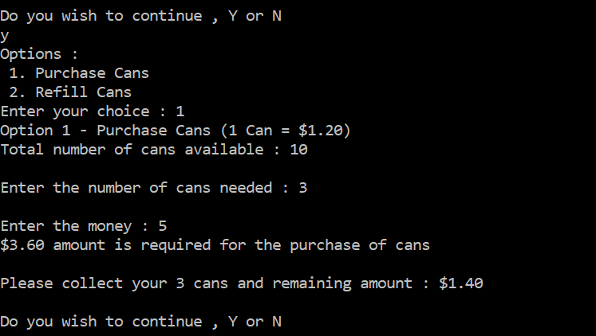

**Below is the output from command prompt:**

Welcome to CAN vending machine

Options:

1. Purchase Cans

2. Refill Cans

Enter your choice : 1

Option 1 - Purchase Cans (1 Can = $1.20)

Total number of cans available : 1

Enter the number of cans needed : 1

Enter the money : 2

$1.20 amount is required for the purchase of cans

Please collect your 1 cans and remaining amount : $0.80

Do you wish to continue , Y or N

y

Options :

1. Purchase Cans

2. Refill Cans

Enter your choice : 1

Option 1 - Purchase Cans (1 Can = $1.20)

Total number of cans available : 0

Enter the number of cans needed : 1

Enter the money : 1

$1.20 amount is required for the purchase of cans

Insufficient money

Do you wish to continue , Y or N

y

Options :

1. Purchase Cans

2. Refill Cans

Enter your choice : 1

Option 1 - Purchase Cans (1 Can = $1.20)

Total number of cans available : 0

Enter the number of cans needed : 1

Enter the money : 1.5

$1.20 amount is required for the purchase of cans

Out of stock

Do you wish to continue , Y or N

y

Options :

1. Purchase Cans

2. Refill Cans

Enter your choice : 2

Option 2 - Refill Cans selected

Enter the number of cans to be resupplied : 10

10 Cans added

Total number of cans available : 10

Do you wish to continue , Y or N

y

Options :

1. Purchase Cans

2. Refill Cans

Enter your choice : 1

Option 1 - Purchase Cans (1 Can = $1.20)

Total number of cans available : 10

Enter the number of cans needed : 3

Enter the money : 5

$3.60 amount is required for the purchase of cans

Please collect your 3 cans and remaining amount : $1.40

Do you wish to continue , Y or N

y

Options :

1. Purchase Cans

2. Refill Cans

Enter your choice : 1

Option 1 - Purchase Cans (1 Can = $1.20)

Total number of cans available : 7

Enter the number of cans needed : 1

Enter the money : 1

$1.20 amount is required for the purchase of cans

Insufficient money

Do you wish to continue , Y or N

n

C:\Temp\test>