SUPERSTORE SALES AND PROFIT ANALYSIS
Complete Analytics Case Study
Internship Organization: SWYNEX Technologies
Project Domain: Data Analytics
Tools Used: Microsoft Excel and Power BI
1. Project Overview
This project analyze Superstore sales data to understand sales performance, profitability, customer segments, product categories, regional performance and shipping methods.
The project includes data cleaning, exploratory data analysis (EDA), an interactive dashboard and business insights.
2. Problem Statement
The objective of this project is to analyze Superstore sales and profit data to identify sales trends, profitable product categories, high-performing regions and products that generate losses.
The analysis aims to identify opportunities to improve profitability and support better business decisions.
3. Dataset Information
- Dataset: Superstore Sales Dataset
- Number of records: 9,994
- Source: Superstore dataset
- Tools: Microsoft Excel and Power BI
The dataset contains information about orders, sales, profit, quantity, discounts, products, customers, region and ship mode.
4. Data Cleaning and Preparation
The dataset was reviewed and prepared before analysis.
The process included:
- Checking missing and unknown values.
- Checking duplicate records.
- Reviewing data types and date formats.
- Identifying inconsistent values.
- Preparing the cleaned dataset for analysis.
The cleaned dataset was then used for exploratory data analysis and dashboard development.
5. Exploratory Data Analysis
Microsoft Excel was used to analyze sales, profit, quantity, product categories, customer segments, region, shipping methods and yearly trends.
Pivot tables and pivot charts were used to summarize the data and identify important patterns.
Overall Performance
- Total Sales: 2,297,201.07
- Total Profit: 286,397.79
- Total Quantity:37,873
Sales by Category
Technology recorded the highest sales, approximately 836,154.10.
Sales by Year
Sales increased from approximately 484,247.56 in 2014 to 733,215.19 in 2017.
Regional Performance
The West region recorded approximately 725,457.93 in sales and 108,418.79 in profit.
Customer Segment
The Consumer segment recorded approximately 1,161,401.34 in sales and 134,119.33 in profit.
Product Profitability
Tables recorded a loss of approximately 17,725.59, while Bookcases recorded a loss of approximately 3,472.56.
6. Power BI Dashboard
An interactive Superstore Sales and Profit Dashboard was developed using Power BI.
The dashboard includes Four KPI cards, six charts and interactive slicers.
The visuals present sales and profit by category, segment and region, sales by shipping mode, yearly sales and products by sales.
The slicers allow users to filter the data and explore performance across different selections.
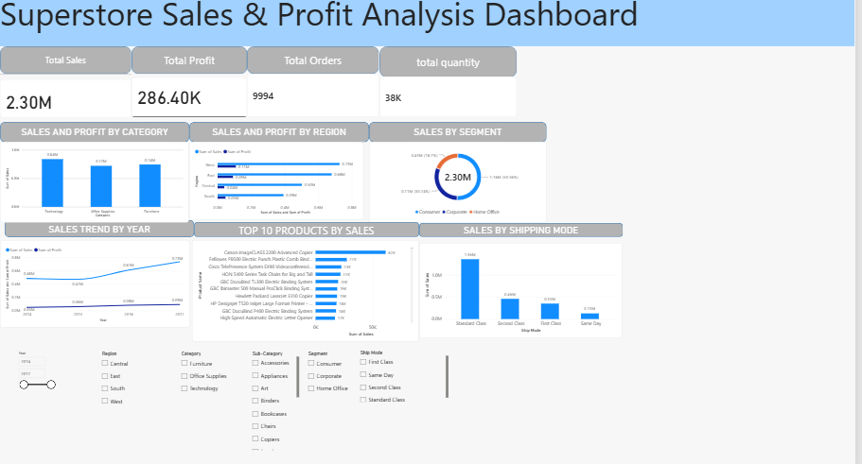
7. Key Business Insights
- Technology was the highest-selling product category.
- The West region recorded the highest sales among the regions in the analysis.
- The Consumer segment contributed the highest sales.
- Sales increased between 2014 and 2017.
- Tables and Bookcases recorded negative profits.
- High discounts were associated with significant losses in some transactions.
- Shipping performance can be monitored using the shipping-mode and average-shipping-days analysis.
8. Recommendations
- Review pricing and discount policies for products with negative profits.
- Monitor the profitability of individual products and categories.
- Continue tracking yearly sales and profit trends.
- Compare regional and customer-segment performance regularly.
- Use the interactive dashboard to monitor business performance.

9. Conclusion
This project demonstrates how Microsoft Excel and Power BI can be used for data cleaning and preparation, exploratory data analysis, data visualization and business reporting.
The analysis identified sales trends, high-performing categories and regions, and products requiring profitability review.
The completed project brings together data preparation, analysis, visualization and business recommendations in one analytics case study.
10. Project Deliverables
- Cleaned Superstore Sales dataset
- EDA Analysis
- Power BI dashboard
- Final case study report
- Project README documentation

