**CU Hub**

**A PROJECT REPORT**

***Submitted by***

Amandeep Singh (19BCA1063)

Shalvi Singh(19BCA1103)

Manthan Kalsi(19BCA1119)

Ritika Rana(19BCA1126)

IN

University institute of computing



**Chandigarh University**

February 2022

**TABLE OF CONTENT**

**1. Introduction to the project**

**2. Client Identification and Recognition of Need**

**3. Recognition & knowledge of relevant contemporary issues**

**4.Project Identification**

**5. Task Identification**

**6. Timeline of the project(in weeks)**

**7. Gant Chart/ Use of modern project planning tools.**

**8. Relevant topics identified for literature review**

**9. Review of previous solutions or related materials, Extent and relevance of the materials and reviewed to the project.**

**10. Summary of how reviewed literature helped in defining problem statement.**

**11. Problem Definition**

**12. Goals and Objectives.**

**13. References (APA format)**

1. **Introduction to the project**

Covid-19 has disrupted our normal lifestyle and everything has shifted to virtual platform. Now we are not getting the same experience which we were getting in physical classes where interaction with teacher’s and classmates was so easy ,where clearing doubts was so easy. So we are introducing ‘**CU HUB’** the android application which would be a miniature of our college website.

Earlier it was difficult to get college notification and information by logging into website everytime and also it was difficult to connect with teachers but **CU HUB** will be a one stop solution of above mentioned problems .this application will facilitate communication between students and faculties via database.

One of the best thing about **CU HUB** is that only authorized students and faculties will be able to join this platform as, admin will have all the rights to add and remove students and faculties so no outsiders can join this platform this feature will improve the security which is a need of every organization.

This app will have a separate login page for faculties, students and admin. Students will have the facility to talk with any teacher separately and they will also have the contact details of all the teachers of the college. Earlier if we had any problrm related to assignments, homework or any important notification we want to connect to the teachers but sometimes we could not get the contact

information of teachers at the right time so, to solve this problem we will attach each and every teachers details to this app which will be visible to all the students.

Teachers will have the facility to upload circulars which will be made visible to every students and through this teacher can easily convey their message to a large number of studens this will reduce the work load of teachers as earlier if teachers had to convey any message to whole department they use to message in groups separately or convey to every class representative which was a hectic task to do

**2. Client Identification and Recognition of Need**

This project is mainly targeted at colleges. It will solve the problem of teachers and students. Generally students face problem in getting right information at right time and sometime they miss important notification regarding training, placement interviews, holidays and project submission etc. . sometimes when we feel difficulty in assignments and in projects we want to connect to teachers but we couldn’t do so because of the unavailability of contact information of teacher’s on official college websites and not only students but teachers also faces some problem in conveying information to students so, we have recognized the needs of teachers and students and are making this application **CU HUB** .

Some of the needs we recognize during the analysis of the requirement, these are:-

1. Admin can create user as per college permission.
2. There will be a separate page for every students where they’ll get notices, their chat history and other facilities in updated manner.
3. Faculties can give notices for the students.
4. A person should be able to login to the system through the first page of the application.

**3. Recognition & knowledge of relevant contemporary issues.**

Suddenly, when Covid hits India in 2020 it disrupted the whole education system and gradually education completely transferred to online mode so both students and teachers face problem in adopting virtual mode. Though we have successfully adopted virtual mode and technology have made everything easy and possible but still there are some gaps which needs to be bridged so we have recognized the needs and have made this application.

We identify several problems including unauthorized access and to solve this we have added a feature that only admin will have the access to add and remove the teachers and students which will prevent with unauthorized access here admin will be college.

**4. Project Identification**

To design and develop this application we have to use **Android Studio** and use it’s **Android Native** feature to build an app which can be installed on user's **Android Devices** through which they can easily chat with there classmates or there respective instructors. They will have to log in through there **user id’s** and then will be able to access all the features of the app

**5. Task Identification**

To meet the set goals the app should have :-

* Login on the basis of UID
* Dynamic Database which can link students to there respective teachers
* Chat Functionality
* Groups Functionality
* Query Feature for student’s doubts
* Circular feature where teachers and admin can upload circulars which will be made visible at the students end.

**6. Timeline of the project(in weeks)**

|  |  |  |
| --- | --- | --- |
| **Start date** | **End date** | **Project status** |
| 18th February | 27th February | Project Planning and Research |
| 25th February | 2nd March | Designing and Markup |
| 28th February | 15th March | Back-end Development |
| 12th March | 22nd March | Testing and Bug Fixes |
| 23rd March | 2nd April | Additional Features |
| 1st April | 18th April | Refinement |

**7. GANTT Chart :**

**8. Relevant topics identified for literature review**

To serve our purpose we have done a research over effect of online learning on communication between instructors and students and how a good communication can be productive for students we found that most of the students are unsatisfied with the communication with their teachers during e-learning. One of the research we found on was this *“Great communication skills will add years to your tenure as a successful teacher.”Dr. JerryWeast of Montgomery County, Maryland (Weast, 2008). Therefore, effective communicationmust be a priority not a forgotten thought for great teachers (Hilliard and Newsome, 2013).Effective communication occurs when a desired effect is the result of intentional orunintentional exchange of information, which is communicated by different individuals andperformed in a desired manner. This influence also ensures no distortion of the messageduring the contact process. Effective communication will achieve the desired effect anduphold the effect, with the potential to improve the message’s effect. Therefore, effectivecommunication serves the purpose it was intended or built for. Possible objectives may be tomake change, to encourage action, to create awareness, to educate or to convey some idea orperspective. Good communication means talking and listening (Velentzas and Borni, 2014).To succeed in their career, instructors need outstanding communication skills. Instructorsneed listening, interpersonal, written and oral communication skills to promote comprehensionof the teaching results and the ability to effectively fulfill their responsibilities. Instructors notonly need to carry out technical tasks, they also do need to communicate effectively andefficiently with internal and external customers. Developing effective communication skills isan essential part of the ability for the instructors to succeed. To become a good professional,instructors must possess highly developed levels of communication skills. Developing theseskills not only increases the potential of the instructors but will also improve the quality of theteachers created. Advanced communication skills are important in all aspects of the teachingcycle. Instructors must have highly developed oral and writing skillsto interact effectively*

*withsupervisors, learners and collaborators. Communication skills are becoming increasinglynecessary for success in the organizational environment of our time.*

*(Ihmeideh et al., 2010). Toincrease communication effectiveness, schools need to gain knowledge of the value of theresponsibilities of the sender and receiver and adhere to the active listening skills(Lunenburg, 2010).*researchgate.net

6.0%

6.0%

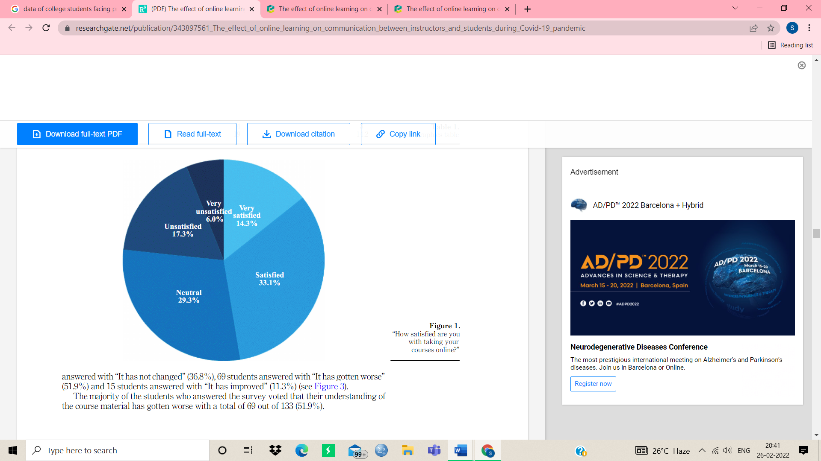

Out of 133 students, 19 were “Very satisfied”(14.3%), 44 were “Satisfied”(33.1%), 39 were “Neutral”(29.3%), 23 were “Unsatisfied”(17.3%), and 8 were “Very unsatisfied”(6.0%)

**9. Review of previous solutions or related materials, Extent and relevance of the materials and reviewed to the project.**

We are building this application with a mindset to connect the students with their teachers at a single place where the communication between teachers and students becomes easier. So, for this purpose there are many applications available(like whatsapp, blackboard and uims) but there is no single application which can fullfill all the requirements of students at a single platform.

Like whatsapp, where we can chat with anyone and we can easily solve our query by texting to the relevant teacher but for this we need whatsapp number and for the whatsapp number we need to go to blackboard and we barely found teachers full contact information there so if you don’t find it there you need to ask to your friends if they have the relevant teacher’s contact number or not and sometimes no one has so in that case we have to wait for the teacher’s lecture to come so that we can ask our query.

Now, if we talk about getting notice at right time so for notice we have two option one is uims and another one is whatsapp so first of all we didn’t get every notice through whatsapp for some notice we need to check our uims and for this you need to login to your cuims every time and also, there is no notification feature available in uims so we didn’t get the notice in real time.

Now we have added one more feature which will be the course information feature. when you login to **CU HUB** and will go to aparticular subject group you will get all course information (like which topics to be covered in unit 1 and which to be covered in 2 and 3) related to that subject. Earlier you have to separately login to blackboard

to get the course information but now **CU HUB** is providing everything at a single platform.

Overall, we conclude that to perform our day to day college work we need to have different applications installed but to do the same work for which you previously need different applications now will be done with a single application.

**10. Summary of how reviewed literature helped in defining problem statement.**

By reviewing existing solutions we came up with different sets of problems and what can we do to improve these issues. Moreover we also focused on what we as students would want to have if wanted to build such application**.** This helped us define a clear problem statement and in turn lay a plan to implement the solutions we thought of

**11. Problem Definition**

There is a lot of confusion and misinformation spreading in unofficial groups created by students and lack of affective communication with their faculty to clear out these queries and many others. There seems to be no official platform which can provide solid information only whatsapp groups and even in those sometimes students are not present and may miss crucial notices.

**12. Goals and Objectives.**

This is a simple yet powerful one joint integrated platform that will connect all the student of various department to their relevant teachers and our goal is to :-

1. Increase operational efficiency.
2. Connect the whole campus to a single place.
3. Provide security as only admin have the access to add or remove faculty.

Main objective of this project is to

1. fill the communication gap between students and faculties.

2. make reach of every important information and circulars to the students.

3. connect each and every student to a single platform.

**13. References (APA format)**

1. <https://www.researchgate.net/publication/343897561_The_effect_of_online_learning_on_communication_between_instructors_and_students>
2. <https://timesofindia.indiatimes.com/readersblog/hearusout/problems-faced-by-students-in-online-learning-34899/>
3. <https://www.j-psp.com/download/challenges-of-online-learning-during-the-covid-19-pandemic-encountered-by-students-in-pakistan-9714.pdf>
4. <https://nevonprojects.com/android-college-connect-chat-app/>
5. https://code.tutsplus.com/tutorials/how-to-create-an-android-chat-app-using-firebase--cms-27397