**Experiment-07**

**Student Name: Ritika Rana UID: 19BCA1126**

**Branch: BCA Section/Group: A/2**

**Semester: 6th Date of Performance: 06-04-2022**

**Subject Name: Microprocessing and Interfacing Lab**

**Subject Code: CAP-356**

1. **Aim/Overview of the practical:**

**A memory location 3040H consist of data 45 and 3041H consist of 84H. Write a program to subtract two 8 bit numbers with borrow and store the result at 3042H.**

1. **Task to be done:**

**subtract two 8 bit numbers with borrow and store the result at 3042H**

1. **Hardware Required:**

8085 Microprocessor Kit, 5V Power Supply, Keyboard.

1. **Steps for experiment/practical:**

LXI H, 3040H;

MOV A,M;

INX H;

MOV B,M;

MVI C, 00H;

SUB B;

JNC 200D;

INR C;

X:INX H;

MOV M,A;

INX H;

MOV M,C;

HLT;

1. **Calculations:**

**Decimal Number Binary number**

45 01000101

84 10000100

-39 11000001

1. **Output:**

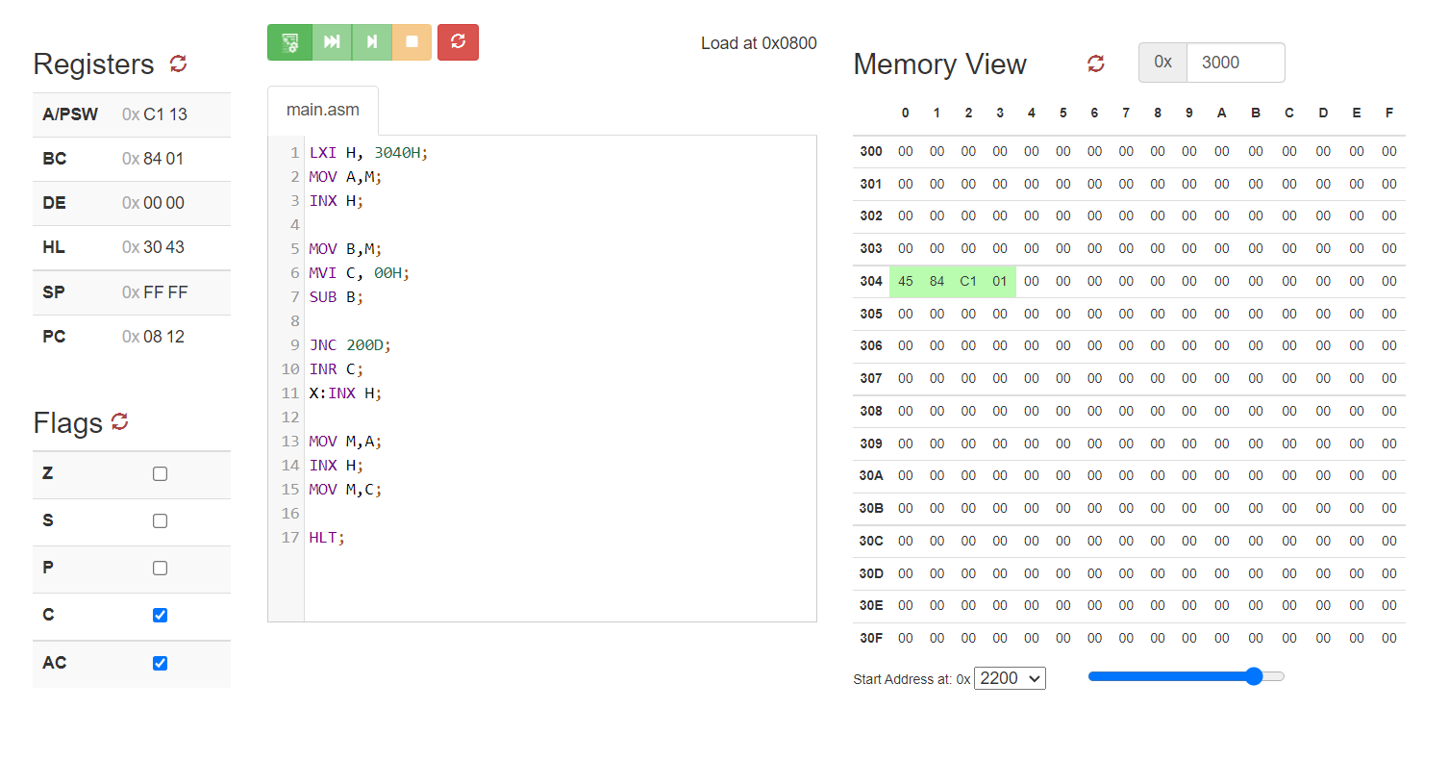

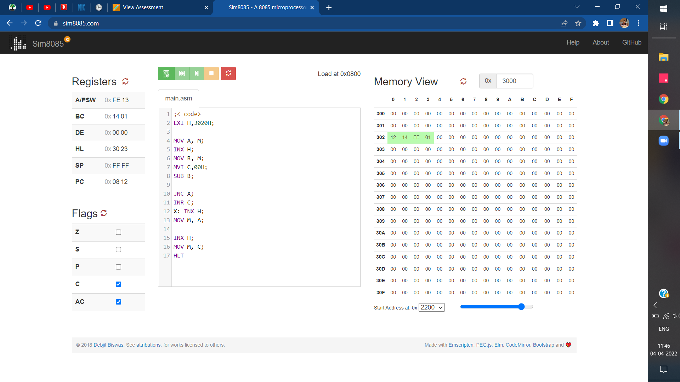

1. **Learning outcomes (What I have learnt):**

1. I have learnt how to subtract two 8 bit numbers with borrow.

2. I have learnt how to use 8085 instructions for subtraction.

3. I have how to execute the subtraction instruction in SIM8085.

4. I have learnt how to store the result and borrow in SIM8085.

**Evaluation Grid (To be created as per the SOP and Assessment guidelines by the faculty):**

|  |  |  |  |
| --- | --- | --- | --- |
| Sr. No. | Parameters | Marks Obtained | Maximum Marks |
| 1. | Worksheet Completion |  | 10 marks |
| 2. | Post Lab Quiz Result |  | 5 marks |
| 3. | Student Engagement  (Simulation/ Demonstrate/Performance and Pre-Lab Questions)) |  | 5 marks |
|  | Total |  | 20 marks |

**Thank You**