**Worksheet 1**

**Student Name: Ritika Rana UID:19BCA1126**

**Branch: BCA Section/Group –A\2**

**Semester: 6th Date of Performance: 28 MARCH 2022**

# Subject Name : MICROPROCESSOR AND INTERFACING LAB

**Subject Code:** CAP-356

1. **Aim/Overview of the practical:** **Write a program to add two 8-bit numbers, in which one of them is any random number, but another number is the result of XOR operation with any immediate value**

**2. Task to be done:** **Load the first number from memory location 2050 to accumulator.**

**Move the content of accumulator to register H.**

**Load the second number from memory location 2051 to accumaltor.**

**Then add the content of register H and accumulator using “ADD” instruction and storing result at 3050**

**The carry generated is recovered using “ADC” command and is stored at memory location 3051**

**3. Hardware Required: sim8085**

**4. Program:** **MVI A,07H**

**XRI 10H**

**MVI B,05H**

**ADD B**

**STA 002H**

**HLT**

**5. Output:**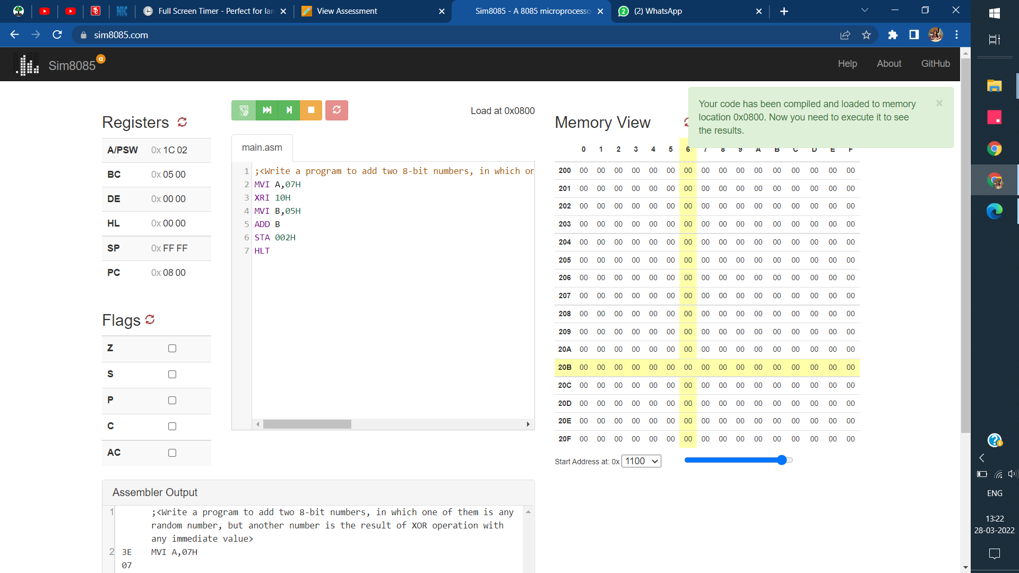

**.**

**Evaluation Grid (To be created as per the SOP and Assessment guidelines by the faculty):**

|  |  |  |  |
| --- | --- | --- | --- |
| Sr. No. | Parameters | Marks Obtained | Maximum Marks |
| 1. |  |  |  |
| 2. |  |  |  |
| 3. |  |  |  |
|  |  |  |  |