**Worksheet 5**

**Student Name: Ritika Rana UID: 19BCA1126**

**Branch: BCA Section/Group: A/2**

**Semester: 6th Date of Performance: 15/03/2022**

**Subject Name: MICROPROCESSOR AND INTERFACING LAB**

**Subject Code: CAP-356**

1. **Aim/Overview of the practical:** A memory location 3050H have data 23H and 3051Hhave 45H. So design a program to Add Two 8-bit Numbers and Show Result in Decimal.
2. **Task to be done:** Add two 8 bit numbers and show the result in Decimal.
3. **Hardware Required:**8085 Microprocessor

**4. Program:**

LXI H,3020H;

MOV A, M;

INX H;

MOV B, M;

MVI C, 00H;

ADD B;

DAA;

JNC X;

INR C;

X: INX H;

MOV M, A;

INX H;

MOV M, C;

HLT

**5. Observations:**

**6. Calculations:**

Input: - 23H, 45H

Binary representation: -

23H – 0010 0011

45H – 0100 0101

Addition - 0110 1000

Hexadecimal – 68H

**7. Output:**

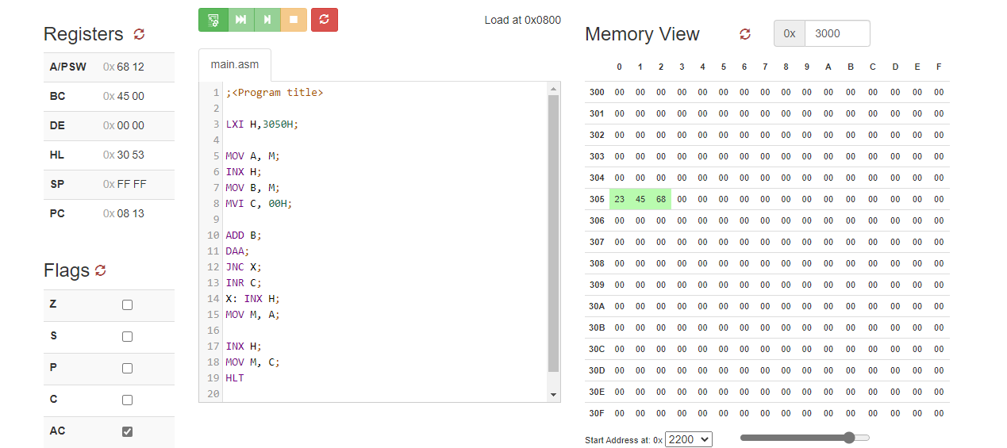

**9.Learning outcomes (What I have learnt):**

1. 8085 also sequences the instructions to be executed.
2. To perform **Add Two 8-bit Numbers and Show Result in Decimal.**
3. To perform addition of two 8-bit numbers with carry on 8085 microprocessors.

**Evaluation Grid (To be created as per the SOP and Assessment guidelines by the faculty):**

|  |  |  |  |
| --- | --- | --- | --- |
| Sr. No. | Parameters | Marks Obtained | Maximum Marks |
| 1. |  |  |  |
| 2. |  |  |  |
| 3. |  |  |  |
|  |  |  |  |