**Worksheet 8**

**Student Name: Ritika Rana UID:19BCA1126**

**Branch: BCA Section/Group: A/2**

**Semester: 6th Date of Performance:13/04/2022**

**Subject Name: MICROPROCESSOR AND INTERFACING LAB**

**Subject Code: CAP-356**

1. **Aim/Overview of the practical:WAP in which a memory location 3020H consist of data 45H and 3021H consist of 04H. Write a program to multiply the data given and store the result at 3022H.**
2. **Task to be done: Multiply** of two 8-bit numbersand show the result in specific location.

**3.Hardware Required:**8085 Microprocessor

**4. Program:**

LXI H,3020H;

MOV B,M;

INX H;

MOV C,M;

MVI A, 00H;

X: ADD B;

DCR C;

JNZ X;

INX H;

MOV M,A;

HLT

**5. Observations:**

LXI The instruction loads 16-bit data in the register pair designated in the operand.

MOV This instruction will move the content.

INX Increment register pair by 1.

JNZ stands for “Jump if Not zero” and his instruction is used to jump to the address as provided in the instruction.

DCR Decrement register by 1.

HLT This instruction will terminate the program.

**6. Calculations:**

Input: - 45H, 04H

Binary representation: -

45H – 0100 0101

04H – 1000 0100

Multiplication–0001 0100

**7. Output:**

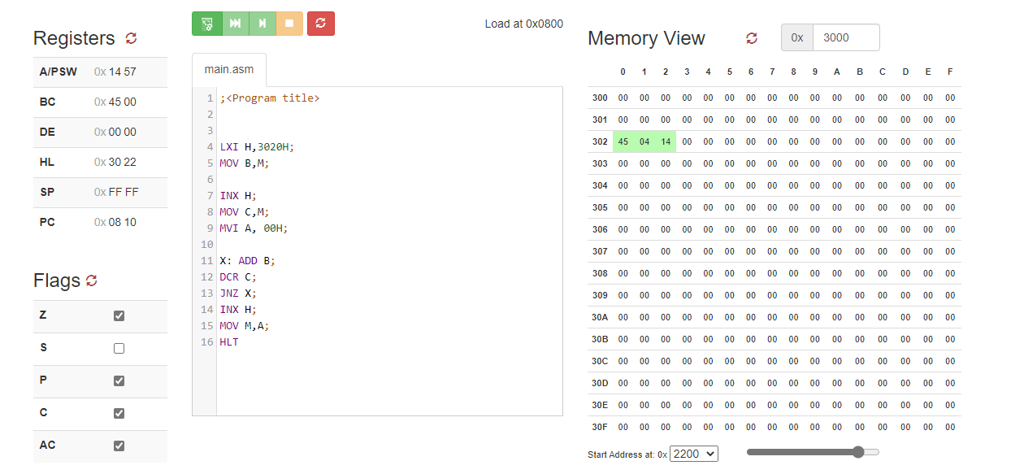

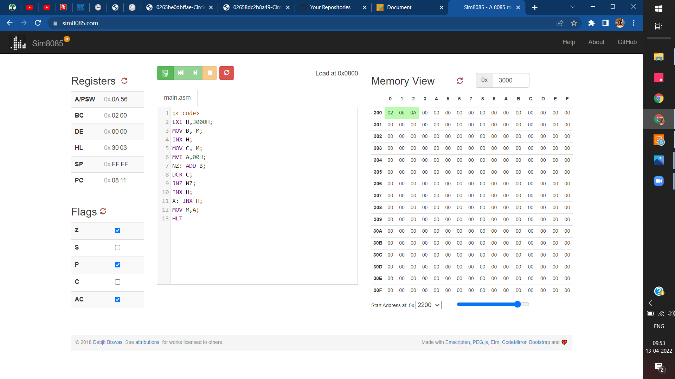

**8.Learning outcomes (What I have learnt):**

1. 8085 also sequences the instructions to be executed.
2. To perform multiplication **Two 8-bit Numbers and Show Result inspecific location.**
3. To perform multiplication of two 8-bit numberson 8085 microprocessors.

**Evaluation Grid (To be created as per the SOP and Assessment guidelines by the faculty):**

|  |  |  |  |
| --- | --- | --- | --- |
| Sr. No. | Parameters | Marks Obtained | Maximum Marks |
| 1. |  |  |  |
| 2. |  |  |  |
| 3. |  |  |  |
|  |  |  |  |

**\*\*\*\*\*\*\*\***