**Worksheet - 1**

**Student Name: Ritika Rana UID: 19BCA1126**

**Branch: UIC Section /Group :A/B**

**Semester: 6th Date of Performance:19/2/22**

**Subject Name : MICROPROCESSOR AND INTERFACING LAB Subject Code:CAP-356**

1. **Aim/Overview of the practical: A register pair HL holds the data 8085H at location 3000H and 3001H. Write a program to find the 1's complement of data given and store the result at given locations 3002H and 3003H.**

**2. Task to be done:**Perform 1’s compliment on the given data and store it

**3. Hardware Required:**8085 Microprocessor

1. **Program:**

**LDA 3000H**

**CMA**

**STA 3002H**

**LDA 3001H**

**CMA**

**STA 3003H**

**HLT**

1. **Observations:**LDA is used to load data into the accumulator.  
    CMA is used to do 1’s compliment on the data stored in the accumulator.  
    STA is used to store data at any memory location .
2. **Calculations:** Input: 8085H  
    Binary: 1000 0000 1000 0101  
    1’s Compliment: 0111 1111 0111 1010  
   Hexa Decimal: 7F 7A

**8.Output:**

**1.** 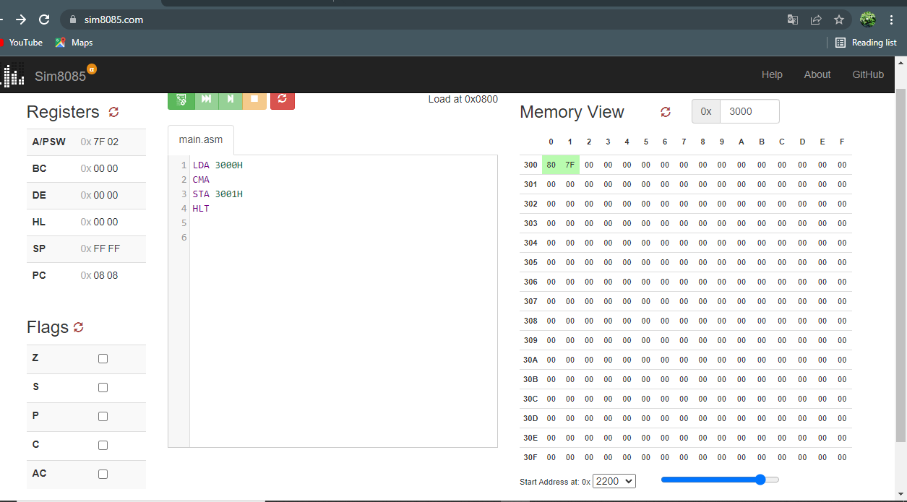

**2.**

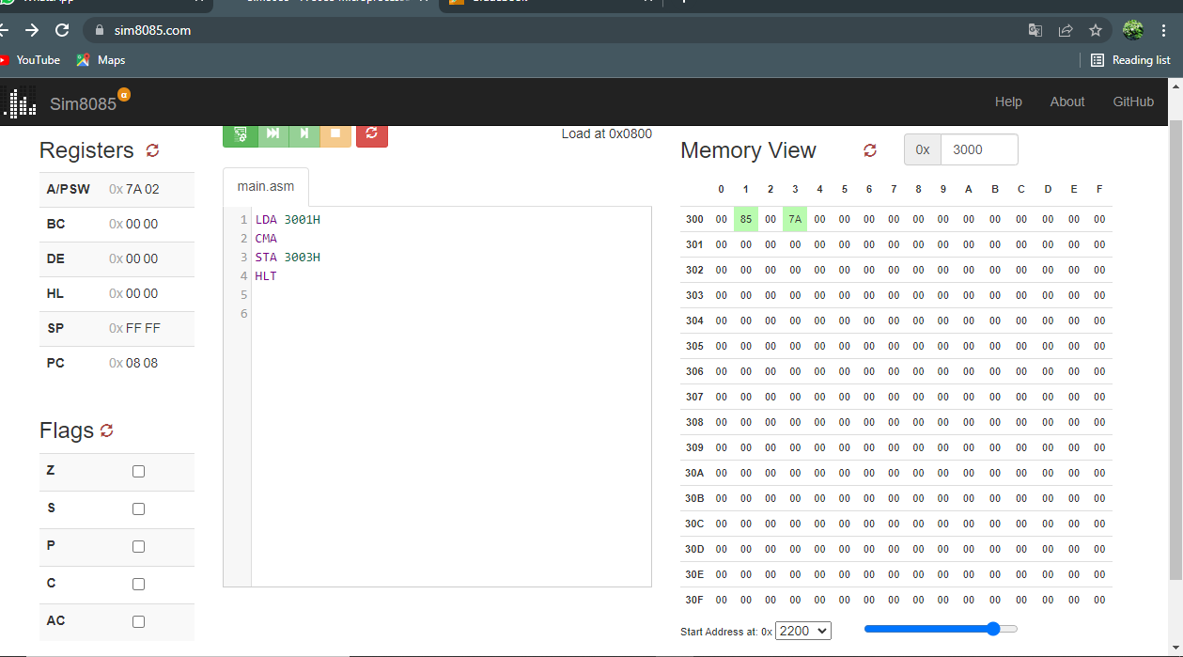

**Evaluation Grid (To be created as per the SOP and Assessment guidelines by the faculty):**

|  |  |  |  |
| --- | --- | --- | --- |
| **S. No** | **Parameter** | **Marks obtained** | **Maximum marks** |
| **1.** | **Worksheet** |  | **10** |
| **2.** | **Post lab Questions** |  | **5** |
| **3.** | **Pree lab Questions** |  | **5** |