**Worksheet 2**

**Student Name: Ritika Rana UID: 19BCA1126**

**Branch: UIC Section/Group: A/2**

**Semester: 6th Date of Performance:18/2/22**

**Subject Name: MICROPROCESSOR AND INTERFACING LAB Subject Code:CAP-356**

1. **Aim/Overview of the practical: A register pair HL holds the data 8085H at location 3000H and 3001H. Write a program to find the 2's complement of data given and store the result at given locations 3002H and 3003H.**

**2. Task to be done:**The user inputs a 16bit value and we have ta make the 2’s complement of it and we have to perform the complement of that value and store it in a certain location

**3. Hardware Required:**8085 Microprocessor

1. **Program:**

**LDA 3000H**

**CMA**

**INR A**

**STA 3002H**

**LDA 3001H**

**CMA**

**ADI 01H**

**STA 3003H**

**HLT**

1. **Observations:**LDA is used to load data into the accumulator.  
    CMA is used to do 1’s compliment   
    INR A is used to do 2’s compliment  
    STA is used to store data at any memory location .
2. **Calculations:  
    Input:** 8085H  
   **Binary:** 1000 0000 1000 0101 **1’s Compliment:** 0111 1111 0111 1010  
   **2’s Compliment:** 0111 1111 0111 1011

**7. Output:**

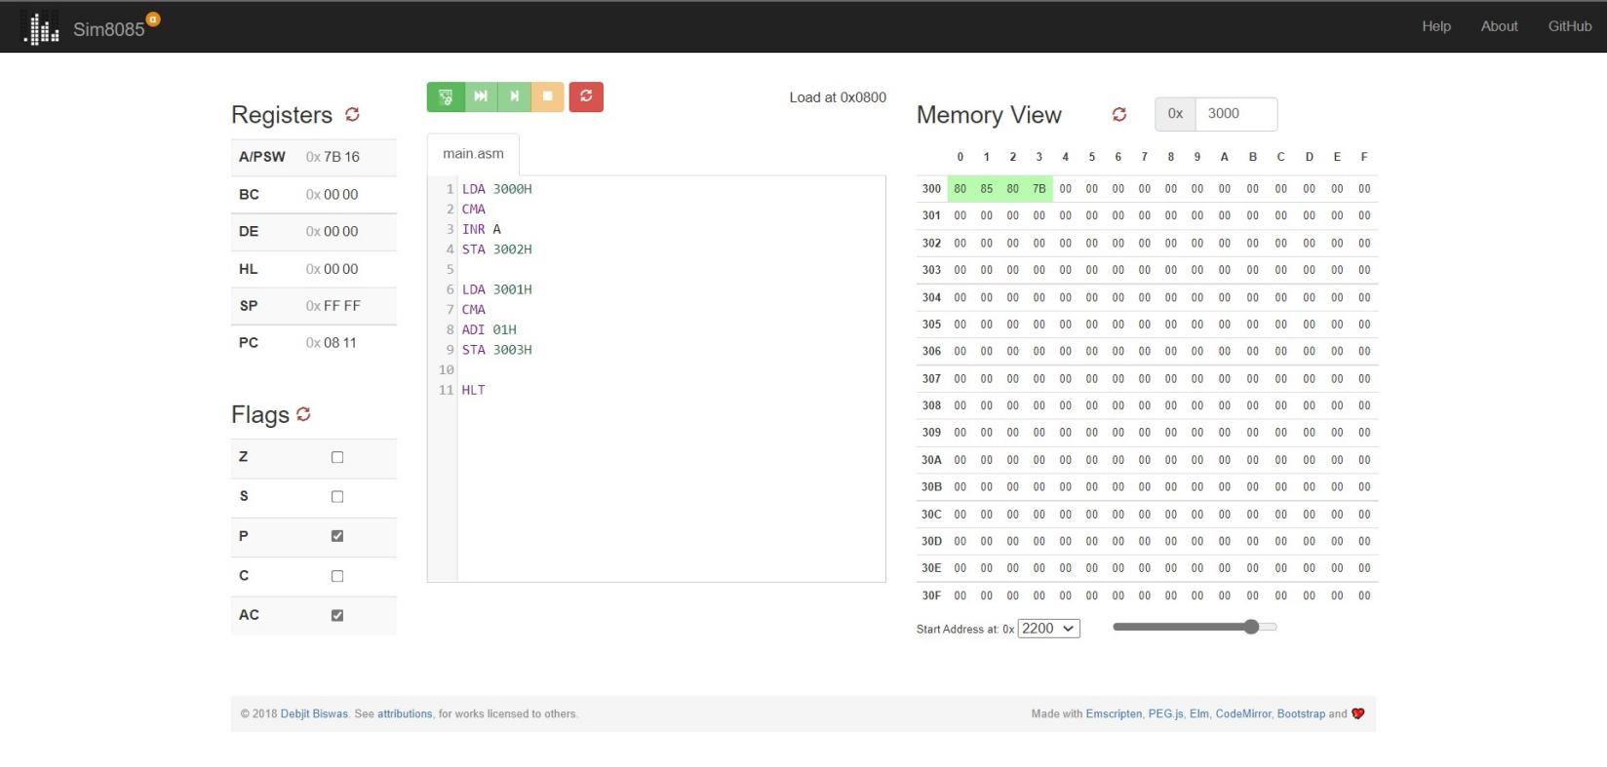

**9. Learning outcomes (What I have learnt):**

**1.**How to code in assembly language

**2.** How to use microprocessor 8085

**3.**How to perform 2’s compliment on MP8085

**Evaluation Grid (To be created as per the SOP and Assessment guidelines by the faculty):**

|  |  |  |  |
| --- | --- | --- | --- |
| Sr. No. | Parameters | Marks Obtained | Maximum Marks |
| 1. |  |  |  |
| 2. |  |  |  |
| 3. |  |  |  |
|  |  |  |  |