Machine Learning Based Buyer Segmentation
and Investment Profiling for Real Estate Market Intelligence
A Data-Driven Buyer Segmentation Study — Parcl Co. Limited
Prepared for: Unified Mentor
Dataset: clients.csv + properties.csv | 2,000 Clients, 10,000 Transactions
Methodology: SQL, Excel, Tableau

Table of Contents
Table of Contents 2
Executive Abstract 3
1. Introduction & Background 3
1.1 Problem Statement 3
1.2 Objectives 3
2. Dataset & Methodology 4
2.1 Data Cleaning & Joining (SQL) 4
2.2 Feature Encoding & Scaling (Excel) 4
2.3 Segmentation Logic 4
3. Buyer Segment Overview 5
4. Segment Profiles 6
4.1 Investment Behavior 6
4.2 Satisfaction 6
4.3 Acquisition Purpose 8
4.4 Financing Behavior 8
4.5 Property Type Preference 10
4.6 Geographic Distribution 10
5. Key Structural Finding 11
6. Recommendations 11
6.1 Segment-Specific Marketing 11
6.2 Financing & Product Strategy 11
6.3 Rethink First-Time Buyer Strategy 11
6.4 Geographic Expansion 11
7. Conclusion 12

Executive Abstract
Parcl should prioritize high-value Luxury Investors for retention and referral growth while urgently diagnosing dissatisfaction among Everyday Buyers, because these two segments represent the clearest combination of revenue upside and broad customer risk across the 2,000-client base. This study segments Parcl Co. Limited’s real estate clients into behaviorally distinct buyer groups using 10,000 property transactions and client-level features including investment value, purchase frequency, satisfaction, financing behavior, and acquisition purpose.
The clearest finding is that satisfaction and investment size move together at the top of the market: Luxury Investors, the smallest segment by count, report the highest satisfaction score (4.49/5) and among the highest average investment ($1.52M), while the largest segment — Everyday Buyers — reports the lowest satisfaction (2.70/5). A second, more structural finding is that every client in the dataset purchased three or more properties; there is no single-transaction "browser" segment in this market, which has direct implications for how Parcl defines and targets first-time buyers.

1. Introduction & Background
Real estate buyers differ enormously in motivation and behavior — individual home buyers, institutional and corporate investors, international buyers, and repeat high-net-worth investors all interact with a property platform differently. Treating this population as one undifferentiated group leads to generic marketing, mistargeted property recommendations, and missed opportunities to serve high-value segments well.
This study applies buyer segmentation to Parcl's client base to replace assumption-driven targeting with a data-grounded view of who the buyers are.

1.1 Problem Statement
Parcl currently lacks a systematic understanding of the different buyer types on its platform, the investment motivations that vary across demographics, geographic differences in behavior, and financing patterns — leading to inefficient marketing spend, generic recommendations, and weak investor targeting.

1.2 Objectives
- Identify distinct buyer segments from transaction and client behavior data
- Profile each segment's investment size, satisfaction, financing, and property preferences
- Translate segment profiles into concrete marketing and targeting recommendations

2. Dataset & Methodology
Two source files were used: a client table (2,000 records covering demographics, acquisition purpose, financing, satisfaction, and referral channel) and a property transaction table (10,000 listings covering price, unit type, and sale status). No missing values were found in the client table; roughly 27% of property listings were unsold inventory with no associated client, which is expected and was excluded from client-level aggregates.

2.1 Data Cleaning & Joining (SQL)
- Removed exact duplicate client records
- Normalized two inconsistent date formats found in date of birth (DD-MM-YYYY and MM/DD/YYYY) into a single standard format before computing age
- Parsed transaction dates and converted sale price text (with $ and commas) into numeric values
- Joined clients to their sold transactions and aggregated: number of properties purchased, total investment value, average purchase price, average floor area, and unit-type mix

2.2 Feature Encoding & Scaling (Excel)
- One-hot encoded client type, acquisition purpose, and referral channel into binary flags
- Standardized (Z-score) all numeric features — age, satisfaction, purchase count, investment value, average price, average floor area — so no single feature dominates due to scale

2.3 Segmentation Logic
Buyers were grouped using a transparent rule-based classification built directly on the scaled and encoded features, applied in priority order so each client falls into exactly one segment: institutional buyers are separated first (Corporate Buyers), then investment-purpose buyers with above-median spend (Global Investors), then highly satisfied high-spend individuals (Luxury Investors), then younger loan-financed buyers (First-Time Buyers), with all remaining individual buyers grouped as a residual segment. The method was selected for interpretability and auditability in SQL and Excel; future validation against a K-Means clustering output would strengthen confidence that the rule-based segments align with the cluster structure specified in the project brief.

3. Buyer Segment Overview
The segmentation produced five groups, four of which map directly onto the archetypes defined in the project brief (C1-C4), plus a residual "Everyday Buyers" segment (C5) that captures individual home buyers who do not meet any of the more specific criteria.
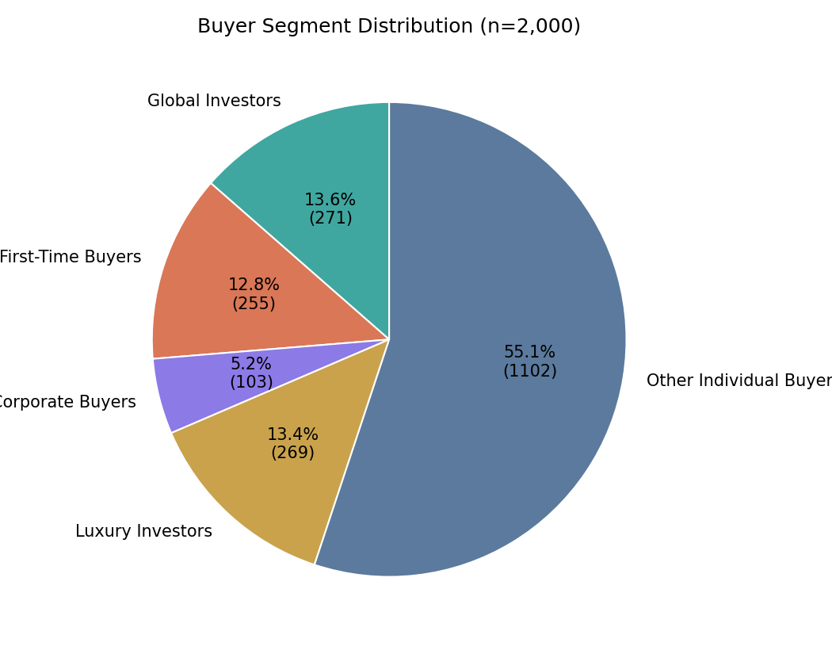
Figure 1. Buyer segment distribution across 2,000 clients.
Segment | Clients | Avg Investment | Avg Satisfaction | Avg Properties
C1 - Global Investors | 271 | $1,525,767 | 3.13 | 4.01
C2 - First-Time Buyers | 255 | $1,135,942 | 2.78 | 3.49
C3 - Corporate Buyers | 103 | $1,263,753 | 3.07 | 3.70
C4 - Luxury Investors | 269 | $1,519,651 | 4.49 | 4.05
C5 - Other Individual Buyers | 1,102 | $1,160,300 | 2.70 | 3.50

4. Segment Profiles

4.1 Investment Behavior
Global Investors and Luxury Investors carry the largest average investment ($1.53M and $1.52M respectively) — more than 30% above the residual Everyday Buyers segment. Corporate Buyers sit in the middle ($1.26M), reflecting multi-unit but individually smaller ticket purchases typical of institutional buying.
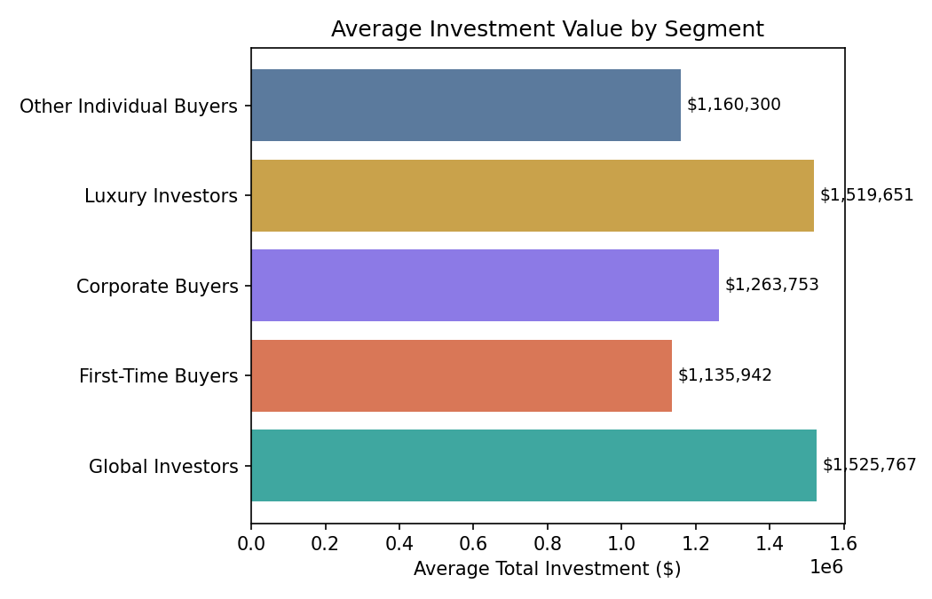
Figure 2. Average total investment by segment.

4.2 Satisfaction
Satisfaction is the sharpest differentiator between segments. Luxury Investors report a 4.49/5 average — nearly a full point above every other segment — while Everyday Buyers, the largest group, average only 2.70/5. Since Luxury Investors also carry high investment value, this segment represents Parcl's clearest combination of profitability and advocacy potential.
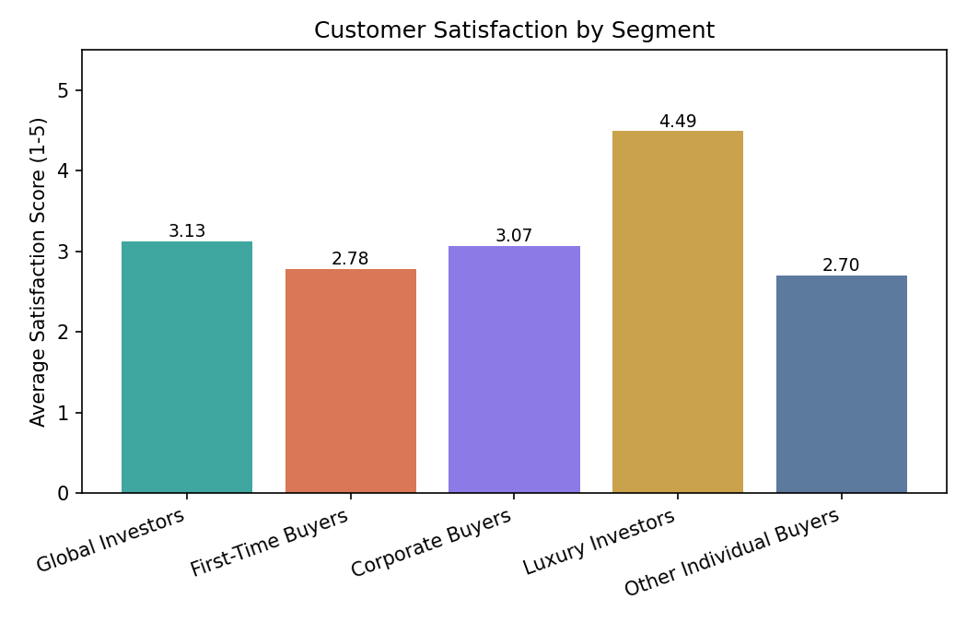
Figure 3. Average satisfaction score by segment.

4.3 Acquisition Purpose
Global Investors are, by definition, 100% investment-purpose buyers, and Luxury Investors are 100% home-purpose — these two segments sit at opposite ends of the buy-to-invest versus buy-to-live spectrum despite having almost identical average investment values, which is a useful distinction for how each should be marketed to.
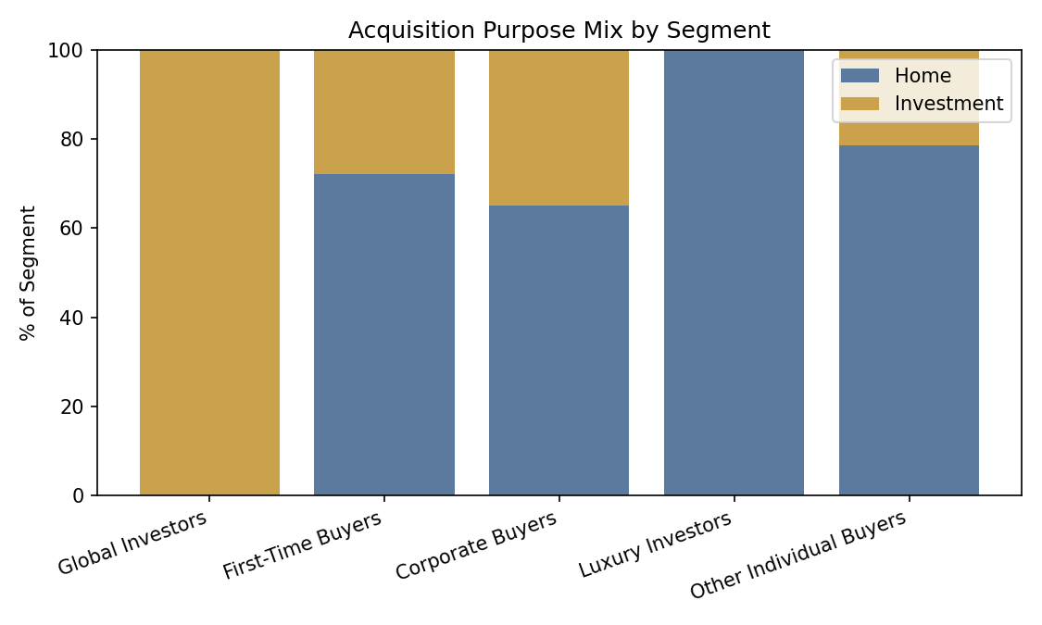
Figure 4. Acquisition purpose mix by segment.

4.4 Financing Behavior
First-Time Buyers are defined partly by loan usage and so show 100% loan financing by construction; more informative is that Corporate Buyers (41.7%) and Global Investors (38.4%) also lean on financing at meaningfully higher rates than Luxury Investors (34.6%) or Everyday Buyers (21.9%) — the segments with the largest average tickets are not simply paying cash.
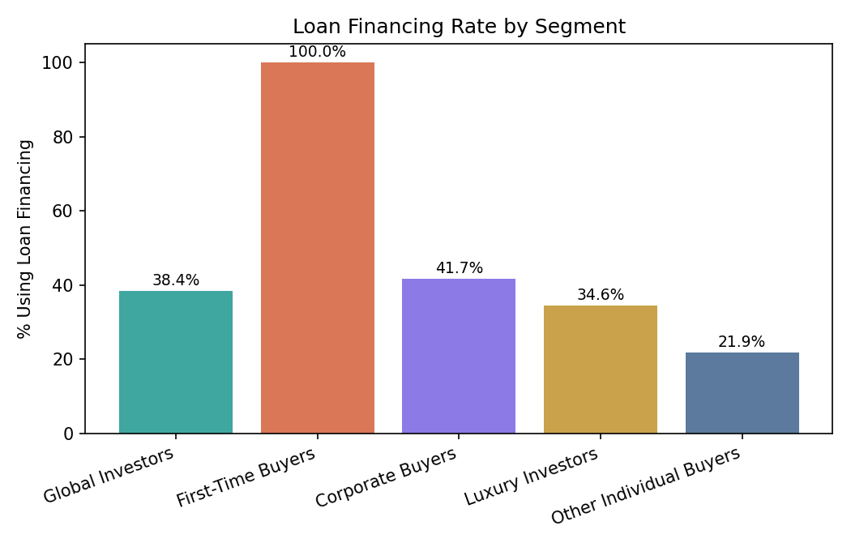
Figure 5. Loan financing rate by segment.

4.5 Property Type Preference
Every segment purchases apartments over office units by a wide margin, but Corporate Buyers show the highest relative share of office purchases, consistent with institutional buyers acquiring commercial space alongside residential inventory.
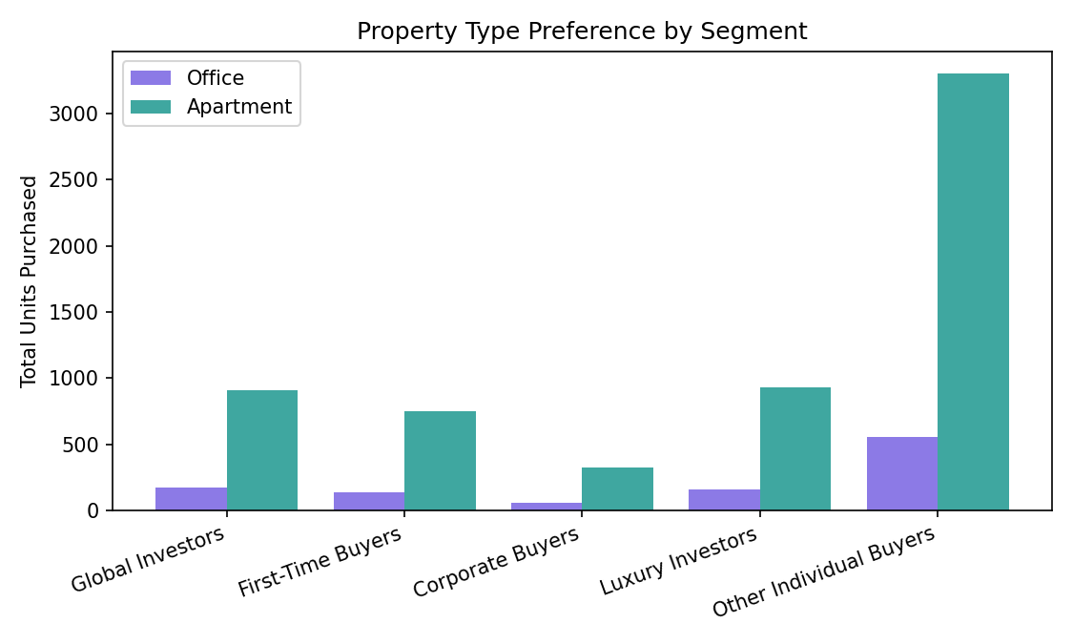
Figure 6. Office vs. apartment units purchased by segment.

4.6 Geographic Distribution
The client base is heavily US-concentrated (1,538 of 2,000 clients), with the UK, Canada, Germany, and France forming a second tier. This concentration means geographic segmentation is currently more useful within the US (by region/state) than across countries, though the international segments are worth monitoring as the platform grows.
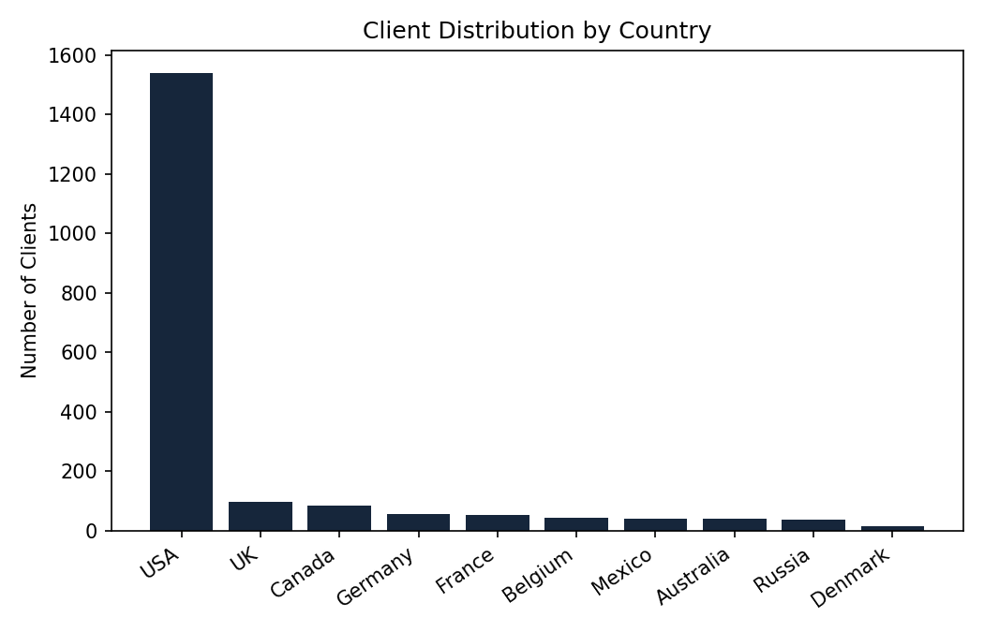
Figure 7. Client distribution by country.

5. Key Structural Finding
Across all 2,000 clients, the minimum number of properties purchased was three. There is no one-time or single-transaction buyer anywhere in this dataset. This is a structural feature of Parcl's current client base, not a segment-specific pattern, and it has an important implication: any marketing or product strategy built around a conventional "first-time buyer" funnel (attract → single purchase → nurture toward a second purchase) does not match how buyers on this platform actually behave. By the time a client appears in Parcl's data, repeat purchasing behavior is already the norm, not the exception.

6. Recommendations

6.1 Segment-Specific Marketing
- Priority 1 — Retain and activate Luxury Investors: Launch premium retention and referral programs for Luxury Investors because they combine very high satisfaction (4.49/5), high average investment ($1.52M), and strong advocacy potential.
- Priority 2 — Separate investor and lifestyle messaging: Build distinct investment-focused campaigns for Global Investors and lifestyle-focused campaigns for Luxury Investors because they spend at similar levels but buy for different purposes.
- Priority 3 — Fix Everyday Buyer dissatisfaction: Investigate service, product-fit, and post-purchase experience gaps for Everyday Buyers because they represent 55% of clients and have the lowest satisfaction score (2.70/5).

6.2 Financing & Product Strategy
- Offer tailored financing partnerships to Corporate and Global Investor segments, since both lean on loans more than expected for their spend level
- Expand office-unit inventory and marketing specifically toward Corporate Buyers, who show a disproportionate preference for commercial space

6.3 Rethink First-Time Buyer Strategy
- Redesign onboarding and marketing around the fact that no client is a true single-transaction buyer — funnel strategy should assume early multi-property intent rather than a slow nurture toward a second purchase

6.4 Geographic Expansion
- Given the current US concentration, prioritize region-level (state/province) segmentation within the US before investing heavily in additional international segmentation

7. Conclusion
This segmentation replaces a one-size-fits-all view of Parcl's buyers with five behaviorally distinct groups, each with a different combination of investment size, satisfaction, financing behavior, and property preference. The clearest opportunity is the small but highly satisfied Luxury Investor segment, and the clearest structural insight is that Parcl's client base does not include a genuine one-time buyer — a finding that should directly inform how the company defines and targets "first-time" customers going forward.
The segmentation logic, built with transparent SQL and Excel formulas rather than a black-box model, gives Parcl's team a system they can audit, adjust, and extend as new client data arrives, while remaining directly comparable to the K-Means cluster structure specified in the original project briefly.

