Executive Summary
Predictive Modeling and Risk Scoring for Bank Customer Churn
The European Central Bank | Prepared for Government Stakeholders | September 2026

Purpose
This summary presents the headline results of a machine learning system built to predict, ahead of time, which retail banking customers are likely to churn — replacing after-the-fact churn analysis with a proactive, quantitative risk score for every customer.

Headline Finding
A Gradient Boosting model correctly identifies roughly half of all customers who actually churn (49.6%), while producing false alarms for only 3.8% of customers who stay — a workable precision-recall balance for a retention team with limited outreach capacity. The two strongest predictors of churn, confirmed by two independent explainability methods, are the number of products a customer holds and their age.
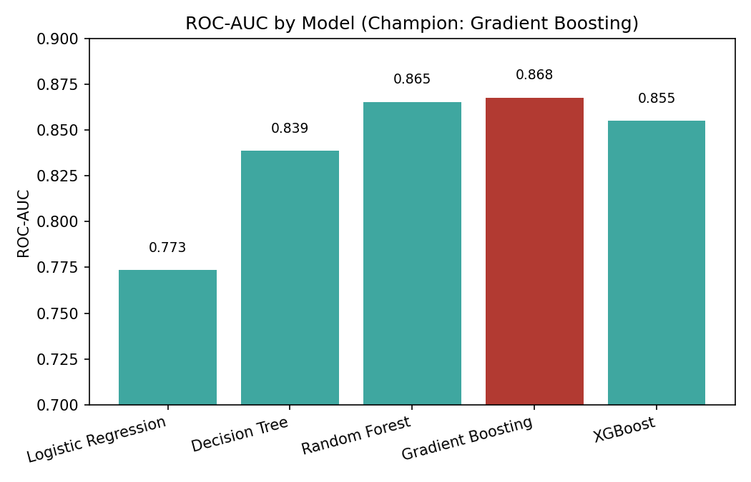
Model discrimination (ROC-AUC) across all five models tested.

Key Metrics
Metric | Result
Champion model | Gradient Boosting
Test-set ROC-AUC | 0.868
Test-set Accuracy | 86.7%
Recall (churners correctly identified) | 49.6%
Precision (false-alarm control) | 76.8%
Top churn drivers | Number of products, Age

What This Means for Strategy
- The bank can now score its full customer base monthly and prioritize retention outreach by risk decile, instead of reacting after a complaint or closure request
- Product count above 2 is a strong, actionable risk signal — not a cross-sell success metric — and should trigger review, not further selling
- Age-based segmentation should inform retention messaging, since age is the second-strongest and most consistent churn predictor
- A live dashboard lets any team member score an individual customer or simulate a change (e.g. reactivating an inactive customer) before committing budget to an intervention

Recommended Actions
- Operationalize monthly batch scoring and route the highest-risk decile to the retention team
- Flag all 3+ product accounts for manual review rather than further cross-sell
- Retrain the model quarterly and monitor feature-importance drift as new churn outcomes accumulate

Full methodology, model comparison, and SHAP-based explainability analysis are provided in the accompanying research paper and interactive risk-scoring dashboard.

