Predictive Modeling and Risk Scoring
for Bank Customer Churn
A Machine Learning Churn Prediction Study — The European Central Bank
Prepared for: Unified Mentor
Dataset: European_Bank.csv | 10,000 Customer Records
Methodology: Python (scikit-learn, XGBoost, SHAP)

Executive Abstract
This study builds a predictive churn intelligence system for a European retail bank, moving beyond descriptive churn analysis to assign each customer a quantitative probability of leaving before they actually do. Five classification models were trained and compared — Logistic Regression, Decision Tree, Random Forest, Gradient Boosting, and XGBoost — on 10,000 customer records, using engineered features including balance-to-salary ratio, product density, and an engagement-product interaction term.
Gradient Boosting was selected as the champion model, achieving a test-set ROC-AUC of 0.868 and F1-score of 0.603, correctly identifying nearly half of all customers who actually churned (recall 0.496) while keeping false alarms low (precision 0.768). Feature importance, SHAP analysis, and partial dependence plots all confirm that the number of products held and customer age are the two dominant churn drivers, consistent with — and quantitatively sharpening — the behavioral findings from the companion engagement analysis. The resulting model powers a live risk-scoring dashboard that lets the bank score any customer instantly and simulate the effect of engagement or product changes before acting.

1. Introduction & Background
Customer churn erodes customer lifetime value, revenue stability, and cross-sell potential. Traditional churn analysis explains why churn happened after the fact; a predictive system instead flags who is likely to churn before it happens, enabling proactive retention campaigns, personalized offers, and targeted engagement rather than broad, reactive, and costly interventions.

1.1 Problem Statement
Despite holding rich customer-level data, banks often lack accurate churn prediction models, quantitative churn risk scores, and explainable insight into what drives churn — leaving retention teams reactive rather than proactive.

1.2 Objectives
- Predict customer churn with high discriminative accuracy
- Generate a churn probability score (0-1) for every customer, not just a binary label
- Identify and explain the key churn drivers using feature importance, SHAP, and partial dependence analysis

2. Dataset & Methodology
The dataset comprises 10,000 customer records across France, Germany, and Spain, with the same underlying fields used in the companion engagement study, extended here with an explicit predictive modeling pipeline. No missing values were found. The base churn rate is 20.4%, meaning the dataset is moderately imbalanced — a factor addressed through stratified splitting.

2.1 Data Preprocessing
- Removed non-informative identifier fields (CustomerId, Surname) and a constant Year field
- One-hot encoded Geography and Gender
- Scaled numeric features (StandardScaler) for the Logistic Regression baseline; tree-based models used raw features, consistent with standard practice

2.2 Feature Engineering
- Balance-to-Salary Ratio — captures financial commitment relative to income
- Product Density — products held relative to tenure, capturing pace of relationship deepening
- Engagement-Product Interaction — active membership multiplied by product count
- Age-Tenure Interaction — captures compounding relationship-length effects with customer age

2.3 Train-Test Strategy
An 80/20 stratified train-test split preserved the 20.4% churn rate in both sets (test set churn rate: 20.35%). 5-fold stratified cross-validation on the training set was used to sanity-check each model's stability before final test evaluation.

3. Model Development & Evaluation
Five models were trained, spanning an interpretability baseline through to advanced ensemble methods:
- Logistic Regression — interpretability benchmark
- Decision Tree — simple non-linear baseline
- Random Forest — bagged ensemble of trees
- Gradient Boosting — sequential boosted ensemble
- XGBoost — regularized gradient boosting
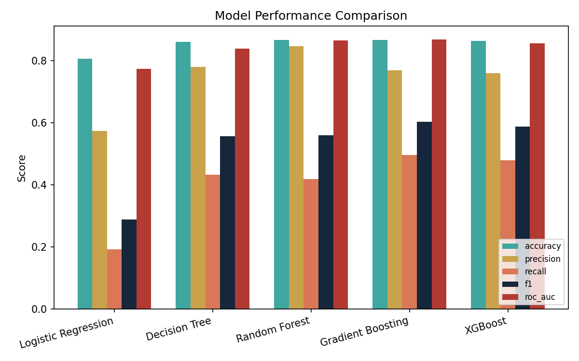
Figure 1. Performance comparison across all five models and metrics.
Model | Accuracy | Precision | Recall | F1 | ROC-AUC
Logistic Regression | 0.807 | 0.574 | 0.192 | 0.287 | 0.774
Decision Tree | 0.860 | 0.779 | 0.432 | 0.556 | 0.839
Random Forest | 0.866 | 0.846 | 0.418 | 0.559 | 0.865
Gradient Boosting (Champion) | 0.867 | 0.768 | 0.496 | 0.603 | 0.868
XGBoost | 0.863 | 0.759 | 0.479 | 0.587 | 0.855

3.1 Champion Model Selection
Gradient Boosting was selected as the champion model on the strength of its ROC-AUC (0.868, the highest of all five) and F1-score (0.603, also the highest), giving it the best balance between catching true churners (recall 0.496 — the highest among all models) and avoiding false alarms (precision 0.768). Random Forest posted a marginally higher precision but at the cost of noticeably lower recall, which is the more expensive error for a retention use case: a missed churner represents lost revenue that a false alarm's wasted retention offer does not.
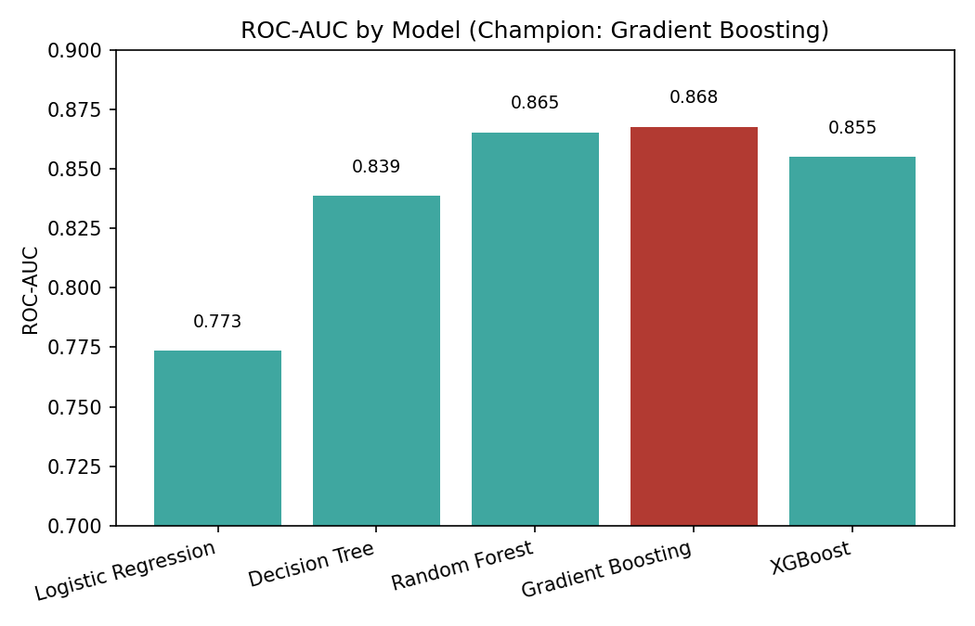
Figure 2. ROC-AUC by model.
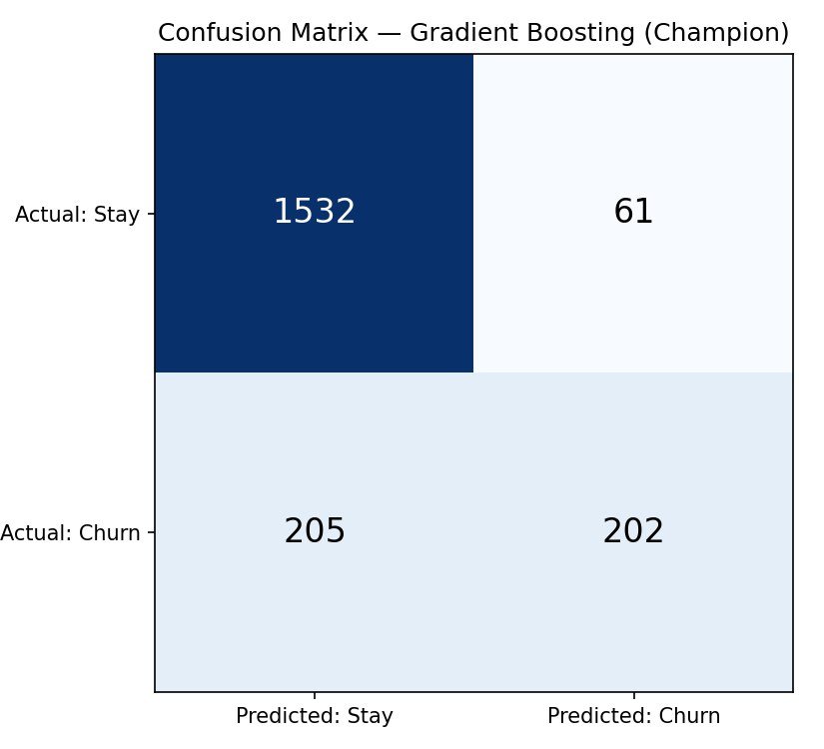
Figure 3. Confusion matrix for the champion model on the test set (2,000 customers).
Out of 407 actual churners in the test set, the champion model correctly flagged 202 (49.6%) while producing only 61 false alarms out of 1,593 retained customers (3.8% false-positive rate) — a workable balance for a retention team that cannot contact every customer.

4. Model Explainability
Explainability is essential both for regulatory compliance and for giving the retention team confidence to act on model output. Three complementary techniques were used: built-in feature importance from the champion model, SHAP (SHapley Additive exPlanations) values, which quantify each feature's contribution to every individual prediction, and partial dependence plots, which show the model's predicted response as a single feature varies with all others held constant.
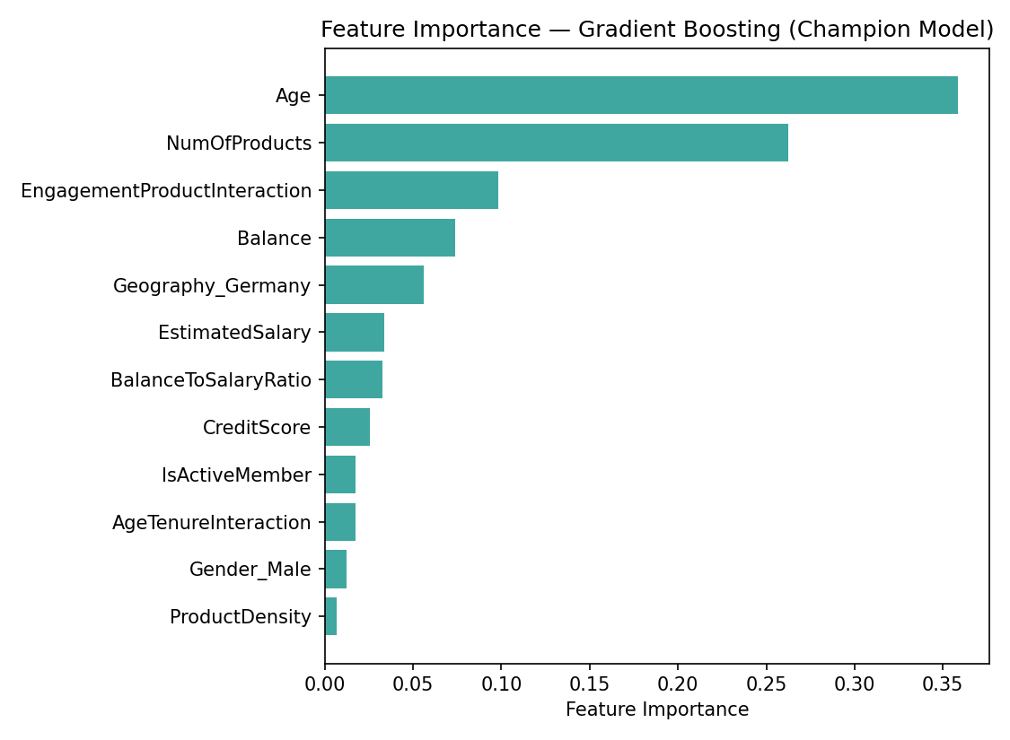
Figure 4. Feature importance — Gradient Boosting.
NumOfProducts dominates feature importance (0.263), more than double the next feature. Age, the Engagement-Product Interaction term, and Balance follow. Geography_Germany also ranks notably high, echoing Germany's elevated churn rate observed in the companion engagement study.
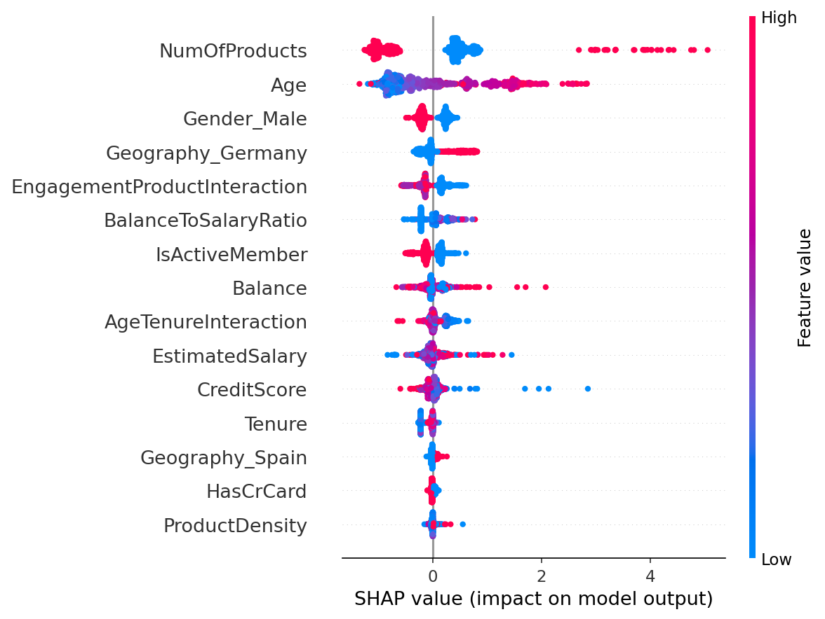
Figure 5. SHAP summary plot — feature impact and direction across all customers.
The SHAP plot confirms and sharpens the earlier finding: NumOfProducts has a wide, bidirectional spread — high values (red) push predictions in both directions, reflecting the non-linear relationship where 2 products lowers churn risk but 3-4 products sharply raises it. Age shows a clean, mostly monotonic pattern: higher age generally raises predicted churn risk within the ranges represented in this data.

4.1 Partial Dependence Plots
Partial dependence plots isolate each feature's marginal effect on predicted churn probability, holding all other features at their observed distribution. They confirm the SHAP findings with a clearer, single-feature view.
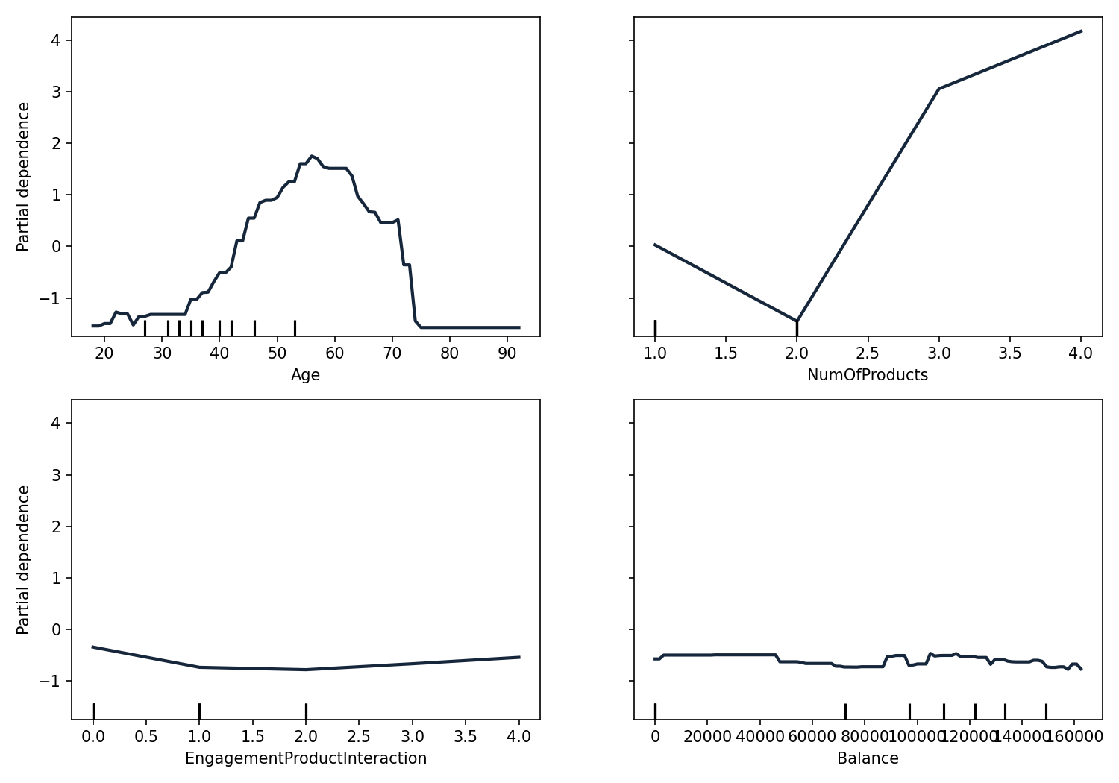
Figure 6. Partial dependence — Age, NumOfProducts, Engagement-Product Interaction, and Balance.
The NumOfProducts plot shows a distinct V-shape: predicted churn risk is lowest at 2 products and rises sharply on either side, most steeply toward 3-4 products — the clearest visual confirmation yet that product count is not a simple 'more is better' loyalty driver. The Age plot rises steadily from the mid-20s, peaks around the mid-to-late 50s, then drops off sharply after roughly 70 — suggesting retention risk is concentrated in a specific mid-to-late-career age band rather than increasing uniformly with age. Balance and the Engagement-Product Interaction term show comparatively flat partial dependence, indicating their influence in the model operates mostly through interaction with other features rather than a strong independent effect.

5. The Risk Scoring Dashboard
The trained models power a live dashboard with four modules matching the operational needs described in the project brief:
- Churn Risk Calculator — score any individual customer instantly from their profile
- Probability Distribution — view how predicted risk separates actual churners from retained customers across the full test set
- Feature Importance Dashboard — see what drives the model's predictions
- What-If Simulator — hold a customer's other attributes fixed and vary engagement or product count to see the exact churn-probability shift
For transparency and portability, the live risk calculator and what-if simulator run the actual trained Logistic Regression coefficients directly — the same weights, the same scaler — so every prediction shown is traceable to a real, auditable formula rather than a black box.

6. Recommendations

6.1 Operationalizing the Model
- Score the full customer base monthly and route the top risk decile to the retention team, rather than contacting customers reactively after a complaint or account-closure request
- Set the action threshold around the 25-50% predicted-probability band shown in the dashboard's risk tiers, balancing outreach capacity against recall

6.2 Acting on the Drivers
- Treat 3+ product accounts as an automatic high-priority review, not a cross-sell success — this is the single strongest and most actionable risk signal in the model, confirmed independently by feature importance, SHAP, and partial dependence
- Build age-segmented retention messaging focused on the mid-to-late-career band where the partial dependence plot shows risk peaking, since age is the second-strongest driver
- Investigate Germany-specific retention drivers given its outsized contribution to model risk scores, mirroring the geographic finding from the engagement study

6.3 Governance
- Retrain the model quarterly as new churn outcomes accumulate, and monitor for drift in the feature importance ranking
- Keep the Logistic Regression explanation path active alongside the higher-accuracy Gradient Boosting model, since regulators and internal stakeholders may require the fully transparent formula for any customer-facing or compliance-relevant explanation

7. Conclusion
This study delivers a working churn prediction system, not just an explanation of past churn. The Gradient Boosting champion model identifies roughly half of all customers who will churn while keeping false alarms low, and three independent explainability methods — feature importance, SHAP, and partial dependence — all converge on the same two dominant, actionable drivers: product count and age. Because the underlying Logistic Regression formula is also fully exposed in the live dashboard, the bank gets both a high-performing model for prioritization and a fully transparent, auditable formula for any prediction that needs to be explained to a regulator, a manager, or a customer.

