How to install python?

Step1: Search www.python.org

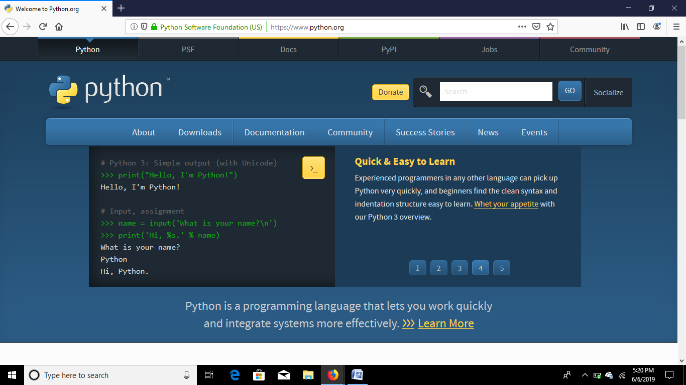

Step2: Click on downloads

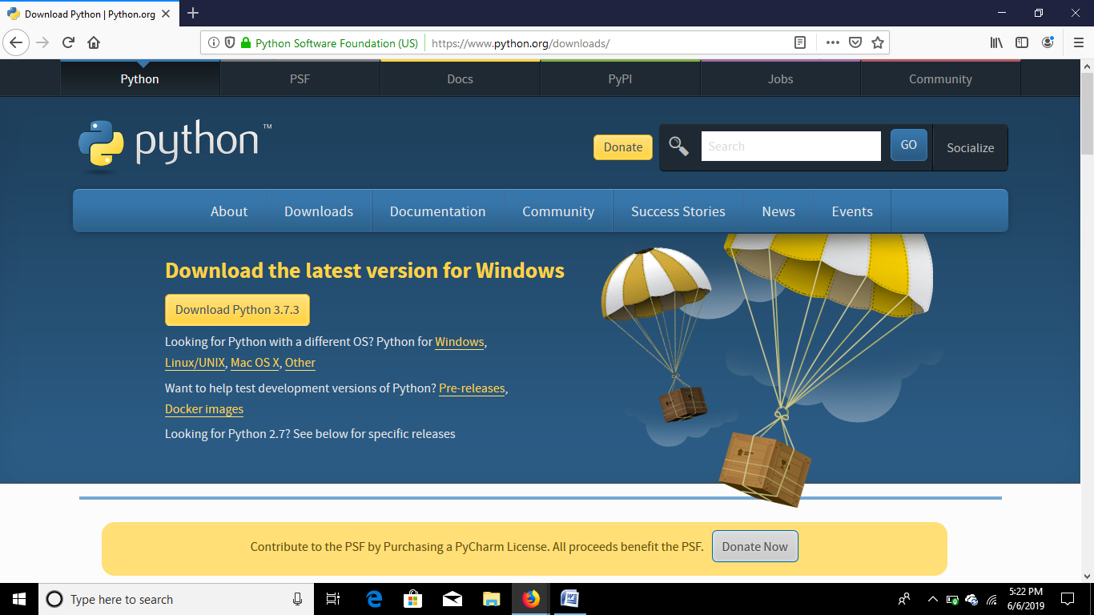

Step3: Download Python3.7.3

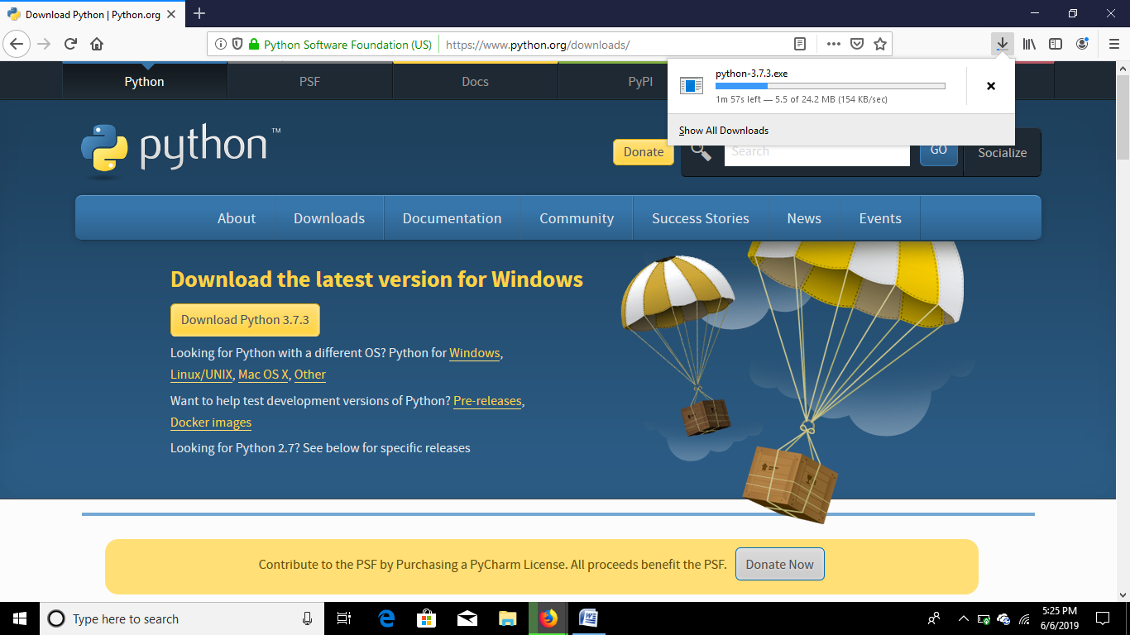

Step4: Run the setup and install using customization installation, select the add python 3.7 to path option and also select all the additional optional files.

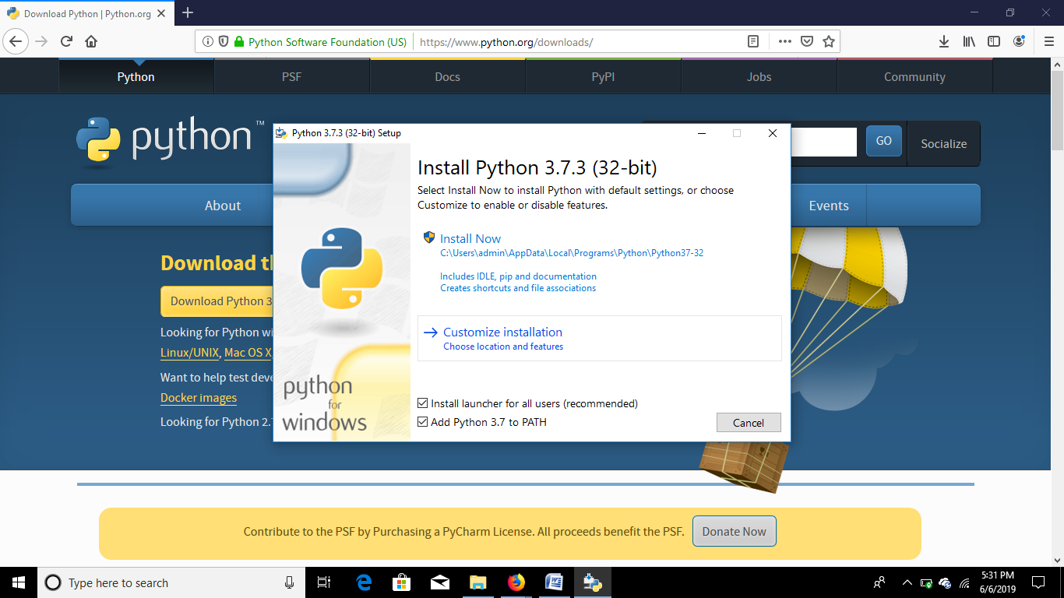

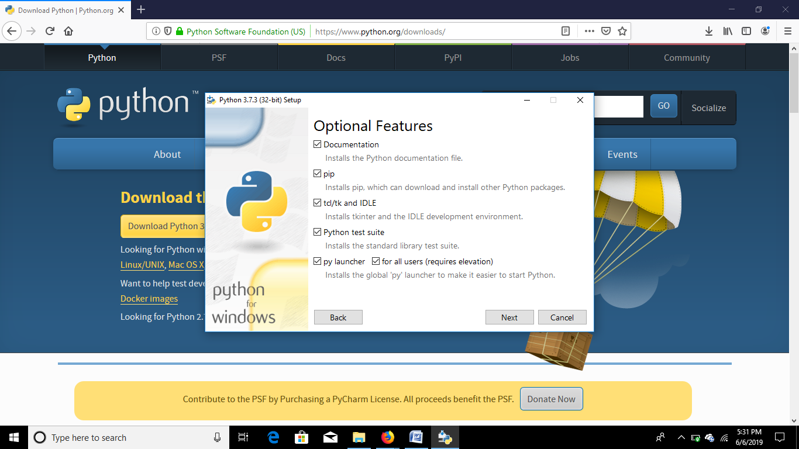

Step5: Set path and install.

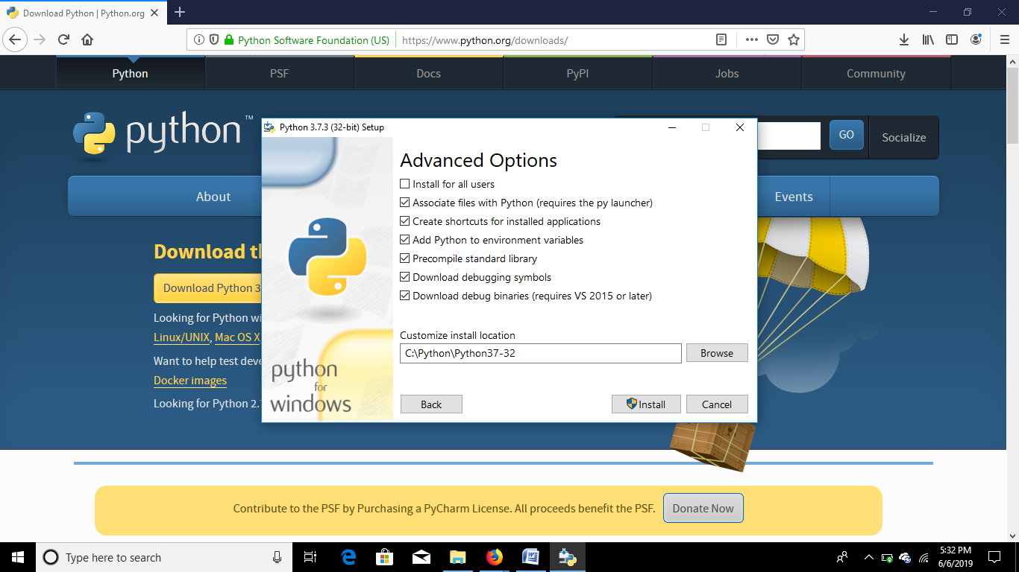

Step6: To check that python has downloaded successfully, open command prompt and write python, if it displays the version with no error, python has downloaded successfully on your computer.

