PROJECT REPORT
LOAN APPROVAL PREDICTION
USING SUPPORT VECTOR MACHINES
A Machine Learning Approach to Fair and Efficient Loan Decisions
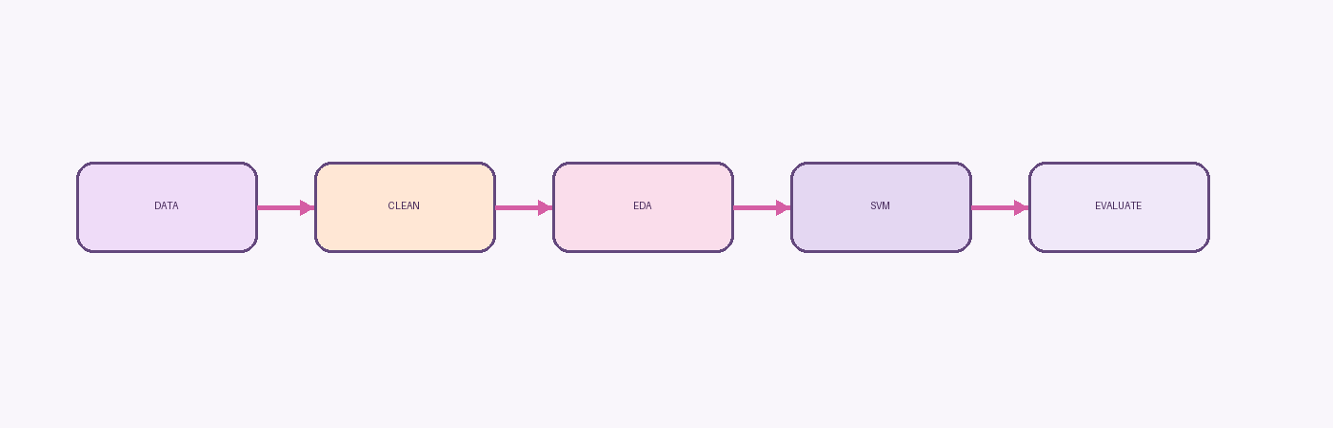
Figure: High-level project workflow
Submitted by: Sharma Ritika Satish
Branch: CSE/IT
Department: Artificial Intelligence

CERTIFICATE
This is to certify that the project report entitled “Loan Approval Prediction Using Support Vector Machines” has been prepared by Sharma Ritika Satish as part of the academic internship / project requirement in the area of Machine Learning and Artificial Intelligence.
The work presented in this report covers the problem formulation, dataset preparation, exploratory analysis, Support Vector Machine model development, evaluation, results, conclusions and future scope of the project.
Place: ____________________
Date: _____________________

ACKNOWLEDGEMENT
I would like to express my sincere gratitude to my project guide, faculty members and department for their guidance and academic support throughout the development of this project.
I am also thankful to the authors and maintainers of the open-source Python libraries used in the implementation, especially NumPy, pandas, Seaborn and scikit-learn. These tools provide the practical foundation required for data preparation, visualization and supervised machine learning.
Finally, I acknowledge the support of family members who encouraged me during the planning, implementation, testing and documentation stages of the project.

ABSTRACT
Loan approval is a binary classification problem in which an applicant is evaluated using demographic, financial and credit-history attributes. This project develops an SVM-based workflow to predict loan approval outcomes and to demonstrate how structured preprocessing, exploratory analysis, supervised learning and evaluation can be combined in an academic machine-learning project.
The project uses a loan dataset containing variables such as Gender, Married, Dependents, Education, Self_Employed, ApplicantIncome, CoapplicantIncome, LoanAmount, Loan_Amount_Term, Credit_History and Property_Area, with Loan_Status as the target. The supplied project specification describes missing-value imputation, categorical encoding, Dependents normalization and feature standardization. The supplied Python implementation instead removes missing rows using dropna(), performs label encoding and categorical conversion, normalizes Dependents, and trains a linear SVM. This implementation detail is documented explicitly so that the report remains faithful to the actual code.
The reported model results are approximately 82% training accuracy and 78% test accuracy. These results provide a useful baseline, while also motivating future work involving hyperparameter tuning, improved feature engineering, comparative classifiers and ensemble methods.

TABLE OF CONTENTS
1. Introduction
2. Literature Review
3. Methodology
4. System Design
5. Implementation
6. Results and Discussion
7. Conclusion
8. Future Scope
9. References
Appendix A. Selected Source Code
Appendix B. Project Checklist

LIST OF TABLES AND FIGURES

Tables
- Table 1. Dataset feature groups
- Table 2. Data preprocessing steps
- Table 3. Model configuration
- Table 4. Evaluation metrics
- Table 5. Reported project results
- Table 6. Future enhancement roadmap

Figures
- Figure 1. High-level project workflow
- Figure 2. System architecture
- Figure 3. Model evaluation concept
- Figure 4. Reported accuracy comparison

1. INTRODUCTION
Loan approval is an important decision-making process in the financial sector. It involves assessing whether an applicant is likely to satisfy the requirements associated with a loan product. Traditional processes may require manual inspection of applicant details, income information, credit history and property information. Such processes are suitable for expert review but can become repetitive as application volume grows.
Machine learning provides a way to learn patterns from historical applications and use those patterns to generate predictions for new applicants. In a classification setting, the model learns a relationship between input variables and a target label. In this project, the target is Loan_Status, represented as approved or not approved.
The choice of Support Vector Machine is consistent with the project's focus on a well-known supervised classification technique. SVMs construct a decision boundary that separates classes while seeking a large margin, and the foundational work by Cortes and Vapnik established the support-vector formulation for classification problems.[1]

1.1 MOTIVATION, PROBLEM STATEMENT AND OBJECTIVES
Motivation
The motivation for this project is to demonstrate how a machine-learning workflow can support loan screening in a structured and reproducible manner. A model does not remove the need for human governance, but it can provide a consistent first-pass prediction and reduce repetitive manual work.
Problem Statement
Financial institutions face practical challenges when large numbers of loan applications must be reviewed. Manual assessment can be time-consuming, and decision quality may vary when similar cases are treated differently. The project therefore aims to build a classifier that predicts whether an application belongs to the approved or not-approved class.
Objectives
- Collect and inspect a loan dataset in CSV format.
- Prepare the data for machine-learning use by handling missing values and encoding categorical variables.
- Explore relationships between selected applicant characteristics and loan status.
- Train a Support Vector Machine classifier using a stratified 90/10 train-test split.
- Evaluate performance using accuracy and discuss precision, recall and F1-score.
- Document the complete workflow and identify realistic improvements for future versions.

1.2 SCOPE, ASSUMPTIONS AND LIMITATIONS
Scope
- The project focuses on binary loan approval prediction using the provided dataset and an SVM classifier.
- The report documents both the intended project workflow and the supplied Python implementation.
- The project is an academic prototype and should not be treated as a production lending system.
Assumptions
- Historical application data is representative enough to demonstrate supervised classification.
- The target label Loan_Status is a suitable representation of the approval outcome for the project.
- The selected features contain useful predictive information.
Limitations
- The reported implementation uses dropna(), which may reduce the available training set.
- The supplied code does not include the StandardScaler step described in the project specification.
- Only a linear SVM is used as the main implemented classifier.
- The reported evaluation is primarily accuracy-based; a full classification report is shown in the project specification but not included in the supplied implementation.

2. LITERATURE REVIEW
Machine learning for loan approval has attracted interest because loan decisions can be treated as supervised classification tasks. Recent literature continues to compare logistic regression, decision trees, random forests, SVM and ensemble approaches on loan-approval datasets. A 2025 comparative assessment examined multiple baseline and ensemble models and reported that ensemble approaches can outperform individual classifiers in some settings.[4]
A 2025 study on predictive modeling for bank loan approval framed automation as a way to improve efficiency, consistency and measurable performance, while comparing multiple classification techniques including SVM.[5]
The broader literature therefore supports a workflow in which data preparation, exploratory analysis, model training and multi-metric evaluation are treated as connected stages rather than isolated steps.

2.1 SUPPORT VECTOR MACHINES IN THE LITERATURE
Support Vector Machines are among the standard supervised learning methods used for binary classification. Cortes and Vapnik introduced support-vector networks for two-group classification and emphasized the construction of a decision surface with strong generalization properties.[1] The basic idea is to identify a separating hyperplane while maximizing the margin between classes.
For data that are not linearly separable, SVMs can use kernels to represent nonlinear relationships. The project uses a linear kernel as the main classifier and notes RBF as a comparison option. This is a sensible academic setup because it keeps the primary model interpretable at the decision-boundary level while acknowledging a common nonlinear alternative.
The practical implementation is performed with scikit-learn, a Python machine-learning library that provides a consistent API for supervised and unsupervised learning algorithms.[2]

2.2 RECENT RESEARCH ON LOAN APPROVAL PREDICTION
Recent studies show that loan approval prediction is commonly addressed through comparative machine-learning experiments. A 2025 comparative paper evaluated ensemble methods alongside baseline classifiers including SVM, logistic regression, decision tree, naive Bayes and neural networks, using several evaluation measures.[4]
Another 2025 study focused on predictive modeling for bank loan approval and compared multiple classification techniques, emphasizing accuracy, precision, recall and F1-score as useful measures for decision-model evaluation.[5]
A 2026 research article on explainable ensemble learning highlights a current direction in the field: moving beyond pure predictive accuracy toward models that can be interpreted and justified in decision-support settings.[6]
These studies indicate that a simple SVM is useful as a baseline, but strong production-oriented systems may require comparative evaluation, explainability, fairness analysis, calibration and more advanced feature-selection or ensemble strategies.

2.3 RESEARCH GAP AND PROJECT SIGNIFICANCE
The academic gap addressed by this project is primarily methodological rather than scientific novelty. The project demonstrates a complete end-to-end workflow using a manageable classifier and an interpretable sequence of steps. It is therefore useful as a foundation for a larger experiment.
The main opportunities for improvement are clear: implement the intended scaling step, compare linear and RBF kernels experimentally, evaluate additional classifiers, inspect class-level precision and recall, and investigate whether feature engineering or imbalance handling changes performance.
This project is significant as a learning exercise because it connects data cleaning, visualization, classification, evaluation and documentation into one reproducible workflow.

3. METHODOLOGY
The methodology follows a structured machine-learning pipeline. The project description defines the intended stages as data collection, preprocessing, EDA, model building, training, evaluation, results and conclusion.

Figure 1. High-level project workflow
The workflow is designed so that each stage has a clear purpose. Data collection creates the input dataset; preprocessing converts raw fields into model-ready representations; EDA helps understand distributions and relationships; model building defines the classifier; training estimates model parameters; evaluation checks predictive performance; and the conclusion interprets the outcome.
A key methodological consideration is consistency between project specification and executable code. This report preserves both views: the planned workflow includes imputation and StandardScaler, while the supplied implementation uses dropna() and does not show StandardScaler.

3.1 DATASET AND VARIABLE DESCRIPTION
Variable | Role | Representation
Gender | Applicant demographic | Male/Female encoded numerically
Married | Marital status | No/Yes encoded numerically
Dependents | Number of dependents | 3+ normalized to 4
Education | Education status | Graduate/Not Graduate
Self_Employed | Employment category | No/Yes
ApplicantIncome | Primary income | Numerical
CoapplicantIncome | Co-applicant income | Numerical
LoanAmount | Requested loan amount | Numerical
Loan_Amount_Term | Loan term | Numerical
Credit_History | Credit history flag | Numerical
Property_Area | Property location | Rural/Semiurban/Urban
Loan_Status | Target | N = 0, Y = 1 in supplied code

3.2 DATA PREPROCESSING
The project specification identifies three core preprocessing requirements: missing-value handling, categorical encoding and feature standardization. These are particularly important when an SVM is used because the geometry of the feature space influences the learned decision boundary.
However, the supplied Python implementation differs from the specification in an important way. It removes records with missing values by calling dropna() rather than applying mean/mode imputation. It also performs categorical conversion through replace(), including target encoding and the Dependents transformation. No StandardScaler call appears in the supplied code.
Selected preprocessing code from the supplied implementation
# supplied implementation
loan_dataset = loan_dataset.dropna()
loan_dataset.replace(
{"Loan_Status": {'N':0,'Y':1}},
inplace=True
)
loan_dataset = loan_dataset.replace(
to_replace='3+', value=4
)

For the final project version, implementing StandardScaler and documenting the exact imputation policy would improve alignment between the written specification and the executable code.

3.3 EXPLORATORY DATA ANALYSIS
EDA is used to inspect distributions and relationships before fitting the classifier. The supplied code creates count plots for Education versus Loan_Status and Married versus Loan_Status. The project description also identifies Property_Area and Dependents as variables worth analyzing.
EDA commands supplied in the project code
sns.countplot(
x='Education',
hue='Loan_Status',
data=loan_dataset
)
sns.countplot(
x='Married',
hue='Loan_Status',
data=loan_dataset
)

The role of EDA here is descriptive rather than predictive. It helps identify whether the target classes appear differently across selected categories and provides context for interpreting the model's later results.
EDA should not be used to select features solely because of visual differences without considering validation and generalization. A structured workflow separates exploration from final evaluation.

3.4 SUPPORT VECTOR MACHINE THEORY
An SVM searches for a decision boundary that separates classes while maximizing the margin between the boundary and the nearest training points, known as support vectors. The resulting decision function can be viewed as a geometric classifier.
A linear SVM is appropriate when a straight decision boundary offers a useful separation in the transformed feature space. Kernel methods provide an alternative when the relationship is nonlinear. The project identifies RBF as a comparison kernel but implements the linear kernel as the main model.
The project uses scikit-learn's SVC class. Scikit-learn provides a standard interface for machine-learning algorithms, which makes it practical for experimentation and reproducibility.[2]
In an academic report, the model should be evaluated not only on accuracy but also on precision, recall and F1-score. This is especially important when the number of approved and not-approved cases is not perfectly balanced.

3.5 TRAIN-TEST SPLIT AND TRAINING STRATEGY
The supplied implementation uses a 90% training and 10% testing split with stratification and random_state=2.
Train-test split
X_train, X_test, Y_train, Y_test = train_test_split(
X, Y,
test_size=0.1,
stratify=Y,
random_state=2
)

Stratification is intended to preserve the relative representation of the target classes in the training and test subsets. Using a fixed random_state supports reproducibility for the reported split.
The project is a baseline experiment rather than a full hyperparameter optimization study. Future work can use cross-validation and systematic parameter search to provide a more robust estimate of generalization.

4. SYSTEM DESIGN
The system can be organized into five logical layers: data input, preprocessing, exploratory analysis, model training and prediction/evaluation. The design is intentionally simple so that each step can be traced to the project code.
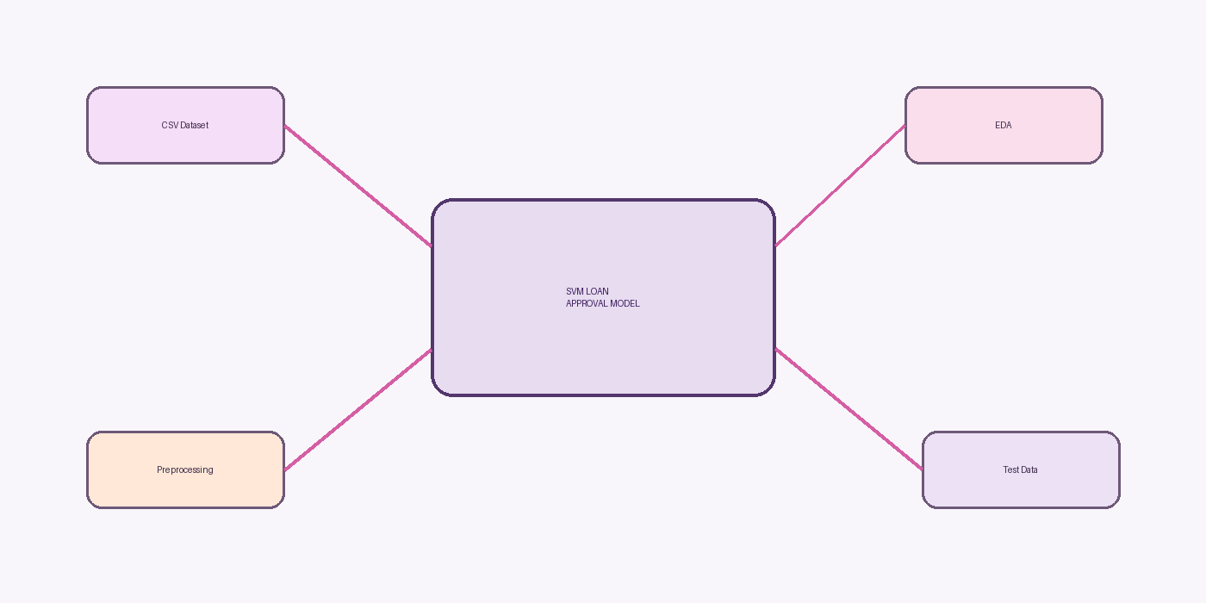
Figure 2. System architecture for the loan approval prediction workflow
The architecture separates data preparation from classification. This separation makes it easier to replace a preprocessing step, change the classifier, or add new evaluation metrics without redesigning the entire workflow.

4.1 SYSTEM FLOW AND COMPONENTS
Component 1 - Data Input
- CSV file is loaded into pandas.
- Initial inspection includes head(), shape, describe() and missing-value counts.
Component 2 - Preprocessing
- Missing values are handled.
- Target and categorical variables are encoded.
- Dependents values of 3+ are normalized to 4.
Component 3 - EDA
- Count plots are generated for selected variables.
Component 4 - Classifier
- SVC(kernel='linear') is instantiated and fitted.
Component 5 - Evaluation
- Training and test predictions are compared with actual labels using accuracy_score.
This modular view provides a practical system-design interpretation of the supplied notebook/code workflow.

5. IMPLEMENTATION

5.1 TOOLS AND TECHNOLOGIES
Tool | Category | Role
Python | Programming language | Data preparation, modeling and evaluation
NumPy | Numerical computing | Array and numerical support
pandas | Data manipulation | CSV loading, inspection and transformation
Seaborn | Visualization | Count plots for EDA
scikit-learn | Machine learning | train_test_split, SVM and accuracy_score
CSV dataset | Data source | Loan application records

The supplied implementation uses Python libraries imported at the top of the script. The scikit-learn ecosystem is particularly relevant because it provides train_test_split, SVC and accuracy_score in a consistent API.[2]

5.2 IMPLEMENTATION CODE
Imports and initial inspection from the supplied implementation
import numpy as np
import pandas as pd
import seaborn as sns
from sklearn.model_selection import train_test_split
from sklearn import svm
from sklearn.metrics import accuracy_score
loan_dataset = pd.read_csv('/content/dataset.csv')
loan_dataset.head()
loan_dataset.shape
loan_dataset.describe()
loan_dataset.isnull().sum()

The implementation begins with the standard imports required for data handling, visualization and SVM classification. The dataset is then loaded from the path used in the supplied notebook environment.

5.3 CATEGORICAL TRANSFORMATION
Categorical encoding from the supplied implementation
loan_dataset.replace({
'Married': {'No':0, 'Yes':1},
'Gender': {'Male':1, 'Female':0},
'Self_Employed': {'No':0, 'Yes':1},
'Property_Area': {'Rural':0, 'Semiurban':1, 'Urban':2},
'Education': {'Graduate':1, 'Not Graduate':0}
}, inplace=True)

The transformations convert the main categorical variables to integer codes. This creates a fully numerical feature matrix for the SVM implementation.
The mapping values are part of the project implementation and should be preserved if the exact model is to be reproduced. If the system is extended to new production data, the encoding strategy should be applied consistently to the incoming records.

5.4 MODEL IMPLEMENTATION
Feature selection and SVM training
X = loan_dataset.drop(
columns=['Loan_ID','Loan_Status'],
axis=1
)
Y = loan_dataset['Loan_Status']
classifier = svm.SVC(kernel='linear')
classifier.fit(X_train, Y_train)

The feature matrix X removes Loan_ID and Loan_Status because Loan_ID is an identifier and Loan_Status is the target. The classifier is an SVC using the linear kernel.
The model is then fitted using X_train and Y_train. At this point the system has learned a decision rule that can be applied to X_test.

5.5 EVALUATION IMPLEMENTATION
Accuracy calculation from the supplied implementation
X_train_prediction = classifier.predict(X_train)
training_data_accuray = accuracy_score(
X_train_prediction, Y_train
)
X_test_prediction = classifier.predict(X_test)
test_data_accuray = accuracy_score(
X_test_prediction, Y_test
)

The code reports training accuracy by predicting the training records again and comparing the predictions with Y_train. It similarly predicts X_test and compares the predictions with Y_test.
A stronger evaluation stage would additionally report precision, recall and F1-score, especially when one class may occur more often than the other.

6. RESULTS AND DISCUSSION

6.1 REPORTED RESULTS
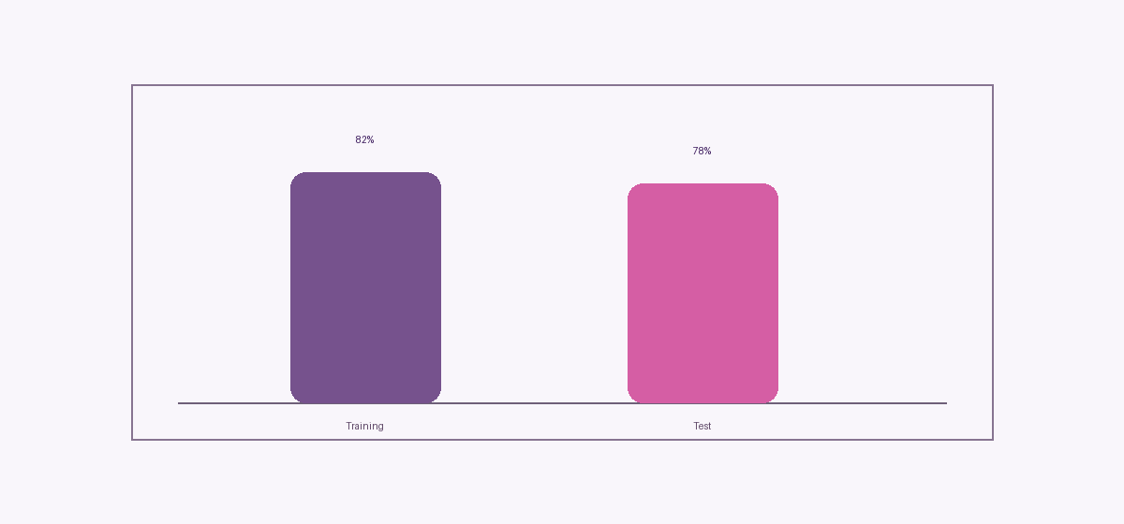
Figure 3. Reported training and test accuracy
The project reports approximately 82% accuracy on the training data and approximately 78% on the test data. The difference between the two values is modest, which suggests that the classifier retains useful performance on the held-out portion of the dataset.
Metric | Reported value | Interpretation
Training Accuracy | ≈ 82% | Correct predictions on training records
Test Accuracy | ≈ 78% | Correct predictions on unseen test records

6.2 DISCUSSION OF RESULTS
The reported accuracy values indicate that the SVM is a useful baseline for the project. However, accuracy alone does not tell us whether the model treats both classes equally well. For example, a model can achieve a reasonable overall accuracy while performing poorly on a smaller class.
The project specification explicitly identifies precision, recall and F1-score as evaluation metrics. Incorporating these metrics would make the results section more complete and would allow a clearer assessment of the approved and not-approved classes.
Another important consideration is preprocessing consistency. The project specification describes mean/mode imputation and StandardScaler, while the supplied code uses dropna() and does not apply StandardScaler. A future experiment should align these two layers and compare performance under a reproducible preprocessing pipeline.
Finally, the current experiment uses a single main classifier. A comparative study across logistic regression, decision tree, random forest, SVM with linear/RBF kernels and an ensemble method would provide stronger evidence for model selection. Recent loan-approval research follows this comparative direction.[4][5]

6.3 APPLICATIONS, LIMITATIONS AND RESPONSIBLE USE
Applications
- Automating first-pass loan screening.
- Reducing repetitive manual workload for financial institutions.
- Supporting consistent evaluation criteria.
Limitations
- The academic dataset and reported results may not generalize to every institution or applicant population.
- The implementation does not demonstrate calibration, fairness auditing or explainability analysis.
- No deployment, API, database or user-interface layer is included in the supplied code.
Responsible Use
- The model should be treated as decision support rather than an unquestioned automatic decision maker.
- Sensitive or protected attributes require careful governance, and model performance should be checked across relevant groups before operational use.
- Human review, policy controls and auditability remain important in high-impact lending decisions.

7. CONCLUSION
This project demonstrates a complete machine-learning workflow for loan approval prediction using a Support Vector Machine. The workflow covers data collection, preprocessing, exploratory analysis, model construction, training, prediction and evaluation.
The SVM model achieves approximately 82% training accuracy and 78% test accuracy in the reported project results. These figures indicate a useful baseline and show that historical applicant information contains predictive signal for the target variable.
The most important learning outcomes are methodological: preprocessing matters, the train-test split must be reproducible, the classifier must be evaluated on unseen data, and accuracy should be supplemented by class-aware metrics. The report also highlights the difference between the written project specification and the supplied implementation, providing a clear path for future refinement.
Overall, the project provides a practical foundation for further work in loan approval prediction and supervised machine learning.

8. FUTURE SCOPE
Step | Future direction | Expected benefit
1 | Align preprocessing | Implement the specified imputation and StandardScaler workflow.
2 | Compare kernels | Evaluate linear versus RBF SVM systematically.
3 | Tune hyperparameters | Use cross-validation for C and kernel-related parameters.
4 | Compare algorithms | Benchmark logistic regression, trees, random forest and ensemble models.
5 | Improve evaluation | Add precision, recall, F1-score, confusion matrix and ROC-AUC.
6 | Feature engineering | Investigate useful transformations and interactions.
7 | Explainability | Use transparent feature analysis or explainability methods.
8 | Deployment | Build a simple web/API layer with input validation and logging.

Recent research suggests that comparative ensembles and explainability are active directions for loan approval modeling, supporting these future extensions.[4][6]

9. REFERENCES
1. Python Standard Library / Python documentation – Python programming and standard functions.
2. pandas documentation – DataFrame, read_csv(), data cleaning and data manipulation.
3. NumPy documentation – Numerical computing and array operations in Python.
4. Seaborn documentation – countplot() and exploratory data visualization.
5. scikit-learn documentation – train_test_split() and machine learning workflow.
6. scikit-learn documentation – Support Vector Machine (SVC) and linear kernel.
7. scikit-learn documentation – accuracy_score() for model evaluation.
8. Project dataset file: dataset.csv.
9. Internship presentation: Loan Approval Prediction Using Support Vector Machines.
10. Project specification / Internship Project Guide: Loan Approval Prediction Using Support Vector Machines.
11. Project source code supplied by Sharma Ritika Satish.

APPENDIX A. SELECTED SOURCE CODE
Appendix A1 - Data loading and preparation
import numpy as np
import pandas as pd
import seaborn as sns
from sklearn.model_selection import train_test_split
from sklearn import svm
from sklearn.metrics import accuracy_score
loan_dataset = pd.read_csv('/content/dataset.csv')
loan_dataset.head()
loan_dataset.shape
loan_dataset.describe()
loan_dataset.isnull().sum()
loan_dataset = loan_dataset.dropna()
loan_dataset.replace(
{"Loan_Status": {'N':0,'Y':1}},
inplace=True
)
loan_dataset = loan_dataset.replace(
to_replace='3+', value=4
)

APPENDIX A. SELECTED SOURCE CODE (CONTINUED)
Appendix A2 - Encoding, split and training
loan_dataset.replace({
'Married': {'No':0,'Yes':1},
'Gender': {'Male':1,'Female':0},
'Self_Employed': {'No':0,'Yes':1},
'Property_Area': {'Rural':0,'Semiurban':1,'Urban':2},
'Education': {'Graduate':1,'Not Graduate':0}
}, inplace=True)
X = loan_dataset.drop(
columns=['Loan_ID','Loan_Status'],
axis=1
)
Y = loan_dataset['Loan_Status']
X_train, X_test, Y_train, Y_test = train_test_split(
X, Y, test_size=0.1, stratify=Y, random_state=2
)
classifier = svm.SVC(kernel='linear')
classifier.fit(X_train,Y_train)

APPENDIX A. SELECTED SOURCE CODE (CONTINUED)
Appendix A3 - Evaluation
X_train_prediction = classifier.predict(X_train)
training_data_accuray = accuracy_score(
X_train_prediction, Y_train
)
print('Accuracy on training data : ', training_data_accuray)
X_test_prediction = classifier.predict(X_test)
test_data_accuray = accuracy_score(
X_test_prediction, Y_test
)
print('Accuracy on test data : ', test_data_accuray)

Implementation note: the spelling of training_data_accuray and test_data_accuray is preserved from the supplied code so that the appendix matches the source implementation exactly.

APPENDIX B. PROJECT CHECKLIST
- Cover Page completed with student and institution details.
- Certificate signed by the project guide / department.
- Acknowledgement included.
- Abstract and keywords included.
- Introduction, motivation, problem statement and objectives included.
- Literature review includes classical SVM foundation and recent loan-approval research.
- Methodology documents both project specification and supplied implementation.
- System design and workflow architecture included.
- Implementation includes selected Python code.
- Results include reported training and test accuracy.
- Conclusion and future scope included.
- References documented.

