Courses

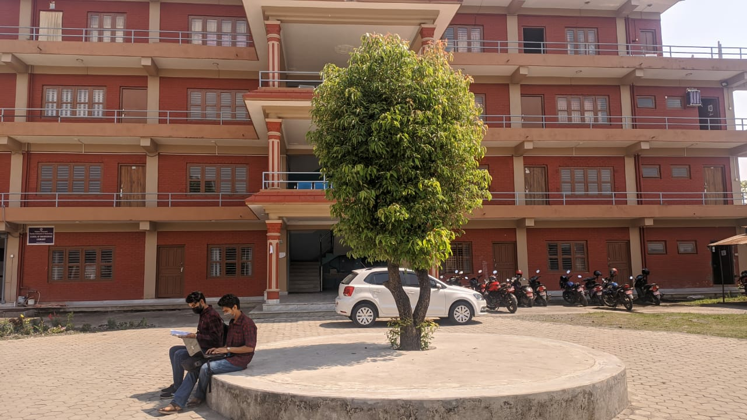

**B.E. Computer’s Course Details**

Semester I

| **#** | **Course Code** | **Course Description** | **Credit Hours** |
| --- | --- | --- | --- |
| **1** | MTH 111 | Engineering Mathematics I | 3 |
| **2** | CHM 103 | Chemistry | 4 |
| **3** | ENG 104 | Communication Technique | 2 |
| **4** | CMP 103 | Programming in C | 3 |
| **5** | ELE 105 | Basic Electrical Engineering | 3 |
| **6** | MEC 178 | Mechanical Workshop | 1 |
|  |  |  |  |

Semester II

| **#** | **Course Code** | **Course Description** | **Credit Hours** |
| --- | --- | --- | --- |
| **1** | MTH 121 | Engineering Mathematics II | 3 |
| **2** | PHY 102 | Physics | 4 |
| **3** | MEC 109 | Engineering Drawing | 1 |
| **4** | CMP 104 | Object Oriented Programming in C++ | 2 |
| **5** | MEC 189 | Thermal Science | 2 |
| **6** | MEC 119 | Applied Mechanics | 3 |
|  |  |  |  |

Semester III

| **#** | **Course Code** | **Course Description** | **Credit Hours** |
| --- | --- | --- | --- |
| **1** | MTH 211 | Engineering Mathematics III | 3 |
| **2** | CMP 331 | Data Structure and Algorithm | 3 |
| **3** | ELE 226 | Electrical Engineering Materials | 2 |
| **4** | ELE 215 | Network Theory | 3 |
| **5** | ELX 213 | Electronic Devices | 3 |
| **6** | ELX 212 | Logic Circuits | 3 |

Semester IV

| **#** | **Course Code** | **Course Description** | **Credit Hours** |
| --- | --- | --- | --- |
| **1** | MTH 223 | Engineering Mathematics IV | 3 |
| **2** | ELE 221 | Instrumentation | 3 |
| **3** | ELX 225 | Electronic Circuits | 3 |
| **4** | CMP 224 | Theory of Computation | 3 |
| **5** | ELX 226 | Microprocessors | 3 |
| **6** | Proj | Project-I | 1 |
|  |  |  |  |

Semester V

| **#** | **Course Code** | **Course Description** | **Credit Hours** |
| --- | --- | --- | --- |
| **1** | MTH 317 | Numerical Methods | 3 |
| **2** | ELX 352 | Microprocessor System and Interfacing | 3 |
| **3** | CMP 332 | Operating System | 3 |
| **4** | CMP 364 | Computer Graphics | 3 |
| **5** | ELX 353 | Integrated Digital Electronics | 3 |
|  |  |  |  |

Semester VI

| **#** | **Course Code** | **Course Description** | **Credit Hours** |
| --- | --- | --- | --- |
| **1** | MTH 212 | Probability and Statistics | 3 |
| **2** | CMP 381 | Simulation and Modeling | 3 |
| **3** | CMM 362 | Data Communication | 3 |
| **4** | CMP 383 | Database Management System | 3 |
| **5** | CMP 388 | Object Oriented Software Engineering | 3 |
| **6** | PRJ 300 | MInor Projects | 2 |
|  |  |  |  |

Semester VII

| **#** | **Course Code** | **Course Description** | **Credit Hours** |
| --- | --- | --- | --- |
| **1** | MNG 410 | Engineering Economics | 3 |
| **2** | CMP 472 | Computer Architecture | 3 |
| **3** | ELX 482 | Digital Signal Processing | 3 |
| **4** | CMP 474 | Computer Network | 3 |
| **5** |  | Elective I | 3 |
|  |  |  |  |

Semester VIII

| **#** | **Course Code** | **Course Description** | **Credit Hours** |
| --- | --- | --- | --- |
| **1** | MNG 411 | Organization and Management | 2 |
| **3** | CMP 421 | Artificial Intelligence | 3 |
| **4** | CMP 481 | Image Processing & Pattern Recognition | 3 |
| **5** | PRJ 400 | Project | 5 |
| **6** |  | Elective II | 3 |
|  |  |  |  |

**B.E. Software Course Details**

Semester I

| **#** | **Course Code** | **Course Description** | **Credit Hours** |
| --- | --- | --- | --- |
| **1** | MTH 112 | Engineering Mathematics I | 3 |
| **2** | PHY 111 | Physics | 4 |
| **3** | ENG 111 | Communication Techniques | 2 |
| **4** | CMP 110 | Fundamentals of IT | 2 |
| **5** | CMP 113 | Programming in C | 3 |
| **6** | CMP 114 | Problem Solving Techniques | 3 |
|  |  |  |  |

Semester II

| **#** | **Course Code** | **Course Description** | **Credit Hours** |
| --- | --- | --- | --- |
| **1** | MTH 114 | Engineering Mathematics II | 3 |
| **2** | ELX 212 | Logic Circuits | 3 |
| **3** | MTH 130 | Mathematicals Foundation of Computer Science | 3 |
| **4** | MEC 120 | Engineering Drawing | 2 |
| **5** | CMP 115 | Object Oriented Programming in C++ | 3 |
| **6** | CMP 213 | Web Technology | 3 |
|  |  |  |  |

Semester III

| **#** | **Course Code** | **Course Description** | **Credit Hours** |
| --- | --- | --- | --- |
| **1** | MTH 212 | Engineering Mathematics III | 3 |
| **2** | CMP 220 | Software Engineering Fundmentals | 3 |
| **3** | CMP 225 | Data Structure and Algorithms | 3 |
| **4** | MTH 221 | Probabaility and Quering Theory | 2 |
| **5** | CMP 212 | Programming in Java | 3 |
| **6** | CMP 214 | Microprocessor and Assembly Language Programming | 3 |
|  |  |  |  |

Semester IV

| **#** | **Course Code** | **Course Description** | **Credit Hours** |
| --- | --- | --- | --- |
| **1** | MTH 230 | Numerical Methods | 3 |
| **2** | CMP 241 | Computer Grphics | 3 |
| **3** | CMP 334 | Computer Organization and Architecture | 3 |
| **4** | CMP 226 | Database Management Systems | 2 |
| **5** | CMP 321 | Object Oriented Design and Modeling through UML | 3 |
| **6** | CMP 290 | Project I | 1 |
|  |  |  |  |

Semester V

| **#** | **Course Code** | **Course Description** | **Credit Hours** |
| --- | --- | --- | --- |
| **1** | CMP 331 | Applied Operating Systems | 3 |
| **2** | CMP 350 | Simulation and Modeling | 3 |
| **3** | CMP 457 | Artificial Intelligence and Neural Networks | 3 |
| **4** | MGT 321 | Organization and Management | 2 |
| **5** | CMP 325 | Analysis and Design of Algorithms | 3 |
| **6** | CMP 311 | System Programming | 3 |
|  |  |  |  |

SemesterVI

| **#** | **Course Code** | **Course Description** | **Credit Hours** |
| --- | --- | --- | --- |
| **1** | CMP 335 | Computer Networks | 3 |
| **2** | CMP 312 | Principles of Programming Languages | 3 |
| **3** | ECO 411 | Engineering Economics | 3 |
| **4** | CMP 322 | Object Oriented Software Development | 3 |
| **5** | CMP 341 | Multimedia Systems | 3 |
| **6** | CMP 390 | Project II | 2 |
|  |  |  |  |

Semester VII

| **#** | **Course Code** | **Course Description** | **Credit Hours** |
| --- | --- | --- | --- |
| **1** | CMP 430 | Real Time Systems | 3 |
| **2** | CMP 435 | Distributed Systems | 3 |
| **3** | CMP 480 | Enterprise Application Development | 2 |
| **4** | CMP 441 | Image Processing and Pattern Recognition | 3 |
| **5** | CMP 421 | Softwre Testing,Verification,Validation and Quality Assurance | 3 |
| **6** | - | Elective I | 3 |
|  |  |  |  |

Semester VIII

| **#** | **Course Code** | **Course Description** | **Credit Hours** |
| --- | --- | --- | --- |
| **1** | CMP 436 | Network Programming | 3 |
| **2** | CMP 420 | Software Project Management | 3 |
| **3** | - | Elective II | 3 |
| **4** | CMP 490 | Project III | 5 |
|  |  |  |  |

**B.E. Electrical Course Details**

Semester I

| **#** | **Course Code** | **Course Description** | **Credit Hours** |
| --- | --- | --- | --- |
| **1** | MTH 112 | Engineering Mathematics I | 3 |
| **2** | PHY 111 | Physics | 4 |
| **3** | MEC 111 | Thermal Science | 2 |
| **4** | MEC 120 | Engineering Drawing | 2 |
| **5** | CMP 113 | Programming in C | 3 |
| **6** | ELE 110 | Basic Electrical Engineering | 3 |
|  |  |  |  |

Semester II

| **#** | **Course Code** | **Course Description** | **Credit Hours** |
| --- | --- | --- | --- |
| **1** | MTH 114 | Engineering Mathematics II | 3 |
| **2** | CHM 111 | Chemistry | 4 |
| **3** | CMP 115 | Object Oriented Programming in C++ | 3 |
| **4** | ENG 111 | Communication technique | 3 |
| **5** | MEC 110 | Mechanical Workshop | 1 |
| **6** | ELE 110 | Applied Mechanics I | 3 |
|  |  |  |  |

Semester III

| **#** | **Course Code** | **Course Description** | **Credit Hours** |
| --- | --- | --- | --- |
| **1** | MTH 212 | Engineering Mathematics III | 3 |
| **2** | ELE 210 | Electrical Engineering Materials | 2 |
| **3** | ELE 211 | Network Theory | 3 |
| **4** | ELX 212 | Logic Circuits | 3 |
| **5** | ELX 210 | Electronics Devices | 3 |
| **6** | ELX 220 | Electromagnetic Field and Wave | 3 |
|  |  |  |  |

Semester IV

| **#** | **Course Code** | **Course Description** | **Credit Hours** |
| --- | --- | --- | --- |
| **1** | MTH 214 | Engineering Mathematics IV | 3 |
| **2** | MTH 230 | Numerical Methods | 3 |
| **3** | ELX 231 | Instrumentation | 3 |
| **4** | ELX 214 | Electronics Circuits | 3 |
| **5** | ELX 230 | Microprocessors | 3 |
| **6** | ELE 220 | Electrical Machines | 3 |
|  |  |  |  |

Semester V

| **#** | **Course Code** | **Course Description** | **Credit Hours** |
| --- | --- | --- | --- |
| **1** | MGT 321 | Organization and Management | 2 |
| **2** | ELE 320 | Advanced Electrical Machines | 3 |
| **3** | CMM 310 | Signals and Systems | 3 |
| **4** | ELE 330 | Transmissions and Distribution | 3 |
| **5** | ELE 322 | Control Systems | 3 |
| **6** | MTH 220 | Probability and Statistics | 3 |
|  |  |  |  |

Semester VI

| **#** | **Course Code** | **Course Description** | **Credit Hours** |
| --- | --- | --- | --- |
| **1** | ELX 310 | Power Electronics | 3 |
| **2** | ELE 333 | Power System Analysis | 3 |
| **3** | CMM 312 | Communication System Engineering | 3 |
| **4** | ELE 331/td> | Power Plant Equipment | 3 |
| **5** | ELE 332 | Switch Gear and Protection | 3 |
| **6** | ELE 360 | Research Methodology/td> | 2 |
|  |  |  |  |

Semester VII

| **#** | **Course Code** | **Course Description** | **Credit Hours** |
| --- | --- | --- | --- |
| **1** | ECO 411 | Engineering Economics | 3 |
| **2** | ELE 430 | Transmission Line Design | 3 |
| **3** | ELE 420 | Machine Design | 3 |
| **4** | ELX 430 | Advanced Instrumentation | 3 |
| **5** |  | Elective I | 3 |
| **6** | ELE 390 | Project I | 1 |
|  |  |  |  |

Semester VIII

| **#** | **Course Code** | **Course Description** | **Credit Hours** |
| --- | --- | --- | --- |
| **1** | ELE 431 | Utilization of Electrical Power | 3 |
| **2** | ELX 460 | Professional Ethics in Engineering | 2 |
| **3** | ELE 433 | Power plant Design | 3 |
| **4** | ELX 432 | High Voltage Engineering | 3 |
| **5** |  | Elective II | 3 |
| **6** | ELE 490 | Project II | 3 |
|  |  |  |  |

**B.E. Civil Course Details**

Semester I

| **#** | **Course Code** | **Course Description** | **Credit Hours** |
| --- | --- | --- | --- |
| **1** | MTH 112 | Engineering Mathematics I | 3 |
| **2** | PHY 111 | Physics | 4 |
| **3** | MEC 111 | Thermal Science | 2 |
| **4** | MEC 120 | Engineering Drawing | 2 |
| **5** | CMP 113 | Programming in C | 3 |
| **6** | ELE 110 | Basic Electrical Engineering | 3 |
|  |  |  |  |

Semester II

| **#** | **Course Code** | **Course Description** | **Credit Hours** |
| --- | --- | --- | --- |
| **1** | MTH 114 | Engineering Mathematics II | 3 |
| **2** | CHM 111 | Chemistry | 4 |
| **3** | CMP 115 | Object Oriented Programming in C++ | 3 |
| **4** | ENG 111 | Communication technique | 3 |
| **5** | MEC 110 | Mechanical Workshop | 1 |
| **6** | ELE 110 | Applied Mechanics I | 3 |
|  |  |  |  |

Semester III

| **#** | **Course Code** | **Course Description** | **Credit Hours** |
| --- | --- | --- | --- |
| **1** | MTH 212 | Engineering Mathematics III | 3 |
| **2** | ELE 210 | Electrical Engineering Materials | 2 |
| **3** | ELE 211 | Network Theory | 3 |
| **4** | ELX 212 | Logic Circuits | 3 |
| **5** | ELX 210 | Electronics Devices | 3 |
| **6** | ELX 220 | Electromagnetic Field and Wave | 3 |
|  |  |  |  |

Semester IV

| **#** | **Course Code** | **Course Description** | **Credit Hours** |
| --- | --- | --- | --- |
|  |  |  |  |
| MTH 214 | Engineering Mathematics IV | 3 |  |
| **2** | MTH 230 | Numerical Methods | 3 |
| **3** | ELX 231 | Instrumentation | 3 |
| **4** | ELX 214 | Electronics Circuits | 3 |
| **5** | ELX 230 | Microprocessors | 3 |
| **6** | ELE 220 | Electrical Machines | 3 |
|  |  |  |  |

Semester V

| **#** | **Course Code** | **Course Description** | **Credit Hours** |
| --- | --- | --- | --- |
| **1** | MGT 321 | Organization and Management | 2 |
| **2** | ELE 320 | Advanced Electrical Machines | 3 |
| **3** | CMM 310 | Signals and Systems | 3 |
| **4** | ELE 330 | Transmissions and Distribution | 3 |
| **5** | ELE 322 | Control Systems | 3 |
| **6** | MTH 220 | Probability and Statistics | 3 |
|  |  |  |  |

Semester VI

| **#** | **Course Code** | **Course Description** | **Credit Hours** |
| --- | --- | --- | --- |
| **1** | ELX 310 | Power Electronics | 3 |
| **2** | ELE 333 | Power System Analysis | 3 |
| **3** | CMM 312 | Communication System Engineering | 3 |
| **4** | ELE 331/td> | Power Plant Equipment | 3 |
| **5** | ELE 332 | Switch Gear and Protection | 3 |
| **6** | ELE 360 | Research Methodology/td> | 2 |
|  |  |  |  |

Semester VII

| **#** | **Course Code** | **Course Description** | **Credit Hours** |
| --- | --- | --- | --- |
| **1** | ECO 411 | Engineering Economics | 3 |
| **2** | ELE 430 | Transmission Line Design | 3 |
| **3** | ELE 420 | Machine Design | 3 |
| **4** | ELX 430 | Advanced Instrumentation | 3 |
| **5** |  | Elective I | 3 |
| **6** | ELE 390 | Project I | 1 |

Semester VIII

| **#** | **Course Code** | **Course Description** | **Credit Hours** |
| --- | --- | --- | --- |
| **1** | ELE 431 | Utilization of Electrical Power | 3 |
| **2** | ELX 460 | Professional Ethics in Engineering | 2 |
| **3** | ELE 433 | Power plant Design | 3 |
| **4** | ELX 432 | High Voltage Engineering | 3 |
| **5** |  | Elective II | 3 |
| **6** | ELE 490 | Project II | 3 |