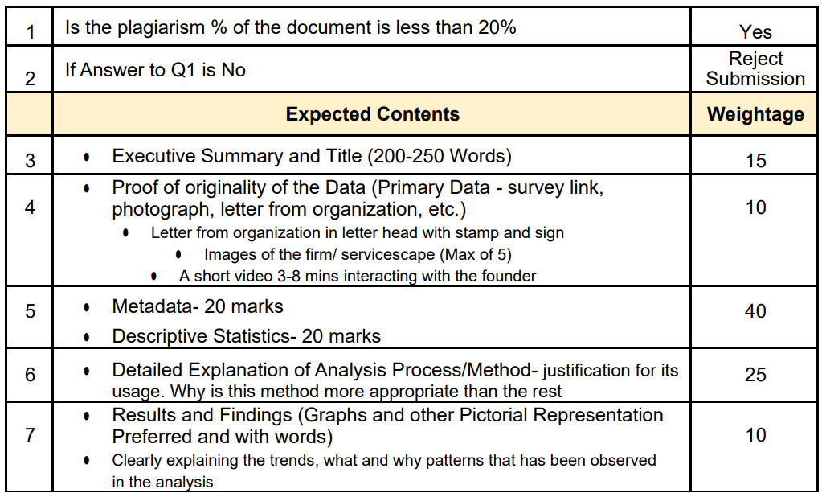

**Link for metadata and descriptive statistics :**

Need to justify and link with the problem statement

1. <https://dataedo.com/kb/data-glossary/what-is-metadata>

2. <https://www.investopedia.com/terms/d/descriptive_statistics.asp>

**Executive summary :**

1 para : organisational details

2 para : about the problem /business problem

3 para : approach and expected outcome

**Please note :**

Once the proposal is accepted, the student must make a midterm submission which also carries 20% weightage. This is an 8-10 page write up and the students must provide a short video interaction clip with the business owner/ manager, tangible evidence like pictures, field notes etc., provide information on the meta data and descriptive statistics (nature of variables collected and how does it help address the business problem), conduct preliminary analysis, provide an interpretation of the results and findings.

**Meta data :**

|  |  |  |
| --- | --- | --- |
| capacity of ware house | 10000 quintal |  |
| chana weight | 90kg | stack weigh |
| soyabean | 90 kg |
| wheat | 90 kg |
| loos in chana | 2kg | weight loose and gain |
| loos in soyabean | 2kg |
| loss in wheat | 2kg |
| labor cost | 3+3 rs bag |  |
| max storage | 240 days |  |
| min storage | 105 days |  |
| min pay | 105 days |  |
| bag count per person chana soyabean | 15-50 bags |  |
| bag count per person wheat | 30-70 bags |  |
| charge of storage soyabean and wheat | 9 rs /bag per month |  |
| charge of storage chana dalar | 11 rs /bag per month |  |
|  |  |  |

**Problem Statement :**

* Warehouse faces a charging dilemma as grains gain weight during storage, requiring an optimized approach to maximize revenue.
* The warehouse confronts the question of whether to employ regular or irregular labor, demanding a decision to optimize workforce efficiency and operational costs.
* The organization confronts the challenge of product selection between chana and soybeans, necessitating a decision that considers market demand, profitability, and operational overheads to maximize revenue and meet consumer needs effectively.

**TA Comments:**

The executive summary should provide an overview of the entire project. It should include a short explanation of how the analysis will be done, what tools will be used etc. The organization's background should include information regarding the annual turnover, number of employees, etc. The problem-solving approach should be written under three subheadings: method, data, and tools with justifications. It should include details about the types of plots you plan to draw and the rationale for the same. The representation of the Gantt chart could have been better. Check the timelines.We would prefer Times New Roman 12, 1.5 spacing and left/ right justification of fonts. A