**Optimizing Revenue Streams: A Holistic Study of Grain Weight Change and Charging Practices**

**A Proposal report for the BDM capstone Project**

Submitted by

Name: Ritik Kumar Badiya

Roll number: 21f3001509



IITM Online BS Degree Program,

Indian Institute of Technology, Madras, Chennai

Tamil Nadu, India, 600036

**Contents**

1 Executive Summary and Title 2

2 Organisation Background 2

3 Problem Statement 2

3.1 Problem statement 1 2

3.2 Problem statement 2 2

3.3 Problem statement 3 2

4 Background of the Problem 3

5 Problem Solving Approach 3

6 Expected Timeline 4

7 Expected Outcome 5

# Executive Summary and Title

This project is on Warehouse, located in village Makdone, specializes in storing and distributing Chana, Soybeans, and Dhana. As a B2C and B2B business, it directly serves the local community's agricultural needs along with some government bonds. Our primary focus will be on B2C business.

The Ganesh Warehouse faces a challenging issue concerning the timing of charging customers. The warehouse experiences a dilemma in deciding when to charge customers as the grains tend to gain weight during storage, which can result in financial losses if charged upfront. Delaying the charging process until the grains are taken off poses the risk of potential payment delays and may impact the warehouse's cash flow.

Through careful analysis of weight changes and seasonal trends, we will identify the most favorable moments for charging. Considering different interest rates on upfront payments, striking a balance between revenue optimization and customer satisfaction.

By leveraging our data-driven approach, We aims to enhance its financial efficiency and make informed decisions with transparency, ensuring success in optimizing revenue streams.

# Organization Background

The Ganesh Warehouse is a well-established B2C organization owned by Mansingh Patidar, catering to the agricultural needs of the Makdone village community for over 25 years. Over the years, it has earned a reputation as a reliable storage and distribution center, specializing in chana, soyabeans, dhaniya, and other essential agricultural items. The warehouse, with its dimensions of 140*40 ft, has been the cornerstone of the village's agricultural ecosystem.

Ganesh Warehouse recently expanded with a new 60*140 ft building, reflecting their commitment to meet the community's demands and modernize operations. Serving local farmers and businesses, it plays a crucial role in minimizing post-harvest losses and contributing to the sustainable development of Makdone village's agricultural sector.

# Problem Statement

## Warehouse faces a charging dilemma as grains gain weight during storage, requiring an optimized approach to maximize revenue.

## The warehouse confronts the question of whether to employ regular or irregular labor, demanding a decision to optimize workforce efficiency and operational costs.

## The organization confronts the challenge of product selection between chana and soybeans, necessitating a decision that considers market demand, profitability, and operational overheads to maximize revenue and meet consumer needs effectively.

# Background of the Problem

The charging dilemma regarding weight gain in the stored grains also creates significant challenges for upfront charges and cash flow management for the warehouse. When customers initially store their grains, they are charged based on the initial weight. However, as the grains gain weight during storage, the warehouse incurs additional costs, which may not be adequately covered by the upfront charges .

This weight gain is caused by factors like moisture absorption and chemical reactions, leading to inaccuracies in charging customers based on initial grain weights. Consequently, the warehouse encounters internal issues such as revenue loss, inventory mismanagement, and customer dissatisfaction.

Externally, market competition becomes a concern as competitors offer more precise charging solutions. Furthermore, regulatory compliance is at risk, potentially resulting in legal consequences. Economically, the dilemma may affect grain pricing and availability, impacting the market.

# Problem Solving Approach

Analyze historical data: Review past data on grain weight gain during storage and corresponding revenue patterns. Identify trends and correlations to understand the impact on revenue. Additionally, consider the interest gained on the upfront amount received for storing the grains until the date when the grains are taken off. This will provide a more comprehensive view of the revenue generation over time. Also Gather historical labor data from the warehouse, including the number of regular and irregular laborers hired per day/week/month.

Seasonal trends analysis: Conduct a detailed analysis of seasonal trends in weight gain during storage. This will help in developing dynamic pricing strategies that account for fluctuations in weight gain, ensuring optimal charges are applied based on the time of storage. Conduct exploratory data analysis to understand the distribution, seasonality, and trends in the labor data.

Dynamic pricing model: Develop a dynamic pricing model that factors in both the grain weight gain and the accrued interest on upfront charges. The model should adjust storage fees based on the current weight of the grains and the duration of storage, including the interest component. This approach will reflect the actual cost of storing the grains over time and maximize revenue accordingly.

Visualize the data using plots like line charts, and histograms to identify any patterns or outliers.

# Expected Timeline

6.1 Work Breakdown Structure

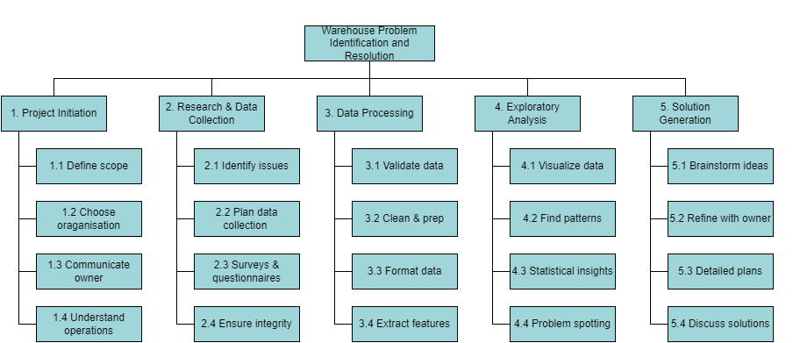

6.2 Gantt Chart

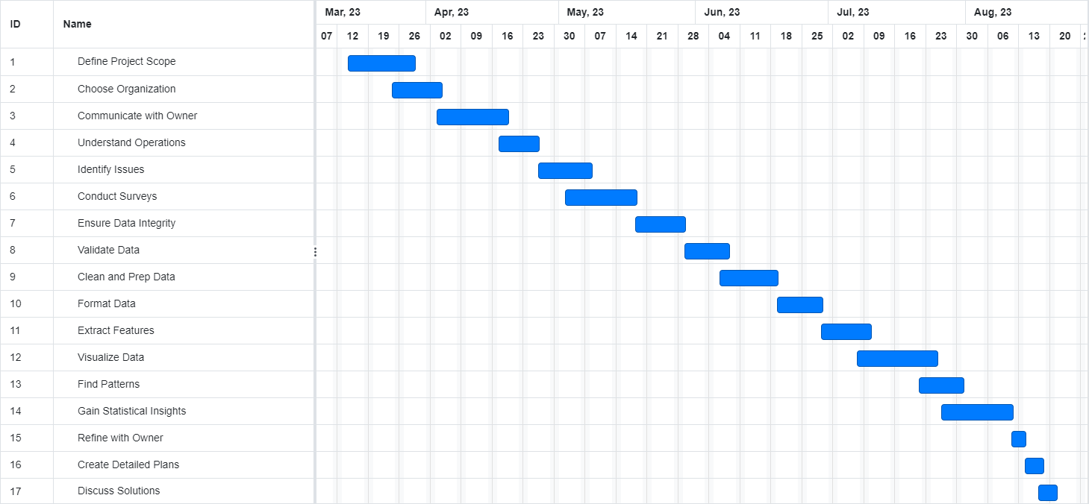

# Expected Outcome

## Develop revenue-maximizing charging and pricing strategies that take into consideration the weight fluctuations of grains during storage. These strategies may encompass dynamic pricing mechanisms, tiered charging structures.

## Establish distinct time periods for employing regular and irregular laborers.

## Obtain a well-informed decision on selecting the optimal inventory from chana and soybean.