**Simulation of 3S1P configuration of Passive Cell Balancing and then Discharging and Charging by Mean SoC Balancing Set Point Strategies**

**Flow Diagram for Mean SoC BSP strategy :**

**Fig 1** represent the flow diagram of cell balancing using Mean SoC BSP strategy.

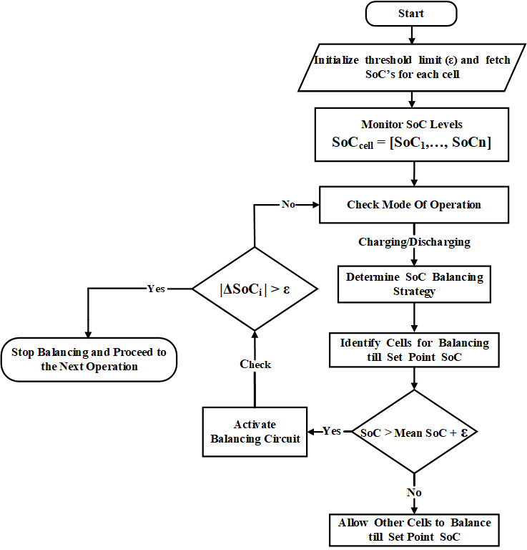

***Fig 1*** *: Flow Diagram for Mean SoC BSP strategy :*