Ritik Ritik

**Address:** 7 Merrybrook Trail, Brampton, Ontario, L7A 0B2

**Phone No: -** +1(437)9911200

**E-mail Id**:​ - ritikchoudhary3115@gmail.com

# Date of Birth –31 March, 2000

**Career Objective** To bring my strong sense of dedication, motivation, and responsibility to an Organization, and to utilize my skills, experience and qualifications for maintaining peace and development in the society.

# CORE COMPTENCIES​

# G2 license

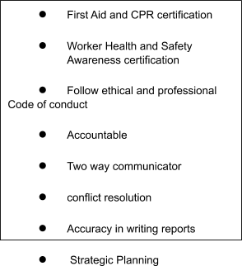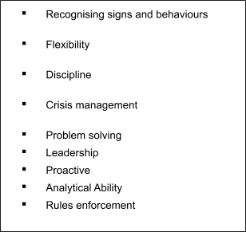

**EDUCATIONAL QUALIFICATIONS**

* **2019** - Web and Design , CDI College ,Montreal
* **2017-2018** - (Class 12th-CBSE) Geeta Niketan Awasiya Vidyalaya, Kurukshetra, India
* ● **2015-2016** - CBSE (Class10th –CBSE) Geeta Niketan Awasiya Vidyalaya , kurukshetra, India​
* **WORK EXPERIENCE**

1. Network Marketing Business

* Lead and train individuals to build and manage their own sales force by recruiting and training.
* Determined customer needs by asking relevant questions and listening actively to the responses.
* Assisted in training for new and current products.
* Sold and promoted products.
* Exceeded monthly sales goals while developing innovative sales strategies.

2.Security Guard at Hospital (July 2018- June 2019)

⦁ Securing premises and personnel by patrolling property; monitoring surveillance equipment; inspecting buildings, equipment, and access points; permitting entry.  
⦁ Prevents losses and damage by reporting irregularities; informing violators of policy and procedures; restraining trespassers.  
⦁ Completes reports by recording observations, information, occurrences, and surveillance activities; interviewing witnesses; obtaining signatures.  
⦁ Maintains organization's stability and reputation by complying with legal requirements.  
⦁ Contributes to team effort by accomplishing related results as needed.  
⦁ Writing reports of daily activities and irregularities, such as equipment or property damage, theft, presence of unauthorized persons, or unusual occurrences.

# CUSTOMER SERVICE SKILLS

* Always believe in excellent and satisfactory Customer Service.
* Helped new employees by explaining them the process.
* Encouraged and motivated each other to continue working by sharing tasks when anyone needed help.
* Carefully listened to the instructions of the supervisor to avoid mistakes.
* Effeciently worked in teams.
* Performed data entry and reports.
* Able to deal huge rush and high pressure while working on the floor.

**ADDITIONAL SKILLS**

* Time management by prioritizing tasks
* Effective communication skills
* Responsibility towards assigned work .
* Skilled in Microsoft Word, Excel and PowerPoint
* Error-free typing speed of 40 words per minute

**I declare that the above information is true to the best of my knowledge .**

# (Ritik Ritik)