A PROJECT REPORT

ON

KIDS CONNECT CHILDCARE CENTER

SUBMITTED IN PARTIAL FULFILLMENT FOR AWARD DEGREE BACHELOR OF

COMPUTER APPLICATIONS

(2020-2023)

BY

Ritik Dhamija & Rehmat kaur

Univ.Roll no-2005931 & 2005930

**UNDER THE GUIDANCE OF**

**Ms.pawandeep kaur**



**MALOUT INSTITUTE OF MANAGEMENT AND INFORMATION**

**TECHNOLOGY, MALOUT**

**INDEX**

CHAPTER NOTITLE PAGE NO.

**ACKNOWLEGEMENT**

**1. INTRODUCTION 5**

1.1 introductions of CCC 6

1.2 Existing system

1.3 proposed system 7

1.4 scope of the system

**2**. **FEASIBILITY STUDY 8**

2.1 Feasibility study 9

2.2 Objective 10

2.3Need of the system 11

2.4 Technical study

2.5 Team architecture

2.6 System requirements 12

**3. SYSTEM DESIGN 13**

3.1 System design Introduction

3.2 System design considerations 14

3.3 Input design introduction 15

3.4 Output design introduction 16

3.5 Getting started 17

**4. ABOUT PROJECT 18**

4.1 Information reports 19

4.2 Childcare Center System 20

4.3 Services 21

4.4 Carriers 22

4.5 Contact us 23

**5. CONCLUSION OF THE SYSTEM 24**

5.1 Future enhancements

5.2 Scope of the system

5.3 Conclusion 25

**REFERENCES: 26**

**ACKNOWLEDGEMENT**

I am extremely grateful to **Ms.pawandeep kaur.** my project guide for her excellent guidance and provide me great support at each level during the development of this project.

I own my gratitude to him who had provided me great support and guidance in collecting all the relevant intial information, as without her support I might not be able to collect that information well in time and in efficient manner.

I am also greatful to my college lectures who have provided total support, care and guidance during our practical session throughtout the academic year.I am greatful to all of them.

I would like to take the pleasure of being greatful to all those personalities who have supported me in my project work and provide me directly or indirectly all the relevant and knowledge tips that were required by me in my assignment. My overall experience with this organization is extremely knowledgeable as each and every personality involved in providing guidance put the best of their efforts to teach students and hence help all of them in the formation of a sound future Success.

**DECLARATION**

**I hereby declare that the project entitled “Kids Connect Childcare project”**

**submitted for the BCA 6**

**th is my original work and the project has not**

**formed the basis for the award of any degree, associateship,**

**fellowship or any other similar titles.**

**Student1 Name: RITIK DHAMIJA**

**Student1 Name: REHMAT KAUR**

**Place: MALOUT INSTITUTE OF MANAGEMENT AND INFORMATION TECHNOLOGY ,MALOUT**

**CERTIFICATE**

**I/we hereby certify that the work which is being presented in the Project report**

**entitled “Childcare Center project” by me/us in partial fulfillment of requirements for the**

**award of degree of BCA submitted in the Department of UGC COURSES at MIMIT**

**Malout under IKG PUNJAB TECHNICAL UNIVERSITY, KAPURTHALA is an**

**authentic record of my/our own work carried out during a period from “1st april**

**,2023” to “30th april ,2023”. The matter presented in this Project-I report has**

**not been submitted by me/us in any other University / Institute for the award of**

**any Degree or Diploma.**

**RITIK DHAMIJA (2005931)**

**REHMAT KAUR(2005930)**

**This is to certify that the above statement made by the candidate/s**

**Is correct to the best of my/our knowledge.**

**MS PAWANDEEP KAUR**

**CHAPTER 1**

**INTRODUCTION**

* 1. **Introduction of the Kids Connect Childcare Center:-**

A Childcare Center System integrated information system for managing all aspects of a childcare center such as speaking, Reading, Speaking, and learning. It includes electronic health records, business intelligence and revenue. Social Media facilities improve the quality of center care services, reduce operating costs and improve the revenue cycle by using such Childcare center system.

1. Childcare center syste typically includes outpatient, healthcare, reading ,Speaking facilities. Our Childcare center system allows user to enter and track kids records, schedule and track center location..

Childcare center System also involves keeping up to date large sets of data including lists of good learning and procedure

The best of this system is that it has reduced the use of paper, keeping all important information in one place to access. Doctors could coordinate with other department with great ease, regarding medical health records. The system has using save time has prescriptions. Bills and other calculation are successful completion of any project involves contribution and cooperation of many peoples who are responsible for the creation of congenial atmosphere where the entire problem are solved. I it gives us tremendous atmosphere in prefacing valuable assistant extended to us by various personalities of in the complete=ion of the project.

**“A Work without the blessing and guidance of elders is always half done and unsatisfactory. The task of prominent person is the subject line.”**

**Functionalities provided project on Childcare center system are as follows:-**

1. *The* *Childcare Center* *System software functions include:-*

1 . Childcare center system will make it easier for Center to get accessed to his Staffs..

2. Reduce the cost of paper usage (books) and embrace digital way.

3. Reduce the clashing time by drivers since booking is online.

4. Management of the Center will be easy.

5. Allow the administrator to update all the information concerning the system.

**.**Kids will be required to sign up fast than for into the system.

**1.2Existing system:-**

A Childcare practice management system lets physicians and their staff quickly enter and access not only basic kids information — for example, the kids's name, address, telephone number, D.O.B and STATE — but also extensive center data, such as Kids history, medications and reasons.

A Childcare practice **management system** is used to manage the Kids, the appointments, the Teacher ' schedules, prescriptions, manage the inventory

**Advantages of having this type of system are:-**

* Easy Access to Patient Data. ...
* Cost Effective. ...
* Improved Efficiency. ...
* Reduces Scope of Error. ...
* Increased Data Security & Retrieve-ability. ...
* Improved Kids Care

**1.3 Proposed System:-**

Childcare center system software or practice management software **provides a suite of functionalities that makes it easy to manage a clinic**.

A Childcare practice management system is used to manage the Kidss, the appointments etc.

**1.4Scope of the system:-**

**This system which manages complete polyclinics details in a single application and in a single database.**

**The users will use this system to A Childcare practice managment system is used to manage the patients, the appointments, the Kids' schedules, prescriptions, manage the inventory, etc.**

**CHAPTER 2**

**FEASIBILITY STUDY**

**2.1Feasibiity study:-**

Abstract of Childcare center System The client uses MS Excel, and maintains their records, however it is not possible them to share the data from multiple system in multi user environment, there is lot of duplicate work, and chance of mistake. When the records are changed they need to update each and every excel file. There is no option to find and print previous saved records. There is no security; any body can access any report and sensitive data, also no reports to summary report. This Childcare center system is used to overcome the entire problem which they are facing currently, and making complete atomization of manual system to computerized system.

**The main limitation of the previous Childcare Center System:**

• The existing system only provides text-based interface, which is not as user-friendly as Graphical user Interface.

Since the system is implemented in Manual, so the response is very slow.

• The transactions are executed in off-line mode, hence on-line data capture and modification is not possible.

• Off-line reports cannot be generated due to batch mode execution. Hence, there is a need of reformation of the system with more advantages and flexibility.

The **Childcare Center System** eliminates most of the limitations of the existing software. It has the following objectives:

**➢ Enhancement:** The main objective of **Childcare Center System**  is to enhance and upgrade the existing system by increasing its efficiency and effectiveness. The software improves the working methods by replacing the existing manual system with the computer based system.

**➢ Automation:** The Childcare Center System automates each and every activity of the manual system and increases its throughput. Thus the response time of the system is very less time and effort.

**➢ Accuracy:** The Childcare Center System provides the uses a quick response with very accurate information regarding the users etc. Any details or system in an accurate manner, as and when required.

**➢ User-Friendly:** The software Childcare Center System has a very user-friendly interface. Thus the users will feel very easy to work on it. The software provides accuracy along with a pleasant interface. Make the present manual system more interactive, speedy and user friendly.

**➢ Availability:** The transaction reports of the system can be retried as and when required. Thus, there is no delay in the availability of any information, whatever needed, can be captured very quickly and easily

**2.2 OBJECTIVE:-**

When developing the system, some objective has been outlined. First, to fulfill the requirement for the final year MAJOR PROJECT (2020-2023).From the technical view, the system will help to make it easier to maintain the record of Kids , Teacher and Facilities . It will help to reduce the number of lost record for the Kids. At the same time, it will improve the data retrieval. It will be easier for the staff of the clinic to retrieve back the record of existing Kids and Teacher may view the Kids history. For the Teacher, it will record all the profile of doctor if the center has more than one Teacher. Furthermore, the inventory modules for the Facilites will help in check the balance Facilities and the information of system.

The Facilities such as manufacture and price. The system will display if the Facilities is running out of stock. The most important thing is the management can view the book appointment for the Center. At the same time, the system may generate report for the operation of the center. For example, report about the number of kids per day and total income for the center per day.

In this we observed. “Besides good environment and ventilation, It is also an essential requirement for the kids..

**2.3 NEED OF THE SYSTEM:-**

• Helps in advance planning.

• Reduces Administrative works.

• Saves time & improves employee.

• Reduces wastage of food items.

• Provides a fast and efficient service.

• Increase customer satisfaction

The Center is an important facility for patients because it provides high-quality operations and services. Center also serves as informal gathering information for kids to unwind with a relaxing conversation. It is the most popular location on India, not only for physical operatons but also for Kids bonding and discussions.

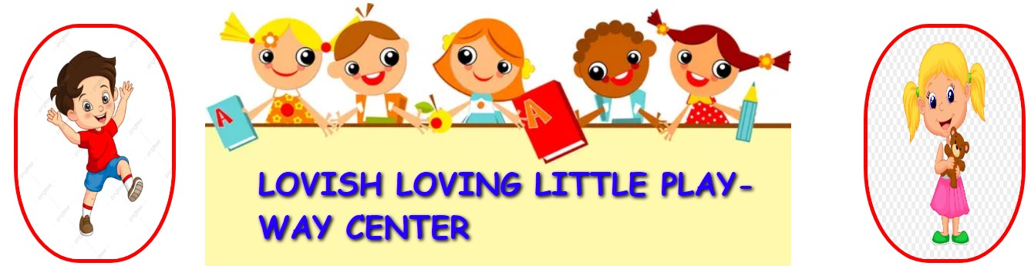

**2.3 Functioning of Center:-**

• A team of Kids monitor the hygienic conditions of the center.

• The Center collects feedback regarding center facilities and quality of services every working through timing hours.

**2.4 TECHNICAL STUDY:-**

Center is a very important facility for the kids through which a better standard of services and about can be obtained, when compare to the make shift patients that spring up around center. Moreover, through this center wholesome services and Activities can be provided to the patients at reasonable prices so as to make available to them a balanced sand hygienic system. This is likely to improve their health and efficiency. Center also serve as places where kids can meet informally and refresh themselves by a relaxing conversation. The center is also an instruments of social change, as the Kids belonging to different castes will have to sit at the same tables and take their services. Thus, a center can help in improving the morale of the kids. Further, the availability of the services stuffs within the center area reduces the botheration and saves time of the kids, otherwise they will have to go out of the center.

**OBJECTIVES OF THE STUDY:**

* **Research Objective:**

The research objectives were discovered through the conversation that center  
are most important part in childcare life. Finding thus, based on the additional  
conversation, the research questions were converted into the following primary  
objectives then primary objectives were achieved, a **clearer** picture was established about the how center facilities affect on kids.

* **Primary Objective:**
* To study the student satisfaction level about the center facilities.
* **Secondary Objective:**
* To understand the center facilities for the suggestion.

**2.5 TEAM ARCHITECTURE:-**

There were two members in our project. The complete project is divided into two teams.  
1: REQUIREMENT GATHERING & PLANNING: Planning identifies all deliverable , describes the facilities, and defines the working and planning problem starts with a specification of user demand system.  
 For this context, the facilities provided to the user faculties are the  
concentrated. This includes the easiest and efficient way to make them available   
lab. Consequently, all the fields must be kept while developing. Generally, a   
 planning exists because there are limited production resources that   
Choices must be made as to which resources to include and how to model their  
behavior, and their costs. Also, there may be uncertainty associated with   
such as uncertain yields or lead times. One might only include the most critical or   
in the planning problem. Here comes the role of proper requirement gathering. If  
requirement of the user are clear then it is quite easier for the developer to   
into all the required resources, and with proper planning and cost estimation, he   
software. Thus a proper planning and requirement gathering leads to efficient software system.

2: DESIGNING AND BACKEND: Designing is the most important and the most   
function while software development. Without a proper design, it is very difficult appropriate software that fulfills nearly all user demands. Therefore, managing   
an organization is a critical activity. A designer needs to ensure that   
be easily understood by the all the members of developing a team. A proper   
coder to implement the system development planning properly. Similarly,   
includes the database management plays a key role in any of the systems. Thus,   
on this field must know proper handling and management of database and its tools

**PROJECT UNDERSTANDING DOCUMENTS PURPOSE OF PROJECT:-**

Childcare Automation System is the system where kids book their admisssions   
the center without any delay as they can directly go and collect what they ordered   
for a turn or waiting time. This system aims to accelerate kids’ appointments and center system used by doters to accept center appointments. The purpose of the system   
simple Center automation Software and implement it, which later will be used for a web-based application. The proposed “Childcare Automation System” is economically feasible because Browsers: Chrome or any other latest web page supporting browser  
Operating System: Window XP and above.

**REQUIREMENTS SPECIFIC REQUIREMENTS**:

EXTERNAL INTERFACE REQUIREMENTS The external system is to assume full  
responsibility for storage functions as well as warehouse management and warehouse control for an entire warehouse. The interfaces in this section are specified by documenting: the name and description of each scheme, source or input, destination or output, ranges, accuracy and tolerances, units of measure, timing, display formats, and organization, and data formats. The user interface required to be developed for the system should be user-friendly and attractive. The interface between the user and the system will be WIMP (Windows, Icons, Menu, Pointers) keeping in mind that the system is to be run through a web browser. All operations will be off point and click nature with all navigations performed through windows of the system specifically buttons and menus: Buttons: The button is activated when the user will click on the left click of the mouse within the bounds of the button. And thus the action associated with it will be carried out. Menu: All the operations will be arranged

**SOFTWARE REQUIREMENTS:-**

Menu Management System The menu management system will be available only clinic patients and will, as the name suggests, allow them to manage the menu that displayed to users of the web ordering system. The functions afforded by the menu management system provide the user with the ability to, using a graphical interface:

The different menus are provided by the system.-

* HOME
* ABOUT US
* CARRIERS
* OUR SERVICES
* CONTACT US

**CHAPTER 3**

**SYSTEM DESIGN**

**3.1 SYSTEM DESIGN (INTRODUCTION):-**

The systems objectives outlined during the feasibility study serve as the basic from which the work of system design is initiated. Much of the activities involved at this stage is of technical nature requiring a certain degree of experience in designing systems, sound knowledge of computer related technology and through understanding of computers available in the market and the various

Facilities provided by the vendors. Nevertheless, a system cannot be designed in isolation without the active involvement of the user. The user has a vital role to play at this stage too. As we know that data collected during feasibility study wills we utilized systematically during the system design. It should, however be kept in mind that detailed study of the existing system is not necessarily over with the completion of the feasibility study

Depending on the plan of feasibility study, the level of detailed study will vary and the system  
design stage will also vary in the amount of investigation that still needs to be done. This  
investigation is generally an urgent activity during the system. Sometimes, but rarely, this  
investigation may form a separate stage between feasibility study and computer system design.  
Designing a new system is a creative process, which calls for logical as well as lateral thinking.  
The logical approach involves systematic moves towards the end product keeping in mind the  
capabilities of the personnel and the equipment at each decision making step. Lateral thought  
implies encompassing of ideas beyond the usual functions and equipment. This is to ensure that  
no efforts are being made to fit previous solutions into new situations.

**3.2 System Design Considerations:-**

The system design process is not a step-by-step adherence of clear procedures and guidelines.  
Though, certain clear procedures and guidelines have emerged in recent days, But still much of  
design work depends on knowledge and experience of the designer. When designer starts working on system design, he will face different type of problems. Many of these will be due to constraints imposed by the user or limitations of the hardware and software available in the market. Sometimes, it is difficult to enumerate the complexity of the problems and solutions thereof since the variety of likely problems is so great and no solutions are exactly similar. However, following considerations should be kept in mind during the system designing phase:

**3.3Design Objectives:-**The primary objective of the design of course, is to deliver the requirements as specified in the feasibility reports. In general the following design objectives should be kept in mind.

• **Practicality**: The system must be stable and can be operated by people with average.

* **Efficiency**: This involves accuracy, timeliness and comprehensiveness to the system  
  output.  
  • **Cost**: It is desirable to aim for a system with a minimum cost subject to the condition that it must satisfy all the requirements.•
* **Flexibility**: The system should be modifiable depending on the changing needs of the user.  
  Such modifications should not entail extensive reconstructing or recreation of software. It  
  should also be portable to different computer systems.

• **Security**: This is very important aspect of the design and should cover areas of hardware reliability, fall back procedures, physical security of data and provision for detection of fraud and abuse. System design involves first logical design and then physical construction of the system. The logical design describes the structure and characteristics of features, like the outputs, inputs, files, database and procedures. The physical construction, which follows the logical design, produces actual program software, files and a working system.

**DESIGING OF THE SYSTEM:-**

**Design Process:-**The computer system design process is an exercise of specifying how, the system will work. It is an iterative process, which is based on what the system will be do as shown in the feasibility report. Mainly, following five parts have been included in the system design process

**Output Design:-**The starting point of the design process is the proper knowledge of system requirements which will normally be converted in terms of output.  
**Input Design: -** Once the output requirements have been finalized, the next step is to find out what data need to be made available to the system to produce the desired outputs. The basic documents in which these data are available need to be identified. If necessary, these documents may have to be revised or new documents may have to be introduced.

**3.4 INPUT DESIGN:-**

Once the analysis and design of the system has been done, it would be necessary to identify the  
data that are required to be processed to produce the outputs. Input is one of the most expensive  
phases of the operation of a computerized system and creates sometimes a major problem.  
Different type of problem with a system can usually be traced back to faulty input design method  
needless to say, therefore, that the input data are the lifeblood of a system and have to be analyze and designed with utmost care and consideration. Input design features can ensure the of the system and generate correct reports from the accurate data. The input design also determines  
whether the user can interact efficiently with the system.

Elements of Input Data Inaccurate input data are the most common cause of errors in data processing. Errors entered by data entry operators can be controlled by input design. Input data are collected and organized into groups of similar data. Once identified, appropriate input media are selected for processing. Input Data The goal of designing input data is to make data entry as easy, logical and error free from errors as possible. In entering data, operators need to know the following:  
The allocated space for each field.

• Field sequence, which much match that in the source document.  
• The format in which data fields are entered for example, filling out the date field is required  
through the edited format mm/dd/yy.

• When we approach input data design, we design the source document. Let us elaborate on each  
step. Source Documents Source data are captured initially on original paper or a source document. For example, a cheque written against an account is a source document. When it reaches the bank, it is encoded with special magnetic ink character recognition so that a reader that is part of the information system of the bank can process it. Therefore, source documents initiate a processing cycle as soon as they are entered into the system. Source documents may be entered into the system from punch cards, from diskettes, or even directly through the keyboard .A source document should be logical and easy to understand. Each area in the form should be  
clearly identified and should specify for the user what to write and where to write it. A source  
document may or may not be retained in the proposed system. Its continued use in the proposed system, the extent of modification for the proposed system & Replacement.  
 **Input Design Guidelines: -** The design of input play very significant role in getting the correct output. It covers all phases of input from creation of initial data (original recording) to actual entering the data to the system for processing. The input design is the link that ties the information system into the world of its users.

Objectives of input design. They focus on:

• Controlling amount of input

• Avoiding delay

• Avoiding errors in data

• Avoiding extra steps

• Keeping the process simple

**3.5 OUTPUT DESIGN (Introduction):**

Presenting the data processed by a computer-based information system in an attractive and usable form good presentation. has become very essential these days’ success and acceptance of a system to some extent depends o Therefore, system analyst must know fully how to design output report in an attractive way. Many new output devices are being introduced in the market because of recent development in computer technology. System analyst must be aware of these new technologies and try to use these new output devices if possible. Currently, excellent graphic displays are widely available. Speech output systems are also fast emerging. There are three main reasons why outputs from the computer are required. They are: For communication to the persons concerned. • For re-input to the computer for being connected with other data and further processing.  
• For permanent storage.

Types of Output:

Outputs of a system can take different forms. The most common are reports, displays on screen,  
printed forms etc. the outputs also vary in terms of their contents, type of stationery. Frequency  
and timing etc. besides, due consideration also need to be given as to who will use the output and  
for what purpose. All these points must be kept in mind while designing outputs so that the  
objectives of the system are met in the best possible way. Outputs of a data-processing system can be placed into two categories:

• Application Output

• Operating Output

Application Output

These are the outputs desired out of the system to meet its objectives. These are of three types:  
• Output as a basis for decision-making. This type of output is generally required by management  
for decision-making purposes

Operating Output These outputs are mainly generated for use of EDP staff and give various indications as to how the system operates. System logs, error messages, status indicators etc. are the examples of such output. These types of output are not concerned for the users

**3.6 GETTING STARTED:**

• Open the internet explorer on the system then enter //local host/MAJORPROJECT in the address bar of the internet explorer and press go button, then login page of the canteen software will open.

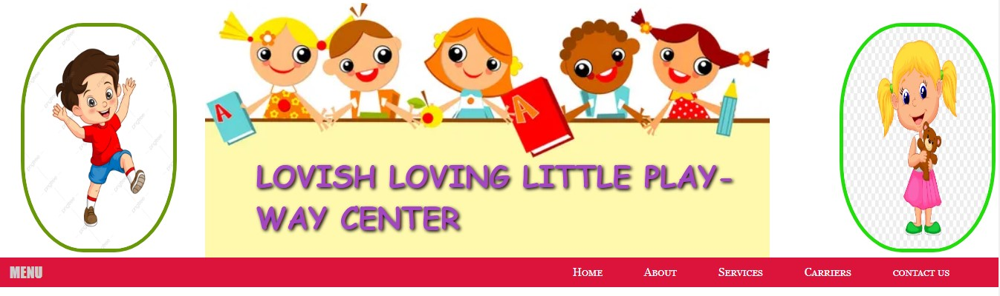**fig:1.2 MENU BAR**

**ADD MENU OPTIONS:-**

* **HOME**
* **ABOUT**
* **SERVICES**
* **CONTACT US**

**4. ABOUT PROJECT:**



Figure 2: Home Page

This is the Homepage of our project. In the Home Page there are tree view of the menu will appear. In this homepage the user can login. Our Childcare Management System store the records of every person availing the service for kids and services.. This solution is designed to cater the needs of all kind of possible users such as pubic center, government childcare. Our solution can be employed to provide efficient center facilities to the kids.

**4.1 Information Reports:**

Through the Information Report you can see the master information like, kids Management  
Information, Master Information, system Management Information, and contact us Information.

**4.2CHILDCARE CENTER SYSTEM:**



Figure 3: childcare center system

**MANAGEMENT:**

Appointment schedulers are business tools that allow clients to book, reschedule,

And cancel appointments through a web interface

**ADVERTISEMENTS:-**

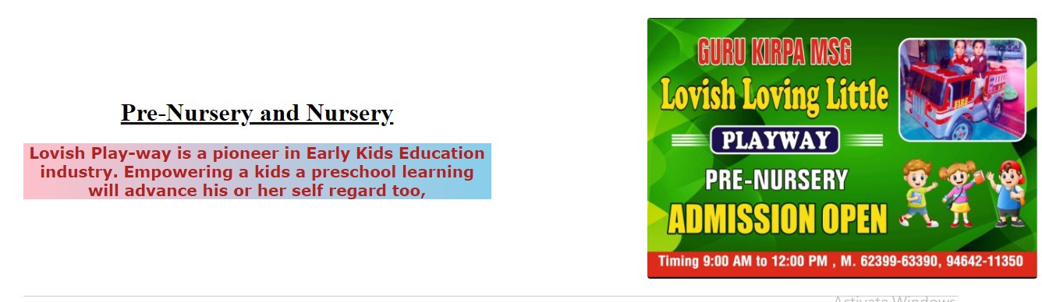

Services: 9:00-12:00 AM LUNCH TIME:11:00-11:30AM

We provide service better:-

LEARNING ACTIVITIES

SOCIAL ACTIVITIES

GAMES

ENJOYING FESTIVAL

**4.3 ABOUT US:-**

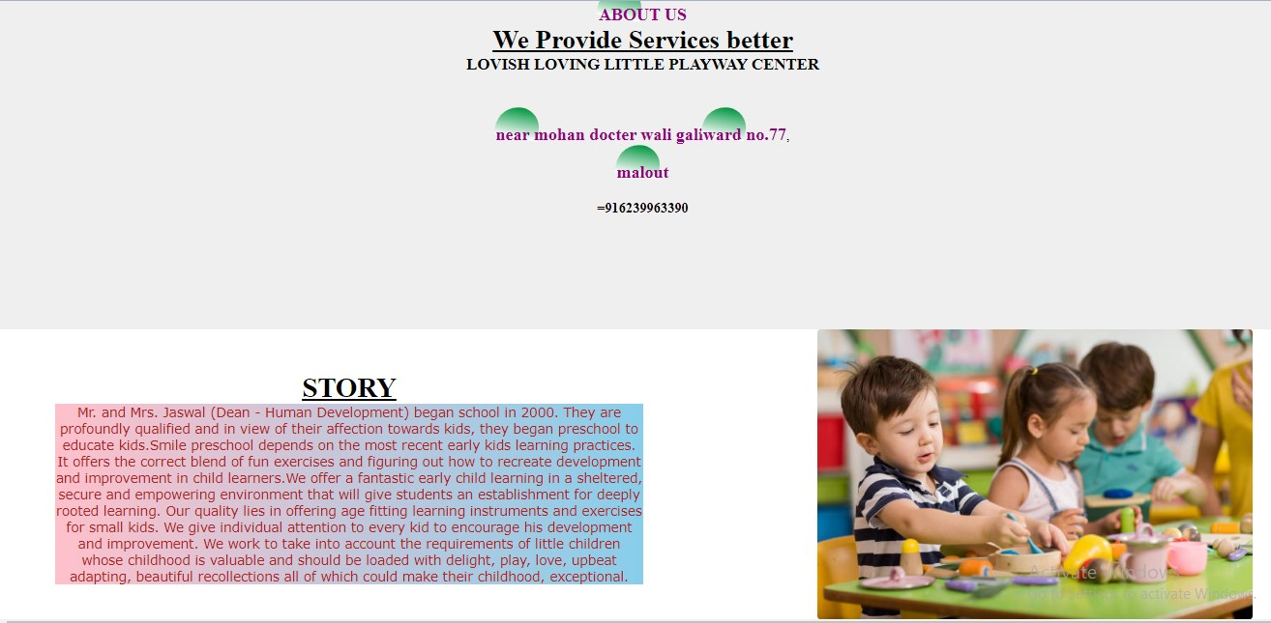

Figure 4: about us

**with delight, play, love, upbeat adapting, beautiful recollections all of which could make their childhood, exceptional.**

**4.4 OUR SERVICES:**

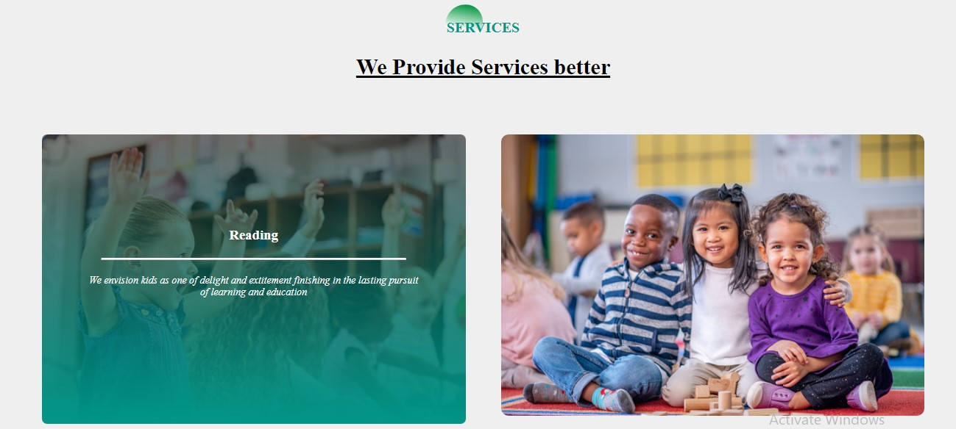

FIGURE 5: OUR SERVICES

* **READING:**

During the readings, the teachers conduct a thorough FACILITES Review by asking questions. The kid should know what the consolation is to be about. In my center reading facilitites about half of the new kids to not even know that they have been referred by their general practitioner

* **SPEAKING:**

Speakings tests are a test used to identify a condition or its cause It is used to speak. A facility able to evaluate a kids condition. The centre used speaking tests to determine a kids conditions.



* **WRITING:**

care is the improvement of handwriting via the creative way. It efforts made to maintain or restore physical mental especially by trained and licensed professionals.

* **LEARNING:**

auditive learning (“by listening and speaking“), • Learning type 2: visual learning (“through the eyes, by watching”), • Learning type 3: haptic learning (“by touching and feeling”), • Learning type 4: learning through the intellect.

**​​​​​​​​​​​​​​​​​​​​​​​​​​​​​​​​​​​​​**

**4.5CONTACT US:**

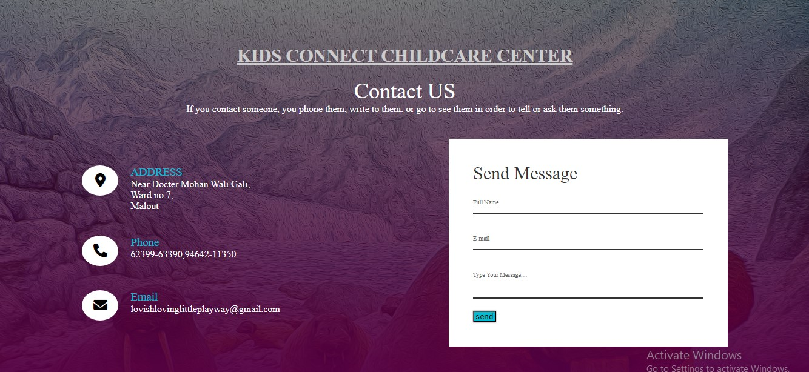

**Figure 6: Contact Us**

**We are CONTACT WITH US:**

Various details for Kids are necessary includes are: FULL NAME ,EMAIL, Type Your Message….

Contact for center:

With the help of center, phone number, email, address

Other contact:

Phone number, email, open: mon-sat :( 9:00am to 9:00pm)

Services: 9:00 -12:00

**CHAPTER 5**

**CONCLUSION OF THE SYSTEM:**

**5.1 Future Enhancement:**

1. In the future we will create more reliable long databases for fetching records. We will also try to provide best services and also online payment methods.  
2. In future we will try to updated student profile and also admin profile. Some more interesting features will be added so that students will find it as more useful.  
The present system depends on the online management. This can be improvised by the automation of the software’s. The data storing will takes time and it requires the manual observation. With the help of the automation it would store the data instantly.  
This will reduce the effort time by the manual observation. The updated data will be finalized and alerts time to time to the admin. The machine learning algorithms can also be used for the prediction of the most preferred item by the customers. The customers will give the feedback and this will be sent to the database. Using the machine learning algorithms these feedbacks will be analyses and preferred food item will be displayed to the regular users on the online system. The menu list can also be updated according to the adman’s choice by the shortcut methods used in the  
learning algorithms. The wave net technology will help in the recognition of the user. It is done by the voice recognition of the user where it does convert them into the small wave nets which on average final wave of the user’s voice will be generated.

**5.2 SCOPE OF CHILDCARE CENTER SYSTEM:**

It may help collecting perfect management in details. In a very short time, the collection will be obvious, simple and sensible. It will help a person to know the management of passed year perfectly and vividly. It also helps in current all works relative to College. It will be also reduced the cost of collecting the management & collection procedure will go on smoothly

**5.3 CONCLUSION:**

The advantage of using a cloud based system is that the scale of a clinic does not make any  
difference. This system can be implemented on small as well as large scale clinic business. We  
can have track of orders and we can give services, operations and we give feedback form after contact in application. The development of CHILDCARE Management System involved many phases. The approach used is a top-down one concentrating on what first  
then how and moving to successive levels of details.• The first phase started with a detailed study of the problems and prospects of Operations in center

**REFFERENCES**



**https//www.academia.edu/13414341/KIDS CONNECT CHILDCRAE CENTER/_PROJECT_DOCUMENTATION**

[**https://e-center.co.uk/**](https://e-center.co.uk/)