**Experiment No.-1**

**Student Name: PUJA KUMARI UID: 20BCA1448**

**Branch: BCA Section/Group: 20BCA5-B**

**Semester: 5th Date of Performance: 27.8.22**

**Subject Name: COMPUTER GRAHICS LAB Subject Code: 20CAP-316**

1. **Aim/Overview of the practical:** Write a program to using Bresenham’s Line drawing algorithm.
2. **Task to be done:** Using the algorithm draw the line.
3. **Concept used:**

**Algorithm Steps if (|m|<1)**

**STEP 1:** Input the two line endpoints and store the left endpoint in (x0, y0).

**STEP 2:** Plot first point (x0, y0).

**STEP 3:** Calculate constants Δx, Δy, 2Δy and 2 Δy- 2Δx, and obtain p0 = 2Δy – Δx.

**STEP 4:** At each xk along the line, starting at k=0, perform the following test: If pk<0, the next point plot is (xk+1, yk) and Pk+1 = pk + 2Δy.

Otherwise, the next point to plot is (xk + 1, yk+1) and Pk+1 = pk + 2Δy - 2Δx.

**STEP 5:** Repeat step 4 Δx times.

**Algorithm Steps when (|m|>1)**

**STEP 1:** Input the two line endpoints and store the left endpoint in (x0, y0).

**STEP 2:** Plot first point (x0, y0).

**STEP 3:** Calculate constants Δx, Δy, 2Δx and 2 Δx- 2Δy, and obtain p0 = 2Δx – Δy.

**STEP 4:** At each xk along the line, starting at k=0, perform the following test: If pk<0, the next point plot is (xk, yk+1) and Pk+1 = pk + 2Δx.

Otherwise, the next point to plot is (xk + 1, yk+1) and Pk+1 = pk + 2Δx - 2Δy.

**STEP 5:** Repeat step 4 Δx times.

**4. Steps/Commands involved to perform practical:**

#include<stdio.h>

#include<graphics.h>

#include<conio.h>

void drawline(int x0, int y0, int x1, int y1)

{ int dx, dy, p, x, y;

dx=x1-x0; dy=y1-y0;

x=x0; y=y0; p=2*dy-dx;

while(x<x1)

{

if(p>=0)

{

putpixel(x,y,7); y=y+1; p=p+2*dy-2*dx;

}

else

{

putpixel(x,y,7); p=p+2*dy;

}

x=x+1;

}

}

int main()

{

int gdriver=DETECT, gmode, error, x0, y0, x1, y1; initgraph(&gdriver, &gmode, "");

printf("\t*********BRESENGHAM'S LINE DRAWING ALGORITHM*********\t\n\n");

printf("Enter co-ordinates of first point: "); scanf("%d%d", &x0, &y0);

printf("Enter co-ordinates of second point: "); scanf("%d%d", &x1, &y1); drawline(x0, y0, x1, y1);

printf("\n\n\t\t\t\t\t\tSubmitted By : PUJA KUMARI (20BCA1448)\t\t\t\t\t\t\n\n");

getch(); return 0;

}

**5. Result/Output/Writing Summary:**

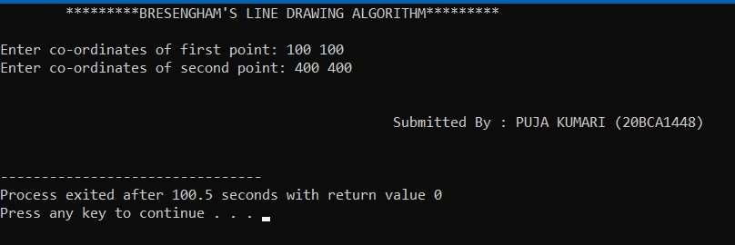

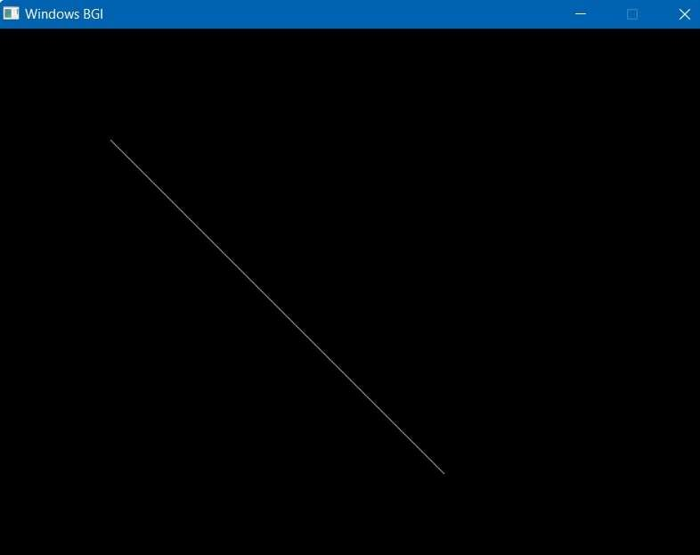

**Learning outcomes (What I have learnt):**

1. I have learnt about how to draw line using Bresenham’s algothrim.

1. I have learnt about the advantages of using this algorithm.
2. This algorithm is used for scan converting a line.

Evaluation Grid:

|  |  |  |  |
| --- | --- | --- | --- |
| Sr. No. | Parameters | Marks Obtained | Maximum Marks |
| 1. | Worksheet |  | 10 |
| 2. | Demonstration/Performance /Pre Lab Quiz |  | 5 |
| 3. | Post Lab Quiz |  | 5 |