**Experiment No.-4**

**Student Name: PUJA KUMARI UID: 20BCA1448**

**Branch: BCA Section/Group: 20BCA5-B**

**Semester: 5th Date of Performance: 11.9.22**

**Subject Name: COMPUTER GRAHICS LAB Subject Code: 20CAP-316**

1. **Aim/Overview of the practical:** Scan Convert a ellipse with center (200, 150) and major axis=60 , minor axis=50  using Midpoint Ellipse Algorithm
2. **Task to be done:** Using the Midpoint Ellipse Algorithm draw the circle.
3. **Concept used:**

Midpoint Ellipse Algorithm:

int x=0, y=b; [starting point]

int fx=0, fy=2a2 b [initial partial derivatives]

int p = b2-a2 b+a2/4

while (fx<="" 1="" {="" set="" pixel="" (x,="" y)="" x++;="" fx="fx" +="" 2b2;

if (p<0)

p = p + fx +b2;

else

{

y--;

fy=fy-2a2

p = p + fx +b2-fy;

}

}

Setpixel (x, y);

p=b2(x+0.5)2+ a2 (y-1)2- a2 b2

while (y>0)

{

y--;

fy=fy-2a2;

if (p>=0)

p=p-fy+a2

else

{

x++;

fx=fx+2b2

p=p+fx-fy+a2;

}

Setpixel (x,y);

}

1. **Steps/Commands involved to perform practical:**

#include<stdio.h>

#include<graphics.h>

#include<conio.h>

int main(){

long x,y,x_center,y_center;

long a_sqr,b_sqr, fx,fy, d,a,b,tmp1,tmp2;

int g_driver=DETECT,g_mode;

initgraph(&g_driver,&g_mode,"");

printf("********* MID POINT ELLIPSE ALGORITHM *********");

printf("\n\n Enter coordinate x and y = ");

scanf("%ld%ld",&x_center,&y_center);

printf("\n Now enter constants a and b = ");

scanf("%ld%ld",&a,&b);

x=0;

y=b;

a_sqr=a*a;

b_sqr=b*b;

fx=2*b_sqr*x;

fy=2*a_sqr*y;

d=b_sqr-(a_sqr*b)+(a_sqr*0.25);

do

{

putpixel(x_center+x,y_center+y,2);

putpixel(x_center-x,y_center-y,2);

putpixel(x_center+x,y_center-y,2);

putpixel(x_center-x,y_center+y,2);

if(d<0)

{

d=d+fx+b_sqr;

}

else

{

y=y-1;

d=d+fx+-fy+b_sqr;

fy=fy-(2*a_sqr);

}

x=x+1;

fx=fx+(2*b_sqr);

delay(10);

}

while(fx<fy);

tmp1=(x+0.5)*(x+0.5);

tmp2=(y-1)*(y-1);

d=b_sqr*tmp1+a_sqr*tmp2-(a_sqr*b_sqr);

do

{

putpixel(x_center+x,y_center+y,2);

putpixel(x_center-x,y_center-y,2);

putpixel(x_center+x,y_center-y,2);

putpixel(x_center-x,y_center+y,2);

if(d>=0)

d=d-fy+a_sqr;

else

{

x=x+1;

d=d+fx-fy+a_sqr;

fx=fx+(2*b_sqr);

}

y=y-1;

fy=fy-(2*a_sqr);

}

while(y>0);

printf("\n\n\t\t\t\t\t\tSubmitted By : PUJA KUMARI (20BCA1448)\t\t\t\t\t\t\n\n");

getch();

return 0;

closegraph();

}

1. **Result/Output/Writing Summary:**

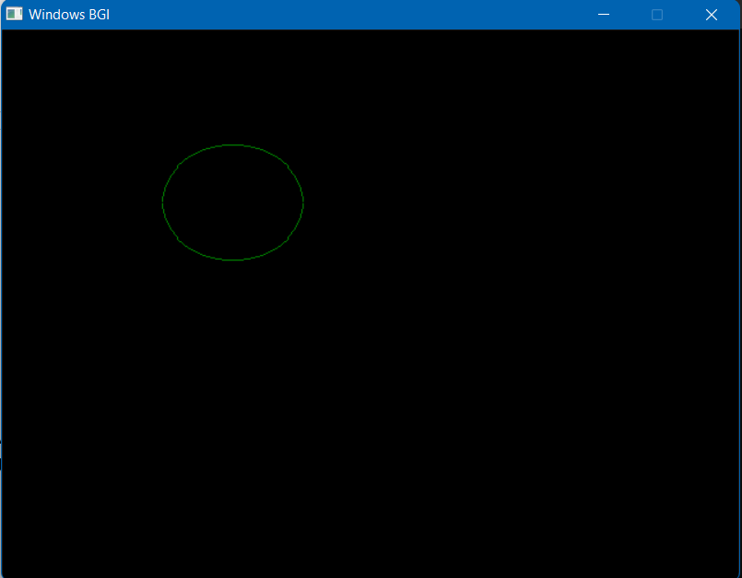

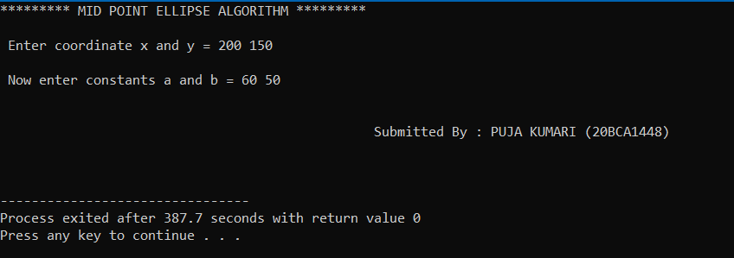

**Learning outcomes (What I have learnt):**

1. I have learnt about how to draw circle using Midpoint Ellipse Algorithm
2. I have learnt about the advantages of using this algorithm.
3. This is an incremental method for scan converting an ellipse that is centered at the origin in standard position i.e., with the major and minor axis parallel to coordinate system axis. It is very similar to the midpoint circle algorithm. Because of the four-way symmetry property we need to consider the entire elliptical curve in the first quadrant.

Evaluation Grid:

|  |  |  |  |
| --- | --- | --- | --- |
| Sr. No. | Parameters | Marks Obtained | Maximum Marks |
| 1. | Worksheet |  | 10 |
| 2. | Demonstration/Performance /Pre Lab Quiz |  | 5 |
| 3. | Post Lab Quiz |  | 5 |