**HSAB principle**

**Hard Soft Acids and Bases (HSAB) Principle** is a qualitative concept introduced by Ralph Pearson to explain the stability of metal complexes.

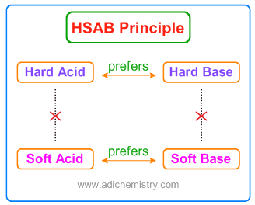

* The large electronegativity differences between hard acids and hard bases give rise to strong ionic interactions.
* The electronegativities of soft acids and soft bases are almost same and hence have less ionic interactions. i.e., the interactions between them are more covalent.
* * The interactions between hard acid - soft base or soft acid - hard base are mostly polar covalent and tend to be more reactive or less stable. The polar covalent compounds readily form either more ionic or more covalent compounds if they are allowed to react.

|  |  |  |
| --- | --- | --- |
| **Type of Acid/Base** | **CHARACTERISTICS** | **EXAMPLES** |
| **Hard acids** | * Atomic centers of small ionic radii (<90 pm). * High positive charge. * Empty orbitals in their valence shells. * Low electronegativity (0.7-1.6) and low electron affinity. * Likely to be strongly solvated. * High energy LUMO. | H+, Li+, Na+, K+, Be2+, Mg2+, Ca2+, Sr2+, Sn2+  Al3+, Ga3+, In3+, Cr3+, Co3+, Fe3+, Ir3+, La3+, Si4+, Ti4+, Zr4+, Th4+,U4+, VO2+ , UO22+  BeMe2, BF3, BCl3, B(OR)3, AlMe3 |
| **Soft acids** | * Large radii (>90 pm). * Low or partial positive charge. * Completely filled orbitals in their valence shells. * Intermediate electronegativities (1.9-2.5) * Low energy LUMOs with a large magnitude of LUMO coefficients. | Cu+, Ag+, Au+, Hg+ , Cs+ , Tl+ , Hg2+ , Pd2+, Cd2+ , Pt2+ AS  Metal atoms in zero oxidation states  BH3 |
| **Borderline acids** |  | Fe2+ , Co2+ , Ni2+ , Cu2+ , Zn2+ , Pb2+ , B(CH3)3, SO2, NO+ |
| **Hard bases** | * Small radii (around 120pm) & highly solvated. * electronegative atomic centres (3.0-4.0). * Weakly polarizable. * Difficult to be oxidized. * High energy HOMO. | H2O, OH-, F-, Cl-, CH3CO2-, PO43-, SO42-, CO32-, NO3-, ClO4-, ROH, RO-, R2O, NH3, RNH2, N2H4 |
| **Soft bases** | * Large atoms (>170 pm) with intermediate electronegativity (2.5-3.0). * High polarizability * Easily undergo oxidation. * Low energy HOMOs but large magnitude HOMO coefficients. | S2-, RSH, RS-, R2S, I-, CN-, SCN-, S2O3-, R3P, R3As, (RO)3P, RNC, CO, C2H4, C6H6, R-, H- |
| **Borderline bases** |  | Aniline, pyridine, N3-, Br-, NO2-, SO32-, N2 |

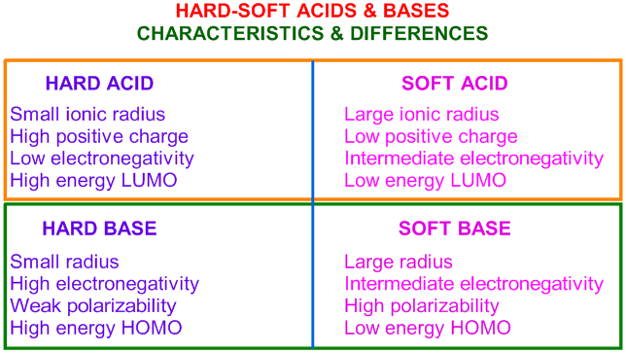

### Application of HSAB to predict the direction of Inorganic reactions:

 HSAB principle is used to predict the outcome of few of the reactions. We can predict whether a reaction proceeds to the right or left based on soft or hard acid/base interactions.

1) The reaction between AsF3 and PI3 is possible and proceeds to the right since As3+ is softer than P3+ and I- is softer than F-.

More softer As prefers softer iodide over fluoride

Remember that both As3+ and P3+ are soft but relatively As3+ is softer due to larger size.

2) The reaction between MgS and BaO as shown below is possible since Mg2+ is harder acid than Ba2+ and O2- is harder base than S2-.

harder acid Mg2+ combines with harder oxide ion

3) P2F4 can be prepared by treating PF2I with mercury as shown below.

2PF2I + 2Hg ------> Hg2I2 + P2F4

In this reaction, it is iodine rather than fluorine that is removed from PF2I.

Explanation: Hg22+ ion is a soft acid that prefers soft base I- rather than hard base F-.

### Solubility in water:

 The compound formed due to soft acid-soft base combination is more covalent and less soluble in polar solvents like water. For example, Silver iodide, AgI is insoluble in water as it has covalent nature since it is the combination of soft acid, Ag+ and soft base, I-.

On the other hand, Lithium iodide, LiI is the result of a combination of Li+ (hard acid) and I- (soft base). Thus it is polar covalent and thus soluble in water.

LUMO: LOWEST UNOCCUPIED MOLECULAR ORBITAL

HOMO: HIGHEST OCCUPIED MOLECULAR ORBITAL

Na Cl- stable

Na I- not stable soft base hsab covalent

**NnaNNN**

* **LUH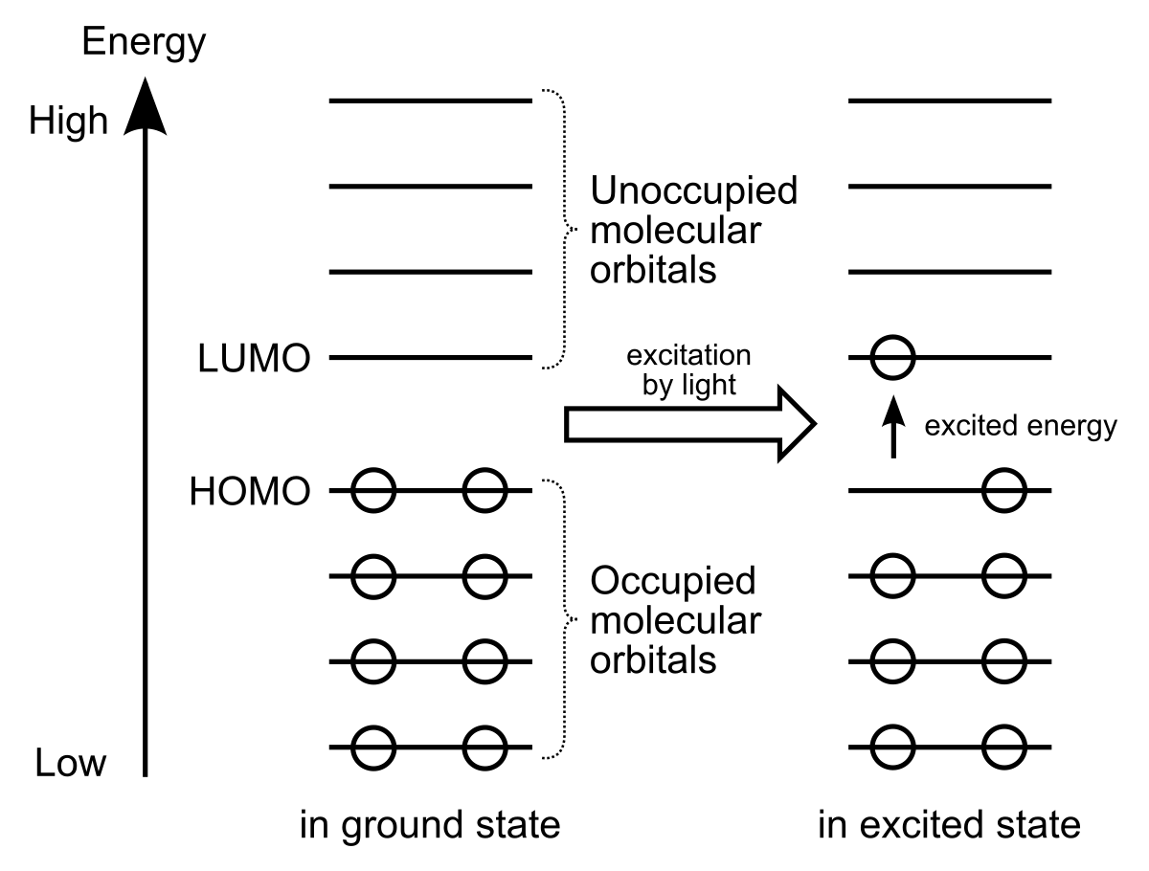SAB & FMO ANAL**