DTU NCC SW ACHIEVEMENTS

2026
NCC BHAWAN, ROHINI
2 DELHI GIRLS BATTALION
1ST POSITION IN BOLLYBOLL
TUG OF WAR 1ST RUNNER-UP
FLAG AREA- CDT AARTI, CDT BHUMIKA, CDT ADITI GUPTA, CDT RIYA YADAV, CDT POOJA
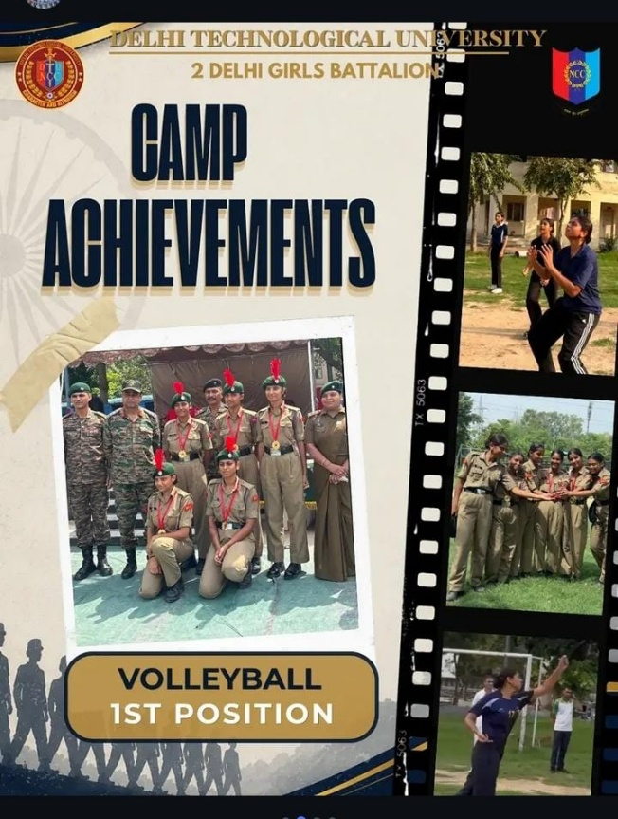 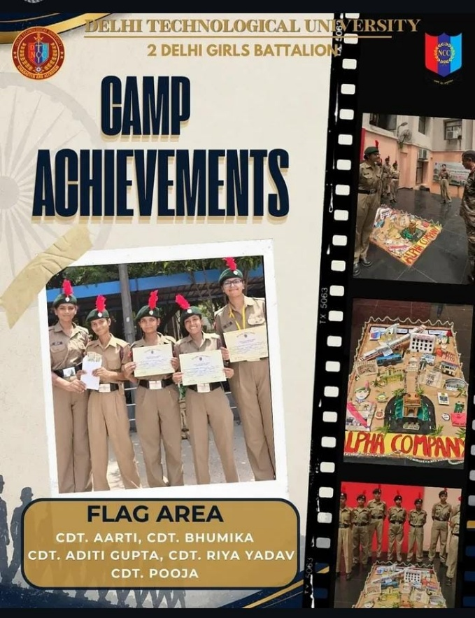S

CATC II 7TH TO 16TH JULY 2026
1ST RUNNER-UP BEST CADET JUO ARPITA PRAKASH
ANCHORING- CDT AYUSHI VATS
WINNER EXTEMPORE- CDT ADITI GUPTA
WINNER ANCHORING- CDT RIYA YADAV

NIMAS, DIRANG, ARUNACHAL PRADESH- JUO KUMARI RASHI SUCCESSFULLY COMPLETED THE SPECIAL ADVENTURE CAMP AT NIMAS
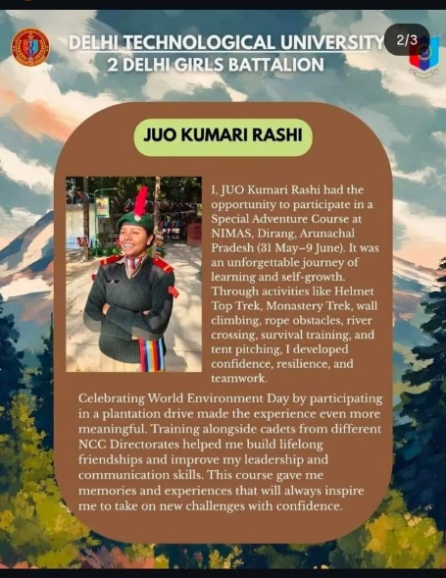

COMBINED ANNUAL TRAINING CAMP-I 12TH MAY TO 21 MAY 2026
SOLO DANCE WINNER- CDT SANJANA CHAUHAN
GROUP DANCE WINNER- CDT PARI, CDT LUCKY, CDT SANJANA, CDT RITU, CDT MILAN, CDT NISHIKA
GROUP SINGING (RUNNER-UP)- CDT SIMMY, CDT DEEPIKA, CDT SANIA SHAHEEN, CDT GEETA, CDT KHUSHBU, CDT CHITRANJALI
EXTEMPORE RUNNER-UP- CDT MILAN
FLAG AREA- CDT BANOTHU SRAVANI, CDT ANJU, CDT GEETA, CDT KASHISH, CDT KAJAL SAH
CALLIGRAPHERS OF THE CAMP- CDT RUPALI & CDT ANJALI

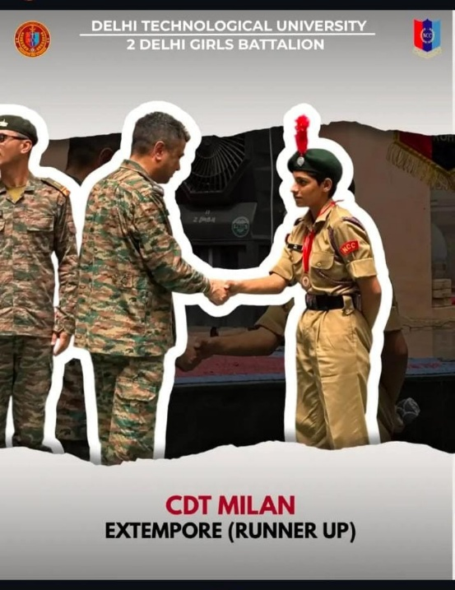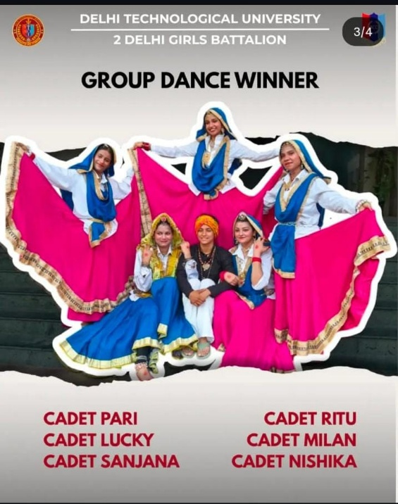

2025
- CATC 11 TO 20 JULY 2025
2ND POSITION IN FLAG AREA - SGT KANCHAN, LCPL BEEPANKIT RAJ, SGT NAVNIDHI SHARMA
2ND POSITION IN QUIZ- CDT ANJALI PAKHARIYAL
2ND POSITION IN BOOK REVIEW- LPCL VIPRANSHI SINGH
APPOINTMENTS- SUO DISHITA (ALFA CMP) SENIOR, DISCIPLINE IN CHANGE OF CAMP
SOCIAL MEDIA TEAM- SGT SOMA GUPTA, CDT KANISHKA
CALLIGRAPHERS OF THE CAMP- LCPL BHUMIKA, LCPL VIPRANSHI SINGH
ADM SUPPORT OF THE CAMP – CPL UMME KUULSOM, LPCL BHUMIKA

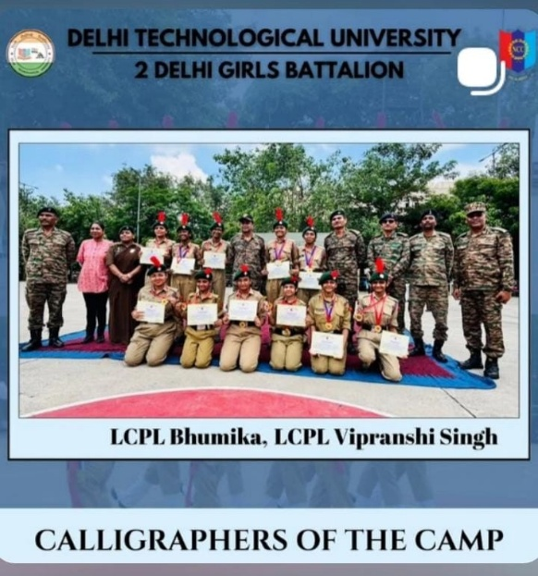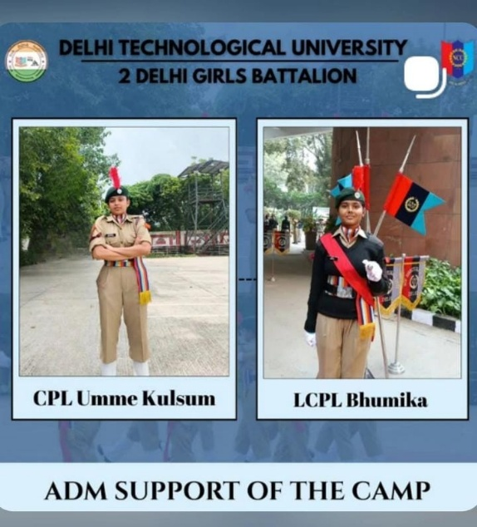

- ATC-1 17 MAY TO 26 MAY 2025

GUARD OF HONOUR- 2ND POSITION, JUO HARSHITA, JUO VAANI
BHARDWAJ, JUO SANIYA PARVEEN, CPL ANUSHKA RAWAT
LPCL NANITA, CDT RIDDHI GARG, CDT PAALIPTA SINGH, CDT HARSHITA
VOLLEYBALL- 1ST POSITION, JUO HARSHITA, CDT MANISHA, CDT MANASWINI, CDT SUMITA
BADMINTON- 2ND POSITION, CDT PRALIPTA, CDT MISHIKA
SOLO DANCE- 1ST POSITION, CDT SANJNA
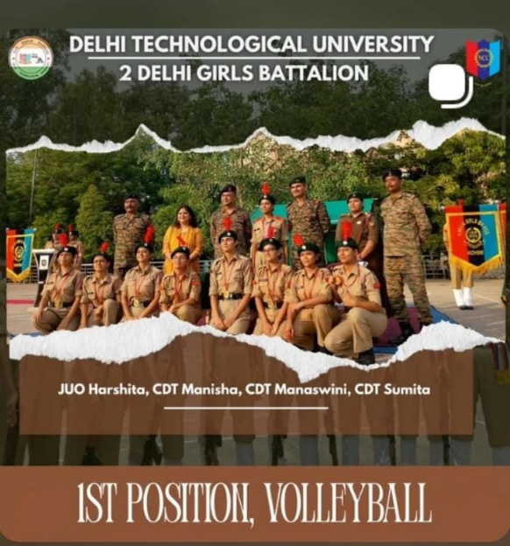
BOOK REVIEW- 2ND JUO SANIYA
EXTEMPORE- 2ND POSITION, CDT NISHTHAN
CAMP APPT.- LPCL NAMITA (CMP 21C), CPL ANUSHKA, JUO VANI (SAFETY AND SECURITY),
JUO HARSHITA (HEALTH & HYGIENE), CDT PRALIPTA- CORNPCOMS
PILOTING- CDT NISHIIKA, CDT SIMRAN
CERTIFICATE WRITING- CDT SANIA
ANCHORING- CDT MISHIKA
SOCIAL- CDT AYUSHI

- 29 DEC TO 2024 TO 30 JAN 2026
NCC PM RALLY 2025 CONGRATULATIONS WORLD RECORD ACHIEVED - OVER 500 NCC CADETS SET A WORLD RECORD BY PERFORMING 12 DIST DANCE FORMS IN JUST 2 MIN
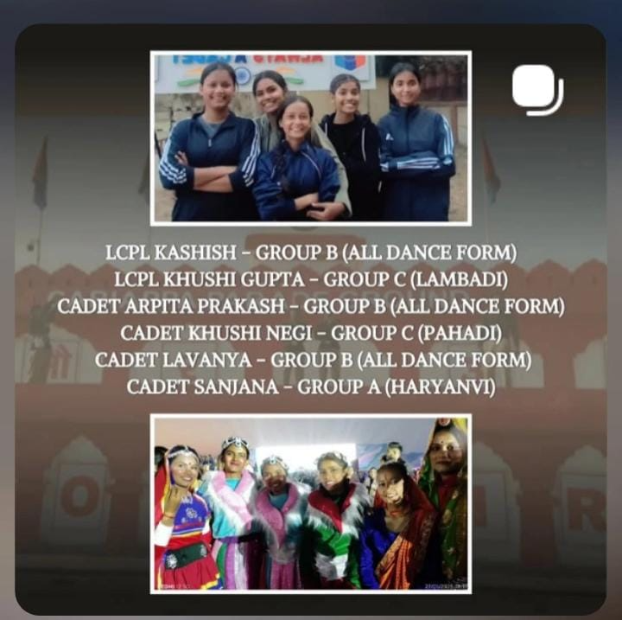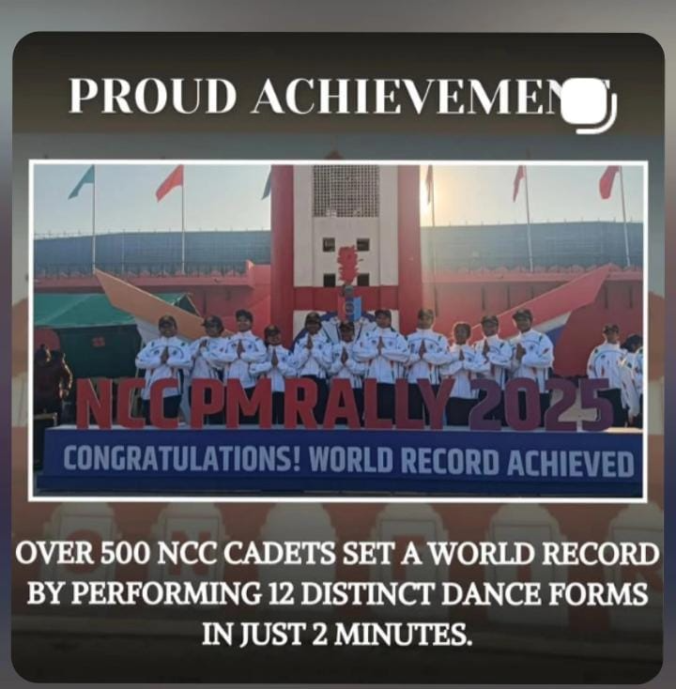

- REPUBLIC DAY CAMP – 1ST PLACE IN BALLET, RUNNER-UP IN ALL INDIA CDT BHAGWATI KANWAR
(SELECTED FOR YEP CULTURAL PERFORMANCES)
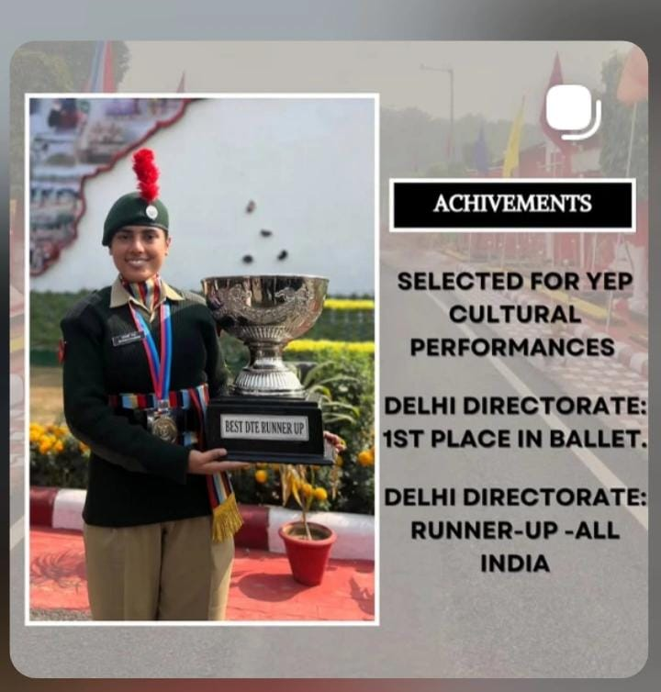

- EBSB CAMP 1ST OCT TO 12TH OCT 2024
1ST POSITION IN PITCHING- LPCL KANCHAN
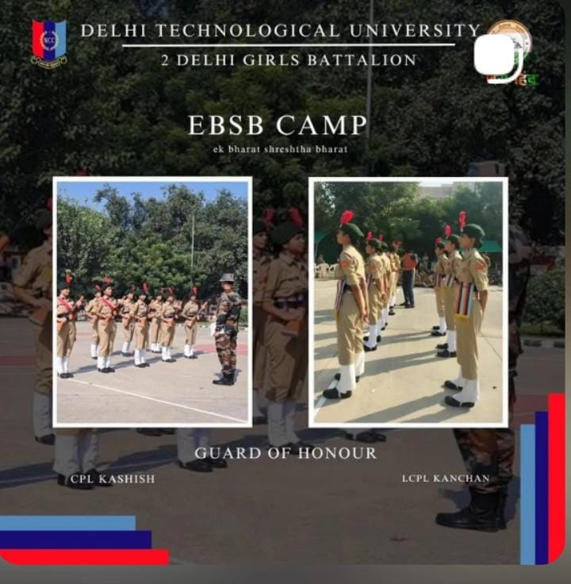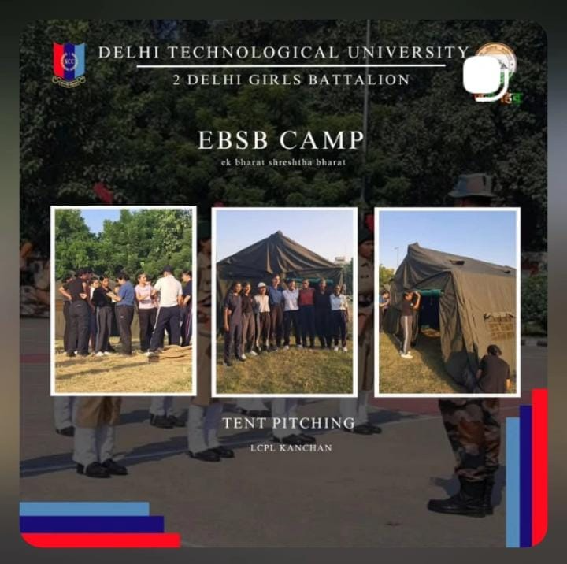

- COMPETITION (NUKKAD NATAK- EK BHARAT SHRESTHA BHARAT) 16TH TO 24 DEC 2024
CAMP AGARTALA- 2ND POSITION CDT PRALIPTA SINGH WITH OTHER CADETS
TUG OF WAR- WON SILVER MEDAL
GROUND SONG- WON SILVER MEDAL
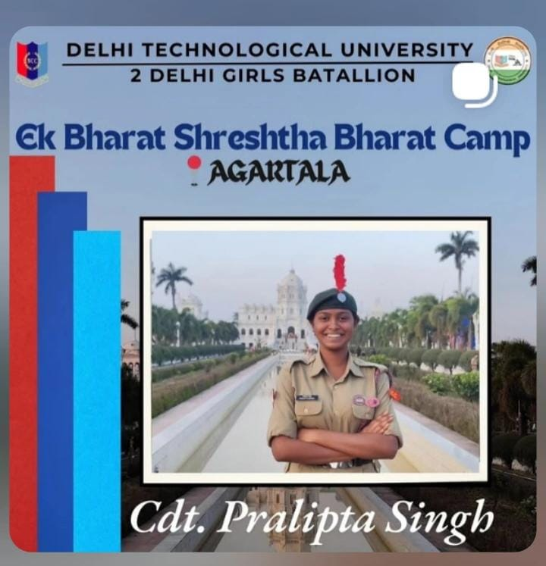
- ARMY ATTACHMENT CAMP 28TH AUG TO 8 SEP 2024
GROUND OF HONOUR- 1ST POSITION CDT NIKITA
GROUND OF HONOUR- CPL DISHITA 15 JULY 2024

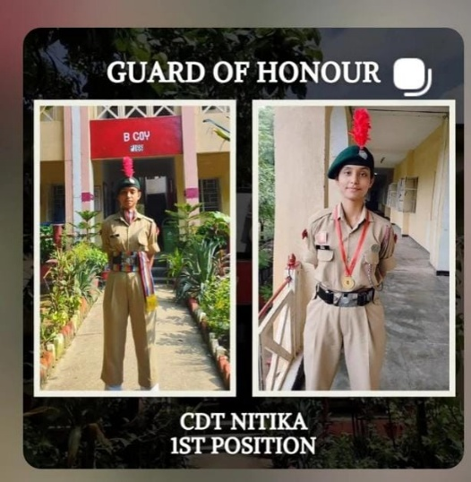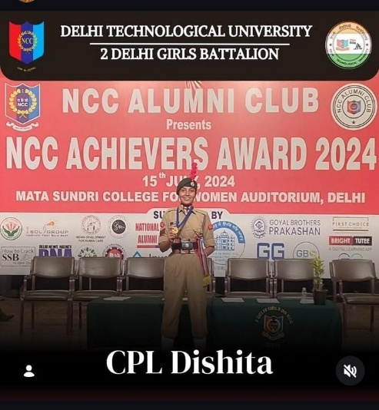
- CATC
HEALTH & HYGIENE- CPL ANISHKA RAWAT, LCPL NAVNIDHI SHARMA, MASTER OF COMMERS- CDT SOMA GUPTA,
1ST POSITION- PEN PICTURE- CDT MANDVI SHUKLA
2ND POSITION- PEN PICTURE- CDT MANISHA
2ND POSITION- BOOK REVIEW- CDT MANISHA
1ST POSITION- LINE AREA- CDT PRALIPTA SINGH, CDT MANDVI, CDT MANISHA, CDT SOMA, CDT SANIYA, CDT SIDDHI GARG, CDT HARSHITA GURJAR
2ND POSITION- FLAG AREA- CDT MANDVI SHUKLA AND CDT HARSHITA GURJAR
3RD POSITION- QUARTER GUARD- CPL DISHITA, CPL ANISHKA, CPL PRIYANSHI, LCPL NOMITA, LCPL HARSHITA, CDT NITIKA, CDT SONIA, CDT NOMITA
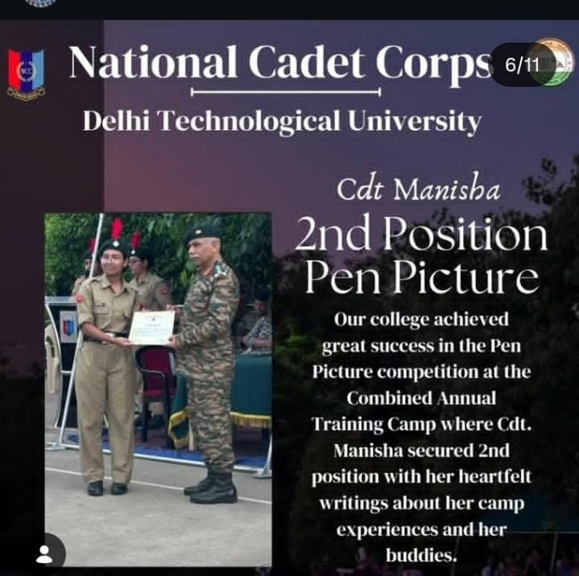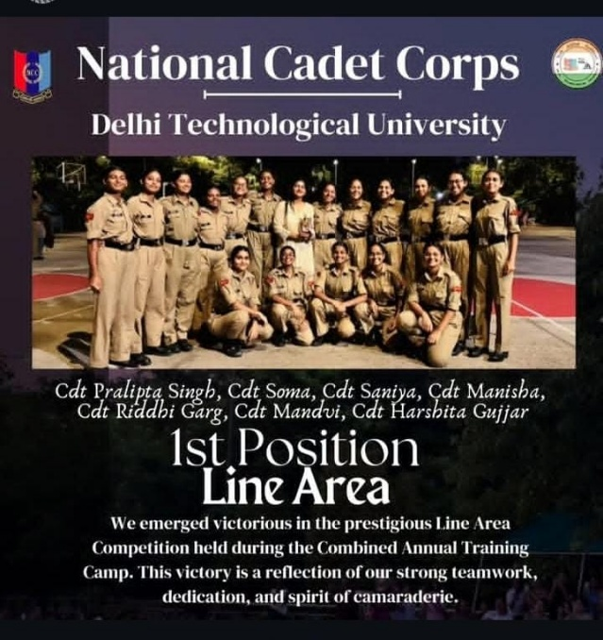

- PARTICIPATION (CATC)
QUARTEER GUARD 3RD POSITION- DTU
BEST CADET- LCPL HARSHITA YADAV
FALG AREA- .2ND POSITION- CDT MANDAVI, CDT HARSHITA,

ATC (SOLO DANCE)- 2ND POSITION- CDT BHAGWATI
ATC (PICTURE)- 3RD POSITION- CDT BHAGWATI
ATC (EXTEMPER) 3RD POSITION- CDT BHAGWATI

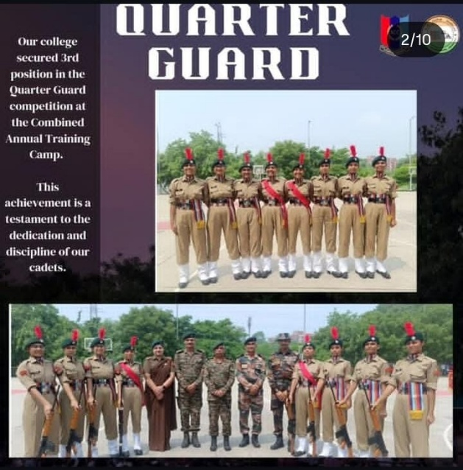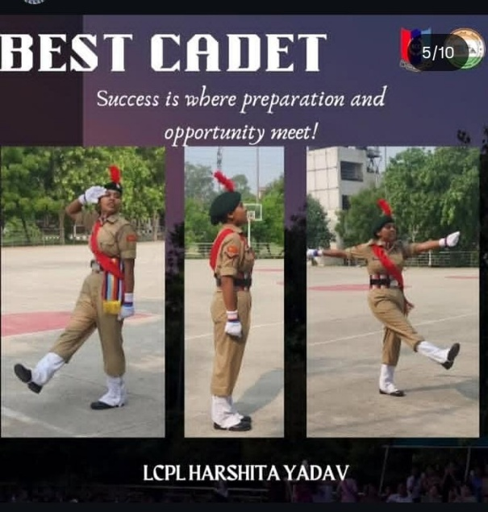

ANNUAL NCC FEST OF ARSD- QUARTER GUARD 2ND POSITION DTU NCC
