**Index :**

|  |  |  |
| --- | --- | --- |
| 1. No. | Experiment | Page No. |
| 1 | To understand importance and use of “how might we” statement. | 1 |
| 2 | To understand importance and use of empathy map. | 2-3 |
| 3 | To understand importance and use of as-is scenario map. | 4-5 |
| 4 | To understand importance and use of brainstorming. | 5-6 |
| 5 | To understand importance and use of prioritization grid. | 7-8 |
| 6 | To understand importance and use of story boarding. | 9-10 |
| 7 | To understand importance and use of Hills. | 10-11 |

**Experiment 1**

**Aim:** To understand importance and use of "How might we" statement.

**Theory:**

"How might we" (HMW) statement allow us to re frame out insights into opportunity areas and innovate on problems found during user research. These statements help inspire user-centered design.

"How" suggest that we do not yet have the answer. It allows us to consider multiple options for innovation and reinforces that we are still exploring for the problem and solution.

"Might" emphasizes that there are many different paths that we may follow when thinking about solutions. This allows us for open-minded creativity, brainstorming and thinking about the problem from multiple perspectives.

"We" brings in the idea of teamwork. "We" should all work collaboratively to come up with a joint understanding of the problem and put our head together to come up with a solution.

Tips to make "How might we" questions better:

* Start with the problems that are uncovered.
* Avoid suggesting a solution in How might we question.
* Keep How might we question broad.
* Focus How might we question on desired outcome.
* Phrase How might we question positively.

Example**:**

**Problem Statement:** How to create a good parking experience for user.

* How might we improve the user experience while parking?
* How might we can create more parking space?
* How might we can well organize car parking?
* How might we make users feel confident they have all the information they need?
* How might we make the return process quick and intuitive?

**Experiment 2**

**Aim:** To understand importance and the use of empathy map.

**Theory:**

An empathy map is a collaborative tool that teams can use to gain a deeper insight into their customers. It is much like a user persona, an empathy map can represent a group of users, such as a customer segment. Empathy map are split into 4 quadrants i.e., says, think, does and feels, with the user or persona in the middle. Empathy maps provide a glance into user as a whole. It is used by agile community.

The "**Says**" quadrant contains what the user says out loud in an interview or some other usability study. It contains direct quotes from research.

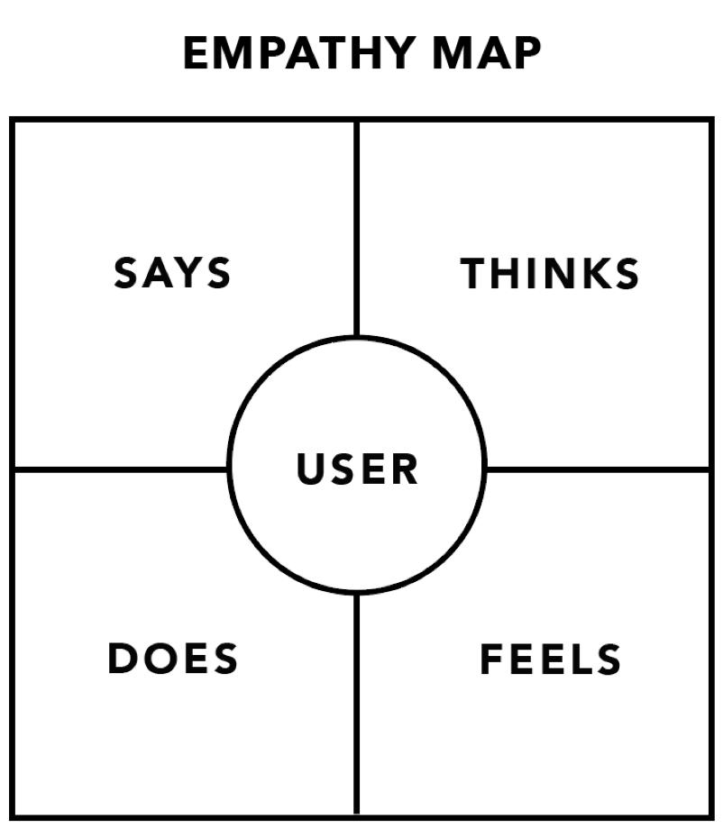

The "**Thinks**" quadrant captures what the user is thinking throughout the experience. Ask yourself: what occupies the user’s thoughts? It is possible to have the same content in both Says and Thinks. However, pay special attention to what users think, but may not be willing to vocalize

The "**Does**" quadrant encloses the actions that user takes. From the research, what does the user physically do? How does the user go about doing it?

The "**Feels**" quadrant is the user’s emotional state, often represented as an adjective plus a short sentence for context. Ask yourself: “What worries the user? What does the user get excited about? How does the user feel about the experience?”.

Example:

**Problem Statement:** How can we make effective learning session during lockdown?

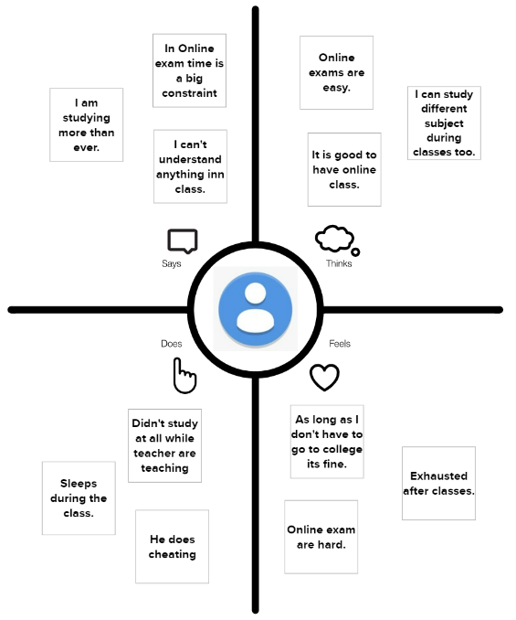

**Experiment 3**

**Aim:** To understand importance and use of as-is scenario map.

**Theory:**

As-is Scenario Maps help to document collective understanding of user workflows and are best used as precursors to exploring new ideas or for finding the right problem to solve.

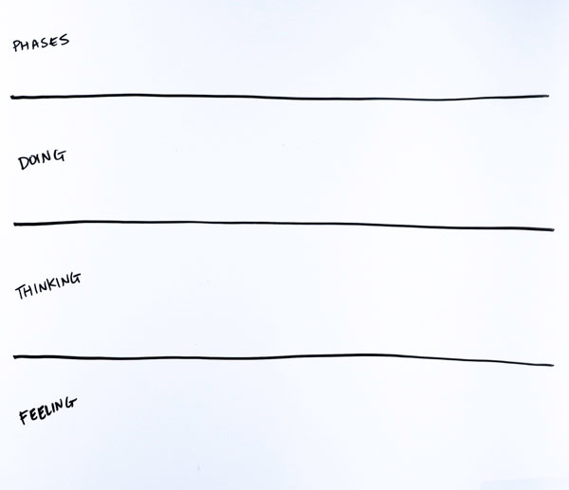

These maps are helpful at many stages during the design process:

* Beginning of the project
* During research
* During solution definition

To make as-is scenario map draw four rows and label each: Phases, Doing, Thinking, and Feeling.

Example:

**Problem Statement:** What students feel, think and do during online classes?

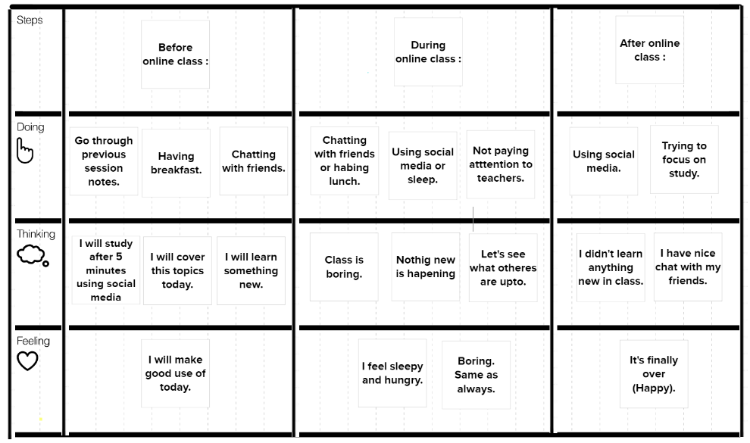

**Experiment 4**

**Aim:** To understand importance and use of brainstorming.

**Theory:**

Brainstorming combines a relaxed, informal approach to problem solving with lateral thinking. It encourages people to come up with ideas that can seem a bit crazy. Some of these ideas can be crafted into original, creative solutions to a problem, while others can spark even more ideas. This helps to get people unstuck them out of their normal ways of thinking. Therefore, during brainstorming sessions, people should avoid criticizing or rewarding ideas. We're trying to open up possibilities and break down incorrect assumptions about the problem's limits. Judgment and analysis at this stage stunts idea generation and limit creativity.

Brainstorming provides a free and open environment that encourages everyone to participate. Quirky ideas are welcomed and built upon, and all participants are encouraged to contribute fully, helping them develop a rich array of creative solutions.

Example:

**Problem Statement:** How can we make effective learning session during lockdown?

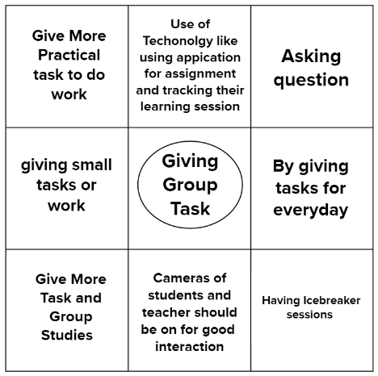

**Experiment 5**

**Aim:** To understand importance and use of prioritization grid.

**Theory:**

A prioritization grid is an organizational system where we sort all of our tasks based on different factors such as time or importance. Each prioritization grid works on a 2X2 axis. It helps to sort out which tasks should we perform first. For example, we may prioritize tasks based on Importance x Feasibility, Importance x Urgency, Impact x Effort, Risk x Reward, etc.

Example:

**Problem Statement:** How can we make effective learning session during lockdown?

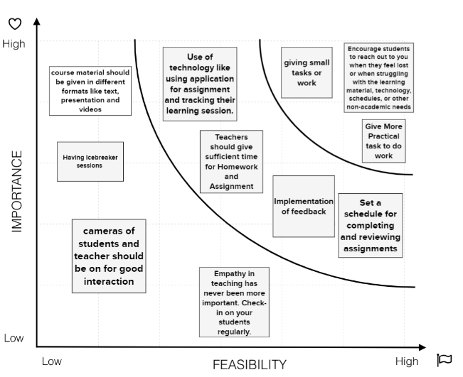

**Experiment 6**

**Aim:** To understand importance and use of story boarding.

**Theory:**

Story boarding is the process of sketching out the progression of a marketing video, animation, or film. Each scene or shot is assigned a panel, and each panel includes a visual sketch or a photo of the concept. We can include dialogue, notes, audio, and more in each panel. It helps to express our idea and problem in form of pictures and animations. It makes easier to understand the problem.

Example:

**Problem Statement:** Make a low-fidelity prototype to pre-order a coffee from a coffee shop so that we don't have to stand in line. Visualize the different stages using storyboarding technique?

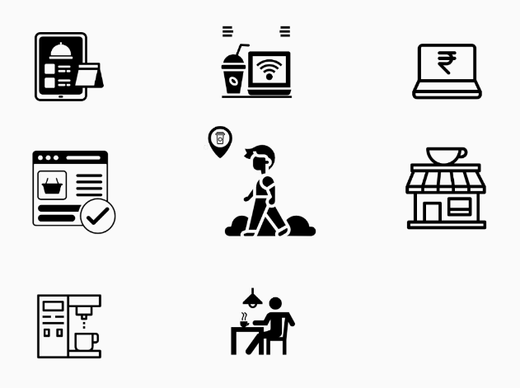

**Experiment 7**

**Aim:** To understand importance and use of Hills.

**Theory**: Hills are statements of intent written as meaningful user outcomes. They tell you where to go, not how to get there, empowering teams to explore breakthrough ideas without losing sight of the goal.

**SYNTAX OF A HILL**

A Hill focuses on three key elements: **WHO**, **WHAT**, and **WOW**.

When you are writing a hill, focus these three aspects. The Hill must address who the outcome will serve, what they will be able to do, and why they will care.

**WHO**Who are the users? (Specific user or class of users)

**WHAT**  
What’s the need they’re trying to meet? (Specific user enablement)

**WOW**  
How will you measure your success? (Specific or differentiating value to the user, i.e., what is the wow factor?)

**Other Example of Hills:**

* A biomedical scientist can view multiple variations of SARS- CoV-2 vaccine on the human body, without having to use humans for trials.
* Amy, the bus passenger, can view all nearby bus stops at a single glance.

