Index :
- No. | Experiment | Teacher’s Remark
1 | Analysis, assembly and testing of logic gates.
2 | Verification of DeMorgan’s theorem.
3 | To construct of half adder and full adder.
4 | To construct of half subtractor and full subtractor circuits.
5 | Verification of versatility of NAND gate.
6 | Verification of versatility of NOR gate.
7 | Design a BCD to Excess – 3 code converter.

Experiment 1
Aim : Analysis, assembly and testing of logic gates.
Apparatus Required:
1. Logic gates trainer Board
2. Connecting patch cords
3. Virtual digital Simulator version 0.9.7
Theory :
Logic Gates: Digital circuits are also called digital logic because any Desired information for computing or control can be operated upon by passing binary signals through various combination of logic circuits, each signal representing a variable and carrying one bit of information.
Logic circuits that can perform the logical operations are AND, OR and NOT. These are the basic gates. The other gates derived from these basic gates are NAND, NOR, EX-OR, EX-NOR. Boolean functions can be expressed in terms of AND, OR and NOT operations.
AND Gate :
- IC - 7408 (AND Gate 2-Input)
Truth Table :
Input |  | Output
X | Y | Y = A.B
0 | 0 | 0
0 | 1 | 0
1 | 0 | 0
1 | 1 | 1
Circuit :
- IC-7411 (AND gate 3-Input)
Truth Table :
Inputs |  |  | Output
A | B | C | Y = A.B.C
0 | 0 | 0 | 0
0 | 0 | 1 | 0
0 | 1 | 0 | 0
0 | 1 | 1 | 0
1 | 0 | 0 | 0
1 | 0 | 1 | 0
1 | 1 | 0 | 0
1 | 1 | 1 | 1

Circuit :
- IC-7421 (AND Gate 4-Input)
Truth Table :
Inputs |  |  |  | Output
A | B | C | D | Y = A.B.C.D
0 | 0 | 0 | 0 | 0
0 | 0 | 0 | 1 | 0
0 | 0 | 1 | 0 | 0
0 | 0 | 1 | 1 | 0
0 | 1 | 0 | 0 | 0
0 | 1 | 0 | 1 | 0
0 | 1 | 1 | 0 | 0
0 | 1 | 1 | 1 | 0
1 | 0 | 0 | 0 | 0
1 | 0 | 0 | 1 | 0
1 | 0 | 1 | 0 | 0
1 | 0 | 1 | 1 | 0
1 | 1 | 0 | 0 | 0
1 | 1 | 0 | 1 | 0
1 | 1 | 1 | 0 | 0
1 | 1 | 1 | 1 | 1
Circuit :
NAND Gate :
IC-7400 (NAND Gate 2-Input)
Truth Table :
Input |  | Output
X | Y | Y = (A.B)’
0 | 0 | 1
0 | 1 | 1
1 | 0 | 1
1 | 1 | 0

Circuit :
NOT Gate :
IC-7404 (NOT Gate)
Truth Table :
Input | Output
0 | 1
1 | 0
Circuit :
OR Gate :
IC-7432 (OR Gate 2-Input)
Truth Table :
Input |  | Output
X | Y | Y = A+B
0 | 0 | 0
0 | 1 | 1
1 | 0 | 1
1 | 1 | 1
Circuit :

NOR Gate :
IC-7402 (NOR Gate 2-Input)

Truth Table :
Input |  | Output
X | Y | Y = (A+B)’
0 | 0 | 1
0 | 1 | 0
1 | 0 | 0
1 | 1 | 0
Circuit :

XOR Gate :
IC-7486 (XOR Gate 2-Input)
Truth Table :
Input |  | Output
X | Y | Y = AB
0 | 0 | 0
0 | 1 | 1
1 | 0 | 1
1 | 1 | 0
Circuit :

Full Adder :
IC-7438 (Adds 4-Bit)
Truth Table :
Inputs |  |  | Output
A | B | C_{in} | Sum | C_{out}
0 | 0 | 0 | 0 | 0
0 | 0 | 1 | 1 | 0
0 | 1 | 0 | 1 | 0
0 | 1 | 1 | 0 | 1
1 | 0 | 0 | 1 | 0
1 | 0 | 1 | 0 | 1
1 | 1 | 0 | 0 | 1
1 | 1 | 1 | 1 | 1

Circuit :

Application of Logic Gates :
1. Used in the designing of logic devices.
2. Used in the implementation of Boolean algebra.
3. Used in the designing of combinational and sequential circuits.
Questions :
1. Give the IC numbers of following logic gates with proper pin diagram
and description: AND, OR, NOT, X-OR, X-NOR, NAND, NOR
2. What is logic, logic circuit and what do you mean by truth table?
3. What do you mean by bubbled AND & bubbled OR Gate?
4. Define basic gates and universal gates.
5. Write short notes on breadboard.
6. Define TTL logic

Experiment 2
Aim : Verification of DeMorgan’s theorem.
Theory : Digital circuits are also called digital logic because any Desired information for computing or control can be operated upon by passing binary signals through various combination of logic circuits, each signal representing a variable and carrying one bit of information.
DeMorgan's First Theorem: (A+B)’ = A’ + B’
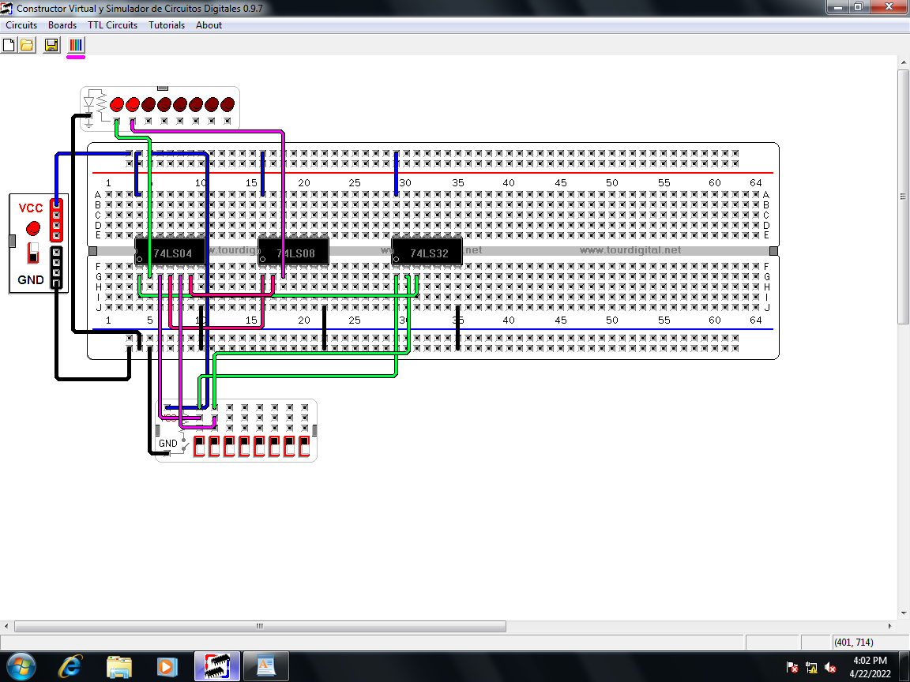
DeMorgan's Second Theorem: (AB)’ = A’ + B’

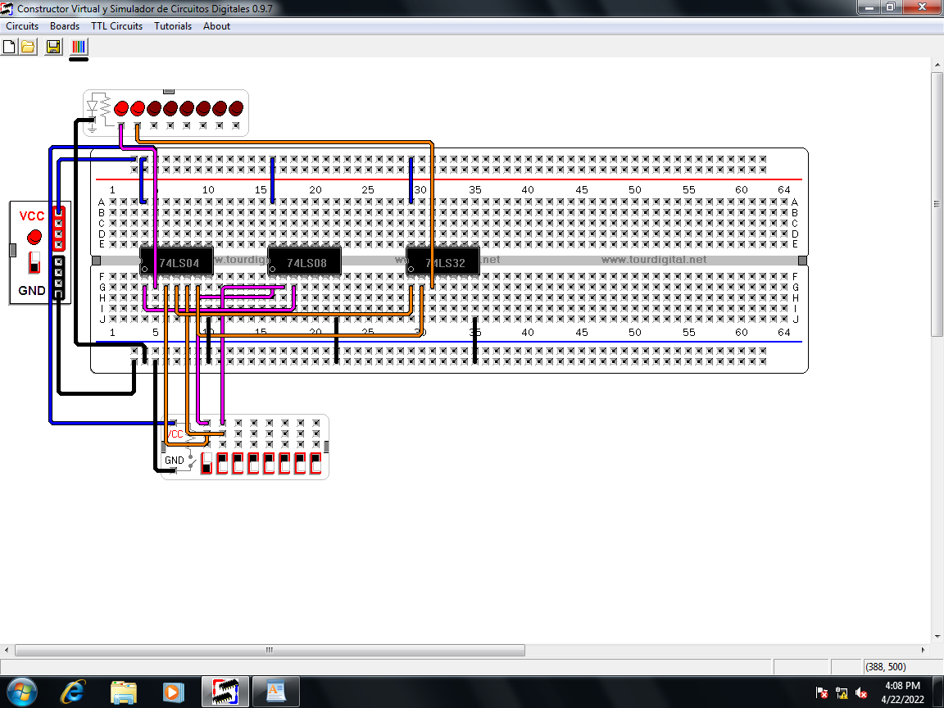

RESULT:
1. Used in the designing of digital circuit and systems.
2. Used in minimization and realization of Boolean function.
Questions:
1. What do you mean by Bit, Byte & Nibble?
2. Write and prove Demorgan’s 1st & 2nd theorem with statements?
3. Write the applications of various logic gates?
4. What do you mean by positive logic system and negative logic system?
5. What are the uses of Boolean algebra?

Experiment 3
Aim : To construct of half adder and full adder.
Theory : ADDER is a circuit, which performs the addition of binary digits. The binary sum consists of two digits. The higher significant digit of this result is called CARRY.
The basic adder is half adder which can be used for implementing full adder.
Half Adder
• It is a combinational circuit that performs the addition of two bits.
• Two input bits are augends and addend bits; the output variables are the SUM and
CARRY.
• The carry output is 0 unless both inputs are 1. The S output represents the least
significant bit of the sum. Truth table is as follows:
Inputs |  | Output
A | B | Sum | C_{out}
0 | 0 | 0 | 0
0 | 0 | 1 | 0
0 | 1 | 1 | 0
0 | 1 | 0 | 1
1 | 0 | 1 | 0
1 | 0 | 0 | 1
1 | 1 | 0 | 1
1 | 1 | 1 | 1
Circuit :
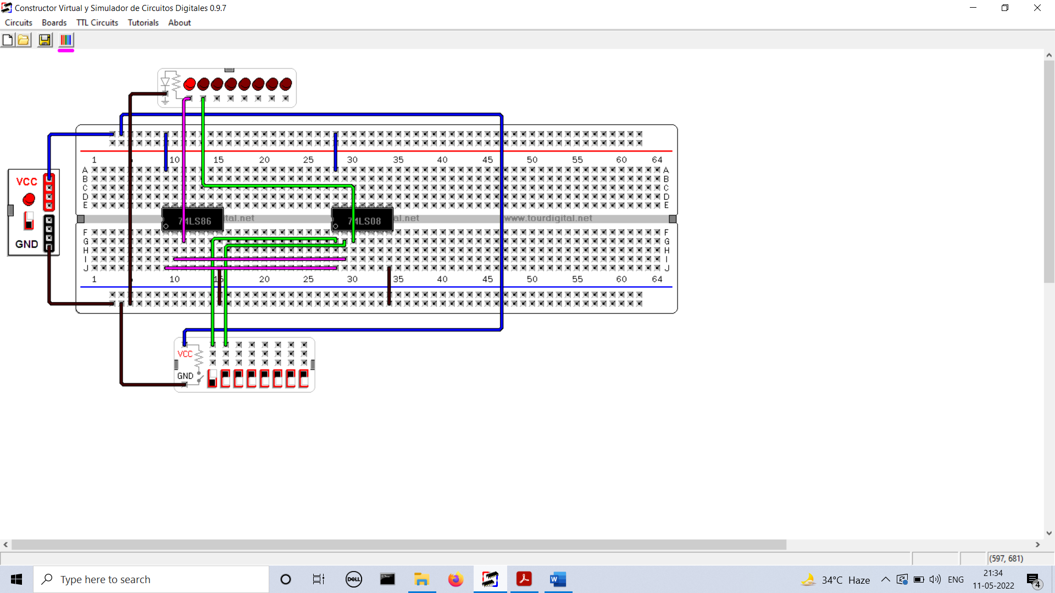
Full Adder
• It is a combinational circuit that performs the arithmetic sum of three input bits.
• It consists of three inputs and two outputs designated by S for SUM and C for CARRY.
• When all the inputs are 0s, the output is 0 .The S output is equal to 1 when only one or
three inputs are 1 .
• The C output is 1 if two or three inputs are 1.
Sum | S = X’Y’Z + X’YZ’ + XY’Z’ + XYZ
Carry | C = XY + YZ + ZX

The truth table is as following:
Inputs |  |  | Output
A | B | C_{in} | Sum | C_{out}
0 | 0 | 0 | 0 | 0
0 | 0 | 1 | 1 | 0
0 | 1 | 0 | 1 | 0
0 | 1 | 1 | 0 | 1
1 | 0 | 0 | 1 | 0
1 | 0 | 1 | 0 | 1
1 | 1 | 0 | 0 | 1
1 | 1 | 1 | 1 | 1

Circuit :
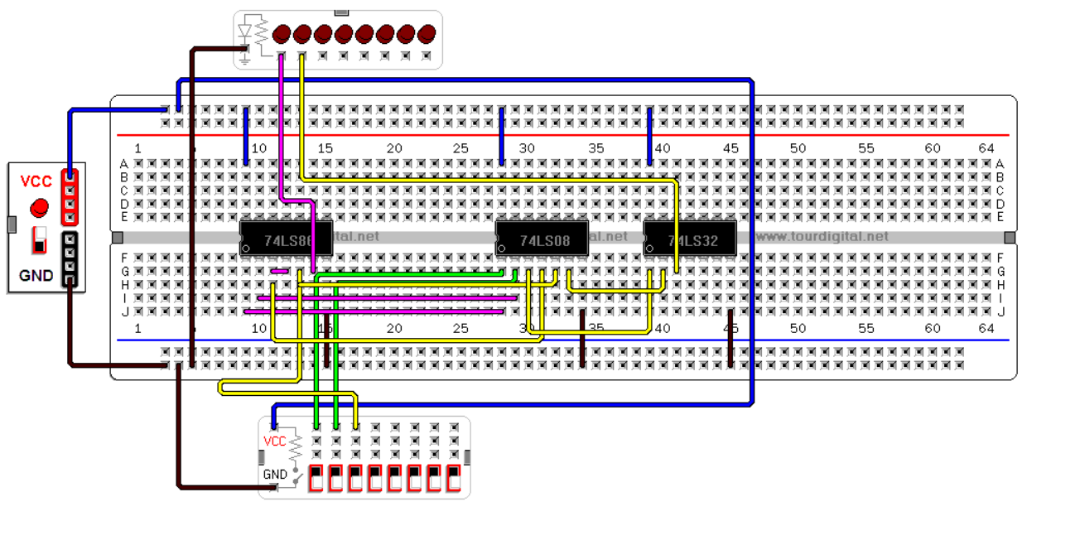
RESULT: Used in digital circuits for performing the addition operation.
Questions:
1 Why half adder is called as half adder & full adder is called as full adder?
2 Work out following binary sums
00001111 + 00110111
00010100 + 00101001
00011000111101110 + 0000111100001000
3 What do you mean by 1’s complement & 2’s complement?
4 How does the Look ahead carry adder speed up the addition process?
5 What are the disadvantage of serial adder? For which application they are preferred?
6 Compare Serial and Parallel adder ?

Experiment 4
Aim : To construct of half subtractor and full subtractor circuits.
Theory : Subtractor is a combinational circuit that performs subtraction operation. It is of two types :
Half Subtractor:
• It subtracts two bits and produces their difference.
• The relative magnitudes of two inputs are compared to produce DIFFERENCE BIT (D).
The other output B designates BORROW, which generates the binary signal that informs
the next stage that a 1 has been borrowed.
Its truth table is as follows:
Input |  | Output
A | B | Difference | Borrow
0 | 0 | 0 | 0
0 | 1 | 1 | 1
1 | 0 | 1 | 0
1 | 1 | 0 | 0
Circuit :
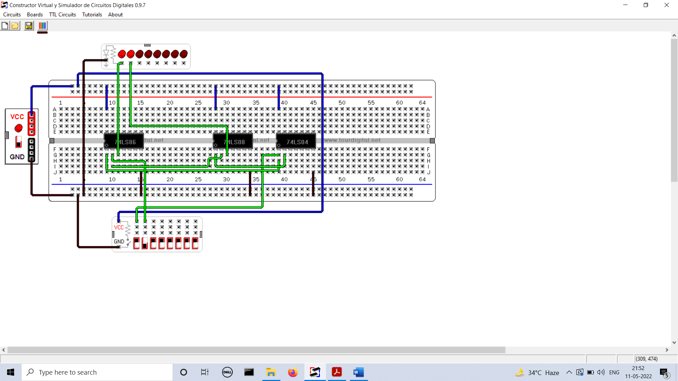
Full Subtractor:
• It performs subtraction of two bits taking into account that a 1 has been borrowed by a
lower significant stage.
• This circuit has three inputs (minuend, subtrahend & previous borrow) and two outputs
(DIFFERENCE & OUTPUT BORROW).
Difference | D = X’Y’Z + X’YZ’ + XY’Z’ + XYZ
Borrow | B = X’Y + X’Z + YZ
The truth table for it is:
Input |  |  | Output
A | B | C | Difference | Borrow
0 | 0 | 0 | 0 | 0
0 | 0 | 1 | 1 | 1
0 | 1 | 0 | 1 | 1
0 | 1 | 1 | 0 | 0
1 | 0 | 0 | 1 | 1
1 | 0 | 1 | 0 | 0
1 | 1 | 0 | 0 | 0
1 | 1 | 1 | 1 | 1
Circuit :
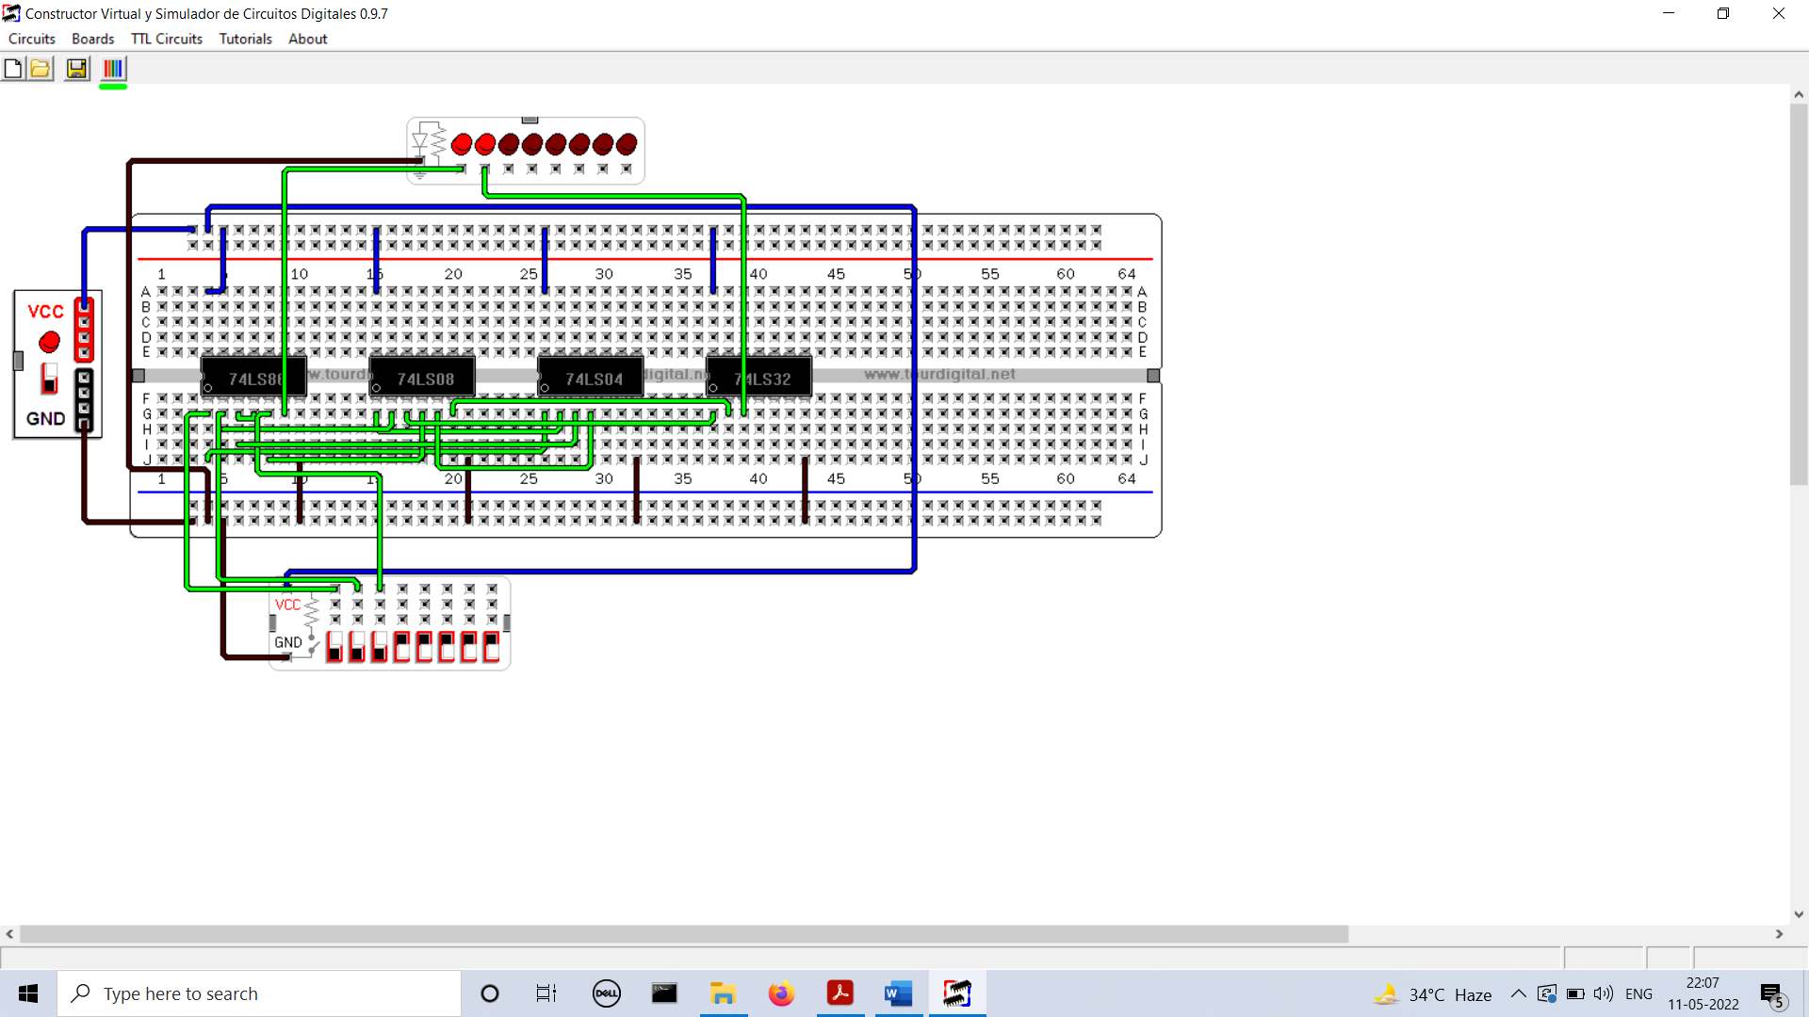
RESULT: Used in digital circuits for performing subtraction.
Questions:
1. Implement Half Subtractor using NAND.
2. Implement Half Subtractor using NOR.
3. Perform following binary subtraction:
1. 1101-1001
2. 110011-011010

Experiment 5
Aim : Verification of versatility of NAND gate.
Theory : The NAND gate & the NOR gate are called universal building blocks or universal gates because using these two gates we can prepare all other gates. Universal gates can be used for implementing any combinational logic including AND, OR and NOT.
Implementation of NOT using NAND gate.
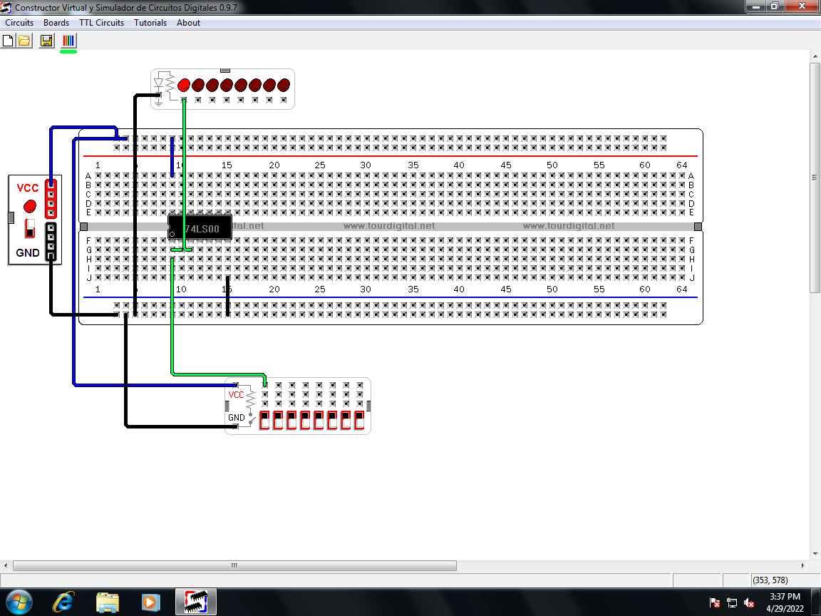

Implementation of AND using NAND gate.
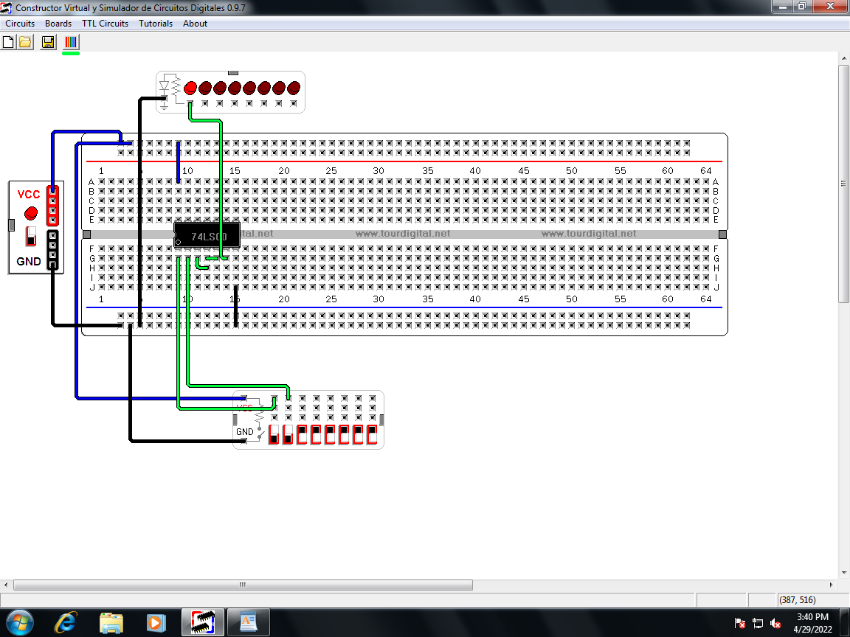

Implementation of OR using NAND gate.
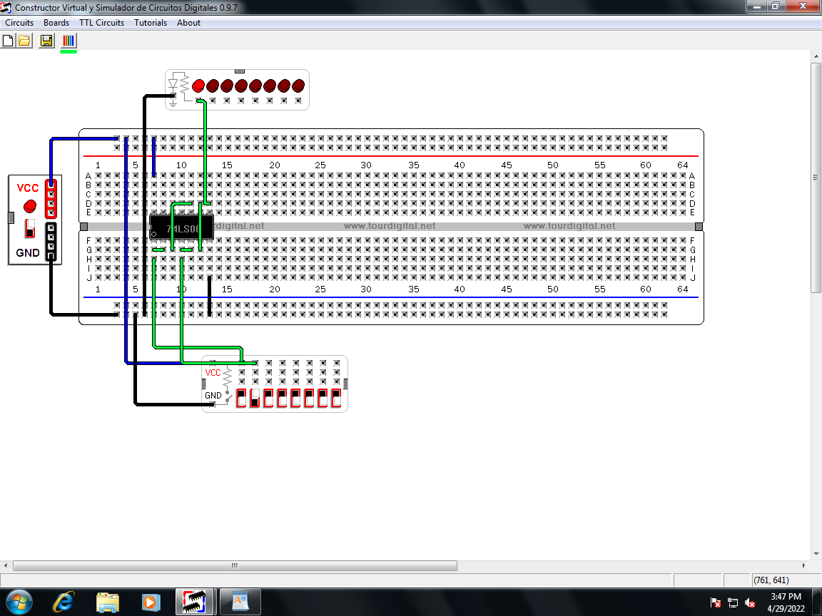
RESULTS:
1. Used as universal gate to realize all logic gates.
Questions:
1. Implement the following switching function using NAND gate only?
i) Y= (A.B)’+A+ (B+C)’
ii) Y= A+BCD’

Experiment 6
Aim : Verification of versatility of NOR gate.
Theory : The NAND gate & the NOR gate are called universal building blocks or universal gates because using these two gates we can prepare all other gates. Universal gates can be used for implementing any combinational logic including AND, OR and NOT.
Implementation of NOT using NOR gate.
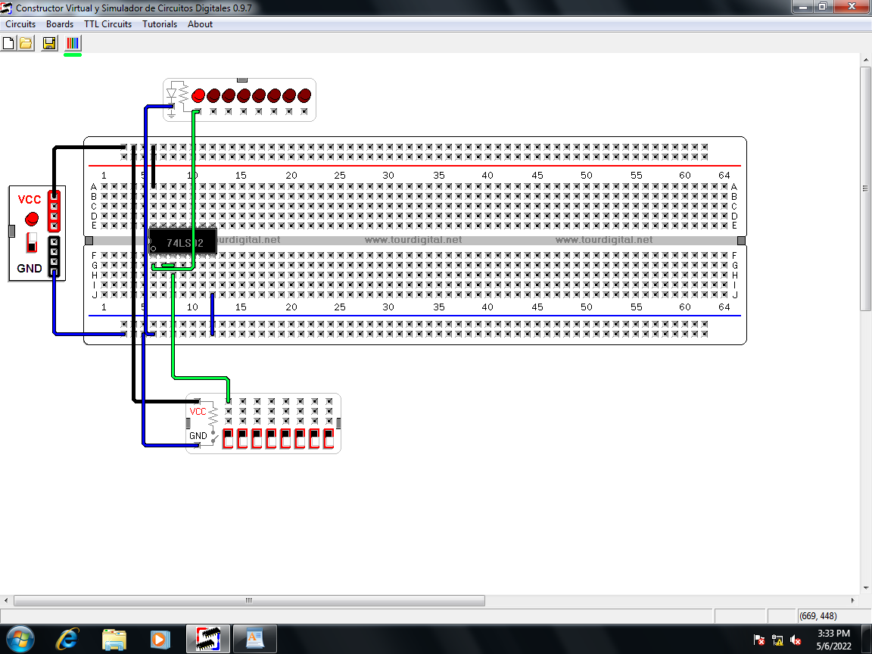
Implementation of AND using NOR gate.
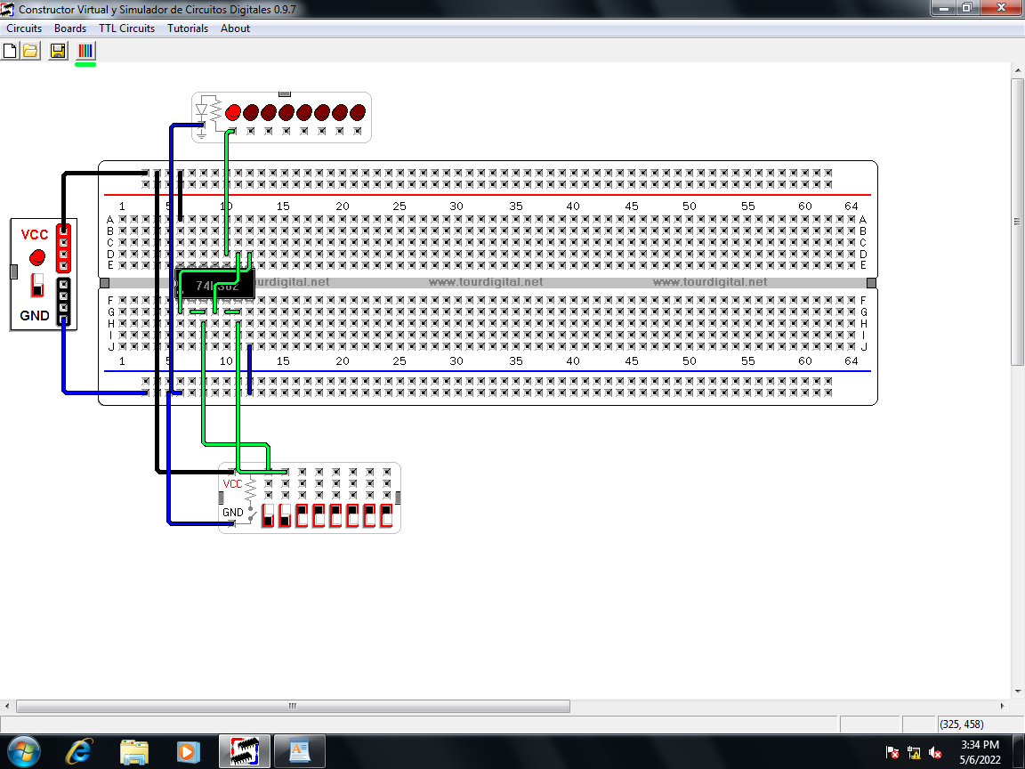

Implementation of OR using NOR gate.
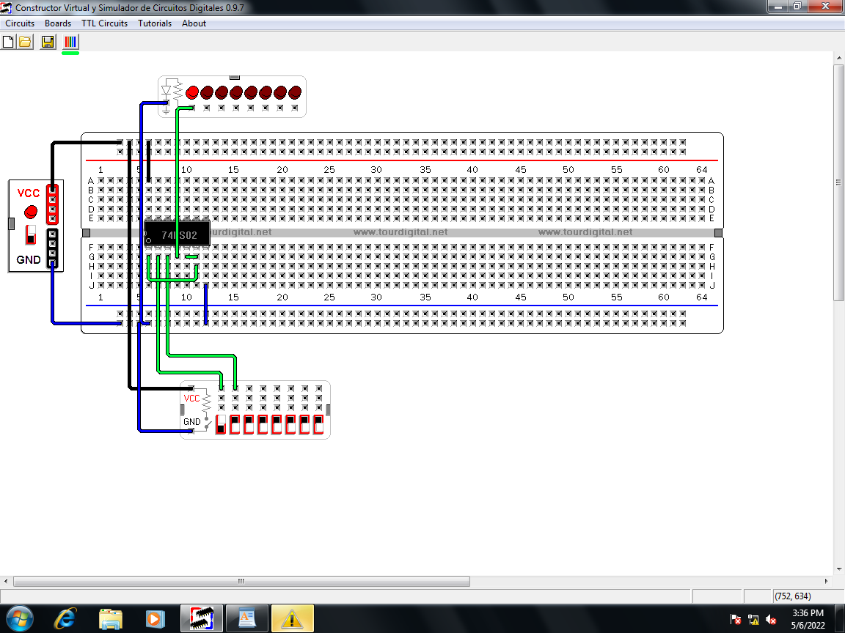
RESULT:
1. Used as universal gate in the implementation of digital circuits.
Questions:
1. Implement the following switching function using NOR gate only?
i) Y= (A.B)’+A+ (B+C)’
ii) Y= (A+C)(A+D’)(A+B+C’)

Experiment 7
Aim : Design a BCD to Excess – 3 code converter.
Theory : Binary-coded decimal (BCD) is a class of binary encoding of decimal numbers where each digit is represented by a fixed number of bits, usually four or eight.
The excess-3 code (or XS3) is a non-weighted code used to express code used to express decimal numbers. It is a self-complementary binary coded decimal (BCD) code and numerical system which has biased representation.
A | B | C | D | W | X | Y | Z
0 | 0 | 0 | 0 | 0 | 0 | 1 | 1
0 | 0 | 0 | 1 | 0 | 1 | 0 | 0
0 | 0 | 1 | 0 | 0 | 1 | 0 | 1
0 | 0 | 1 | 1 | 0 | 1 | 1 | 0
0 | 1 | 0 | 0 | 0 | 1 | 1 | 1
0 | 1 | 0 | 1 | 1 | 0 | 0 | 0
0 | 1 | 1 | 0 | 1 | 0 | 0 | 1
0 | 1 | 1 | 1 | 1 | 0 | 1 | 0
1 | 0 | 0 | 0 | 1 | 0 | 1 | 1
1 | 0 | 0 | 1 | 1 | 1 | 0 | 0
1 | 0 | 1 | 0 | X | X | X | X
1 | 0 | 1 | 1 | X | X | X | X
1 | 1 | 0 | 0 | X | X | X | X
1 | 1 | 0 | 1 | X | X | X | X
1 | 1 | 1 | 0 | X | X | X | X
1 | 1 | 1 | 1 | X | X | X | X

Circuit :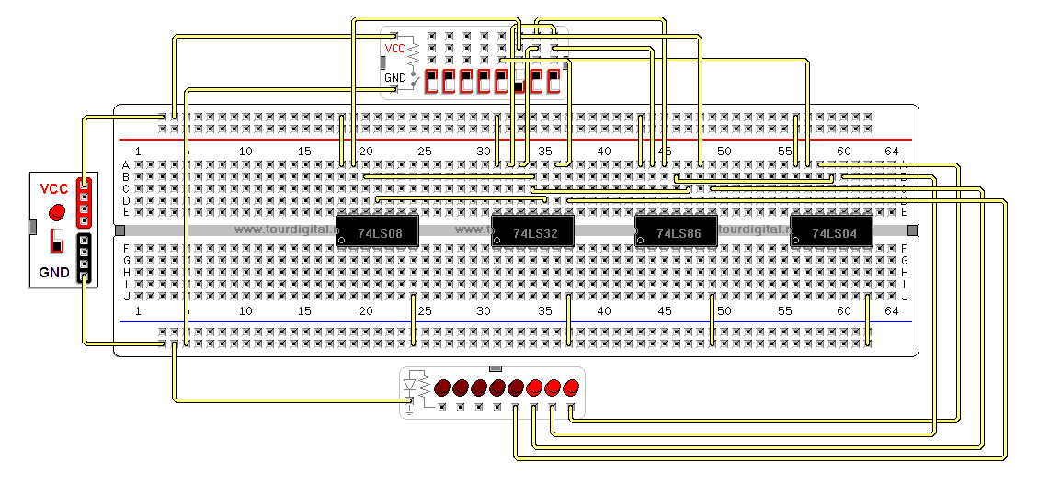
Result : Special bit patterns are used for a sign or other indications.

