**Shri Vaishnav Vidyapeeth Vishwavidyalaya**

**Shri Vaishnav Institute of Information and Technology**

**Department Of Information Technology**

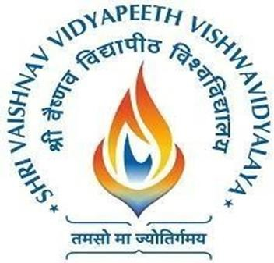

**Lab Manual**

**Subject: Agile Development Methodologies (DevOps + Agile)**

**Semester: II**

**Subject Code: BTIBM202N**

**Submitted To: Submitted By:**

Name: Mr. Virendra Dani Name: Ritik Prajapat

Roll Number: 21100BTCSFBI0965

Section: B.Tech. CSE (FSDB)

BTIBM202N Agile + DevOps

### BTIBM202N – Agile + DevOps

### LAB CONTENTS

|  |  |  |  |
| --- | --- | --- | --- |
| S. No. | Name Of the Experiment | Experiment Date | Page No. |
| 1. |  |  |  |
| 2. |  |  |  |
| 3. |  |  |  |
| 4. |  |  |  |
| 5. |  |  |  |
| 6. |  |  |  |
| 7. |  |  |  |
| 8. |  |  |  |
| 9. |  |  |  |
| 10. |  |  |  |
| 11. |  |  |  |
| 12. |  |  |  |
| 13. |  |  |  |
| 14 |  |  |  |
| 15. |  |  |  |

BTIBM202N Agile + DevOps

**Shri Vaishnav Institute of Information Technology, Indore (M.P.)**

VISION

**“To be renowned for excellence in Computer Science & Engineering.”**

MISSION

**“To impart quality education, meeting the latest industry requirements, futuristic research & developments in Computer Science & Engineering.”**