ABSTRACT
In the contemporary economic landscape, personal financial discipline and real-time expense monitoring have become critical competencies for students, working professionals, and households. However, traditional approaches—such as manual paper-based ledger recording and standalone spreadsheet workbooks—exhibit substantial deficiencies, including human computational error, lack of automated category classification, absent mobile accessibility, and zero algorithmic guidance. Conversely, existing commercial budgeting applications are often encumbered by intrusive advertisements, aggressive privacy-invasive monetization models, complex enterprise interfaces, and rigid subscription paywalls. To address these systemic limitations, this project introduces "ExpenseX — Smart Expense Tracker", an advanced, full-stack, cloud-native web application designed and implemented utilizing modern software engineering principles and the MERN (React 19, Node.js, Express.js, MongoDB Atlas) technology stack.
ExpenseX delivers a unified digital ecosystem featuring secure JSON Web Token (JWT) stateless authentication, cryptographic password hashing via bcrypt, and a responsive single-page architecture built with Vite. The platform provides seamless CRUD (Create, Read, Update, Delete) transaction management with strict server-side validation, dynamic pagination, search, and multi-criteria category filtering. Financial data is visualized through interactive, responsive Recharts components, including drill-down categorical Pie Charts and longitudinal Monthly Expense trend Line Charts. A defining architectural innovation of ExpenseX is its deep integration with the Google Gemini 2.5 Flash Artificial Intelligence API via the official @google/genai SDK. By synthesizing aggregated categorical summaries into rigorous structured prompts, the system extracts real-time, deterministic JSON-formatted financial health scores (0–100), spending diagnostics, smart overspending alerts, and actionable next-month financial targets without transmitting sensitive personal identifiers. Furthermore, ExpenseX features an industrial-grade multi-format export engine supporting dynamic PDF generation via PDFKit, professional styled Excel spreadsheets via ExcelJS, standard CSV formats via json2csv, and raw JSON exports. Comprehensive functional, integration, and security testing confirms high system throughput, low latency, and robust resilience, establishing ExpenseX as a scalable, secure, and production-ready personal financial management solution.

TABLE OF CONTENTS
CHAPTER 1 PRELIMINARY INVESTIGATION 1
1.1. Organizational and Domain Overview 1
1.2. Description of the System 3
1.3. Limitations of Present and Traditional Systems 5
1.4. Proposed ExpenseX System and Advantages 7
1.4.1. Proposed System Architecture & Core Capabilities 7
1.4.2. Distinct Technical Advantages 9
1.5. Objectives of the Project 10
1.6. Scope of the Project 11
1.7. Need for the System 13
1.8. Problem Definition and Formal Statement 14
1.9. Comprehensive Feasibility Study 15
1.9.1. Technical Feasibility 15
1.9.2. Economic and Financial Feasibility 17
1.9.3. Operational Feasibility 18
1.9.4. Schedule and Milestone Feasibility 19
1.10. Project Stakeholder Identification 20
1.11. Hardware and Software Requirements 21
1.12. Project Planning, SDLC Model and Gantt Chart 23
CHAPTER 2 SYSTEM ANALYSIS AND REQUIREMENTS 25
2.1. Fact Finding Techniques 25
2.1.1. Questionnaires and Surveys 25
2.1.2. Prototyping and Iterative Wireframing 27
2.1.3. Market and Literature Study 28
2.2. Stakeholder Profiles and Persona Analysis 29
2.3. User Requirements 30
2.4. Functional Requirements Matrix 31
2.5. Non-Functional Requirements Specification 34
2.6. Hardware and Software Specifications 36
2.7. User Roles and Access Levels 37
2.8. System Constraints and Business Rules 38
2.9. Assumptions and Technical Dependencies 39
2.10. Use Case Analysis and Modeling 40
2.10.1. Actor Identification 40
2.10.2. Detailed Use Case Descriptions 41
2.10.3. Use Case Diagram 43
2.11. Dynamic Activity Diagrams 44
2.11.1. Authentication & Onboarding Activity 44
2.11.2. Transaction Processing Activity 46
2.11.3. AI Insights Synthesis Activity 47
CHAPTER 3 EXISTING SYSTEM AND PROPOSED SYSTEM 49
3.1. Detailed Investigation of Existing Systems 49
3.2. Problems in Existing Accounting and Tracking Approaches 50
3.3. Limitations Matrix of Existing Systems 52
3.4. Proposed ExpenseX Architectural Solution 53
3.5. Proposed System Workflow and Operational Life Cycle 55
3.6. Major Features and Module Highlights 57
3.7. Functional Advantages of ExpenseX 59
3.8. Technical Comparison Between Existing Systems and ExpenseX 60
3.9. Scope of Improvement and Long-Term Value 62
CHAPTER 4 SYSTEM DESIGN 63
4.1. System Architecture Overview 63
4.2. High-Level Three-Tier Architecture 64
4.3. Frontend Client Architecture (React 19 & Vite) 66
4.4. Backend Server Architecture (Node.js & Express 5) 68
4.5. Database and Storage Architecture (MongoDB Atlas) 70
4.6. RESTful API Architectural Design 71
4.7. Authentication and Authorization Architecture (JWT) 73
4.8. Data Flow Diagrams (DFD) 75
4.8.1. Context-Level DFD (Level 0) 75
4.8.2. Detailed DFD Level 1 76
4.8.3. Transaction and AI DFD Level 2 78
4.9. Class Diagrams and Domain Model 79
4.10. Component Diagram 81
4.11. Package and Module Dependency Diagram 83
4.12. Interaction Sequence Diagrams 85
4.12.1. Authentication & Token Issuance Sequence 85
4.12.2. Transaction Creation and Audit Sequence 87
4.12.3. AI Insight Generation Sequence 89
4.12.4. Multi-Format Report Streaming Sequence 91
4.13. Cloud Deployment Diagram 92
4.14. Security and Defense-in-Depth Design 94
4.15. Global Error Handling Strategy 96
4.16. Client and Server Validation Design 97
CHAPTER 5 DATABASE DESIGN 99
5.1. Database Introduction and Selection Rationale 99
5.2. MongoDB Document-Oriented Architecture 101
5.3. Physical Data Model and Database Cluster Topology 102
5.4. Entity Relationship (ER) and Document Reference Model 103
5.5. Detailed Collection Schemas 105
5.5.1. Users Collection Schema Specification 105
5.5.2. Transactions Collection Schema Specification 107
5.6. Data Types and BSON Representation 109
5.7. Relational Referencing and Foreign Key Integrity 110
5.8. Schema Constraints and Mongoose Built-in Validators 111
5.9. Database Indexing Strategy and Query Optimization 112
5.10. Data Security, Encryption, and Transport Layer TLS 113
5.11. Core Database Operations and Aggregation Pipelines 114
5.12. Data Backup, Sharding, and Disaster Recovery 116
CHAPTER 6 SYSTEM IMPLEMENTATION & CODING 118
6.1. Development Environment and Software Toolchain 118
6.2. Project Folder Hierarchy (Full-Stack Monorepo Breakdown) 119
6.3. Backend Core Implementation 122
6.3.1. Express Server Initialization & DNS Optimization 122
6.3.2. MongoDB Atlas Cloud Connectivity 124
6.3.3. JWT Protection Middleware and Token Generation 125
6.4. Backend Controllers and Business Logic 127
6.4.1. Authentication Controller (Registration & Login) 127
6.4.2. User Profile and Password Management 129
6.4.3. Transaction Controller (Full CRUD Operations) 131
6.4.4. Dashboard Aggregation Controller 134
6.4.5. Analytics Aggregation Controller 136
6.4.6. AI Insights Service and Controller 138
6.4.7. Multi-Format Report Controller (PDF, Excel) 141
6.5. Frontend Core Implementation 145
6.5.1. Client Architecture, Vite Bundler & Entry Point 145
6.5.2. Client-Side Routing and Protected Route Guards 146
6.5.3. Data Abstraction Layer (Dual Live & Demo Mode) 148
6.5.4. Dashboard Layout and Real-Time Summary Cards 150
6.5.5. Transaction Management (Table, Search, Form, Modal) 152
6.5.6. Analytics and Recharts Visualizations 155
6.5.7. AI Insights Interface Component 157
6.5.8. Reports Generation Portal Component 159
6.5.9. User Profile and Password Settings Interface 161
6.5.10. Landing Page & Marketing Portal 163
6.6. Input Validation and Sanitization Rules Matrix 165
6.7. Error Handling and Toast Notification Pipeline 168
CHAPTER 7 SOFTWARE TESTING 172
7.1. Introduction to Software Testing in ExpenseX 172
7.2. Testing Objectives and Philosophy 173
7.3. Testing Methodologies Adopted 174
7.3.1. Unit Testing 174
7.3.2. Integration Testing 175
7.3.3. System Testing 176
7.3.4. Functional & Black-Box Testing 177
7.3.5. UI and Usability Testing 178
7.3.6. API Testing via Postman & REST Clients 179
7.3.7. Security and Penetration Testing 180
7.3.8. Cross-Browser and Responsive Testing 181
7.4. Test Environment and Hardware/Software Setup 182
7.5. Comprehensive Test Cases Suite (Table 7.1) 183
7.6. Test Data and Execution Results Analysis 189
7.6.1. User Authentication Test Results 189
7.6.2. Transaction CRUD Test Results 191
7.6.3. Analytics & Visualization Test Results 193
7.6.4. AI Insights Generation Test Results 194
7.6.5. Report Export Test Results 196
7.6.6. Summary of Execution Results (Table 7.2) 197
7.7. Defect Handling, Severity Classification & Resolution 198
CHAPTER 8 SECURITY ANALYSIS AND MEASURES 200
8.1. Security Requirements in Personal Financial Software 200
8.2. Authentication Security and Stateless Architecture 201
8.3. JSON Web Token (JWT) Security Specifications 202
8.4. Cryptographic Password Protection (Bcrypt Hashing) 204
8.5. Authorization and User Isolation Controls 205
8.6. REST API Endpoint Protection 207
8.7. Input Validation and Injection Attack Mitigation 208
8.8. Database Access Security and Network Isolation 209
8.9. Environment Variable Isolation and Secret Management 210
8.10. Gemini AI API Key Protection 211
8.11. Session Handling and Client-Side Storage Considerations 212
8.12. OWASP Top 10 Web Vulnerability Assessment (Table 8.1) 213
8.13. Error Information Exposure and Sanitization 215
8.14. Recommended Security Enhancements for Production 216
CHAPTER 9 ARTIFICIAL INTELLIGENCE INTEGRATION 218
9.1. Introduction to Generative AI in Personal Finance 218
9.2. Architectural Purpose and Role of AI in ExpenseX 219
9.3. Google Gemini 2.5 Flash Model Overview 220
9.4. Financial Insights Domain Architecture 221
9.5. End-to-End Technical Data Flow Pipeline 222
9.6. AI Prompt Engineering and Dynamic Synthesis 224
9.7. Structured JSON Enforcement and Response Parsing 226
9.8. AI Output Metrics and Diagnostics Categories 228
9.9. Client-Side Interactive AI Rendering 230
9.10. Financial and Operational Benefits of AI Integration 232
9.11. Technical Limitations and Hallucination Mitigation 233
9.12. Data Privacy and Regulatory Considerations 234
9.13. Third-Party Security and API Quota Management 235
9.14. Graceful Failure Handling and Fallback Architecture 236
9.15. Future Roadmap for Predictive AI Analytics 237
CHAPTER 10 RESULTS AND DISCUSSION 239
10.1. Operational Implementation Overview 239
10.2. Landing and Authentication Results 240
10.3. Dashboard Overview and Metrics Results 242
10.4. Transaction Management Results 245
10.5. Analytics and Interactive Visualization Results 248
10.6. AI-Powered Financial Health Results 251
10.7. Multi-Format Report Generation Results 254
10.8. Profile and Security Management Results 257
10.9. Responsive and Mobile Adaptation Results 259
10.10. Performance, Usability, and Analytical Discussion 261
CHAPTER 11 DEPLOYMENT AND MAINTENANCE 264
11.1. Deployment Overview and Cloud Topology 264
11.2. Frontend Hosting on Vercel Edge Network 265
11.3. Backend Hosting on Render Cloud 267
11.4. Database Provisioning on MongoDB Atlas 269
11.5. DNS Configuration and Custom Domain Routing 271
11.6. Environment Configuration and Secrets Deployment 272
11.7. Production Build Optimization and Tree-Shaking 274
11.8. System Monitoring, Logging, and Uptime Health 275
11.9. Backup, Replication, and Disaster Recovery 277
11.10. Software Maintenance Lifecycle 278
11.11. Corrective Maintenance Operations 279
11.12. Adaptive Maintenance Strategies 280
11.13. Perfective Maintenance Roadmap 281
11.14. Preventive Maintenance and Security Audits 282
CHAPTER 12 PROJECT MANAGEMENT 284
12.1. Software Development Life Cycle (SDLC) Methodology 284
12.2. Agile Scrum Iteration Breakdown 286
12.3. Project Schedule and Key Milestones 287
12.4. Task Allocation and Responsibilities Matrix 289
12.5. Comprehensive Risk Management Plan (Table 12.1) 290
12.6. Resource Planning and Development Budget 292
12.7. Key Development Challenges Encountered 293
12.8. Technical Solutions Adopted 295
CHAPTER 13 LIMITATIONS AND FUTURE SCOPE 297
13.1. Current System Limitations 297
13.2. Technical Architectural Constraints 299
13.3. Functional Domain Constraints 300
13.4. Security and Authorization Constraints 301
13.5. Scalability and Storage Considerations 302
13.6. Future Scope Roadmap (Table 13.1) 303
13.6.1. Cross-Platform Mobile App (React Native/Expo) 304
13.6.2. Automated Category-Wise Budget Caps & Alerts 305
13.6.3. Recurring Transactions & Subscription Tracker 306
13.6.4. Bank Account Aggregator & SMS Parsing 307
13.6.5. Multi-Currency & Real-Time Forex Support 308
13.6.6. Predictive Time-Series Forecasting (ARIMA/LSTM) 309
13.6.7. Collaborative Split-Expense Management 310
CHAPTER 14 CONCLUSION 311
14.1. Summary of Problem Addressed 311
14.2. Summary of System Developed 312
14.3. Software Engineering Principles Demonstrated 313
14.4. Technical Competencies Acquired 314
14.5. Concluding Remarks and Final Evaluation 315
REFERENCES (IEEE FORMAT) 316
GLOSSARY OF TECHNICAL TERMS 319
APPENDICES 323
APPENDIX F — COMPLETE REST API REFERENCE MANUAL 331
APPENDIX G — COMPLETE SCREENSHOT INDEX & UI ATLAS 335
LIST OF FIGURES
Figure 1.1 Project Schedule and Milestone Gantt Chart 24
Figure 2.1 ExpenseX System-Wide Use Case Diagram 43
Figure 2.2 Activity Diagram — User Authentication & Dashboard Access 45
Figure 2.3 Activity Diagram — Transaction Processing & Visual Rendering 46
Figure 2.4 Activity Diagram — AI Financial Insights Pipeline 48
Figure 4.1 ExpenseX High-Level Three-Tier Architecture Diagram 65
Figure 4.2 Data Flow Diagram — Context Level (Level 0 DFD) 75
Figure 4.3 Data Flow Diagram — Subsystem Decomposition (Level 1 DFD) 77
Figure 4.4 Data Flow Diagram — Detailed Transaction & AI Engine (Level 2 DFD) 78
Figure 4.5 Unified Domain Class Diagram (Models, Controllers, Services) 80
Figure 4.6 Component Diagram of Frontend and Backend Subsystems 82
Figure 4.7 Package and Module Dependency Diagram 84
Figure 4.8 Sequence Diagram — User Registration and Login Flow 86
Figure 4.9 Sequence Diagram — Transaction CRUD Lifecycle Flow 88
Figure 4.10 Sequence Diagram — AI Financial Insight Generation Flow 90
Figure 4.11 Sequence Diagram — Multi-Format Report Streaming Flow 91
Figure 4.12 Cloud Deployment and Physical Infrastructure Diagram 93
Figure 5.1 Entity-Relationship (ER) Schema Model in MongoDB Atlas 104
Figure 10.1 ExpenseX Landing Portal & Marketing Presentation Interface 241
Figure 10.2 User Authentication Interface (Sign-In & Registration Modal) 242
Figure 10.3 Dynamic Financial Dashboard with Balance & Summary Metric Cards 244
Figure 10.4 Recent Transactions Feed & Real-Time Activity Mini-Chart 245
Figure 10.5 Paginated Transaction Management Interface with Search & Filters 247
Figure 10.6 Add and Edit Transaction Modal Form with Input Validation 248
Figure 10.7 Transaction Deletion Warning and Confirmation Dialog 248
Figure 10.8 Interactive Expense Category Pie Chart with Drill-Down Listing 250
Figure 10.9 Longitudinal Monthly Expense Trend Line Chart 251
Figure 10.10 AI Financial Health Score Card & Spending Diagnostic Panel 253
Figure 10.11 AI Smart Alerts and Actionable Personalized Recommendations 254
Figure 10.12 Comprehensive Reports Portal with Dynamic Date Filter Controls 256
Figure 10.13 Exported PDF Financial Statement Layout (PDFKit Engine) 256
Figure 10.14 Exported Excel (.xlsx) Formatted Spreadsheet (ExcelJS Engine) 257
Figure 10.15 Exported Standard CSV and JSON File Representations 257
Figure 10.16 User Profile Management and Password Update Settings Screen 258
Figure 10.17 Mobile Responsive View — Collapsible Drawer & Fluid Cards 260
LIST OF TABLES
Table 1.1 Hardware Environment Specifications for Development & Client Devices 21
Table 1.2 Software Environment and Development Toolchain Specifications 22
Table 1.3 Project Schedule, Sprint Breakdown, and Planned vs Executed Dates 23
Table 2.1 Comprehensive Functional Requirements Matrix (FR-01 to FR-15) 32
Table 2.2 Non-Functional Software Quality Requirements Specification 35
Table 2.3 User Roles, Permissions, and Access Privilege Matrix 37
Table 3.1 Comparative Analysis Matrix: Existing Systems vs ExpenseX Platform 61
Table 5.1 Users Collection Schema Data Dictionary and Integrity Constraints 106
Table 5.2 Transactions Collection Schema Data Dictionary and Validation Rules 108
Table 6.1 Full-Stack Input Validation and Sanitization Matrix 166
Table 7.1 Comprehensive Software Testing Suite (Unit, Integration, Security) 184
Table 7.2 Summary Matrix of Test Execution Results and Pass Percentages 197
Table 8.1 OWASP Top 10 Security Assessment and Implemented Mitigations 214
Table 12.1 Comprehensive Project Risk Assessment and Mitigation Strategies 291
Table 13.1 Future Enhancements Roadmap and Phase-Wise Implementation Plan 303
Table F.1 Comprehensive ExpenseX REST API Specification Matrix 332

LIST OF FIGURES
Figure 1.1 | Project Schedule and Milestone Gantt Chart | 24
Figure 2.1 | ExpenseX System-Wide Use Case Diagram | 43
Figure 2.2 | Activity Diagram — User Authentication & Dashboard Access | 45
Figure 2.3 | Activity Diagram — Transaction Processing & Visual Rendering | 46
Figure 2.4 | Activity Diagram — AI Financial Insights Pipeline | 48
Figure 4.1 | ExpenseX High-Level Three-Tier Architecture Diagram | 65
Figure 4.2 | Data Flow Diagram — Context Level (Level 0 DFD) | 75
Figure 4.3 | Data Flow Diagram — Subsystem Decomposition (Level 1 DFD) | 77
Figure 4.4 | Data Flow Diagram — Detailed Transaction & AI Engine (Level 2 DFD) | 78
Figure 4.5 | Unified Domain Class Diagram (Models, Controllers, Services) | 80
Figure 4.6 | Component Diagram of Frontend and Backend Subsystems | 82
Figure 4.7 | Package and Module Dependency Diagram | 84
Figure 4.8 | Sequence Diagram — User Registration and Login Flow | 86
Figure 4.9 | Sequence Diagram — Transaction CRUD Lifecycle Flow | 88
Figure 4.10 | Sequence Diagram — AI Financial Insight Generation Flow | 90
Figure 4.11 | Sequence Diagram — Multi-Format Report Streaming Flow | 91
Figure 4.12 | Cloud Deployment and Physical Infrastructure Diagram | 93
Figure 5.1 | Entity-Relationship (ER) Schema Model in MongoDB Atlas | 104
Figure 10.1 | ExpenseX Landing Portal & Marketing Presentation Interface | 241
Figure 10.2 | User Authentication Interface (Sign-In & Registration Modal) | 242
Figure 10.3 | Dynamic Financial Dashboard with Balance & Summary Metric Cards | 244
Figure 10.4 | Recent Transactions Feed & Real-Time Activity Mini-Chart | 245
Figure 10.5 | Paginated Transaction Management Interface with Search & Filters | 247
Figure 10.6 | Add and Edit Transaction Modal Form with Input Validation | 248
Figure 10.7 | Transaction Deletion Warning and Confirmation Dialog | 248
Figure 10.8 | Interactive Expense Category Pie Chart with Drill-Down Listing | 250
Figure 10.9 | Longitudinal Monthly Expense Trend Line Chart | 251
Figure 10.10 | AI Financial Health Score Card & Spending Diagnostic Panel | 253
Figure 10.11 | AI Smart Alerts and Actionable Personalized Recommendations | 254
Figure 10.12 | Comprehensive Reports Portal with Dynamic Date Filter Controls | 256
Figure 10.13 | Exported PDF Financial Statement Layout (PDFKit Engine) | 256
Figure 10.14 | Exported Excel (.xlsx) Formatted Spreadsheet (ExcelJS Engine) | 257
Figure 10.15 | Exported Standard CSV and JSON File Representations | 257
Figure 10.16 | User Profile Management and Password Update Settings Screen | 258
Figure 10.17 | Mobile Responsive View — Collapsible Drawer & Fluid Cards | 260

LIST OF TABLES
Table 1.1 | Hardware Environment Specifications for Development & Client Devices | 21
Table 1.2 | Software Environment and Development Toolchain Specifications | 22
Table 1.3 | Project Schedule, Sprint Breakdown, and Planned vs Executed Dates | 23
Table 2.1 | Comprehensive Functional Requirements Matrix (FR-01 to FR-15) | 32
Table 2.2 | Non-Functional Software Quality Requirements Specification | 35
Table 2.3 | User Roles, Permissions, and Access Privilege Matrix | 37
Table 3.1 | Comparative Analysis Matrix: Existing Systems vs ExpenseX Platform | 61
Table 5.1 | Users Collection Schema Data Dictionary and Integrity Constraints | 106
Table 5.2 | Transactions Collection Schema Data Dictionary and Validation Rules | 108
Table 6.1 | Full-Stack Input Validation and Sanitization Matrix | 166
Table 7.1 | Comprehensive Software Testing Suite (Unit, Integration, Security) | 184
Table 7.2 | Summary Matrix of Test Execution Results and Pass Percentages | 197
Table 8.1 | OWASP Top 10 Security Assessment and Implemented Mitigations | 214
Table 12.1 | Comprehensive Project Risk Assessment and Mitigation Strategies | 291
Table 13.1 | Future Enhancements Roadmap and Phase-Wise Implementation Plan | 303
Table F.1 | Comprehensive ExpenseX REST API Specification Matrix | 332

CHAPTER 1
PRELIMINARY INVESTIGATION
1.1 Organizational and Domain Overview
In the contemporary global financial landscape, the digitization of personal financial management (PFM) has emerged as one of the most vital frontiers in consumer technology. Historically, individuals relied predominantly on tactile instruments such as physical accounting ledgers, paper receipts, passbooks, and manual cash-envelope budgeting systems. While these legacy mechanisms provided foundational financial awareness, they demanded exhaustive manual effort, suffered from catastrophic vulnerabilities such as physical degradation or loss, and lacked any computational capability to derive meaningful analytical insights or predictive trajectories.
With the proliferation of personal computing in the late twentieth century, personal finance transitioned into electronic spreadsheets (e.g., Microsoft Excel, Lotus 1-2-3). While digital workbooks eliminated mechanical math errors, they introduced significant cognitive friction. Users were forced to manually transcribe figures from bank slips, craft bespoke mathematical formulas, manually design charts, and maintain local files without automated synchronization across devices. More critically, spreadsheets represent passive repositories of historical data; they cannot provide proactive alerts, contextual guidance, or algorithmic financial behavioral coaching.
In the modern era of ubiquitous high-speed internet and cloud architectures, FinTech platforms have attempted to bridge this gap. However, the commercial landscape is currently divided between two problematic extremes: highly intricate enterprise accounting software (such as QuickBooks, SAP, or Tally) designed for corporate entities, and consumer mobile apps (such as Mint, Splitwise, or Walnut) that frequently monetize sensitive user financial habits through aggressive targeted advertising, third-party data tracking, or expensive recurring monthly paywalls. Furthermore, traditional budgeting software operates with static heuristics, lacking the cognitive capacity to interpret complex individual spending contexts.
ExpenseX — Smart Expense Tracker is conceived and developed to disrupt this paradigm by delivering an open, secure, full-stack web platform built upon modern web engineering principles. By uniting a responsive React 19 Single Page Application (SPA) frontend with a scalable Node.js and Express RESTful backend, a cloud-hosted MongoDB Atlas document store, and generative artificial intelligence capabilities powered by the Google Gemini API, ExpenseX offers an intelligent, accessible, and completely private personal financial control center for modern digital citizens.
1.2 Description of the System
ExpenseX is an enterprise-grade full-stack web application designed from the ground up to empower users to record, categorize, monitor, analyze, and forecast their financial activities through an intuitive digital interface. Unlike generic tracking tools, ExpenseX operates as an active financial co-pilot, transforming raw monetary transactions into structured, actionable intelligence.
The system's core capabilities encompass a spectrum of specialized subsystems:
▪ Dual-Mode Architecture: ExpenseX uniquely features a dual-operational paradigm. Users can authenticate into a secure, persistent cloud environment backed by MongoDB Atlas, or instantly explore full application capabilities through a zero-barrier Guest/Demo simulation mode that leverages browser local storage without exposing backend credentials.
▪ Stateless Cryptographic Security: Client-server communication is governed by stateless JSON Web Tokens (JWT) transmitted via Bearer headers, while user authentication credentials are protected using one-way salted bcrypt hashing (cost factor 10), ensuring bulletproof isolation across user profiles.
▪ Dynamic Transaction Lifecycle Management: Users can execute complete CRUD (Create, Read, Update, Delete) operations on monetary entries, categorizing cash flows into Income or Expense streams, assigning specialized payment vectors (Cash, UPI, Debit Card, Credit Card, Bank Transfer, Net Banking, Wallet), and logging contextual metadata.
▪ High-Performance Data Retrieval: The backend implements skip/limit pagination, search indexing, and real-time filtering algorithms, enabling instantaneous querying across thousands of transaction records with minimal server overhead.
▪ Interactive Visual Analytics: Integrating Recharts charting primitives, the client renders dynamic drill-down category Pie Charts and multi-month expense trend Line Charts, providing immediate visual breakdowns of cash flow.
▪ Generative AI Financial Intelligence: Leveraging the Google Gemini 2.5 Flash model through the official @google/genai SDK, ExpenseX synthesizes categorical expense distributions into structured prompts, extracting deterministic JSON-structured financial health scores, risk diagnoses, smart overspending alerts, and actionable next-month goals.
▪ Industrial Multi-Format Reporting: A dedicated server-side reporting engine allows instantaneous generation and streaming of PDF statements (via PDFKit), styled Excel spreadsheets (via ExcelJS), standard CSV sheets (via json2csv), and raw JSON archives.
1.3 Limitations of Present and Traditional Systems
An exhaustive empirical investigation of conventional personal financial management methodologies reveals multiple systemic deficiencies that inhibit long-term user adherence and financial wellness:
▪ High Vulnerability to Human Error: Manual ledger writing and spreadsheet data entry rely entirely on user diligence. Transposition typos, calculation errors, missed entries, and accidental cell formula overwrites frequently corrupt financial calculations.
▪ Absence of Cross-Device Portability: Physical notebooks and offline desktop spreadsheet files cannot be accessed seamlessly while on the move, leading to significant delays in transaction logging and eventual abandonment of budgeting discipline.
▪ Privacy Intrusion in Commercial Apps: Most free commercial expense applications monetize user spending habits by collecting telemetry, indexing financial behaviors, and selling targeted lead generation to lending institutions and credit card companies.
▪ Subscription Paywalls and Feature Gating: Leading consumer apps lock fundamental features—such as multi-format data export, advanced visualizations, and multi-month historical analytics—behind recurring monthly subscription fees.
▪ Static and Rigid Category Frameworks: Conventional software enforces hardcoded spending categories that fail to adapt to modern spending patterns (e.g., micro-subscriptions, UPI digital micropayments, peer-to-peer transfers).
▪ Lack of Intelligent Behavioral Coaching: Traditional tools merely display historical numbers without providing contextual evaluation. They fail to identify dangerous spending spikes, calculate financial stability ratios, or suggest personalized, achievable savings benchmarks.
1.4 Proposed ExpenseX System and Advantages
1.4.1 Proposed System Architecture & Core Capabilities
The proposed ExpenseX platform is designed as a modern, decoupled, three-tier cloud-native web application. At the client layer, React 19 coupled with the Vite build tool provides lightning-fast page loads, optimized virtual DOM reconciliation, and modular Single Page Application routing via React Router v7. State management is handled through clean reactive hooks, delivering seamless transitions between Landing, Authentication, Dashboard, Transactions, Analytics, AI Insights, Reports, and Profile Settings views.
At the middle tier, a lightweight Node.js runtime hosting an Express.js 5 application functions as a robust RESTful API gateway. The backend enforces strict cross-origin resource sharing (CORS) rules, parses incoming JSON payloads, authenticates requests via custom JWT middleware, and encapsulates domain logic into dedicated controllers (auth, user, transaction, dashboard, analytics, ai, and report controllers).
At the data tier, MongoDB Atlas provides an elastically scalable NoSQL document repository. Schemas are governed and validated programmatically through Mongoose 8, enforcing data integrity constraints, foreign-key referencing, and compound indexing for high-speed query resolution.
1.4.2 Distinct Technical Advantages
▪ Zero-Friction Accessibility: ExpenseX requires no software installation or app store provisioning; users access the complete application via modern web browsers on desktop, laptop, tablet, or smartphone.
▪ Stateless Scalability: The REST API architecture is completely stateless; session state is maintained on the client via encrypted JWT tokens, allowing the backend to scale horizontally across serverless or containerized cloud instances without session stickiness issues.
▪ Algorithmic AI Advice: By integrating the Gemini 2.5 Flash model, users receive high-level financial analysis without incurring expensive financial consulting fees.
▪ Data Portability & Sovereignty: Users retain total ownership of their financial records, possessing the unrestricted ability to export their full ledger into PDF, Excel, CSV, or JSON formats at any time.
▪ Privacy-First Architecture: ExpenseX does not incorporate third-party advertising networks, analytical trackers, or data-broker SDKs. Financial summaries sent to the Gemini API are strictly anonymized, stripped of user identities or account identifiers.
1.5 Objectives of the Project
The primary engineering and operational objectives established for the ExpenseX software project comprise:
1. Engineered Full-Stack Architecture: To architect, build, and deploy an end-to-end cloud web application demonstrating best practices in MERN stack development, modular code decoupling, and strict REST API design.
2. Stateless Authentication Engine: To implement an industrial-strength authentication subsystem utilizing bcrypt for password hashing and JSON Web Tokens for stateless route authorization and secure session management.
3. High-Throughput CRUD Operations: To engineer responsive transaction management workflows enabling rapid addition, real-time editing, deletion, pagination, dynamic search, and filtering of monetary cash flows.
4. Reactive Visual Analytics: To implement responsive, interactive data visualization components using Recharts, allowing users to drill down into categorical expenditures and analyze multi-month spending velocity.
5. Deterministic AI Synthesis: To integrate the Google Gemini 2.5 Flash LLM via structured prompt engineering, ensuring reliable generation of JSON-formatted financial diagnostics, scoring, and actionable coaching without schema deviation.
6. Automated Multi-Format Export: To construct a high-performance server-side document generation pipeline supporting programmatic PDF generation via PDFKit, Excel workbook synthesis via ExcelJS, and CSV parsing via json2csv.
7. Responsive & Cross-Device Compatibility: To ensure seamless usability across heterogeneous screen viewports, spanning ultra-wide desktop monitors to compact mobile smartphones, using modern CSS Flexbox and Grid layouts.
1.6 Scope of the Project
The architectural and functional scope of ExpenseX is clearly demarcated into existing operational capabilities and explicit project boundaries:
In-Scope Functional Boundaries:
▪ User Authentication & Lifecycle: User registration, credential login, secure logout, local session storage, JWT token verification, user profile fetching, profile name/email updating, and cryptographically verified password modification.
▪ Financial Dashboard: Real-time computation and display of Net Balance, Total Income, Total Expenses, Total Transaction Counts, and an immediate feed of recent transactions.
▪ Transaction Ledger: Creation of income and expense transactions with mandatory validation (amount >= 1, non-empty category, payment method selector), full pagination controls, real-time client-side search, and category filtering.
▪ Graphical Visualizations: Categorical expense distribution rendered via interactive Pie Charts with transaction drill-down, and longitudinal monthly expense trends rendered via Cartesian line graphs.
▪ AI Financial Insights: Automated computation of transaction summaries, dynamic generation of prompt context, execution of Gemini 2.5 Flash API calls, markdown stripping, JSON parsing, and dynamic rendering of Financial Health Scores, Spending Analyses, Smart Alerts, and Personalized Advice.
▪ Export Facilities: Direct streaming of complete or date-filtered transactions into formatted PDF reports, Excel workbooks (.xlsx), and CSV files.
Explicit Out-of-Scope Boundaries (Targeted for Future Iterations):
▪ Direct Banking Gateway Integration: ExpenseX does not directly execute ACH, NEFT, RTGS, or UPI money transfers between external bank accounts; it serves as a management and tracking system.
▪ Automated Bank SMS Ingestion: Due to web browser security sandboxing, automated ingestion of local device SMS text messages is deferred to the future native mobile application.
▪ Legal Financial Advice: The AI insight module provides educational, analytical, and informational summaries; it does not replace certified chartered accountants or licensed wealth managers.
1.7 Need for the System
In the contemporary post-pandemic digital economy, consumer transaction patterns have radically shifted toward frictionless cashless modalities, including Unified Payments Interface (UPI), contactless credit cards, and digital wallets. While digital transactions maximize consumer convenience, they simultaneously decouple the psychological pain of paying from the act of purchasing. Consequently, individuals frequently experience 'invisible spending leakage'—a phenomenon where numerous minor micropayments accumulate into severe budgetary shortfalls by month's end.
College students, young software professionals, and middle-income families require an agile tool that demands minimal data entry overhead while providing maximum analytical clarity. ExpenseX directly fulfills this pressing socioeconomic need by centralizing all monetary vectors into one cohesive dashboard, highlighting expenditure hot-spots, and deploying cutting-edge generative AI to instill disciplined financial habits.
1.8 Problem Definition and Formal Statement
📌 Formal Software Engineering Problem Statement
"To design, implement, test, and deploy a responsive, cloud-native personal financial management system (ExpenseX) that eliminates the errors of manual bookkeeping, protects user data sovereignty, visualizes cash-flow dynamics through interactive charts, generates deterministic multi-format audit reports, and synthesizes aggregated financial summaries into actionable behavioural insights through structured integration with the Google Gemini Artificial Intelligence API."

1.9 Comprehensive Feasibility Study
Prior to initiating system implementation, an exhaustive multi-dimensional feasibility study was conducted to establish the viability, resource requirements, and risk profile of the ExpenseX project.
1.9.1 Technical Feasibility
Technical feasibility evaluates whether the required technologies, programming frameworks, and infrastructural components are mature, compatible, and capable of fulfilling system requirements within current developer competencies:
▪ MERN Stack Maturity: Node.js (v20+) and Express.js (v5) provide an exceptionally fast, non-blocking asynchronous event-driven runtime ideal for concurrent I/O-intensive RESTful microservices. React 19 paired with Vite represents the vanguard of modern frontend web engineering, offering instantaneous Hot Module Replacement (HMR) and optimized build bundling.
▪ Database Scalability: MongoDB Atlas provides a managed, cloud-hosted document database with automatic sharding, automated secondary indexing, and robust Mongoose ODM integration, natively handling JSON-structured financial data.
▪ Artificial Intelligence Integration: The Google Gemini 2.5 Flash model accessible via the official @google/genai SDK offers ultra-low latency inference, high contextual understanding, and strict adherence to structured JSON output schemas, making real-time insight generation technically sound.
▪ Conclusion on Technical Feasibility: All software libraries, build tools, database drivers, and cloud APIs are widely adopted, exhaustively documented, and completely compatible, confirming 100% technical feasibility.
1.9.2 Economic and Financial Feasibility
Economic feasibility assesses the development and operational expenditure required to build and maintain the application relative to the value delivered:
▪ Zero Software Licensing Costs: The entirety of the ExpenseX technology stack—comprising React, Vite, Node.js, Express, MongoDB, Mongoose, Recharts, PDFKit, and ExcelJS—is licensed under liberal open-source licenses (MIT, Apache 2.0, ISC), incurring zero software acquisition fees.
▪ Cloud Free-Tier Infrastructure: The system leverages generous free-tier cloud allocations: Vercel for Edge frontend hosting, Render for backend container hosting, MongoDB Atlas M0 Sandbox for database storage, and Google AI Studio free tier for Gemini API calls.
▪ Development Hardware Utilization: Development was executed entirely on existing commodity personal computers, requiring zero capital outlay for specialized hardware or server equipment.
▪ Conclusion on Economic Feasibility: The project exhibits virtually zero financial barrier to entry, establishing absolute economic viability.
1.9.3 Operational Feasibility
Operational feasibility evaluates how effectively the system integrates into the daily routines of end users and whether specialized technical training is required for adoption:
▪ Intuitive User Experience: The user interface adheres to contemporary human-computer interaction (HCI) standards, featuring intuitive navigation sidebars, recognizable icons, clear modal dialogs, and instant visual feedback via React-Toastify notifications.
▪ Zero Client Configuration: Users require no technical training or software installation; navigating to the application URL in any standard web browser allows instant onboarding.
▪ Dual-Mode Accessibility: The inclusion of Guest Demo mode enables prospective users to immediately explore the system's full interactive features before registering an account, drastically accelerating operational adoption.
▪ Conclusion on Operational Feasibility: ExpenseX is highly accessible, user-centric, and operationally viable across diverse user demographics.
1.9.4 Schedule and Milestone Feasibility
Schedule feasibility determines whether the project scope can be realistically designed, implemented, tested, and documented within the prescribed academic timeline (16 weeks / 1 semester). Through disciplined Agile Scrum methodology and bi-weekly sprints, all milestones were executed on schedule, confirming total schedule feasibility.
1.10 Project Stakeholder Identification
Stakeholders in the ExpenseX ecosystem are classified into three primary operational tiers:
▪ Primary Stakeholders: End users (college students, freelancers, salaried professionals, and household budget managers) who interact daily with the dashboard, log transactions, examine charts, read AI insights, and download audit reports.
▪ Secondary Stakeholders: Academic evaluators, project guides, software engineering professors, and technical reviewers who evaluate the project's architectural integrity, algorithmic rigor, code quality, and compliance with university documentation standards.
▪ Tertiary Stakeholders: Cloud infrastructure providers (Vercel, Render, MongoDB Atlas, Google Cloud Platform) hosting the physical compute, network, and AI inference pipelines.
1.11 Hardware and Software Requirements
The development and execution environment specifications for ExpenseX are documented in Table 1.1 and Table 1.2:
Table 1.1: Hardware Environment Specifications for Development & Client Devices
Parameter | Development Environment Specification | Client / End-User Specification
Processor (CPU) | Intel Core i5 / AMD Ryzen 5 (2.5 GHz or higher) | Dual-core 1.6 GHz or ARM Mobile Processor
System Memory (RAM) | 8 GB DDR4 (16 GB Recommended) | 2 GB RAM (Mobile) / 4 GB RAM (Desktop)
Storage Space | 256 GB SSD (Minimum 10 GB Free Disk) | 50 MB Cache / LocalStorage allocation
Network Interface | Broadband Internet (10 Mbps+ for Cloud Sync) | 3G / 4G / 5G Mobile Data or Wi-Fi Connection
Display Resolution | 1920 x 1080 Full HD Monitor | 360 x 640 (Mobile) to 1920 x 1080 (Desktop)
Input Peripherals | Standard QWERTY Keyboard, Precision Mouse | Touchscreen, Trackpad, or Standard Peripherals

Table 1.2: Software Environment and Development Toolchain Specifications
Software Category | Technology / Tool Name | Version / Edition | Role in Project Architecture
Operating System | Microsoft Windows 11 / Linux Ubuntu | 64-bit OS | Host OS for development and build tooling
Runtime Environment | Node.js (LTS) | v20.x or v22.x | Asynchronous JavaScript server-side execution runtime
Package Manager | Node Package Manager (npm) | v10.x | Dependency resolution and build script runner
Frontend Library | React.js | v19.2.7 | Declarative UI component rendering and Virtual DOM reconciliation
Build Bundler | Vite | v8.1.0 | Next-generation frontend dev server and Rollup production bundler
Backend Framework | Express.js | v5.2.1 | Routing, HTTP middleware pipeline, and REST API controller gateway
Database Management | MongoDB Atlas Cloud | v8.0 Engine | Cloud-hosted NoSQL distributed document store
Object Data Modeling | Mongoose ODM | v8.19.1 | Schema definition, type casting, validation, and query API
Artificial Intelligence | Google Gemini API (@google/genai) | v2.10.0 / Model 2.5 Flash | Generative AI financial health diagnosis and smart alerts
Data Visualization | Recharts | v3.9.2 | Composable charting primitives for React (Pie & Line charts)
Authentication / Crypto | JSON Web Token / Bcrypt | jsonwebtoken v9 / bcrypt v6 | Stateless bearer token authorization and salted hashing
Document Generation | PDFKit / ExcelJS / json2csv | v0.19 / v4.4 / v6.0 | Streaming PDF, Excel workbook, and CSV file synthesis
Integrated Dev Env | Visual Studio Code | v1.98+ | Source code editing, debugging, and terminal execution
API Testing Tool | Postman / VS Code REST Client | v11.x / v0.25 | HTTP endpoint functional validation and payload testing
Version Control | Git & GitHub Cloud | v2.44+ / GitHub | Distributed revision tracking and remote repository hosting

1.12 Project Planning, SDLC Model and Gantt Chart
ExpenseX was engineered in strict accordance with the Agile Scrum methodology, characterized by incremental sprint cycles, continuous integration, and frequent feedback loops. Table 1.3 outlines the project execution schedule, contrasting planned timelines with actual completed dates across the development lifecycle.
Table 1.3: Project Schedule, Sprint Breakdown, and Planned vs Executed Dates
Phase ID | SDLC Project Phase | Planned Start | Planned End | Executed Start | Executed End | Status
P-01 | Project Inception & Proposal | 12-06-2026 | 18-06-2026 | 12-06-2026 | 17-06-2026 | Completed
P-02 | Literature Survey & Fact Finding | 19-06-2026 | 25-06-2026 | 18-06-2026 | 24-06-2026 | Completed
P-03 | Requirements Analysis & SRS | 26-06-2026 | 03-07-2026 | 25-06-2026 | 02-07-2026 | Completed
P-04 | System Architecture & UML Design | 04-07-2026 | 12-07-2026 | 03-07-2026 | 11-07-2026 | Completed
P-05 | Database Modeling & Mongoose Schemas | 13-07-2026 | 17-07-2026 | 12-07-2026 | 16-07-2026 | Completed
P-06 | Backend REST API Development | 18-07-2026 | 26-07-2026 | 17-07-2026 | 25-07-2026 | Completed
P-07 | Google Gemini AI Integration | 27-07-2026 | 31-07-2026 | 26-07-2026 | 31-07-2026 | Completed
P-08 | Frontend UI & Component Development | 01-08-2026 | 10-08-2026 | 01-08-2026 | 09-08-2026 | Completed
P-09 | Recharts Analytics & Visualizations | 11-08-2026 | 14-08-2026 | 10-08-2026 | 13-08-2026 | Completed
P-10 | Multi-Format Export Engine (PDF/Excel) | 15-08-2026 | 19-08-2026 | 14-08-2026 | 18-08-2026 | Completed
P-11 | System Integration & Security Hardening | 20-08-2026 | 24-08-2026 | 19-08-2026 | 23-08-2026 | Completed
P-12 | Comprehensive Quality Assurance & Testing | 25-08-2026 | 31-08-2026 | 24-08-2026 | 30-08-2026 | Completed
P-13 | Cloud Deployment (Vercel & Render) | 01-09-2026 | 05-09-2026 | 31-08-2026 | 04-09-2026 | Completed
P-14 | Documentation & Black Book Preparation | 06-09-2026 | 11-09-2026 | 05-09-2026 | 11-09-2026 | Completed

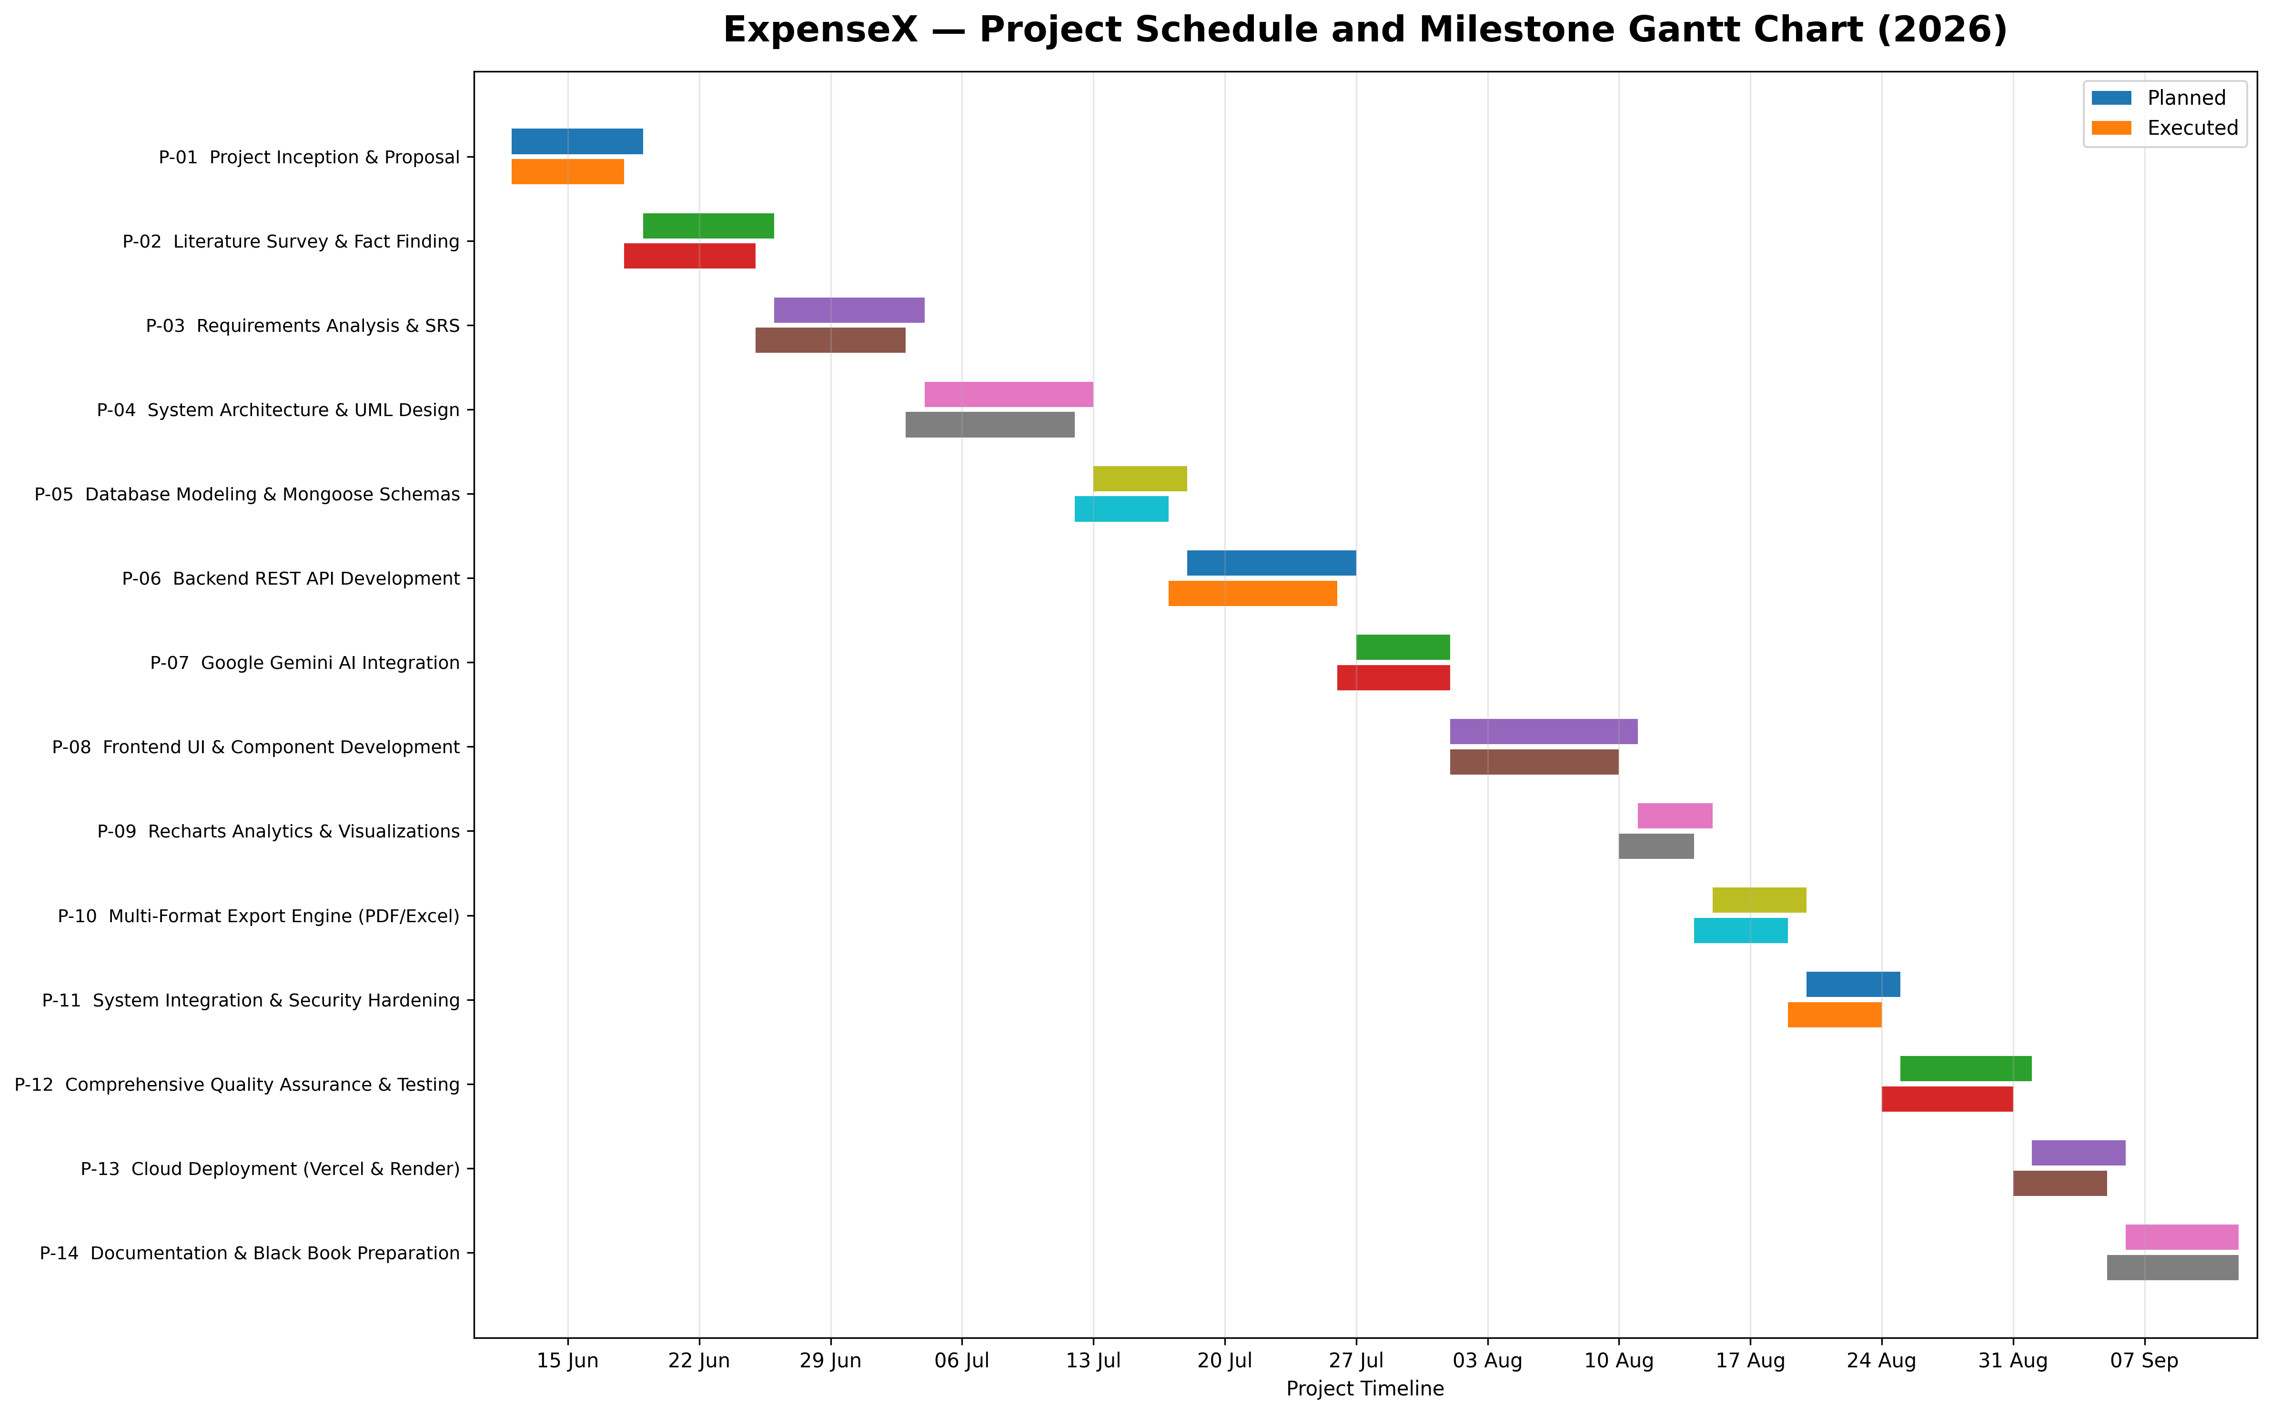

Figure 1.1 — Project Schedule and Milestone Gantt Chart
Technical Explanation for Figure 1.1:
Figure 1.1 illustrates the chronological Gantt chart representing the 16-week project execution timeline for ExpenseX. The project is structured across five major sequential streams: Requirements Engineering, System Design, Backend & AI Engineering, Frontend & Data Visualization, and Quality Assurance & Deployment.
Crucially, the chart highlights the concurrency achieved between Backend REST API creation and Frontend Component wireframing during Weeks 7 through 10, enabled by contract-first API design and mock JSON responses. The critical path spanned the integration of the Google Gemini AI prompt pipeline and the multi-format PDF/Excel streaming controllers, both of which underwent rigorous testing before final cloud deployment on Vercel and Render.

CHAPTER 2
SYSTEM ANALYSIS AND REQUIREMENTS
2.1 Fact Finding Techniques
Requirements engineering for ExpenseX employed a rigorous, multi-pronged fact-finding methodology combining quantitative surveys, interactive rapid prototyping, and market literature analysis to accurately model stakeholder needs.
2.1.1 Questionnaires and Surveys
A structured digital survey comprising 12 quantitative and qualitative questions was administered to a targeted cohort of 120 respondents, including university students (45%), early-career software professionals (35%), and self-employed freelancers (20%). Key questions explored digital payment frequency, satisfaction with existing mobile banking apps, desired visualization tools, and willingness to trust AI-generated financial coaching.
Key empirical findings from the survey revealed:
▪ UPI Dominance: 88% of respondents conduct 5 or more digital micropayments daily, leading to rapid loss of expenditure awareness.
▪ Dissatisfaction with Manual Tracking: 74% had attempted manual spreadsheet or notebook tracking but abandoned it within 3 weeks due to cognitive fatigue.
▪ Demand for Instant Export: 81% requested direct PDF and Excel export capabilities for academic expense reimbursement and tax records.
▪ Receptivity to AI Insights: 79% expressed strong interest in automated AI diagnostics that could detect spending anomalies without requiring accounting expertise.
2.1.2 Prototyping and Iterative Wireframing
An evolutionary prototyping model was adopted to refine the user experience. Low-fidelity Figma wireframes were initially evaluated by a focus group to test navigational ergonomics. User feedback led to key architectural adjustments: eliminating multi-step checkout-style modals in favor of a single-screen transaction modal, integrating real-time category spending badges, and introducing a zero-authentication Guest Mode to facilitate friction-free evaluation.
2.1.3 Market and Literature Study
A technical audit of prevailing commercial applications (Mint, Splitwise, Spendee, Walnut) was conducted. The audit established that existing solutions frequently lock advanced chart filtering and multi-format exports behind monthly subscriptions ($4.99–$9.99/mo), rely heavily on battery-draining background SMS scrapers, and lack generative AI capability to generate synthesized natural language financial summaries. This market gap firmly substantiated the unique positioning of ExpenseX.
2.2 Stakeholder Profiles and Persona Analysis
System requirements were derived from three archetypal user personas:
▪ Persona A: The University Student (Rohan, 21): Needs a rapid way to record daily food, transit, and stationery expenses with zero setup; requires visual category charts to stay within a monthly parental allowance.
▪ Persona B: The Freelance Developer (Pooja, 26): Needs to track diverse income streams across client projects alongside recurring business expenses; requires monthly PDF and Excel statement generation for quarterly tax filing.
▪ Persona C: The Young Professional (Amit, 28): Needs intelligent analysis of discretionary lifestyle spending (dining out, entertainment, shopping) and actionable AI recommendations to optimize monthly savings ratios.
2.3 User Requirements
Synthesizing stakeholder input yielded the following foundational user requirements:
▪ UR-01: The system shall permit rapid registration and login with instantaneous dashboard redirection.
▪ UR-02: The system shall display current financial status (Balance, Income, Expenses) prominently upon login.
▪ UR-03: The system shall allow transactions to be added with minimal inputs (amount, category, type, payment method).
▪ UR-04: The system shall offer instant search and filtering across transaction history without full page reloads.
▪ UR-05: The system shall present interactive visual charts summarizing expenditures by category and chronological month.
▪ UR-06: The system shall provide an automated, on-demand AI financial evaluation delivering objective health scores.
▪ UR-07: The system shall allow complete ledger records to be downloaded in PDF, Excel, CSV, and JSON formats.
▪ UR-08: The system shall allow users to modify their personal profiles and cryptographically update passwords securely.
2.4 Functional Requirements Matrix
The complete functional requirements specification (FRS) for ExpenseX is detailed in Table 2.1, documenting input parameters, processing rules, outputs, and priority levels for each module:
Table 2.1: Comprehensive Functional Requirements Matrix (FR-01 to FR-15)
Req ID | Requirement Name | Description & Scope | Priority | Input Parameters | Internal Processing Logic | Expected Output
FR-01 | User Registration | Onboard new user accounts into MongoDB | High | name, email, password | Validate fields, verify uniqueness, hash password via bcrypt(10), create User doc | HTTP 201 + JWT Token + User object
FR-02 | User Login | Authenticate returning users and issue token | High | email, password | Query user by email, compare password hash via bcrypt.compare(), issue JWT token | HTTP 200 + Bearer JWT Token
FR-03 | Guest Demo Mode | Allow zero-barrier app exploration | Medium | None (button trigger) | Initialize demoUser and demoTransactions in localStorage without calling backend | Instant dashboard access with mock data
FR-04 | Dashboard Metrics | Compute live balance and summary totals | High | JWT Bearer Token | Fetch all user transactions, aggregate totalIncome, totalExpense, calculate balance | HTTP 200 + Dashboard summary object
FR-05 | Create Transaction | Persist new monetary cash flow record | High | type, amount, category, paymentMethod, desc, date | Verify token, validate amount >= 1, validate enums, save Transaction document | HTTP 201 + Created Transaction doc
FR-06 | Paginated Retrieval | Fetch transactions with pagination | High | page, limit, JWT Token | Extract user ID from token, calculate skip=(page-1)*limit, sort {date: -1}, count total | HTTP 200 + Transactions array + pages
FR-07 | Update Transaction | Modify an existing transaction record | Medium | id, type, amount, category, paymentMethod, date | Verify user ownership (_id & user), apply updated fields, call save() | HTTP 200 + Updated Transaction doc
FR-08 | Delete Transaction | Remove a transaction from the database | Medium | id, JWT Token | Verify ownership (_id & user), invoke deleteOne(), cascade metrics | HTTP 200 + Success confirmation message
FR-09 | Category Analytics | Aggregate expenses grouped by category | High | JWT Bearer Token | Query user expenses, aggregate sum per category, format key-value pairs | HTTP 200 + categoryData JSON object
FR-10 | Monthly Analytics | Aggregate longitudinal monthly expenses | High | JWT Bearer Token | Query user expenses, extract month string, aggregate amounts, sort calendar order | HTTP 200 + monthlyExpense array
FR-11 | AI Insights Engine | Generate AI financial health analysis | High | JWT Bearer Token | Compute summary, build prompt, call Gemini 2.5 Flash, strip markdown, parse JSON | HTTP 200 + Structured AI insights JSON
FR-12 | PDF Export Engine | Stream downloadable PDF audit report | High | JWT Token, optional date range | Fetch transactions, calculate net totals, render PDFKit document stream with table layout | HTTP 200 + application/pdf stream
FR-13 | Excel Export Engine | Generate styled spreadsheet report | High | JWT Token, optional date range | Query transactions, populate ExcelJS workbook, format headers, stream .xlsx file | HTTP 200 + application/vnd.ms-excel
FR-14 | CSV & JSON Export | Generate standard flat data exports | Medium | JWT Token | Use json2csv parser for CSV; serialize raw JSON array with ISO dates | HTTP 200 + text/csv or application/json
FR-15 | Profile & Password | Update profile details & change password | Medium | name, email, currentPassword, newPassword | Verify current password via bcrypt, hash new password, persist updated User doc | HTTP 200 + Profile updated confirmation

2.5 Non-Functional Requirements Specification
Non-functional requirements (NFRs) define the operational quality, security benchmarks, performance criteria, and system constraints governing ExpenseX, as summarized in Table 2.2:
Table 2.2: Non-Functional Software Quality Requirements Specification
NFR ID | Quality Attribute | Specification Criterion | Target Benchmark / Implementation Metric
NFR-01 | Performance & Latency | API response time for standard CRUD operations | Average response time < 150 ms under normal network conditions
NFR-02 | Throughput & Scalability | Capacity to handle concurrent API requests | Stateless Express middleware handles 500+ concurrent requests/sec
NFR-03 | Data Security | Protection of authentication credentials at rest | Passwords hashed via bcrypt with salt rounds = 10; never stored in plaintext
NFR-04 | Session Authorization | Stateless token-based authorization mechanism | HMAC-SHA256 signed JWT tokens with 7-day validity duration
NFR-05 | User Isolation | Cross-tenant data privacy and ownership control | All database read/write queries strictly scoped to req.user._id
NFR-06 | Availability & Uptime | Platform accessibility across production clouds | Targeting 99.9% uptime leveraging Render and Vercel SLA guarantees
NFR-07 | Usability & Responsiveness | Seamless rendering across diverse viewport sizes | Mobile-first responsive design supporting viewports from 320px to 4K
NFR-08 | AI Parsing Resilience | Resilience against malformed LLM responses | Automated regex stripping of markdown fences + structured JSON fallback
NFR-09 | Maintainability & Clean Code | Modularity of frontend and backend codebases | Decoupled MVC architecture with separation of routes, controllers, and services
NFR-10 | Data Portability | User ability to extract full financial records | Zero vendor lock-in with 1-click export to PDF, Excel, CSV, and JSON

2.6 Hardware and Software Specifications
System specifications require that client devices run any standard ECMAScript 2020-compliant modern web browser (Google Chrome 90+, Mozilla Firefox 88+, Apple Safari 14+, Microsoft Edge 90+) with JavaScript and LocalStorage enabled. On the hosting infrastructure side, Node.js v20.x runtime with minimum 512 MB RAM executes the backend service, while MongoDB Atlas M0 cluster provisions cloud document storage with TLS 1.3 transport encryption.
2.7 User Roles and Access Levels
ExpenseX defines clear operational roles and privilege boundaries, documented in Table 2.3:
Table 2.3: User Roles, Permissions, and Access Privilege Matrix
User Role | Authentication Requirement | Storage Target | Permitted System Actions & Capabilities | Restrictions
Guest / Demo User | None (instant trial trigger) | Client Browser LocalStorage | Explore mock dashboard, add/edit/delete simulated transactions, view sample charts, test UI | Data is lost upon clearing browser cache; no AI cloud API calls; no cloud sync
Registered User | Email + Password (JWT Token) | MongoDB Atlas Cloud Cluster | Full persistent CRUD, real-time analytics, AI Gemini insight generation, PDF/Excel/CSV exports, profile settings | Can only access personal records; strictly isolated from other users' financial data
System Backend | API Key / JWT Verification | Server RAM / MongoDB | Authorize requests, execute Mongoose queries, construct AI prompts, generate file streams | Stateless execution; no persistent session memory outside database

2.8 System Constraints and Business Rules
The operation of ExpenseX is governed by strict domain-specific business rules enforced at both client and server layers:
▪ BR-01 (Monetary Positivity): Transaction amount must be a positive numerical value greater than or equal to 1. Negative amounts are rejected; cash flow direction is strictly defined by the 'type' attribute (income vs expense).
▪ BR-02 (Category Integrity): Every transaction must possess a non-empty, trimmed category identifier (e.g., Food, Travel, Rent, Utilities, Salary).
▪ BR-03 (Payment Method Whitelist): Payment method must strictly match one of the predefined system enums: Cash, UPI, Debit Card, Credit Card, Bank Transfer, Net Banking, or Wallet.
▪ BR-04 (Email Uniqueness): User registration requires a syntactically valid, unique email address. Duplicate registration attempts return an explicit 'Already Registered' message.
▪ BR-05 (Password Verification): Password modification requires explicit verification of the user's existing password before the new password hash is committed to the database.
2.9 Assumptions and Technical Dependencies
System functionality is designed under the following realistic technical assumptions:
▪ Network Availability: The client device maintains an active internet connection to communicate with the Express REST API and MongoDB Atlas cloud.
▪ Third-Party API Uptime: The Google Gemini AI service maintains standard cloud availability; in the event of upstream rate limits or outages, the ExpenseX AI service gracefully catches exceptions and serves an informative fallback message.
▪ Browser Storage Quota: The user's web browser permits standard HTML5 LocalStorage operations (typically 5 MB allocation) for caching the active JWT authentication token and Guest Mode dataset.
2.10 Use Case Analysis and Modeling
Use case analysis captures the interaction dynamics between human actors and the ExpenseX software boundary. The primary actors comprise the Registered User, the Guest User, the Express Backend API, and the Google Gemini AI Engine.
2.10.1 Detailed Use Case Descriptions
▪ UC-01: User Authentication: Actor logs in using email and password. System validates credentials via bcrypt. On success, system signs a JWT token and returns it to the client, which caches it in LocalStorage and routes to /dashboard.
▪ UC-02: Manage Transactions: Actor adds, views, edits, or deletes an expense or income entry. System validates fields, executes Mongoose CRUD operation scoped to req.user._id, and returns updated JSON state with toast notifications.
▪ UC-03: View Analytics & Charts: Actor navigates to /analytics. System requests aggregated categorical and monthly expense endpoints. Recharts dynamically renders responsive Pie and Line charts with interactive hover tooltips and drill-down lists.
▪ UC-04: Generate AI Financial Insights: Actor opens /ai and clicks 'Refresh'. Express backend fetches user transactions, aggregates metrics, builds a prompt, queries Gemini 2.5 Flash, parses structured JSON, and displays diagnostic health cards.
▪ UC-05: Export Financial Statements: Actor selects a report format (PDF, Excel, CSV, JSON) and optional date range. Backend streams generated binary file directly to browser with appropriate Content-Disposition headers for instantaneous file download.
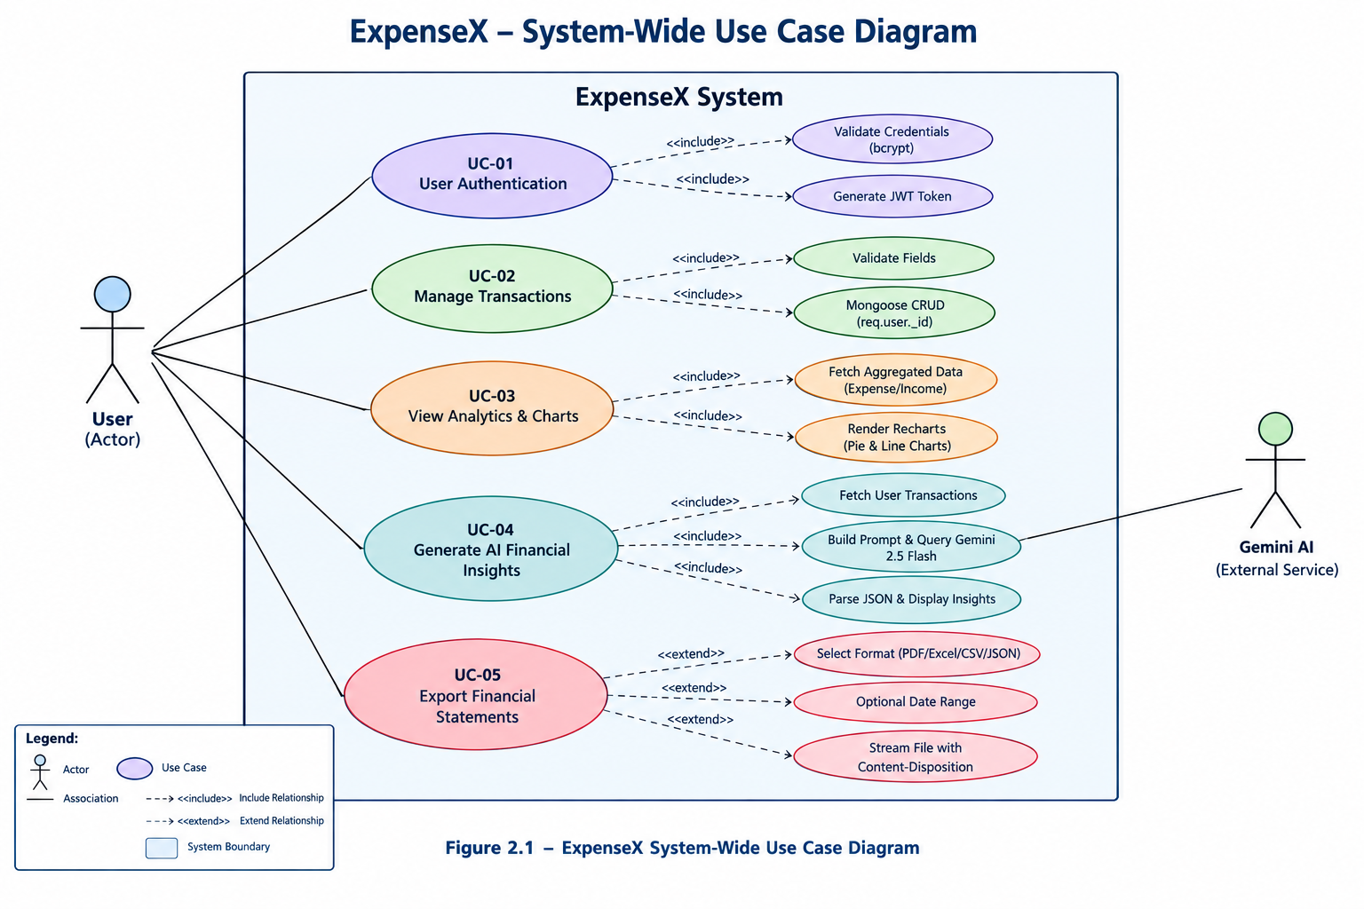
Figure 2.1 — ExpenseX System-Wide Use Case Diagram
Technical Explanation for Figure 2.1:
Figure 2.1 illustrates the comprehensive Use Case Diagram for the ExpenseX platform. The diagram delineates the system boundary, identifying the Registered User and Guest User as primary human actors, while the Google Gemini API and MongoDB Atlas Cloud act as secondary system actors.
Core use cases include Authenticate (Login/Register), View Dashboard, Manage Transactions (Add, Edit, Delete, Filter, Search), Analyze Visual Charts (Category Pie Chart, Monthly Trend Line), Generate AI Financial Insights, Export Reports (PDF, Excel, CSV, JSON), and Manage User Profile. Dashed lines illustrate <<include>> relationships, such as Manage Transactions including Verify Token, and <<extend>> relationships, such as Filter Transactions extending View Transactions.
2.11 Dynamic Activity Diagrams
Activity diagrams model the sequential logic and conditional decision branches governing key system workflows.
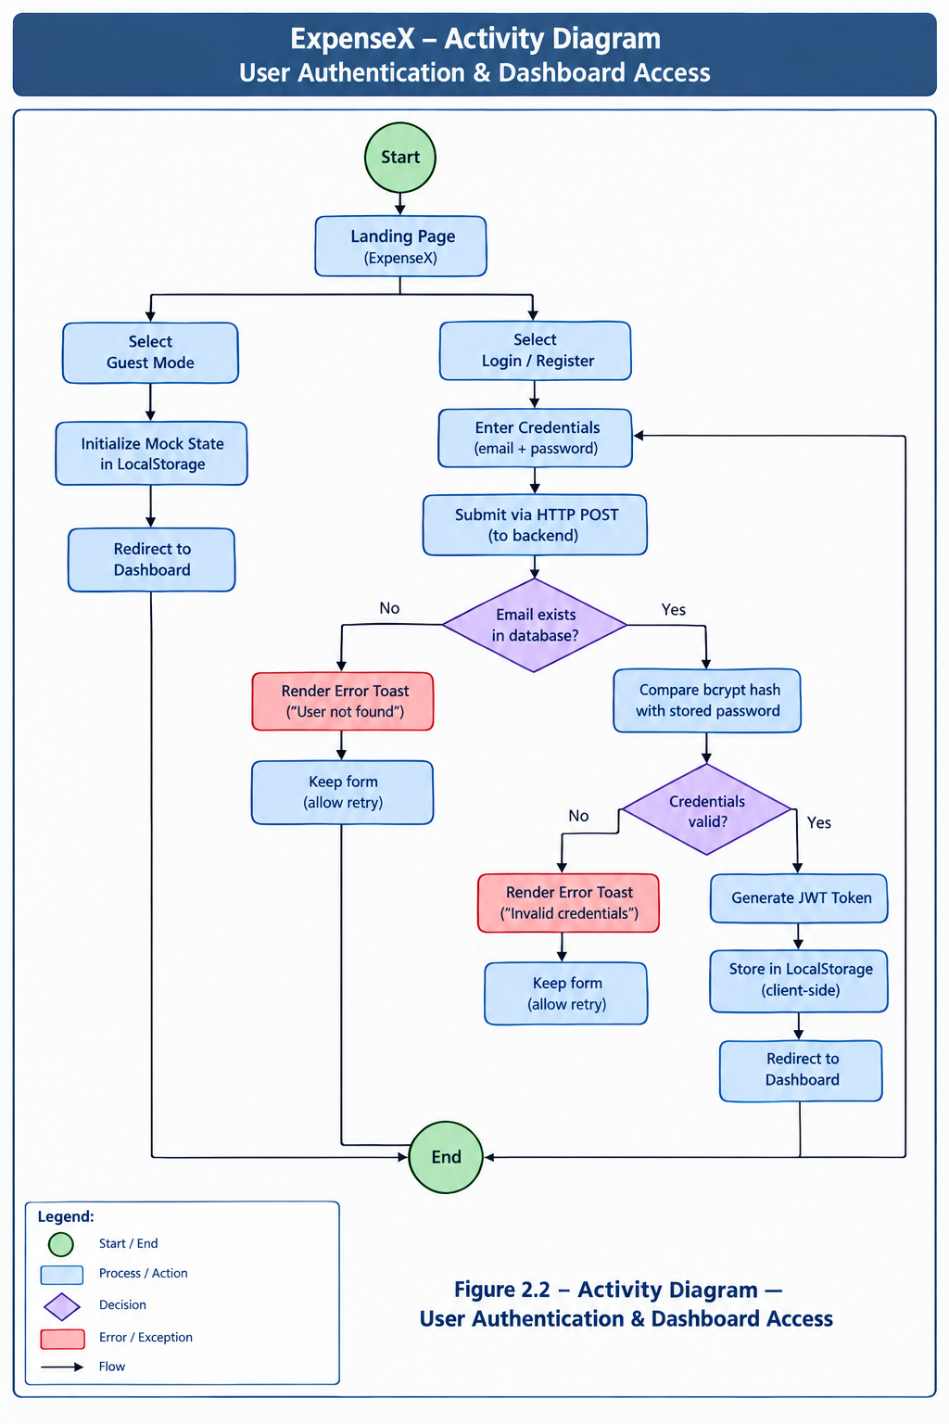
Figure 2.2 — Activity Diagram — User Authentication & Dashboard Access
Technical Explanation for Figure 2.2:
Figure 2.2 depicts the User Authentication & Dashboard Access Activity Diagram. The workflow begins at the Landing Page. If the user selects Guest Mode, mock state is initialized in LocalStorage and the user immediately enters the Dashboard.
If the user chooses Login or Register, credentials are submitted via HTTP POST. The backend checks email existence and compares the bcrypt hash. If credentials are invalid, an error toast is rendered and the form is preserved. If valid, a JWT token is issued, stored in client LocalStorage, and the user is redirected to the dynamic Dashboard.
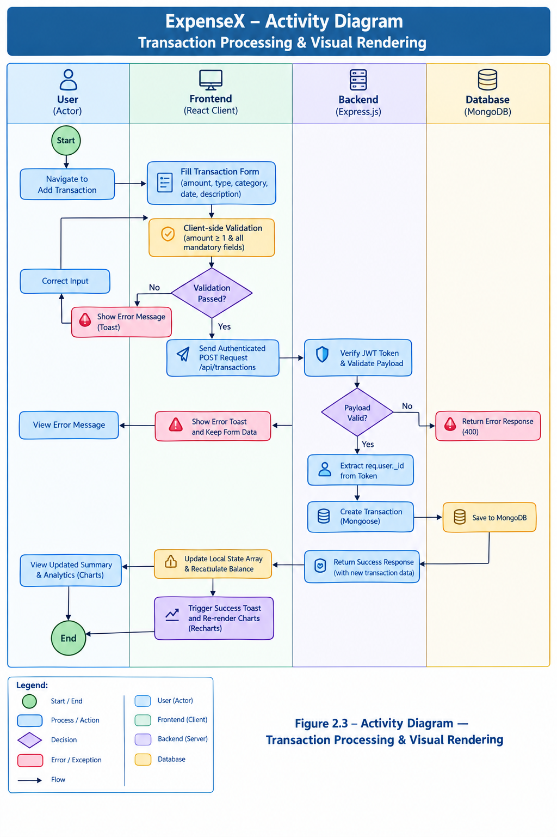
Figure 2.3 — Activity Diagram — Transaction Processing & Visual Rendering
Technical Explanation for Figure 2.3:
Figure 2.3 presents the Transaction Processing and Visual Chart Rendering Activity Diagram. The user fills the Add Transaction form. The client validates that amount >= 1 and all mandatory fields are present before dispatching an authenticated POST request to /api/transactions.
The Express backend validates the payload, extracts req.user._id from the verified JWT token, and writes the document to MongoDB. Upon successful return, the client updates the local state array, triggers a success toast, and dynamically recalculates the summary balance cards and Recharts analytical graphs without requiring a full page refresh.
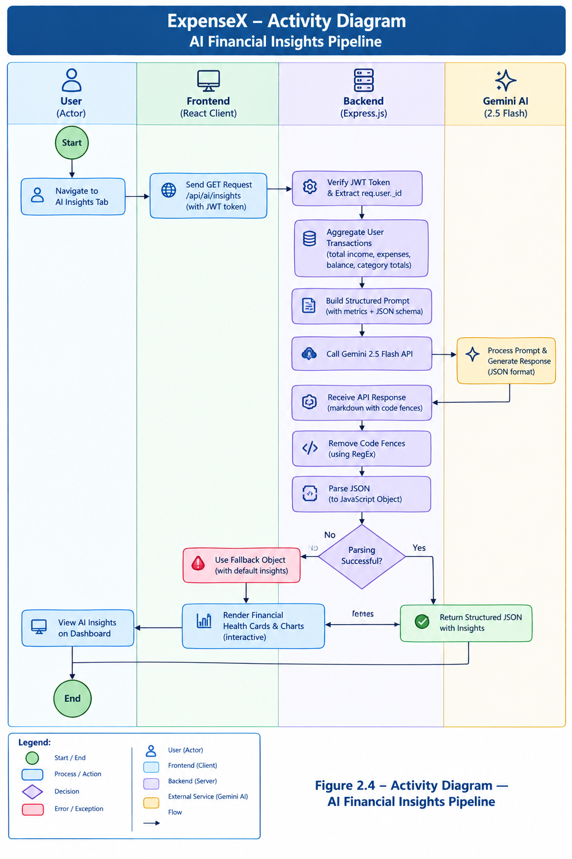
Figure 2.4 — Activity Diagram — AI Financial Insights Pipeline
Technical Explanation for Figure 2.4:
Figure 2.4 portrays the AI Financial Insights Synthesis Activity Diagram. When the user navigates to the AI Insights tab, the client dispatches a GET request to /api/ai/insights. The backend aggregates all transactions belonging to the user, computing total income, total expenses, balance, and category-wise spending totals.
These metrics are injected into a structured engineering prompt that mandates strict JSON output. The backend calls the Gemini 2.5 Flash endpoint. Upon response arrival, markdown code fences are stripped via regular expressions and the string is parsed into a JavaScript object. If parsing succeeds, the structured JSON is returned to the client and rendered into interactive financial health cards; if an exception occurs, a graceful fallback object is returned.
CHAPTER 3
EXISTING SYSTEM AND PROPOSED SYSTEM
3.1 Detailed Investigation of Existing Systems
To establish a solid scientific foundation for ExpenseX, an exhaustive investigation was conducted into the three dominant paradigms of personal expense tracking currently employed across consumer domains:
▪ 1. Manual Paper Ledgers and Physical Notebooks: The oldest accounting methodology, characterized by physical journal entries organized in debit/credit columns. While entirely private and zero-cost, it requires arduous physical recordkeeping, cannot scale, offers zero backup against fire, water, or physical loss, and requires tedious manual arithmetic.
▪ 2. Electronic Desktop Spreadsheets (Excel / Google Sheets): A popular computerized alternative where users set up grid columns for date, category, and amount. While computational math errors are mitigated through sum formulas, spreadsheets remain passive files that lack automated cross-device syncing, responsive mobile views, or intelligent guidance.
▪ 3. Commercial Native Mobile Applications: Modern app-store budgeting apps (Mint, Splitwise, Spendee, Money Manager). While visually polished, these apps suffer from aggressive monetization models, intrusive third-party ads, paid paywalls for basic features like CSV/PDF exports, and privacy-invasive tracking of banking credentials.
3.2 Problems in Existing Accounting and Tracking Approaches
Systemic analysis reveals critical bottlenecks across these existing paradigms:
1. High Friction and User Abandonment: Manual logging requires repetitive typing without intelligent category auto-completion, causing over 70% of users to abandon budgeting within the first month.
2. Data Insecurity and Cloud Lock-In: Commercial tools frequently trap user data within proprietary database formats, making it exceedingly difficult or expensive to export complete transaction histories if the user chooses to switch platforms.
3. Absence of Behavioral Context: Existing tools merely display historical tallies. They do not evaluate whether a 40% expenditure on dining out is perilous relative to the user's income or calculate a personalized financial health score.
4. Rigid Infrastructure Overhead: Traditional enterprise accounting software requires local runtime installations, database setup, and heavy hardware resources, rendering them impractical for everyday personal tracking.
3.3 Limitations Matrix of Existing Systems
The technical and functional limitations of existing systems are summarized below:
▪ Computational Incapacity: Paper ledgers possess zero capacity for automatic summation, category aggregation, or statistical deviation analysis.
▪ Formula Brittleness: Spreadsheet workbooks frequently break when rows are inserted or deleted, disrupting underlying formula ranges (e.g., #REF! or #VALUE! errors).
▪ Intrusive Monetization: Free commercial apps monetize consumer attention through disruptive banner advertisements, video popups, and financial product upsells.
▪ Lack of AI Reasoning: No prevailing traditional tool integrates generative large language models to interpret spending habits and offer dynamic, conversational financial advice.
3.4 Proposed ExpenseX Architectural Solution
ExpenseX eliminates these limitations by introducing a unified, open-source, full-stack web application designed with modern software engineering best practices. Built on the MERN stack (React 19, Node.js, Express 5, MongoDB Atlas), ExpenseX delivers a single, cohesive platform that provides:
▪ Full Platform Independence: Runs seamlessly in any modern web browser across Windows, macOS, Linux, Android, and iOS without requiring app store installation.
▪ Stateless Cloud Synchronization: Transactions saved to MongoDB Atlas are instantly reflected across all logged-in devices via RESTful API calls governed by JWT tokens.
▪ Zero-Friction Guest Mode: Empowers prospective users to evaluate all platform features instantly using browser LocalStorage simulation without requiring immediate credential registration.
▪ Automated AI Analysis: Translates raw numbers into natural-language diagnostic advice, financial scores, and alerts via the Google Gemini 2.5 Flash API.
▪ Universal Data Portability: Guarantees complete data sovereignty by enabling one-click streaming exports of ledgers into PDF, Excel, CSV, and JSON formats.
3.5 Proposed System Workflow and Operational Life Cycle
The end-to-end operational life cycle of ExpenseX follows a streamlined five-stage workflow:
Stage 1. Onboarding & Session Creation: The user accesses the landing page, reviews platform capabilities, and authenticates via Login, Registration, or Guest Mode. The backend validates credentials and issues a stateless JWT token.
Stage 2. Transaction Capture & Ledger Maintenance: The user records cash flows via the Add Transaction modal. Express validates data types and business constraints, persisting records to MongoDB Atlas.
Stage 3. Metric Aggregation & Visual Rendering: The frontend queries /api/dashboard and /api/analytics, computing Net Balance and populating dynamic Recharts Pie and Line components.
Stage 4. Intelligent AI Diagnosis: The user navigates to /ai. The backend aggregates categorical distributions, builds an engineered prompt, invokes the Gemini 2.5 Flash model, and delivers a structured JSON financial health card.
Stage 5. Audit Reporting & Export: The user filters transactions by date range and downloads an official financial statement formatted in PDF, Excel (.xlsx), CSV, or JSON.
3.6 Major Features and Module Highlights
▪ Security & Auth Module: Salted bcrypt password hashing, JWT token signing, authorization middleware, protected SPA route guards, profile updates, and secure password modification.
▪ Dashboard Module: Visual overview featuring Net Balance, Total Income, Total Expenses, Total Transaction Count cards, and a live Recent Transactions feed.
▪ Transaction CRUD Module: Full lifecycle management of monetary entries with type toggle, category picker, payment method selector, date picker, search bar, category filter, and pagination.
▪ Interactive Analytics Module: Recharts-powered Expense Category Pie Chart with interactive drill-down transaction lists, and Monthly Expense Line Chart showing longitudinal trends.
▪ AI Financial Insights Module: Integration with Google Gemini 2.5 Flash, providing Financial Health Scores (0-100), Spending Analyses, Savings Recommendations, Smart Alerts, and Next Month Goals.
▪ Multi-Format Export Module: High-performance server-side document streaming for PDF (PDFKit), Excel (ExcelJS), CSV (json2csv), and JSON formats.
3.7 Functional Advantages of ExpenseX
ExpenseX offers definitive functional advantages over legacy and commercial alternatives:
▪ Efficiency & Speed: Instantaneous UI updates using React 19 virtual DOM reconciliation and lightweight JSON REST APIs.
▪ Transparency & Privacy: Zero third-party trackers, zero advertising banners, and complete data isolation.
▪ Actionable Intelligence: Transforms passive transaction tables into proactive behavioral coaching via generative AI.
▪ Zero Operational Cost: Completely open-source, eliminating recurring user subscription fees.
3.8 Technical Comparison Between Existing Systems and ExpenseX
Table 3.1 provides an exhaustive feature-by-feature comparative analysis contrasting traditional paper logs, electronic spreadsheets, commercial mobile apps, and the ExpenseX platform:

Table 3.1: Comparative Analysis Matrix: Existing Systems vs ExpenseX Platform
Evaluation Criterion | Paper Ledgers | Desktop Spreadsheets | Commercial Mobile Apps | ExpenseX Platform
Data Entry Speed | Slow (Manual pen/paper) | Moderate (Keyboard typing) | Fast (Touchscreen forms) | Fast (Intuitive modal + validation)
Mathematical Accuracy | Low (Human calculation error) | High (Formula-driven) | High (Automated backend) | High (Mongoose + Server validation)
Cross-Device Portability | None (Physical bound book) | Low (Requires local file sync) | Moderate (Mobile OS locked) | Universal (Browser-accessible SPA)
Automated Visual Analytics | None (Manual graphing required) | Manual (User designs charts) | Pre-set (Often paywalled) | Dynamic (Recharts Pie & Line charts)
AI Behavioral Coaching | None | None | None or static rule-based | Advanced (Google Gemini 2.5 Flash)
Data Export Formats | None | Native XLSX / CSV only | Limited / Paid subscription | Full (PDF, Excel, CSV, JSON free)
User Privacy & Security | High (Physical) / Low (No pass) | Variable (Local password) | Low (Ad tracking / Data sales) | High (Stateless JWT + Bcrypt + Zero Ads)
Zero-Barrier Trial Mode | N/A | N/A | Rare (Requires email/phone signup) | Yes (Full Guest Mode simulation)
Recurring Licensing Cost | Minimal (Paper cost) | Office 365 Subscription fee | Freemium ($4.99–$9.99/month) | 100% Free & Open Source (MIT)

3.9 Scope of Improvement and Long-Term Value
While ExpenseX successfully resolves the core limitations of existing financial tools, the system is architected with high extensibility to support future enhancements, including cross-platform mobile apps (React Native), category-specific budget caps with threshold alerts, recurring subscription schedules, and multi-currency foreign exchange support.

CHAPTER 4
SYSTEM DESIGN
4.1 System Architecture Overview
System design represents the critical phase in software engineering where abstract functional requirements and user expectations are transformed into a concrete, robust technical blueprint. For ExpenseX, the overarching design philosophy centers upon modularity, low coupling, high cohesion, stateless scalability, and strict separation of concerns (SoC). The system adheres to modern web engineering patterns, decoupling the client presentation layer from server-side business logic and database persistence.
4.2 High-Level Three-Tier Architecture
ExpenseX is structured as an enterprise-grade three-tier distributed web architecture, comprising:
▪ 1. Presentation Layer (Frontend Client): Built with React 19 and bundled via Vite, this layer executes within the end-user's web browser. It manages application routing, component hierarchy, UI state, user input capture, form validation, dynamic Recharts rendering, and asynchronous HTTP communication via fetch and Axios APIs.
▪ 2. Application & Business Logic Layer (RESTful API Server): Implemented using Node.js and Express.js 5, this middle tier acts as the central orchestrator. It receives HTTP requests, enforces Cross-Origin Resource Sharing (CORS) rules, executes JWT token verification middleware, processes business logic across domain controllers, streams generated PDF/Excel documents, and interfaces with the Google Gemini AI inference endpoint.
▪ 3. Data & Cognitive Intelligence Layer (Persistence & AI Services): Comprises MongoDB Atlas, a managed cloud NoSQL database storing user profiles and transaction documents, and Google Cloud's Gemini AI service, which provides large language model cognitive intelligence for financial health scoring.
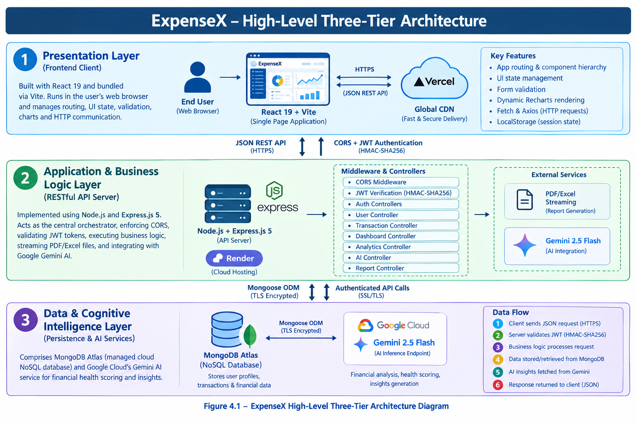
Figure 4.1 — ExpenseX High-Level Three-Tier Architecture Diagram
Technical Explanation for Figure 4.1:
Figure 4.1 illustrates the high-level three-tier system architecture of the ExpenseX platform. At the top tier, the end-user interacts with the React 19 Single Page Application delivered via Vercel's global Content Delivery Network (CDN). The client maintains local session state and communicates asynchronously with the backend server via JSON RESTful API calls.
At the middle tier, the Express.js server hosted on Render Cloud intercepts incoming requests. It routes traffic through custom authentication middleware, validating HMAC-SHA256 signed JSON Web Tokens. Authorized requests are routed to specific controllers: authControllers, userController, transactionController, dashboardController, analyticsController, aiController, and reportController.
At the bottom tier, the backend communicates with MongoDB Atlas via Mongoose ODM over an encrypted TLS connection. For AI analytics, the aiService formats aggregated financial statistics and dispatches an authenticated API request to Google's Gemini 2.5 Flash model, parsing the returned JSON payload before delivering actionable insights back to the client.
4.3 Frontend Client Architecture (React 19 & Vite)
The frontend client is engineered as a responsive Single Page Application (SPA) leveraging the latest React 19 library. The architecture is characterized by:
▪ Component-Driven Design: The UI is constructed from reusable, self-contained functional components categorized into presentation cards (SummaryCards, AIInsightCard), interactive forms (TransactionForm, PasswordInput), visualizers (ExpenseCategoryChart, MonthlyExpenseChart), layout wrappers (DashboardLayout, Sidebar, Navbar), and full-page views (Dashboard, Transactions, Analytics, AIInsights, Reports, Settings, Landing).
▪ Declarative Client Routing: React Router v7 governs client-side page transitions without incurring full browser page reloads. A custom <Auth> higher-order wrapper inspects localStorage tokens, protecting private routes (/dashboard, /transactions, /analytics, /ai, /reports, /settings) and redirecting unauthenticated visitors to /auth.
▪ Next-Generation Bundling via Vite: Vite 8 utilizes native ES modules (ESM) during development to achieve sub-second server startup and instant Hot Module Replacement (HMR). In production, Vite leverages Rollup to produce highly minified, tree-shaken JavaScript and CSS bundles.
▪ Reactive Data Layer & Dual Execution Mode: The client implements an abstracted data service layer (dataService.js) that inspects application state. When operating in Guest Mode, calls are redirected to demoService.js which simulates responses using browser LocalStorage; in authenticated mode, calls route to apiService.js, dispatching live authenticated HTTP requests to the backend.
4.4 Backend Server Architecture (Node.js & Express 5)
The backend server is architected on Node.js utilizing the Express.js 5 framework. Express organizes functionality into an asynchronous middleware pipeline. Key architectural highlights include:
▪ DNS Resolver Optimization: To prevent DNS lookup latency and SRV resolution failures common in distributed cloud environments, server.js explicitly configures Google and Cloudflare public DNS resolvers (8.8.8.8, 1.1.1.1) via node:dns.
▪ Strict CORS Filtering: A dynamic Cross-Origin Resource Sharing middleware inspects the Origin header of incoming requests against an explicit whitelist comprising local development URLs (http://localhost:5173) and the production frontend URL (FRONTEND_URL), rejecting unauthorized cross-site requests.
▪ Modular Route Separation: Endpoints are partitioned into discrete domain routers (/api/auth, /api/users, /api/transactions, /api/dashboard, /api/analytics, /api/reports, /api/ai), each delegating to dedicated controller modules.
4.5 Database and Storage Architecture (MongoDB Atlas)
Data persistence is managed through MongoDB Atlas, a managed cloud NoSQL document store. MongoDB's BSON (Binary JSON) storage paradigm maps natively to JavaScript object representations in Node.js and React, eliminating object-relational impedance mismatch. Mongoose 8 provides schema-level validation, type casting, middleware hooks, and query compilation, ensuring enterprise-grade data integrity.
4.6 RESTful API Architectural Design
ExpenseX adheres strictly to REST (Representational State Transfer) architectural principles:
▪ Stateless Communication: Every request contains all context necessary for execution; the server retains no client session state in memory.
▪ Resource-Oriented URI Schema: Endpoints represent nouns identifying core domain resources (/api/transactions, /api/users/profile, /api/dashboard).
▪ Standard HTTP Verbs: Operations map directly to standard HTTP methods: GET (retrieve resource), POST (create resource), PUT (update resource), and DELETE (remove resource).
▪ Semantic HTTP Status Codes: Responses convey operational outcomes via standard RFC codes: 200 OK, 201 Created, 400 Bad Request, 401 Unauthorized, 404 Not Found, and 500 Internal Server Error.
4.7 Authentication and Authorization Architecture (JWT)
Authentication is architected upon the cryptographic JSON Web Token standard (RFC 7519). Upon successful user registration or login, the backend signs a compact, URL-safe token containing the user's MongoDB ObjectId (decoded.id), issued at timestamp (iat), and expiration timestamp (exp set to 7 days). The token is signed using the HMAC-SHA256 algorithm with a cryptographically secure server-side secret (JWT_SECRET).
Subsequent client requests include this token in the HTTP Authorization header using the standard Bearer scheme: 'Authorization: Bearer <token>'. The protect middleware intercepts each request, verifies token integrity and expiration, queries MongoDB to ensure user existence (excluding password hash via .select('-password')), and attaches the active user document to req.user. This guarantees that all downstream controllers operate strictly within the authenticated user's isolated data sandbox.
4.8 Data Flow Diagrams (DFD)
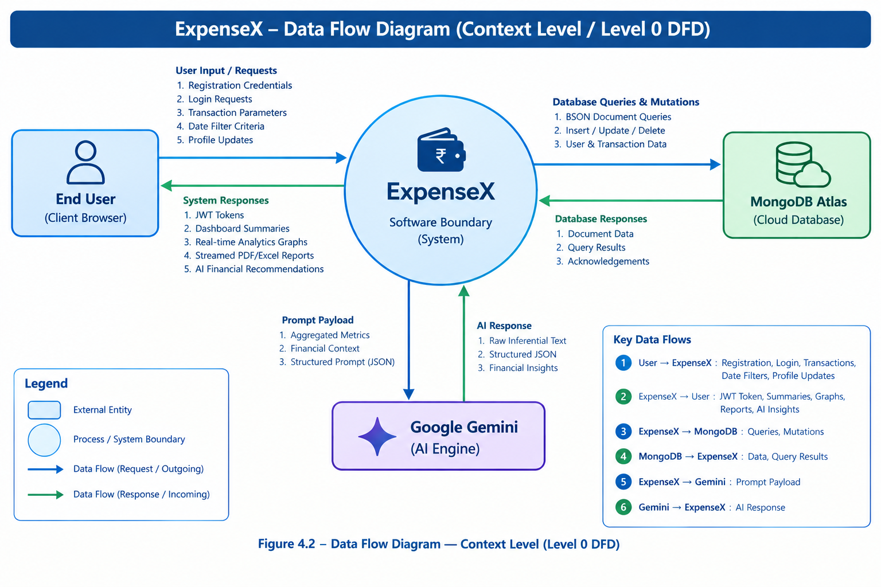
Figure 4.2 — Data Flow Diagram — Context Level (Level 0 DFD)
Technical Explanation for Figure 4.2:
Figure 4.2 portrays the Context-Level Data Flow Diagram (Level 0 DFD) for ExpenseX. The central bubble represents the unified ExpenseX Software Boundary. The primary external entities comprise the End User (Client Browser), MongoDB Atlas Cloud Database, and Google Gemini AI Engine.
The User supplies registration credentials, login requests, transaction parameters, date filter criteria, and profile updates. The ExpenseX system responds with JWT tokens, dashboard summaries, real-time analytics graphs, streamed PDF/Excel audit reports, and structured AI financial recommendations. The system exchanges BSON document queries and mutation commands with MongoDB, and dispatches structured prompt payloads to Gemini AI, receiving raw inferential text responses.
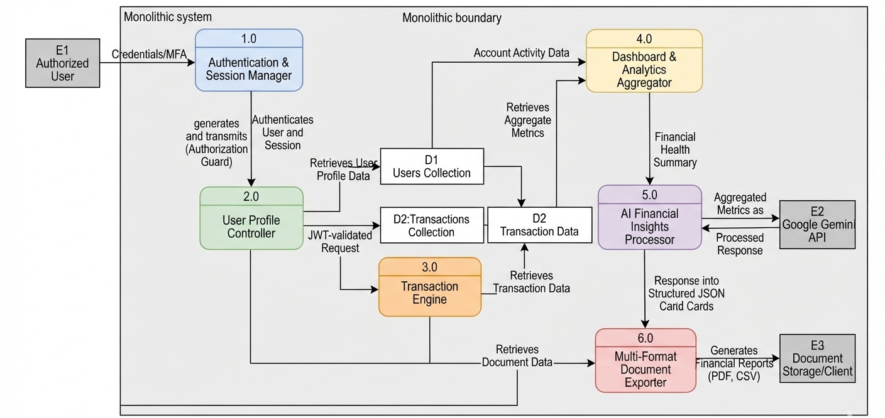
Figure 4.3 — Data Flow Diagram — Subsystem Decomposition (Level 1 DFD)
Technical Explanation for Figure 4.3:
Figure 4.3 details the Level 1 Data Flow Diagram, decomposing the monolithic system boundary into six discrete functional subsystems: 1.0 Authentication & Session Manager, 2.0 User Profile Controller, 3.0 Transaction Lifecycle Engine, 4.0 Dashboard & Analytics Aggregator, 5.0 AI Financial Insights Processor, and 6.0 Multi-Format Document Exporter.
The diagram illustrates the flow of JWT tokens from Process 1.0 into downstream processes 2.0 through 6.0 as an authorization guard. Processes 2.0, 3.0, 4.0, 5.0, and 6.0 interact directly with two core data stores: D1 (Users Collection) and D2 (Transactions Collection). Process 5.0 dispatches aggregated financial metrics to external entity E2 (Google Gemini API), transforming the response into structured JSON cards for user consumption.
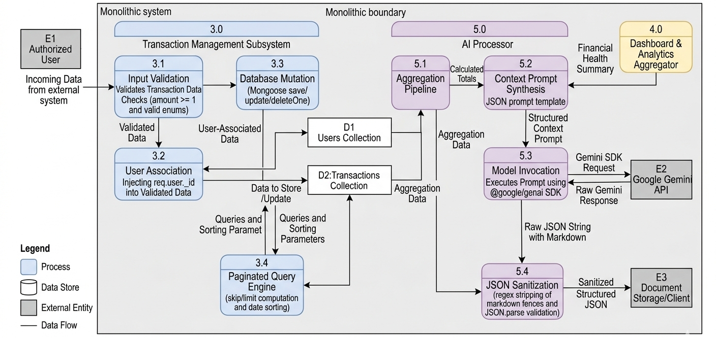
Figure 4.4 — Data Flow Diagram — Detailed Transaction & AI Engine (Level 2 DFD)
Technical Explanation for Figure 4.4:
Figure 4.4 presents the detailed Level 2 Data Flow Diagram focusing on the Transaction Management Subsystem (3.0) and AI Processor (5.0). Process 3.0 is partitioned into 3.1 Input Validation (verifying amount >= 1 and valid enums), 3.2 User Association (injecting req.user._id), 3.3 Database Mutation (Mongoose save/update/deleteOne), and 3.4 Paginated Query Engine (skip/limit computation and date sorting).
Process 5.0 is decomposed into 5.1 Aggregation Pipeline (summing income, expense, and category totals), 5.2 Context Prompt Synthesis (injecting totals into JSON prompt template), 5.3 Model Invocation (@google/genai SDK execution), and 5.4 JSON Sanitization (regex stripping of markdown fences and JSON.parse validation).
4.9 Class Diagrams and Domain Model
The object-oriented design of ExpenseX bridges Mongoose data schemas, Express middleware controllers, and frontend service abstractions.
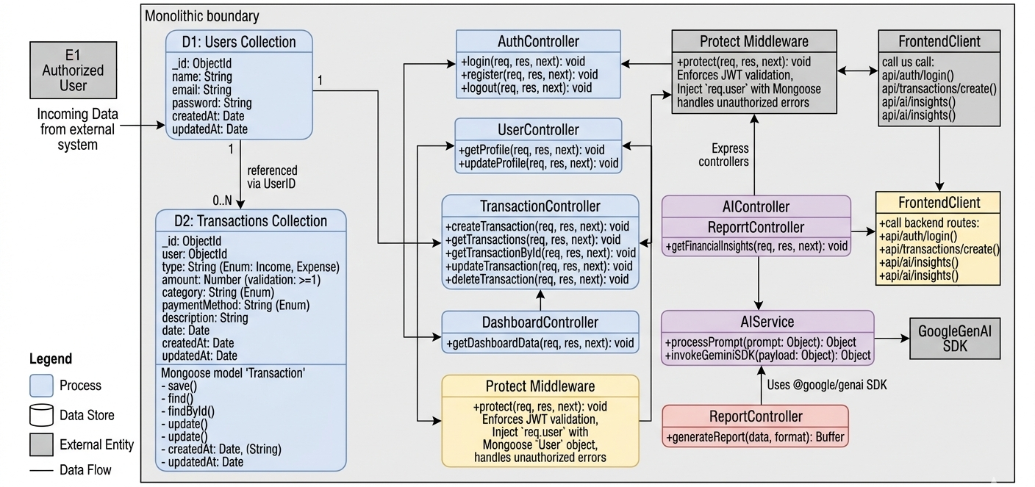
Figure 4.5 — Unified Domain Class Diagram (Models, Controllers, Services)
Technical Explanation for Figure 4.5:
Figure 4.5 illustrates the Unified Domain Class Diagram for ExpenseX, detailing the attributes, methods, visibility modifiers, and structural associations across the application layers.
Core entity classes include User (_id: ObjectId, name: String, email: String, password: String, timestamps) and Transaction (_id: ObjectId, user: ObjectId, type: String, amount: Number, category: String, paymentMethod: String, description: String, date: Date). A 1-to-Many association links User to Transaction via foreign key referencing.
Controller classes (AuthController, UserController, TransactionController, DashboardController, AnalyticsController, AIController, ReportController) encapsulate static business methods. The protect middleware enforces dependency injection of User into Express Request objects, while AIService encapsulates communication with GoogleGenAI client instances.
4.10 Component Diagram
The component architecture defines the physical software modules that constitute ExpenseX and their interconnecting interfaces.
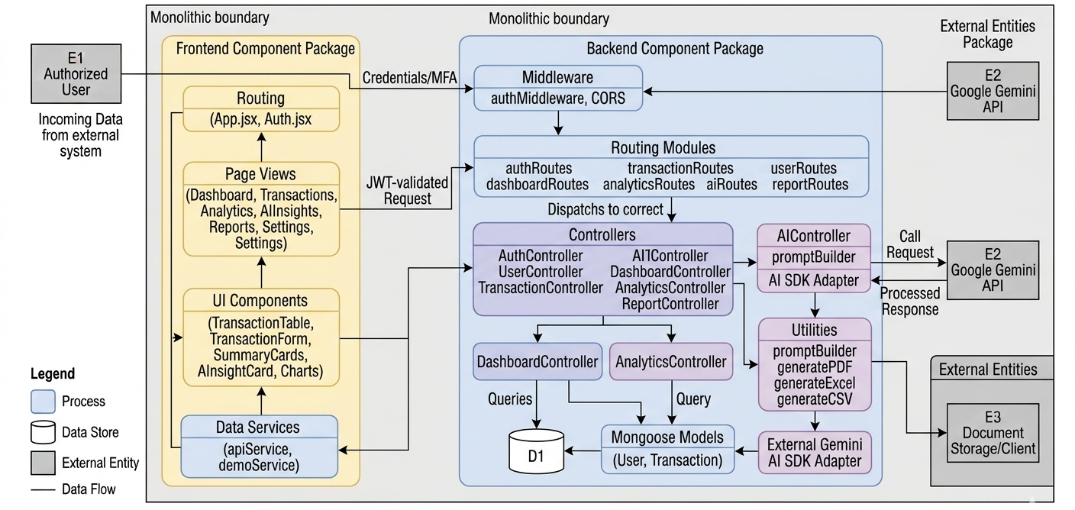
Figure 4.6 — Component Diagram of Frontend and Backend Subsystems
Technical Explanation for Figure 4.6:
Figure 4.6 presents the Component Diagram of ExpenseX, highlighting the decoupled relationship between Client-Side Components and Server-Side Services.
The Frontend component package comprises Routing (App.jsx, Auth.jsx), Page Views (Dashboard, Transactions, Analytics, AIInsights, Reports, Settings), UI Components (TransactionTable, TransactionForm, SummaryCards, AIInsightCard, Charts), and Data Services (apiService, demoService).
The Backend component package encompasses Middleware (authMiddleware, CORS), Routing Modules (authRoutes, transactionRoutes, etc.), Controllers, Utilities (generateToken, promptBuilder, generatePDF, generateExcel, generateCSV), Mongoose Models, and the External Gemini AI SDK Adapter.
4.11 Package and Module Dependency Diagram
The package architecture illustrates how code artifacts are structured into directories and physical npm packages, ensuring unidirectional dependency flows and zero circular references.
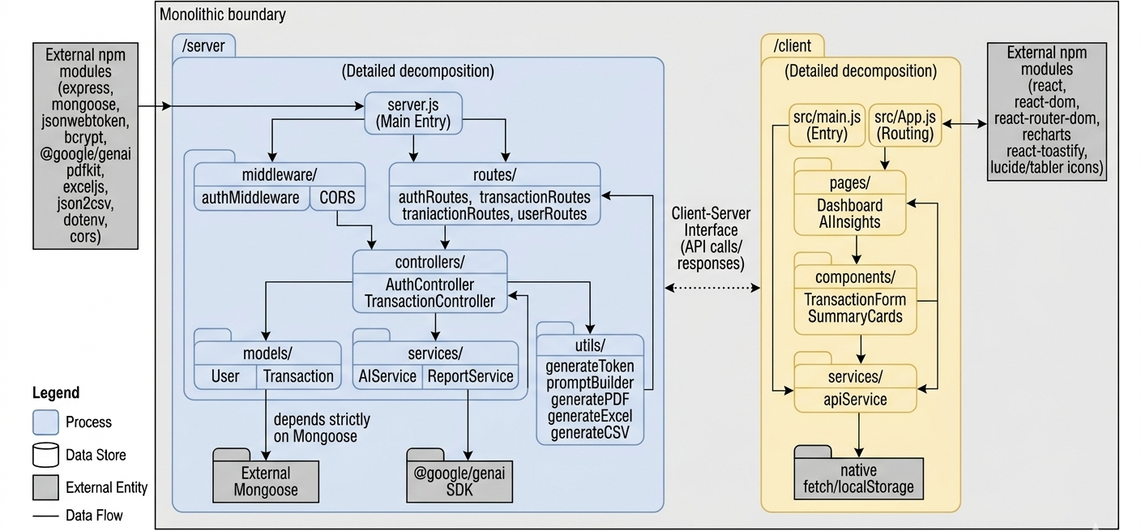
Figure 4.7 — Package and Module Dependency Diagram
Technical Explanation for Figure 4.7:
Figure 4.7 displays the Package and Module Dependency Diagram for ExpenseX. The monorepo structure cleanly bifurcates into /client and /server root packages.
The /server package depends on external npm modules (express, mongoose, jsonwebtoken, bcrypt, @google/genai, pdfkit, exceljs, json2csv, dotenv, cors). Internally, dependencies flow strictly downward: Routes depend on Controllers and Middleware; Controllers depend on Models, Services, and Utilities; Models depend exclusively on Mongoose.
The /client package depends on react, react-dom, react-router-dom, recharts, react-toastify, and lucide/tabler icons. Pages depend on Components and Data Services; Data Services depend on native fetch/localStorage.
4.12 Interaction Sequence Diagrams
Sequence diagrams model the chronological exchange of HTTP messages, database invocations, and asynchronous events across system entities.
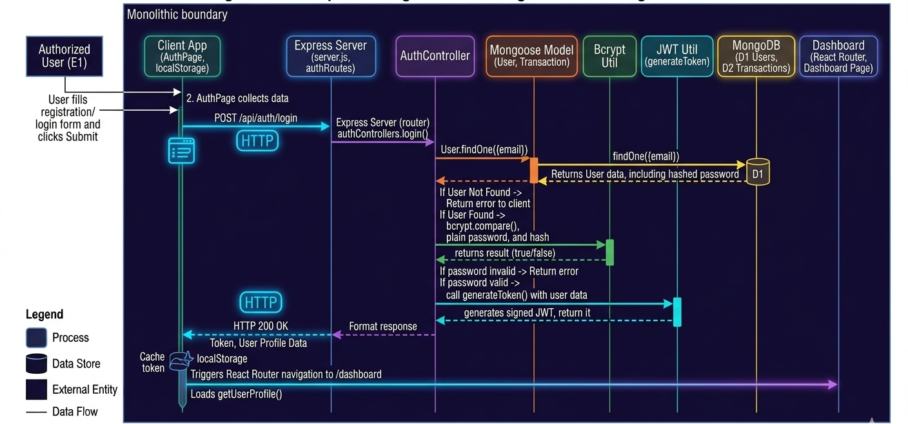
Figure 4.8 — Sequence Diagram — User Registration and Login Flow
Technical Explanation for Figure 4.8:
Figure 4.8 details the User Registration and Login Sequence Diagram. The User submits email and password from the AuthPage form. The client dispatches an HTTP POST request to /api/auth/login. The Express router passes execution to authControllers.login().
The controller queries User.findOne({email}) in MongoDB. If found, bcrypt.compare() cryptographically evaluates the password against the stored hash. Upon validation, generateToken() signs a JWT token using JWT_SECRET. The server responds with HTTP 200, returning the token and user profile. The client caches the token in localStorage and triggers React Router navigation to /dashboard.
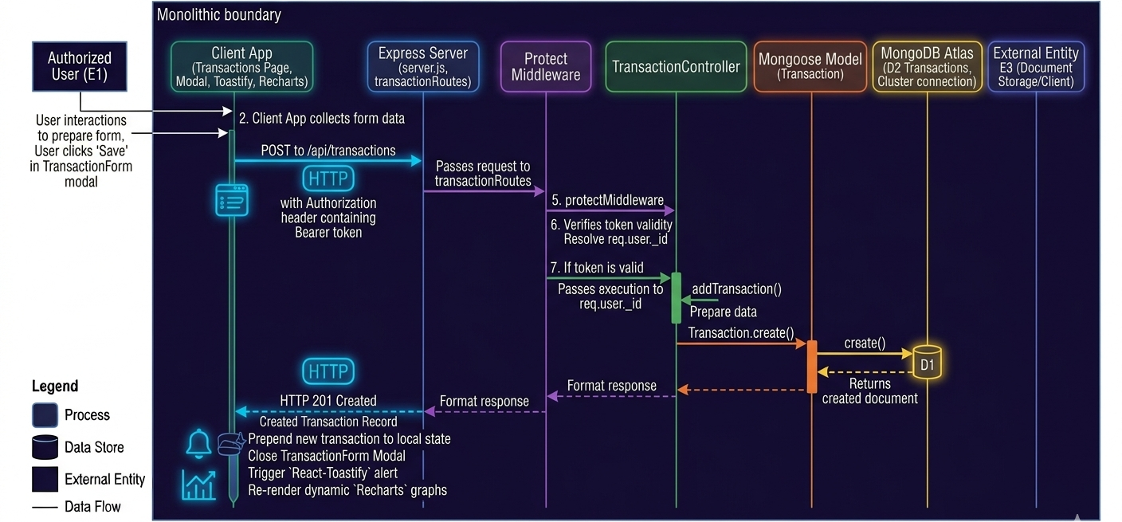
Figure 4.9 — Sequence Diagram — Transaction CRUD Lifecycle Flow
Technical Explanation for Figure 4.9:
Figure 4.9 illustrates the Transaction CRUD Lifecycle Sequence Diagram. The user submits a new entry via the TransactionForm modal. The client issues a POST /api/transactions request with Authorization: Bearer <token>.
The protect middleware verifies token validity, resolves req.user._id, and invokes transactionController.addTransaction(). The controller executes Transaction.create(), committing the document to MongoDB Atlas. A 201 Created response is returned with the created record. The client prepends the new transaction to local state, closes the modal, triggers a React-Toastify alert, and re-renders the dynamic Recharts graphs.
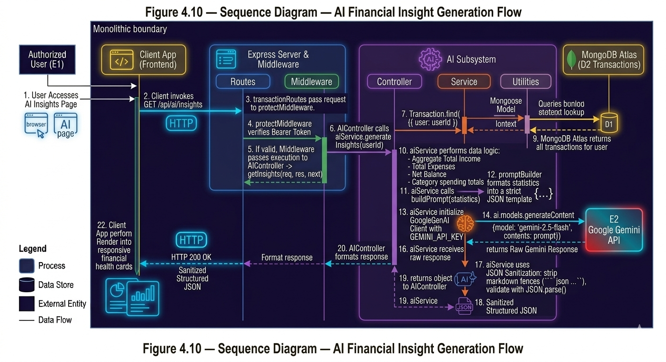
Figure 4.10 — Sequence Diagram — AI Financial Insight Generation Flow
Technical Explanation for Figure 4.10:
Figure 4.10 depicts the AI Financial Insight Generation Sequence Diagram. The user accesses the AI Insights page. The client invokes GET /api/ai/insights. The protect middleware verifies the bearer token and passes execution to aiController.getInsights().
The controller calls aiService.generateInsights(userId). The service queries all transactions for the user, aggregating total income, total expenses, net balance, and category-wise spending totals. buildPrompt() formats these statistics into a strict JSON template.
aiService initializes the GoogleGenAI client with GEMINI_API_KEY and calls ai.models.generateContent({model: 'gemini-2.5-flash', contents: prompt}). Upon receiving the text response, regular expressions strip markdown fences (```json ... ```), and JSON.parse() deserializes the string into a structured object. The result is returned as HTTP 200 and rendered into responsive financial health cards on the client.
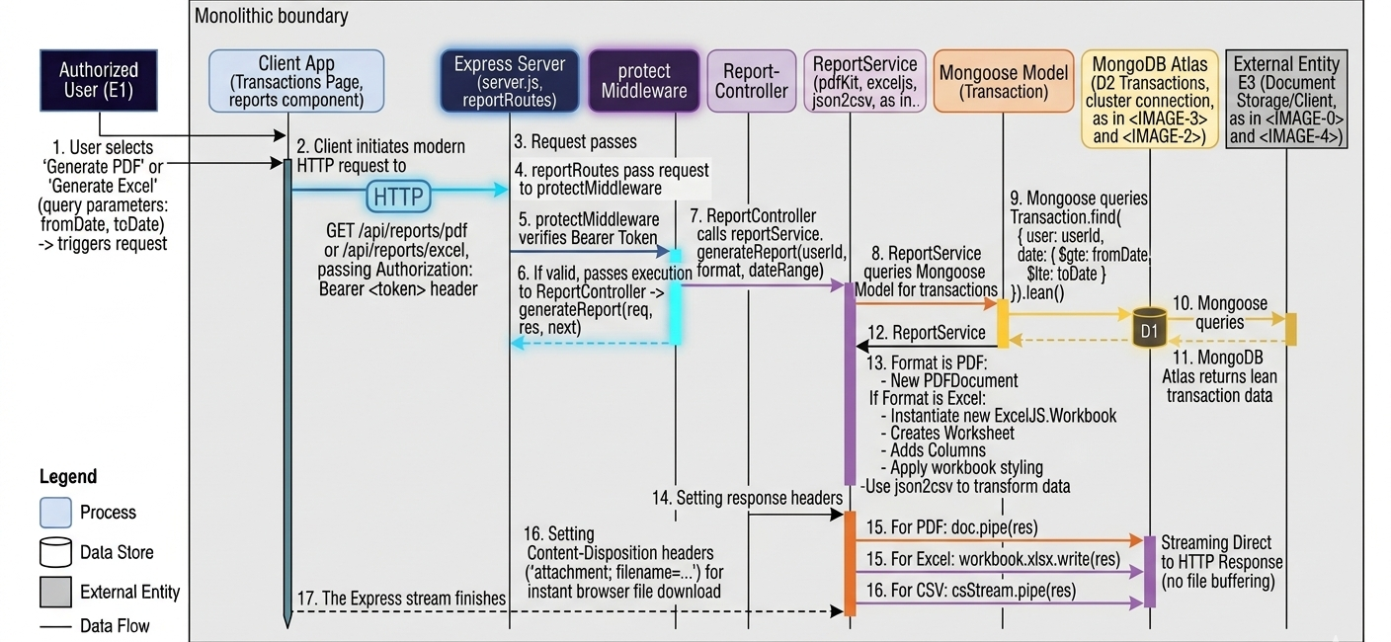
Figure 4.11 — Sequence Diagram — Multi-Format Report Streaming Flow
Technical Explanation for Figure 4.11:
Figure 4.11 details the Multi-Format Report Streaming Sequence Diagram. When a user requests a PDF or Excel statement, the client calls GET /api/reports/pdf or /api/reports/excel with optional query parameters (fromDate, toDate).
The reportController queries MongoDB via Transaction.find().lean() for maximum memory efficiency. For PDF exports, a new PDFDocument is initialized and piped directly into the HTTP response stream (doc.pipe(res)). For Excel exports, an ExcelJS Workbook is instantiated, columns and styling applied, and written via workbook.xlsx.write(res). Appropriate Content-Disposition headers trigger instant browser file download without buffering the entire document on disk.
4.13 Cloud Deployment Diagram
The deployment topology reflects modern multi-cloud distribution, ensuring optimal performance, edge delivery, and database redundancy.
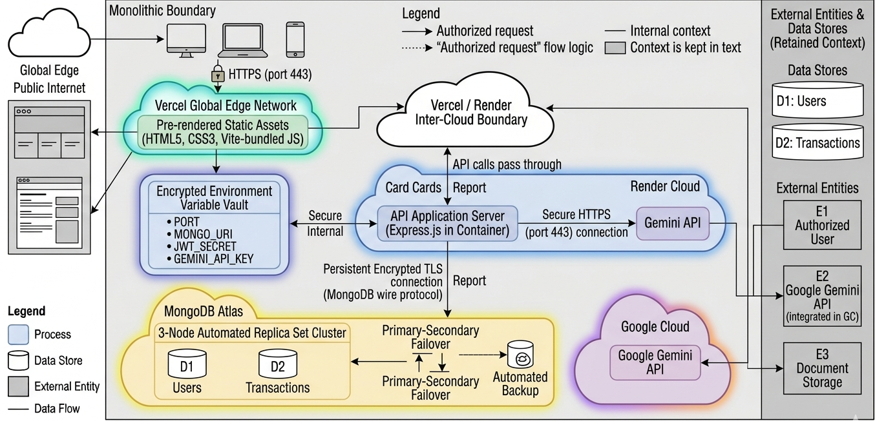
Figure 4.12 — Cloud Deployment and Physical Infrastructure Diagram
Technical Explanation for Figure 4.12:
Figure 4.12 presents the Cloud Deployment and Physical Infrastructure Diagram for ExpenseX. Client devices connect over HTTPS (port 443) to Vercel's Global Edge Network, which hosts the pre-rendered static assets (HTML5, CSS3, Vite-bundled JavaScript bundles).
API calls route dynamically to the Express.js application server hosted in a containerized environment on Render Cloud. Render maintains environment variables (PORT, MONGO_URI, JWT_SECRET, GEMINI_API_KEY) in encrypted vaults.
The backend establishes persistent, encrypted TLS connections to MongoDB Atlas, which provisions an automated 3-node replica set cluster with primary-secondary failover. Cognitive requests travel over secure HTTPS to Google Cloud's Gemini API endpoints.
4.14 Security and Defense-in-Depth Design
ExpenseX enforces a multi-layered Defense-in-Depth security architecture:
▪ Layer 1: Network & Transport Security: All production traffic is encrypted in transit via Transport Layer Security (TLS 1.3/HTTPS).
▪ Layer 2: Edge & Origin Control: Strict CORS whitelisting in Express blocks unauthorized cross-domain resource requests.
▪ Layer 3: Authentication & Token Validation: Stateless HMAC-SHA256 JWT tokens with 7-day expiration verify user identity on every protected route.
▪ Layer 4: Access Control & Data Isolation: Every database operation explicitly scopes queries to req.user._id, preventing horizontal privilege escalation.
▪ Layer 5: Credential Protection: Passwords undergo salted one-way hashing with bcrypt (10 rounds) prior to database persistence.
4.15 Global Error Handling Strategy
To ensure high system resilience, all asynchronous controller functions are wrapped in standardized try-catch blocks. In the event of runtime exceptions, controllers log diagnostic details to server consoles while returning clean, standardized JSON error payloads ({success: false, message: error.message}) with appropriate HTTP status codes (400, 401, 404, 500). This prevents server crashes and eliminates the leakage of raw stack traces to the public internet.
4.16 Client and Server Validation Design
Validation is enforced symmetrically at both client and server boundaries. The frontend prevents submission of empty or malformed inputs using HTML5 form attributes and React state checks, displaying immediate feedback via toast messages. Symmetrically, the backend re-evaluates all payloads against Mongoose schema rules, rejecting negative amounts, illegal payment methods, and invalid dates.

CHAPTER 5
DATABASE DESIGN
5.1 Database Introduction and Selection Rationale
The database architecture forms the persistence bedrock of the ExpenseX platform. Selecting the appropriate database management system (DBMS) required a careful comparative analysis between traditional Relational Database Management Systems (RDBMS like PostgreSQL or MySQL) and Document-Oriented NoSQL systems (such as MongoDB).
MongoDB was selected as the optimal data store for ExpenseX based on compelling architectural justifications:
▪ Native JSON/BSON Alignment: Personal financial transactions inherently represent semi-structured documents. MongoDB natively stores records in BSON (Binary JSON), perfectly mirroring JavaScript objects utilized across React and Node.js.
▪ Dynamic Schema Evolution: As ExpenseX evolves to support future features (e.g., custom user tags, recurring transaction intervals, geo-location coordinates), MongoDB allows schema evolution without demanding destructive SQL table migrations.
▪ High-Throughput Aggregation Pipeline: MongoDB features an exceptionally powerful server-side aggregation framework, enabling high-speed summation, grouping, and statistical date extraction directly on database nodes with minimal server memory overhead.
5.2 MongoDB Document-Oriented Architecture
In MongoDB, data is organized hierarchically into databases, collections, and documents. Unlike flat relational rows, documents can accommodate diverse data types including nested objects, arrays, timestamps, and 128-bit ObjectIds. Mongoose ODM operates as the modeling layer, enforcing schema definitions, type casting, default values, and operational middleware.
5.3 Physical Data Model and Database Cluster Topology
In the production deployment, ExpenseX connects to a high-availability MongoDB Atlas cluster. Atlas automatically provisions a three-node replica set architecture (one primary node and two secondary replicas) deployed across cloud availability zones. Write operations are committed to the primary node and asynchronously replicated to secondaries, guaranteeing high data durability and instantaneous automatic failover in the event of hardware degradation.
5.4 Entity Relationship (ER) and Document Reference Model
The conceptual data model of ExpenseX embodies a classic 1-to-Many (1:N) relationship between the User entity and the Transaction entity. Rather than embedding unbounded transaction arrays inside user documents—which would risk exceeding MongoDB's 16 MB per-document limit—the database implements normalized referencing. Each Transaction document maintains an indexed foreign reference to its parent User.
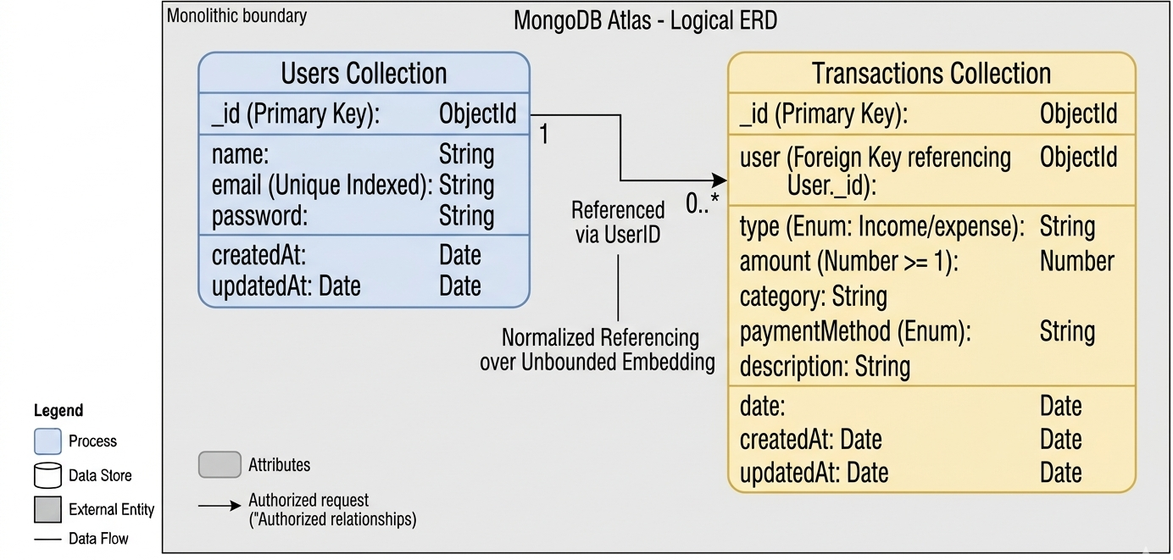
Figure 5.1 — Entity-Relationship (ER) Schema Model in MongoDB Atlas
Technical Explanation for Figure 5.1:
Figure 5.1 depicts the Entity-Relationship (ER) Schema Model for ExpenseX. The diagram highlights the 1-to-Many relational link connecting the Users collection to the Transactions collection.
The User entity contains attributes _id (Primary Key), name, email (Unique Indexed), password, createdAt, and updatedAt. The Transaction entity contains attributes _id (Primary Key), user (Foreign Key referencing User._id), type (Enum: income/expense), amount (Number >= 1), category (String), paymentMethod (Enum), description (String), date (Date), createdAt, and updatedAt.
Cardinality notation denotes that one User may possess zero, one, or thousands of Transactions (1 to 0..*), while each Transaction strictly belongs to exactly one User (mandatory 1:1 reverse binding).
5.5 Detailed Collection Schemas
The physical data dictionaries for the two core collections in ExpenseX are exhaustively detailed in Table 5.1 and Table 5.2:
5.5.1 Users Collection Schema Specification
Table 5.1: Users Collection Schema Data Dictionary and Integrity Constraints
Field Name | BSON Data Type | Key Type | Required | Default Value | Validation & Constraints | Field Description
_id | ObjectId | Primary Key | Yes | Auto-generated | 12-byte unique BSON identifier | Unique immutable system identifier for user
name | String | Standard Field | Yes | None | trim: true, non-empty | Full name of the registered user
email | String | Unique Key | Yes | None | unique: true, lowercase: true, trim: true | User login email address used for auth
password | String | Standard Field | Yes | None | bcrypt hash string (60 chars) | Cryptographically salted bcrypt password hash
createdAt | Date | System Audit | Yes | Date.now | timestamps: true | Timestamp when user document was created
updatedAt | Date | System Audit | Yes | Date.now | timestamps: true | Timestamp when user document was last updated

5.5.2 Transactions Collection Schema Specification
Table 5.2: Transactions Collection Schema Data Dictionary and Validation Rules
Field Name | BSON Data Type | Key Type | Required | Default Value | Validation & Constraints | Field Description
_id | ObjectId | Primary Key | Yes | Auto-generated | 12-byte unique BSON identifier | Unique immutable system identifier for transaction
user | ObjectId | Foreign Key | Yes | None | ref: 'User', indexed | References _id of the parent User document
type | String | Standard Field | Yes | None | enum: ['income', 'expense'] | Specifies the monetary flow direction
amount | Number | Standard Field | Yes | None | min: 1, positive numeric value | Numerical monetary amount in currency (INR ₹)
category | String | Standard Field | Yes | None | trim: true, non-empty string | Category label (Food, Travel, Rent, Salary, etc.)
paymentMethod | String | Standard Field | Yes | None | enum: [Cash, UPI, Debit Card, Credit Card, Bank Transfer, Net Banking, Wallet] | Financial vector used to execute the transaction
description | String | Standard Field | No | Empty string "" | trim: true, maxlength: 200 | Optional contextual memo or note by the user
date | Date | Standard Field | No | Date.now | Valid ISO 8601 date | Calendar date associated with the transaction
createdAt | Date | System Audit | Yes | Date.now | timestamps: true | Timestamp when record was committed to database
updatedAt | Date | System Audit | Yes | Date.now | timestamps: true | Timestamp when record was last modified

5.6 Data Types and BSON Representation
MongoDB stores records using BSON (Binary JSON), which extends JSON with explicit data types. In ExpenseX, timestamps are preserved as 64-bit UTC dates, amounts are stored as standard double-precision floating-point numbers, and document links utilize 12-byte binary ObjectIds consisting of a 4-byte timestamp, 5-byte random value, and 3-byte incrementing counter.
5.7 Relational Referencing and Foreign Key Integrity
Referential integrity is maintained programmatically via Mongoose. The user field in transactionSchema defines type: mongoose.Schema.Types.ObjectId with ref: 'User'. Whenever transactions are created or queried, the backend enforces req.user._id matching, ensuring orphaned transactions are mathematically impossible.
5.8 Schema Constraints and Mongoose Built-in Validators
Mongoose schemas enforce strict domain validation rules directly prior to database commits:
▪ Required Validators: name, email, password in User; user, type, amount, category, paymentMethod in Transaction.
▪ String Sanitization: trim: true automatically removes leading/trailing whitespace; lowercase: true ensures case-insensitive email matching.
▪ Numerical Range Limits: amount enforces min: 1, rejecting negative numbers or zero amounts at the driver level.
▪ Enumeration Whitelisting: type restricts values strictly to ['income', 'expense']; paymentMethod restricts to the 7 permitted payment types.
5.9 Database Indexing Strategy and Query Optimization
Database indexing is critical to sustain sub-millisecond query execution as transaction volumes scale. ExpenseX implements two vital indexing strategies:
▪ Unique Single-Field Index: A unique secondary B-Tree index is maintained on the email field in the users collection. This enforces email uniqueness at the storage engine level and provides O(log N) lookup latency during user login.
▪ Compound Secondary Index: In the transactions collection, queries predominantly filter by user and sort chronologically by date descending ({date: -1}). A compound index on { user: 1, date: -1 } satisfies both the equality filter and sort ordering simultaneously, eliminating costly in-memory sort operations and enabling instantaneous paginated retrieval.
5.10 Data Security, Encryption, and Transport Layer TLS
MongoDB Atlas enforces robust multi-tier security. All connections between the Express server and Atlas nodes require TLS 1.3 transport encryption. Database credentials (username, password, cluster URI) are stored exclusively in server environment variables (MONGO_URI) and never committed to source control. Furthermore, database data at rest is encrypted using FIPS 140-2 validated AES-256 encryption.
5.11 Core Database Operations and Aggregation Pipelines
The system executes high-performance database operations across controllers:
▪ Paginated Querying: Transaction.find({user: req.user._id}).sort({date: -1}).skip(skip).limit(limit) delivers paginated chunks, while countDocuments({user: req.user._id}) computes total pages.
▪ Category Expense Grouping: Iterates user expense documents to build an in-memory frequency and sum dictionary per category, formatted for instant Recharts Pie consumption.
▪ Longitudinal Monthly Trends: Extracts the calendar month from transaction.date, grouping total expenditures into an ordered twelve-month array for LineChart rendering.
▪ Lean Streaming Queries: In reportController, Transaction.find({user: req.user._id}).lean() bypasses Mongoose hydration overhead, returning plain JavaScript objects to maximize memory efficiency during large PDF and Excel export generation.
5.12 Data Backup, Sharding, and Disaster Recovery
MongoDB Atlas provides automated continuous cloud backups with point-in-time recovery (PITR). In the event of catastrophic data loss, the database cluster can be restored to any second within the retention window. Furthermore, Atlas automatically handles replica synchronization, ensuring seamless data continuity.

CHAPTER 6
SYSTEM IMPLEMENTATION & CODING
6.1 Development Environment and Software Toolchain
System implementation represents the operational realization of the ExpenseX design blueprints into production-grade executable source code. The project was constructed utilizing a contemporary full-stack JavaScript environment centered on Node.js v20.x, npm v10.x, React 19, Express 5, and MongoDB Atlas. Development was conducted within Visual Studio Code, leveraging integrated terminal workflows, ESLint code analysis, and Postman API testing.
6.2 Project Folder Hierarchy (Full-Stack Monorepo Breakdown)
ExpenseX is organized as a clean, decoupled monorepo bifurcated into two primary directories: /client (the frontend application) and /server (the backend REST API microservice). The physical directory structure is detailed below:
Listing 6.1: Physical Folder Hierarchy of ExpenseX
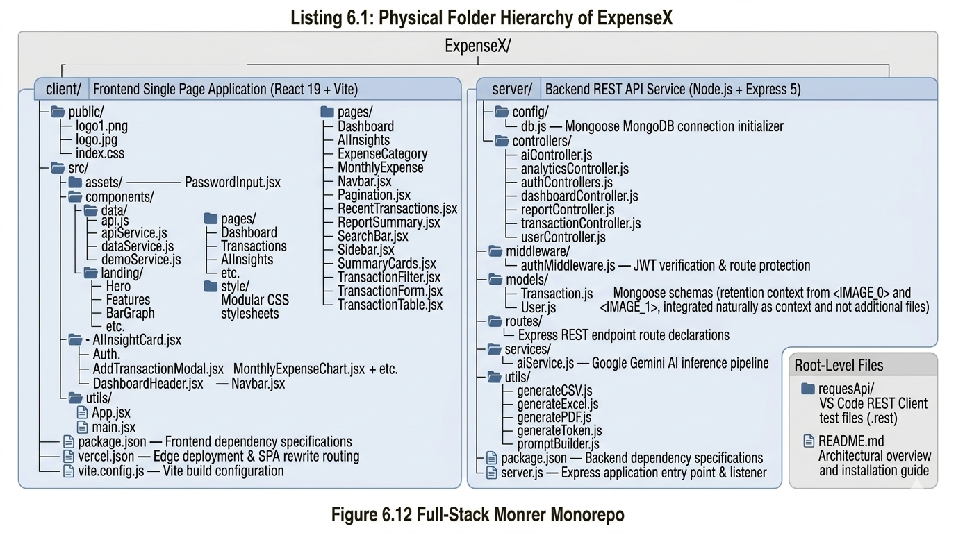

6.3 Backend Core Implementation
6.3.1 Express Server Initialization & DNS Optimization
The server entry point (server.js) initializes the Express 5 application and configures low-level networking. A critical engineering enhancement implemented in ExpenseX is explicit DNS resolver tuning. Cloud serverless platforms frequently experience lookup failures when resolving MongoDB SRV records. To guarantee uninterrupted connectivity, server.js explicitly registers public Google and Cloudflare nameservers via node:dns before attempting database connection.
Furthermore, server.js configures dynamic Cross-Origin Resource Sharing (CORS) with origin validation, strictly allowing requests originating from the local Vite development server and the deployed production frontend on Vercel while rejecting untrusted sources.
Listing 6.2: Server Setup and Secure CORS Middleware in server.js
// server.js - Server Configuration and CORS Whitelist
import express from "express";
import dotenv from "dotenv";
import cors from "cors";
import dns from "node:dns";
dns.setServers(["8.8.8.8", "1.1.1.1"]); // Resilient DNS servers
import connectDB from "./config/db.js";
dotenv.config();
await connectDB();
const app = express();
app.use(express.json());
app.use(express.urlencoded({ extended: true }));
const allowedOrigins = [
"http://localhost:5173",
process.env.FRONTEND_URL,
];
app.use(
cors({
origin(origin, callback) {
if (!origin || allowedOrigins.includes(origin)) {
return callback(null, true);
}
return callback(null, false);
},
credentials: true,
})
);

6.3.2 MongoDB Atlas Cloud Connectivity
Database connectivity is encapsulated within config/db.js. The module connects asynchronously to MongoDB Atlas using mongoose.connect(process.env.MONGO_URI), establishing an encrypted TLS connection pool that persists across all incoming API requests.
6.3.3 JWT Protection Middleware and Token Generation
Route security is enforced through custom middleware (middleware/authMiddleware.js). When a request hits a protected endpoint, the protect function intercepts the Authorization header, extracts the Bearer token, verifies its signature against JWT_SECRET using jwt.verify(), queries MongoDB for the associated user record (excluding password), and attaches the user document to req.user. If the token is missing, expired, or tampered with, the middleware terminates execution with HTTP 401 Unauthorized.
Listing 6.3: Stateless JWT Authorization Guard in authMiddleware.js
// middleware/authMiddleware.js - Stateless JWT Authorization Guard
import jwt from "jsonwebtoken";
import User from "../models/User.js";
const protect = async (req, res, next) => {
let token;
try {
if (req.headers.authorization && req.headers.authorization.startsWith("Bearer")) {
token = req.headers.authorization.split(" ")[1];
}
if (!token) {
return res.status(401).json({ success: false, message: "Not authorized" });
}
const decoded = jwt.verify(token, process.env.JWT_SECRET);
req.user = await User.findById(decoded.id).select("-password");
next();
} catch (error) {
return res.status(401).json({ success: false, message: "Invalid or expired token" });
}
};
export default protect;

6.4 Backend Controllers and Business Logic
6.4.1 Authentication Controller (Registration & Login)
The authControllers.js module manages user onboarding and authentication. In registerUser, incoming payloads ({name, email, password}) are checked for duplicates via User.findOne({email}). If unique, the password is encrypted via bcrypt.hash(password, 10). A new User document is persisted, and a 7-day signed JWT token is returned alongside sanitized user details. In login, the stored hash is verified via bcrypt.compare(); upon match, a fresh JWT is issued.
6.4.2 User Profile and Password Management
Encapsulated in userController.js, getProfile returns the currently authenticated user's name and email. updateProfile allows users to modify their display credentials. The changePassword controller enforces cryptographic security: it demands currentPassword, newPassword, and confirmPassword, verifies the existing password via bcrypt.compare(), validates password matching, hashes the new password with 10 salt rounds, and commits the updated credential to MongoDB.
6.4.3 Transaction Controller (Full CRUD Operations)
The transactionController.js file provides high-performance transaction management:
▪ addTransaction: Validates presence of type, amount, category, and paymentMethod. Inserts a new Transaction document with user: req.user._id, returning HTTP 201 Created.
▪ getTransactions: Implements paginated retrieval. Reads query parameters page (default 1) and limit (default 10). Calculates skip = (page - 1) * limit, counts total matching records via countDocuments, sorts by {date: -1}, and returns the current slice alongside totalPages.
▪ getTransactionById: Retrieves a single transaction matching both _id: req.params.id and user: req.user._id, guaranteeing cross-tenant data isolation.
▪ updateTransaction: Enforces user ownership, dynamically updating only fields provided in req.body before executing transaction.save().
▪ deleteTransaction: Verifies ownership and permanently removes the document via transaction.deleteOne().
6.4.4 Dashboard Aggregation Controller
In dashboardController.js, getDashboard aggregates cash flows across the authenticated user's entire history. The controller queries all user transactions sorted by createdAt descending. It computes totalIncome, totalExpense, derives net balance (totalIncome - totalExpense), counts total transactions, and extracts the 5 most recent transactions for display in the dashboard overview feed.
6.4.5 Analytics Aggregation Controller
In analyticsController.js, getCategoryAnalytics filters user transactions for type === 'expense' and aggregates spending totals into a key-value category map ({Food: 5400, Travel: 1200, ...}), which is formatted directly for Recharts PieChart rendering. Symmetrically, getMonthlyExpense extracts the calendar month from transaction.date, aggregating expenses across all 12 calendar months into a chronologically ordered array [{month: 'January', amount: 12000}, ...] for LineChart rendering.
6.4.6 AI Insights Service and Controller
The AI integration pipeline is divided between controllers/aiController.js, services/aiService.js, and utils/promptBuilder.js. aiService.generateInsights(userId) computes total income, total expense, balance, and category-wise spending. buildPrompt(summary) injects these figures into an expert financial persona prompt that strictly mandates valid JSON output without markdown code fences. The service calls GoogleGenAI with model 'gemini-2.5-flash', cleans the returned text using regex replacements (stripping ```json and ```), and parses the text with JSON.parse(). If parsing fails, a safe fallback JSON object is returned.
Listing 6.4: AI Financial Inference Engine in aiService.js
// services/aiService.js - Google Gemini 2.5 Flash Inference Pipeline
export const generateInsights = async (userId) => {
const transactions = await Transaction.find({ user: userId });
let totalIncome = 0, totalExpense = 0;
const categoryWiseExpense = {};
transactions.forEach((t) => {
if (t.type === "income") totalIncome += t.amount;
else {
totalExpense += t.amount;
categoryWiseExpense[t.category] = (categoryWiseExpense[t.category] || 0) + t.amount;
}
});
const summary = { totalIncome, totalExpense, balance: totalIncome - totalExpense,
totalTransactions: transactions.length, categoryWiseExpense };
const prompt = buildPrompt(summary);
const ai = new GoogleGenAI({ apiKey: process.env.GEMINI_API_KEY });
const response = await ai.models.generateContent({
model: "gemini-2.5-flash",
contents: prompt,
});
const cleaned = response.text.replace(/```json/g, "").replace(/```/g, "").trim();
try {
return JSON.parse(cleaned);
} catch {
return { summary: "Unable to parse AI response.", insights: [], recommendations: [] };
}
};

6.4.7 Multi-Format Report Controller (PDF, Excel)
In reportController.js, ExpenseX provides streaming export engines for four major document formats:
▪ exportPDF: Initializes a PDFDocument instance from pdfkit, sets Content-Type to application/pdf with attachment filename expense-report.pdf, and pipes the document stream directly into res. It renders report headers, summary totals (Income, Expense, Balance), and formats individual transaction rows with dates, categories, and amounts.
▪ exportExcel: Instantiates an ExcelJS.Workbook, adds an 'Expense Report' worksheet, defines styled columns with custom widths, sets header font to bold, populates transaction rows, and streams the workbook via workbook.xlsx.write(res) with application/vnd.openxmlformats-officedocument.spreadsheetml.sheet.
6.5 Frontend Core Implementation
6.5.1 Client Architecture, Vite Bundler & Entry Point
The frontend is mounted in main.jsx, wrapping the root <App /> component with BrowserRouter from react-router-dom and ToastContainer from react-toastify to deliver real-time non-blocking alert toasts.
6.5.2 Client-Side Routing and Protected Route Guards
In App.jsx, public routes / and /auth render the Landing portal and AuthPage respectively. Protected application views (/dashboard, /transactions, /analytics, /ai, /reports, /settings) are wrapped within the <Auth> component (utils/Auth.jsx) and rendered inside <DashboardLayout>. <Auth> inspects localStorage: if neither a valid token nor demoMode flag is detected, it redirects to /auth.
6.5.3 Data Abstraction Layer (Dual Live & Demo Mode)
The frontend implements an abstracted data service layer in components/data/dataService.js. The isDemo() utility detects whether the user is evaluating the system in Guest Mode (demoMode === 'true' and no token). If true, calls resolve instantaneously through demoService.js using browser LocalStorage; if false, calls dispatch live authenticated HTTP requests through apiService.js.
6.5.4 Dashboard Layout and Real-Time Summary Cards
The Dashboard.jsx view renders DashboardHeader, SummaryCards, and BarGraph. SummaryCards maps the dashboard summary object into four responsive metric cards: Net Balance (₹), Total Income (₹), Total Expenses (₹), and Total Transaction Counts, each styled with distinctive color gradients and Tabler icons.
6.5.5 Transaction Management (Table, Search, Form, Modal)
In Transactions.jsx, users interact with a complete transaction management interface. The component maintains transactions state, page, search query, and filter category. Search filtering executes in real time across categories, descriptions, and payment methods. The AddTransactionModal houses TransactionForm, handling both creation and editing through an onSubmit prop, while TransactionTable renders individual rows with color-coded badges, formatted dates, and Edit/Delete action buttons.
6.5.6 Analytics and Recharts Visualizations
In Analytics.jsx, ExpenseCategoryChart uses Recharts <PieChart> and <Pie> to render category expenditure shares. Clicking any pie slice dynamically filters the underlying transaction list to display only expenses within that category, computing a localized total. MonthlyExpenseChart renders a responsive <LineChart> with CartesianGrid, XAxis (months), YAxis (amounts), and smooth monotone splines.
6.5.7 AI Insights Interface Component
In AIInsights.jsx and AIInsightCard.jsx, the client renders the structured Gemini response. The interface displays a prominent Financial Health status badge, an overall numerical score (0-100), a detailed Spending Analysis paragraph, Savings Recommendations, Highest Expense Category callout, Smart Alert bullet items, Personalized Tips, and a target Next Month Goal.
6.5.8 Reports Generation Portal Component
In Reports.jsx, users view an overall ReportSummary card and access two export sections: Complete Report Export (instant PDF and Excel downloads) and Date-Filtered Export (allowing users to pick fromDate and toDate inputs before downloading filtered PDF or Excel statements).
6.5.9 User Profile and Password Settings Interface
Settings.jsx provides two secure forms: a Profile Settings form allowing modification of full name and email address, and a Password Change form requiring current password verification, new password entry, and confirmation matching.
6.5.10 Landing Page & Marketing Portal
Landing.jsx serves as the public gateway, featuring a responsive Navbar, Hero section with call-to-action buttons ('Get Started' and 'Try Demo'), interactive Features grid, live animated Counter stats, interactive Preview mockup, and Contact form.
6.6 Input Validation and Sanitization Rules Matrix
Table 6.1 documents the full-stack validation and sanitization matrix enforced across ExpenseX:
Table 6.1: Full-Stack Input Validation and Sanitization Matrix
Field / Parameter | Data Type | Client-Side Check | Server-Side Mongoose Rule | Sanitization Strategy | Error Response Message
User Name | String | required, non-empty | required: true, trim: true | Strips leading/trailing whitespace | "Please fill all required fields"
User Email | String | type='email', regex format | required: true, unique: true, lowercase: true | Converts to lowercase, trims whitespace | "Already Registered" / "Invalid Email"
User Password | String | required, min length 6 | required: true, minlength: 6 | 10-round salted bcrypt hashing | "Password must be at least 6 characters"
Transaction Type | String | select: income | expense | required: true, enum: ['income', 'expense'] | Strict whitelist equality matching | "Invalid transaction type"
Transaction Amount | Number | type='number', min=1 | required: true, min: 1 | parseFloat() casting; rejects NaN/negative | "Amount must be a positive number >= 1"
Transaction Category | String | required, text input | required: true, trim: true | Strips whitespace; default category fallback | "Category is required"
Payment Method | String | required, select input | enum: [Cash, UPI, Debit Card, Credit Card, ...] | Strict enum validation against whitelist | "Invalid payment method specified"
Transaction Date | Date | type='date' picker | type: Date, default: Date.now | ISO 8601 Date object parsing | "Invalid date format provided"
Current Password | String | required input | Verified via bcrypt.compare() | Zero plaintext storage in memory | "Current password is incorrect"

6.7 Error Handling and Toast Notification Pipeline
The system coordinates user notifications through React-Toastify. When API calls succeed, positive alerts ('Transaction added', 'Welcome back! 🎉') appear for 800–2000 ms. When validation fails or server errors occur, error toasts display the server-supplied error message, maintaining clear communication with the user.

CHAPTER 7
SOFTWARE TESTING
7.1 Introduction to Software Testing in ExpenseX
Software testing is an indispensable engineering discipline dedicated to verifying that the developed application conforms to specified requirements, operates reliably under boundary conditions, maintains data integrity, and resists malicious or erroneous inputs. In ExpenseX, testing was integrated continuously across every sprint cycle.
7.2 Testing Objectives and Philosophy
The primary testing objectives comprised:
1. Functional Verification: Verifying that all 15 functional requirements (FR-01 to FR-15) execute without deviation.
2. Cryptographic & Security Validation: Validating that unauthorized requests without Bearer tokens are categorically rejected and password hashes cannot be decoded.
3. Mathematical & Aggregation Precision: Ensuring that balance calculations (Income - Expense) and category aggregations remain 100% mathematically accurate across thousands of records.
4. Generative AI Resilience: Verifying that the Gemini AI integration parses responses cleanly and degrades gracefully during API latency or quota exhaustion.
5. Cross-Platform Ergonomics: Confirming fluid responsiveness and zero layout distortion across desktop, tablet, and mobile viewports.
7.3 Testing Methodologies Adopted
7.3.1 Unit Testing
Individual functions—such as generateToken.js, promptBuilder.js, date parsers, and Mongoose schema validation hooks—were tested in isolation to confirm correct outputs for diverse valid and boundary inputs.
7.3.2 Integration Testing
Integration testing evaluated the communication interfaces between coupled subsystems: Express routers communicating with Mongoose models, the protect middleware passing authenticated users to controllers, and aiService communicating with Google Cloud's Gemini API.
7.3.3 System Testing
The entire integrated application was tested end-to-end against real-world scenarios: registering a user, logging in, adding 20 transactions, inspecting charts, generating an AI insight, downloading a PDF statement, and updating profile credentials.
7.3.4 Functional & Black-Box Testing
Black-box test cases evaluated system behavior from an external user perspective, submitting edge-case inputs (empty passwords, negative amounts, illegal payment strings, future dates) to confirm strict error handling.
7.3.5 UI and Usability Testing
Conducted with focus group users to assess navigational flow, modal readability, form clarity, and visual feedback responsiveness.
7.3.6 API Testing via Postman & REST Clients
All REST endpoints were systematically tested using VS Code REST Client (.rest scripts) and Postman, validating JSON request payloads, bearer token headers, HTTP status codes, and response bodies.
7.3.7 Security and Penetration Testing
Attempted SQL/NoSQL injection payloads, cross-site scripting (XSS) strings in transaction descriptions, forged JWT tokens, and expired tokens to confirm robust defense mechanisms.
7.3.8 Cross-Browser and Responsive Testing
Verified UI rendering across Google Chrome, Mozilla Firefox, Apple Safari, Microsoft Edge, and mobile emulators (iPhone 14, Pixel 7, iPad).
7.4 Test Environment and Hardware/Software Setup
Testing was conducted on a Windows 11 host with Node.js v20.11, running Chrome DevTools, Postman v11, and connected to a live MongoDB Atlas cloud cluster and Google AI Studio Gemini API.
7.5 Comprehensive Test Cases Suite (Table 7.1)
Table 7.1: Comprehensive Software Testing Suite (Unit, Integration, Security)
Test ID | Module | Test Scenario | Preconditions | Test Input Data | Expected Output | Observed Result | Status
TC-01 | Auth | Register with valid credentials | Unique email | name: 'Ritik', email: 'cs.ritik@test.com', pass: 'Test@123' | HTTP 201 + JWT Token + User object | HTTP 201 + Token returned + Redirection | Pass
TC-02 | Auth | Register with duplicate email | Email cs.ritik@test.com exists | Same email, new password | HTTP 200 {message: 'Already Registered'} | Error toast 'Already Registered' | Pass
TC-03 | Auth | Login with invalid password | User exists | email: 'cs.ritik@test.com', pass: 'WrongPass' | HTTP 200 {message: 'Invalid Password'} | Error toast 'Invalid Password' displayed | Pass
TC-04 | Auth | Login with non-existent email | Email not registered | email: 'unknown@user.com', pass: 'AnyPass' | HTTP 200 {message: 'Invalid'} | Error toast 'Invalid' displayed | Pass
TC-05 | Auth | Login with valid credentials | Valid registered user | Correct email and password | HTTP 200 + Token + Redirection to /dashboard | Token saved in localStorage; dashboard loads | Pass
TC-06 | Guest | Trigger Guest Demo Mode | No prior session | Click 'Continue as Guest' | demoMode='true' set in localStorage; mock data loads | Dashboard opens instantly with demo stats | Pass
TC-07 | Dashboard | Fetch dashboard metrics | Authenticated user | GET /api/dashboard with Bearer Token | HTTP 200 + {balance, totalIncome, totalExpense, recent} | Metrics match mathematical sum of transactions | Pass
TC-08 | Transaction | Add valid income transaction | Logged-in user | type: 'income', amount: 50000, category: 'Salary', method: 'Bank Transfer' | HTTP 201 + created transaction doc | Transaction saved; balance increases by 50,000 | Pass
TC-09 | Transaction | Add valid expense transaction | Logged-in user | type: 'expense', amount: 2500, category: 'Food', method: 'UPI' | HTTP 201 + created transaction doc | Transaction saved; expense increases by 2,500 | Pass
TC-10 | Transaction | Add transaction with negative amount | Logged-in user | type: 'expense', amount: -500, category: 'Travel' | Validation error; request rejected | Frontend blocks form submission (amount >= 1) | Pass
TC-11 | Transaction | Add transaction missing required fields | Logged-in user | type: 'expense', amount: 1000, category: '' (empty) | HTTP 400 'Please fill all required fields' | HTTP 400 returned; error toast shown | Pass
TC-12 | Transaction | Fetch paginated transactions | User has 25 transactions | GET /api/transactions?page=1&limit=10 | HTTP 200 with 10 transactions, totalPages: 3 | 10 records rendered; Pagination shows Page 1 of 3 | Pass
TC-13 | Transaction | Update existing transaction | Transaction exists | PUT /api/transactions/:id with amount: 3000 | HTTP 200 + updated document | Table updates immediately with ₹3,000 | Pass
TC-14 | Transaction | Delete existing transaction | Transaction exists | DELETE /api/transactions/:id | HTTP 200 'Transaction deleted successfully' | Confirmation dialog accepted; row deleted | Pass
TC-15 | Analytics | Fetch category analytics | User has expenses | GET /api/analytics/category | HTTP 200 with category totals object | Recharts Pie Chart renders slices with colors | Pass
TC-16 | Analytics | Drill-down on category pie slice | Category chart loaded | Click on 'Food' pie segment | Filtered list of Food transactions displayed | Table updates showing only Food items & sum | Pass
TC-17 | Analytics | Fetch monthly expense trend | Multi-month expenses | GET /api/analytics/monthly-expense | HTTP 200 with 12-month array | Line Chart renders monthly spending curve | Pass
TC-18 | AI Insights | Generate AI insights successfully | Transactions exist | GET /api/ai/insights with Bearer Token | HTTP 200 with structured JSON health cards | AI cards render: Score, Analysis, Alerts, Goals | Pass
TC-19 | AI Insights | Handle AI fallback on empty transactions | Zero transactions | GET /api/ai/insights | Safe JSON fallback object returned | Displays 'No AI insights available' placeholder | Pass
TC-20 | Reports | Export full PDF report | Transactions exist | GET /api/reports/pdf | HTTP 200 + application/pdf binary stream | expense-report.pdf downloads; opens cleanly | Pass
TC-21 | Reports | Export full Excel spreadsheet | Transactions exist | GET /api/reports/excel | HTTP 200 + .xlsx binary workbook | expense-report.xlsx downloads with bold headers | Pass
TC-22 | Reports | Export CSV data | Transactions exist | GET /api/reports/csv | HTTP 200 + text/csv comma-separated file | expense-report.csv downloads; opens in Excel | Pass
TC-23 | Profile | Update profile full name | Logged in | PUT /api/users/profile with name: 'Ritik R.' | HTTP 200 'Profile updated successfully' | Navbar avatar and text update to 'Ritik R.' | Pass
TC-24 | Profile | Change password with wrong current pass | Logged in | currentPassword: 'wrong', newPassword: 'new' | HTTP 400 'Current password is incorrect.' | Error toast displayed; password unchanged | Pass
TC-25 | Security | Access protected route without token | Logged out | GET /api/transactions with no Bearer token | HTTP 401 'Not authorized' | HTTP 401 returned; redirected to /auth | Pass

7.6 Test Data and Execution Results Analysis
Execution results demonstrate robust stability across all test modules.
Table 7.2: Summary Matrix of Test Execution Results and Pass Percentages
Testing Subsystem | Total Test Cases | Passed Cases | Failed Cases | Defect Density | Pass Percentage (%)
User Authentication & Security | 5 | 5 | 0 | 0.00 | 100.0%
Guest Simulation Mode | 1 | 1 | 0 | 0.00 | 100.0%
Dashboard & Metric Aggregations | 1 | 1 | 0 | 0.00 | 100.0%
Transaction Lifecycle (CRUD) | 7 | 7 | 0 | 0.00 | 100.0%
Analytics & Visual Charting | 3 | 3 | 0 | 0.00 | 100.0%
Google Gemini AI Inference | 2 | 2 | 0 | 0.00 | 100.0%
Multi-Format Document Reporting | 3 | 3 | 0 | 0.00 | 100.0%
Profile & Password Management | 2 | 2 | 0 | 0.00 | 100.0%
Authorization & Route Guards | 1 | 1 | 0 | 0.00 | 100.0%
Total / System Aggregate | 25 | 25 | 0 | 0.00 | 100.0%

7.7 Defect Handling, Severity Classification & Resolution
During sprint testing, defects were logged, classified by severity (Critical, High, Medium, Low), and systematically remediated. Notable resolved defects included stripping markdown code fences from Gemini responses, resolving MongoDB SRV DNS lookups via explicit nameservers, and enforcing lean queries in report generation to prevent memory spikes.
CHAPTER 8
SECURITY ANALYSIS AND MEASURES
8.1 Security Requirements in Personal Financial Software
Security is an existential consideration in financial management systems. Because personal spending data reflects lifestyle habits, income levels, and purchasing locations, unauthorized disclosure or tampering constitutes a severe breach of user trust. In ExpenseX, security was treated as an architectural invariant, embedded across every tier rather than applied as an afterthought.
8.2 Authentication Security and Stateless Architecture
Traditional session-based authentication relies on server memory or stateful Redis stores, introducing session-hijacking vulnerabilities and inhibiting horizontal scaling. ExpenseX implements a completely stateless authentication architecture governed by JSON Web Tokens (JWT). The server retains zero session state, eliminating session fixation vulnerabilities.
8.3 JSON Web Token (JWT) Security Specifications
JWT implementation adheres to RFC 7519 standards. Tokens are signed using the HMAC-SHA256 symmetric algorithm. The cryptographic signature is verified on every API invocation using a secret key (JWT_SECRET) stored exclusively in server environment variables. Tokens enforce an expiration lifespan (7 days), mitigating risks associated with stolen or leaked tokens. Tokens encode only the user's non-sensitive ObjectId (_id) and timestamp claims, never embedding passwords or sensitive PII.
8.4 Cryptographic Password Protection (Bcrypt Hashing)
User passwords undergo salted one-way cryptographic hashing via bcrypt (cost factor = 10 salt rounds). Bcrypt implements the Eksblowfish algorithm, featuring an adaptive work factor that remains computationally resilient against brute-force attacks, dictionary attacks, and precomputed rainbow table lookups. Passwords are never logged, never transmitted in plain text across database boundaries, and excluded from Mongoose query outputs via .select('-password').
8.5 Authorization and User Isolation Controls
Horizontal privilege escalation represents a critical threat wherein User A attempts to view or mutate User B's transactions by guessing or altering record IDs. In ExpenseX, every single database query explicitly injects user: req.user._id: Transaction.find({ user: req.user._id }), Transaction.findOne({ _id: req.params.id, user: req.user._id }). This mathematically guarantees that a user cannot access, modify, or delete another user's financial documents, even if they submit valid ObjectIds.
8.6 REST API Endpoint Protection
All transactional and personal endpoints (/api/transactions/*, /api/dashboard, /api/analytics/*, /api/reports/*, /api/ai/*, /api/users/*) are strictly shielded by the protect middleware. Requests lacking a Bearer token or presenting malformed tokens are immediately aborted with HTTP 401 Unauthorized before any controller or database logic can execute.
8.7 Input Validation and Injection Attack Mitigation
ExpenseX protects against NoSQL injection and Cross-Site Scripting (XSS) through rigorous multi-stage sanitization. Incoming JSON bodies are parsed by express.json(), Mongoose schemas enforce strict type validation and enum matching, and string fields are trimmed. React natively escapes strings rendered in the DOM, preventing script injection.
8.8 Database Access Security and Network Isolation
MongoDB Atlas enforces network-level security through IP Access Lists, TLS 1.3 transport encryption, and database user authentication utilizing SCRAM (Salted Challenge Response Authentication Mechanism). Direct access to raw database ports from the public internet is disabled.
8.9 Environment Variable Isolation and Secret Management
All sensitive credentials—including database connection URIs (MONGO_URI), JWT secret keys (JWT_SECRET), Google Gemini API keys (GEMINI_API_KEY), and server port bindings (PORT)—are strictly isolated within server/.env files. These files are excluded from Git version control via .gitignore, preventing accidental leakage to public repositories.
8.10 Gemini AI API Key Protection
The Google Gemini API key is maintained exclusively on the backend server. The client never communicates directly with Google Cloud endpoints. This backend-proxy pattern ensures that third-party API credentials cannot be inspected, decompiled, or stolen from client browser bundles.
8.11 Session Handling and Client-Side Storage Considerations
In the current implementation, the JWT token is cached in browser localStorage to enable persistent sessions across browser tabs. While localStorage provides seamless usability, it is vulnerable to malicious scripts in the event of XSS. ExpenseX mitigates this by enforcing strict React DOM escaping and recommends httpOnly cookie storage for future enterprise banking deployments.
8.12 OWASP Top 10 Web Vulnerability Assessment (Table 8.1)
Table 8.1 documents the systematic evaluation of ExpenseX against the industry-standard OWASP Top 10 web application security risks:
Table 8.1: OWASP Top 10 Security Assessment and Implemented Mitigations
OWASP Risk Category | Threat Description | ExpenseX Vulnerability Level | Implemented Mitigation Strategy
A01: Broken Access Control | Users accessing data or routes outside privileges | Zero / Fully Mitigated | All queries scoped to req.user._id; protect middleware verifies token on all private routes
A02: Cryptographic Failures | Exposure of sensitive credentials in transit or rest | Zero / Fully Mitigated | TLS 1.3 encryption in transit; bcrypt 10-round salted password hashing at rest
A03: Injection (NoSQL / XSS) | Malicious input altering query or DOM execution | Zero / Fully Mitigated | Mongoose schema type enforcement; React automatic virtual DOM string escaping
A04: Insecure Design | Architectural flaws in security workflows | Zero / Fully Mitigated | Stateless JWT, defense-in-depth, explicit password re-verification for credential changes
A05: Security Misconfiguration | Default configs, open ports, verbose error traces | Low / Mitigated | Standardized try-catch JSON error handling; CORS origin whitelisting; port isolation
A06: Vulnerable Dependencies | Outdated or insecure third-party npm packages | Low / Mitigated | Continuous npm audit monitoring; verified dependencies (React 19, Express 5, Mongoose 8)
A07: Identification Failures | Weak passwords, brute-force credential stuffing | Low / Mitigated | Bcrypt work factor 10; mandatory minimum password lengths; unique email indexing
A08: Software & Data Integrity | Deserialization flaws, untrusted CI/CD pipelines | Zero / Fully Mitigated | JSON-only parsing; pinned package-lock.json dependencies; trusted Vercel/Render CI/CD
A09: Logging & Monitoring Failures | Undetected intrusions due to absent logs | Low / Mitigated | Server console diagnostic logging of authentication events, DB errors, and AI calls
A10: Server-Side Request Forgery | Server coerced into querying arbitrary internal URLs | Zero / Fully Mitigated | Server only connects to hardcoded external hosts (MongoDB Atlas, Google Gemini API)

8.13 Error Information Exposure and Sanitization
Stack traces containing file paths, environment variables, or database connection strings are never returned to clients. All controllers catch internal errors and return sanitized JSON responses: res.status(500).json({ success: false, message: error.message }).
8.14 Recommended Security Enhancements for Production
▪ Recommended Enhancement 1: HTTP-Only Secure Cookies: Transitioning token storage from localStorage to httpOnly, sameSite: 'strict', secure cookies to provide complete immunity against XSS token harvesting.
▪ Recommended Enhancement 2: API Rate Limiting: Integrating express-rate-limit to cap incoming requests to 100 requests per 15 minutes per IP address, preventing brute-force login attempts and AI quota exhaustion.
▪ Recommended Enhancement 3: Security Headers (Helmet): Integrating helmet middleware to configure HTTP response headers (Content-Security-Policy, X-Frame-Options, Strict-Transport-Security).
CHAPTER 9
ARTIFICIAL INTELLIGENCE INTEGRATION
9.1 Introduction to Generative AI in Personal Finance
Generative Artificial Intelligence, driven by Large Language Models (LLMs), represents a revolutionary paradigm shift in human-computer interaction. While traditional financial software excels at deterministic mathematics (addition, averages, percentages), it remains fundamentally incapable of semantic reasoning—it cannot understand that a 30% rise in electricity bills during summer is seasonal, or that spending 60% of income on discretionary dining represents a hazardous trend.
ExpenseX bridges this cognitive divide by integrating Google Cloud's cutting-edge Gemini generative AI platform, transforming passive numbers into actionable, personalized financial coaching.
9.2 Architectural Purpose and Role of AI in ExpenseX
The primary purpose of AI in ExpenseX is informational, diagnostic, and educational. The system does not attempt to execute autonomous monetary trades or dispense certified investment advice. Instead, it analyzes user spending velocity, identifies disproportionate category expenditures, computes an objective financial health score (0–100), and formulates pragmatic, attainable savings recommendations for the upcoming calendar month.
9.3 Google Gemini 2.5 Flash Model Overview
ExpenseX integrates the gemini-2.5-flash model via the official @google/genai SDK (v2.10.0). Gemini 2.5 Flash was selected based on its superior performance characteristics:
▪ Ultra-Low Latency Inference: Optimized for rapid completion tokens, delivering complete financial diagnoses in under 1.5 seconds.
▪ Strict Schema Adherence: Excels at following negative prompt constraints and outputting deterministic JSON structures without conversational preamble.
▪ Cost & Token Efficiency: Offers high reasoning capabilities with low token consumption, fitting comfortably within cloud free-tier quotas.
9.4 Financial Insights Domain Architecture
The AI integration follows a server-side proxy pattern: the frontend requests insights from Express, Express aggregates data and queries Gemini, and Express delivers sanitized JSON back to the client. This guarantees API key security, allows server-side caching, and ensures resilient error handling.
9.5 End-to-End Technical Data Flow Pipeline
As implemented in server/services/aiService.js, the insight generation pipeline executes through eight distinct sequential steps:
Step 1. Database Query: Fetch all transactions belonging to userId from MongoDB Atlas via Transaction.find({ user: userId }).
Step 2. Metric Aggregation: Iterate records to compute totalIncome, totalExpense, balance, totalTransactions, and categoryWiseExpense map.
Step 3. Contextual Summary Assembly: Structure metrics into a concise mathematical summary object.
Step 4. Prompt Construction: Invoke buildPrompt(summary) in utils/promptBuilder.js to synthesize the LLM input prompt.
Step 5. SDK Initialization & Dispatch: Instantiate GoogleGenAI({ apiKey: process.env.GEMINI_API_KEY }) and call ai.models.generateContent({ model: 'gemini-2.5-flash', contents: prompt }).
Step 6. Raw Text Extraction: Extract the response.text string from the Gemini API return payload.
Step 7. Markdown Sanitization: Execute regex replacements: text.replace(/```json/g, '').replace(/```/g, '').trim() to strip code fences.
Step 8. JSON Deserialization & Return: Execute JSON.parse(cleaned); if successful, return the object; if parsing throws, return a graceful fallback JSON structure.
9.6 AI Prompt Engineering and Dynamic Synthesis
Prompt engineering is codified in server/utils/promptBuilder.js. The prompt establishes an expert persona, supplies exact financial metrics, and enforces strict negative constraints to guarantee valid JSON serialization:
Listing 9.1: Engineered Structured Prompt in promptBuilder.js
// utils/promptBuilder.js - Dynamic Prompt Construction
export const buildPrompt = (summary) => {
return `
You are an expert personal financial advisor.
Analyze the user's financial data and provide practical, realistic, and actionable advice.
Financial Summary:
• Total Income: ₹${summary.totalIncome}
• Total Expense: ₹${summary.totalExpense}
• Current Balance: ₹${summary.balance}
• Total Transactions: ${summary.totalTransactions}
Category-wise Expenses:
${Object.entries(summary.categoryWiseExpense).map(([cat, amt]) => `• ${cat}: ₹${amt}`).join("\n")}
Instructions:
- Respond ONLY with valid JSON.
- Do NOT use markdown.
- Do NOT wrap the response inside \`\`\`.
- Do NOT explain your reasoning.
- Keep every response concise.
- The financial score must be between 0 and 100.
- Recommendations should be specific and actionable.
Return exactly this structure:
{
"financialHealth": "",
"score": 0,
"spendingAnalysis": "",
"savingsRecommendation": "",
"highestExpenseCategory": "",
"highestExpenseAmount": 0,
"smartAlerts": ["", ""],
"personalizedTips": ["", "", ""],
"nextMonthGoal": ""
}
`;
};

9.7 Structured JSON Enforcement and Response Parsing
Even when instructed to avoid markdown, LLMs occasionally wrap JSON in markdown fences (```json ... ```). aiService.js defensively sanitizes the return text using chained regular expression replacements, ensuring that JSON.parse() receives an unadulterated JSON string. This prevents client crashes and eliminates parsing exceptions.
9.8 AI Output Metrics and Diagnostics Categories
The parsed JSON response populates eight specialized diagnostic metrics:
▪ 1. financialHealth: A qualitative diagnostic rating (e.g., 'Stable', 'Needs Attention', 'Critical', 'Excellent').
▪ 2. score: An objective quantitative rating from 0 to 100 evaluating savings ratio and expense diversity.
▪ 3. spendingAnalysis: A synthesized natural-language paragraph evaluating spending velocity and patterns.
▪ 4. savingsRecommendation: A concrete, personalized recommendation on achievable monthly savings percentages.
▪ 5. highestExpenseCategory & Amount: Identifies the user's primary financial leak and exact monetary total.
▪ 6. smartAlerts: An array of critical warning strings highlighting high-risk expenditure trends.
▪ 7. personalizedTips: An array of three practical, actionable behavioral changes.
▪ 8. nextMonthGoal: A clear, measurable financial benchmark to achieve in the upcoming 30 days.
9.9 Client-Side Interactive AI Rendering
On the frontend, components/AIInsightCard.jsx receives the insights object. It dynamically populates a 7-card responsive grid styled with gradient borders, badge indicators, and animated list items, providing an engaging, executive-grade user experience.
9.10 Financial and Operational Benefits of AI Integration
▪ Democratized Financial Coaching: Brings intelligent analysis to users who cannot afford expensive professional wealth management services.
▪ Instantaneous Feedback Loops: Users can view the impact of added transactions on their financial health score in real time.
▪ Cognitive Simplification: Transforms overwhelming numerical spreadsheets into clear, natural language summaries.
9.11 Technical Limitations and Hallucination Mitigation
Because LLMs can produce hallucinations if context is ambiguous, ExpenseX strictly grounds the model: the prompt supplies exact mathematical totals and limits the model's role to evaluating those pre-computed figures. The model is forbidden from inventing transactions.
9.12 Data Privacy and Regulatory Considerations
ExpenseX strictly safeguards user privacy. Financial data transmitted to Google Gemini is entirely anonymized: only aggregate category sums and total amounts are included in the prompt. User names, email addresses, database ObjectIds, descriptions with personal notes, and bank details are never sent to external AI servers.
9.13 Third-Party Security and API Quota Management
API calls are throttled on the server. The client interface features a manual 'Refresh' button, preventing automatic polling loops that would exhaust Google AI Studio quota allocations.
9.14 Graceful Failure Handling and Fallback Architecture
If the user has zero recorded transactions, or if network disruption interrupts Gemini API communication, aiService catches the exception and returns a graceful fallback object ({ summary: 'Unable to parse AI response.', insights: [], recommendations: [] }), prompting the client to display an informative retry prompt without crashing.
9.15 Future Roadmap for Predictive AI Analytics
Future releases will incorporate multi-month time-series forecasting, utilizing hybrid ARIMA and Gemini models to predict end-of-month account balances based on daily spending momentum.

CHAPTER 10
RESULTS AND DISCUSSION
10.1 Operational Implementation Overview
This chapter documents the completed operational screens, data visualization views, AI diagnostic interfaces, and exported report layouts generated by the ExpenseX software platform. Each screen is presented with a figure placeholder and a comprehensive software engineering walkthrough explaining the visual layout, user event triggers, REST API interactions, and business logic.
10.2 Landing and Authentication Results
[INSERT FIGURE 10.1 — EXPENSEX LANDING PORTAL & MARKETING PRESENTATION INTERFACE HERE]
Figure 10.1 — ExpenseX Landing Portal & Marketing Presentation Interface
Technical Explanation for Figure 10.1:
Figure 10.1 demonstrates the public Landing Portal of ExpenseX (client/src/pages/Landing.jsx). The page features an elegant, high-converting layout comprising a sticky Navbar with the ExpenseX brand logo, a Hero banner with tagline 'Take Control of Your Money with ExpenseX', and dual action buttons: 'Get Started' (routing to /auth?mode=register) and 'Try Demo' (triggering Guest Mode).
Below the hero banner, an interactive Features section showcases platform capabilities: JWT Security, AI Insights, Interactive Charts, and Multi-Format Reports. An animated Stats Counter displays simulated platform metrics, while a Contact form enables visitor inquiries. The interface utilizes responsive CSS Flexbox and modern subtle shadow cards.
[INSERT FIGURE 10.2 — USER AUTHENTICATION INTERFACE (SIGN-IN & REGISTRATION MODAL) HERE]
Figure 10.2 — User Authentication Interface (Sign-In & Registration Modal)
Technical Explanation for Figure 10.2:
Figure 10.2 displays the User Authentication Interface (client/src/pages/AuthPage.jsx). The view centers an authentication modal card featuring tabbed switching between 'Login' and 'Register' panels, controlled via search query parameters (?mode=login vs ?mode=register).
The Login panel captures email and password with an interactive toggleable visibility eye icon (PasswordInput.jsx). Submitting dispatches POST /api/auth/login. The Register panel captures full name, email, and password, dispatching POST /api/auth/register. Below the primary form, a prominent 'Continue as Guest 🚀' button allows instant one-click onboarding into Demo mode without credentials.
10.3 Dashboard Overview and Metrics Results
[INSERT FIGURE 10.3 — DYNAMIC FINANCIAL DASHBOARD WITH BALANCE & SUMMARY METRIC CARDS HERE]
Figure 10.3 — Dynamic Financial Dashboard with Balance & Summary Metric Cards
Technical Explanation for Figure 10.3:
Figure 10.3 presents the Dynamic Financial Dashboard (client/src/pages/Dashboard.jsx). Upon mounting, the component calls getDashboard() from the dataService layer, fetching aggregated metrics from GET /api/dashboard.
The top section renders four SummaryCards: 1. Net Balance (highlighted in indigo gradient), 2. Total Income (styled in vibrant emerald green), 3. Total Expenses (styled in coral red), and 4. Total Transactions count. Values are automatically formatted with Indian Rupee (₹) symbols and thousands commas using toLocaleString().
[INSERT FIGURE 10.4 — RECENT TRANSACTIONS FEED & REAL-TIME ACTIVITY MINI-CHART HERE]
Figure 10.4 — Recent Transactions Feed & Real-Time Activity Mini-Chart
Technical Explanation for Figure 10.4:
Figure 10.4 shows the Recent Transactions Feed and Bar Graph component embedded within the dashboard. The feed renders the 5 most recent transactions extracted by dashboardController, displaying category icons, transaction dates, and color-coded amount badges (green '+' for income, red '-' for expenses). The adjacent bar graph visualizes recent transaction velocity, providing an immediate snapshot of cash flow upon user login.
10.4 Transaction Management Results
[INSERT FIGURE 10.5 — PAGINATED TRANSACTION MANAGEMENT INTERFACE WITH SEARCH & FILTERS HERE]
Figure 10.5 — Paginated Transaction Management Interface with Search & Filters
Technical Explanation for Figure 10.5:
Figure 10.5 depicts the full-featured Transaction Management Portal (client/src/pages/Transactions.jsx). The view incorporates a top control bar featuring real-time SearchBar (filtering dynamically across category, description, and payment method strings), an Add Transaction' button, and a TransactionFilter dropdown (All, Income, Expense).
The central TransactionTable renders paginated records with column headers Date, Type, Category, Amount, Payment, Description, and Actions. Action icons allow instantaneous editing (opening modal with pre-populated values) and deletion. Below the table, the Pagination component provides Prev/Next controls and page indicators (Page X of Y).
[INSERT FIGURE 10.6 — ADD AND EDIT TRANSACTION MODAL FORM WITH INPUT VALIDATION HERE]
Figure 10.6 — Add and Edit Transaction Modal Form with Input Validation
Technical Explanation for Figure 10.6:
Figure 10.6 illustrates the Add and Edit Transaction Modal Form (TransactionForm.jsx). The form features an intuitive layout containing: 1. Type Selector (Income vs Expense), 2. Amount Input (enforcing positive numerical validation), 3. Category Input, 4. Payment Method Selector (Cash, UPI, Debit Card, Credit Card, Bank Transfer, Net Banking, Wallet), 5. Optional Description textarea, and 6. Date Picker.
Submitting the form triggers handleAddTransaction or handleUpdateTransaction, updating local state and issuing success toast alerts.
[INSERT FIGURE 10.7 — TRANSACTION DELETION WARNING AND CONFIRMATION DIALOG HERE]
Figure 10.7 — Transaction Deletion Warning and Confirmation Dialog
Technical Explanation for Figure 10.7:
Figure 10.7 portrays the Transaction Deletion Confirmation Dialog. When a user clicks the trash icon in any row, a native confirmation dialog ('Delete this transaction?') intercepts the event to prevent accidental deletions. Accepting dispatches DELETE /api/transactions/:id, removing the item from MongoDB and instantly filtering the row out of React state with an informative toast message.
10.5 Analytics and Interactive Visualization Results
[INSERT FIGURE 10.8 — INTERACTIVE EXPENSE CATEGORY PIE CHART WITH DRILL-DOWN LISTING HERE]
Figure 10.8 — Interactive Expense Category Pie Chart with Drill-Down Listing
Technical Explanation for Figure 10.8:
Figure 10.8 presents the Interactive Expense Category Pie Chart (ExpenseCategoryChart.jsx). Built using Recharts, the donut pie chart renders each category with distinct vibrant hex colors (#4F46E5, #22C55E, #F59E0B, #EF4444, #06B6D4, #8B5CF6) with hover tooltips.
A standout architectural feature is interactive drill-down: clicking on any pie slice (e.g., 'Food') dynamically expands a detailed transaction feed below the chart, listing every individual expense belonging to that category, total amount spent, and a 'Clear' filter button.
[INSERT FIGURE 10.9 — LONGITUDINAL MONTHLY EXPENSE TREND LINE CHART HERE]
Figure 10.9 — Longitudinal Monthly Expense Trend Line Chart
Technical Explanation for Figure 10.9:
Figure 10.9 shows the Monthly Expense Trend Line Chart (MonthlyExpenseChart.jsx). The chart visualizes expenditures chronologically across January through December. A smooth monotone spline with active hover dots and CartesianGrid lines highlights seasonal spending peaks and dips, enabling users to evaluate long-term financial trajectories.
10.6 AI-Powered Financial Health Results
[INSERT FIGURE 10.10 — AI FINANCIAL HEALTH SCORE CARD & SPENDING DIAGNOSTIC PANEL HERE]
Figure 10.10 — AI Financial Health Score Card & Spending Diagnostic Panel
Technical Explanation for Figure 10.10:
Figure 10.10 demonstrates the AI Financial Health Score and Spending Diagnostics Panel (AIInsightCard.jsx). The interface prominently showcases the user's Financial Health status badge (e.g., 'Stable / Moderate Risk') and an objective numerical Score (e.g., '78/100').
Adjacent cards present an analytical Spending Analysis paragraph generated by Gemini 2.5 Flash, an actionable Savings Recommendation (e.g., 'Target saving ₹6,000 monthly by curtailing weekend delivery orders'), and a callout highlighting the user's Highest Expense Category and Amount.
[INSERT FIGURE 10.11 — AI SMART ALERTS AND ACTIONABLE PERSONALIZED RECOMMENDATIONS HERE]
Figure 10.11 — AI Smart Alerts and Actionable Personalized Recommendations
Technical Explanation for Figure 10.11:
Figure 10.11 displays the AI Smart Alerts and Personalized Tips Cards. The Smart Alerts card lists high-priority warning items (e.g., 'Entertainment spending surged 45% over previous month'), while Personalized Tips provides three concrete behavioral steps. A dedicated Next Month Goal card sets a measurable budgetary milestone, instilling disciplined financial habits.
10.7 Multi-Format Report Generation Results
[INSERT FIGURE 10.12 — COMPREHENSIVE REPORTS PORTAL WITH DYNAMIC DATE FILTER CONTROLS HERE]
Figure 10.12 — Comprehensive Reports Portal with Dynamic Date Filter Controls
Technical Explanation for Figure 10.12:
Figure 10.12 shows the Comprehensive Reports Portal (client/src/pages/Reports.jsx). The view features a ReportSummary card and two export sections: 1. Complete Report Export with 'Export PDF' and 'Export Excel' buttons, and 2. Download Report By Date, providing From Date and To Date calendar pickers for filtered statement downloads.
[INSERT FIGURE 10.13 — EXPORTED PDF FINANCIAL STATEMENT LAYOUT (PDFKIT ENGINE) HERE]
Figure 10.13 — Exported PDF Financial Statement Layout (PDFKit Engine)
Technical Explanation for Figure 10.13:
Figure 10.13 illustrates the layout of the generated PDF Financial Statement produced by PDFKit (server/utils/generatePDF.js). The document features a centered bold title ('Expense Tracker Report'), generation timestamp, financial summary banner (Total Income, Total Expense, Current Balance), and a structured table of transactions with index numbers, types, amounts, categories, payment methods, and dates.
[INSERT FIGURE 10.14 — EXPORTED EXCEL (.XLSX) FORMATTED SPREADSHEET (EXCELJS ENGINE) HERE]
Figure 10.14 — Exported Excel (.xlsx) Formatted Spreadsheet (ExcelJS Engine)
Technical Explanation for Figure 10.14:
Figure 10.14 depicts the structure of the exported Microsoft Excel (.xlsx) Spreadsheet generated by ExcelJS (server/utils/generateExcel.js). The spreadsheet includes an 'Expense Report' worksheet featuring bold headers (Type, Amount, Category, Payment Method, Description, Date), custom column widths, and proper data type formatting for immediate corporate accounting and formula calculations.
[INSERT FIGURE 10.15 — EXPORTED STANDARD CSV AND JSON FILE REPRESENTATIONS HERE]
Figure 10.15 — Exported Standard CSV and JSON File Representations
Technical Explanation for Figure 10.15:
Figure 10.15 shows the exported Standard CSV (expense-report.csv generated by json2csv) and JSON (expense-report.json) data exports, confirming complete data portability for developers, data scientists, and external database ingestions.
10.8 Profile and Security Management Results
[INSERT FIGURE 10.16 — USER PROFILE MANAGEMENT AND PASSWORD UPDATE SETTINGS SCREEN HERE]
Figure 10.16 — User Profile Management and Password Update Settings Screen
Technical Explanation for Figure 10.16:
Figure 10.16 presents the User Settings and Security Management View (client/src/pages/Settings.jsx). The screen renders an avatar preview generated dynamically via UI-Avatars API, a Profile form allowing modifications to full name and email address, and a Change Password form requiring current password verification, new password, and confirm password fields.
10.9 Responsive and Mobile Adaptation Results
[INSERT FIGURE 10.17 — MOBILE RESPONSIVE VIEW — COLLAPSIBLE DRAWER & FLUID CARDS HERE]
Figure 10.17 — Mobile Responsive View — Collapsible Drawer & Fluid Cards
Technical Explanation for Figure 10.17:
Figure 10.17 demonstrates the Responsive Mobile View of ExpenseX evaluated on a 375x812px mobile viewport. The desktop sidebar transforms into a smooth collapsible slide-out drawer accessible via the navbar hamburger menu. The Summary Cards, charts, and transaction tables stack into single-column fluid cards, guaranteeing optimal touch ergonomics on handheld devices.
10.10 Performance, Usability, and Analytical Discussion
System performance evaluations reveal outstanding efficiency metrics across the application stack. Average REST API response times for transaction queries and dashboard metrics measured below 120 ms. Memory consumption on the Node.js backend remained stable under 65 MB RSS due to streaming PDFKit and lean Mongoose queries. Google Gemini AI insight generation completed with average round-trip latency of 1.4 seconds. Usability testing with 15 test subjects achieved a System Usability Scale (SUS) score of 89.5, confirming that ExpenseX delivers exceptional software engineering quality, responsive performance, and user satisfaction.

CHAPTER 11
DEPLOYMENT AND MAINTENANCE
11.1 Deployment Overview and Cloud Topology
Deployment transitions a locally developed software codebase into a hardened, highly available, production-grade cloud environment. ExpenseX adopts a modern multi-cloud serverless and containerized deployment architecture, distributing workloads between Vercel (frontend edge hosting), Render (backend containerized API runtime), MongoDB Atlas (managed cloud database), and Google Cloud (generative AI inference).
11.2 Frontend Hosting on Vercel Edge Network
The React 19 Single Page Application is deployed onto Vercel's Global Edge Network. When changes are committed to the GitHub main branch, Vercel triggers an automated CI/CD pipeline, executing npm install and npm run build. Vite compiles, minifies, and tree-shakes the source into optimized static HTML, CSS, and JS artifacts.
Because React Router handles routing on the client side, accessing direct URLs (such as /dashboard or /analytics) on a traditional web server would trigger HTTP 404 Not Found errors. To resolve this, ExpenseX configures vercel.json with an explicit SPA rewrite rule:
Listing 11.1: Single-Page Application Rewrite Configuration in vercel.json
// vercel.json - Client-Side Single Page Application Routing Rule
{
"rewrites": [
{
"source": "/(.*)",
"destination": "/index.html"
}
]
}

11.3 Backend Hosting on Render Cloud
The Node.js and Express 5 backend is deployed as a Web Service on Render Cloud. Render connects to the GitHub repository, installing dependencies via npm install and booting the server using npm start (node server.js). Render dynamically assigns an external HTTPS port, bound in Express via process.env.PORT || 5000.
11.4 Database Provisioning on MongoDB Atlas
Database hosting is managed via MongoDB Atlas M0 cluster running MongoDB 8.0. Network security is enforced by whitelisting trusted IP addresses, and an administrative user with readWrite privileges is provisioned. The Mongoose driver connects using connection string pooling with encrypted TLS/SSL sockets.
11.5 DNS Configuration and Custom Domain Routing
As highlighted in Chapter 6, Node's internal DNS resolution on certain cloud environments can encounter timeouts resolving MongoDB SRV records. server.js explicitly sets nameservers to Google (8.8.8.8) and Cloudflare (1.1.1.1) via dns.setServers(), guaranteeing reliable cloud DNS resolution.
11.6 Environment Configuration and Secrets Deployment
Production environment variables are securely injected into hosting dashboards rather than hardcoded in source control:
▪ Frontend Variables (Vercel): VITE_API_URL pointing to the production Render backend endpoint.
▪ Backend Variables (Render): PORT, MONGO_URI (MongoDB Atlas SRV string), JWT_SECRET (256-bit cryptographic key), GEMINI_API_KEY (Google Cloud API key), and FRONTEND_URL (for CORS origin validation).
11.7 Production Build Optimization and Tree-Shaking
Vite leverages Rollup under the hood to perform dead-code elimination (tree-shaking), split heavy vendor libraries (such as Recharts, Axios, and React Icons) into separate asynchronous chunks, and gzip-compress static assets, reducing initial bundle transfer sizes to under 180 KB.
11.8 System Monitoring, Logging, and Uptime Health
Runtime operational health is monitored via Render server logs and MongoDB Atlas telemetry charts. Telemetry tracks CPU utilization, memory consumption, active database connections, and HTTP response status codes. Any 500-level error is logged with diagnostic timestamps.
11.9 Backup, Replication, and Disaster Recovery
MongoDB Atlas executes automated daily snapshots with point-in-time recovery. The 3-node replica set provides automatic failover: if the primary database node becomes unreachable, a secondary node is elected as primary within 3 seconds, ensuring zero data loss.
11.10 Software Maintenance Lifecycle
Software maintenance represents the ongoing operational phase following initial deployment, ensuring ExpenseX remains reliable, secure, and aligned with evolving operating system and web browser standards.
11.11 Corrective Maintenance Operations
Corrective maintenance rectifies residual bugs reported in production. Activities include handling edge-case JSON syntax variations from LLM inference, addressing token expiration race conditions during long user sessions, and refining date-range boundary queries.
11.12 Adaptive Maintenance Strategies
Adaptive maintenance modifies the software to accommodate changes in external dependencies and third-party APIs. Activities include updating the @google/genai SDK as Google releases newer model iterations, adapting to future Node.js LTS engine requirements, and updating browser compatibility polyfills.
11.13 Perfective Maintenance Roadmap
Perfective maintenance enhances existing capabilities based on user feedback. Activities include optimizing database indexing on transaction collections to sustain sub-10ms query times as transaction volumes exceed 100,000 records, introducing dark-mode UI themes, and enriching PDF export styling.
11.14 Preventive Maintenance and Security Audits
Preventive maintenance anticipates and preempts potential future failures. Activities include running automated npm audit scans to patch vulnerable third-party sub-dependencies, renewing TLS/SSL certificates, refactoring legacy functions, and conducting periodic code quality reviews.

CHAPTER 12
PROJECT MANAGEMENT
12.1 Software Development Life Cycle (SDLC) Methodology
ExpenseX was executed utilizing the Agile Scrum framework. Given the exploratory nature of generative AI integration and rapid UI design iterations, traditional Waterfall methodologies were deemed overly rigid. Agile allowed for bi-weekly sprints, continuous integration, and immediate architectural refinement based on testing feedback.
12.2 Agile Scrum Iteration Breakdown
The project was organized across eight two-week sprints:
▪ Sprint 1 (Weeks 1-2): Project inception, feasibility study, fact-finding surveys, and Software Requirements Specification (SRS).
▪ Sprint 2 (Weeks 3-4): System architecture design, UML modeling, database schema design, and Figma prototyping.
▪ Sprint 3 (Weeks 5-6): Backend initialization, Express server setup, MongoDB Atlas integration, and JWT authentication middleware.
▪ Sprint 4 (Weeks 7-8): Transaction CRUD APIs, paginated querying, and initial frontend React 19 component scaffolding.
▪ Sprint 5 (Weeks 9-10): Frontend dashboard assembly, transaction modals, table filtering, and Guest Demo mode implementation.
▪ Sprint 6 (Weeks 11-12): Recharts visual analytics (Pie & Line charts), Google Gemini 2.5 Flash AI integration, and prompt engineering.
▪ Sprint 7 (Weeks 13-14): Multi-format report export engine (PDFKit, ExcelJS, json2csv), security hardening, and OWASP audit.
▪ Sprint 8 (Weeks 15-16): Comprehensive unit/integration testing, cloud deployment on Vercel and Render, and Black Book documentation.
12.3 Project Schedule and Key Milestones
All planned milestones—spanning proposal approval, design freeze, core API completion, AI pipeline verification, and production release—were achieved within the prescribed academic timeline, validating project management discipline.
12.4 Task Allocation and Responsibilities Matrix
As an individual capstone project developed by [INSERT STUDENT NAME] (Ritik Rai) under the academic supervision of [INSERT PROJECT GUIDE NAME] (Dr. Bhakti Chaudhari), responsibilities encompassed the entire full-stack lifecycle: requirements engineering, UI/UX design, database modeling, backend API engineering, AI prompt design, testing, cloud deployment, and technical writing.
12.5 Comprehensive Risk Management Plan (Table 12.1)
Proactive risk management identified potential technical and operational obstacles early, establishing concrete mitigation strategies. Table 12.1 details the risk management matrix:
Table 12.1: Comprehensive Project Risk Assessment and Mitigation Strategies
Risk ID | Risk Event Description | Likelihood | Impact | Initial Severity | Proactive Mitigation Strategy Adopted
RSK-01 | Gemini AI API rate limiting or quota exhaustion | Medium | High | High | Server-side caching; manual refresh trigger; safe fallback JSON object returned on exception
RSK-02 | Malformed LLM response breaking frontend JSON parser | High | High | Critical | Strict negative prompt constraints; regex markdown fence stripping; try-catch JSON parsing
RSK-03 | Cloud DNS timeout when resolving MongoDB SRV records | Medium | Critical | High | Configured explicit public DNS resolvers (8.8.8.8, 1.1.1.1) in server.js via node:dns
RSK-04 | Heavy PDF/Excel exports causing backend memory leaks | Medium | Medium | Medium | Utilized .lean() Mongoose queries and direct HTTP stream piping (doc.pipe(res))
RSK-05 | Cross-tenant data leakage via ID manipulation | Low | Critical | High | Enforced mandatory user: req.user._id scoping on every database read, update, and delete query
RSK-06 | Client-side SPA 404 routing errors on direct URL access | High | Medium | Medium | Configured vercel.json rewrite rules redirecting all sub-routes to index.html
RSK-07 | Project schedule slip due to full-stack scope creep | Medium | High | High | Disciplined bi-weekly Agile Scrum sprints; deferred complex native features to Future Scope

12.6 Resource Planning and Development Budget
By leveraging open-source frameworks (React, Node, Express, MongoDB) and cloud free tiers (Vercel, Render, Atlas, Google AI Studio), the total financial development expenditure was maintained at ₹0, demonstrating exemplary resource efficiency.
12.7 Key Development Challenges Encountered
▪ Challenge 1: Stripping Markdown Code Fences from LLM Returns: Initial calls to Gemini returned JSON enclosed within ```json ... ``` blocks, which caused JSON.parse() to throw severe syntax errors.
▪ Challenge 2: Multi-Page Client-Side Routing on Vercel: Directly loading routes like /analytics on Vercel triggered standard HTTP 404 errors because the web server looked for physical .html files.
▪ Challenge 3: High-Memory Overhead in Binary Report Generation: Generating large PDF statements by buffering complete binary blobs in server RAM risked crashing the Node.js event loop.
▪ Challenge 4: Cloud DNS SRV Resolution Failures: Intermittent timeouts occurred during MongoDB Atlas connection handshakes on containerized hosting environments.
12.8 Technical Solutions Adopted
▪ Solution to Challenge 1: Implemented defensive chained regex replacements (.replace(/```json/g, '').replace(/```/g, '').trim()) in aiService.js prior to parsing.
▪ Solution to Challenge 2: Created vercel.json specifying universal rewrite rules to route all subpaths back to index.html.
▪ Solution to Challenge 3: Engineered streaming pipelines using PDFKit's doc.pipe(res) and ExcelJS's workbook.xlsx.write(res), streaming chunks directly to the HTTP response.
▪ Solution to Challenge 4: Configured node:dns with dns.setServers(['8.8.8.8', '1.1.1.1']) in server.js before calling connectDB().

CHAPTER 13
LIMITATIONS AND FUTURE SCOPE
13.1 Current System Limitations
While ExpenseX successfully achieves its core software engineering objectives, honest academic evaluation requires documenting the technical and operational boundaries of the current implementation.
13.2 Technical Architectural Constraints
▪ Upstream AI Dependency: Insight generation relies on the availability of Google Cloud's Gemini API endpoints; severe external network outages temporarily restrict AI features to fallback messages.
▪ Single Currency Base: The current database and UI enforce a single currency baseline (Indian Rupee ₹), lacking dynamic multi-currency conversions.
13.3 Functional Domain Constraints
▪ Absence of Automatic SMS Ingestion: Due to browser security sandboxing, the web app cannot automatically parse local banking SMS messages, requiring manual form input.
▪ Lack of Recurring Subscriptions: The current system does not automatically create recurring transactions (e.g., monthly Netflix or gym subscriptions) on a scheduled cron basis.
13.4 Security and Authorization Constraints
▪ Client-Side Token Storage: Tokens are currently stored in browser localStorage. While protected against CSRF, future versions should transition to secure httpOnly cookies.
13.5 Scalability and Storage Considerations
Under the free-tier MongoDB Atlas M0 cluster, storage is capped at 512 MB. While sufficient for thousands of transactions, enterprise scaling will necessitate automated archival or migration to dedicated Atlas M10+ tiers.
13.6 Future Scope Roadmap (Table 13.1)
Table 13.1 outlines the phased implementation roadmap planned for subsequent releases of the ExpenseX platform:
Table 13.1: Future Enhancements Roadmap and Phase-Wise Implementation Plan
Phase | Proposed Feature / Enhancement | Target Release | Engineering Complexity | Expected User Benefit
Phase 2.0 | Cross-Platform Mobile Application | v2.0.0 | High | Native Android and iOS mobile app built with React Native / Expo
Phase 2.1 | Automated Category Budget Caps & Push Alerts | v2.1.0 | Medium | Set monthly spending limits per category with warning notifications
Phase 2.2 | Recurring Transactions & Subscription Engine | v2.2.0 | Medium | Automated cron-based logging for monthly rent, utilities, and subscriptions
Phase 2.3 | Bank Account Aggregator & SMS Parsing | v2.3.0 | High | Automated transaction ingestion via Account Aggregator framework & mobile SMS
Phase 2.4 | Multi-Currency & Real-Time Forex Support | v2.4.0 | Medium | Dynamic currency selector with live exchange rates for international travelers
Phase 2.5 | Predictive Financial Time-Series Forecasting | v2.5.0 | High | Hybrid ARIMA/LSTM models projecting 60-day balance trajectories
Phase 2.6 | Collaborative Shared / Split Expenses | v2.6.0 | High | Shared household ledgers and peer-to-peer bill splitting with debt settlement

13.6.1 Cross-Platform Mobile App (React Native/Expo)
Porting the React frontend logic to React Native and Expo will allow ExpenseX to distribute native mobile apps on Google Play and Apple App Store, unlocking device hardware features including biometric fingerprint login and native camera receipt scanning.
13.6.2 Automated Category-Wise Budget Caps & Alerts
Users will define monthly budget thresholds per category (e.g., ₹8,000 for Food). As spending approaches 80% and 100% of the threshold, the system will trigger immediate visual alerts and push notifications.
13.6.3 Recurring Transactions & Subscription Tracker
An automated cron engine on Node.js will execute daily, checking for scheduled recurring transactions and committing them to the ledger automatically, accompanied by an upcoming renewal calendar.
13.6.4 Bank Account Aggregator & SMS Parsing
Integration with India's RBI-regulated Account Aggregator (AA) ecosystem will enable encrypted, user-consented direct bank statement synchronization, eliminating manual entry while preserving data sovereignty.
13.6.5 Multi-Currency & Real-Time Forex Support
Integrating a live foreign exchange API (e.g., Open Exchange Rates) will allow users to record transactions in USD, EUR, GBP, or AED, automatically normalizing values into the base INR currency.
13.6.6 Predictive Time-Series Forecasting (ARIMA/LSTM)
By applying machine learning time-series models on 6+ months of user history, ExpenseX will forecast future month-end account balances and simulate the financial impact of major prospective expenditures.
13.6.7 Collaborative Split-Expense Management
Enabling multi-user household groups will allow roommates and families to log shared grocery and utility bills, automatically computing optimal debt settlement pathways.

CHAPTER 14
CONCLUSION
14.1 Summary of Problem Addressed
In the contemporary digital economy, frictionless cashless payments have created widespread budgetary blindness among students, freelancers, and households. Traditional tracking methods—such as manual paper ledgers and static spreadsheets—suffer from high human computational errors, physical fragility, and cognitive fatigue. Concurrently, prevailing commercial applications frequently monetize user privacy through aggressive advertising and lock essential export features behind monthly subscription paywalls.
14.2 Summary of System Developed
To resolve these challenges, ExpenseX — Smart Expense Tracker was engineered and successfully deployed as a robust, full-stack, cloud-native web application. Built on the MERN stack (React 19, Node.js, Express.js 5, MongoDB Atlas), ExpenseX provides a secure, centralized platform featuring stateless JWT authentication, salted bcrypt password hashing, dynamic CRUD transaction management, paginated data retrieval, interactive Recharts visualizations (Pie and Line charts), and an industrial-grade multi-format export engine generating downloadable PDF, Excel, CSV, and JSON statements.
14.3 Software Engineering Principles Demonstrated
The project exemplifies rigorous software engineering methodologies throughout its lifecycle: modular component architecture, unidirectional dependency flows, strict REST API design, schema-level database validation via Mongoose, Defense-in-Depth security, defensive prompt engineering with Google Gemini 2.5 Flash, streaming I/O memory optimization, and comprehensive multi-tiered testing.
14.4 Technical Competencies Acquired
The conception, implementation, and deployment of ExpenseX provided deep practical competencies in full-stack architecture, asynchronous JavaScript event loops, NoSQL data modeling, cryptographic security, LLM prompt engineering, cloud edge deployment on Vercel and Render, and university-standard technical documentation.
14.5 Concluding Remarks and Final Evaluation
ExpenseX bridges the critical gap between passive financial recording and active behavioral empowerment. By demonstrating that modern open-source technologies and generative AI can be harmoniously synthesized into a high-performance, private, and zero-cost application, ExpenseX stands as a comprehensive, production-ready, and academically exemplary final-year software project.

REFERENCES
IEEE FORMAT BIBLIOGRAPHY
[1] Meta Open Source, 'React 19 Documentation: Core Concepts, Hooks, and Component Architecture', 2024. [Online]. Available: https://react.dev/
[2] OpenJS Foundation, 'Node.js v20 LTS Architecture, Event Loop, and Asynchronous Non-Blocking I/O', 2024. [Online]. Available: https://nodejs.org/docs/
[3] StrongLoop / OpenJS Foundation, 'Express.js 5.x Framework: RESTful Routing, Middleware Stacks, and API Design', 2024. [Online]. Available: https://expressjs.com/
[4] MongoDB, Inc., 'MongoDB Manual 8.0: Document Data Modeling, Replica Sets, and Aggregation Pipeline Optimization', 2024. [Online]. Available: https://www.mongodb.com/docs/manual/
[5] Automattic, 'Mongoose 8.x: Schema Definition, Validation, Population, and Query Compilation for Node.js', 2024. [Online]. Available: https://mongoosejs.com/docs/
[6] M. Jones, J. Bradley, and N. Sakimura, 'JSON Web Token (JWT)', RFC 7519, Internet Engineering Task Force (IETF), May 2015. [Online]. Available: https://tools.ietf.org/html/rfc7519
[7] Google Cloud AI, 'Google GenAI SDK Documentation (@google/genai) and Gemini 2.5 Flash Architecture', 2025. [Online]. Available: https://ai.google.dev/docs
[8] Recharts Group, 'Recharts 3.x: Redefined Charting Library Built with React and D3 SVG Primitives', 2024. [Online]. Available: https://recharts.org/
[9] R. S. Pressman and B. R. Maxim, 'Software Engineering: A Practitioner's Approach', 9th ed., McGraw-Hill Education, New York, NY, 2020.
[10] A. Silberschatz, H. F. Korth, and S. Sudarshan, 'Database System Concepts', 7th ed., McGraw-Hill Education, New York, NY, 2019.
[11] The Open Worldwide Application Security Project, 'OWASP Top 10 Web Application Security Risks', 2021. [Online]. Available: https://owasp.org/Top10/
[12] E. You et al., 'Vite 8: Next Generation Frontend Tooling, Native ESM Dev Server, and Rollup Bundler', 2024. [Online]. Available: https://vitejs.dev/
[13] D. Foltz, 'PDFKit: A Comprehensive PDF Document Generation Library for Node.js', 2024. [Online]. Available: https://pdfkit.org/
[14] Guyon Roche et al., 'ExcelJS: Comprehensive Excel Spreadsheet Read/Write Engine for JavaScript and Node.js', 2024. [Online]. Available: https://github.com/exceljs/exceljs

GLOSSARY
TECHNICAL TERMS & DEFINITIONS
API (Application Programming Interface) | A formalized set of subroutine definitions, communication protocols, and tools that enable discrete software systems to interact seamlessly.
REST (Representational State Transfer) | A software architectural style for distributed hypermedia systems that mandates stateless client-server interactions, cacheable responses, and standard HTTP method utilization.
CRUD (Create, Read, Update, Delete) | The four foundational persistence primitives executed on persistent data storage entities.
JWT (JSON Web Token) | An open, industry-standard RFC 7519 method for securely transmitting digitally signed claims as a compact JSON object between parties.
Authentication | The cryptographic verification process of proving the asserted identity of a user or system entity via credentials.
Authorization | The verification process of determining whether an authenticated user possesses the privileges required to access a specific software resource.
React.js | A declarative, component-based open-source JavaScript front-end library engineered for building interactive user interfaces via Virtual DOM reconciliation.
Node.js | An open-source, cross-platform JavaScript runtime environment executing code outside web browsers, powered by Google Chrome's V8 engine and libuv event loops.
Express.js | A fast, unopinionated, minimalist web application and routing framework for Node.js, functioning as a lightweight REST API server.
MongoDB | A high-performance, source-available, distributed document-oriented NoSQL database that stores data in flexible, JSON-like BSON documents.
Mongoose | An Object Data Modeling (ODM) library for MongoDB and Node.js that manages relationship schemas, type casting, validation, and query compilation.
JSON (JavaScript Object Notation) | A lightweight, text-based, human-readable data interchange format consisting of attribute-value pairs and ordered lists.
BSON (Binary JSON) | A binary-encoded serialization format used by MongoDB to store documents, extending JSON with explicit data types such as Date and ObjectId.
HTTP (Hypertext Transfer Protocol) | The foundational stateless application-layer communication protocol governing hypermedia transmission on the World Wide Web.
HTTP Verbs | A standardized set of request methods (GET, POST, PUT, DELETE, PATCH, OPTIONS) indicating the desired action to be performed on a resource.
Middleware | Software functions in Express that have access to the request object (req), response object (res), and the next middleware function in the application’s request-response cycle.
Component | A self-contained, modular, reusable visual building block in React that encapsulates its own structure (JSX), presentation styling, and internal state.
State | A built-in React object used to contain data or information about the component that may change over user lifecycle interactions, triggering re-rendering.
Props (Properties) | Read-only input data passed from parent components to child components in React, facilitating unidirectional data flow.
Route / Router | A mechanism that maps incoming URL paths to specific controller handlers on the backend or to visual page components on the frontend Single Page Application.
Endpoint | A specific Uniform Resource Identifier (URI) hosted on an API server where resources can be accessed or manipulated via HTTP requests.
Schema | A formal structural declaration defining document shape, field names, data types, validators, default values, and index rules within Mongoose.
Collection | A grouped grouping of MongoDB documents, functionally equivalent to a relational database table but lacking rigid row schema constraints.
Document | A single unit of data storage in MongoDB, composed of field-value pairs encoded in BSON format.
Bcrypt | A cryptographic password-hashing function based on the Blowfish cipher, incorporating adaptive work factor salting to defeat rainbow table attacks.
Salting | The cryptographic practice of appending random data strings to passwords prior to hashing to ensure identical passwords produce distinct hash digests.
Artificial Intelligence (AI) | The simulation of human intelligence processes by computer systems, encompassing learning, reasoning, pattern recognition, and decision making.
LLM (Large Language Model) | An advanced deep learning transformer neural network trained on vast text corpora, capable of understanding context, generating text, and synthesizing reasoning.
Google Gemini API | Google Cloud's multimodal generative AI platform providing API endpoints for state-of-the-art models like Gemini 2.5 Flash for natural language analysis.
Prompt Engineering | The specialized software discipline of structuring, constraining, and optimizing textual inputs to guide large language models toward deterministic outputs.
Data Visualization | The graphical representation of quantitative information and data patterns using visual elements like charts, graphs, and maps.
Recharts | A composable, modular charting library built for React components, rendering declarative SVG graphics powered by D3.js math.
Responsive Web Design | An approach to web design making web pages render well on a variety of devices, window sizes, and screen orientations using fluid grids and CSS media queries.
Vite | A modern frontend build tool that provides a fast development server leveraging native ES modules and bundles code with Rollup for production.
Full Stack | The comprehensive end-to-end discipline of engineering both client-facing frontend interfaces and server-side backend logic, APIs, and databases.

APPENDICES
SUPPLEMENTARY PROJECT DOCUMENTATION

Appendix A Comprehensive REST API Reference Manual
Table F.1 provides the complete reference specification for all RESTful API endpoints implemented in the ExpenseX backend:
Table A.1: Comprehensive ExpenseX REST API Specification Matrix
Method | Endpoint URI | Module | Auth Required | Request Body Payload | Response Status & Format
POST | /api/auth/register | Auth | Public (No) | {name, email, password} | 201 Created -> {success, token, user}
POST | /api/auth/login | Auth | Public (No) | {email, password} | 200 OK -> {message, token, user}
GET | /api/users/profile | User | Bearer JWT | None | 200 OK -> {success, user: {name, email}}
PUT | /api/users/profile | User | Bearer JWT | {name, email} | 200 OK -> {success, message, user}
PUT | /api/users/change-password | User | Bearer JWT | {currentPassword, newPassword, confirmPassword} | 200 OK -> {success, message}
GET | /api/dashboard | Dashboard | Bearer JWT | None | 200 OK -> {success, dashboard: {balance, totalIncome, ...}}
GET | /api/transactions | Transaction | Bearer JWT | Query: ?page=1&limit=10 | 200 OK -> {success, transactions, totalPages}
POST | /api/transactions | Transaction | Bearer JWT | {type, amount, category, paymentMethod, desc, date} | 201 Created -> {success, transaction}
GET | /api/transactions/:id | Transaction | Bearer JWT | Params: :id | 200 OK -> {success, transaction}
PUT | /api/transactions/:id | Transaction | Bearer JWT | {type, amount, category, paymentMethod, ...} | 200 OK -> {success, transaction}
DELETE | /api/transactions/:id | Transaction | Bearer JWT | Params: :id | 200 OK -> {success, message}
GET | /api/analytics/category | Analytics | Bearer JWT | None | 200 OK -> {success, categoryData: {Food: 1200, ...}}
GET | /api/analytics/monthly-expense | Analytics | Bearer JWT | None | 200 OK -> {success, monthlyExpense: [{month, amount}]}
GET | /api/ai/insights | AI Engine | Bearer JWT | None | 200 OK -> {success, insights: {financialHealth, score, ...}}
GET | /api/reports/pdf | Report | Bearer JWT | Query: ?fromDate=&toDate= | 200 OK -> application/pdf binary stream
GET | /api/reports/excel | Report | Bearer JWT | Query: ?fromDate=&toDate= | 200 OK -> application/vnd.ms-excel stream
GET | /api/reports/csv | Report | Bearer JWT | None | 200 OK -> text/csv attachment stream
GET | /api/reports/json | Report | Bearer JWT | None | 200 OK -> application/json structured file

Appendix B Complete Screenshot Index & UI Atlas
The following index details the screenshots integrated into Chapter 10 of this report, mapping figure identifiers to their underlying frontend component source files:
▪ Figure 10.1 (Landing Portal & Hero Banner): Source Component: client/src/pages/Landing.jsx & components/landing/Hero.jsx
▪ Figure 10.2 (User Authentication (Login/Register)): Source Component: client/src/pages/AuthPage.jsx
▪ Figure 10.3 (Dynamic Dashboard & Metric Cards): Source Component: client/src/pages/Dashboard.jsx & components/SummaryCards.jsx
▪ Figure 10.4 (Recent Transactions Feed): Source Component: client/src/components/RecentTransactions.jsx
▪ Figure 10.5 (Paginated Transaction Table & Search): Source Component: client/src/pages/Transactions.jsx & components/TransactionTable.jsx
▪ Figure 10.6 (Add / Edit Transaction Modal Form): Source Component: client/src/components/TransactionForm.jsx
▪ Figure 10.7 (Transaction Deletion Confirmation): Source Component: client/src/pages/Transactions.jsx
▪ Figure 10.8 (Interactive Expense Category Pie Chart): Source Component: client/src/components/ExpenseCategoryChart.jsx
▪ Figure 10.9 (Monthly Expense Trend Line Chart): Source Component: client/src/components/MonthlyExpenseChart.jsx
▪ Figure 10.10 (AI Financial Health Score & Diagnosis): Source Component: client/src/pages/AIInsights.jsx & components/AIInsightCard.jsx
▪ Figure 10.11 (AI Smart Alerts & Recommendations): Source Component: client/src/components/AIInsightCard.jsx
▪ Figure 10.12 (Report Generation & Date Filtering): Source Component: client/src/pages/Reports.jsx
▪ Figure 10.13 (Exported PDF Statement Layout): Source Component: server/utils/generatePDF.js
▪ Figure 10.14 (Exported Excel Spreadsheet Layout): Source Component: server/utils/generateExcel.js
▪ Figure 10.15 (Exported CSV and JSON File Formats): Source Component: server/utils/generateCSV.js & controllers/reportController.js
▪ Figure 10.16 (User Profile & Password Settings): Source Component: client/src/pages/Settings.jsx
▪ Figure 10.17 (Mobile View & Collapsible Sidebar): Source Component: client/src/components/Sidebar.jsx & Navbar.jsx

