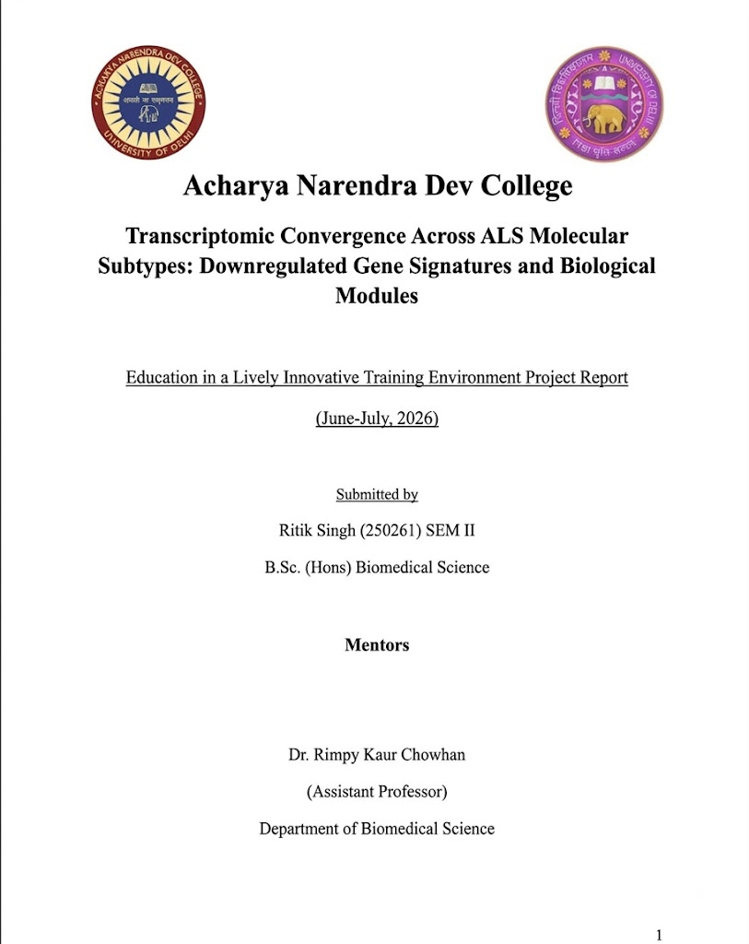

Declaration
This report titled “Transcriptomic Convergence Across Selected ALS Molecular Subtypes: A Comparative Analysis of Downregulated Gene Signatures and Biological Modules” represents work undertaken as part of the academic/research project at Acharya Narendra Dev College, University of Delhi, under the guidance of the project supervisor.
The report presents the analysis of publicly available transcriptomic datasets, including differential gene expression, Gene Ontology Biological Process enrichment, biological-module analysis, and cross-profile functional comparison. The interpretations and conclusions are based on the analyses described in the report and the supporting project outputs.
I declare that the report has not been submitted, in whole or in part, for any other degree, diploma, or academic award.

Ritik Singh,
B.Sc. (Hons.) Biomedical Science
Acharya Narendra Dev College, University of Delhi
Date: 18/08/2026


ACHARYA NARENDRA DEV COLLEGE
UNIVERSITY OF DELHI
Govindpuri, Kalkaji, New Delhi – 110 019
Certificate
This is to certify that the project entitled “Transcriptomic Convergence Across Selected ALS Molecular Subtypes: A Comparative Analysis of Downregulated Gene Signatures and Biological Modules” has been carried out by Ritik Singh, a student of B.Sc. (Hons.) Biomedical Science, 1st Year at Acharya Narendra Dev College, University of Delhi, under my supervision.
The work involved analysis of publicly available transcriptomic datasets representing selected ALS molecular subtypes, followed by differential gene expression analysis, Gene Ontology Biological Process enrichment, biological-module analysis, and comparison of functional signatures across profiles.
To the best of my knowledge, the work presented in this report represents the student's contribution to the project and has not been submitted, either in part or in full, for any other academic award.

Rimpy Kaur Chowhan
Assistant Professor
Department of Biomedical Science

Acknowledgement
I would like to express my sincere gratitude to Acharya Narendra Dev College, University of Delhi, for providing the academic environment and opportunity to undertake this project.
I am especially grateful to my project supervisor, Dr. Rimpy Kaur Chowhan, Department of Biomedical Science, for the guidance, encouragement, and scientific feedback provided throughout the project. Their support was invaluable in understanding transcriptomic data analysis, interpreting results, and developing this report.
I also thank the faculty members and staff of the Department of Biomedical Science for their support and for providing the resources required to complete the work. I am grateful to my peers and colleagues for their discussions and assistance during the project.
Finally, I would like to thank my family and friends for their continued encouragement and support throughout the project.

Abstract
Amyotrophic lateral sclerosis (ALS) is a molecularly heterogeneous neurodegenerative disease in which distinct genetic and pathological mechanisms can produce overlapping clinical phenotypes. This study investigated whether selected C9orf72-, SOD1-, and TDP-43-associated ALS transcriptomic profiles show recurring biological signatures despite differences in their underlying molecular contexts.
Four publicly available transcriptomic comparisons were analyzed independently: GSE52202 for C9orf72-associated ALS, GSE210969 for SOD1- and TDP-43-associated ALS, and GSE283507 for TDP-43-associated ALS. Differential expression analysis was used to identify significantly downregulated genes, followed by Gene Ontology Biological Process (GO-BP) enrichment. Enriched GO terms were organized into a predefined biological-module framework and compared across profiles using a recurrence-based convergence score.
The analyses identified 65, 147, 34, and 1,082 significantly downregulated genes in the four dataset-level comparisons, respectively. Significant GO-BP enrichment was observed for the C9orf72, SOD1, and GSE283507 TDP-43 profiles, whereas the GSE210969 TDP-43 profile produced no significant GO-BP terms and was therefore not carried forward to module-level convergence analysis. Five biological modules were represented across all three profiles included in the final convergence comparison, while additional modules showed partial or profile-specific representation.
These findings provide exploratory evidence of functional/module-level transcriptomic convergence across selected ALS molecular profiles, while also demonstrating substantial dataset- and profile-specific variation. The study therefore supports a hierarchical view of ALS transcriptomic organization in which distinct molecular disturbances may converge on some shared biological programs without producing an identical global transcriptome.
Keywords: amyotrophic lateral sclerosis; ALS; transcriptomics; C9orf72; SOD1; TDP-43; differential gene expression; Gene Ontology; biological modules; transcriptomic convergence

Contents
Declaration 2
Certificate 3
Acknowledgement 4
Abstract 5
1. Introduction 7
1.1 Amyotrophic Lateral Sclerosis 7
1.2 Molecular Pathology of ALS 7
1.3 Genetic and Molecular Subtypes of ALS 8
1.4 Transcriptomic Heterogeneity in ALS 8
1.5 Transcriptomic Convergence 9
1.6 Rationale of the Study 9
1.7 Aim 10
1.8 Objectives 10
2. Literature Review 10
2.1 Molecular Heterogeneity of ALS 10
2.2 Transcriptomic Studies in ALS 11
2.3 C9orf72-, SOD1-, and TDP-43-associated ALS 11
2.4 Biological Processes Associated with ALS Subtypes 11
2.5 Pathway and Biological-Module Analysis in Transcriptomics 12
2.6 Transcriptomic Convergence in ALS and Neurodegeneration 12
2.7 Research Gap 12
2.8 Relevance of the Present Study 13
3. Methodology 13
3.1 Study Design and Overall Workflow 13
3.2 Transcriptomic Dataset Selection 14
3.3 Data Acquisition and Preprocessing 14
3.4 Metadata Curation 14
3.5 Differential Gene Expression Analysis 15
3.6 Identification of Downregulated Genes 15
3.7 Gene Ontology Biological Process Enrichment 15
3.8 Biological Module Analysis 15
3.9 Cross-Subtype Convergence Analysis 16
3.10 Software and Code Availability 16
4. Results 16
4.1 Dataset and Sample Overview 16
4.2 Exploratory Expression Structure and Differential Expression 17
4.3 Downregulated Gene Signatures 19
4.4 Gene Ontology Biological Process Enrichment 20
4.5 Biological Module Analysis 21
4.6 Cross-Subtype Functional Convergence 22
4.7 Key Findings 24
5. Discussion 35
5.1 Overview of Major Findings 35
5.2 From Mutation-Specific Insults to Shared Biological Programs 35
5.3 Differential-Expression Heterogeneity and the Effect of Dataset Context 36
5.4 GO-BP Enrichment as the Bridge from Genes to Convergence 36
5.5 Functional Convergence at the Module Level 36
5.6 Shared versus Profile-Specific Functional Programs 37
5.7 Why the GSE210969 TDP-43 Profile Did Not Enter the Convergence Analysis 37
5.8 Batch Effects, Dataset Independence and the Limits of Integration 38
5.9 What the Study Demonstrates—and What It Does Not 38
5.10 Strengths and Limitations 38
5.11 Future Directions 39
5.12 Discussion Summary 39
6. Conclusion 39
6.1 Conclusion 40
6.2 Future Directions 40
References 41
Appendices 25
Appendix A. Supporting Differential-Expression and Quality-Control Figures 25
Appendix B. Supporting Downregulated GO-BP Figures 26
Appendix C. Additional Original GO-BP Outputs from Upregulated Analysis 27
Appendix D. Biological-Module Source Tables 28
Appendix E. Convergence Data and Visualizations 32
Appendix F. Supporting Spreadsheet and Data-File Inventory 34

CHAPTER 1
INTRODUCTION

1.1 Amyotrophic Lateral Sclerosis
ALS is a progressive neurodegenerative disease where degeneration of upper and lower motor neurons is observed. These neurons are responsible for transmitting signals in voluntary muscle movement, so their progressive loss leads to muscle weakness, loss of motor function, and eventually paralysis.
The disease mainly affects motor neurons in the brain and spinal cord, and depending on the pattern of involvement, patients can initially present with limb or bulbar symptoms. Limb weakness is a common initial presentation, while approximately one-third of cases initially involve muscles involved in chewing, speaking, and swallowing.
Although ALS shares a pattern of motor-neuron degeneration, the way the disease presents and progresses can vary considerably from one patient to another. Patients can differ in the site of symptom onset, relative involvement of upper and lower motor neurons, rate of disease progression, and presence of cognitive or behavioral abnormalities. This heterogeneity and differences reflects the diverse biological mechanisms underlying ALS and provides a rationale for investigating its molecular subtypes.

1.2 Molecular Pathology of ALS
ALS is a complex neurodegenerative disorder in which several interconnected cellular processes contribute to motor-neuron dysfunction and death. Central pathological mechanisms in ALS include protein misfolding and aggregation, abnormalities in RNA metabolism, mitochondrial dysfunction and oxidative stress, impaired axonal transport, and neuroinflammation. These processes are closely interconnected, instead of occurring independently with disturbances in one cellular pathway often affecting others which ultimately contributes to the progressive damage and loss of motor neurons.
Abnormal protein homeostasis and RNA dysregulation are particularly highlighted features of ALS. Abnormal accumulation and mislocalization of proteins such as TDP-43 are observed in many forms of ALS, and mutations affecting proteins involved in RNA metabolism can disrupt RNA processing, transport, and translation. Mitochondrial dysfunction and oxidative stress can further hinder neuronal energy production and cellular balance. Moreover, abnormalities in axonal transport and cytoskeletal organization can interfere with the movement of proteins, RNA, mitochondria, and other essential cellular components along the exceptionally long axons of motor neurons.
ALS pathology also includes neuroinflammation and changes in the interactions between neurons and glial cells, both of which can affect motor-neuron survival. Although these pathological changes may result from different genetic abnormalities, they often disrupt similar cellular processes. This shows that different forms of ALS, despite having distinct molecular origins, may eventually converge on shared biological pathways and patterns of gene expression. Identifying these common molecular features could therefore help reveal the biological mechanisms shared across different ALS subtypes.

1.3 Genetic and Molecular Subtypes of ALS
ALS is genetically and molecularly heterogeneous, with numerous genes implicated in familial and sporadic disease. Among the most well-characterized forms are those associated with SOD1, C9orf72, and TARDBP/TDP-43, each of which is linked to distinct initiating molecular abnormalities. SOD1-associated ALS results from pathogenic variants in the SOD1 gene and is primarily associated with toxic gain-of-function mechanisms involving abnormal protein folding and aggregation, oxidative stress, and mitochondrial dysfunction. C9orf72-associated ALS is caused by a hexanucleotide repeat expansion and can involve both loss of normal C9orf72 function and toxic gain-of-function mechanisms, including the formation of repeat RNA foci and dipeptide repeat proteins that disrupt RNA metabolism, protein homeostasis, and cellular transport. TDP-43-associated ALS is characterized by abnormal cytoplasmic accumulation and mislocalization of the RNA-binding protein TDP-43, which is involved in RNA processing and regulation. Although mutations in TARDBP, the gene encoding TDP-43, are relatively rare, TDP-43 pathology is present in the large majority of ALS cases, making it an important molecular feature of the disease. Despite these distinct molecular origins, these forms of ALS can affect overlapping cellular processes, including RNA metabolism, proteostasis, mitochondrial function, and intracellular transport. This raises the possibility that genetically distinct forms of ALS may ultimately converge on shared biological programs, providing the basis for comparative transcriptomic analysis.

1.4 Transcriptomic Heterogeneity in ALS
Transcriptomics provides a means of studying the complete set of RNA transcripts expressed by cells or tissues under specific biological conditions, allowing changes in gene expression to be examined on a genome-wide scale. In ALS research, transcriptomic approaches such as RNA sequencing and microarray analysis have been used to identify differentially expressed genes, altered RNA-processing patterns, and biological processes associated with disease. These approaches have revealed widespread transcriptional changes in ALS and have helped characterize molecular mechanisms involved in neurodegeneration, including alterations in RNA metabolism, mitochondrial function, neuroinflammation, and other disease-associated processes.
The high-dimensional nature of transcriptomic data also makes it possible to investigate molecular heterogeneity within ALS. Comparative analysis of gene-expression profiles can identify distinct molecular signatures associated with different genetic or pathological forms of the disease and can reveal groups of genes that participate in common biological processes. Recent studies have used transcriptomic data to identify molecular subtypes of ALS characterized by differences in processes such as oxidative stress, neuroinflammation, and glial activity.
Thus, transcriptomic analysis provides a useful framework for moving beyond individual disease-associated genes and examining broader patterns of molecular dysfunction. Comparing transcriptomic signatures across genetically distinct ALS subtypes can therefore help determine whether different molecular causes produce distinct expression patterns or converge on shared biological processes and functional programs.

1.5 Transcriptomic Convergence in ALS
Although ALS-associated genetic and molecular subtypes can exhibit distinct transcriptional alterations, different forms of ALS may also share common molecular signatures. Transcriptomic studies have identified both subtype-specific and ALS-wide changes involving processes such as oxidative stress, mitochondrial dysfunction, neuroinflammation, and TDP-43-related dysfunction. Such findings suggest that different molecular causes may produce overlapping downstream biological alterations even when their initiating mechanisms differ.
Transcriptomic convergence can be considered at different biological levels. At the gene level, convergence occurs when different ALS subtypes show changes in the same genes. At the functional level, distinct sets of genes may nevertheless affect the same biological processes. At a higher level, differentially expressed genes can form shared biological or transcriptional programs, even when individual gene overlap is limited. This distinction is important because different genetic causes may produce different initial molecular disturbances while ultimately disrupting common cellular functions.
In the present study, transcriptomic convergence was investigated primarily at the biological-process and functional-module level. Downregulated genes from C9orf72-, SOD1-, and TDP-43-associated ALS datasets were subjected to Gene Ontology Biological Process enrichment analysis, and enriched terms were organized into broader biological modules to enable comparison across the three molecular subtype profiles. This approach allows the study to examine whether distinct downregulated gene signatures converge on shared biological programs, while also identifying processes that may be more specific to individual ALS subtypes.

1.6 Rationale of the Study
Amyotrophic lateral sclerosis is characterized by substantial molecular heterogeneity, with different genetic and pathological forms involving distinct cellular abnormalities while potentially affecting overlapping biological processes. Transcriptomic analysis provides an opportunity to examine these changes simultaneously across thousands of genes and to identify molecular signatures associated with different forms of ALS. Previous transcriptomic studies have demonstrated distinct molecular patterns involving processes such as oxidative stress, glial activation, transcriptional dysregulation, and other disease-associated biological programs, supporting the use of gene-expression profiles to investigate ALS heterogeneity.
However, comparison of transcriptomic datasets generated by different studies can be complicated by differences in experimental conditions, sample characteristics, sequencing procedures, and other sources of technical variation. In the present study, an initial attempt was made to assess the feasibility of combining datasets representing comparable cellular models. Principal component analysis revealed substantial batch-associated variation, and subsequent harmonization resulted in considerable loss of genes. Consequently, the datasets were analyzed independently rather than being combined into a single integrated expression matrix. This approach allowed the study to retain a larger proportion of the available transcriptomic information while subsequently comparing the biological signatures identified across datasets.
The present study therefore focuses on C9orf72-, SOD1-, and TDP-43-associated ALS, with particular emphasis on significantly downregulated genes. Gene Ontology Biological Process enrichment was used to characterize the biological functions represented by these genes, after which enriched processes were organized into broad biological modules. Comparing these modules across the three ALS subtype profiles provides a means of investigating whether distinct molecular forms of ALS exhibit convergent functional signatures despite differences in their underlying genetic and molecular origins.

1.7 Aim
To investigate transcriptomic convergence across selected ALS molecular subtypes by comparing downregulated gene signatures and their associated biological modules.

1.8 Objectives
1. To identify and curate publicly available transcriptomic datasets representing selected molecular subtypes of ALS.
2. To identify significantly downregulated genes associated with C9orf72-, SOD1-, and TDP-43-associated ALS through differential gene expression analysis.
3. To characterize the biological functions associated with the identified downregulated genes using Gene Ontology Biological Process enrichment analysis.
4. To organize enriched Gene Ontology Biological Process terms into biologically relevant functional modules.
5. To compare biological module enrichment across C9orf72-, SOD1-, and TDP-43-associated ALS and identify convergent and subtype-specific functional signatures.

CHAPTER 2
LITERATURE REVIEW
This chapter reviews the literature relevant to the molecular heterogeneity of amyotrophic lateral sclerosis (ALS), transcriptomic approaches to ALS research, molecularly distinct forms associated with C9orf72, SOD1 and TDP-43, and the use of pathway- and module-level analyses to investigate shared disease biology. Particular emphasis is placed on how transcriptomic data can be used to move from mutation-specific gene signatures toward broader functional patterns.

2.1 Molecular Heterogeneity of ALS
ALS is a clinically and biologically heterogeneous neurodegenerative disease rather than a single molecular entity. Genetic studies have identified numerous ALS-associated genes, including C9orf72, SOD1, TARDBP and FUS, while clinical presentation and disease progression can also vary substantially between individuals. This heterogeneity has important implications for mechanistic studies because apparently similar clinical phenotypes can arise from different molecular disturbances. Reviews of ALS genetics and pathophysiology therefore increasingly describe the disease as a collection of interconnected molecular processes rather than a single pathway-driven disorder. [1,2]
The biological consequences of ALS-associated mutations span several interconnected systems, including RNA metabolism, protein homeostasis, nucleocytoplasmic transport, mitochondrial function, oxidative stress, axonal transport and neuroinflammation. These pathways can interact, producing downstream effects that extend beyond the primary molecular lesion. As a result, studying ALS solely at the level of individual causal genes may fail to capture the broader cellular programs that contribute to motor-neuron vulnerability. [2,3]

2.2 Transcriptomic Studies in ALS
Transcriptomics provides a genome-wide view of RNA abundance and regulation, making it useful for investigating molecular states associated with disease. In ALS, transcriptomic studies have been performed using post-mortem tissues, patient-derived cells and induced pluripotent stem cell (iPSC)-derived motor neurons. These approaches have identified widespread alterations in gene expression and have helped connect genetic or pathological subtypes with changes in specific biological processes. An important strength of transcriptomic profiling is that it can reveal coordinated alterations across many genes rather than focusing on one molecular target at a time. [4,5]
The use of iPSC-derived motor neurons is particularly relevant because these cells provide a human neuronal model that can be studied at defined stages of differentiation and can capture disease-associated molecular phenotypes without requiring direct access to living motor neurons. Multi-omic and transcriptomic studies of patient-derived motor neurons have demonstrated that some molecular abnormalities are reproducible across experimental systems, while others vary according to the causal mutation or differentiation protocol. [5,6]

2.3 C9orf72-, SOD1-, and TDP-43-associated ALS
C9orf72, SOD1 and TARDBP/TDP-43 represent biologically distinct entry points into ALS pathology. C9orf72 repeat expansion is a major genetic cause of ALS and frontotemporal dementia and has been linked to disturbances in RNA processing, nucleocytoplasmic transport and protein homeostasis. C9orf72-associated motor neurons have also shown transcriptional signatures involving extracellular-matrix and cell-adhesion programs and inflammatory signaling. [1,7]
SOD1-associated ALS is commonly linked to toxic gain-of-function mechanisms involving abnormal protein homeostasis, oxidative stress and mitochondrial dysfunction. Transcriptomic work has shown that SOD1-associated motor neurons can display expression patterns that differ substantially from C9orf72-associated neurons, illustrating that genetically distinct forms of ALS can produce different molecular states even when the clinical syndrome is similar. [7,8]
TDP-43 is both a major pathological feature of ALS and a disease-linked RNA-binding protein. Its nuclear clearance and cytoplasmic accumulation are associated with disruption of RNA processing and splicing, and TDP-43 dysfunction has been linked to cryptic exon inclusion and altered RNA homeostasis. Recent work using iPSC-derived motor neurons continues to identify TDP-43-dependent transcriptional and post-transcriptional abnormalities and highlights RNA metabolism as an important component of TDP-43-associated pathology. [2,9]
Importantly, these molecular categories should not be interpreted as completely isolated biological entities. Large transcriptomic and multi-omic studies show both subtype-specific and shared alterations. A 2019 analysis of patient-derived motor neurons, for example, found strong differences between C9orf72- and SOD1-associated transcriptional landscapes, while more recent integrated studies across multiple ALS genotypes have identified shared changes as well as mutation-specific alterations. [7,10]

2.4 Biological Processes Associated with ALS Subtypes
A recurring theme in ALS transcriptomic literature is that disease-associated changes cluster into biological processes rather than appearing as unrelated individual-gene effects. Processes repeatedly reported across studies include oxidative stress and mitochondrial dysfunction, RNA processing and splicing, extracellular-matrix and cell-adhesion changes, inflammatory and glial activation, cytoskeletal organization, synaptic function, and cellular stress responses. [2,5,7,10]
The balance among these processes can differ substantially between molecular contexts. Transcriptomic subtype studies have identified groups characterized by oxidative and proteotoxic stress, glial and inflammatory activity, or transcriptional dysregulation and TDP-43-associated abnormalities. The distribution of these signatures across cohorts and tissues is not identical, demonstrating that both biological state and experimental context influence the observed transcriptome. [3,11]
Recent temporal profiling of iPSC-derived motor neurons carrying different ALS-associated mutations has further suggested that some abnormalities may be shared across genetic backgrounds. In a 2025 study of C9orf72, FUS, TARDBP and SOD1 motor-neuron models, cytoskeletal and synaptic alterations emerged as common features during maturation, while additional gene-expression and alternative-splicing changes remained subgroup-specific. [10]

2.5 Pathway and Biological-Module Analysis in Transcriptomics
The large number of genes measured in transcriptomic experiments makes functional interpretation an essential step after differential-expression analysis. Gene Ontology (GO) provides a structured vocabulary for describing biological processes, molecular functions and cellular components and is continuously updated as functional knowledge changes. GO-based enrichment analysis can therefore translate a list of differentially expressed genes into a smaller set of interpretable biological themes. [12]
Tools such as clusterProfiler provide statistical enrichment and visualization workflows for comparing biological themes across gene sets. These approaches are especially useful when individual genes show limited overlap between datasets but participate in related biological processes. [13] At a broader level, grouping related GO terms into biological modules can reduce redundancy and provide a functional representation that is easier to compare across experimental conditions.
This distinction is important in heterogeneous disorders. Two datasets may contain few or no identical differentially expressed genes yet still show enrichment of related processes, because different genes can contribute to the same cellular function. Module-level analysis therefore provides a framework for testing convergence above the individual-gene level.

2.6 Transcriptomic Convergence in ALS and Neurodegeneration
The concept of transcriptomic convergence refers to the possibility that distinct genetic or molecular disturbances ultimately produce overlapping changes in cellular programs. This idea is particularly relevant to ALS because many causative genes differ in their primary molecular functions, while the disease phenotype converges on motor-neuron degeneration. Omics studies of neurodegenerative disease increasingly use molecular profiling and integrative analysis to identify biological subgroups and shared pathways rather than treating each disease-associated genotype as an isolated entity. [3,14]
Evidence for both divergence and convergence is emerging from ALS studies. C9orf72- and SOD1-associated motor neurons can show strongly different transcriptional landscapes, yet shared alterations in particular cellular programs have also been observed across multiple ALS genotypes. Recent integrated profiling of C9orf72, FUS, TARDBP and SOD1 motor neurons reported common synaptic and cytoskeletal abnormalities alongside mutation-specific signatures, illustrating that convergence can coexist with marked molecular divergence. [7,10]
Transcriptomic subtype studies provide a complementary perspective. Rather than defining ALS only by causal gene, they identify molecular groups characterized by shared expression programs such as oxidative stress, glial activation and transcriptional dysregulation. A recent 2026 review of ALS molecular-subtyping studies concluded that transcriptomic stratification can reveal biologically meaningful subgroups but also emphasized methodological differences, tissue effects and the need for independent validation. [11]

2.7 Research Gap
The literature therefore supports two observations that are directly relevant to the present study. First, ALS molecular subtypes can exhibit substantially different transcriptomic signatures, meaning that direct pooling of datasets from distinct studies may obscure biologically meaningful variation. Second, apparent differences at the individual-gene level do not exclude convergence at the level of biological processes or functional programs. [3,7,10,11]
Existing studies have already demonstrated transcriptomic convergence within selected experimental systems, including multi-omic and multi-genotype motor-neuron models. However, there remains value in transparent, dataset-level comparisons of public transcriptomic data that preserve the identity of individual studies while examining whether their downregulated gene signatures map onto shared functional modules. This is particularly relevant when datasets differ in sample composition, experimental design and technical characteristics. The present study therefore addresses a focused gap at the interface between independent differential-expression analysis and module-level comparison, rather than attempting to claim that ALS subtypes are transcriptomically identical.

2.8 Relevance of the Present Study
The present study builds on this literature by comparing downregulated gene signatures from selected C9orf72-, SOD1- and TDP-43-associated ALS transcriptomic datasets at multiple functional levels. Differential-expression analysis provides dataset-specific gene signatures, while GO Biological Process enrichment translates those signatures into biological themes. A predefined biological-module framework then allows recurring functions to be compared across profiles. The resulting convergence analysis is intended to determine whether distinct ALS molecular contexts show recurring functional patterns even when their individual gene-level responses differ.
This approach is consistent with the broader direction of ALS research toward molecular stratification and systems-level interpretation. It does not assume that the three molecular contexts are equivalent, nor does it require pooling their expression matrices into a single integrated dataset. Instead, it preserves dataset-specific differential-expression results and asks whether functional modules recur across independently analyzed profiles.

CHAPTER 3
METHODOLOGY

3.1 Study Design and Overall Workflow
This study employed a comparative transcriptomic approach to investigate potential functional convergence across selected molecular forms of amyotrophic lateral sclerosis (ALS). Publicly available transcriptomic datasets representing C9orf72-, SOD1-, and TDP-43-associated ALS were selected and analyzed independently. Following data preparation and metadata curation, differential gene expression analysis was performed to identify significantly downregulated genes. These gene sets were subjected to Gene Ontology (GO) Biological Process enrichment analysis. Biological-module analysis was subsequently performed for datasets that yielded significant GO Biological Process enrichment, allowing functional patterns to be compared across the selected ALS molecular subtypes. The overall workflow consisted of dataset selection, data preprocessing, metadata curation, differential expression analysis, identification of downregulated genes, GO Biological Process enrichment, biological-module classification, and cross-subtype comparison.
The study was designed to determine whether genetically and molecularly distinct forms of ALS exhibit shared functional signatures despite differences in their underlying molecular origins.
An initial attempt was made to assess the feasibility of combining comparable transcriptomic datasets. Principal component analysis showed substantial batch-associated variation, and subsequent harmonization resulted in considerable loss of genes. The datasets were therefore analyzed independently rather than being combined into a single integrated expression matrix.

3.2 Transcriptomic Dataset Selection
Publicly available transcriptomic datasets were obtained from the NCBI Gene Expression Omnibus (GEO) database and selected based on their representation of the ALS molecular subtypes investigated in this study, availability of appropriate control samples, and availability of gene-level expression count data suitable for differential expression analysis. Four dataset-level comparisons were included: GSE52202 representing C9orf72-associated ALS, GSE210969 representing both SOD1-associated and TDP-43-associated ALS, and GSE283507 representing TDP-43-associated ALS. Each ALS-associated group was compared with its corresponding control samples, and the datasets were analyzed independently.
GEO accession | Molecular subtype | Control | ALS | Comparison
GSE52202 | C9orf72 | 4 | 4 | C9ALS vs Control
GSE210969 | SOD1 | 3 | 2 | SOD1 vs Control
GSE210969 | TDP-43 | 3 | 3 | TDP43 vs Control
GSE283507 | TDP-43 | 3 | 3 | TDP43 vs Control
Table 3.1. Transcriptomic datasets analyzed in the study.

3.3 Data Acquisition and Preprocessing
Transcriptomic expression data for the selected datasets were obtained from the NCBI Gene Expression Omnibus (GEO) database and downloaded locally for analysis. The downloaded expression files were imported into R for dataset-specific processing. For GSE52202 and GSE210969, raw count matrices were used as input for downstream analysis. For GSE283507, the downloaded expression file contained Read Count, FPKM, and TPM measurements; only the Read Count columns corresponding to the selected samples were retained for analysis.
For each dataset, the selected gene-level count matrix was prepared for differential expression analysis. Gene identifiers were retained as row identifiers, while the expression columns corresponding to the selected samples were retained for analysis. A corresponding sample metadata table was subsequently prepared for each dataset.
For GSE210969, genes with a total read count of less than 10 across all samples were removed before differential expression analysis. No equivalent manual low-count filtering step was present in the GSE52202 or GSE283507 analysis scripts; therefore, no additional manual count-based filtering is reported for these datasets.
The resulting count matrices and corresponding metadata were subsequently used to construct DESeq2 datasets for differential expression analysis. Variance-stabilizing transformation (VST) was applied later in the workflow for exploratory visualization and principal component analysis.

3.4 Metadata Curation
For each dataset, sample information was obtained from the corresponding GEO metadata. Sample names and their associated experimental conditions were extracted and used to construct dataset-specific metadata tables. Sample identifiers were standardized and renamed where necessary so that they corresponded to the sample columns in the respective expression matrices. The curated metadata primarily contained the sample identifier and experimental condition required for differential expression analysis.
For GSE52202, the metadata distinguished Control and C9ALS samples; for GSE210969, Control, SOD1, and TDP43 groups were specified; and for GSE283507, Control and TDP43 groups were specified. The sample identifiers in each expression matrix were then compared with the row names of the corresponding metadata table to confirm that all selected samples were represented and that their ordering was identical. This ensured that each expression profile was associated with the correct experimental condition before construction of the DESeq2 dataset.

3.5 Differential Gene Expression Analysis
Differential gene expression analysis was performed independently for each selected dataset using the DESeq2 package in R. For each dataset, a DESeqDataSet was constructed from the gene-level count matrix and corresponding sample metadata, with experimental condition specified as the design variable (design = ~ Condition). Control samples were set as the reference level of the condition factor.
The DESeq2 workflow was applied to the count data for differential expression testing. Comparisons were specified according to the molecular subtype represented in each dataset. For GSE52202, C9orf72-associated ALS samples were compared with controls. For GSE210969, separate contrasts were performed for SOD1 versus Control and TDP-43 versus Control. For GSE283507, TDP-43 was compared with Control.
For exploratory assessment of the expression data, variance-stabilizing transformation was applied and principal component analysis (PCA) was performed using experimental condition as the grouping variable. For GSE210969, a sample-to-sample distance matrix was additionally generated and visualized as a heatmap. Normalized count matrices were also generated from the fitted DESeq2 objects for downstream inspection and visualization.

3.6 Identification of Downregulated Genes
Significantly differentially expressed genes were identified using an adjusted p-value threshold of < 0.05 and an absolute log2 fold-change threshold of > 1. Genes with a log2 fold change < -1 and adjusted p-value < 0.05 were classified as significantly downregulated. This criterion was applied to each dataset-specific comparison, including C9orf72-associated ALS versus Control in GSE52202, SOD1-associated ALS versus Control and TDP-43-associated ALS versus Control in GSE210969, and TDP-43-associated ALS versus Control in GSE283507.
The resulting dataset-specific downregulated gene sets were subsequently used as inputs for Gene Ontology Biological Process enrichment analysis.

3.7 Gene Ontology Biological Process Enrichment Analysis
The significantly downregulated gene sets identified from each dataset were subjected to Gene Ontology (GO) Biological Process enrichment analysis using the enrichGO() function from the clusterProfiler R package. Gene identifiers were interpreted as Entrez Gene IDs, and human gene annotations were obtained from the org.Hs.eg.db annotation database. Genes that could not be mapped to a corresponding gene symbol were removed from the curated gene lists before downstream analysis.
Enrichment analysis was performed separately for the downregulated gene sets corresponding to GSE52202 C9orf72, GSE210969 SOD1, GSE210969 TDP-43, and GSE283507 TDP-43. The Biological Process (BP) ontology was selected for analysis. Multiple testing was controlled using the Benjamini-Hochberg method, with both the p-value and q-value cutoffs set to 0.05. The resulting enriched GO terms were converted to data frames and exported as CSV files for downstream analysis.
For visualization, enriched Biological Process terms were represented using dot plots and bar plots, with up to the 20 most relevant enriched terms displayed for each analysis. Additional visualizations, including enrichment maps, GO hierarchy plots, and category-gene heatmaps, were generated to explore relationships among enriched Biological Process terms and their associated genes.
Gene Ontology Biological Process enrichment was performed independently for each dataset-level downregulated gene set. Profiles yielding significant GO Biological Process enrichment were subsequently considered for biological-module analysis.

3.8 Biological Module Analysis
Enriched Gene Ontology Biological Process terms from profiles yielding significant enrichment were organized according to a predefined biological-module framework provided for the study. The framework grouped biologically related processes into broader functional modules relevant to ALS. The enriched GO terms were reviewed and assigned to the corresponding predefined modules based on their biological relevance and the descriptions associated with the module framework.
The resulting module assignments were compiled into dataset-specific spreadsheets and used to represent the biological processes associated with the downregulated gene signatures at a broader functional level. For each module, the enrichment results were summarized using measures including the number of associated GO terms, fold enrichment, RichFactor, and false-discovery rate (FDR), where applicable. Biological-module analysis was performed for profiles with significant GO Biological Process enrichment.

3.9 Cross-Subtype Convergence Analysis
The biological-module enrichment profiles obtained from the selected transcriptomic datasets were compared to assess functional convergence across C9orf72-, SOD1-, and TDP-43-associated ALS. The predefined biological modules identified from enriched Gene Ontology Biological Process terms were compared to determine which functional modules were shared across the molecular subtypes and which were represented in fewer datasets.
Cross-subtype convergence was evaluated across the profiles carried forward from the biological-module analysis. For each module, the convergence score was calculated as the number of profiles in which the module was represented divided by the total number of profiles included in the convergence comparison.
The resulting module-level patterns were summarized using convergence scores and visualized using heatmaps and bubble plots to facilitate comparison of shared and profile-associated biological signatures.

3.10 Software and Code Availability
All transcriptomic data processing, differential gene expression analysis, Gene Ontology enrichment analysis, and visualization were performed using R and relevant Bioconductor and R packages. Differential expression analysis was performed using DESeq2, while Gene Ontology Biological Process enrichment was conducted using clusterProfiler with the human annotation database org.Hs.eg.db. Additional packages were used for data manipulation, annotation, visualization, and generation of enrichment plots. The complete computational workflow, analysis scripts, processed results, and supporting documentation will be made available through the accompanying GitHub repository; the repository URL will be added to the final version of this report.

CHAPTER 4
RESULTS
This chapter presents the results obtained from the four dataset-level transcriptomic comparisons performed in the study. Differential-expression results are reported for all four comparisons. Gene Ontology Biological Process (GO-BP) enrichment is reported for all four comparisons, including the GSE210969 TDP-43 comparison that returned no significant GO-BP terms. Biological-module and convergence analyses are reported for the three profiles that yielded significant GO-BP enrichment and were therefore carried forward to the module-level comparison.
[ORGANIZATION] Original project figures are used throughout this chapter. Supporting images serving similar purposes are grouped into compact appendix layouts (generally four to six figures per page). Full raw spreadsheets are summarized in report tables and retained for GitHub/supplementary use.

4.1 Dataset and Sample Overview
Four dataset-level comparisons representing three ALS molecular subtypes were analyzed independently. GSE52202 represented C9orf72-associated ALS and contained four Control and four C9ALS samples. GSE210969 contained three Control samples, two SOD1 samples, and three TDP-43 samples, allowing separate SOD1-versus-Control and TDP-43-versus-Control comparisons. GSE283507 contained three Control and three TDP-43 samples.
The four comparisons were retained as separate dataset-level analyses. The later biological-module and convergence analysis used three profiles: GSE52202 C9orf72, GSE210969 SOD1, and GSE283507 TDP-43. The GSE210969 TDP-43 comparison was not carried forward because its downregulated gene set produced no significant GO-BP enrichment.
GEO accession | Subtype | Control | ALS | Comparison | Downregulated genes
GSE52202 | C9orf72 | 4 | 4 | C9ALS vs Control | 65
GSE210969 | SOD1 | 3 | 2 | SOD1 vs Control | 147
GSE210969 | TDP-43 | 3 | 3 | TDP43 vs Control | 34
GSE283507 | TDP-43 | 3 | 3 | TDP43 vs Control | 1082
Table 4.1. Dataset-level comparisons and final downregulated gene-set sizes.

4.2 Exploratory Expression Structure and Differential Expression
Principal component analysis (PCA) was used to visualize the overall structure of the transformed expression data within each dataset. In GSE52202, the C9ALS samples occupy the positive PC1 region while the Control samples are more dispersed across the PCA space (Figure 4.1). In GSE210969, the Control, SOD1 and TDP-43 samples occupy distinct regions; the original figure reports that PC1 and PC2 account for 33% and 23% of the variance, respectively (Figure 4.2). In GSE283507, PC1 accounts for 94% of the variance and clearly separates the Control and TDP-43 samples (Figure 4.3).
⭐ Figure 4.1. PCA of GSE52202 samples, coloured by experimental condition.
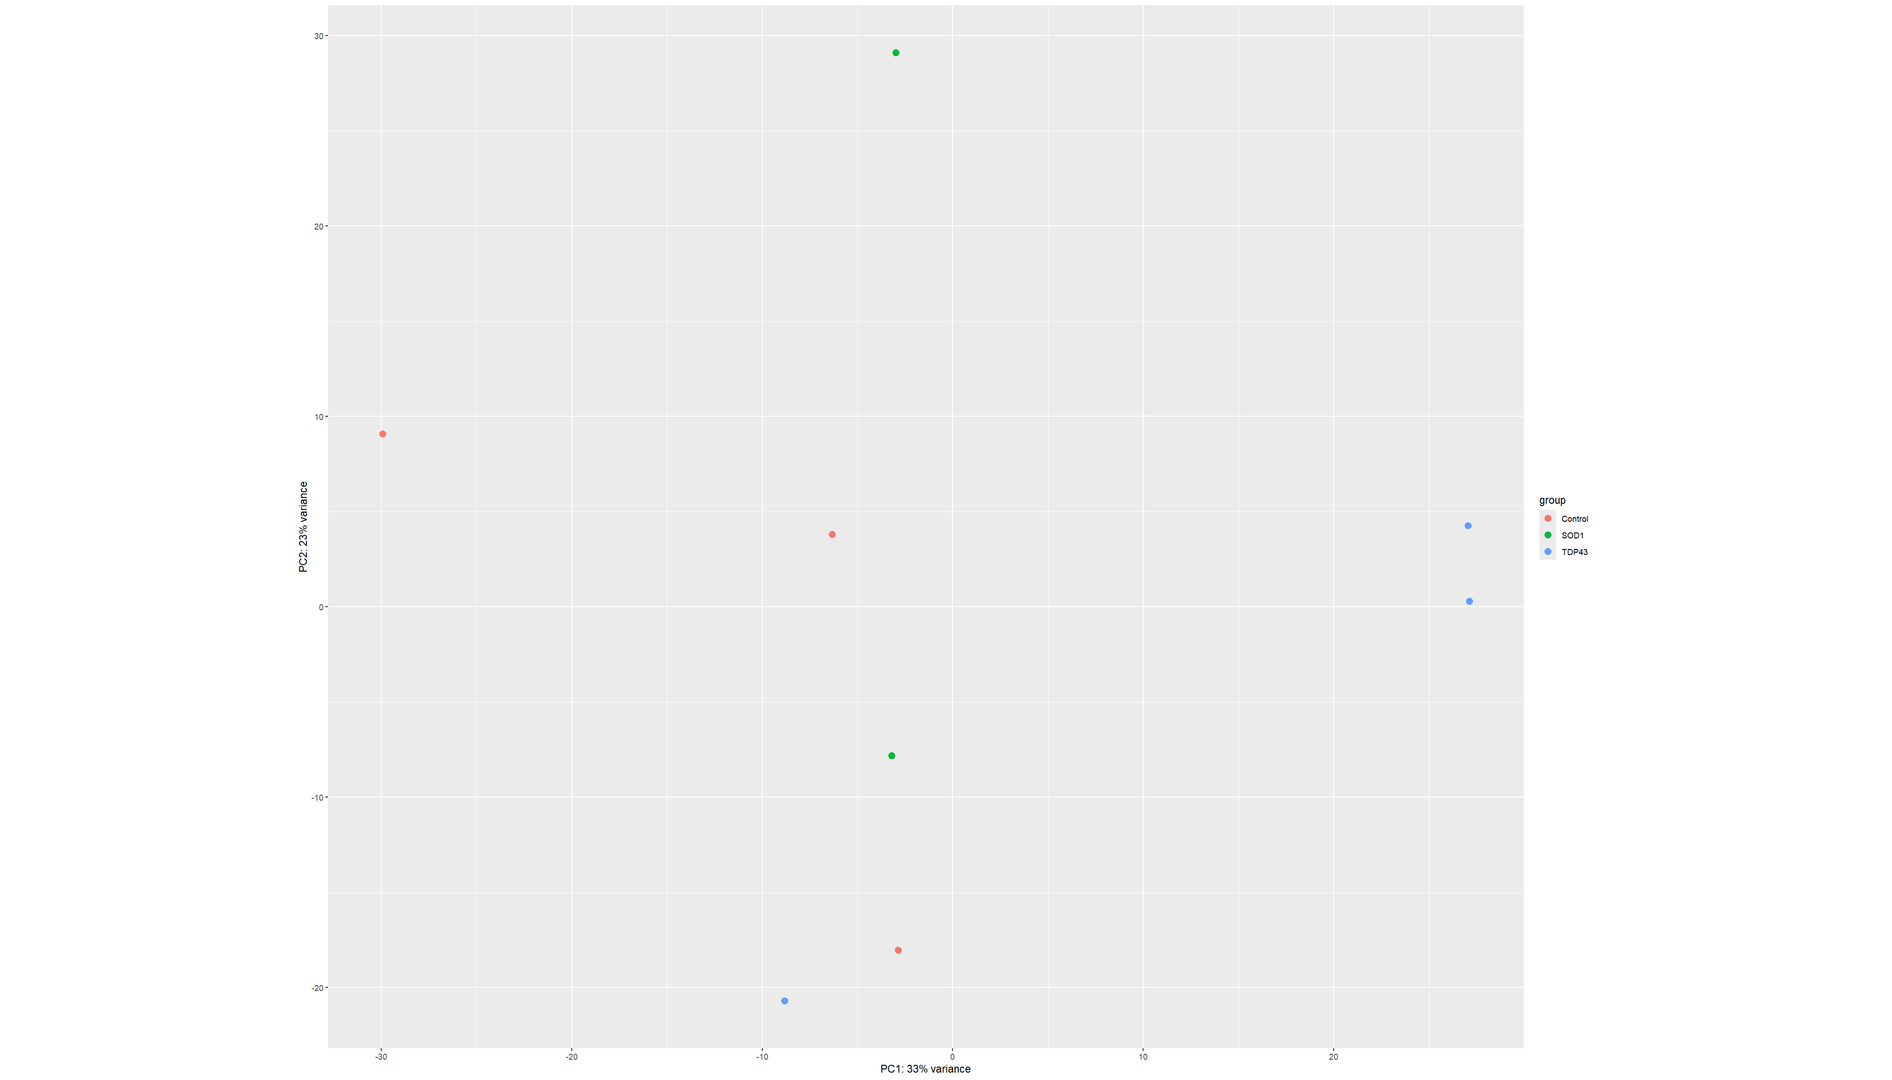
⭐ Figure 4.2. PCA of GSE210969 samples; PC1 and PC2 account for 33% and 23% of the variance, respectively.
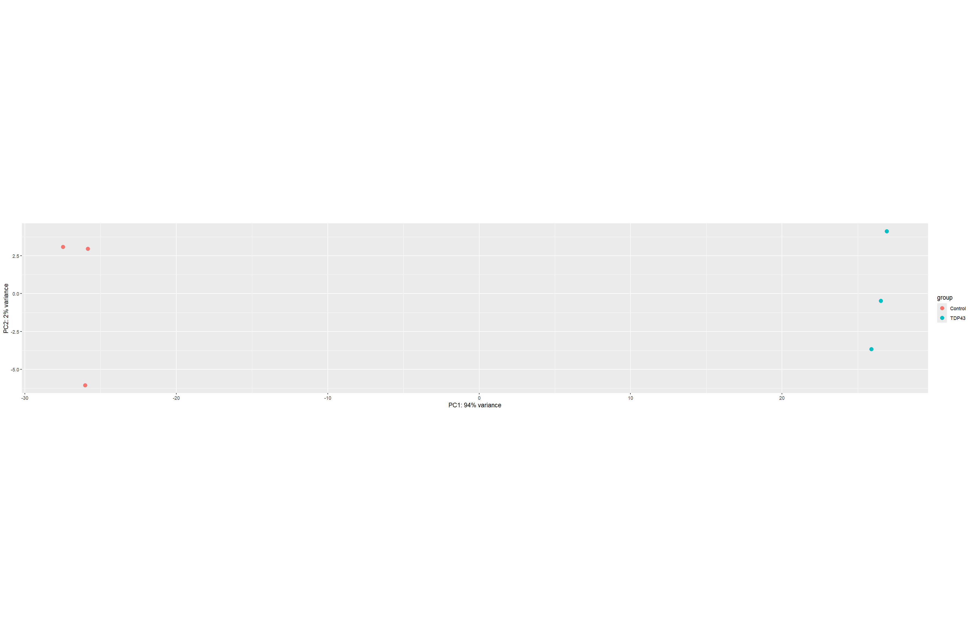
⭐ Figure 4.3. PCA of GSE283507 samples; PC1 accounts for 94% of the variance and separates the Control and TDP-43 groups.
Differential-expression results were visualized using volcano plots and MA plots. The original volcano plots for the C9orf72, SOD1, TDP-43 (GSE210969), and TDP-43 (GSE283507) comparisons are shown in Figures 4.4–4.7. Supporting MA plots and the GSE210969 expression heatmaps are provided in Appendix A (Figures A1–A5).
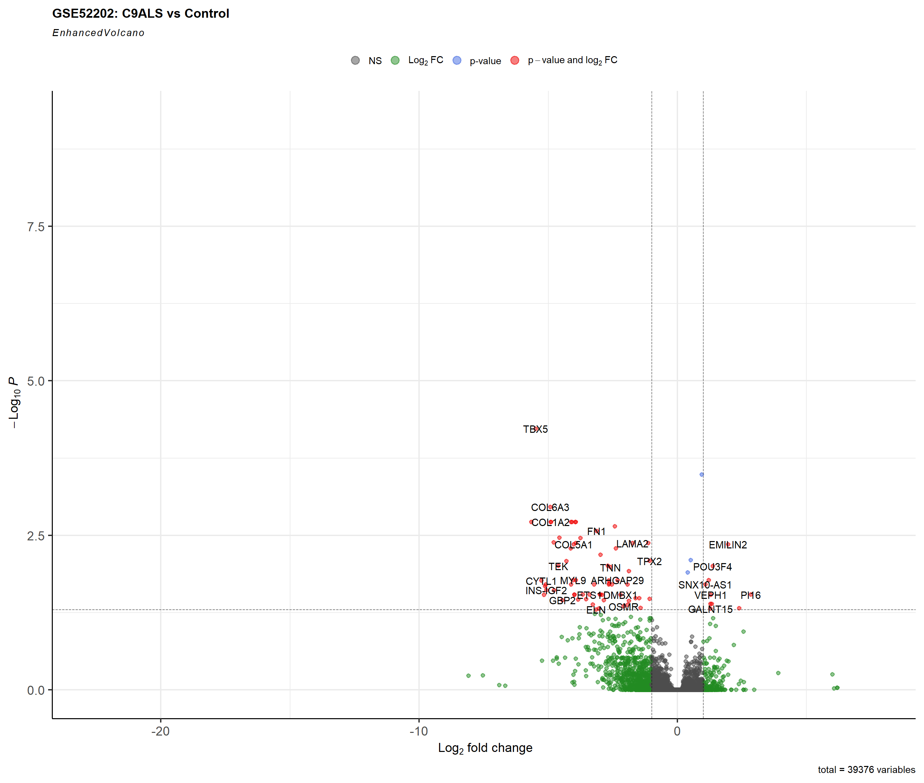  Figure 4.4. GSE52202 C9orf72 vs Control. ⭐ Main-text priority. | Figure 4.5. GSE210969 SOD1 vs Control. ⭐ Main-text priority.
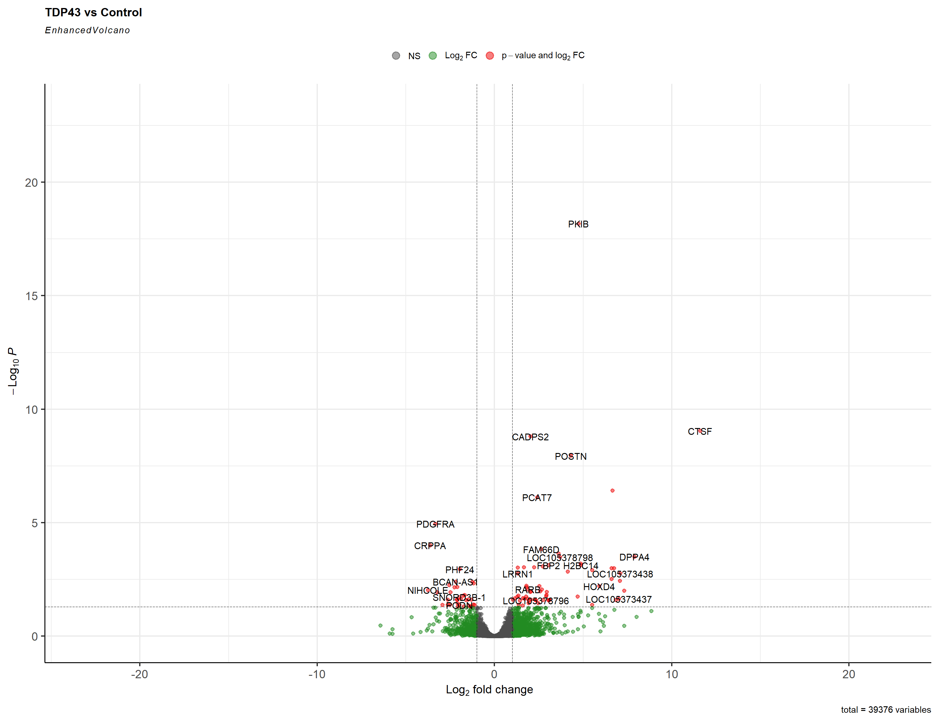  Figure 4.6. GSE210969 TDP-43 vs Control. Supporting comparison. | 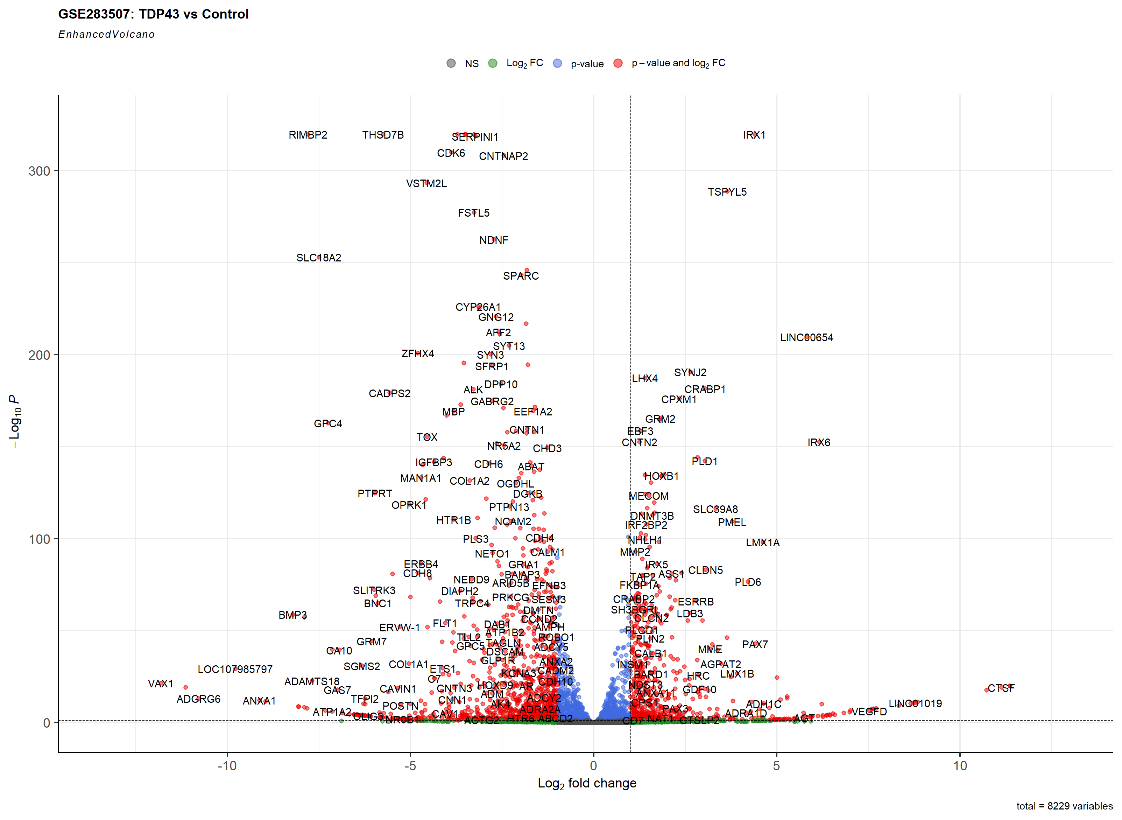  Figure 4.7. GSE283507 TDP-43 vs Control. ⭐ Main-text priority.

The volcano plots in Figure 4.4–3.7 show the distribution of log2 fold changes and adjusted p-values across the four dataset-level comparisons. The exact downregulated gene sets were then extracted using the predefined criteria of adjusted p-value < 0.05 and log2 fold change < -1, as summarized in Table 4.2.

4.3 Downregulated Gene Signatures
Application of the predefined differential-expression thresholds identified four distinct downregulated gene sets. GSE52202 yielded 65 downregulated genes, GSE210969 yielded 147 downregulated genes for SOD1 and 34 for TDP-43, and GSE283507 yielded 1,082 downregulated genes (Table 4.2). The size of the final downregulated gene sets therefore varied substantially between dataset-level comparisons.
Dataset | Subtype | n downregulated | log2FC range | Minimum padj | Maximum padj
GSE52202 | C9orf72 | 65 | -5.648 to -1.069 | 5.94 × 10⁻⁵ | 0.04995
GSE210969 | SOD1 | 147 | -8.150 to -1.034 | 1.13 × 10⁻¹⁰ | 0.04904
GSE210969 | TDP-43 | 34 | -3.753 to -1.119 | 1.12 × 10⁻⁵ | 0.04909
GSE283507 | TDP-43 | 1082 | -11.808 to -1.000 | 0.0 (reported) | 0.04959
Table 4.2. Summary statistics for the final downregulated gene sets.
[DATA NOTE] The GSE283507 downregulated file reports a minimum adjusted p-value of 0. This value is retained as recorded in the supplied file and was not re-estimated.

4.4 Gene Ontology Biological Process Enrichment
The final downregulated gene sets were subjected to GO-BP enrichment separately. Significant enrichment was obtained for three of the four dataset-level comparisons (Table 4.3). The GSE52202 C9orf72 set contained 112 significant GO-BP terms, the GSE210969 SOD1 set contained 24, and the GSE283507 TDP-43 set contained 899. The GSE210969 TDP-43 downregulated set returned no significant GO-BP terms.
Dataset | Subtype | Downregulated genes | Significant GO-BP terms | Outcome
GSE52202 | C9orf72 | 65 | 112 | Significant enrichment
GSE210969 | SOD1 | 147 | 24 | Significant enrichment
GSE210969 | TDP-43 | 34 | 0 | No significant GO-BP terms
GSE283507 | TDP-43 | 1082 | 899 | Significant enrichment
Table 4.3. GO Biological Process enrichment results.
The main GO-BP visualizations are the original dot plots shown in Figures 3.8–3.10. Additional original GO bar plots, enrichment maps, hierarchy plots, and category–gene heatmaps are provided in Appendix B (Figures B1–B12). The GSE210969 TDP-43 result is not associated with a significant GO-BP plot because its GO output file contains zero enriched terms.
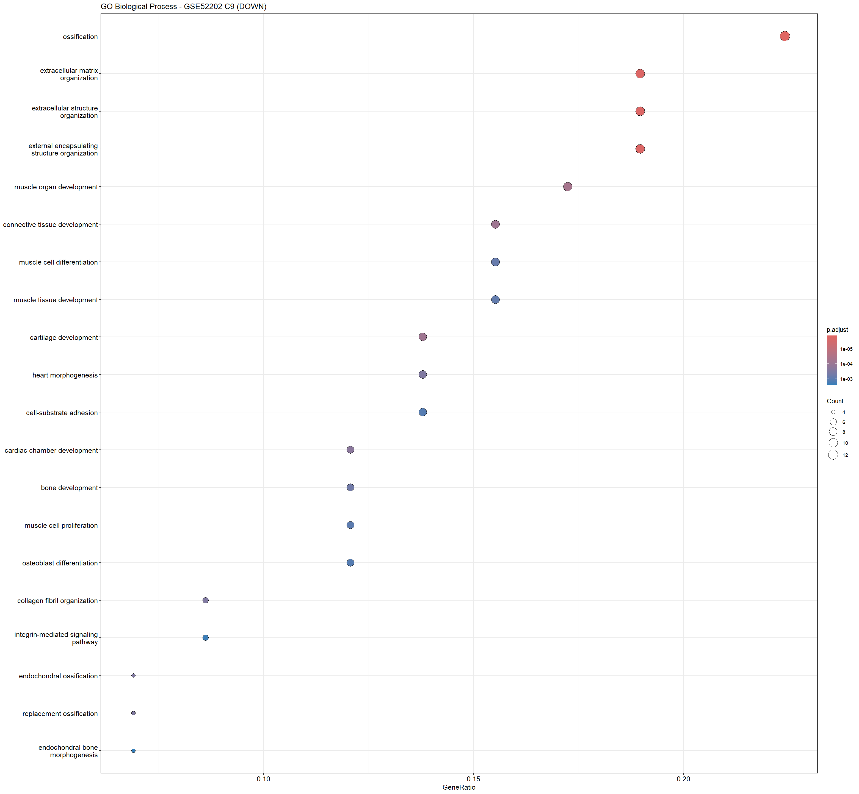  Figure 4.8. GSE52202 C9orf72 downregulated genes. ⭐ Main-text priority. | 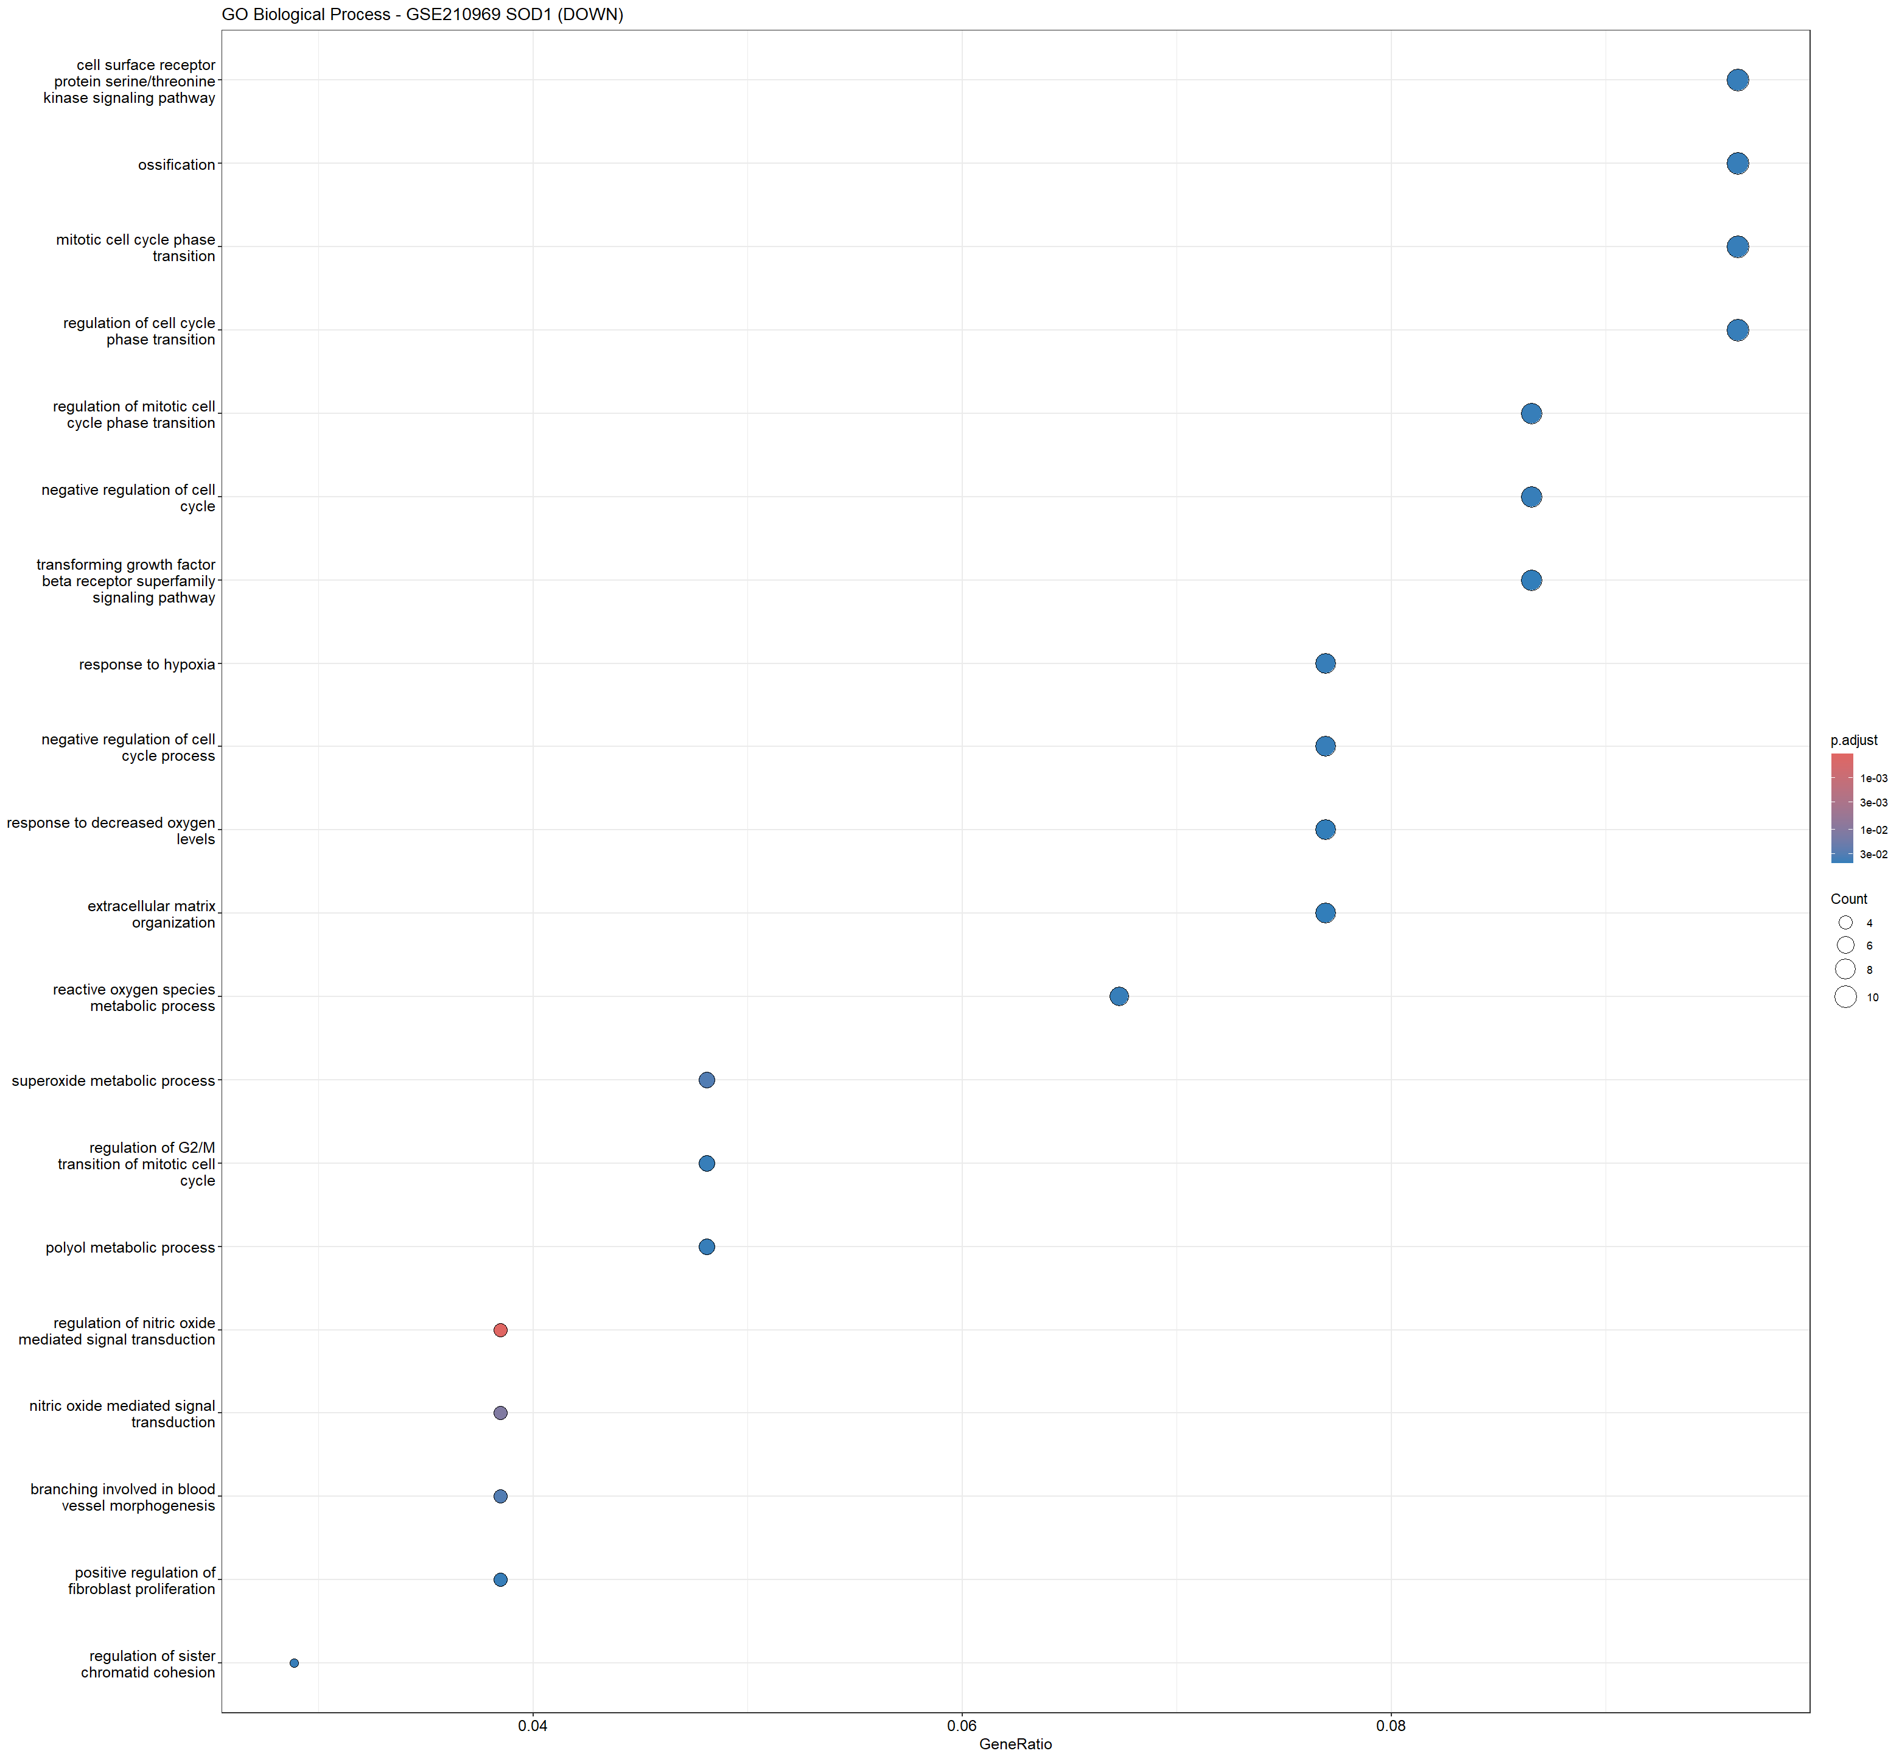  Figure 4.9. GSE210969 SOD1 downregulated genes. ⭐ Main-text priority. | Figure 4.10. GSE283507 TDP-43 downregulated genes. ⭐ Main-text priority.

GO Biological Process | Gene count | Fold enrichment | Adjusted p-value | q-value
ossification | 13 | 9.29064039408867 | 1.30211812538726e-06 | 9.68553998372135e-07
extracellular matrix organization | 11 | 10.8063339931243 | 1.67784103136041e-06 | 1.24802781550532e-06
extracellular structure organization | 11 | 10.7737847943498 | 1.67784103136041e-06 | 1.24802781550532e-06
external encapsulating structure organization | 11 | 10.7414310862587 | 1.67784103136041e-06 | 1.24802781550532e-06
muscle organ development | 10 | 8.71775908292503 | 5.10012232291596e-05 | 3.79362192395417e-05
cartilage development | 8 | 12.0434227330779 | 7.11620255085882e-05 | 5.29324206420243e-05
connective tissue development | 9 | 9.53274177243626 | 7.55546968845251e-05 | 5.61998196143205e-05
cardiac chamber development | 7 | 12.9329937304075 | 0.0001928415264054 | 0.0001434412345628
heart morphogenesis | 8 | 9.35747953361449 | 0.0003002356876 | 0.0002233241900326
endochondral ossification | 4 | 41.9577308120133 | 0.0003002356876 | 0.0002233241900326
Table 4.4. Top enriched GO-BP terms for GSE52202 C9orf72, ordered by adjusted p-value.
GO Biological Process | Gene count | Fold enrichment | Adjusted p-value | q-value
regulation of nitric oxide mediated signal transduction | 4 | 72.5384615384615 | 0.000344540121488 | 0.0002996900240931
nitric oxide mediated signal transduction | 4 | 27.8994082840237 | 0.0114588672741383 | 0.0099672229597972
branching involved in blood vessel morphogenesis | 4 | 18.5996055226824 | 0.0302237247686556 | 0.0262893876190211
superoxide metabolic process | 5 | 11.9306680161943 | 0.0302237247686556 | 0.0262893876190211
regulation of sister chromatid cohesion | 3 | 30.224358974359 | 0.0430117946598044 | 0.0374127858381644
regulation of mitotic cell cycle phase transition | 9 | 4.57175177763413 | 0.0430117946598044 | 0.0374127858381644
cell surface receptor protein serine/threonine kinase signaling pathway | 10 | 4.06605726112453 | 0.0430117946598044 | 0.0374127858381644
ossification | 10 | 3.98562975486052 | 0.0430117946598044 | 0.0374127858381644
mitotic cell cycle phase transition | 10 | 3.93375604872351 | 0.0430117946598044 | 0.0374127858381644
regulation of cell cycle phase transition | 10 | 3.87491781722551 | 0.0430117946598044 | 0.0374127858381644
Table 4.5. Top enriched GO-BP terms for GSE210969 SOD1, ordered by adjusted p-value.
GO Biological Process | Gene count | Fold enrichment | Adjusted p-value | q-value
cell-cell adhesion via plasma-membrane adhesion molecules | 52 | 4.13058219509832 | 8.338894075686221e-15 | 6.23139800591249e-15
synapse assembly | 49 | 3.82375333079558 | 1.0746149924016e-12 | 8.0302659561291e-13
homophilic cell adhesion via plasma membrane adhesion molecules | 36 | 4.74903474903475 | 6.1561911448284495e-12 | 4.6003315158723e-12
axonogenesis | 63 | 2.95808520384792 | 1.21763161667905e-11 | 9.09898502036726e-12
extracellular matrix organization | 49 | 3.28080346207234 | 1.80014013574742e-10 | 1.34518912825217e-10
extracellular structure organization | 49 | 3.27092152393357 | 1.80014013574742e-10 | 1.34518912825217e-10
external encapsulating structure organization | 49 | 3.26109893677461 | 1.80014013574742e-10 | 1.34518912825217e-10
axon guidance | 39 | 3.55689022355689 | 2.9592774019619104e-09 | 2.21137660871533e-09
neuron projection guidance | 39 | 3.54231280460789 | 2.99875185108912e-09 | 2.24087464542658e-09
wound healing | 56 | 2.73969333571983 | 3.6805239310413703e-09 | 2.7503418650532603e-09
Table 4.6. Top enriched GO-BP terms for GSE283507 TDP-43, ordered by adjusted p-value.

4.5 Biological Module Analysis
Significant GO-BP terms were mapped to the predefined biological-module framework supplied for the study. Module summaries were available for three profiles: GSE52202 C9orf72, GSE210969 SOD1, and GSE283507 TDP-43. The GSE210969 TDP-43 comparison was not included in this stage because its GO-BP result contained no significant terms.
Profile | Modules represented | Highest median FE module | Highest median FE
GSE52202 C9orf72 | 10 | Cytoskeleton & Cell Motility | 24.22
GSE210969 SOD1 | 7 | Cardiovascular & Angiogenesis | 18.6
GSE283507 TDP-43 | 18 | Neuroinflammation & Immune Signaling | 5.277
Table 4.7. Profile-level summary of biological-module enrichment.
The highest median fold enrichment was observed for Cytoskeleton & Cell Motility in GSE52202 C9orf72 (24.22), Cardiovascular & Angiogenesis in GSE210969 SOD1 (18.60), and Neuroinflammation & Immune Signaling in GSE283507 TDP-43 (5.28) (Table 4.7). The complete module summaries are provided in Appendix D (Tables D1–D3).

4.6 Cross-Subtype Functional Convergence
The final convergence analysis compared the three module profiles that yielded significant GO-BP enrichment: GSE52202 C9orf72, GSE210969 SOD1, and GSE283507 TDP-43. The convergence score was calculated as the number of compared profiles in which a module was represented divided by three. Thus, scores of 1.00, 0.67, and 0.33 correspond to representation in three, two, and one profile(s), respectively.
Biological Module | GSE52202_C9_DOWN | GSE210969_SOD1_DOWN | GSE283507_TDP43_DOWN | Convergence Score
Cardiovascular & Angiogenesis | 15.671 | 18.5996 | 3.3441 | 1.0
Cell Adhesion & Extracellular Matrix (ECM) | 11.4096 | 4.3698 | 3.2591 | 1.0
Signal Transduction | 5.2279 | 15.9827 | 2.5328 | 1.0
Cell Cycle, Growth & Survival | 10.2782 | 5.1952 | 2.1107 | 1.0
Organ-Specific Development | 10.6383 | 3.9856 | 2.932 | 1.0
Tissue Remodeling & Wound Healing | 6.6702 |  | 3.4374 | 0.6667
Neuroinflammation & Immune Signaling | 18.0904 |  | 5.2767 | 0.6667
Homeostasis & Metabolism |  | 8.243 | 2.7703 | 0.6667
Cytoskeleton & Cell Motility | 24.2197 |  | 2.3551 | 0.6667
Developmental Patterning & Morphogenesis | 9.5837 |  | 2.5849 | 0.6667
Oxidative Stress & Hypoxia |  | 4.9664 | 2.1673 | 0.6667
Neuronal Development & Axon Biology | 11.0826 |  | 3.2181 | 0.6667
Calcium & Ion Homeostasis |  |  | 2.7703 | 0.3333
Glial Biology & Myelination |  |  | 2.6432 | 0.3333
Endocrine & Hormonal Regulation |  |  | 3.3741 | 0.3333
Protein Localization & Membrane Organization |  |  | 2.3711 | 0.3333
Synaptic Organization & Neurotransmission |  |  | 3.8238 | 0.3333
Vesicle Trafficking & Exocytosis |  |  | 2.4146 | 0.3333
Table 4.8. Original biological-module convergence table used for the final cross-profile comparison.
Five modules were represented in all three profiles and therefore had a convergence score of 1.00 (Table 4.8): Cardiovascular & Angiogenesis, Cell Adhesion & Extracellular Matrix (ECM), Signal Transduction, Cell Cycle, Growth & Survival, Organ-Specific Development. Seven modules had a score of 0.67 because they were represented in two profiles, while six modules had a score of 0.33 because they were represented only in the GSE283507 TDP-43 profile (Table 4.8).
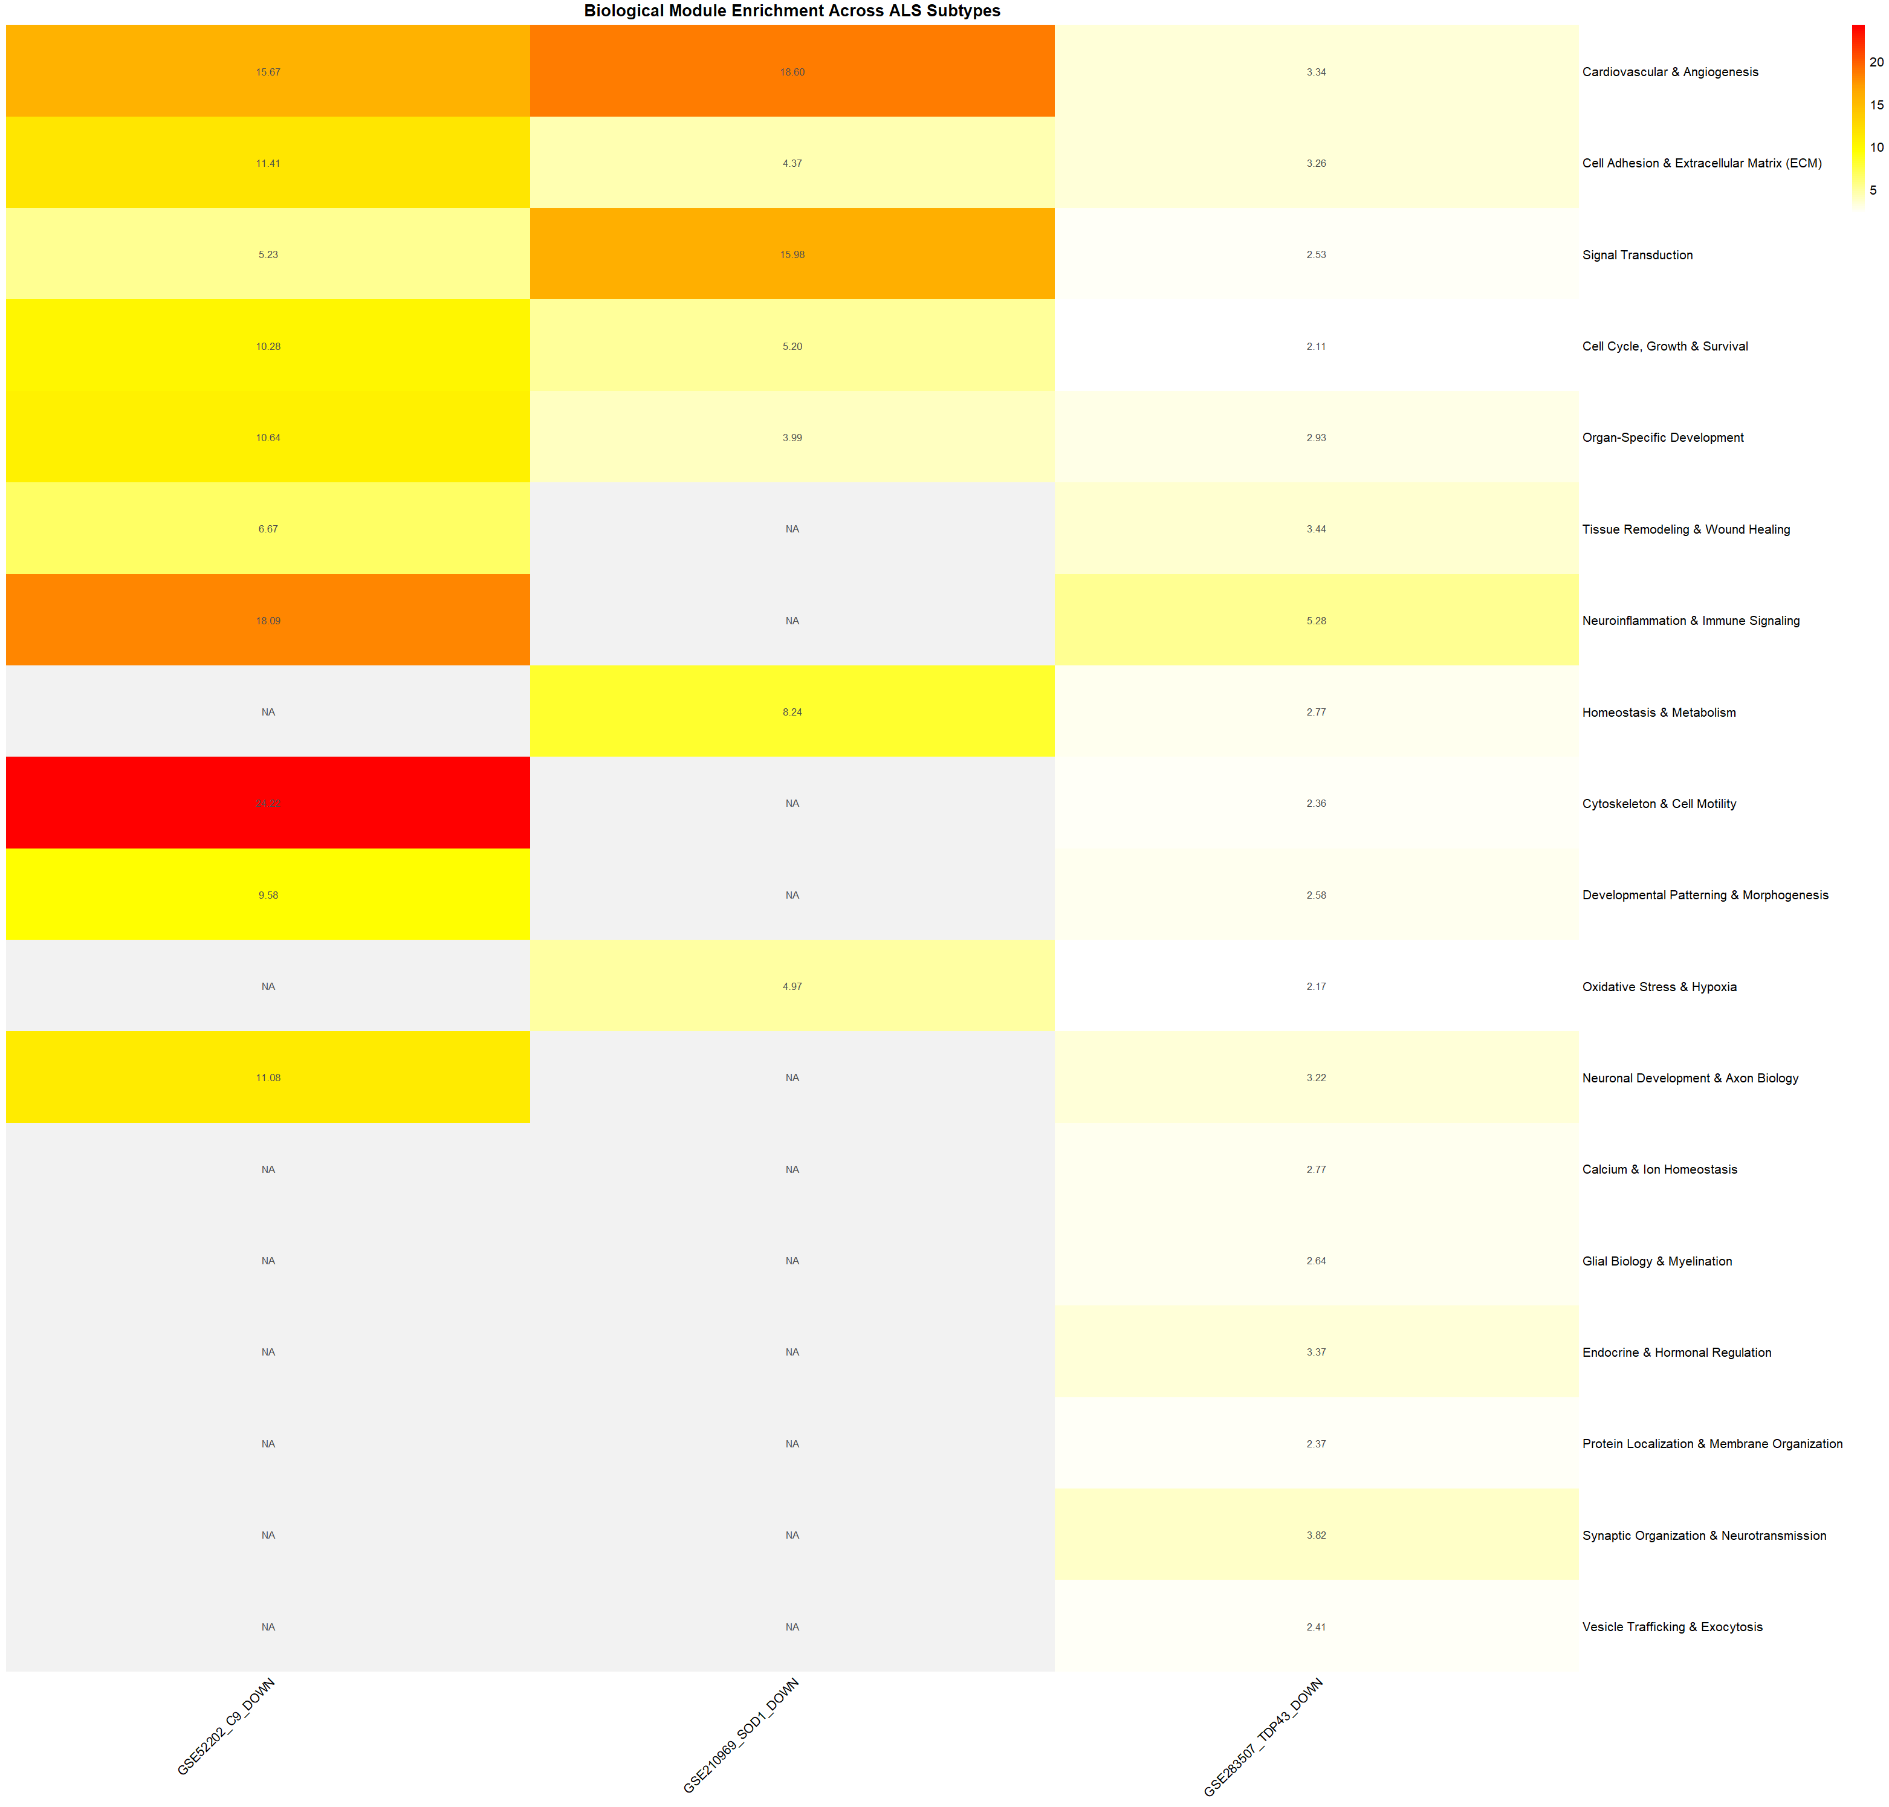
⭐ Figure 4.11. Original biological-module enrichment heatmap across the three profiles included in the final convergence analysis.
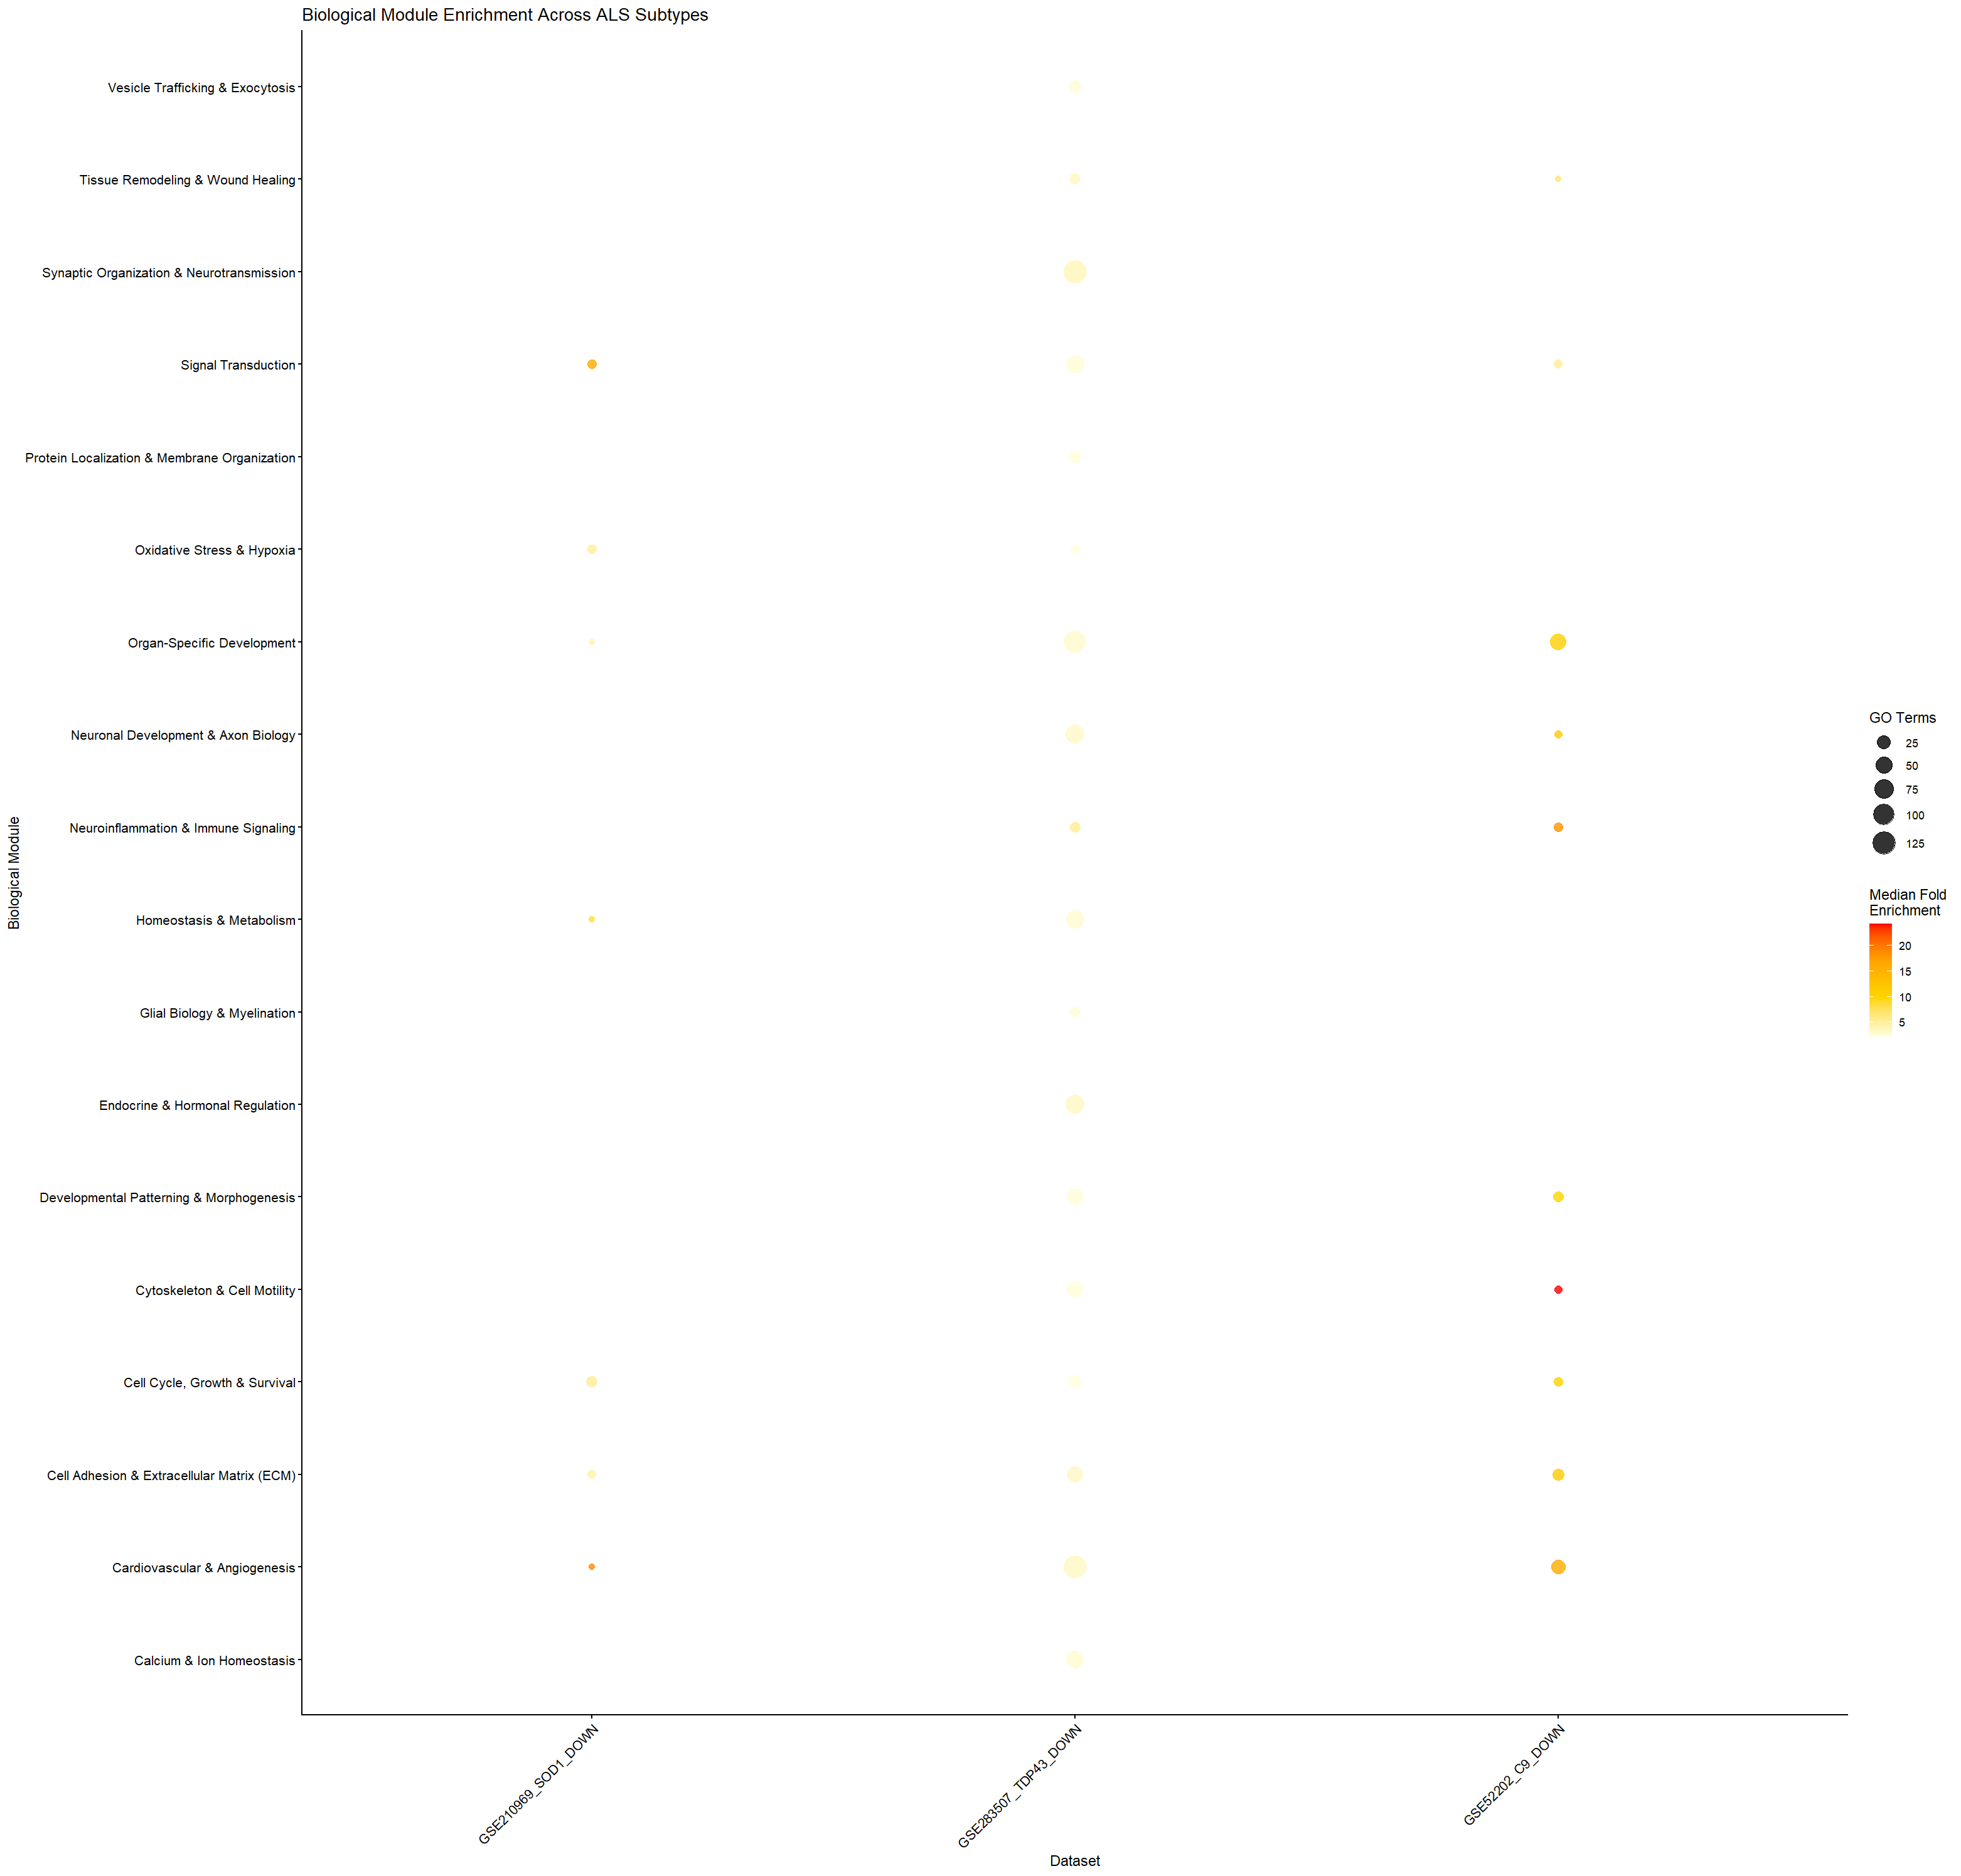
⭐ Figure 4.12. Original biological-module bubble plot; bubble size represents the number of GO terms and colour represents median fold enrichment.

4.7 Key Findings
The study produced four dataset-level differential-expression comparisons and four corresponding downregulated gene sets (Table 4.1). Three of the four downregulated gene sets yielded significant GO-BP enrichment, while the GSE210969 TDP-43 set yielded no significant terms (Table 4.3). The three enriched profiles were carried forward to biological-module analysis (Table 4.7), where five modules were represented across all three profiles and therefore received a convergence score of 1.00 (Table 4.8). Figures 3.11 and 3.12 summarize the cross-profile module patterns. These statements describe the observed results; interpretation of their biological significance is reserved for the Discussion chapter.

Appendix A. Supporting Differential-Expression and Quality-Control Figures
Supporting figures serving similar purposes are grouped into compact grids. Original images are retained without scientific reconstruction. The main PCA and volcano figures are kept in Section 3.2; the following figures are supporting outputs.
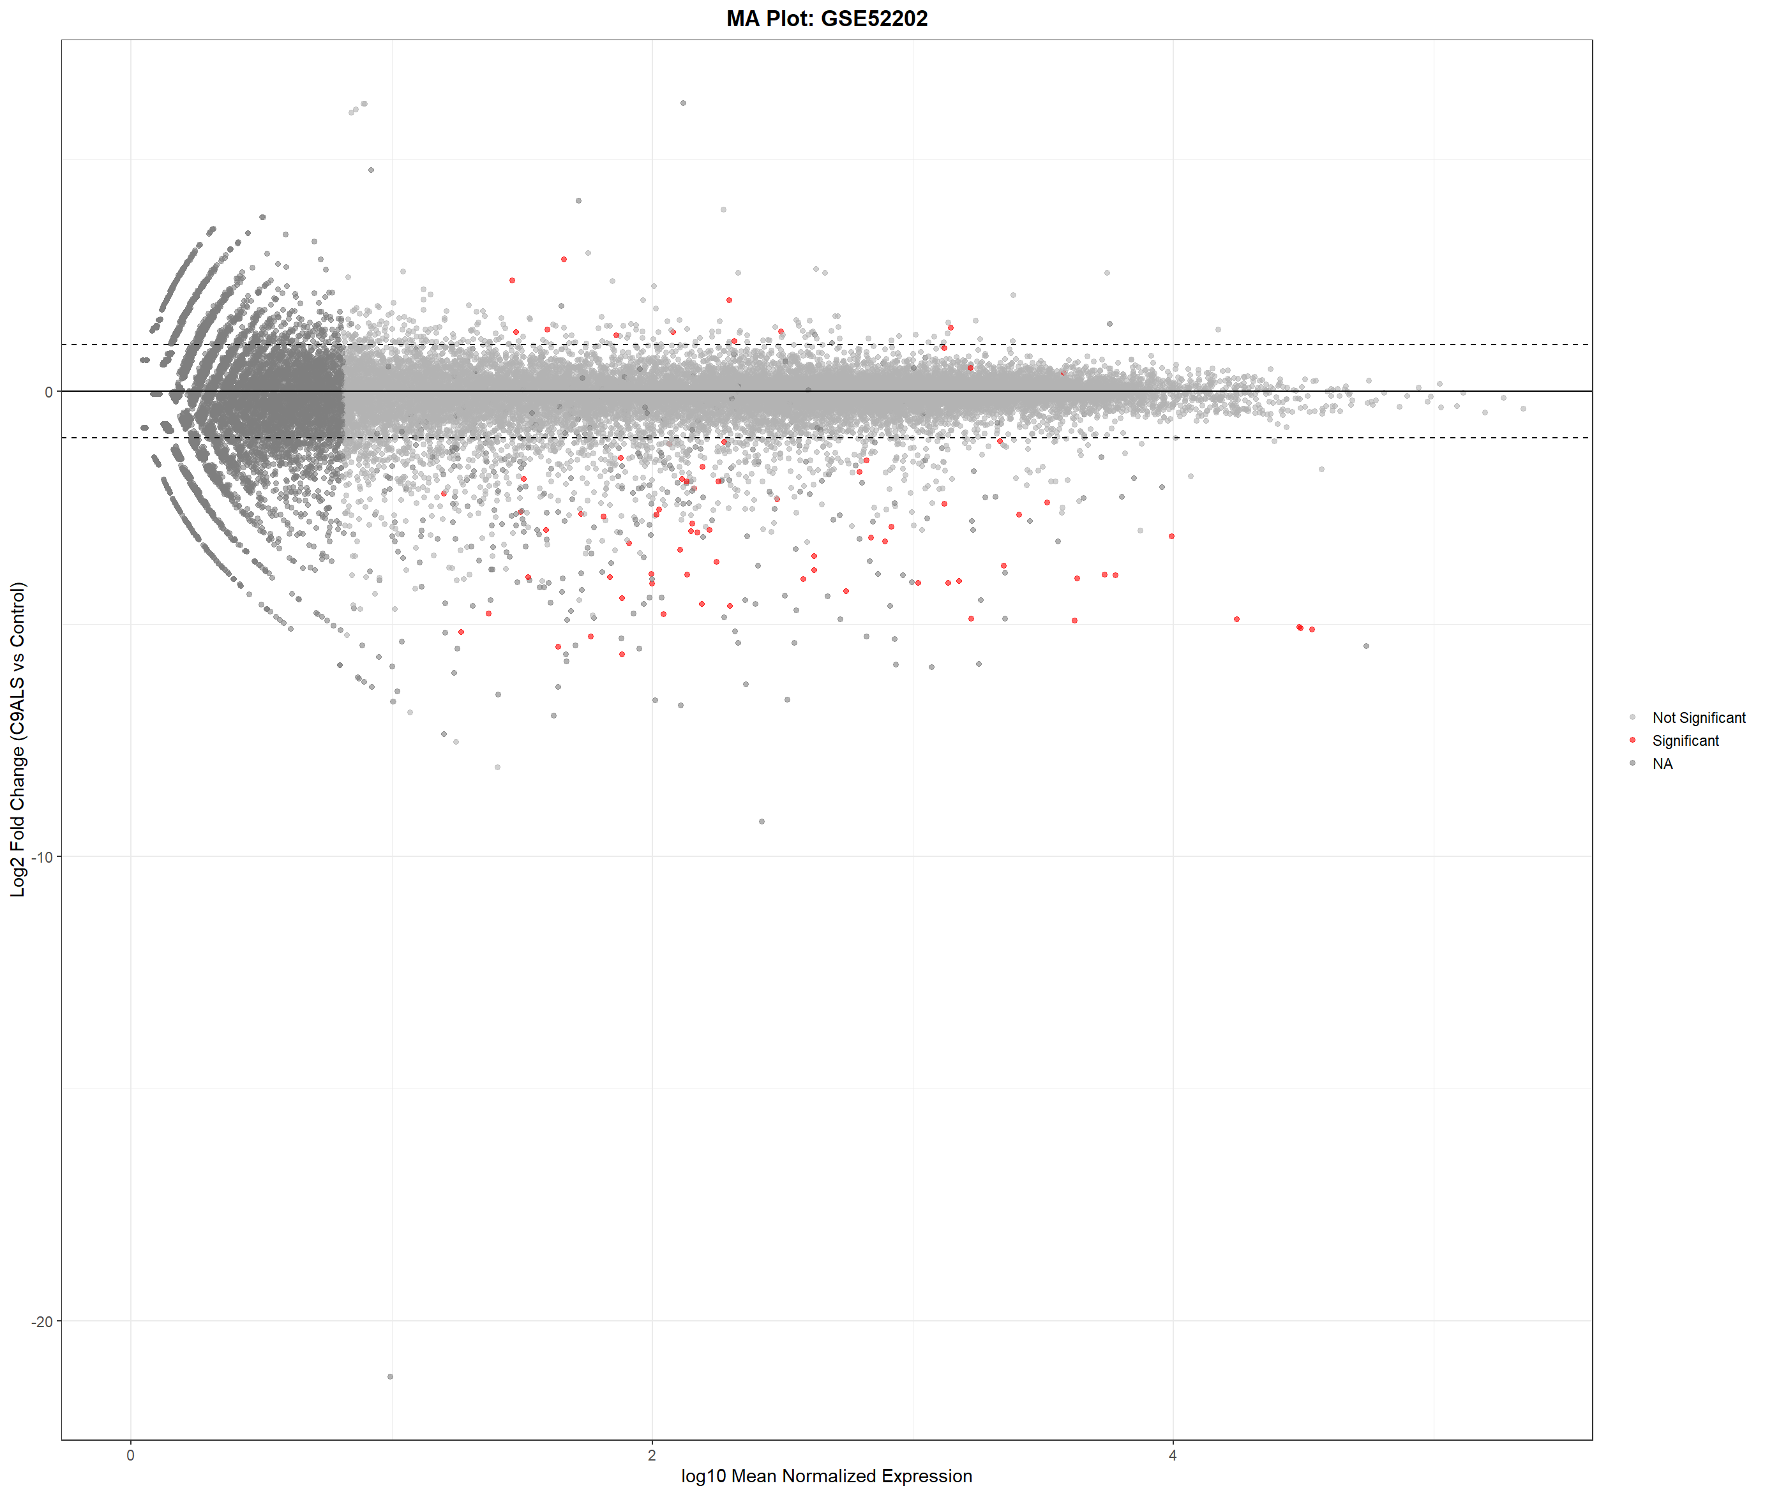  Figure A1. GSE52202 MA plot. | 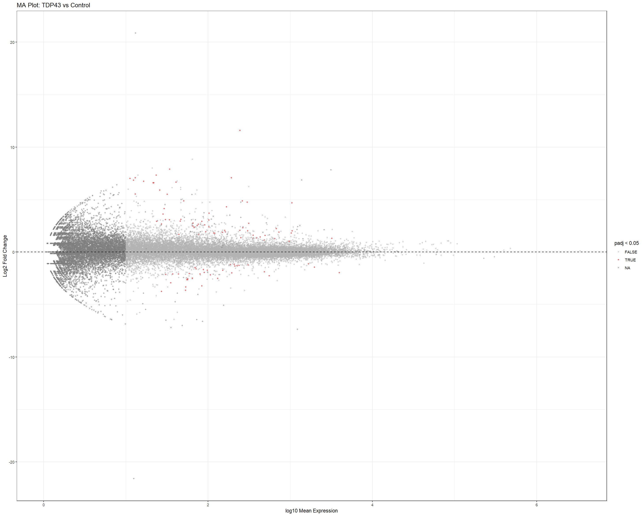  Figure A2. GSE210969 TDP-43 MA plot. | 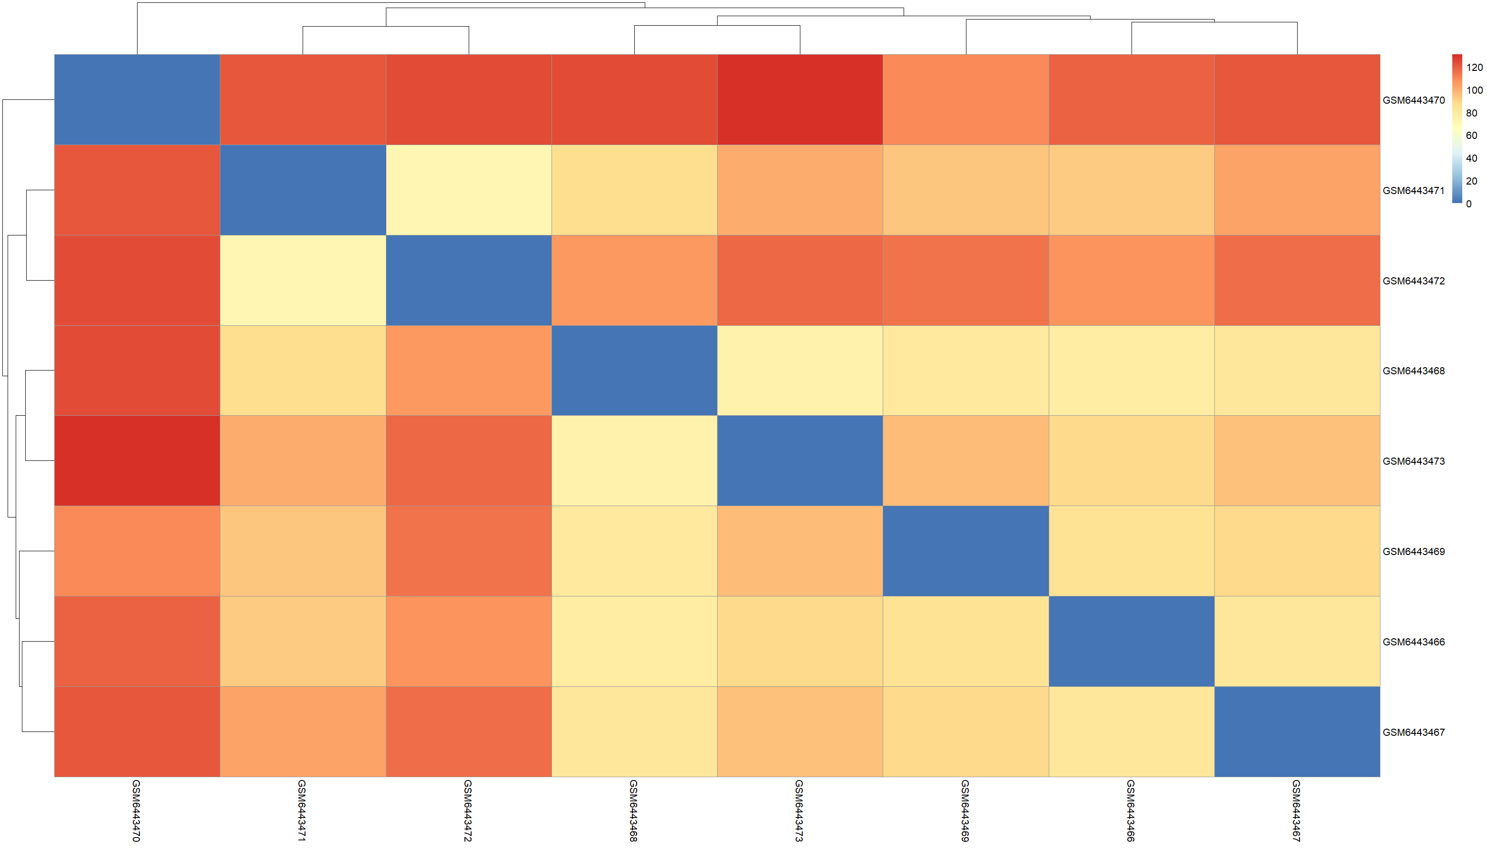  Figure A3. GSE210969 sample-to-sample distance heatmap.
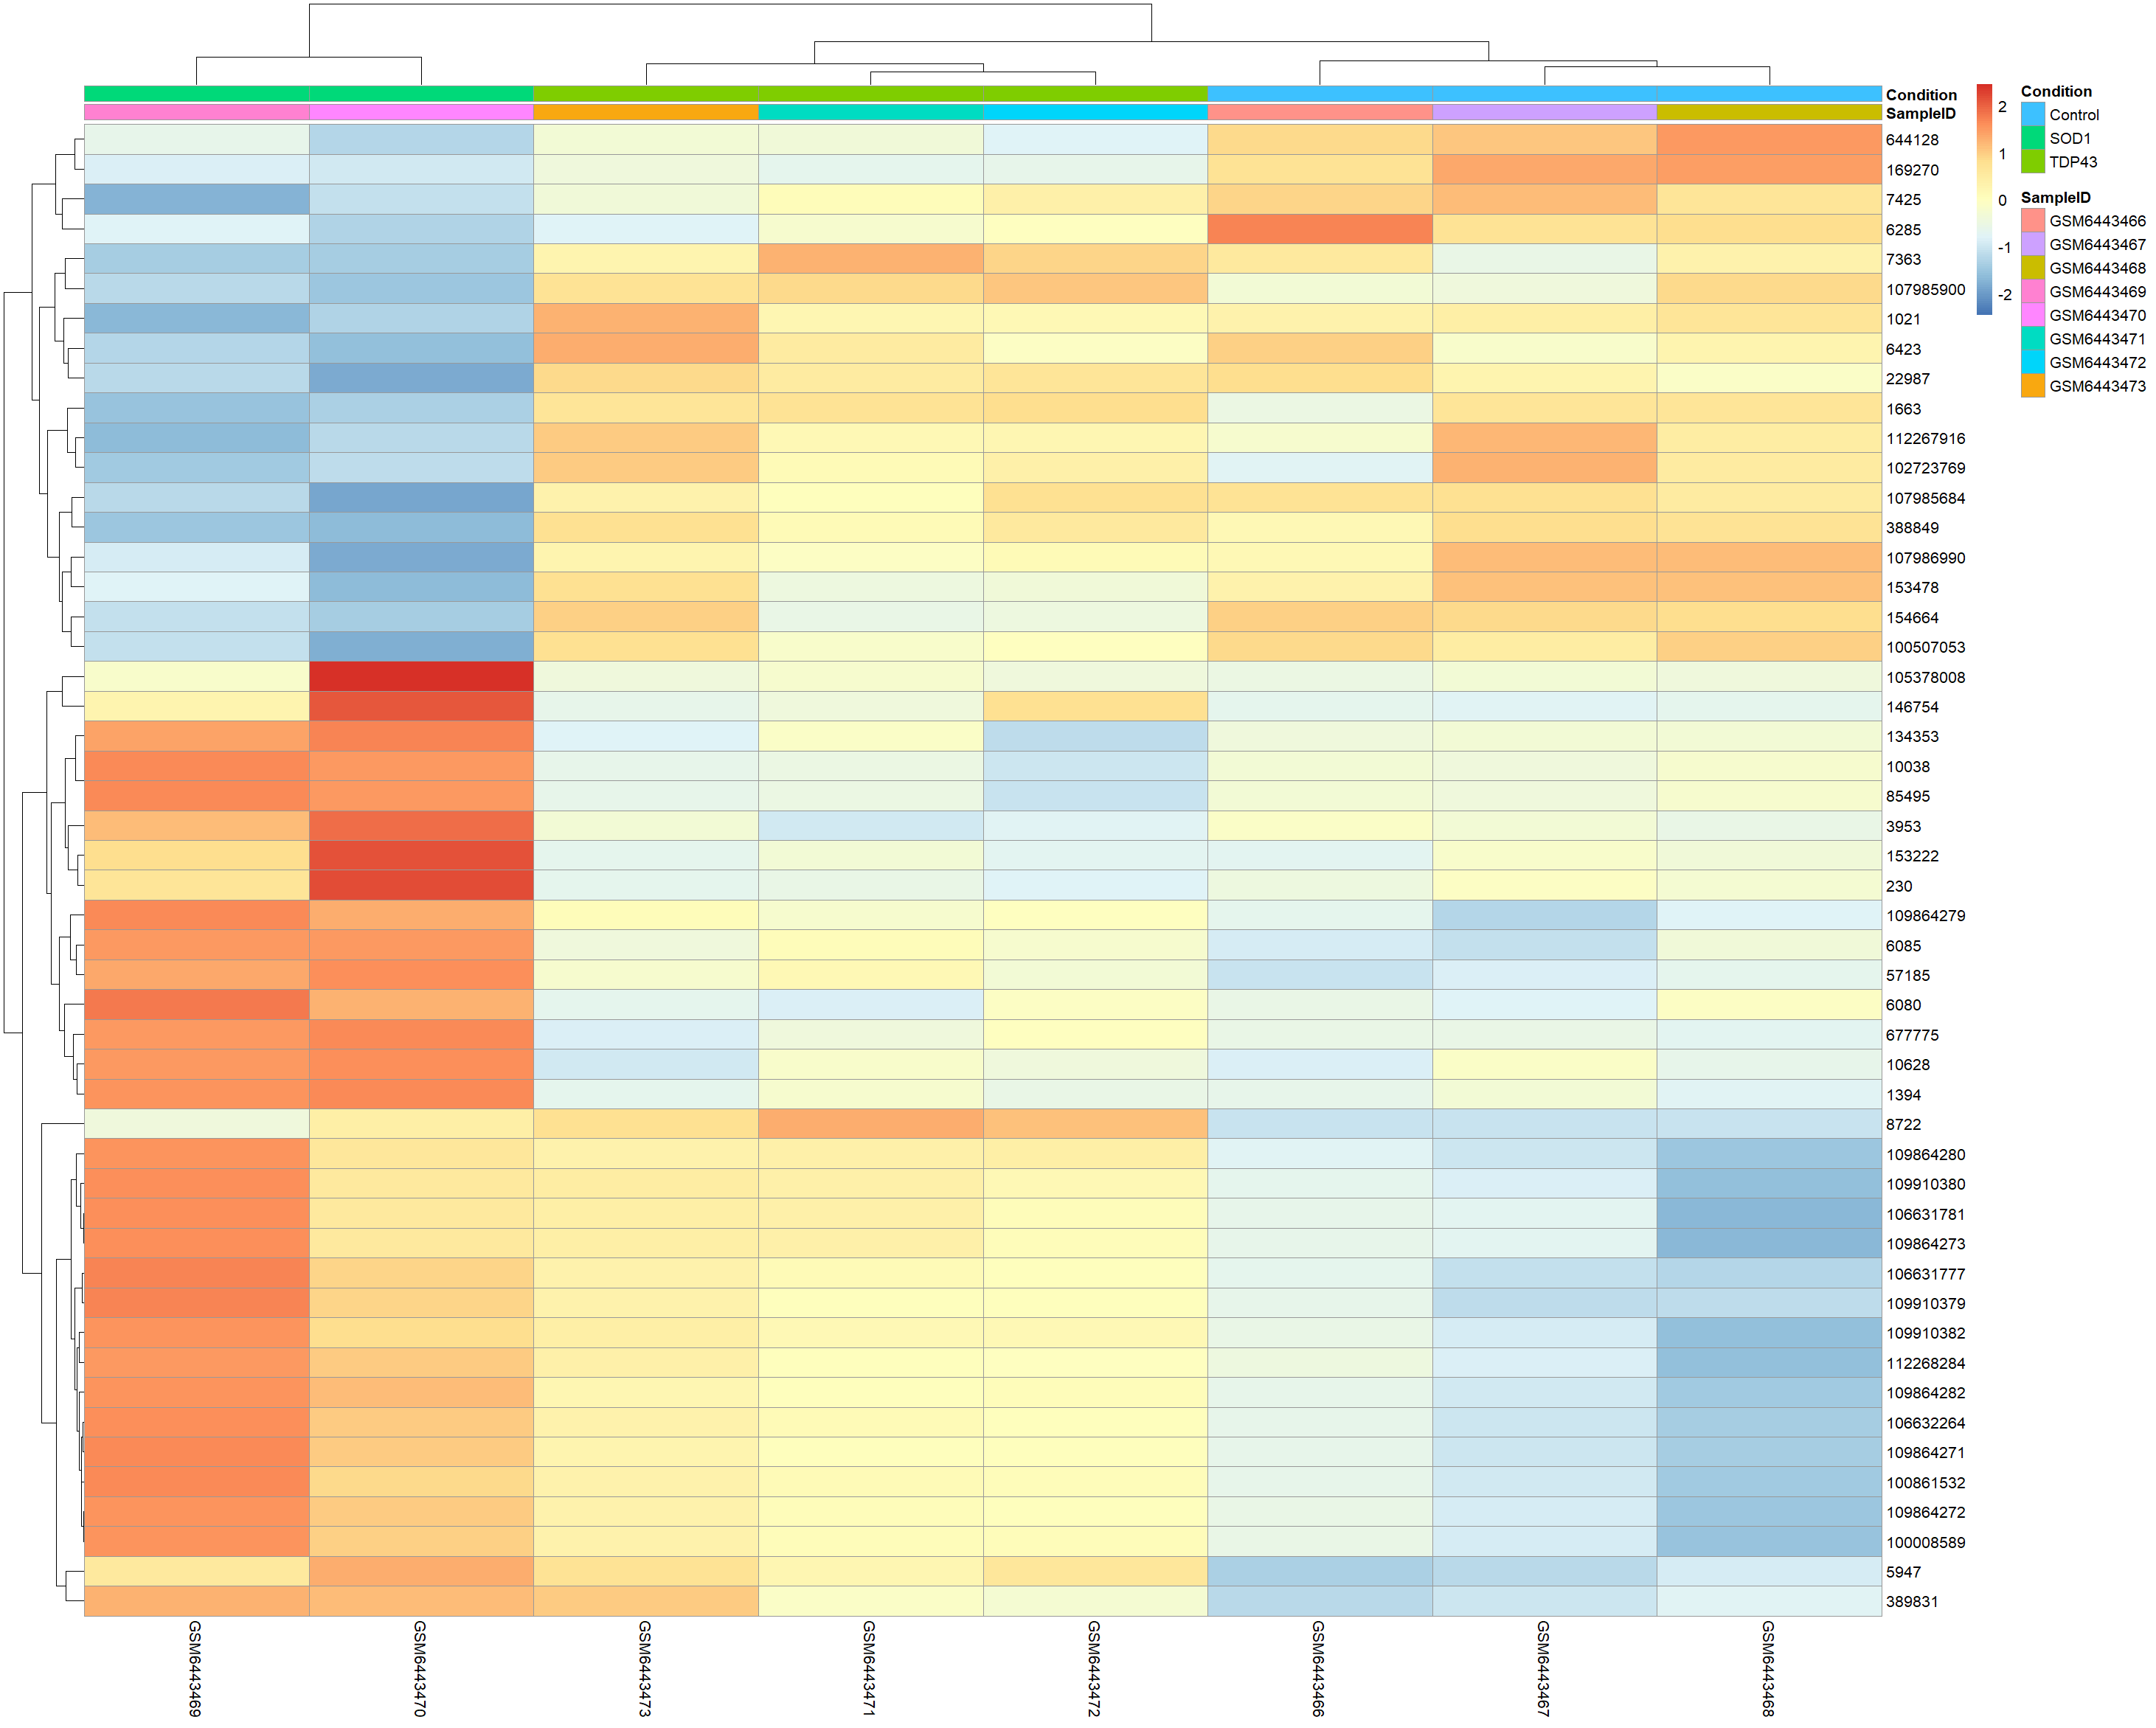  Figure A4. GSE210969 selected-gene heatmap. | 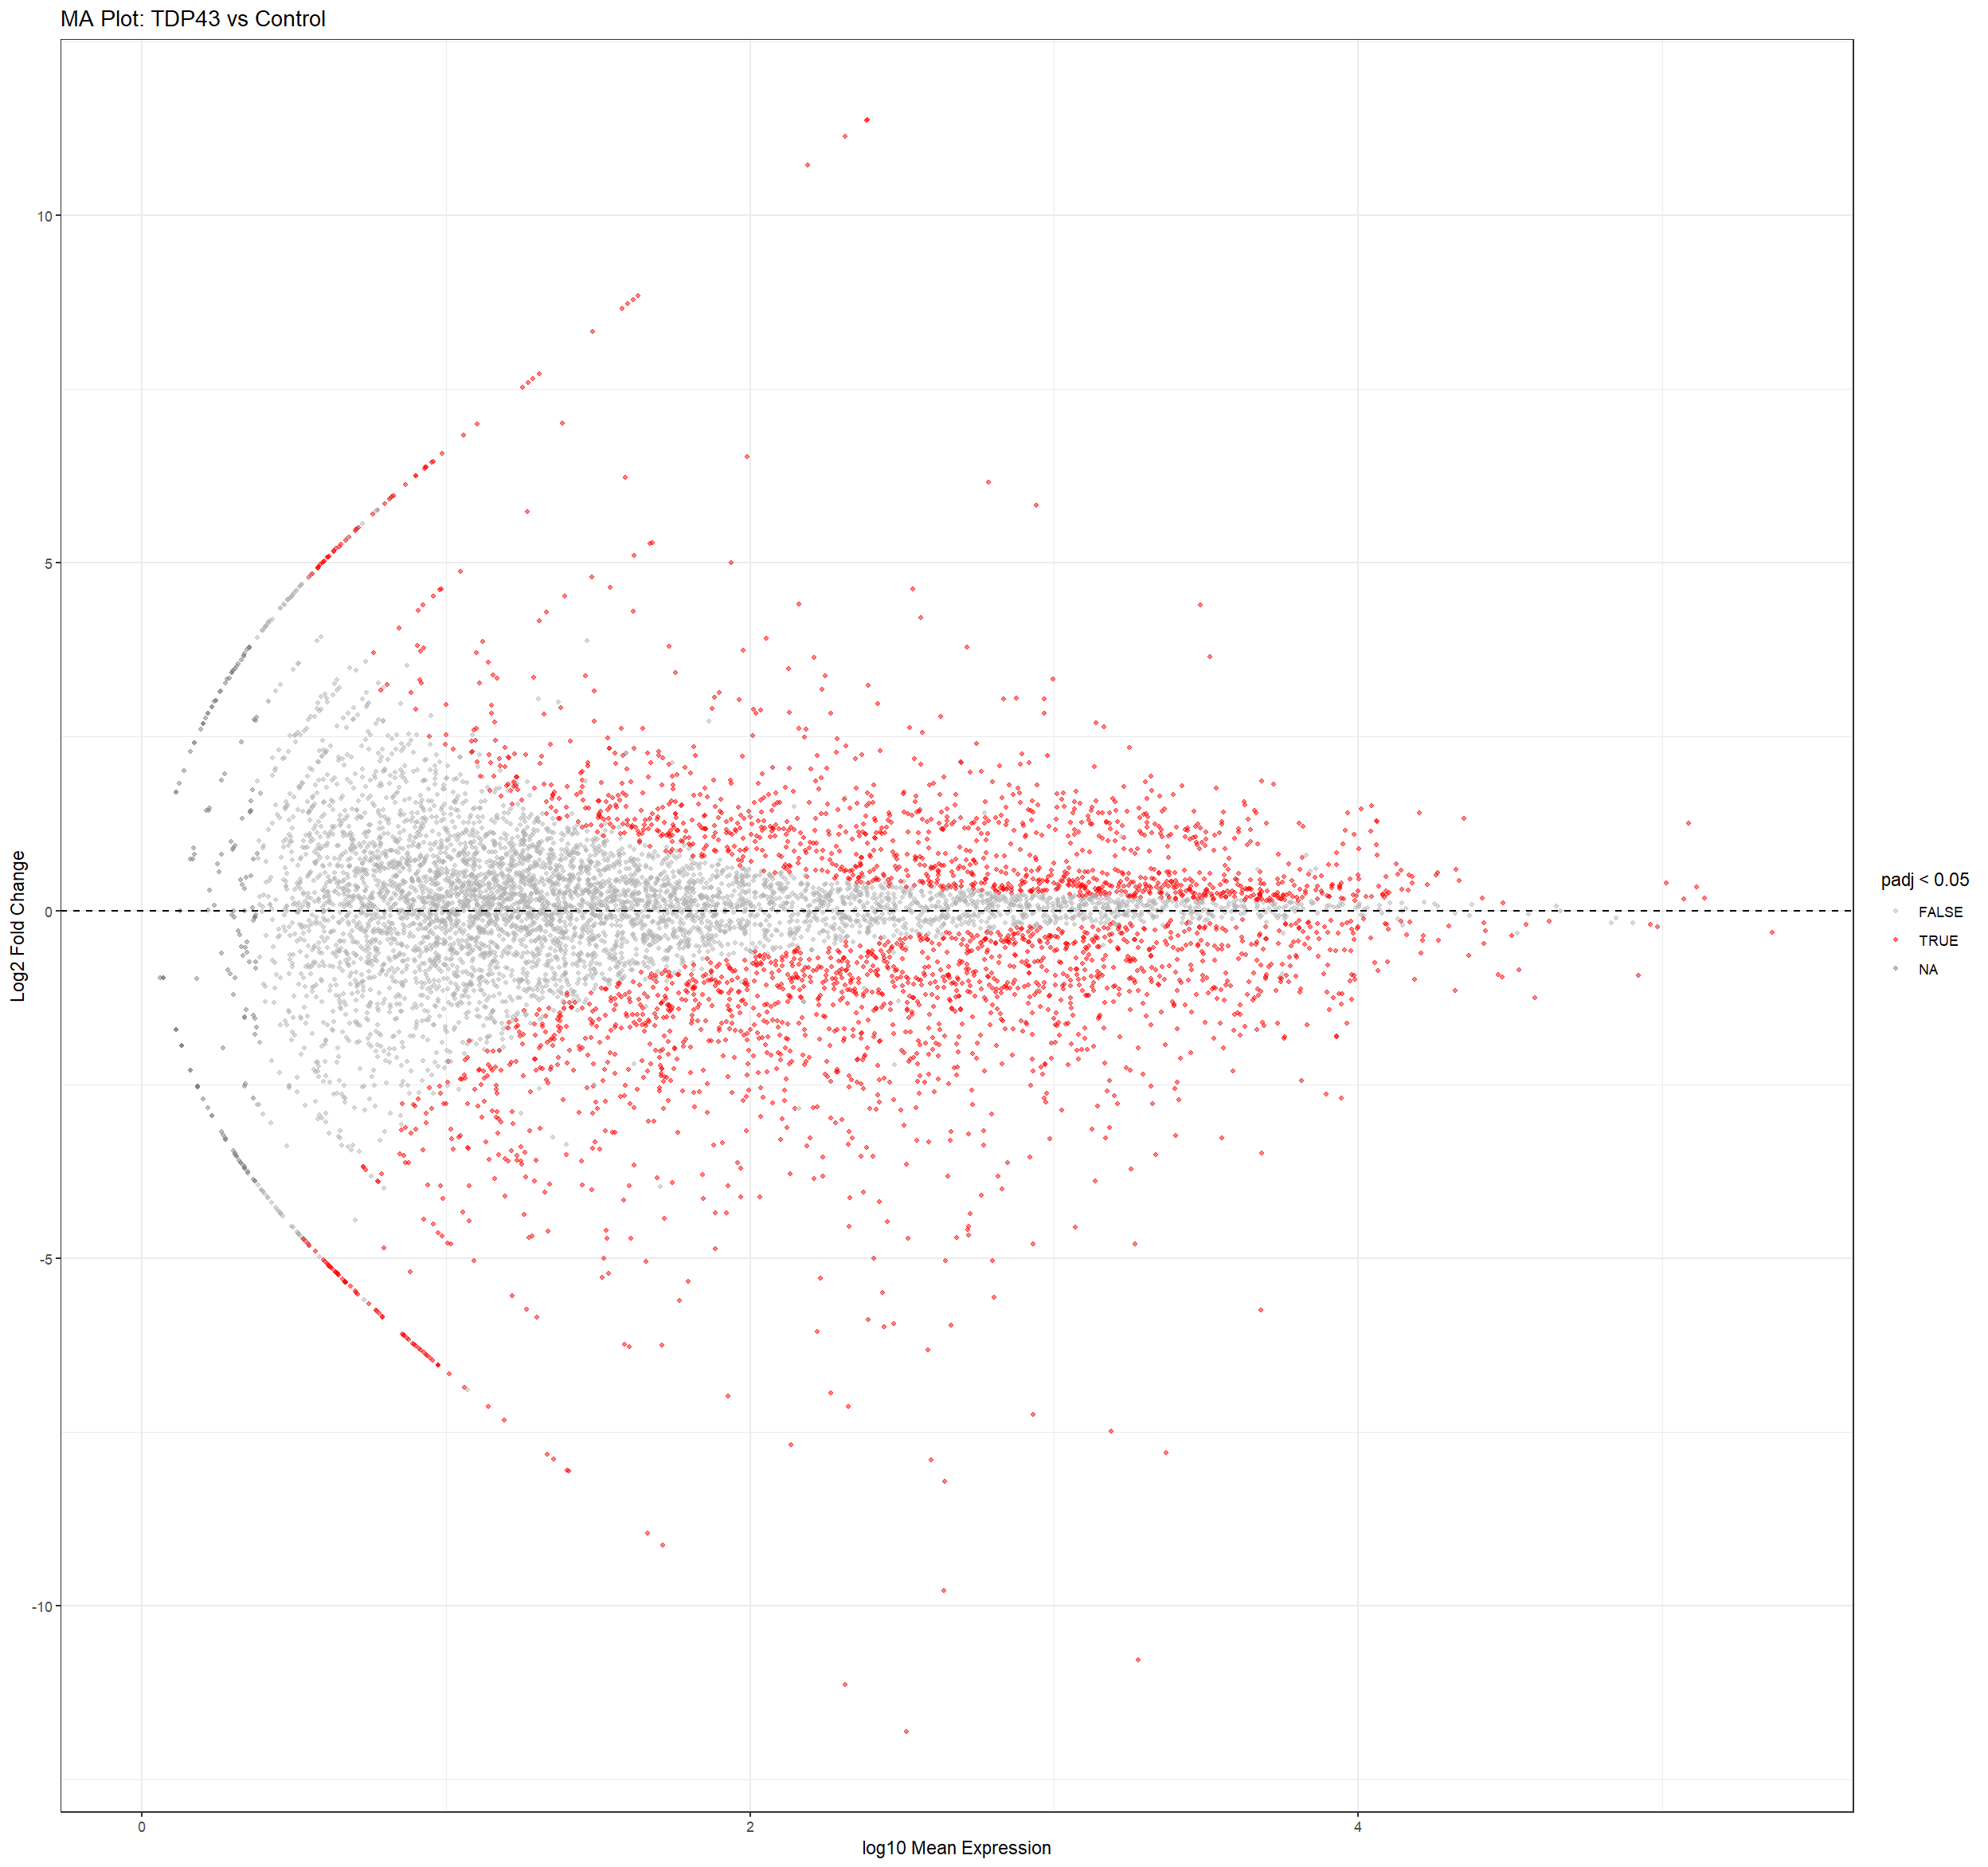  Figure A5. GSE283507 TDP-43 MA plot.

[LAYOUT] Appendix A contains five supporting images; the first page uses five cells in a six-cell layout. This is the smallest group because only five original supporting DE/QC images were supplied.

Appendix B. Supporting Downregulated GO-BP Figures
The following original GO-BP outputs support the main dot plots in Figures 3.8–3.10. Similar plot types are grouped to reduce page use. The GSE210969 TDP-43 comparison has no corresponding significant enrichment figures because its GO result contains zero rows.
GSE52202 C9orf72: Bar plot | 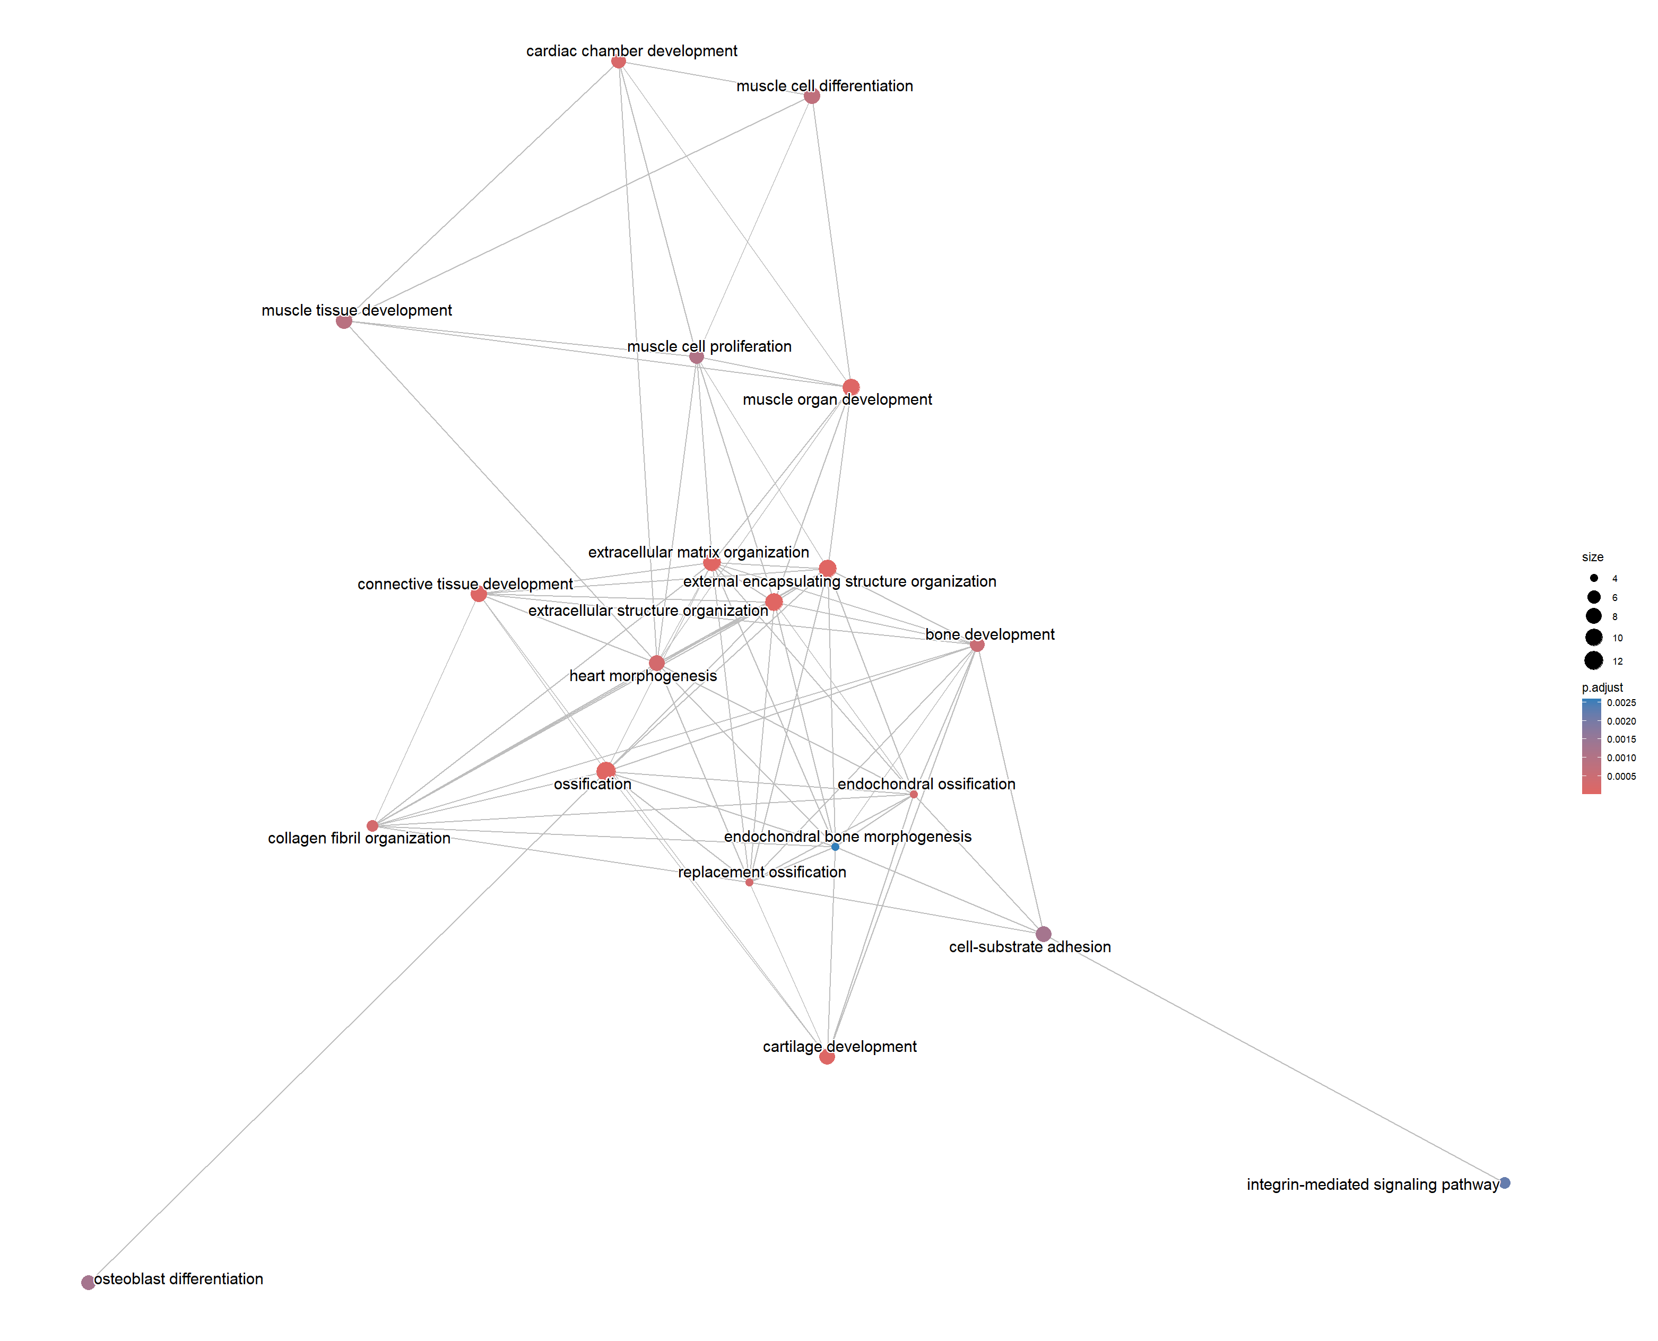  GSE52202 C9orf72: Enrichment plot | GSE52202 C9orf72: Hierarchy plot
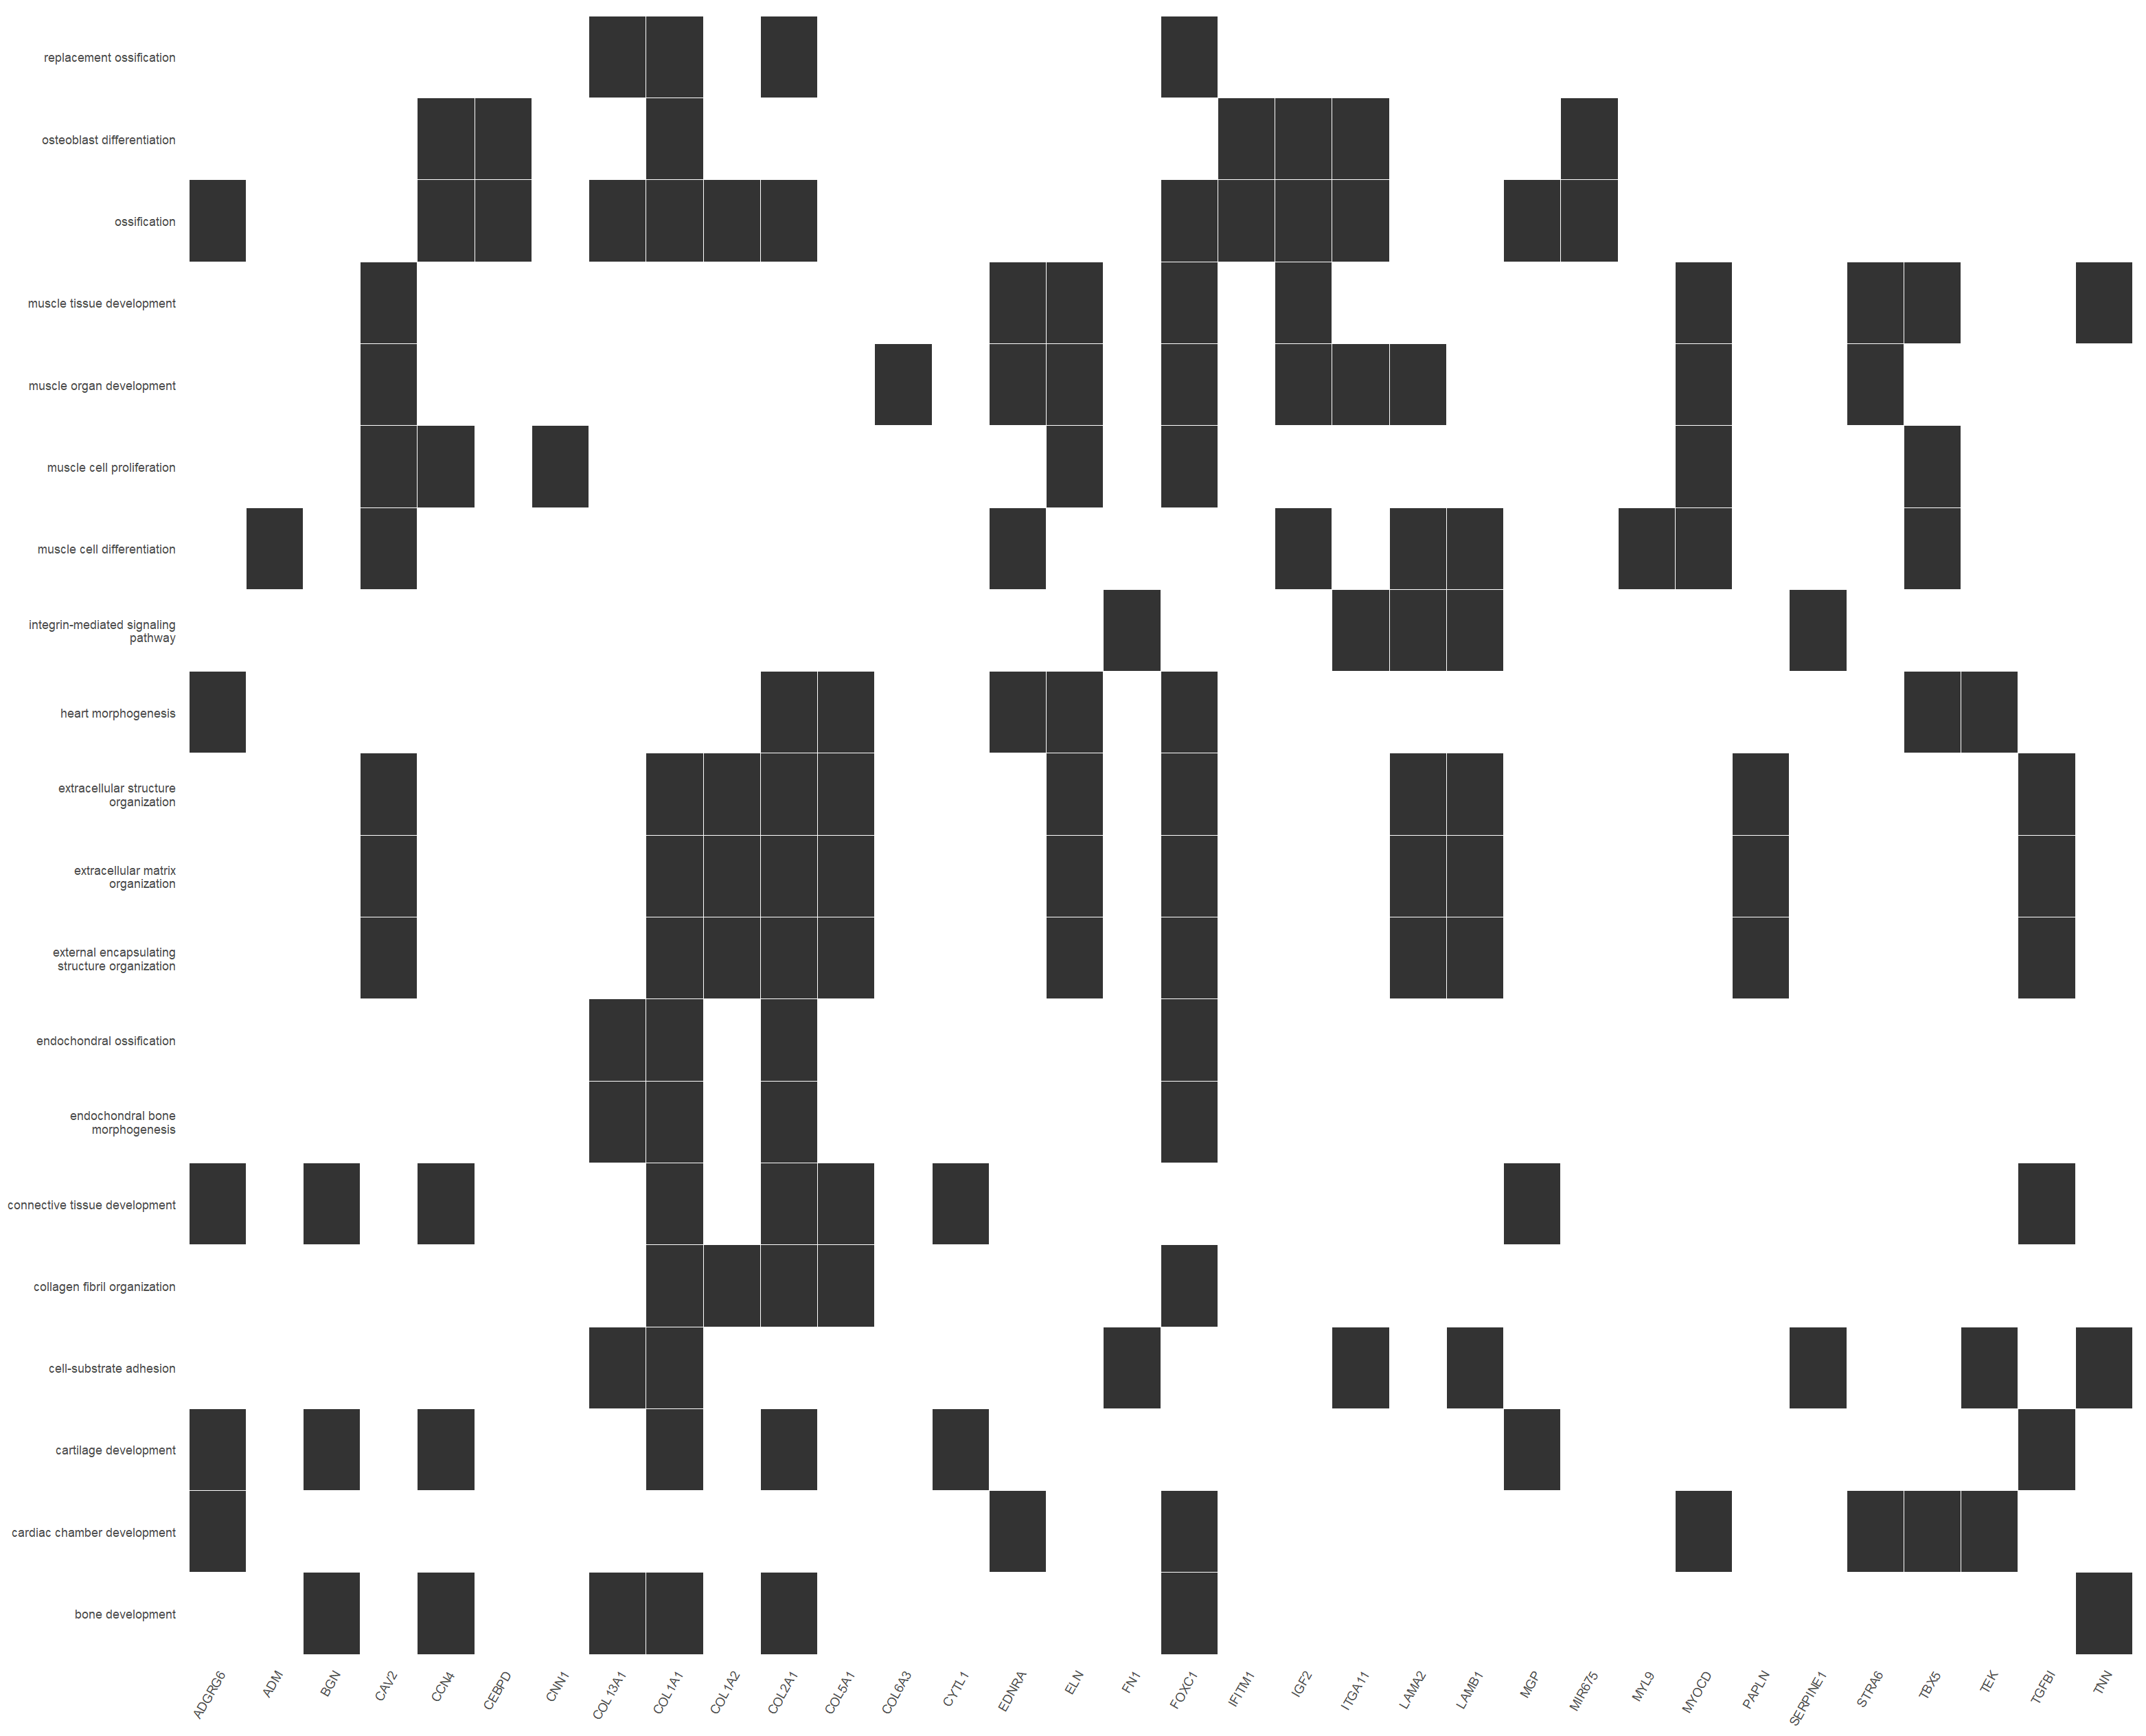  GSE52202 C9orf72: Category#U2013Gene Heatmap | 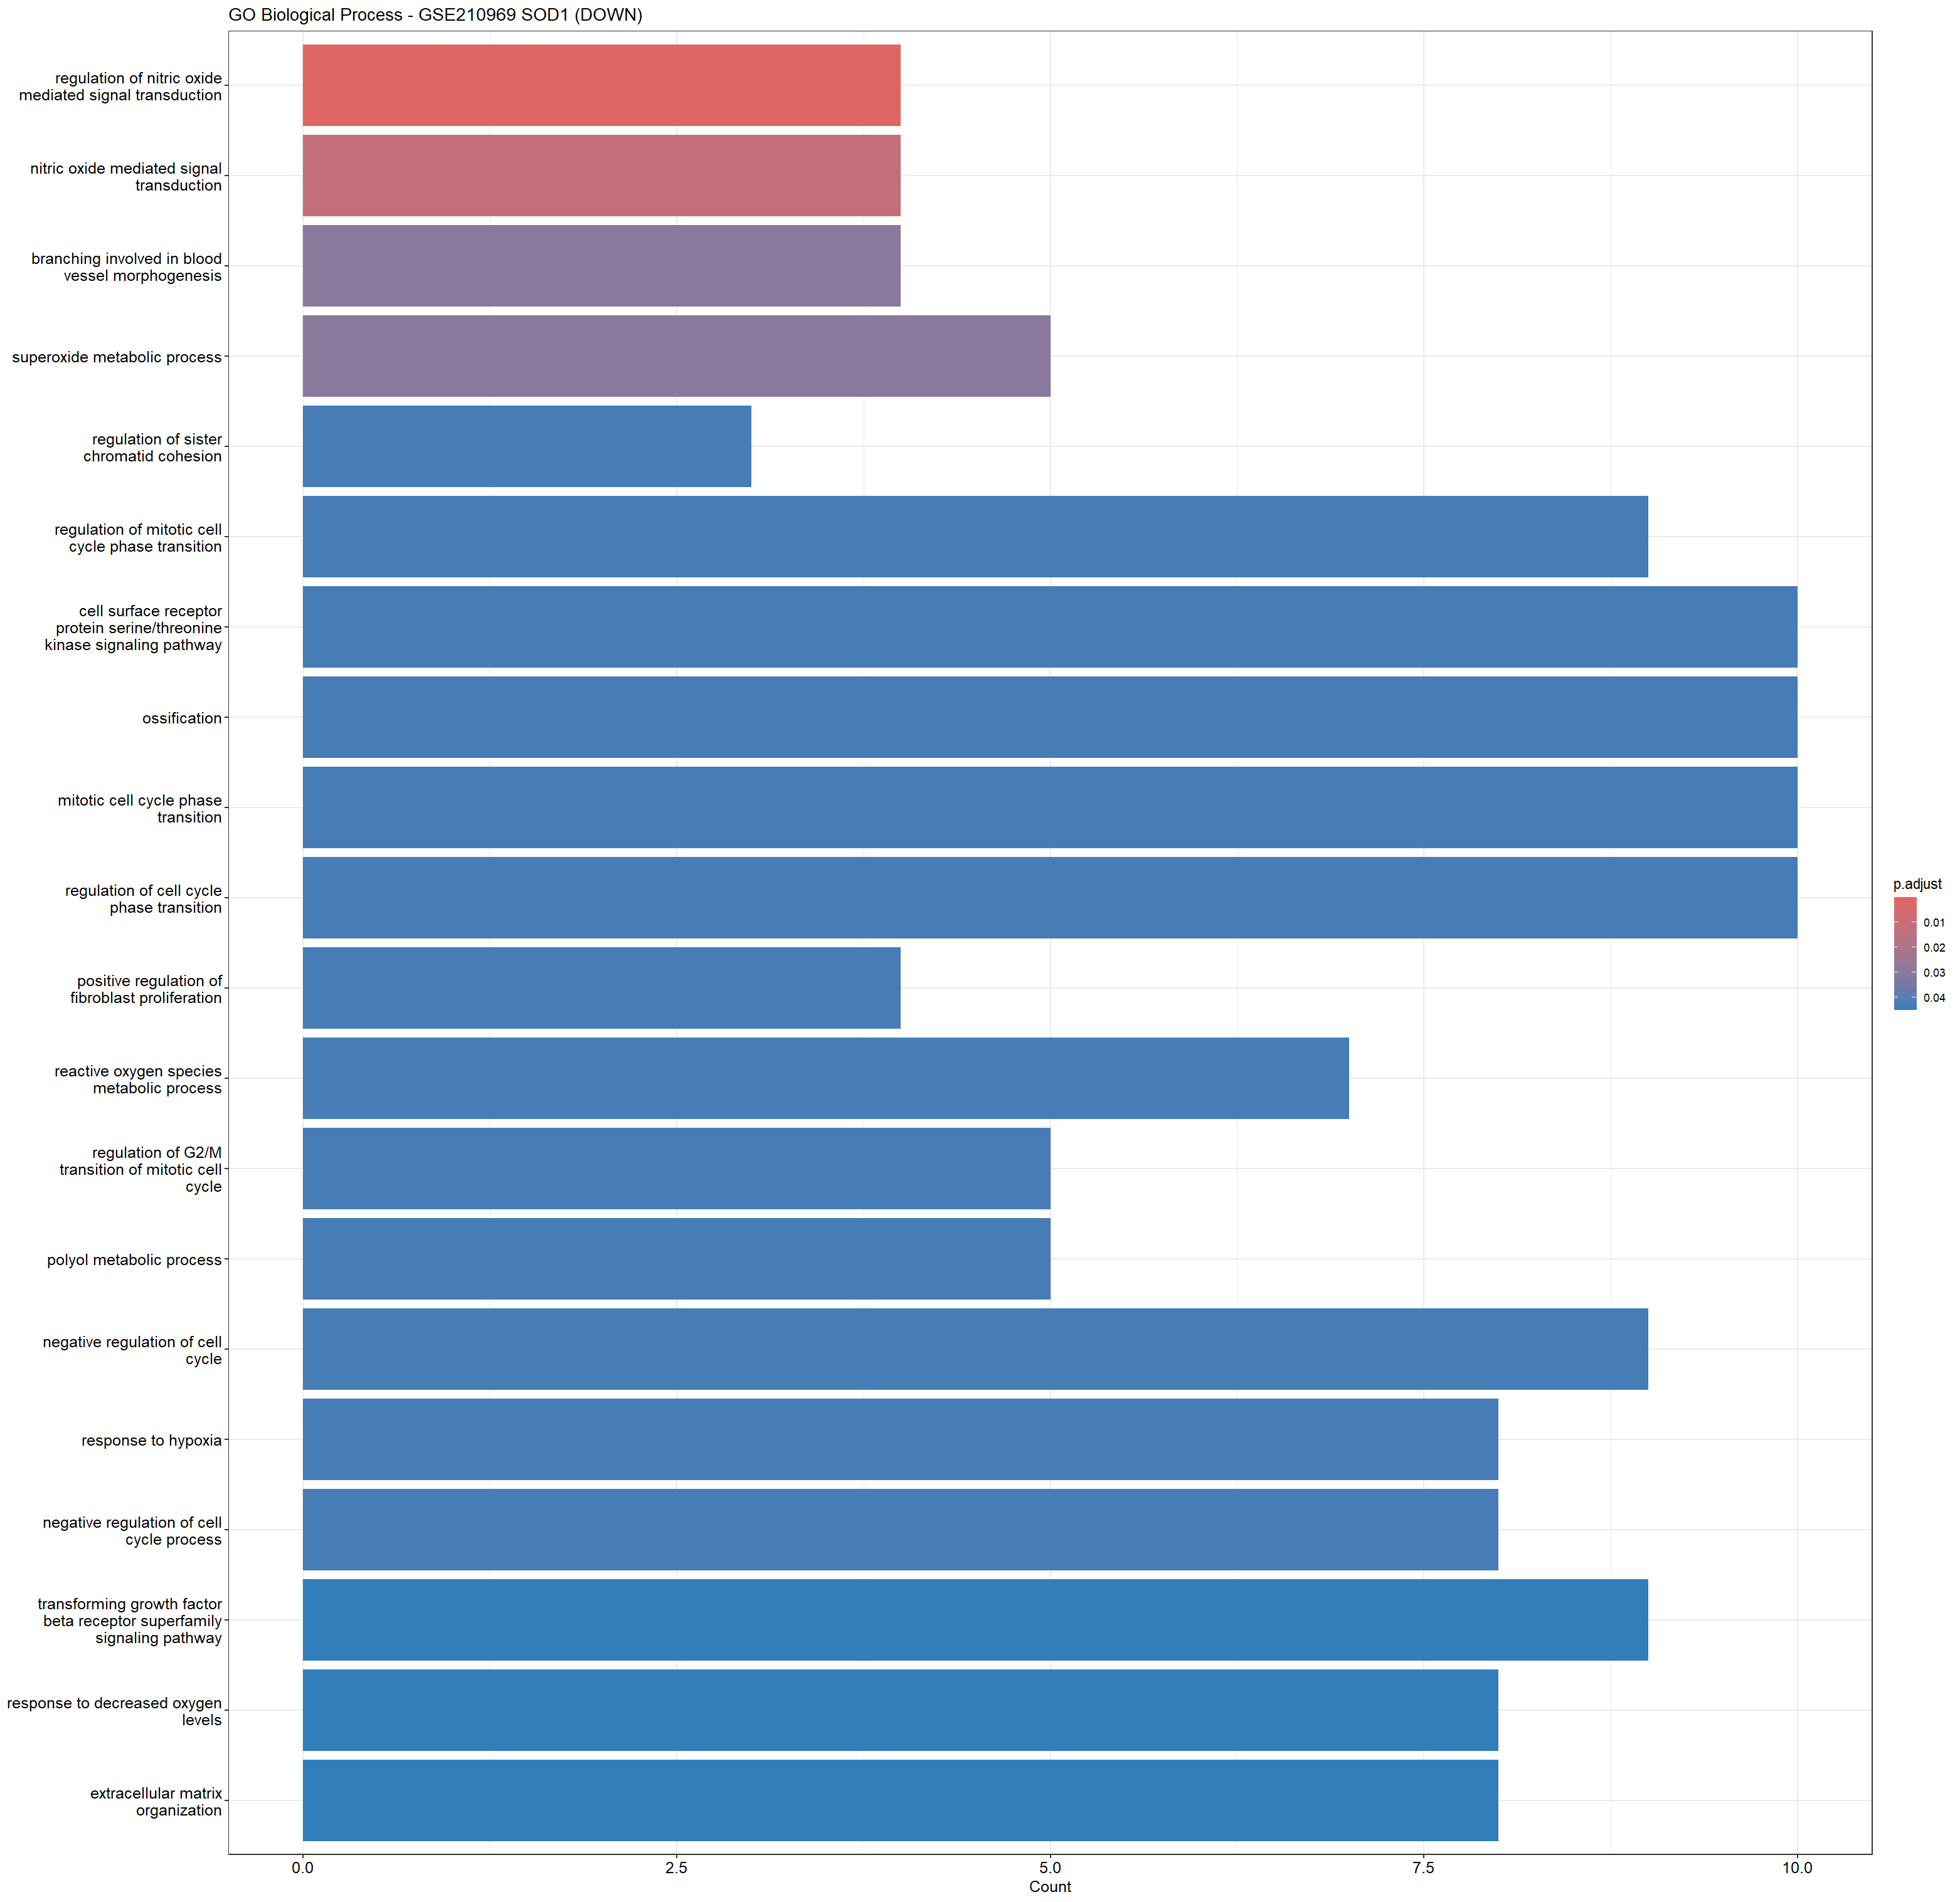  GSE210969 SOD1: Bar plot | GSE210969 SOD1: Enrichment plot

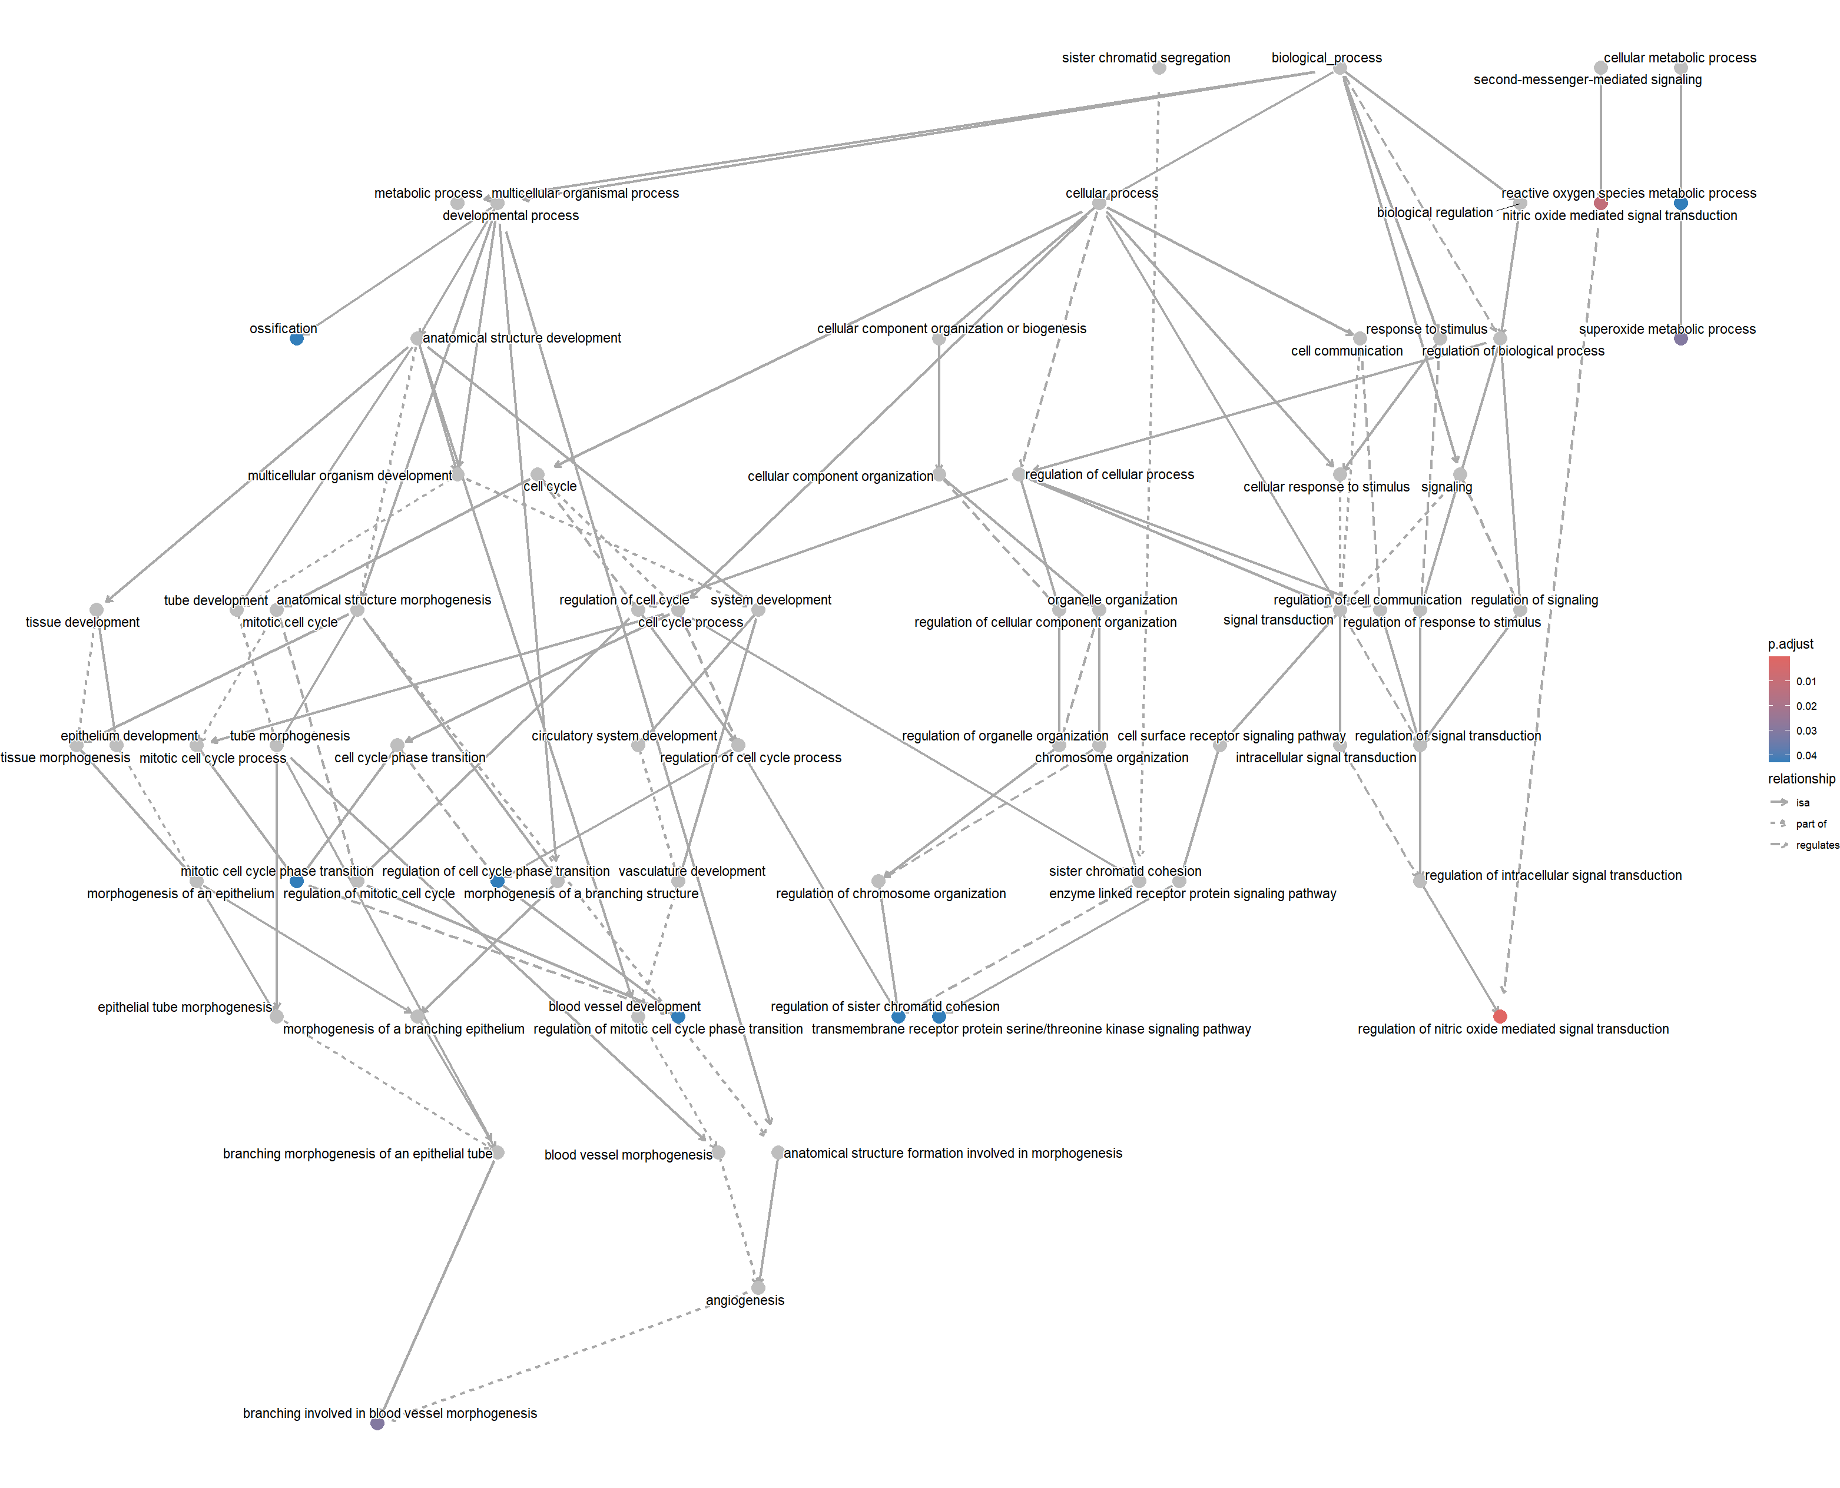  GSE210969 SOD1: Hierarchy plot | 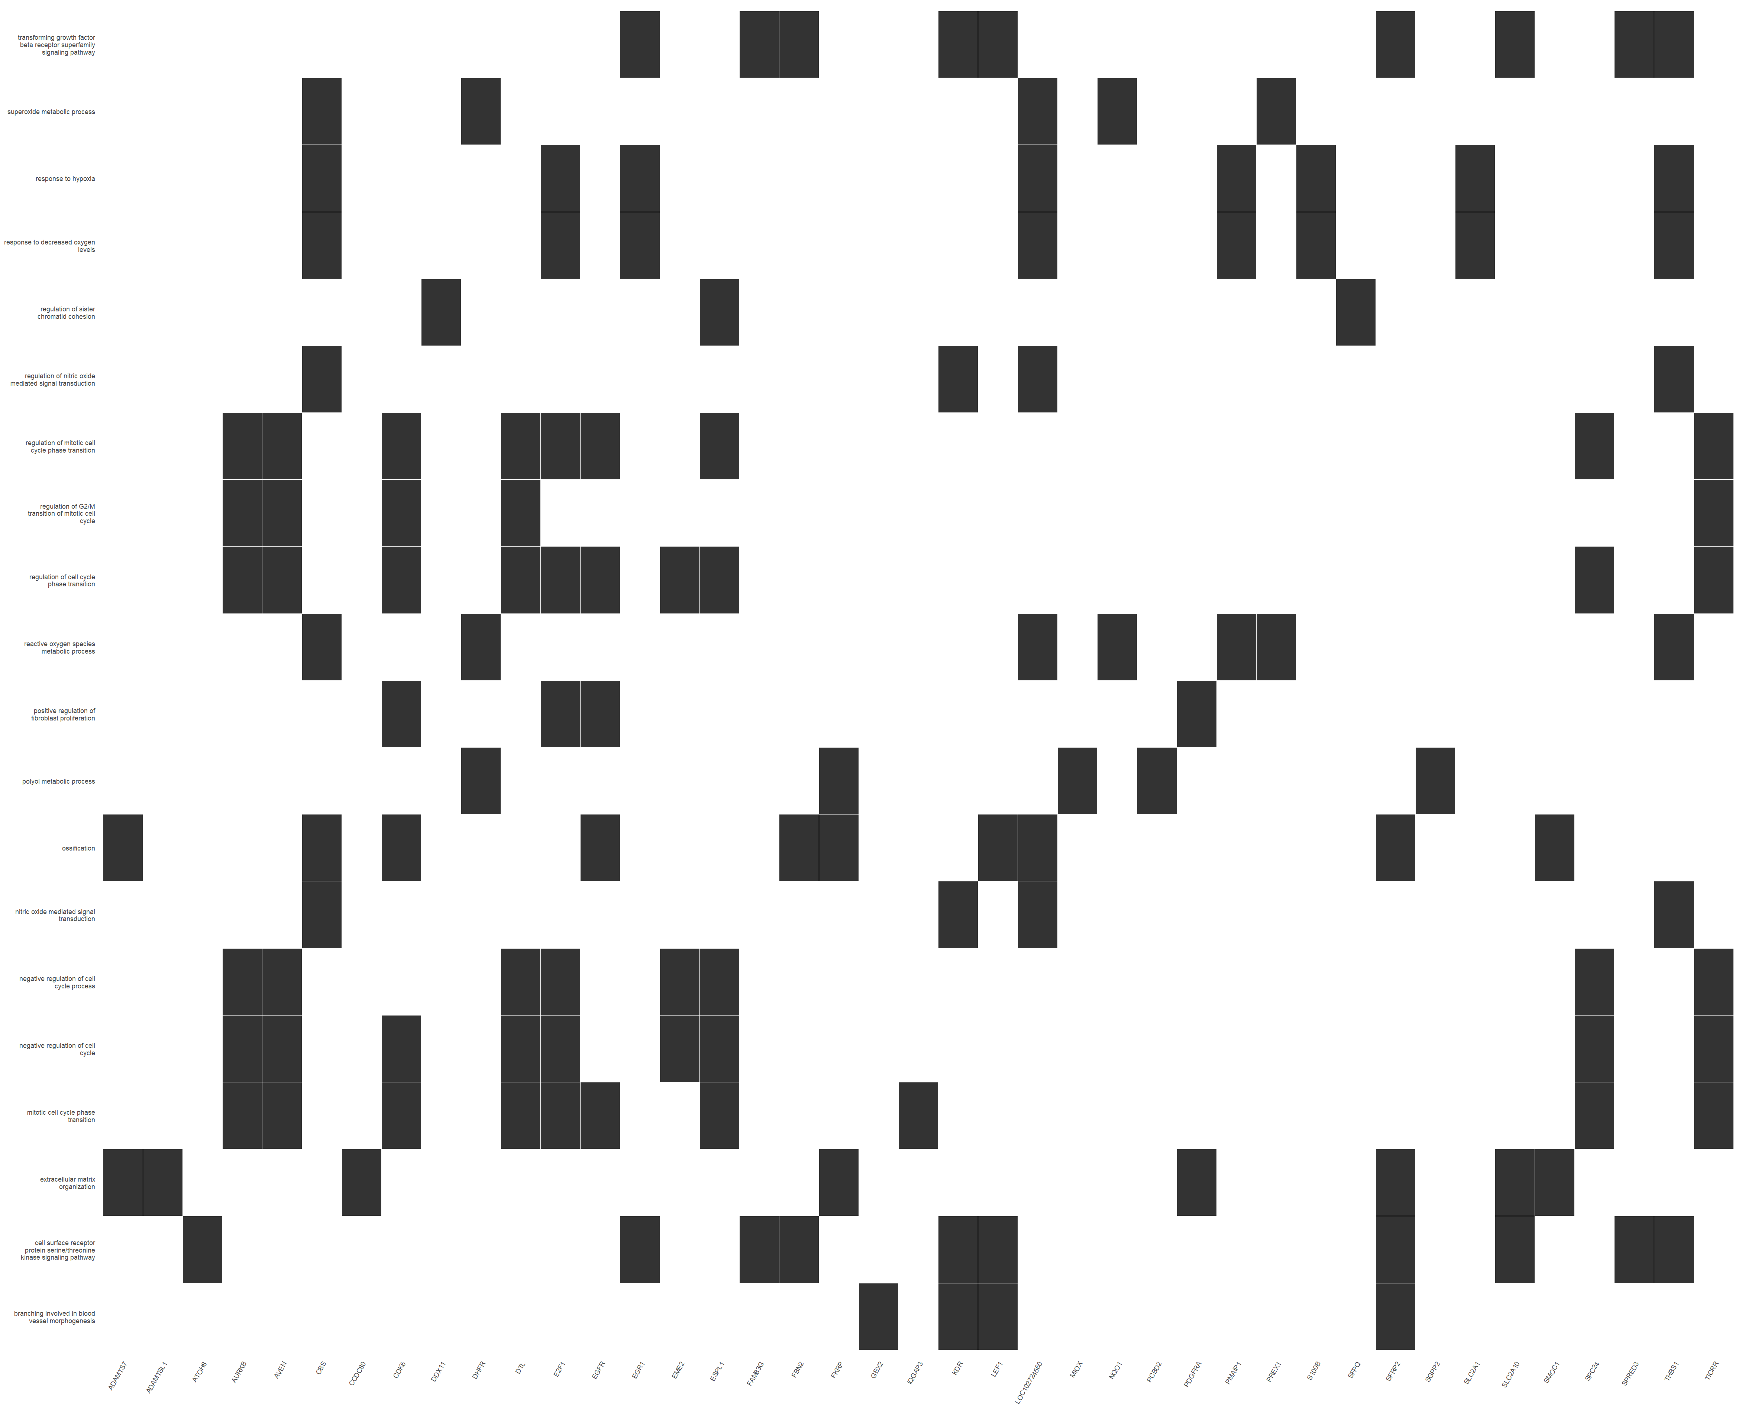  GSE210969 SOD1: Category#U2013Gene Heatmap | GSE283507 TDP-43: Enrichment plot
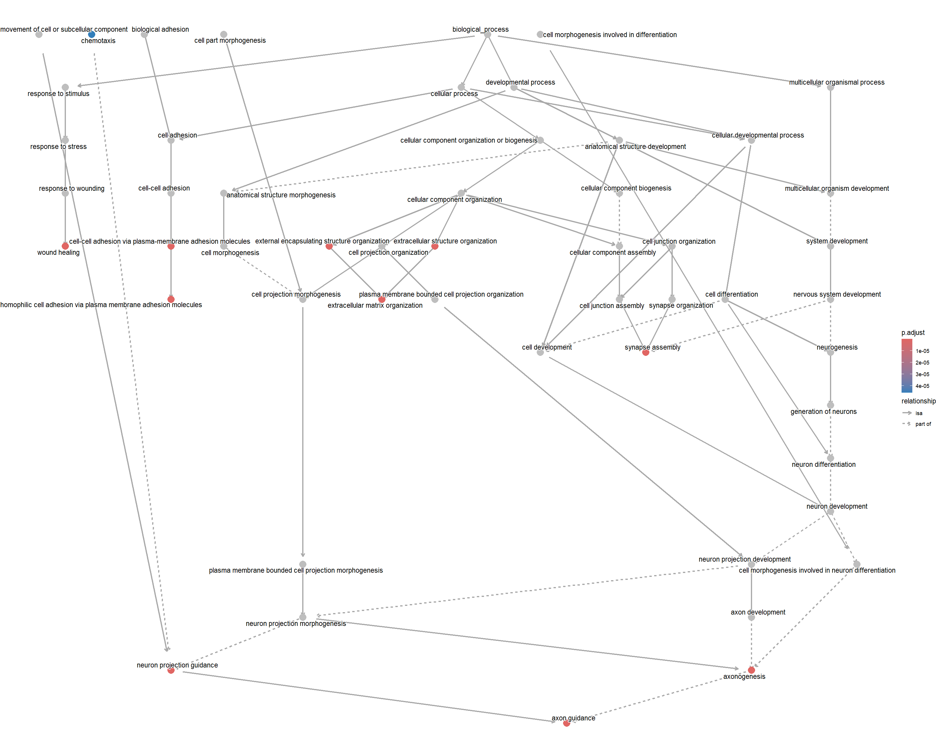  GSE283507 TDP-43: Hierarchy plot | GSE283507 TDP-43: Category#U2013Gene Heatmap

Appendix C. Additional Original GO-BP Outputs from Upregulated Analysis
These figures are included because they were present in the project archive. They are not used to support the main downregulated-gene convergence analysis.
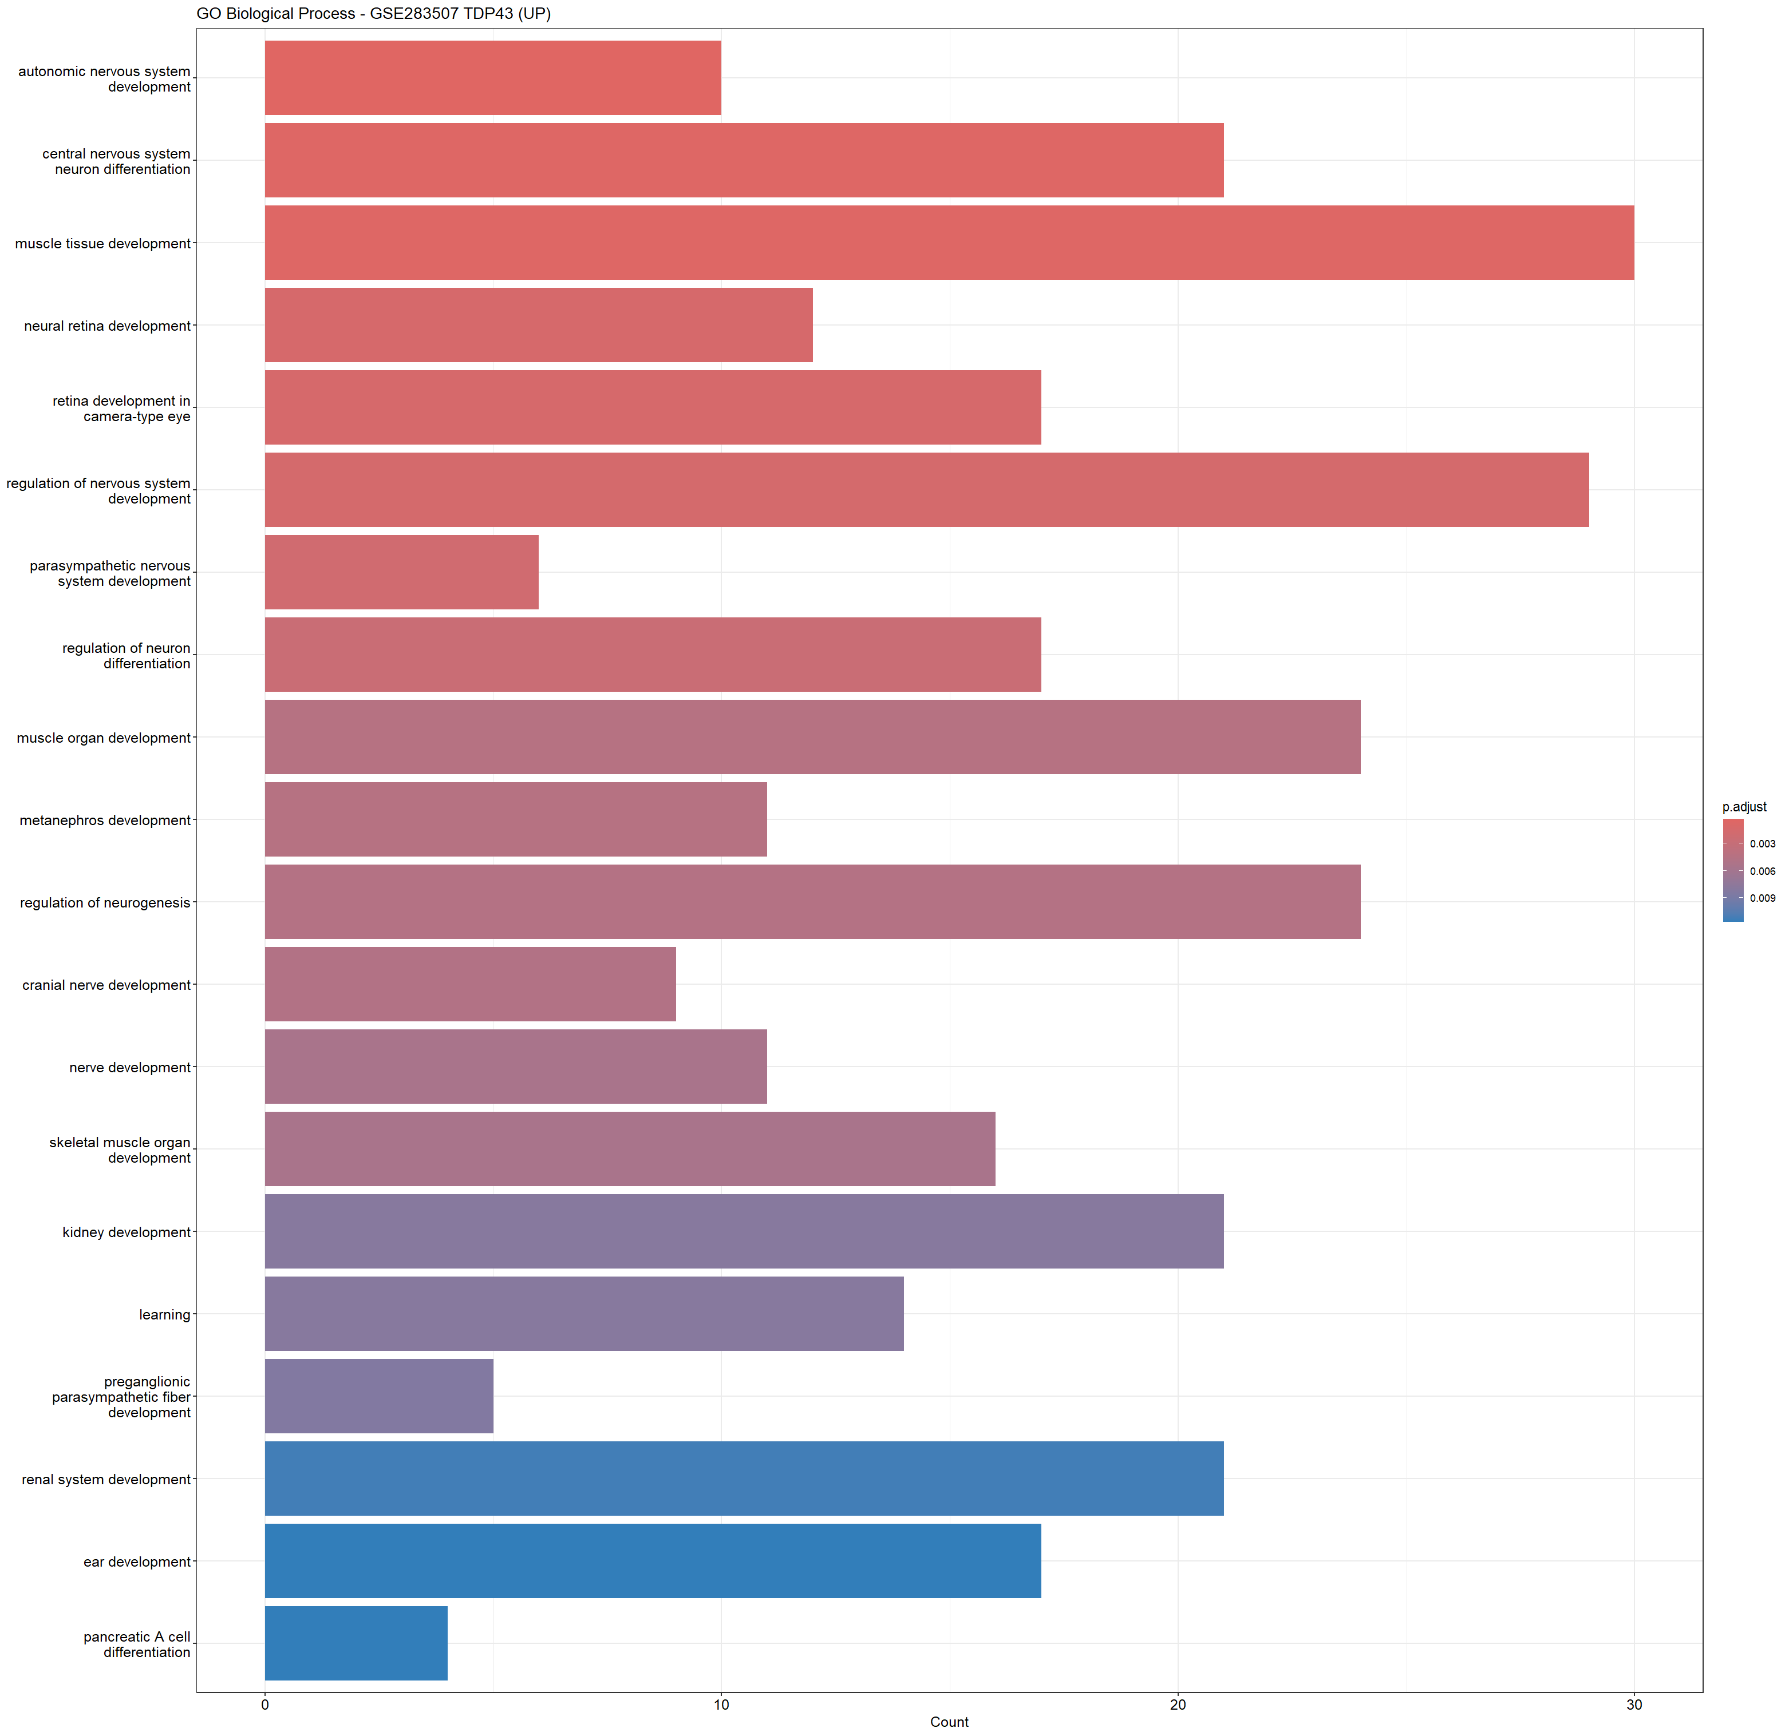  GSE283507 TDP-43 upregulated: Bar plot | 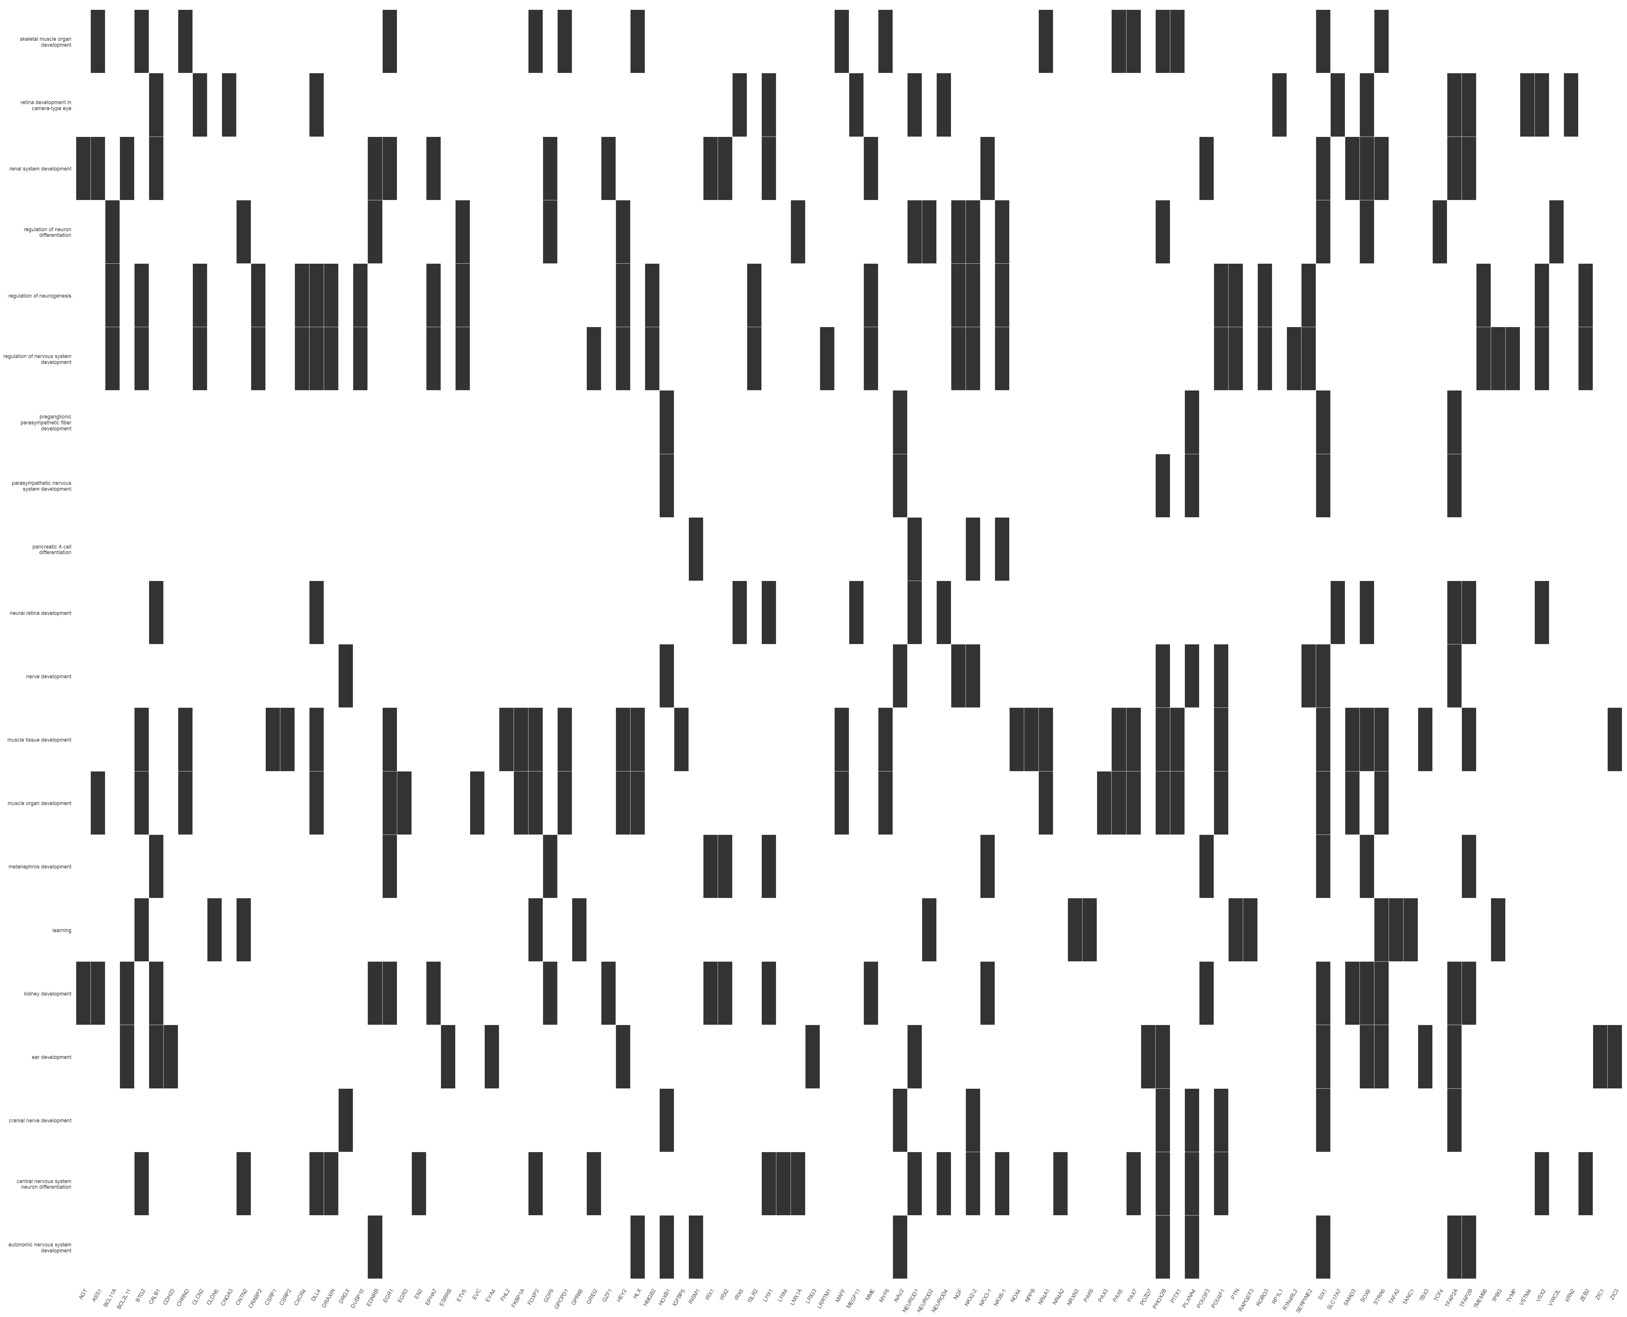  GSE283507 TDP-43 upregulated: Category#U2013Gene Heatmap | GSE283507 TDP-43 upregulated: Dot Plot
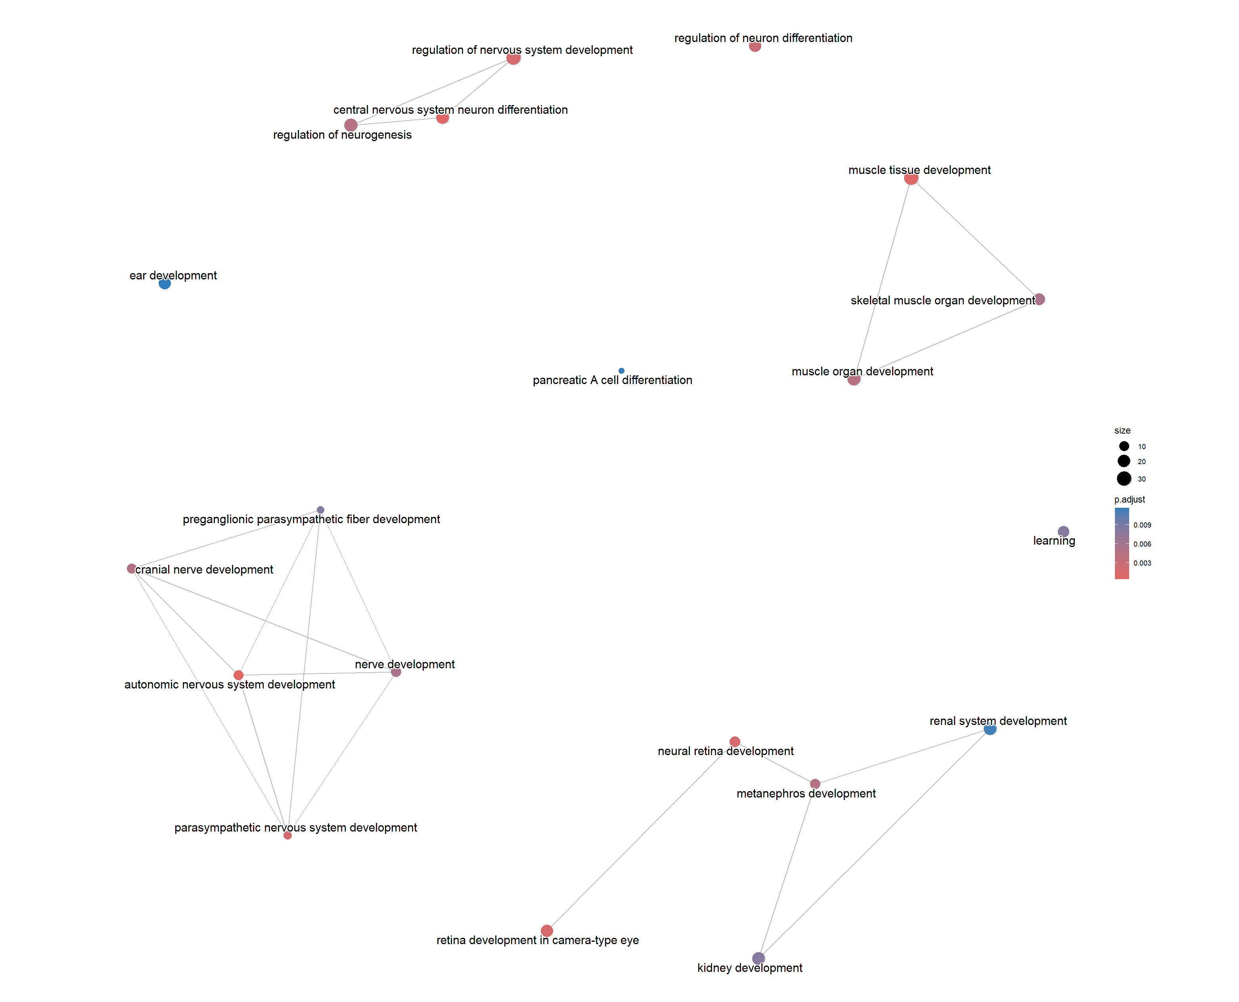  GSE283507 TDP-43 upregulated: Enrichment plot | 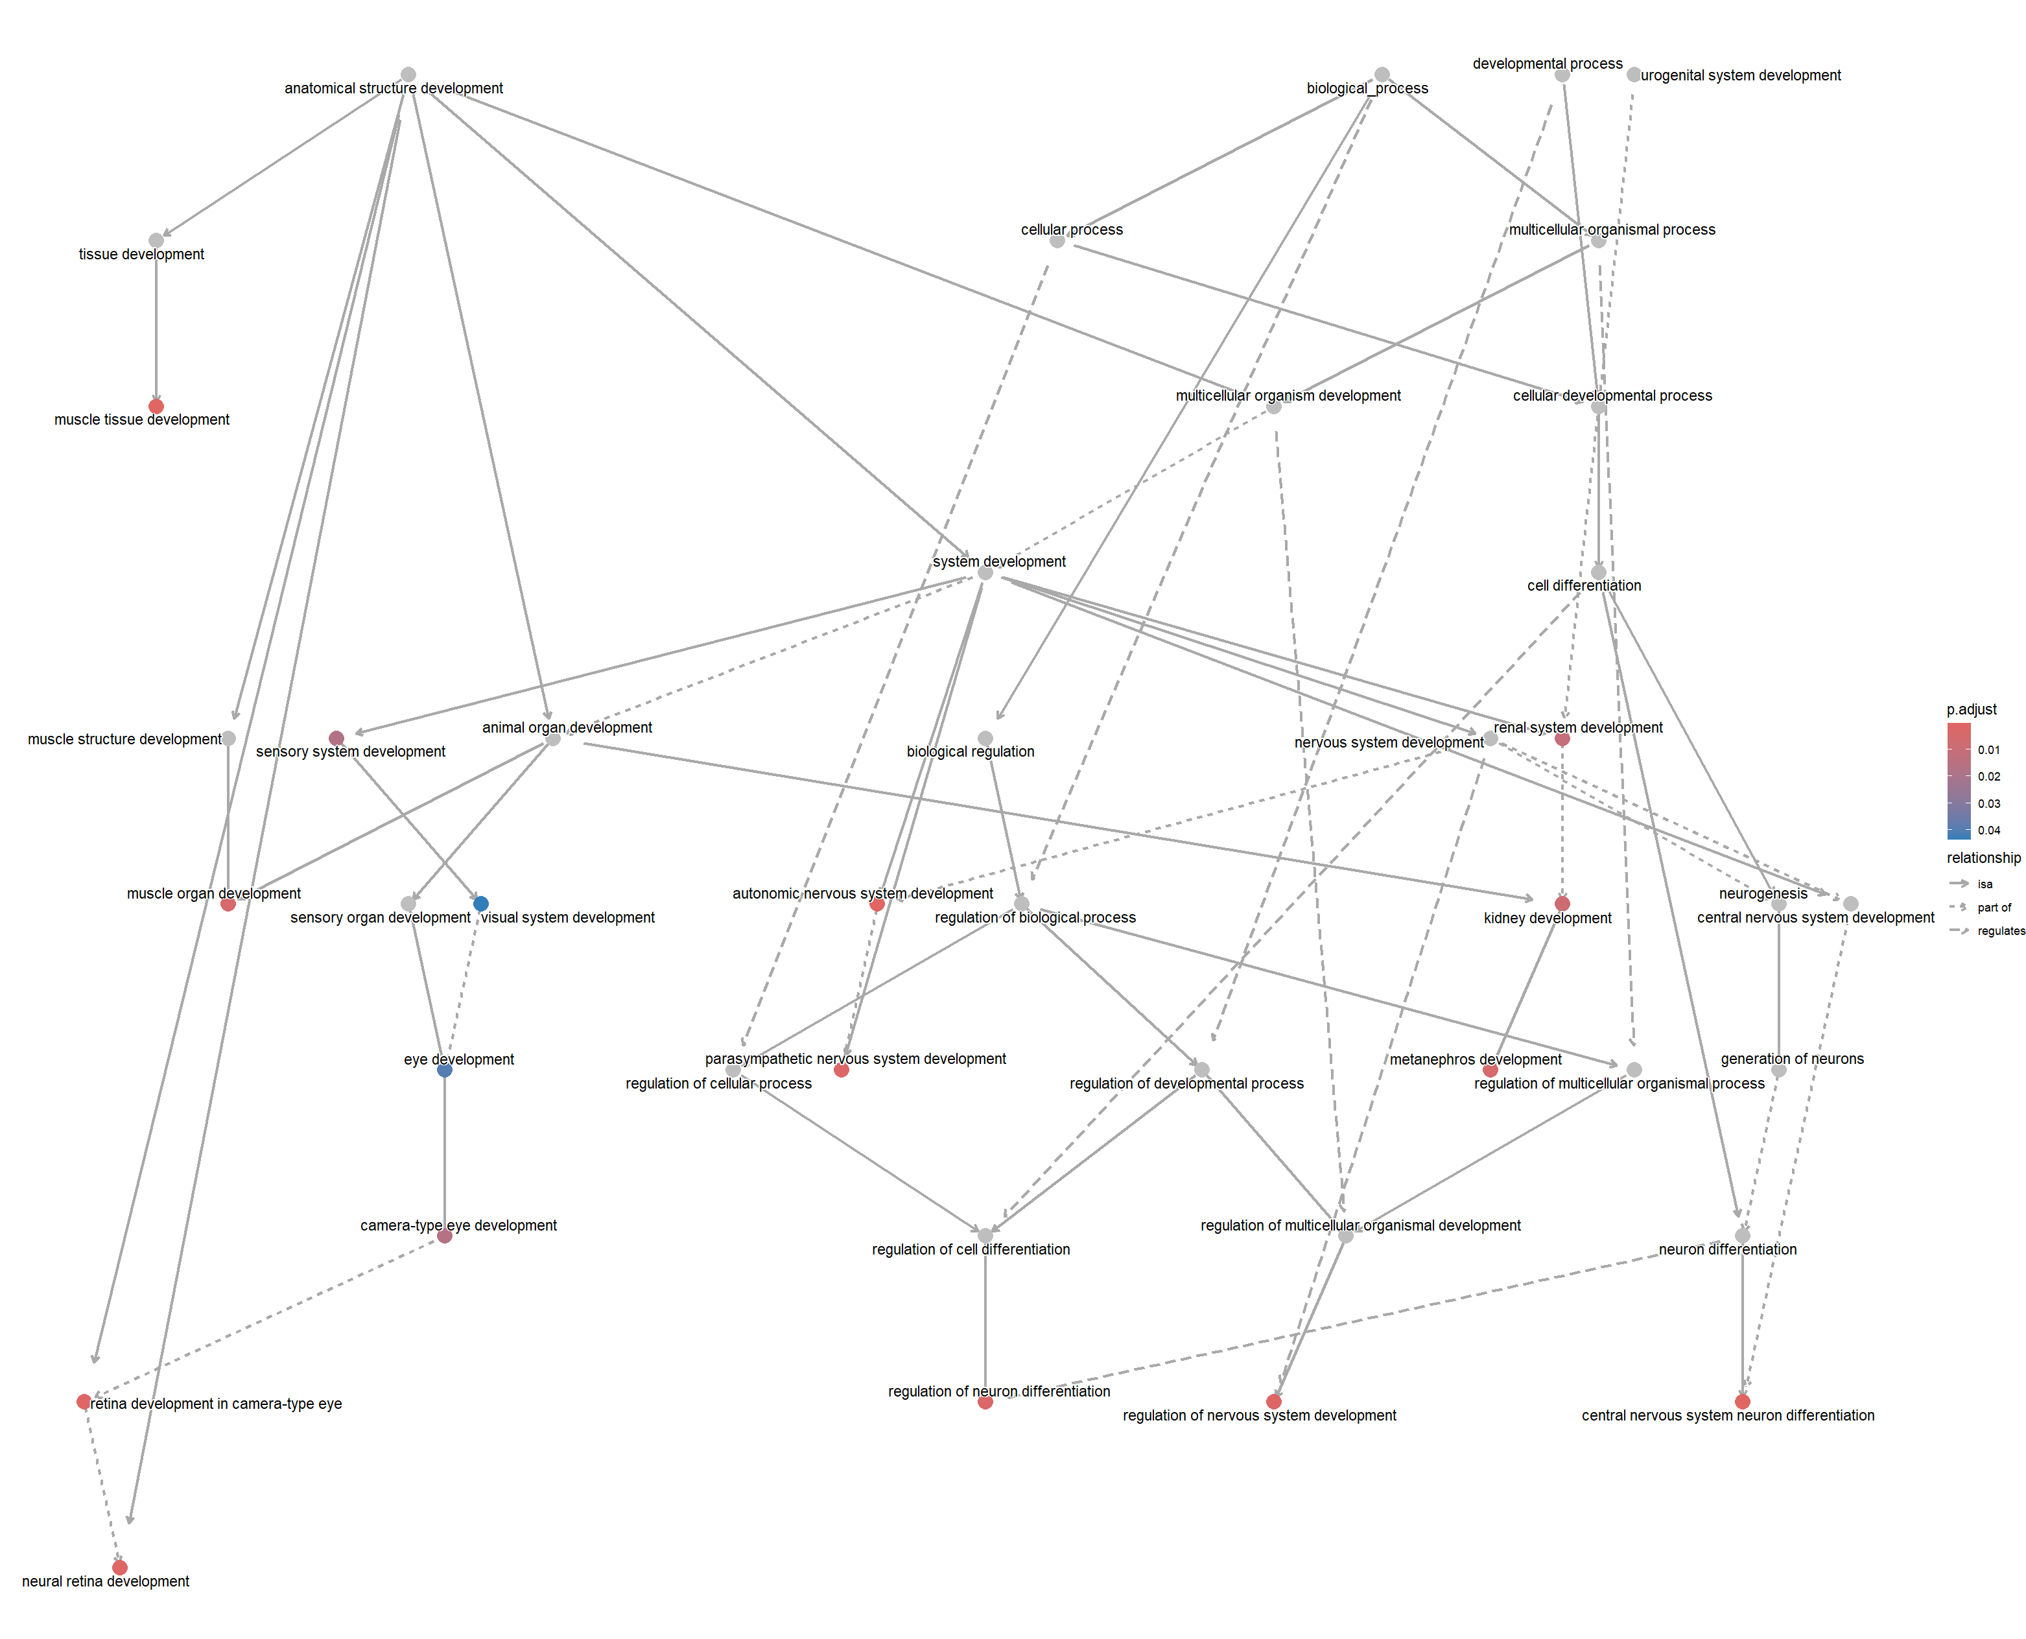  GSE283507 TDP-43 upregulated: Hierarchy plot

Appendix D. Biological-Module Source Tables
The complete module-summary spreadsheets used for the module-level analysis are reproduced here as reference tables. The concise profile-level summary appears as Table 4.7.

GSE52202 C9orf72
Biological Module | Representative GO Terms (Top 3–5) | Median Fold Enrichment | Median RichFactor | Minimum FDR | Number of GO Terms
Organ-Specific Development | ossification; muscle organ development; cartilage development; endochondral ossification; replacement ossification | 10.63828 | 0.032716 | 1.30211812538726e-06 | 44
Cell Adhesion & Extracellular Matrix (ECM) | extracellular matrix organization; extracellular structure organization; external encapsulating structure organization; collagen fibril organization; cell-substrate adhesion | 11.409558 | 0.035088 | 1.67784103136041e-06 | 15
Developmental Patterning & Morphogenesis | connective tissue development; endodermal cell differentiation; formation of primary germ layer; endoderm formation; mesenchymal cell differentiation | 9.58374 | 0.029473 | 7.55546968845251e-05 | 8
Cardiovascular & Angiogenesis | cardiac chamber development; heart morphogenesis; cardiac ventricle development; cardiac chamber morphogenesis; trabecula formation | 15.67096 | 0.048193 | 0.000192841526405424 | 29
Neuroinflammation & Immune Signaling | positive regulation of inflammatory response; response to interferon-alpha; host-mediated suppression of symbiont invasion; regulation of inflammatory response | 18.090365 | 0.055633 | 0.009428905711649 | 4
Signal Transduction | Rho protein signal transduction; cellular response to transforming growth factor beta stimulus; response to transforming growth factor beta | 5.227852 | 0.016077 | 0.0241261987977827 | 3
Cell Cycle, Growth & Survival | stem cell differentiation; positive regulation of stem cell differentiation; stem cell development; regulation of organ growth | 10.278232 | 0.031609 | 0.0283743694885092 | 4
Neuronal Development & Axon Biology | neural crest cell development; neural crest cell differentiation | 11.082577 | 0.034082 | 0.0347304234265004 | 2
Cytoskeleton & Cell Motility | cell aggregation; substrate-dependent cell migration | 24.219738 | 0.074483 | 0.0391473596745051 | 2
Tissue Remodeling & Wound Healing | epithelial to mesenchymal transition | 6.670203 | 0.020513 | 0.0425251820855887 | 1
Table D1. Original module-summary data for GSE52202 C9orf72.

GSE210969 SOD1
Biological Module | Representative GO Terms (Top 3–5) | Median Fold Enrichment | Median RichFactor | Minimum FDR | Number of GO Terms
Signal Transduction | regulation of nitric oxide mediated signal transduction; nitric oxide mediated signal transduction; cell surface receptor protein serine/threonine kinase signaling pathway; transforming growth factor beta receptor superfamily signaling pathway | 15.982733 | 0.088134 | 0.000344540121488 | 4
Cardiovascular & Angiogenesis | branching involved in blood vessel morphogenesis | 18.599606 | 0.102564 | 0.0302237247686556 | 1
Oxidative Stress & Hypoxia | superoxide metabolic process; reactive oxygen species metabolic process; response to hypoxia; response to decreased oxygen levels | 4.966387 | 0.027386 | 0.0302237247686556 | 4
Cell Cycle, Growth & Survival | regulation of sister chromatid cohesion; regulation of mitotic cell cycle phase transition; mitotic cell cycle phase transition; regulation of cell cycle phase transition; positive regulation of fibroblast proliferation | 5.195172 | 0.028648 | 0.0430117946598044 | 10
Organ-Specific Development | ossification | 3.98563 | 0.021978 | 0.0430117946598044 | 1
Homeostasis & Metabolism | polyol metabolic process | 8.243007 | 0.045455 | 0.0430117946598044 | 1
Cell Adhesion & Extracellular Matrix (ECM) | extracellular matrix organization; extracellular structure organization; external encapsulating structure organization | 4.369787 | 0.024096 | 0.0450938202590733 | 3
Table D2. Original module-summary data for GSE210969 SOD1.

GSE283507 TDP-43
Biological Module | Representative GO Terms (Top 3–5) | Median Fold Enrichment | Median RichFactor | Minimum FDR | Number of GO Terms
Cell Adhesion & Extracellular Matrix (ECM) | cell-cell adhesion via plasma-membrane adhesion molecules; homophilic cell adhesion via plasma membrane adhesion molecules; extracellular matrix organization; extracellular structure organization; external encapsulating structure organization | 3.259141 | 0.147059 | 8.33889407568622e-15 | 42
Synaptic Organization & Neurotransmission | synapse assembly; learning or memory; regulation of membrane potential; positive regulation of synaptic transmission; cognition | 3.823753 | 0.172535 | 1.0746149924016e-12 | 125
Neuronal Development & Axon Biology | axonogenesis; axon guidance; neuron projection guidance; regulation of nervous system development; forebrain development | 3.218075 | 0.145206 | 1.21763161667905e-11 | 66
Tissue Remodeling & Wound Healing | wound healing; regulation of wound healing; regulation of response to wounding; negative regulation of wound healing; positive regulation of wound healing | 3.437401 | 0.155102 | 3.68052393104137e-09 | 12
Organ-Specific Development | kidney development; renal system development; gland development; gland morphogenesis; cartilage development | 2.932004 | 0.132298 | 1.92653452440431e-07 | 118
Cardiovascular & Angiogenesis | heart process; heart contraction; regulation of heart contraction; regulation of blood circulation; cardiac muscle tissue development | 3.344112 | 0.150893 | 2.10730015351554e-07 | 122
Calcium & Ion Homeostasis | calcium ion transmembrane transport; intracellular calcium ion homeostasis; regulation of monoatomic ion transport; calcium ion homeostasis; calcium ion transport | 2.77027 | 0.125 | 2.36920676525255e-07 | 53
Developmental Patterning & Morphogenesis | connective tissue development; morphogenesis of a branching structure; morphogenesis of a branching epithelium; epithelial tube morphogenesis; developmental growth involved in morphogenesis | 2.584893 | 0.116635 | 7.88008318701361e-07 | 46
Protein Localization & Membrane Organization | protein localization to membrane; protein localization to cell periphery; regulation of protein localization to membrane; receptor clustering; protein localization to extracellular region | 2.371061 | 0.106987 | 2.10508129966034e-06 | 15
Vesicle Trafficking & Exocytosis | regulation of exocytosis; calcium-ion regulated exocytosis; regulation of calcium ion-dependent exocytosis; negative regulation of secretion; negative regulation of secretion by cell | 2.414644 | 0.108953 | 8.85695978179207e-06 | 20
Signal Transduction | Notch signaling pathway; positive regulation of MAPK cascade; response to BMP; cellular response to BMP stimulus; phospholipase C-activating G protein-coupled receptor signaling pathway | 2.532819 | 0.114286 | 1.03898989650151e-05 | 63
Homeostasis & Metabolism | regulation of transmembrane transport; multicellular organismal response to stress; response to vitamin; regulation of metal ion transport; response to ketone | 2.77027 | 0.125 | 1.36644059107247e-05 | 61
Endocrine & Hormonal Regulation | regulation of hormone biosynthetic process; response to angiotensin; regulation of steroid hormone biosynthetic process; cellular response to angiotensin; response to vitamin D | 3.374098 | 0.152246 | 1.37365214225767e-05 | 70
Cytoskeleton & Cell Motility | positive regulation of cell projection organization; chemotaxis; taxis; actin-mediated cell contraction; regulation of chemotaxis | 2.355107 | 0.106267 | 3.61204255063879e-05 | 43
Glial Biology & Myelination | gliogenesis; glial cell differentiation; glial cell migration; positive regulation of gliogenesis; oligodendrocyte differentiation | 2.643194 | 0.119266 | 0.0001050428055512 | 7
Cell Cycle, Growth & Survival | epithelial cell proliferation; positive regulation of cell development; cell growth; regulation of cell growth; regulation of epithelial cell proliferation | 2.110682 | 0.095238 | 0.0002782775694719 | 23
Oxidative Stress & Hypoxia | response to hypoxia; response to oxygen levels; response to decreased oxygen levels; regulation of reactive oxygen species metabolic process; regulation of superoxide metabolic process | 2.167278 | 0.097792 | 0.0011372134900273 | 5
Neuroinflammation & Immune Signaling | chemokine (C-X-C motif) ligand 2 production; regulation of chemokine (C-X-C motif) ligand 2 production; establishment of T cell polarity; regulation of leukocyte migration; establishment of lymphocyte polarity | 5.276705 | 0.238095 | 0.0183532788017581 | 8
Table D3. Original module-summary data for GSE283507 TDP-43.

Appendix E. Convergence Data and Visualizations

The complete convergence table and the original convergence visualizations are retained here as supporting source material. The same key visualizations are presented in the main Results section as Figures 3.11 and 3.12.
Biological Module | GSE52202_C9_DOWN | GSE210969_SOD1_DOWN | GSE283507_TDP43_DOWN | Convergence Score
Cardiovascular & Angiogenesis | 15.671 | 18.5996 | 3.3441 | 1.0
Cell Adhesion & Extracellular Matrix (ECM) | 11.4096 | 4.3698 | 3.2591 | 1.0
Signal Transduction | 5.2279 | 15.9827 | 2.5328 | 1.0
Cell Cycle, Growth & Survival | 10.2782 | 5.1952 | 2.1107 | 1.0
Organ-Specific Development | 10.6383 | 3.9856 | 2.932 | 1.0
Tissue Remodeling & Wound Healing | 6.6702 |  | 3.4374 | 0.6667
Neuroinflammation & Immune Signaling | 18.0904 |  | 5.2767 | 0.6667
Homeostasis & Metabolism |  | 8.243 | 2.7703 | 0.6667
Cytoskeleton & Cell Motility | 24.2197 |  | 2.3551 | 0.6667
Developmental Patterning & Morphogenesis | 9.5837 |  | 2.5849 | 0.6667
Oxidative Stress & Hypoxia |  | 4.9664 | 2.1673 | 0.6667
Neuronal Development & Axon Biology | 11.0826 |  | 3.2181 | 0.6667
Calcium & Ion Homeostasis |  |  | 2.7703 | 0.3333
Glial Biology & Myelination |  |  | 2.6432 | 0.3333
Endocrine & Hormonal Regulation |  |  | 3.3741 | 0.3333
Protein Localization & Membrane Organization |  |  | 2.3711 | 0.3333
Synaptic Organization & Neurotransmission |  |  | 3.8238 | 0.3333
Vesicle Trafficking & Exocytosis |  |  | 2.4146 | 0.3333
Table E1. Original convergence data table.

Original convergence visualizations
Figure E1. Original convergence heatmap. | Figure E2. Original convergence bubble plot.

Appendix F. Supporting Spreadsheet and Data-File Inventory
The full raw count matrices, complete DESeq2 result tables, complete GO enrichment CSVs, significant-gene tables, normalized counts, and GEO metadata files are not embedded in the Word report because of their size. These files should be preserved in the GitHub repository and/or supplied as supplementary data. The following inventory records the main supporting file types present in the submitted archive.

Spreadsheets
• Biological module summary/GSE210969_SOD1_DOWN_ModuleSummary.xlsx
• Biological module summary/GSE283507_TDP43_DOWN_ModuleSummary.xlsx
• Biological module summary/GSE52202_C9_DOWN_ModuleSummary (1).xlsx
• Convergence table/Biogolical module summary/GSE210969_SOD1_DOWN_ModuleSummary.xlsx
• Convergence table/Biogolical module summary/GSE283507_TDP43_DOWN_ModuleSummary.xlsx
• Convergence table/Biogolical module summary/GSE52202_C9_DOWN_ModuleSummary.xlsx
• Convergence table/Convergence Table/Convergence_Table (1).xlsx
• GO annotations101/Biological module mapping/GO_BP_GSE210969_SOD1_DOWN_categorized.xlsx
• GO annotations101/Biological module mapping/GO_BP_GSE283507_TDP43_DOWN_categorized.xlsx
• GO annotations101/Biological module mapping/GO_BP_GSE52202_C9_DOWN_categorized.xlsx
• GO annotations101/gse52202/GO annotations/GO_BP_GSE52202_C9_DOWN.csv.xlsx

CSV result files
• GO annotations101/gse210969/GO annotations/SOD1/GO_BP_GSE210969_SOD1_DOWN.csv
• GO annotations101/gse210969/GO annotations/SOD1/GO_BP_GSE210969_SOD1_UP.csv
• GO annotations101/gse210969/GO annotations/TDP43/GO_BP_GSE210969_TDP43_DOWN.csv
• GO annotations101/gse210969/GO annotations/TDP43/GO_BP_GSE210969_TDP43_UP.csv
• GO annotations101/gse283507/GO annotations/GO_BP_GSE283507_TDP43_DOWN.csv
• GO annotations101/gse283507/GO annotations/GO_BP_GSE283507_TDP43_UP.csv
• GO annotations101/gse52202/GO annotations/GO_BP_GSE52202_C9_DOWN.csv
• GO annotations101/gse52202/GO annotations/GO_BP_GSE52202_C9_UP.csv
• GSE283507/Raw counts/GSE283507_raw_Count_FPKM_TPM.csv

Raw count files
• GSE210969/Raw counts/GSE210969_raw_counts_GRCh38.p13_NCBI.tsv
• GSE52202/Raw counts/GSE52202_raw_counts_GRCh38.p13_NCBI.tsv

GEO metadata files
• GSE52202/Meta Data/GSE52202_family.soft

Metadata text files
• GSE210969/Metadata/GSE210969_series_matrix.txt
• GSE283507/Metadata/GSE283507_series_matrix.txt
[FINAL DATA NOTE] All scientific figures in this chapter were taken directly from the uploaded project archive. Where an expected output was not present, it was not invented or reconstructed.

CHAPTER 5
DISCUSSION
The central premise of this study was that genetically distinct ALS/FTD-associated molecular insults may produce different initial transcriptional disturbances while potentially converging at higher levels of biological organization. The conceptual framework supplied for the study proposed a hierarchy of possible convergence: individual genes, biological pathways, transcriptional programs or co-expression modules, and the global transcriptomic state. The completed analysis principally examined the functional pathway/module level; therefore, the present discussion interprets the findings as evidence of functional or module-level convergence rather than as proof of convergence across the entire transcriptome.

5.1 Overview of Major Findings
Four dataset-level transcriptomic comparisons were analyzed independently, representing C9orf72-, SOD1-, and TDP-43-associated ALS. The resulting downregulated gene sets differed considerably in size, with 65 genes identified for GSE52202 C9orf72, 147 for GSE210969 SOD1, 34 for GSE210969 TDP-43, and 1,082 for GSE283507 TDP-43 (Chapter 4, Tables 4.1 and 4.2). GO Biological Process enrichment was significant for three of the four profiles, whereas the GSE210969 TDP-43 set yielded no significant GO-BP terms (Chapter 4, Table 4.3). The three profiles with significant enrichment were then represented within the biological-module framework and compared using a recurrence-based convergence score (Chapter 4, Tables 4.7–4.9).
At the module level, five biological modules were represented in all three profiles, seven were represented in two profiles, and six were represented only in the GSE283507 TDP-43 profile (Chapter 4, Table 4.9; Figures 4.11–4.12). Thus, the overall pattern was neither complete transcriptomic similarity nor complete subtype separation. Instead, the findings are most consistent with the hierarchical-convergence scenario described in the original study framework: relatively heterogeneous dataset-level signatures can coexist with recurrence at a broader functional level. The study material explicitly identified this as the expected 'low DEG overlap but high pathway/module overlap' scenario.

5.2 From Mutation-Specific Insults to Shared Biological Programs
The rationale for examining convergence at a functional level comes from the biological diversity of ALS-associated genes. The study framework identifies SOD1 with protein misfolding and oxidative stress, TARDBP with RNA processing and splicing, FUS with RNA transport, C9orf72 with repeat-expansion-associated mechanisms and immune dysfunction, and other genes such as VCP and TBK1 with protein degradation, autophagy and innate immunity. These primary defects are mechanistically different, yet the clinical phenotypes can converge on motor-neuron degeneration, weakness and paralysis.
The transcriptomic results fit this biological rationale. The four comparisons did not produce equally sized or identical downregulated signatures, indicating that the molecular state captured by each dataset remained strongly context-dependent. Such heterogeneity is expected in ALS, where genotype, cell model, differentiation state, tissue context, disease stage and experimental design can all influence the measured transcriptome. The observed divergence at the gene-signature level therefore does not contradict the convergence hypothesis; rather, it provides the reason for testing convergence at a higher level of organization.
The subsequent module analysis provides that higher-level view. Rather than requiring the same genes to change in every profile, it asks whether different gene sets can be organized into recurring functional categories. This corresponds most closely to the third conceptual level in the study framework—transcriptional-program or module convergence—although the present implementation used predefined biological modules rather than formal co-expression networks.

5.3 Differential-Expression Heterogeneity and the Effect of Dataset Context
The large difference between 34 and 1,082 downregulated genes across the two TDP-43 datasets is particularly informative. It demonstrates that even datasets representing the same broad molecular subtype can produce very different statistical signatures. The difference should not be interpreted as evidence that one TDP-43 model contains substantially more disease biology than the other. Statistical power depends strongly on biological replicate number, dispersion and effect size, and studies of RNA-seq experimental design consistently find that additional biological replication has a major effect on the ability to detect differentially expressed genes.
The sample sizes in the present project were modest in several comparisons, including three versus three samples for the GSE210969 TDP-43 comparison and GSE283507. Consequently, the number of genes crossing the adjusted-p-value and fold-change thresholds is likely to be sensitive to dataset-specific variance and effect sizes. This provides a methodological explanation for why two TDP-43 datasets should not be collapsed into a single assumed TDP-43 signature. The independent-dataset approach preserves this heterogeneity instead of averaging it away.
The same principle applies to the interpretation of the large GSE283507 downregulated gene set. It indicates a broad transcriptional difference within that particular comparison, but it cannot be used to rank molecular subtypes by biological importance. The number of significant genes is a property of the observed experiment and its statistical power as well as of the underlying biology.

5.4 GO-BP Enrichment as the Bridge from Genes to Convergence
GO-BP analysis provided the intermediate functional layer required to move beyond individual-gene comparisons. The 65 C9orf72 downregulated genes generated 112 significant GO-BP terms, the 147 SOD1 genes generated 24 terms, and the 1,082 GSE283507 TDP-43 genes generated 899 terms (Chapter 4, Table 4.3). These numbers again reflect differences in gene-set size and statistical characteristics and should not be interpreted as a measure of disease severity.
The enrichment profiles nevertheless contained biologically recognizable categories. The C9orf72 profile included extracellular-matrix, developmental, cardiovascular/vascular, cytoskeletal, neuronal, signaling, immune and tissue-remodeling processes. The SOD1 profile included vascular morphogenesis, signaling, oxidative-stress/hypoxia-related processes, extracellular-matrix organization and metabolic/cell-cycle processes. The GSE283507 TDP-43 profile included neuronal and synaptic processes, cell adhesion, calcium and ion homeostasis, membrane and vesicle organization, cytoskeletal processes, glial biology, oxidative stress and immune/inflammatory processes. These broad themes are compatible with the literature describing ALS as involving interacting disturbances in RNA biology, protein homeostasis, neuronal structure, cellular stress and inflammatory systems rather than a single pathway.
The important analytical step was therefore not to treat each enriched GO term as an isolated finding, but to organize related terms into the predefined module framework. The study's original proposal explicitly described pathway-level convergence and transcriptional-program convergence as distinct analytical levels. The present analysis provides evidence mainly at this functional/module level.

5.5 Functional Convergence at the Module Level
The strongest evidence supporting the study's central hypothesis is the recurrence of five biological modules across all three profiles carried forward to convergence analysis (Chapter 4, Table 4.9). Cardiovascular & Angiogenesis, Cell Adhesion & Extracellular Matrix, Signal Transduction, Cell Cycle, Growth & Survival, and Organ-Specific Development all received a convergence score of 1.00. A further seven modules received 0.67, while six received 0.33 because they were represented only in the GSE283507 TDP-43 profile.
This pattern is particularly relevant because the central research question was not simply whether the same genes changed, but whether genetically distinct ALS-associated insults could converge toward a common transcriptomic landscape at a higher biological level. The results support the possibility of such functional convergence while simultaneously showing that convergence is incomplete.
The findings also fit the original expected-outcome framework, in which low overlap at the DEG level accompanied by greater overlap at the pathway or module level would represent hierarchical convergence rather than a universal transcriptomic program. The current study did not directly quantify gene-level overlap, but the large differences in the dataset-level downregulated signatures combined with recurring modules are directionally consistent with this model.
However, the convergence score must be interpreted narrowly. A value of 1.00 means that a predefined module was represented in each of the three profiles; it does not mean that the same genes changed, that the same pathways were statistically significant within the module, or that the underlying mechanisms were identical. It also does not establish statistical significance of convergence. It is therefore best described as a transparent descriptive measure of module recurrence.

5.6 Shared versus Profile-Specific Functional Programs
The presence of profile-specific modules is as important as the shared modules. Six modules received a score of 0.33 because they occurred only in the GSE283507 TDP-43 profile, including Calcium & Ion Homeostasis, Glial Biology & Myelination, Endocrine & Hormonal Regulation, Protein Localization & Membrane Organization, Synaptic Organization & Neurotransmission, and Vesicle Trafficking & Exocytosis (Chapter 4, Table 4.9). Seven additional modules were shared by two profiles.
This mixture of shared and profile-specific modules is consistent with the original hypothesis that different mutations may begin with distinct molecular insults and converge only partially at downstream functional levels. The study framework explicitly proposed that convergence could occur at genes, pathways, transcriptional programs or global transcriptomic organization, with different mutations potentially retaining mutation-specific signatures even while sharing broader programs.
The profile-specific TDP-43 modules are also biologically plausible. TDP-43 is a central RNA-binding protein, and its dysfunction has been linked to widespread disturbances in RNA processing and neuronal homeostasis. Recent human iPSC-derived motor-neuron work continues to support TDP-43-dependent transcriptional and post-transcriptional abnormalities. The presence of neuronal, synaptic, vesicle and membrane-related categories in one TDP-43 dataset therefore provides a biologically coherent pattern, although the present analysis cannot determine whether these categories are causal, downstream or specific to the experimental context.

5.7 Why the GSE210969 TDP-43 Profile Did Not Enter the Convergence Analysis
A critical result was the absence of significant GO-BP enrichment for the 34 downregulated genes identified in GSE210969 TDP-43 (Chapter 4, Table 4.3). This result should not be interpreted as evidence that TDP-43-associated ALS lacks coherent biological processes. It means only that the particular gene list produced by this comparison did not yield statistically significant GO-BP enrichment under the predefined analysis criteria.
The small input gene set is one plausible explanation. Enrichment tests have less opportunity to detect over-represented categories when the input list is small, and small sample sizes also reduce differential-expression power. The GSE210969 TDP-43 comparison contained three Control and three TDP-43 samples, so individual-sample variability could have influenced which genes crossed the significance and fold-change thresholds. The RNA-seq literature demonstrates that replicate number has a substantial effect on differential-expression power.
Other factors, including the chosen significance thresholds and the annotation/background universe used by the enrichment analysis, can also affect whether a gene set produces significant functional categories. Therefore, the correct interpretation is dataset-specific: this comparison did not provide a statistically significant GO-BP signal suitable for the subsequent module analysis.
The exclusion of this profile from the convergence calculation was therefore methodologically preferable to forcing it into a module based on weak or non-significant enrichment. At the same time, it reduces the scope of the convergence conclusion: the final score describes three profiles with usable GO-BP enrichment, not four independent dataset-level analyses.

5.8 Batch Effects, Dataset Independence and the Limits of Integration
The original study workflow included harmonization and batch correction of comparable datasets, but PCA of the combined analysis revealed substantial batch-associated variation and harmonization resulted in considerable loss of genes. The decision to analyze datasets independently was therefore a deliberate response to a practical integration problem.
This decision is important for interpreting the final convergence result. Cross-study integration can increase sample size, but it can also introduce or amplify technical differences arising from sample processing, experimental protocol, sequencing, culture conditions and other study-specific factors. When technical variables are strongly associated with biological groups, aggressive correction can remove genuine biological signal as well as technical variation. The present approach therefore prioritised retention of dataset-specific information over forcing the datasets into a common expression space.
The resulting strategy can be viewed as a form of hierarchical comparison: expression-level inference remained within each dataset, while functional recurrence was evaluated across datasets. This is closely aligned with the study framework, which proposed multiple hierarchical levels of convergence rather than requiring a single globally integrated transcriptome.

5.9 What the Study Demonstrates—and What It Does Not
The strongest conclusion supported by the completed analysis is that selected ALS transcriptomic profiles show recurring biological-module representation despite substantial dataset-level heterogeneity. This is evidence consistent with functional or module-level convergence. It does not establish gene-level convergence because systematic Venn, Jaccard or rank-based overlap analysis was not completed. It does not establish pathway-level convergence across multiple pathway databases because KEGG, Reactome, Hallmark and GSEA were not performed. It does not establish co-expression-program convergence because WGCNA was not performed. Finally, it does not establish global transcriptomic convergence because the complete transcriptome signatures were not compared using a dedicated similarity framework.
This distinction is important because the original project framework explicitly described these as separate levels of convergence. The present study reaches only as far as the functional/module level. This is not a weakness in itself; rather, it defines the scope of the conclusion and provides a clear basis for future work.

5.10 Strengths and Limitations
A strength of the study is that the independent dataset-level analyses preserved study-specific biological and technical context instead of assuming that all transcriptomic measurements were directly interchangeable. Another strength is the transparent transition from differential expression to GO-BP enrichment and then to a predefined module framework. The convergence score is simple enough to reproduce and interpret directly.
The major limitations are the small sample sizes in several comparisons, cross-dataset heterogeneity, the focus on downregulated genes, reliance on GO-BP for functional enrichment, and the absence of formal gene-level, multi-database pathway, network-level and global-transcriptome convergence analyses. The manual/assisted assignment of GO terms to predefined modules also introduces subjectivity. Finally, the convergence score is descriptive and does not provide a formal statistical test of whether recurrence exceeds chance expectation.
These limitations mean that the findings should be regarded as exploratory. In particular, a convergence score of 1.00 should not be interpreted as proof that a module represents a universal ALS mechanism. It indicates recurrence within the particular three-profile comparison defined in this study.

5.11 Future Directions
The original study framework proposed a broader hierarchy of analyses including gene-overlap methods, multiple pathway resources, co-expression networks and global transcriptomic comparisons. These analyses provide a logical roadmap for extending the present work.
At the gene level, Venn/Jaccard analyses and rank-based approaches such as RRHO could determine whether the same genes or similarly ranked transcriptional changes recur across molecular subtypes. At the pathway level, KEGG, Reactome, Hallmark and GSEA could test whether the convergence observed with GO-BP is reproduced using complementary annotation systems. At the transcriptional-program level, WGCNA or related network approaches could test whether shared biological modules correspond to conserved co-expression structures rather than only curated functional groupings. At the global level, correlation, distance-based approaches, UMAP or other transcriptome-wide similarity measures could test whether the overall expression states become more similar across subtypes.
Future studies should also use larger and preferably harmonized cohorts with stronger replication. Because biological replication has a major influence on differential-expression power, additional independent samples would be especially valuable for comparisons such as GSE210969 TDP-43, where only a small downregulated gene set was obtained.
For TDP-43-associated ALS, longitudinal iPSC-derived motor-neuron models and complementary cellular systems may help determine whether differences between datasets reflect disease stage, cell state, experimental conditions or true biological heterogeneity. More comprehensive multi-omic studies could also connect transcriptomic convergence with RNA processing, proteostasis, epigenetic regulation and cellular phenotypes.

5.12 Discussion Summary
The results support a nuanced form of the original convergence hypothesis. Genetically distinct ALS-associated contexts produced clearly different dataset-level downregulated signatures, demonstrating molecular heterogeneity. At the same time, three profiles with significant GO-BP enrichment contained recurring predefined biological modules, including five modules represented across all three profiles. The pattern is therefore consistent with functional/module-level transcriptomic convergence coexisting with substantial subtype- and dataset-specific variation.
The study does not establish convergence at every hierarchical level proposed in the original framework, nor does it demonstrate a universal transcriptomic state. Instead, it identifies the biological-module level as the level at which recurrence could be observed in the completed analysis. This provides a focused, testable result and a foundation for future analyses that extend convergence assessment to genes, pathways, co-expression programs and the global transcriptome.

CHAPTER 6
CONCLUSION

6.1 Conclusion
This study compared transcriptomic signatures associated with C9orf72-, SOD1-, and TDP-43-associated ALS using independent public datasets. The analyses showed substantial variation in downregulated gene signatures across datasets, while GO Biological Process enrichment identified recurring functional themes in three profiles. At the biological-module level, several modules were represented across all three profiles, providing exploratory evidence of functional/module-level transcriptomic convergence despite substantial dataset-level heterogeneity.
The findings support the study hypothesis at the module level, but they do not establish convergence at the individual-gene, co-expression, or whole-transcriptome levels. The results therefore suggest that distinct ALS-associated molecular perturbations may share broader biological programs while retaining subtype- and dataset-specific signatures.

6.2 Future Directions
- Validate the identified shared modules using larger and independent ALS transcriptomic cohorts.
- Extend convergence analysis to gene-level overlap, additional pathway databases and ranked-gene methods such as GSEA.
- Use co-expression/network and whole-transcriptome analyses to test convergence at higher hierarchical levels.
- Further investigate the GSE210969 TDP-43 profile using larger datasets to determine whether its lack of significant GO-BP enrichment is dataset-specific.

REFERENCES
1. Mathis S, Goizet C, Soulages A, Vallat JM, Le Masson G. Genetics of amyotrophic lateral sclerosis: a review. J Neurol. 2019;266:1579–1590. doi:10.1016/j.jns.2019.02.030.
2. González-Sánchez M, Ramírez-Expósito MJ. Pathophysiology, Clinical Heterogeneity, and Therapeutic Advances in Amyotrophic Lateral Sclerosis: A Comprehensive Review. Life. 2025;15(4):647. doi:10.3390/life15040647.
3. La Cognata V, Morello G, Cavallaro S. Omics Data and Their Integrative Analysis to Support Stratified Medicine in Neurodegenerative Diseases. Int J Mol Sci. 2021;22(9):4820. doi:10.3390/ijms22094820.
4. Anders S, Huber W. Differential expression analysis for sequence count data. Genome Biol. 2010;11:R106. doi:10.1186/gb-2010-11-10-r106.
5. Ziff OJ, Neeves J, Mitchell J, et al. Integrated transcriptome landscape of ALS identifies genome instability linked to TDP-43 pathology. Nat Commun. 2023;14:2516. doi:10.1038/s41467-023-37630-6.
6. Li J, Lim RG, Kaye JA, et al. An integrated multi-omic analysis of iPSC-derived motor neurons from C9ORF72 ALS patients. iScience. 2021;24(11):103221. doi:10.1016/j.isci.2021.103221.
7. Wong CO, Venkatachalam K. Motor neurons from ALS patients with mutations in C9ORF72 and SOD1 exhibit distinct transcriptional landscapes. Hum Mol Genet. 2019;28(16):2799–2810. doi:10.1093/hmg/ddz104.
8. Kirby J, Halligan E, Baptista MJ, et al. Mutant SOD1 alters the motor neuronal transcriptome: implications for familial ALS. Brain. 2005;128(Pt 7):1686–1706. doi:10.1093/brain/awh503.
9. Yokoi S, Iguchi Y, Katsuno M. Human iPSC-derived motor neurons as a platform for elucidating TDP-43-related amyotrophic lateral sclerosis pathogenesis: a mini review. Front Mol Neurosci. 2026;19:1864964. doi:10.3389/fnmol.2026.1864964.
10. Ma GM, Xia CC, Lyu BY, et al. Integrated profiling of iPSC-derived motor neurons carrying C9orf72, FUS, TARDBP, or SOD1 mutations. Stem Cell Reports. 2025;20(10):102649. doi:10.1016/j.stemcr.2025.102649.
11. Jammal JK, Gomez EA, Al-Chalabi A, Iacoangeli A. Classification of ALS molecular subtypes: a literature review on machine learning applications and their clinical value. BMC Med. 2026;24:183. doi:10.1186/s12916-026-04725-y.
12. Gene Ontology Consortium. The Gene Ontology knowledgebase in 2023. Genetics. 2023;224(1):iyad031. doi:10.1093/genetics/iyad031.
13. Wu T, Hu E, Xu S, et al. clusterProfiler 4.0: A universal enrichment tool for interpreting omics data. Innovation (Camb). 2021;2(3):100141. doi:10.1016/j.xinn.2021.100141.
14. Su XW, Broach JR, Connor JR, Gerhard GS, Simmons Z. Genetic heterogeneity of amyotrophic lateral sclerosis: implications for clinical practice and research. Muscle Nerve. 2014;49(6):786–803. doi:10.1002/mus.24198.
15. Schurch NJ, Schofield P, Gierliński M, et al. How many biological replicates are needed in an RNA-seq experiment and which differential expression tool should you use? RNA. 2016;22(6):839–851. doi:10.1261/rna.053959.115.
16. Chikuchi R, Kato Y, Tomatsu A, et al. The TDP-43I383V heterozygous mutation results in increased TDP-43 expression and altered neuronal activity in ALS patient-derived iPSC motor neurons. Neurosci Res. 2026;222:105003. doi:10.1016/j.neures.2025.105003.
17. Chen W, Zhang S, Easton G, et al. A comparison of methods accounting for batch effects in differential expression analysis of UMI count based single cell RNA sequencing. Comput Struct Biotechnol J. 2020.

GitHub Repository
The complete code, analysis scripts, and supporting data for this project are available at the following GitHub repository:
https://github.com/ritiksingh17593-netizen/ALS-Transcriptomic-Convergence.git

Disclaimer
AI has been used for paraphrasing and grammatical check.

