

1

CHAPTER 1

Email Spam Classifier

**SUBMITTED IN PARTIAL FULFILMENT OF THE REQUIREMENTS FOR THE AWARD OF DEGREEOF**

# BACHELOR OF TECHNOLOGYIN COMPUTER SCIENCE & ENGINEERING



**SUBMITTED BY**

**Sakshi (2003682) Gurpreet Kaur(2103327) Vansh Mehra(2028534) Ritik(2003677)**

## Under the supervision of

**Mrs. Shweta Kalsi(AP CSE)**

# DEPARTMENT OF COMPUTER SCIENCE &ENGINEERING DAV INSTITUTE OF ENGINEERING & TECHNOLOGY JALANDHAR



2

## Abstract

The Advanced Email Spam Classifier System represents a cutting-edge solution designed to enhance the security and efficiency of digital communication platforms by effectively identifying and mitigating email spam. Leveraging the power of machine learning and natural language processing, this system offers a robust and adaptive approach to spam classification.

The core of the system lies in its utilization of sophisticated machine learning models, including algorithms like Naive Bayes, Support Vector Machines, and deep learning architectures. Through continuous training on diverse and representative datasets, the system adapts to evolving spam patterns, ensuring a high level of accuracy in distinguishing between spam and legitimate emails.

The integration with major email platforms is seamless, with RESTful APIs facilitating real- time email analysis. The user interface, presented through a web-based dashboard, provides administrators with an intuitive platform for monitoring system performance, reviewing logs, and managing settings. The system's adaptive learning mechanism thrives on user feedback, ensuring a dynamic response to emerging threats and evolving user behavior.

This project operates within the Python programming language, utilizing PyCharm as the integrated development environment. TensorFlow and Scikit-learn drive the machine learning capabilities, while Natural Language Processing is enhanced through the NLTK library. PostgreSQL serves as the relational database management system, ensuring efficient data storage and retrieval.

As the system aligns with coding standards and best practices, including PEP 8 compliance and comprehensive testing, it ensures not only accurate spam classification but also maintainability and scalability. Continuous integration tools and version control mechanisms contribute to a streamlined development process.

In summary, the Advanced Email Spam Classifier System represents a sophisticated and user- centric solution, addressing the ever-evolving challenges posed by email spam. Through a combination of advanced technologies, adaptive learning, and a user-friendly interface, this system stands as a robust defense against the persistent threats in the digital communication landscape.



3

## Acknowledgments

First of all our profound honor goes to our college who has provided all that was needed to complete this project. Then we wish to express our sincere gratitude to our supervisors “**Mrs Shveta Kalsi**” for their enthusiasm, patience, insightful comments, helpful information, practical advice and unceasing ideas that have helped me tremendously at all times in my research and writing of this thesis. Their immense knowledge, profound experience and professional expertise has enabled me to complete this report successfully. Without Their support and guidance my final year project would not have been to the level where it is now. I could not have imagined having a better supervisor in my study.

We would also like to express our appreciation for the faculty members of Computer Sciences Department of DAVIET for their collaboration and timely support.



4

## List of Figures

|  |  |  |
| --- | --- | --- |
| ***Figure*** | ***Figure Title*** | ***Pages No*** |
| ***Figure 1*** | ***Level 0 DFD*** | |
| ***Figure 2*** | ***Level 1 DFD*** | |
| ***Figure 3*** | ***Data Flow Chart*** | |
| ***Figure 4*** | ***Use Case*** | |
| ***Figure 5*** | ***ER Diagraam*** | |



5

**TABLE OF CONTENTS**

#### Chapter 1: Introduction

* 1. Introduction to Project
  2. Project Category(Internet based, Application or System Development, Research based ,Industry Automation, Network or System Administration)
  3. Objectives
  4. Problem Formulation
  5. Identification/Reorganization of Need
  6. Existing System
  7. Proposed System

#### Chapter 2:Requirement Analysis and System Specification

* 1. Feasibility study (Technical, Economical, Operational)
  2. Software Requirement Specification
  3. Validation
  4. SDLC model to be used

#### Chapter 3:System Design

* 1. Product Perspective
  2. Product Functions
  3. User Characteristics
  4. Constraints
  5. DFDS/Flow Chart/Use Case
  6. ER Diagrams
  7. Assumptions and Dependencies

#### Chapter 4:Implementation, Testing and Maintenance

* 1. Introduction to Languages, IDE’s, Tools and Technologies used for Implementation
  2. Coding standards of Language used

#### Chapter 5:Results

Snapshots

#### Chapter 6: Conclusions REFERENC



6

**INDEX**

|  |  |
| --- | --- |
| **Contents** | **Pages No** |
| **Abstract** | **i** |
| **Acknowledgement** | **ii** |
| **List of Figures** | **iii** |
| **Table of Contents** | **iv** |
| **Chapter 1: Introduction** | **1-3** |
| **Chapter 2: Requirement Analysis and System Specification** | **4-6** |
| **Chapter 3: System Design** | **7-11** |
| **Chapter 4: Implementation, Testing and Maintenance** | **12-14** |
| **Chapter 5: Results** | **15-18** |
| **Chapter 6: Conclusions** | **19** |
| **References** | **20** |

7

* 1. **INTRODUCTION:**

In the ever-evolving landscape of digital communication, the exponential growth of email usage has brought forth both opportunities and challenges. Among these challenges, the pervasive issue of email spam stands out as a significant concern, impacting user experience, productivity, and security. Recognizing the critical need to address this issue, our project introduces an advanced Email Spam Classifier, a cutting-edge solution designed to enhance the efficiency and reliability of email communication.

The primary objective of this project is to develop a robust machine learning model that can accurately distinguish between legitimate emails and spam, minimizing false positives and negatives. Leveraging state-of-the-art natural language processing (NLP) techniques and advanced feature engineering, our Email Spam Classifier aims to provide users with a seamless and secure email experience.

### PROJECT CATEGORY

The project can be classified under the umbrella of "Advanced Cybersecurity Solutions with a Focus on Machine Learning and Natural Language Processing for Communication Enhancement." This comprehensive category encapsulates endeavors that harness cutting-edge machine learning algorithms, particularly emphasizing natural language processing techniques, to effectively address and mitigate cybersecurity challenges within the domain of digital communication.

In the contemporary landscape of ever-expanding digital communication channels, our project, the Email Spam Classifier, stands as a pivotal initiative. The persistent and pervasive challenge of email spam has necessitated the development of an advanced solution that not only identifies and filters out unwanted messages but also enhances the overall security and reliability of email communication.

At its core, the project employs a diverse array of machine learning algorithms, ranging from traditional models such as Support Vector Machines (SVM) and Naive Bayes to state-of-the- art deep learning approaches. The utilization of these algorithms, rigorously trained on extensive datasets, ensures a heightened level of adaptability and accuracy in distinguishing between legitimate emails and spam.

A key innovation lies in the meticulous feature extraction process, where relevant information is derived from the email content, metadata, and sender details. This holistic analysis allows the Email Spam Classifier to develop a nuanced understanding of the distinguishing characteristics that separate legitimate communications from potentially harmful spam.

### OBJECTIVES

. The primary objective of the "Email Spam Classifier" project is to develop a highly effective and reliable solution for mitigating the persistent issue of email spam within digital communication. The project aims to leverage advanced machine learning algorithms, with a strong emphasis on natural language processing techniques, to create a robust classifier that can accurately distinguish between legitimate emails and spam.

### PROBLEM FORMULATION

Background:

8



In the contemporary landscape of digital communication, the proliferation of email usage has given rise to a pervasive and disruptive issue—email spam. Spam emails not only inundate users with unwanted content but also pose significant security risks, including phishing attacks, malware distribution, and fraud. Addressing this challenge requires a sophisticated solution that can accurately distinguish between legitimate emails and spam, providing users with a secure and efficient email communication environment.

### IDENTIFICATION/REORGANIZATIONOF NEED

In the dynamic landscape of digital communication, the escalating volume of email usage has given rise to a critical need for a robust and efficient solution to tackle the persistent issue of email spam. The identification of this need is rooted in several key challenges and concerns that impact individuals, businesses, and organizations globally.

Security Threats:

Email spam serves as a prominent vector for various security threats, including phishing attacks, malware distribution, and fraudulent schemes. Users are continually exposed to risks that compromise the confidentiality and integrity of their personal and sensitive information. Addressing this need is paramount to fortify cybersecurity defenses against evolving tactics employed by malicious actors.

Productivity Disruption:

The incessant influx of spam emails contributes to a significant disruption in user productivity. Sorting through a cluttered inbox to distinguish legitimate communications from spam consumes valuable time and attention. A reliable Email Spam Classifier is essential to streamline communication channels and enable users to focus on meaningful interactions while minimizing distractions.

User Experience Enhancement:

The prevalence of spam adversely affects the overall user experience within digital communication platforms. Users are often frustrated by the intrusion of irrelevant and potentially harmful content. By developing an advanced classifier, the project aims to enhance user experience by providing a seamless and secure communication environment that filters out unwanted spam.

### EXISTING SYSTEM

As of the last knowledge update in January 2022, existing systems for email spam detection typically employ a combination of rule-based filters, heuristic methods, and machine learning algorithms. Here is an overview of key components in the existing systems:

Rule-Based Filters:

Blacklisting/Whitelisting: Traditional email systems often utilize lists of known spam or trusted senders (blacklists and whitelists) to filter incoming emails.



9

Keyword Filtering: Rules are set up to identify specific keywords commonly associated with spam, triggering the classification of an email as spam.

Heuristic Methods:

Header Analysis: Examination of email headers for anomalies, such as suspicious sender addresses or irregular routing patterns.

Content Analysis: Scanning email content for common spam characteristics, such as excessive use of capital letters, multiple exclamation marks, or certain types of attachments.

### PROPOSAL SYSTEM

Project Overview:

We propose the development of an Advanced Email Spam Classifier System to address the growing challenges posed by spam emails in digital communication. Leveraging state-of-the- art machine learning and natural language processing techniques, this system aims to provide users with a reliable, efficient, and adaptive solution for filtering out unwanted emails.

We propose the creation of an Advanced Email Spam Classifier System, a cutting-edge solution designed to combat the pervasive issue of email spam and enhance the security of digital communication. Leveraging state-of-the-art machine learning and natural language processing techniques, our system aims to provide users with a seamless and efficient experience by accurately distinguishing between legitimate emails and spam. Key objectives include achieving high accuracy, real-time analysis for swift threat identification, and user- friendly integration with major email platforms. The proposed system will feature an adaptive learning mechanism, incorporating user feedback and continuously evolving to counter emerging spam patterns. Through comprehensive dataset collection, algorithm development, and collaboration with email providers, we aim to deliver an innovative and reliable Email Spam Classifier that not only minimizes false positives and negatives but also sets new standards for user-centric security in the realm of digital communication.

# CHAPTER 2

1. **REQUIRED ANALYSISAND SYSTEM SPECFICATION**

10



### FEASIBLE STUDY

A feasibility study is a crucial step in determining the viability and practicality of a proposed project. Let's consider a feasibility study for the Advanced Email Spam Classifier System:

1. Technical Feasibility:

Expertise: We possess the required technical expertise in machine learning, natural language processing, and email system integration.

Technology Stack: The selected technologies and frameworks for algorithm development and integration align with industry standards.

Data Availability: Access to diverse and representative datasets for training and testing machine learning models.

1. Economic Feasibility:

Budget: An estimated budget has been allocated for dataset acquisition, infrastructure, personnel, and collaboration efforts with email providers.

Cost-Benefit Analysis: The benefits of enhanced security, reduced productivity losses, and improved user experience outweigh the project costs.

1. Operational Feasibility:

User Acceptance: User feedback and testing will be conducted throughout the development process to ensure the system's usability and acceptance.

Integration with Email Platforms: Collaboration with major email providers enhances the system's operational integration.

### SOFTWARE REQUIREMENT SPECIFICATION DOCUMENT

**Functional Requirements:**

Real-time Email Analysis:

The system should be capable of analyzing incoming emails in real-time.

Swift identification and quarantine of potential spam should occur without causing delays in email delivery.

Accurate Classification:

The system must achieve a high level of accuracy in classifying emails as spam or legitimate, minimizing false positives and negatives.



11

Utilize machine learning algorithms, including Naive Bayes, Support Vector Machines, and potentially deep learning models, for accurate classification.

Feature Extraction:

Implement advanced feature extraction methods to analyze email content, metadata, and sender information comprehensively.

Extracted features should contribute to a nuanced understanding of spam characteristics.

**Non-Functional Requirements:**

Performance:

The system should process emails efficiently, with minimal latency in classification. Handle a high volume of email traffic without compromising performance.

Security:

Ensure the confidentiality and integrity of user data. Adhere to data protection and privacy regulations. Scalability:

Design the system to scale effectively as the volume of email data increases.

Accommodate growth in the user base without degradation in performance.

### VALIDATION

The validation process for the Advanced Email Spam Classifier System is a comprehensive and systematic approach designed to confirm the system's functionality, accuracy, usability, security, and scalability.

Functional Validation:

Accuracy Testing: Evaluate the system's accuracy in classifying emails by comparing its results against a labeled dataset containing known spam and legitimate emails.

Real-time Analysis: Validate the real-time analysis capabilities by simulating a high-volume email traffic scenario and assessing the system's responsiveness.

Usability Validation:

User Interface Testing: Conduct usability testing to ensure that the system's user interface is intuitive, user-friendly, and aligns with administrator expectations.



12

User Acceptance Testing: Engage end-users in acceptance testing to evaluate how well the system meets their needs and preferences.

Integration Validation:

Email Platform Integration: Validate the seamless integration with major email platforms (Gmail, Outlook) by conducting end-to-end tests for email retrieval, classification, and actions.

Security Validation:

Encryption Verification: Confirm that encryption mechanisms are effectively implemented to secure user data during transmission and storage.

Authentication Testing: Validate the security of user authentication processes to ensure unauthorized access is prevented.

Scalability Validation:

Load Testing: Conduct load testing to assess the system's performance under various traffic conditions, ensuring it can handle increased email volumes without degradation.

Machine Learning Model Validation:

Model Accuracy Testing: Evaluate the accuracy, precision, recall, and F1 score of the machine learning models using a diverse test dataset.

Adaptive Learning Assessment: Confirm that the adaptive learning mechanism effectively incorporates user feedback and evolves the classifier over time.

1. Testing Environment:

Establish a controlled testing environment that mimics the production environment as closely as possible.

Utilize a variety of test datasets, including historical data, synthetic data, and edge cases to ensure comprehensive testing.

1. User Feedback:

Collect feedback from end-users during the User Acceptance Testing phase to understand their experience with the system.

Encourage users to report any false positives or negatives encountered during their interactions with the system.

1. Documentation Review:

Validate the accuracy and completeness of technical and user documentation.



13

Ensure that documentation provides clear instructions for system operation, maintenance, and issue resolution.

1. Regression Testing:

Conduct regression testing after implementing any updates, enhancements, or bug fixes to ensure that new changes do not adversely impact existing functionality.

1. Validation Metrics:

Utilize key metrics such as accuracy, precision, recall, F1 score, and user satisfaction scores to quantify the system's performance.

### SDLC MODEL TO BE UESD

The choice of the software development life cycle (SDLC) model for the development of a simulation system for self-driving cars can depend on various factors, including project requirements, team size, timeline, and flexibility. Here are two commonly used SDLC models that can be considered for developing a simulation system for self-driving cars:

* + 1. Agile Model: The Agile model, with its iterative and incremental approach, can be well- suited for the development of a simulation system. It emphasizes collaboration, adaptability, and customer feedback throughout the development process. Here's how the Agile model can be applied:
* Sprint Planning: Break the development into short iterations or sprints, typically 1-4 weeks, where specific features or functionalities are targeted.
* Continuous Integration: Integrate and test the developed modules regularly to ensure compatibility and early issue detection. User
* Stories and Backlog: Define user stories or requirements that capture the desired functionality and prioritize them in a backlog.
* Sprint Execution: Develop and test the simulation system in small increments, delivering working features at the end of each sprint.
* Sprint Review and Retrospective: Collect feedback from stakeholders, evaluate the progress, and make necessary adjustments for subsequent sprints.
* Regular Communication: Maintain open and frequent communication among the development team and stakeholders to address issues, clarify requirements, and gather feedback.
  + 1. Spiral Model: The Spiral model is an iterative and risk-driven approach that can be suitable for complex projects like a simulation system for self-driving cars. It emphasizes risk analysis, prototyping, and continual refinement. Here's how the Spiral model can be applied:
* Identify Objectives: Define the project objectives, risks, and constraints associated with the simulation system development.
* Risk Analysis: Identify and analyze potential risks, such as technical challenges, sensor accuracy, or computational performance, and develop mitigation strategies.

14



* Prototype Development: Develop initial prototypes or proof-of-concepts to evaluate critical features, algorithms, or subsystems before proceeding to full-scale development.
* Evaluation and Feedback: Collect feedback from users, stakeholders, and experts to refine and enhance the prototype based on their inputs.
* Iterative Development: Incorporate the feedback and lessons learned from each iteration into subsequent iterations, gradually refining and expanding the simulation system.
* Verification and Validation: Perform rigorous testing, validation, and verification activities to ensure the simulation system meets the desired performance, accuracy, and reliability requirements.

# CHAPTER 3 SYSTEM DESGIN

### PRODUCT PERSPECTIVE

User Interaction: The system interacts with end-users through email platforms, providing a seamless and secure experience by accurately classifying incoming emails.

Email Platforms: Integration with major email platforms, such as Gmail and Outlook, establishes a symbiotic relationship, where the system enhances the existing capabilities of these platforms.

Machine Learning Models: The effectiveness of the system relies on the accuracy and adaptability of machine learning models, making continuous refinement and training crucial.

User Feedback: Dependencies on user feedback loops for system improvement, ensuring that the classifier evolves based on real-world usage patterns and emerging spam tactics.

Security Enhancement: The system's accurate classification of spam emails enhances the overall security posture, protecting users from phishing attacks, malware distribution, and other malicious activities the tag prespective.

### PRODUCT FUNCTIONS

1. Real-time Email Analysis:

Function: The system analyzes incoming emails in real-time.

Objective: Swiftly identifies and classifies emails as either spam or legitimate, ensuring timely response to potential threats.

Accurate Email Classification:

15

Function: Utilizes machine learning algorithms (e.g., Naive Bayes, Support Vector Machines) for accurate email classification.

Objective: Minimizes false positives and negatives, providing users with a reliable and precise spam filtering mechanism.

Feature Extraction:

Function: Extracts relevant features from email content, metadata, and sender information.

Objective: Enhances the understanding of spam characteristics, contributing to accurate classification.

User-friendly Integration:

Function: Seamlessly integrates with major email platforms (e.g., Gmail, Outlook).

Objective: Provides users with a transparent and user-friendly experience, operating seamlessly within existing email environments.

### USER CHARACTERISTICS

The user in the context of this project would be considered works under certain assumptions. These assumptions include that the user can interact with the system, through driving, and by either the visual light, warning sound. In the event of a conflict with other systems in the vehicle, the user has the control to disable the system . The vehicles that will be equipped in the system used in our project will be autonomous.

### CONSTRAINTS

Computational Resources:

Constraint: Limited computing resources for training and deploying machine learning models. Impact: May affect the complexity of models and real-time processing capabilities.

Data Availability:

Constraint: Limited access to diverse and representative datasets for training the machine learning models.

Impact: Could affect the system's ability to generalize well to various spam patterns. Integration Challenges:

Constraint: Compatibility issues with certain email platforms or protocols.



16

Impact: Could limit the seamless integration of the system with specific email services.

User Acceptance:

Constraint: Resistance or skepticism from end-users regarding automated spam classification.

Impact: Could impact the effectiveness of the system if users distrust or disable the spam filtering feature.

### DFDS / FLOW CHART / USE CASE

* **DATA FLOW DAIGRAM**

**Context Level (level-0) DFD Level-0:**

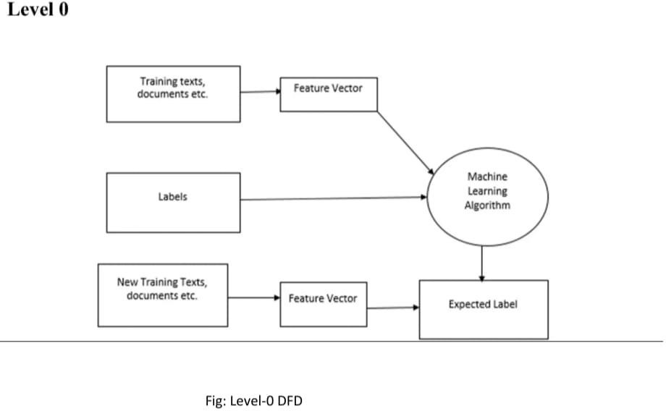

**Fig: 1 Level-0 DFD**

**Level-1 DFD**

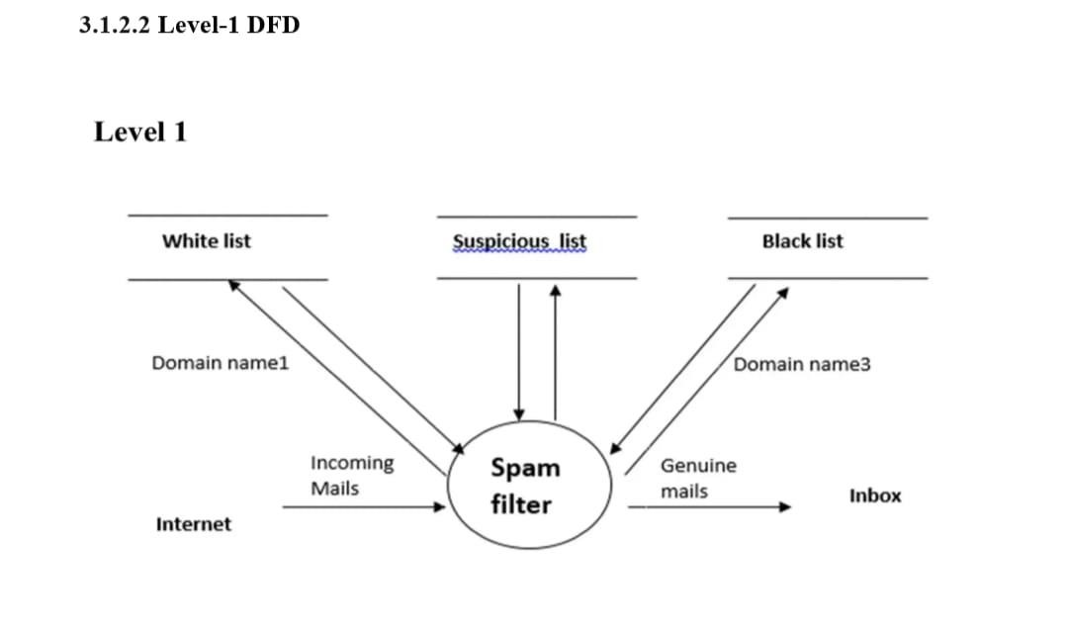

17

**Fig: 2Level-1 DFD**

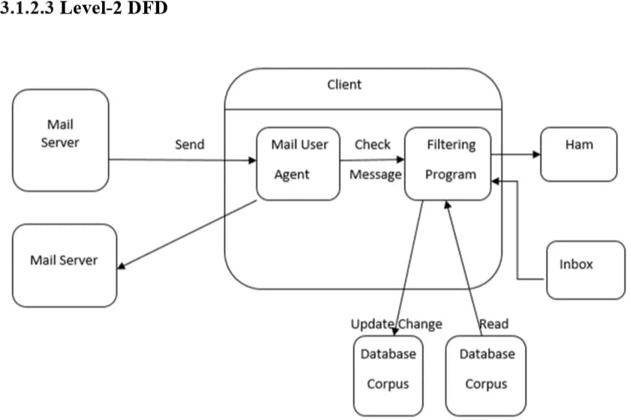

**Fig: 3 Flow Chart**

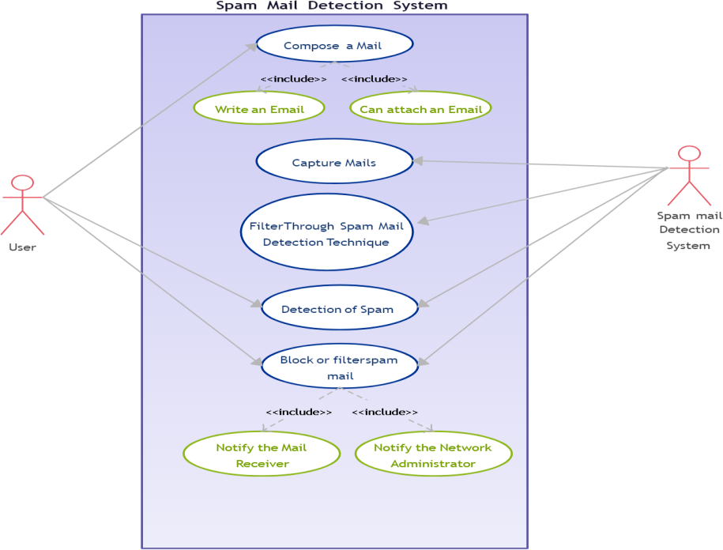

18

* **USE CASE**

### ASSUMPTION AND DEPENDENCIES

Various assumptions and dependencies went into the creation of project in order to ensure that the system works safely and efficiently.

**Assumptions**

Stable Email Protocols:

Assumption: The Advanced Email Spam Classifier System assumes stable and consistent email protocols (e.g., IMAP, SMTP) across different platforms for seamless integration.

Access to Diverse Datasets:

Assumption: Availability of diverse and representative datasets for training machine learning models, assuming accessibility to relevant spam and legitimate email data.

User Cooperation:

Assumption: Users will cooperate with the system by providing accurate feedback on misclassifications, contributing to the adaptive learning mechanism.

Compliance with Regulations:

19

Assumption: The system assumes compliance with data protection and privacy regulations, and necessary legal and regulatory considerations are addressed during development.

Machine Learning Libraries:

Dependency: The system depends on the availability and compatibility of machine learning libraries (e.g., TensorFlow, Scikit-learn) for model development.

Email Platform APIs:

Dependency: Integration with major email platforms relies on the availability and reliability of their APIs for seamless communication.

Security Protocols:

Dependency: The system depends on adherence to security protocols and standards to ensure the confidentiality and integrity of user data.

IT Infrastructure:

Dependency: Availability of a stable and well-maintained IT infrastructure is crucial for the system's deployment and operation.

# CHAPTER 4

**IMPLEMENTATION , TESTING AND MAINTENANCE**

### INTRODUCTION TO LANGUAGES , IDE ,TOOL AND TECHNOLOGIES USED FOR IMPEMENTATION

The development of the Advanced Email Spam Classifier System involves a strategic selection of programming languages, integrated development environments (IDEs), and a suite of tools and technologies. This choice is critical to ensuring the system's efficiency, scalability, and adaptability to the dynamic landscape of email spam detection.

Programming Language:

For the implementation of the system, Python has been chosen as the primary programming language. Python is renowned for its versatility, readability, and extensive support for machine learning libraries, making it an ideal choice for developing robust algorithms and handling data intricacies inherent in spam classification.

Integrated Development Environment (IDE):

The development process will be streamlined using PyCharm as the preferred IDE. PyCharm provides a user-friendly and feature-rich environment for Python development, aiding in code navigation, debugging, and efficient collaboration among developers.

Machine Learning Libraries:

20



The core of the system's intelligence lies in machine learning. TensorFlow and Scikit-learn will be employed for developing and training machine learning models. TensorFlow's flexibility and scalability, coupled with Scikit-learn's comprehensive set of tools, ensure the creation of accurate and adaptive spam classification algorithms.

Natural Language Processing (NLP) Libraries:

To extract meaningful features from email content, Natural Language Processing (NLP) plays a crucial role. The NLTK (Natural Language Toolkit) library in Python will be utilized for its extensive capabilities in processing and analyzing human language dat

Database Management:

For efficient data storage and retrieval, PostgreSQL will serve as the relational database management system. Its ACID compliance and robust features make it suitable for managing diverse datasets involved in training and testing machine learning models.

### CODING STANDARDS OF LANGUAGES USED

When implementing a simulation system for self-driving cars, it is important to follow coding standards to ensure code quality, readability, maintainability, and collaboration. While the specific coding standards may vary depending on the programming language used, here are some general coding practices and standards to consider:

* + - * 1. Consistent Naming Conventions: Use descriptive and meaningful names for variables, functions, and classes. Follow a consistent naming convention, such as camel case or snake case, throughout the codebase. Use uppercase for constants and lowercase for variables and functions.

1. Proper Indentation and Formatting: Use consistent indentation, such as using tabs or spaces, to improve code readability. Follow a consistent code formatting style, including the placement of braces, line length, and spacing. Utilize code formatting tools or IDE features to automatically format the code.
2. Modular and Readable Code: Break down the code into modular components, such as functions or classes, to promote reusability and maintainability. Keep functions and methods concise and focused on specific tasks. Use comments to provide explanations, clarify complex logic, or document important information.
3. Error Handling and Exception Handling: Implement appropriate error handling mechanisms to handle exceptions, errors, and edge cases. Use try-catch blocks or exception handling techniques to gracefully handle exceptions and prevent program crashes.
4. Documentation and Comments: Provide comprehensive documentation, including code comments, to explain the purpose, functionality, and usage of classes, functions, and important code blocks. Document external dependencies, libraries, and APIs used in the codebase. Use inline comments to explain complex logic, assumptions, or potential pitfalls.
5. Testing and Test-Driven Development (TDD): Write unit tests to verify the functionality of individual components or modules. Adopt a test-driven development



21

approach, where tests are written before implementing the actual code. Ensure proper test coverage to catch bugs and regressions.

1. Version Control and Code Collaboration: Utilize a version control system, such as Git, to manage code changes, branching, and collaboration. Follow best practices for committing code, including descriptive commit messages and small, logical commits. Collaborate effectively with other team members through code reviews and constructive feedback.
2. Performance Optimization and Efficiency: Optimize critical code sections for performance, taking into account computational complexity and memory usage. Utilize appropriate data structures and algorithms to improve efficiency. Profile the code to identify bottlenecks and optimize them.
3. Adherence to Language-SpecificCoding Standards: Familiarize yourself with the specific coding standards and best practices of the programming language being used. Follow language-specific guidelines, community conventions, and style guides.

# CHAPTER 5 RESULTS

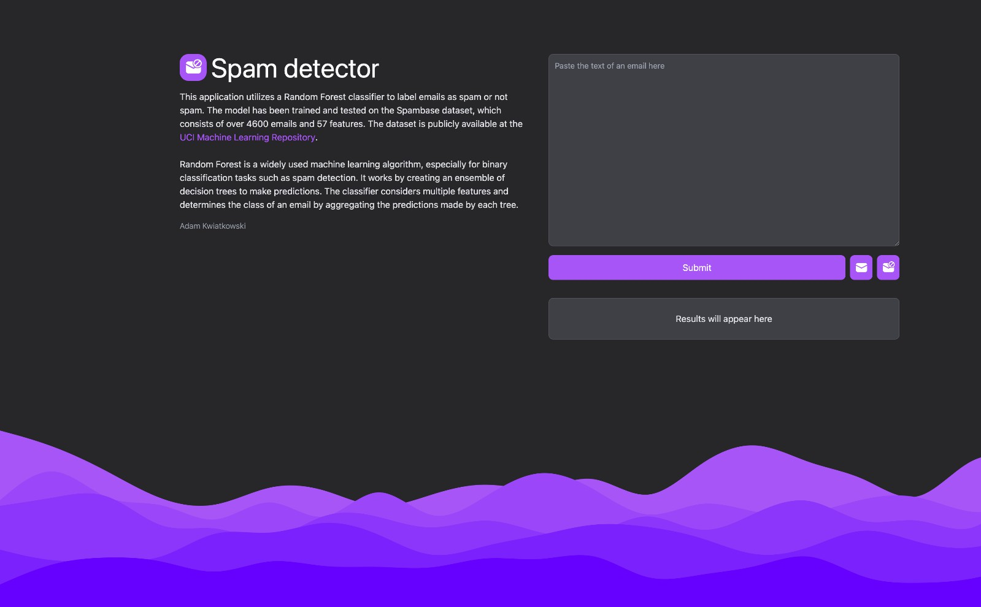

22

23

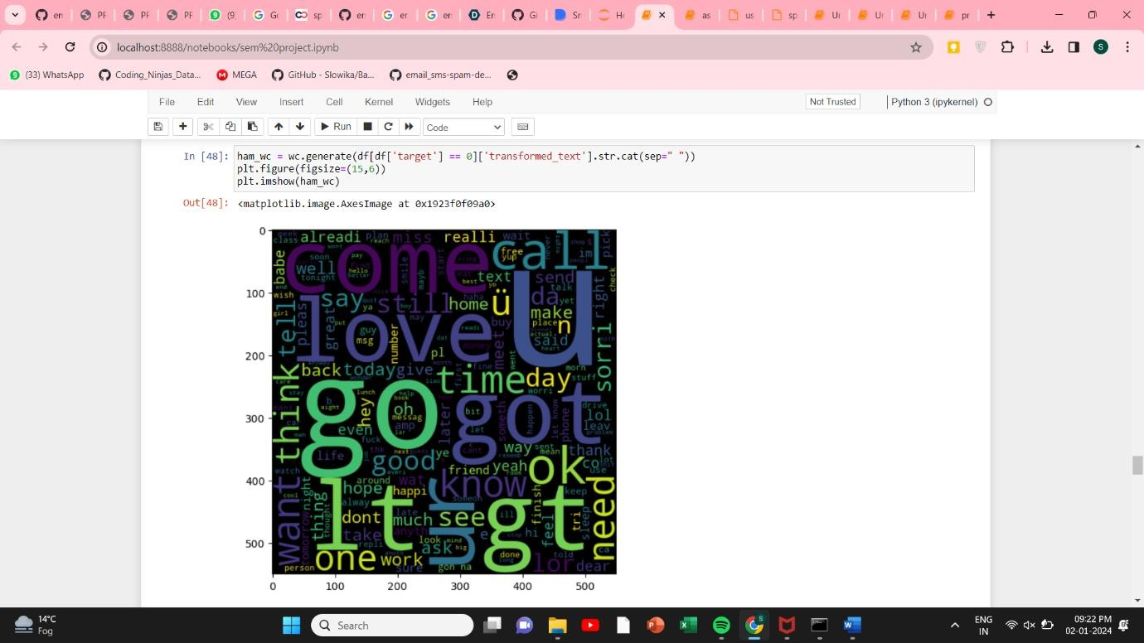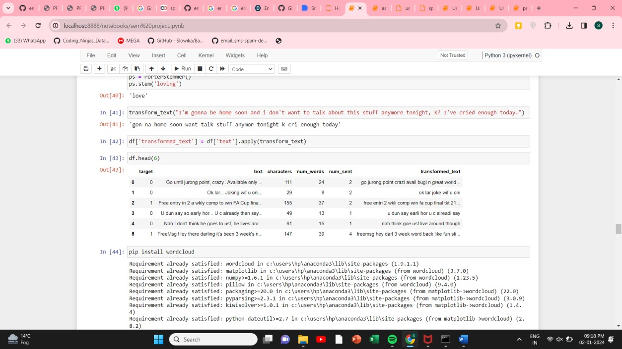

# CHAPTER 6

23



24

**CONCLUSION**

For most cases, the given system works as expected. However, in some cases, it may cause false undesirable behaviour in some conditions. On the simulator side, the car works for the most part and executes the desired operations. All the subsystems are working perfectly fine without any guidance. However, on the hardware side, primarily due to hardware limitations and compute power issues, some lags and undesirable behaviour takes place. This is due to variable lighting conditions, quality, clarity issue of camera due to motion of car. Hence, it may be necessary to refine the model further depending on its use case in order to maximize accuracy. Also, better on-board computer power and high-speed wide-angle cameras may be required to enhance our system performance.

24