INT 404 (ARTIFICIAL INTELLIGENCE)

AI IN VEHICLE COUNTING

REPORT



PROJECT MEMBERS:

|  |  |  |
| --- | --- | --- |
| NAME | REG. NO. | ROLL NO. |
| RITIK VERMA | 12100714 | B66 |
| MANREET | 12109354 | A18 |
| HARSH CHAUDHARY | 12109509 | B42 |

**SUBMITTED TO:**

Ankita Wadhawan: 23891

**1. AI in Vehicle Counting**

Ritik Verma, Manreet, Harsh Chaudhary

Department of Computer Science and Engineering, Lovely Professional University, Phagwara, India

***Abstract***

Artificial intelligence (AI)-based automated vehicle counting is a popular and efficient way to manage traffic flow in urban areas. In this method, photos, or data from passing vehicles are captured using cameras or other sensors, then machine learning algorithms are used to analyze the data to calculate the number of vehicles on the road. Compared to conventional human counting techniques, AI-based vehicle counting has several benefits, including improved accuracy, real-time data processing, and lower labor costs. Additionally, this method can be combined with additional smart city technologies to deliver more complete traffic control solutions. The introduction of AI-based vehicle counting systems does, however, also bring up significant ethical and privacy issues that need to be resolved in order to assure the proper application of these technologies.

In the realm of highway management, intelligent vehicle detection and counting are becoming more and more crucial. However, because vehicles come in a variety of sizes, it might be difficult to detect them, which has an impact on how accurately counts of vehicles are made. This study presents a brand-new high-definition highway vehicle dataset with a total of 57,290 annotated instances in 11,129 photos. The proposed dataset, which offers the whole data foundation for vehicle detection based on deep learning, incorporates annotated microscopic items in the image as opposed to the existing public datasets. The newly proposed segmentation method is significant because it extracts the highway road surface from the image and divides it into a remote area and a proximal area before being used in the proposed vehicle identification and counting system.

In this chapter, various things related to AI has been discussed along with their pros and cons.

**Keywords:** Artificial Intelligence, real-time, machine learning, high-definition

* 1. **What is AI**

Artificial Intelligence (AI) is a multidisciplinary field of study that focuses on creating intelligent machines that can perform tasks that typically require human intelligence, such as visual perception, speech recognition, decision-making, and language translation. AI is achieved through the development of algorithms and computer programs that enable machines to learn from data, reason, and improve their performance over time.

Machine learning, natural language processing, computer vision, robotics, and expert systems are just a few of the subfields that fall under the umbrella of AI. One of the most important aspects of AI is machine learning, which involves instructing computers to learn from data and increase the precision of their outcome predictions. This is accomplished by feeding machines massive amounts of data, which they use to find patterns and create models that may be applied to forecast future events or categorize fresh data.

Numerous industries, including healthcare, banking, transportation, and education, have used AI in some capacity. AI is utilized in the healthcare industry, for instance, to analyze medical images, identify disorders, and create treatment plans. AI is used in finance to spot fraud, forecast stock prices, and streamline trade. AI is applied to the transportation industry to enhance safety, develop autonomous cars, and optimize routes. AI is used in education to personalize learning, evaluate students' progress, and give teachers feedback.

Overall, AI is a rapidly expanding field that has the power to drastically change the way we work and live. AI is likely to become more sophisticated and incorporated into our daily lives as technology develops, opening us fresh possibilities for growth and innovation.

* 1. **Importance of AI**

Artificial Intelligence (AI) has become an essential technology in many industries, from healthcare to finance and transportation. AI has revolutionized the way we live and work, and its importance cannot be overstated. In this report, we will discuss the importance of AI, its benefits, and some of the challenges that need to be addressed.

Here are some of the benefits of AI:

* **Automation:** One of the key benefits of AI is automation. AI algorithms can automate repetitive and mundane tasks, allowing humans to focus on more complex and creative tasks. This increases productivity, reduces errors, and improves the quality of work.
* **Personalization:** AI can personalize products and services based on individual preferences and behaviors. For example, AI algorithms can recommend products to customers based on their past purchases, search history, and social media activity. This improves the customer experience and increases customer loyalty.
* **Efficiency:** AI can improve efficiency in various industries, such as manufacturing, transportation, and logistics. AI algorithms can optimize supply chains, reduce waste, and improve delivery times. This increases profitability and competitiveness.
* **Decision Making:** AI can assist in decision making by providing insights and predictions based on data analysis. For example, AI algorithms can analyze medical records to help doctors diagnose diseases, or analyze financial data to help investors make informed decisions.
  1. **Challenges**

AI has numerous advantages, but it also has certain drawbacks. The ethical and legal ramifications of AI are one of the major challenges. If AI systems are educated on biased data, bias and discrimination may be reinforced. Concerns exist over how AI will affect jobs, privacy, and security. Another difficulty is the opaqueness of some AI algorithms, which makes it challenging to comprehend how judgements are being made.

There are significant challenges associated with the development and deployment of AI. These include:

1. **Lack of Standards:** Because there are currently no international benchmarks for AI development, it is challenging to assess and compare various AI systems. It could become difficult to integrate AI systems with present technology due to a lack of standards that prevent AI systems from becoming compatible.
2. **Data Quality and Availability:** To be trained and become more precise, AI systems need a lot of data. However, the quality and accessibility of data can be a major issue, especially in sectors where data is in short supply or not easily accessible.
3. **Cybersecurity:** AI systems are susceptible to online attacks that jeopardize the security and integrity of data. The prevalence of AI systems will undoubtedly raise the risk of cyberattacks, necessitating the development of strong security measures.
4. **Explainability:** It can be tricky to describe how decisions are made because many AI algorithms are sophisticated and challenging to comprehend. Users may become distrustful and sceptic due to this lack of openness, especially in crucial areas like healthcare and banking.
5. **Regulation:** Because of the rapid development and deployment of AI, regulations have not kept up, leaving a regulatory gap. To ensure that AI is created and deployed in an ethical and responsible manner, there is a need for clear and uniform regulatory frameworks.
   1. **Vehicle Counting**

**1.4.1 What is Vehicle Counting?**

The technique of gathering information on the number of vehicles that pass through a specified location in a specific amount of time is known as vehicle counting. As it offers insights into traffic flow patterns and aids in locating congested regions, this information is crucial for effective traffic management and planning. In this article, we will go through the value of vehicle counting, the drawbacks of manual counting techniques, and the advantages of AI-based vehicle counting systems.

**1.4.2 Importance of Vehicle Counting**

Vehicle counting is essential for traffic management and planning, as it provides valuable data on traffic flow patterns and volume. This information is used to identify areas of congestion and develop strategies to improve traffic flow, reduce travel times, and enhance road safety. Vehicle counting data is also used to inform decisions related to infrastructure investments, such as the construction of new roads and highways.

**1.4.3 Challenges in manual counting methods**

Traditional manual counting methods, such as hand counting and the use of mechanical counters, are time-consuming and labor-intensive. Manual counting methods are also prone to errors, such as double-counting and undercounting, which can result in inaccurate data. Additionally, manual counting methods are not scalable, meaning that they are not suitable for large-scale data collection.

**1.4.4 Benefits**

Vehicle counting systems powered by AI have several advantages over manual counting techniques. These devices do not require manual counting because they automatically capture data using cameras and sensors. As a result, accuracy is increased, errors are decreased, and real-time data is made available for quick decision-making. AI-based vehicle counting systems are suited for wide-scale data collection since they can manage massive volumes of data.

Vehicle counting systems powered by AI can offer more data insights than just the volume of vehicles passing through a particular point. They can recognize the kind of vehicle, its speed, and its direction of travel, for instance. This data can be utilized to determine traffic trends and create plans for enhancing mobility and easing congestion.

* 1. **Implementation**

There are various ways that AI can be used in vehicle counting. Some of the most common methods are:

1. **Methods based on computer vision:** These techniques take pictures of moving vehicles using cameras mounted on the side of the road. Computer vision algorithms are then used to analyze the photos in order to count and identify the vehicles. In order to identify automobiles based on their size, shape, and other characteristics, computer vision algorithms can be taught using supervised learning approaches.
2. **Magnetic Sensors:** To detect approaching automobiles, magnetic sensors can be buried in the road's surface. The magnetic field that sensors produce gets disturbed when a car is nearby. It is possible to gauge the interruption and count the passing vehicles.
3. **Acoustic Sensors:** Acoustic sensors can be used to detect the sound of passing vehicles. The sensors can be placed on the side of the road and used to detect the sound of passing vehicles. The data collected can then be used to count the number of vehicles passing through.
4. **Radio Frequency Identification (RFID):** To track the movement of cars, RFID tags can be mounted to the vehicles. To monitor and count passing cars, RFID scanners can be set up alongside the road. For this technique to work, RFID tags must be installed on every vehicle.
5. **Methods based on GPS:** GPS can be used to monitor a vehicle's motion. Automobiles may be equipped with GPS devices to monitor their location. The number of vehicles going through a specific location can then be calculated using the data gathered.

In general, all these methods relate to the AI model later. The basic model for AI can be implemented in either PYTHON or JAVASCRIPT depending upon the requirement.

The libraries involved in making of this model are COCO SSD, OPEN CV etc. These APIs are freely available on the internet which can further be used to implement the detection and counting mechanism.

**1.5.1 COCO SSD for OpenCV:**

The COCO SSD for OpenCV is a pre-trained deep neural network model that can detect objects in real-time. This model is based on the SSD architecture and has been trained on the COCO dataset, which consists of over 330,000 images and 2.5 million object instances. The COCO dataset contains 80 object categories, including vehicles.

To implement the COCO SSD for vehicle detection using OpenCV, the following steps need to be followed:

* Install OPENCV
* Download the COCO-SSD model
* Load the model
* Read the input images
* Prepare the input image
* Detect objects in input image

The COCO SSD model can also be adjusted for particular use scenarios to enhance its vehicle detection precision. For instance, the model can be trained using a dataset of photos from the location where the system is intended to detect automobiles. The model can be fine-tuned to understand elements unique to that area, which will increase its ability to recognize cars.

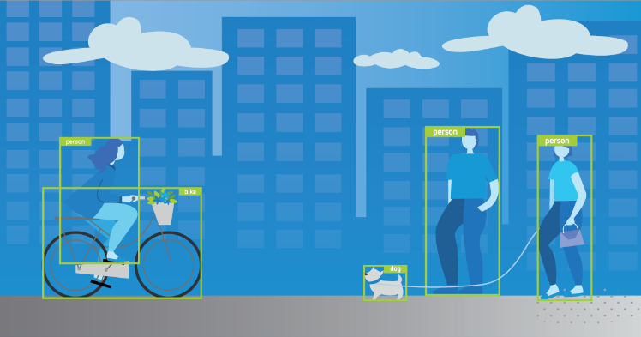

Img a. COCO-SSD

**1.5.2 Vehicle detection using R-CNN**

R-CNN (Region-based Convolutional Neural Network) is an object detection algorithm that uses a combination of selective search and deep convolutional neural networks (CNNs) for object detection. R-CNN has been successfully used for detecting a wide range of objects, including vehicles.

The implementation of R-CNN for vehicle detection involves the following steps:

* **Gathering and annotating the dataset:** To train the R-CNN model, a sizable dataset of photos with cars is needed. Bounding boxes around the cars should be annotated in the dataset.
* **R-CNN model training**: The annotated dataset is used to train the R-CNN model. Based on the vehicle dataset, a pre-trained CNN model is adjusted during training, and a linear SVM (Support Vector Machine) is developed using CNN features.
* **Object proposal generation:** The selective search algorithm is used to generate region proposals for the input image.
* **Feature extraction:** The CNN model is used to extract features from each region proposal.
* **Classification:** The SVM is used to classify each region proposal as a vehicle or not.
* **Non-maximum suppression:** Overlapping region proposals are merged into a single detection.
* **Visualization:** The final detections are visualized by drawing bounding boxes around the detected vehicles.

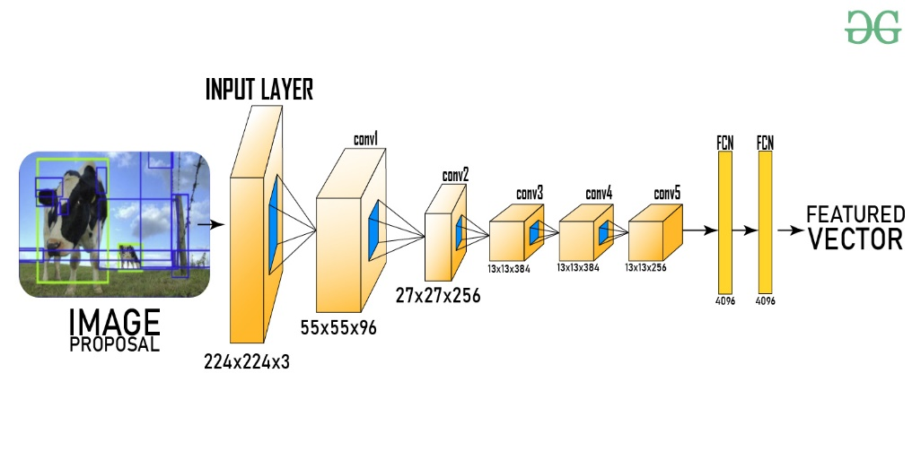

Img b. R-CNN

**1.5.3 Vehicle detection using YOLO**

Another well-liked object detection technique that is renowned for its quickness and precision is YOLO (You Only Look Once). A single-stage detector called YOLO may find several items in a single pass.

The implementation of YOLO for vehicle detection involves the following steps:

* **Gathering and annotating the dataset:** To train the YOLO model, a sizable dataset of photos with cars is needed. Bounding boxes around the cars should be annotated in the dataset.
* **YOLO model training:** The annotated dataset is utilized to train the YOLO model. The input image is divided into a grid during training, and each grid cell's bounding box and class probability are predicted.
* **Non-maximum suppression:** Overlapping bounding boxes are merged into a single detection.
* **Visualization:** The final detections are visualized by drawing bounding boxes around the detected vehicles.

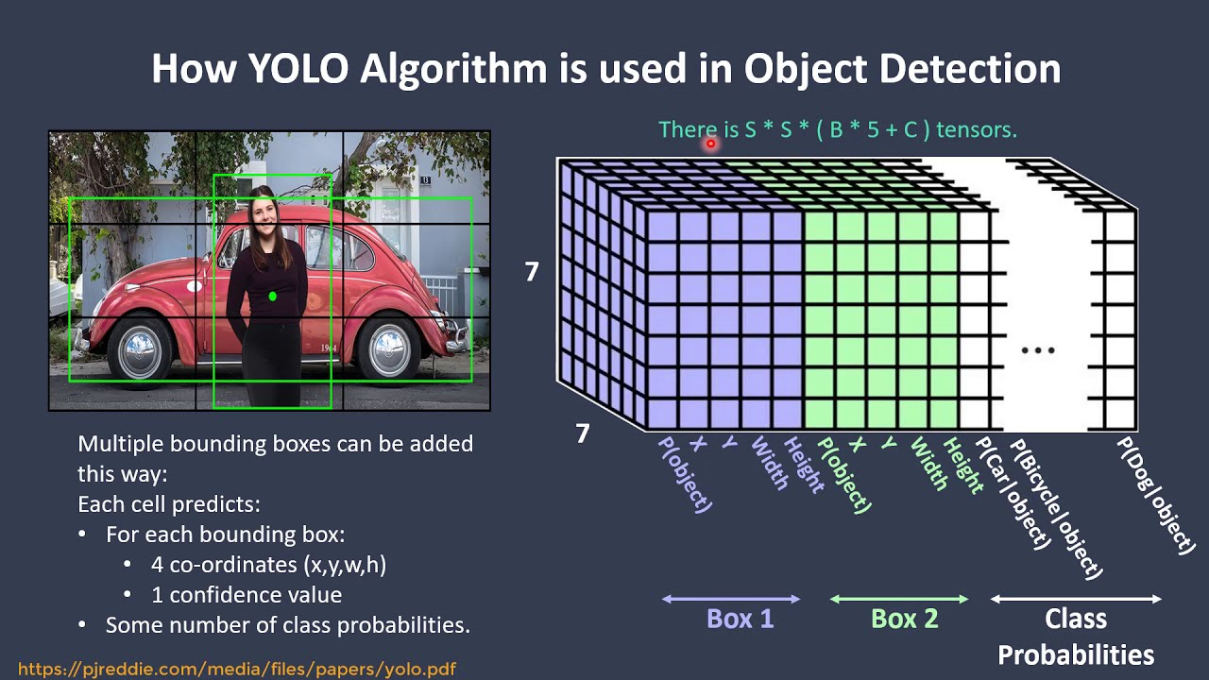

Img c. YOLO

**1.5.4 Project**

We made a basic website using HTML, CSS and, JAVASCRIPT. Which emphasizes on the contrast of AI. In the website, all the basics of AI are covered. We also implemented the object detection model which is the base for detecting the vehicles. The model we implemented uses the pre-trained model that is the COCO-SSD model. With this model, we can easily detect real-life objects such as cars, animals, person etc.

**1.5.5 Screenshots of the project**

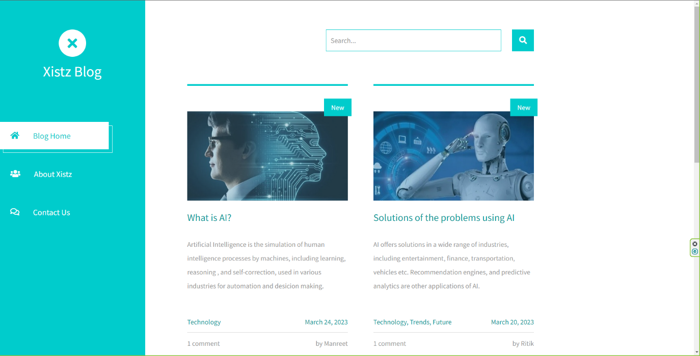

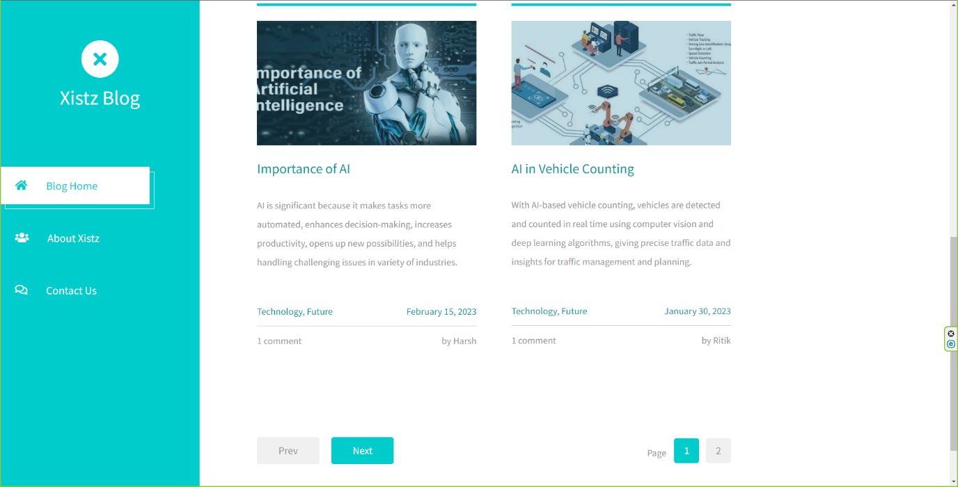

a. home page





b. About Page

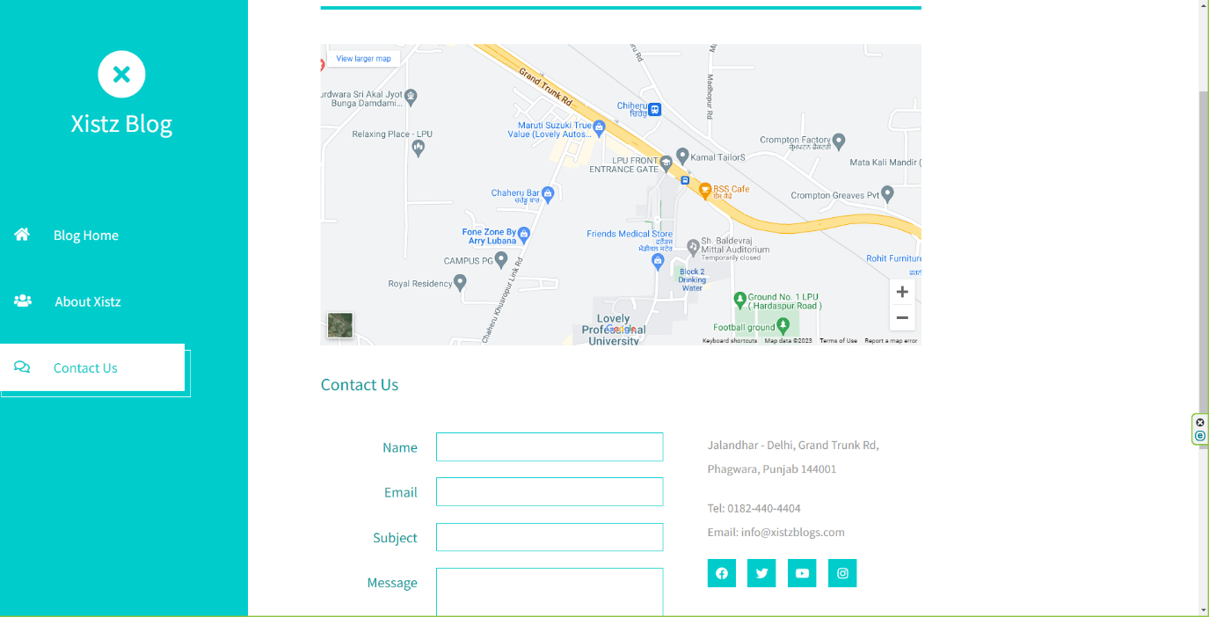

c. Contact Page

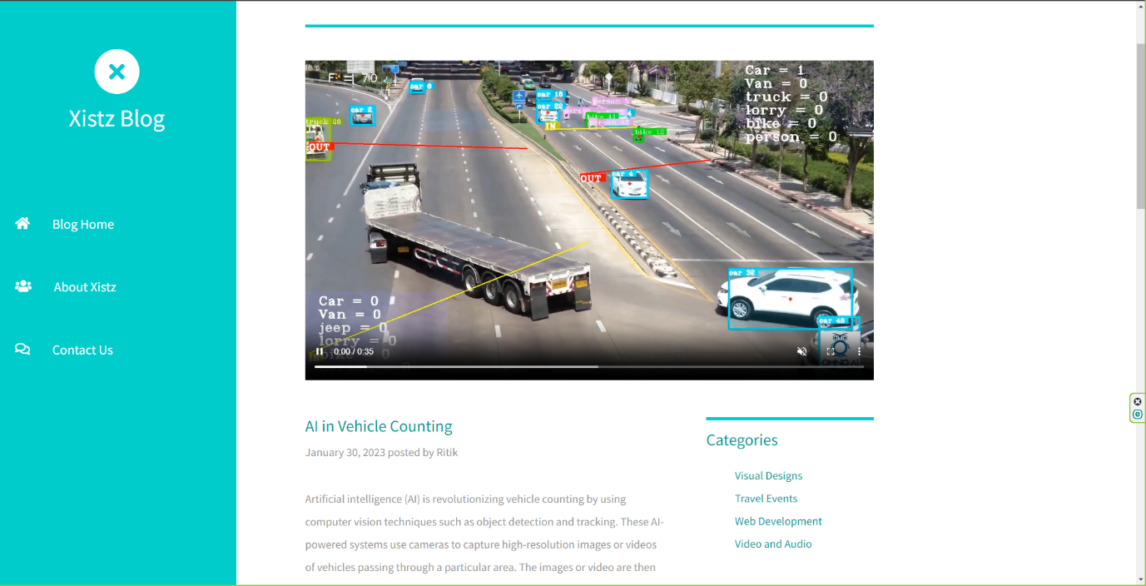

d. Blog Page

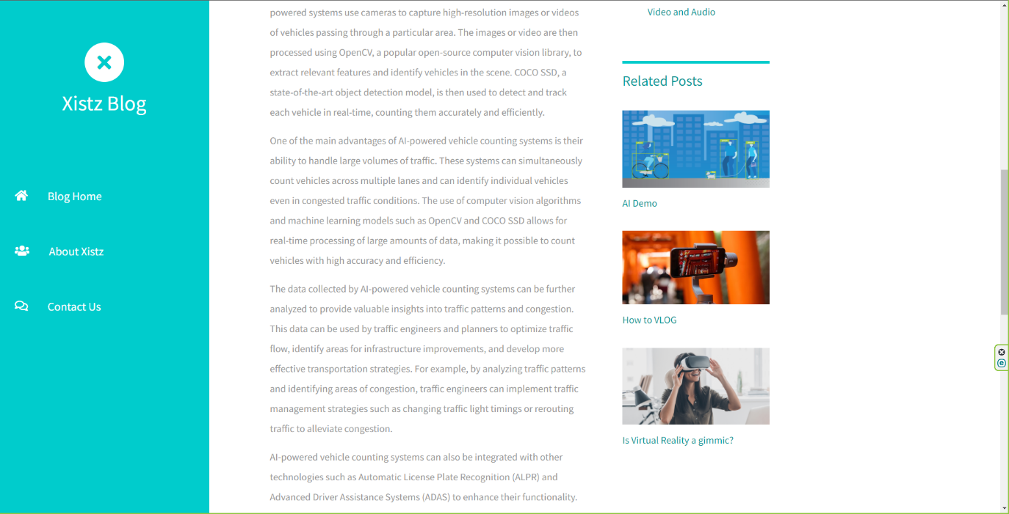

d. Blog Page

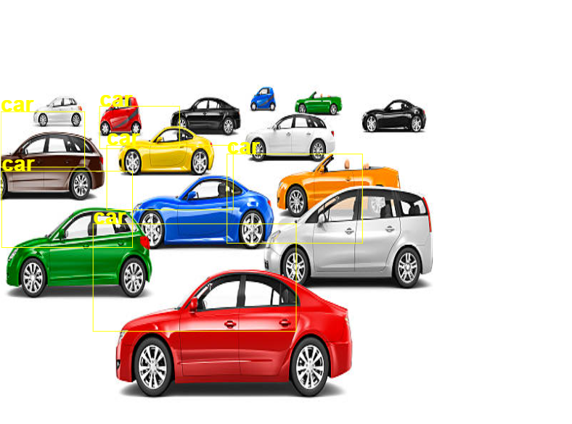

e. Object Detection

**References**

1. <https://towardsdatascience.com/r-cnn-fast-r-cnn-faster-r-cnn-yolo-object-detection-algorithms-36d53571365e>
2. <https://www.npmjs.com/package/@tensorflow-models/coco-ssd>
3. <https://www.hindawi.com/journals/jat/2021/4438861/>
4. <https://etrr.springeropen.com/articles/10.1186/s12544-019-0390-4>