PROJECT DOCUMENTATION
Sales Insights Dashboard

Tableau | MySQL | SQL | ETL | Data Cleaning

Prepared by: Ritik Verma
MCA | Data Analyst
ritikverma0333@gmail.com

1. Project Overview

This project builds an end-to-end Sales Insights Dashboard for a computer hardware business operating across multiple regions of India. The business was struggling to track sales performance due to a fragmented data environment — regional managers reported different numbers, and the leadership had no single source of truth. The goal was to connect a MySQL sales database directly to Tableau, clean the raw data, and build an interactive dashboard that answers key business questions at a glance.

1.1 Problem Statement
The sales director had no clear visibility into which markets were performing, which products were driving revenue, and why overall revenue was declining. Verbal reports from regional managers were inconsistent and optimistic. A data-driven dashboard was needed to give the leadership team reliable, unfiltered insights.

1.2 Core Business Questions
- Which markets (cities) generate the most revenue, and which are declining?
- Who are the top 5 customers driving the majority of sales?
- Which products are the top revenue contributors?
- How has revenue trended month-over-month and year-over-year?
- What is the total revenue and total quantity sold in any given period?

1.3 Key Metrics Tracked
Metric | Description
Total Revenue | Sum of all normalized sales amounts for the selected period
Total Sales Quantity | Sum of units sold across all transactions
Revenue by Market | Breakdown of revenue contribution per city/region
Revenue Trend | Monthly revenue line chart showing growth or decline over time
Top 5 Customers | Ranked list of customers by total revenue generated
Top 5 Products | Ranked list of products by total revenue contribution

2. Database Schema — MySQL (sales)

The project uses a MySQL database named 'sales' containing four tables. Understanding this schema is critical as all SQL queries and Tableau connections are built on top of it.

Database Name: sales — MySQL 8.0.22 | Dump Date: 2020-12-12

2.1 Table: transactions
The central fact table. Every row represents one sales transaction.
Column | Description / Notes
product_code | Product identifier (e.g., Prod316, Prod318). Foreign key to products table
customer_code | Customer identifier (e.g., Cus001, Cus006). Foreign key to customers table
market_code | Market/city code (e.g., Mark001=Chennai, Mark004=Delhi). Foreign key to markets table
order_date | Date of the transaction in YYYY-MM-DD format
sales_qty | Number of units sold in the transaction
sales_amount | Revenue amount in INR (or USD — requires normalization before aggregation)
currency | Currency of the transaction — 'INR\r' or 'USD\r' (note: carriage return suffix is a data quality issue)

2.2 Table: customers
Column | Description
customer_code | Unique customer ID (e.g., Cus001 through Cus038)
custmer_name | Customer company name
customer_type | Type: 'Brick & Mortar' (physical store) or 'E-Commerce' (online)

2.3 Table: markets
Column | Description
markets_code | Market code (e.g., Mark001 through Mark015)
markets_name | City name (e.g., Chennai, Delhi NCR, Mumbai, Ahmedabad, Bhopal, etc.)
zone | Geographic zone: North, South, Central — blank for Paris and New York (irrelevant markets)

2.4 Table: date

Column | Description
date | Full date (YYYY-MM-DD) — primary join key with transactions.order_date
cy_date | Calendar year date
year | Year extracted (2017, 2018, 2019, 2020)
month_name | Full month name (January, February, etc.)
date_yy_mmm | Formatted date label for display (e.g., '20-Jan')

3. SQL Exploration — Data Discovery

Before building any Tableau visuals, the raw MySQL database is explored via SQL queries to understand data quality, scope, and the key business metrics.

3.1 Initial Data Discovery Queries

View all transaction records
SELECT * FROM sales.transactions;

Count total number of transactions
SELECT COUNT(*) FROM sales.transactions;

Filter transactions for a specific market — Chennai (Mark001)
SELECT * FROM sales.transactions WHERE market_code = 'Mark001';

Find distinct product codes sold in Chennai
SELECT DISTINCT product_code FROM sales.transactions WHERE market_code = 'Mark001';

Find all USD transactions (the currency anomaly)
SELECT * FROM sales.transactions WHERE currency = 'USD';

3.2 Revenue Validation Queries

Total revenue for the year 2020
SELECT SUM(sales.transactions.sales_amount)
FROM sales.transactions
INNER JOIN sales.date ON sales.transactions.order_date = sales.date.date
WHERE sales.date.year = 2020;

Total revenue for Chennai (Mark001) in 2020
SELECT SUM(sales.transactions.sales_amount)
FROM sales.transactions
INNER JOIN sales.date ON sales.transactions.order_date = sales.date.date
WHERE sales.date.year = 2020 AND sales.transactions.market_code = 'Mark001';

All 2020 transactions with date details
SELECT sales.transactions.*, sales.date.*
FROM sales.transactions
INNER JOIN sales.date ON sales.transactions.order_date = sales.date.date
WHERE sales.date.year = 2020;

4. Data Cleaning & ETL

Four critical data quality issues were identified during SQL exploration. Each is handled before or during the Tableau data source connection phase.

4.1 Issue 1 — Garbage sales_amount Values
Problem: Transactions with sales_amount = 0 or sales_amount = -1 exist in the dataset

Fix — Apply a Data Source Filter in Tableau:
[sales_amount] > 0

4.2 Issue 2 — Irrelevant Markets (Paris & New York)
Problem: The markets table contains 'Paris' and 'New York' — the business only operates in India

Fix — Filter markets where zone is not blank:
[zone] != ''

4.3 Issue 3 — Currency Normalization (Most Critical)
Problem: sales_amount is stored in both INR and USD. Direct SUM() gives wrong totals

Fix — Create a Calculated Field in Tableau called 'Normalized Revenue':
IF [Currency] == "USD" THEN [Sales Amount] * 74
ELSE [Sales Amount] END

Extended version (handles carriage return suffix in currency strings):
IF [Currency] == "USD" OR [Currency] == "USD#(cr)" THEN [Sales Amount] * 74
ELSE [Sales Amount] END

4.4 Issue 4 — Carriage Return in Currency Field
Problem: Currency values appear as 'INR\r' and 'USD\r' instead of clean 'INR' and 'USD'

This is a known data export artifact from the MySQL dump. The Normalized Revenue formula handles this by checking for both string variants.

5. Tableau Calculated Fields

5.1 Revenue Measures

Normalized Revenue
IF [Currency] == "USD" OR [Currency] == "USD#(cr)" THEN [Sales Amount] * 74
ELSE [Sales Amount] END

Total Revenue
SUM([Normalized Revenue])

Total Sales Quantity
SUM([Sales Qty])

5.2 Profitability & Contribution Measures

Profit Margin %
SUM([Profit Margin Amount]) / SUM([Normalized Revenue])

Revenue Contribution % by Market
SUM([Normalized Revenue]) / TOTAL(SUM([Normalized Revenue]))

6. Dashboard Architecture & Visuals

The finalized Tableau dashboard uses a single-page layout designed for immediate executive readability, with year and month slicers at the top for time-period filtering.

6.1 Dashboard Screenshot

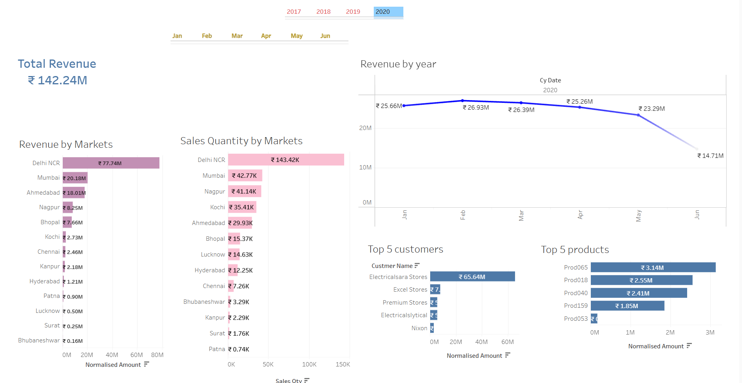
Figure 1: Sales Insights Dashboard — Tableau (2020, Jan–Jun) | Total Revenue: ₹142.24M

6.2 Key Observations from the Dashboard
- Total Revenue for 2020 (Jan–Jun): ₹142.24M — filtered view showing first half of year
- Delhi NCR dominates at ₹77.74M revenue — more than 3× the next market (Mumbai at ₹20.18M)
- Delhi NCR also leads in sales quantity at 143.42K units, confirming it's a true volume market
- Revenue trend declining sharply from May (₹25.26M) to June (₹14.71M) — a critical business concern
- Electricalsara Stores is the top customer at ₹65.64M — massive revenue concentration risk
- Prod065 is the top product at ₹3.14M, followed by Prod018 (₹2.55M) and Prod040 (₹2.41M)

6.3 Visual Components
Visual Element | Details from Dashboard
Total Revenue KPI Card | ₹142.24M for 2020 (Jan–Jun) — filtered via year/month slicers at top
Revenue by Markets (Bar) | 14 markets shown; Delhi NCR ₹77.74M, Mumbai ₹20.18M, Ahmedabad ₹18.01M
Sales Qty by Markets (Bar) | Delhi NCR 143.42K, Mumbai 42.77K, Nagpur 41.14K, Kochi 35.41K
Revenue by Year (Line Chart) | 2020 monthly trend: Jan ₹25.66M → peak Mar ₹26.93M → drop Jun ₹14.71M
Top 5 Customers | Electricalsara Stores, Excel Stores, Premium Stores, Electricalslytical, Nixon
Top 5 Products | Prod065 ₹3.14M, Prod018 ₹2.55M, Prod040 ₹2.41M, Prod159 ₹1.85M, Prod053

7. Market Code Reference

Market Code | City / Region
Mark001 | Chennai
Mark002 | Mumbai
Mark003 | Ahmedabad
Mark004 | Delhi NCR
Mark005 | Kochi
Mark006 | Internal/Test — sales_amount = 0, filtered out
Mark007 | Bhopal
Mark008 | Nagpur
Mark009 | Surat
Mark010 | Patna
Mark011 | Hyderabad
Mark012 | Lucknow
Mark013 | Bengaluru / Bhubaneshwar
Mark014 / Mark015 | Paris / New York (filtered out — outside India)

8. Tools & Technologies Used

Tool / Technology | Purpose in This Project
MySQL 8.0 | Source database — stores all raw sales transactions, customers, markets, and date data
SQL | Data exploration, metric validation, and identifying data quality issues before Tableau
Tableau Desktop | Primary visualization tool — connects to MySQL, applies ETL, builds all dashboard visuals
Tableau Calculated Fields | Currency normalization, contribution %, KPI measures
Tableau Data Source Filters | Filtering zero/negative sales amounts and non-Indian markets
GitHub | Version control and portfolio documentation

— End of Documentation —
Ritik Verma • ritikverma0333@gmail.com • linkedin.com/in/ritik-verma-253614249/

