pragma solidity ^0.8.10;

contract lab_evaluation {

    uint[] public arr;

    function delete_el(uint index) public {

        require(index < arr.length, "index out of bound");

        for (uint i = index; i < arr.length - 1; i++) {

            arr[i] = arr[i + 1];

        }

        arr.pop();

    }

function update_el(uint index, uint val) public {

        // require(index < arr.length, "index out of bound");

        arr[index] = val;

    }

function get(uint i) public view returns(uint){

    return arr[i];

    }

    function test() external {

        arr = [10, 20, 30, 40, 50];

        delete_el(2);

        // [1, 2, 4, 5]

        assert(arr[0] == 10);

        assert(arr[1] == 20);

        assert(arr[2] == 40);

        assert(arr[3] == 50);

        assert(arr.length == 4);

        arr = [1];

        delete_el(0);

        // []

        assert(arr.length == 0);

get(2);

arr = [10, 20, 30, 50];

        update_el(2, 40);

        // [1, 2, 4, 5]

        assert(arr[0] == 10);

        assert(arr[1] == 20);

        assert(arr[2] == 40);

        assert(arr[3] == 50);

        assert(arr.length == 4);

    }

}

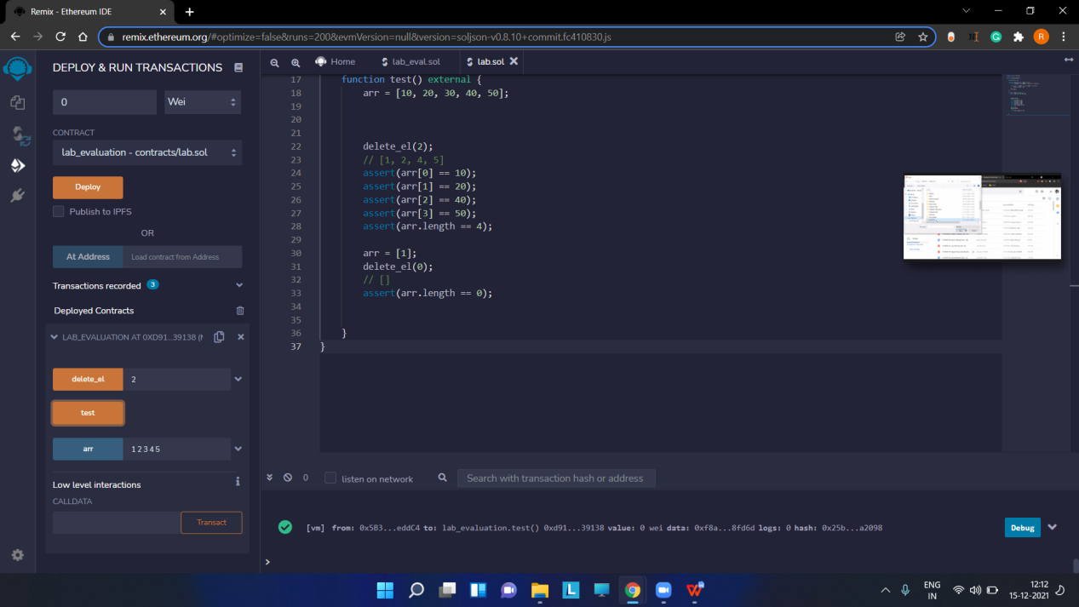

delete

Update

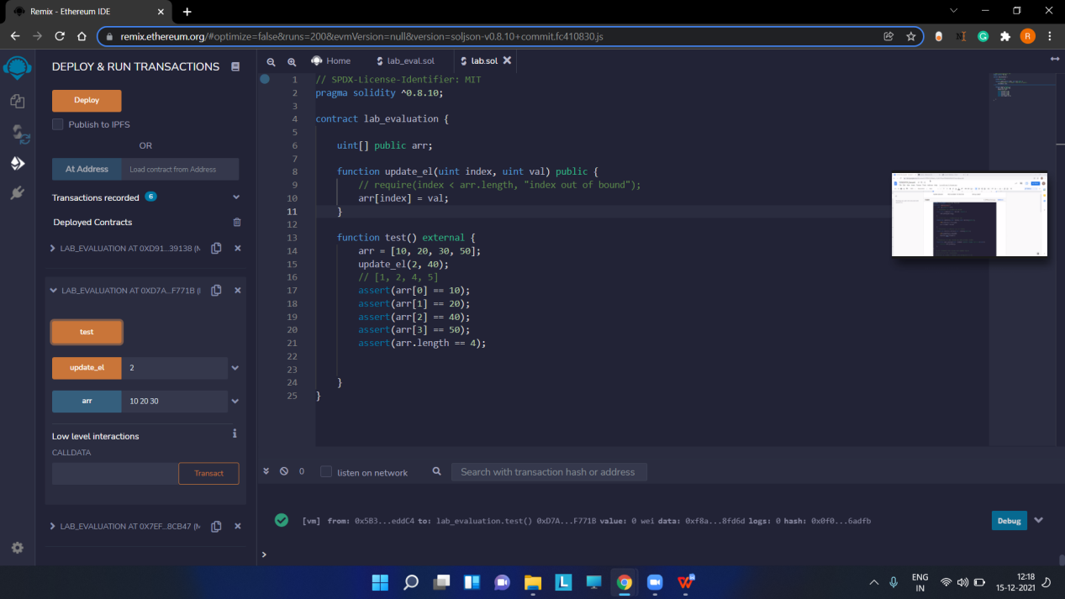

Get

