


A
Project Report
on
NEXUS
submitted as partial fulfillment for the award of

BACHELOR OF TECHNOLOGY
DEGREE
SESSION 2025-26
in
Computer Science Engineering
By
Ritiwesh Bhardwaj (2200290100133)
Neha Singh (2200290100108)
Manya Jain (2200290100100)
Gun Singhal (2200290100070)

Under the supervision of
Ms. Mani Dwivedi
KIET Group of Institutions, Ghaziabad
Affiliated to
Dr. A.P.J. Abdul Kalam Technical University, Lucknow

(Formerly UPTU)
May, 2026

DECLARATION

We hereby declare that this submission is our own work and that, to the best of our knowledge and belief, it contains no material previously published or written by another person nor material which to a substantial extent has been accepted for the award of any other degree or diploma of the university or other institute of higher learning, except where due acknowledgment has been made in the text.

Date | Name | Roll No. | Signature
 | Ritiwesh Bhardwaj | 2200290100133
 | Neha Singh | 2200290100108
 | Manya Jain | 2200290100100
 | Gun Singhal | 2200290100070

CERTIFICATE

This is to certify that the Project Report entitled “NEXUS”, which is submitted by Ritiwesh Bhardwaj, Neha Singh, Manya Jain and Gun Singhal in partial fulfilment of the requirement for the award of degree B. Tech. in Department of Computer Science & Engineering of Dr
A.P.J. Abdul Kalam Technical University, Lucknow, is a record of the candidate's own work carried out by them under my supervision. The matter embodied in this report is original and has not been submitted for the award of any other degree.

Ms. Mani Dwivedi Dr Vineet Sharma
Assistant Professor, CSE Dean CSE

Date:

ACKNOWLEDGEMENT

It gives us a great sense of pleasure to present the report of the B. Tech Project undertaken during
B. Tech. Final Year. We owe special debt of gratitude to Ms. Mani Dwivedi, Department of Computer Science & Engineering, KIET, Ghaziabad, for her constant support and guidance throughout the course of our work. Her sincerity, thoroughness and perseverance have been a constant source of inspiration for us. It is only her cognizant efforts that our endeavors have seen light of the day.
We also take the opportunity to acknowledge the contribution of Dr. Vineet Sharma, Dean of the Department of Computer Science & Engineering, KIET, Ghaziabad, for his full support and assistance during the development of the project. We also do not like to miss the opportunity to acknowledge the contribution of all the faculty members of the department for their kind assistance and cooperation during the development of our project.

Date | Name | Roll No. | Signature
 | Ritiwesh Bhardwaj | 2200290100133
 | Neha Singh | 2200290100108
 | Manya Jain | 2200290100100
 | Gun Singhal | 2200290100070

ABSTRACT
The rapid growth of digital technologies and the increasing dependence on computers in daily life have created a strong demand for intelligent systems that can simplify and enhance human–computer interaction. Virtual assistants have emerged as one of the most promising solutions in this domain, enabling users to interact with systems using natural inputs such as voice and visual cues instead of traditional input devices. In this context, the present project introduces NEXUS, a multifunctional AI-based virtual assistant designed specifically for desktop environments, with the objective of providing a seamless, efficient, and intelligent user experience.

NEXUS is inspired by advanced assistant systems like J.A.R.V.I.S., aiming to combine multiple intelligent features into a single unified platform. Unlike conventional virtual assistants that primarily focus on mobile or cloud-based ecosystems, NEXUS emphasizes local processing, system-level control, and enhanced customization for desktop users. The system integrates a variety of advanced functionalities, including speech recognition for voice-based interaction, face recognition for personalized user engagement, automated task execution, real-time information retrieval such as weather updates and news, and continuous system monitoring for performance tracking. These features collectively contribute to creating a smart, responsive, and interactive digital assistant capable of adapting to diverse user requirements.

The development of NEXUS is carried out using Python as the core programming language due to its extensive support for artificial intelligence and machine learning applications. Various libraries and tools such as OpenCV for computer vision, Speech Recognition for voice input processing, pyttsx3 for text-to-speech conversion, and multiple web APIs for real-time data retrieval have been utilized to ensure robust functionality. The system follows a modular architecture, where different components such as input processing, command interpretation, automation, and output generation operate cohesively while maintaining scalability and flexibility. This modular approach not only simplifies development and debugging but also allows future enhancements and feature integration without significant restructuring.

Furthermore, NEXUS addresses several limitations observed in existing virtual assistants, particularly their dependency on cloud services, limited desktop integration, and restricted access to system-level operations. By focusing on a local-first approach, NEXUS enhances data privacy, reduces latency, and provides better control over system resources. The assistant is capable of executing tasks such as launching applications, performing web searches, interacting with online platforms, and monitoring CPU, memory, and battery usage, thereby acting as a comprehensive productivity tool for users.

The system has been designed keeping in mind a wide range of users, including students,

developers, and professionals, who can benefit from automation and intelligent assistance in their daily tasks. By reducing manual effort and enabling hands-free interaction, NEXUS improves efficiency, accessibility, and overall user experience. Additionally, the inclusion of a web-based interface further enhances usability by allowing users to interact with the assistant remotely through a browser-based control panel.

In conclusion, NEXUS represents a significant step toward the development of intelligent, customizable, and privacy-oriented desktop virtual assistants. It demonstrates how the integration of artificial intelligence, machine learning, and automation technologies can transform traditional computing into a more interactive and user-friendly experience. The project not only highlights the practical implementation of AI-driven systems but also opens opportunities for future advancements in smart assistants, including improved natural language processing, offline capabilities, and enhanced personalization features

TABLE OF CONTENTS Page No.

DECLARATION……………………………………………………………………. ii
CERTIFICATE……………………………………………………………………… iii
ACKNOWLEDGEMENTS…………………………………………………………. iv
ABSTRACT………………………………………………………………………..... v
LIST OF FIGURES…………………………………………………………………. xi
LIST OF TABLES…………………………………………………………………… xii
LIST OF ABBREVIATIONS………………………………………………………... xiii
CHAPTER 1 (INTRODUCTION)………………………………………………….. 1
  - Introduction of the problem……………………………………………………… 1
  - Objectives……………………………………………………..………………….. 3
  - Scope of the project………………………………………………………………. 4
CHAPTER 2 (LITERATURE RIVIEW)……………………………………………. 6
  - Introduction to Literature Review ……………………………………………… 6
  - Existing Virtual Assistants .……………………………………………………… 6
  - Open-Source and Desktop-Based Assistants …………………………………… 7
  - Speech Recognition Technology………………………………………………….. 8
  - Computer Vision and Face Recognition………………………………………….. 8
  - Automation and System Control………………………………………………….. 9
  - Limitations of Existing Systems………………………………………………… 9
  - Comparative Analysis of Existing Systems……………………………………. 9
  - Research Gap……………………………………………………………………. 10
  - Summary……………………………………………………………….……….. 10
CHAPTER 3 (PROPOSED METHODOLOGY) …........................................................ 11
  - Introduction……………………………………………………………………….. 11
  - System Overview…………………………………………………………………. 11
  - Requirement Analysis……………………………………………………………. 12
    - Functional Requirements………………………………………………….. 13
    - Non-Functional Requirements……………………………………………. 13
  - Technology Stack………………………………………………………………… 13
  - Module-Based System Design.…………………………………………………... 14
  - Input And Recognition Module.…………………………………………………. 14
  - Command Processing Module.…………………………………………………... 16
  - Automation And Api Integration Module……………………………………….. 16
  - System Monitoring Module………………………………………………………. 16
  - Output And Feedback Module…………………………………………………… 17
  - Web Interface Module……………………………………………………………. 17
  - System Integration……………………………………………………………….... 18
  - Working Of The System………………………………………………………….. 18
  - Testing And Optimization………………………………………………………… 19
  - Summary…………………………………………………………………………... 19
CHAPTER 4 (RESULTS AND DISCUSSION)………………………………………... 20
  - Introduction…………………………………………………………………………… 20
  - Testing Methodology…………………………………………………………………. 20
    - Unit Testing…………………………………………………………………. 20

    - Integration Testing………………………………………………………….. 20
    - System Testing……………………………………………………………… 21
  - Functional Validation…………………………………………………………………. 21
    - Voice Command Processing …………………………………………………… 21
    - Face Recognition Performance…………………………………………………….. 21
    - Automation Task…………………………………………………………………… 21
    - Real-Time Data Retrieval 21
    - System Monitoring 21

  - System Working Demonstration… 22

    - Code Execution… 22

    - Homepage Interface 22

    - Assistant Interaction Interface 23

    - Command Execution Output… 24

    - Face Recognition Output 25
  - Performance Evaluation 26
  - Response Time Analysis 27
  - Resource Utilization Analysis 28
  - Accuracy Analysis 29
  - User Experience Analysis 30
  - Discussion of Results 31
  - Limitations of the System 31
  - Summary 32

CHAPTER 5 (CONCLUSIONS AND FUTURE SCOPE) 33

  - Introduction…………………………………………………………………………. 33
  - Conclusion………………………………………………………………………………. 33
  - Future Scope……………………………………………………………………………. 34
    - Offline Functionality…………………………………………………………… 34

    - Advanced Natural Language Processing……………………………………… 34
    - Enhanced Face Recognition 34
    - Cross-Platform Support 34
    - Integration with IoT Devices………………………………………………….. 34
    - Improved Security Features 35
    - Machine Learning for Personalization 35
    - Mobile Application Integration 35
  - Final Remarks 35

REFERENCES…………………………………………………………………… 36
APPENDEX1……………………………………………………………………….... 37

LIST OF FIGURES

Figure No. | Description | Page No.
Figure 1.1 | System architecture of NEXUS | 4
Figure 3.1 | Overall system architecture | 12
Figure 3.2 | Voice command workflow | 15
Figure 3.3 | Web interface interaction | 17
Figure 3.4 | System workflow diagram | 18
Figure 4.1 | Backend Code Implementation of NEXUS System | 22
Figure 4.2 | Homepage Interface of NEXUS System | 23
Figure 4.3 | Assistant Interaction Interface | 24
Figure 4.4 | Command Execution using Voice Input | 25
Figure 4.5 | Face Recognition Detection Output | 26
Figure 4.6 | Performance Indicators of NEXUS | 27

LIST OF TABLES

Table. No. | Description | Page No.
Table 1.1 | Objectives and Functional Areas of NEXUS | 3
Table 2.1 | Comparative analysis of virtual assistants | 10
Table 3.1 | System monitoring parameters | 16
Table 4.1 | Response Time Analysis | 28
Table 4.2 | Resource utilization | 29
Table 4.3 | Accuracy Analysis | 30

LIST OF ABBREVIATIONS

Abbreviations | Full Form
AI | Artificial Intelligence
ML | Machine Learning
NLP | Natural Language Processing
API | Application Programming Interface
GUI | Graphical User Interface
CPU | Central Processing Unit
RAM | Random Access Memory
IoT | Internet of Things
TTS | Text-to-Speech
STT | Speech-to-Text
CV | Computer Vision

CHAPTER 1 INTRODUCTION

INTRODUCTION OF THE PROBLEM
In the modern times of rapid digitalization, computer systems have become an integral part of everyday human life. Virtually every task today depends on computing devices, from learning and working to communicating and entertaining. However , despite this technological advancement , the interaction between humans and computers is still largely reliant on traditional input devices such as keyboards and mice , and touch interfaces . Such traditional approaches are effective, but they require manual effort and do not provide a natural and intuitive interaction experience.

The increasing popularity of Artificial Intelligence (AI) and Machine Learning (ML) has resulted in an increased interest in the development of systems that can understand human behavior and respond accordingly. The development of virtual assistants is one of the most important innovations in this field. They help users interact with machines via natural inputs such as voice commands and visual recognition, reducing the need for manual input methods.
Current virtual assistants such as Google Assistant, Amazon Alexa and Apple Siri have shown the potential for intelligent systems to improve user convenience. They can answer questions, control smart devices, set reminders and access real-time information among many other things. But, most of these assistants are primarily made for mobile devices and smart home ecosystems and don’t provide enough help in desktop environments.
One of the biggest challenges with existing virtual assistants is that they are heavily reliant on cloud-based services. They are not suitable for use in environments where there is no Internet access, as their operation requires continuous Internet access. Furthermore, user data is transmitted to remote servers, which raises concerns about data privacy and security. Users are usually afraid to use such systems for sensitive operations because of the risk of data leakage.
Another drawback is the lack of integration with desktop systems. Most commercial assistants are unable to perform system-level tasks such as managing files or monitoring system performance or automating desktop workflows. This leaves a void in terms of availability of intelligent assistants tailored for desktop-based environments.
Also, users tend to do the same things over and over again, like launching applications, looking up information, and checking the status of the system. When done manually, these

tasks take time and reduce productivity. There is a need for a system that can automate these operations and provide a more efficient and user-friendly interaction mechanism. To address these challenges, the proposed system NEXUS: A Multifunctional AI-Based Virtual Assistant is developed. The system aims to provide a desktop-based intelligent assistant that integrates multiple functionalities such as voice recognition, face recognition, automation, real-time data retrieval, and system monitoring.

In recent years, the development of intelligent virtual assistants has been significantly influenced by advancements in artificial intelligence, natural language processing, and automation technologies. These systems are designed to enhance human-computer interaction by enabling users to communicate with machines in a more natural and efficient manner. Modern research in this domain focuses on improving accuracy, reducing response time, and ensuring better integration with user environments [1].

Furthermore, the growing demand for personalized and efficient computing systems has led to the exploration of desktop-based virtual assistants that can operate with minimal dependency on cloud services. Such systems aim to provide improved privacy, faster execution, and better control over system-level operations. This shift highlights the importance of developing solutions like NEXUS, which combine multiple intelligent features into a single platform for enhanced usability and performance [3].

OBJECTIVES

The primary objective of this project is to develop an intelligent and multifunctional virtual assistant that enhances user interaction with desktop systems. The system aims to simplify complex operations and improve productivity by providing a user-friendly interface and automated functionalities.

The specific objectives of the project are as follows:

    - To design a system capable of understanding and processing voice commands with high accuracy [5]
    - To implement face recognition for personalized interaction and user identification [4]
    - To automate routine tasks such as launching applications, performing web searches, and accessing system utilities
- To provide real-time information such as weather updates and news

- To monitor system performance, including CPU usage, memory utilization, and battery status
- To develop a web-based interface for remote interaction with the system

- To ensure efficient performance with minimal resource consumption

- To maintain user privacy by minimizing dependency on cloud-based services

In addition to these objectives, the project also focuses on creating a modular architecture that allows easy expansion and integration of new features in the future.

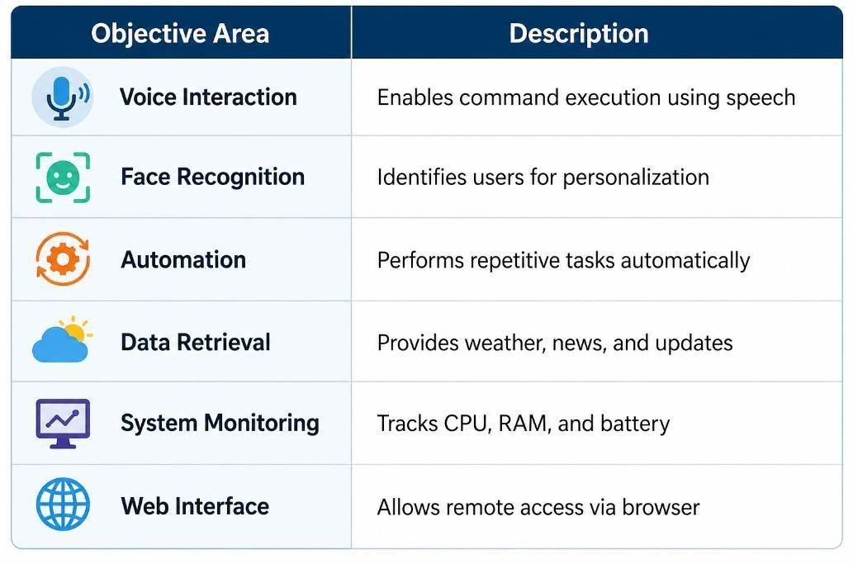
Table 1.1: Objectives and Functional Areas of NEXUS

Table 1.1 summarizes the major functional areas of the NEXUS system along with their
respective roles. This representation helps in understanding how different components contribute to the overall functionality of the system.

1.2 SCOPE OF THE PROJECT

The NEXUS virtual assistant project includes designing and building a desktop-based system that can do a lot of smart things. The system's main goal is to improve how people and computers interact by giving users a natural and easy-to-use interface.
The project includes important features like voice-based interaction, face recognition, task automation, and system monitoring. These features are all part of one platform, which makes the user experience smooth and interactive.
Python is used to build the system, and it uses a number of libraries, including Speech Recognition, OpenCV, and pyttsx3. It also has APIs that let you get real-time data. Using these technologies makes sure that the system is flexible, scalable, and efficient.
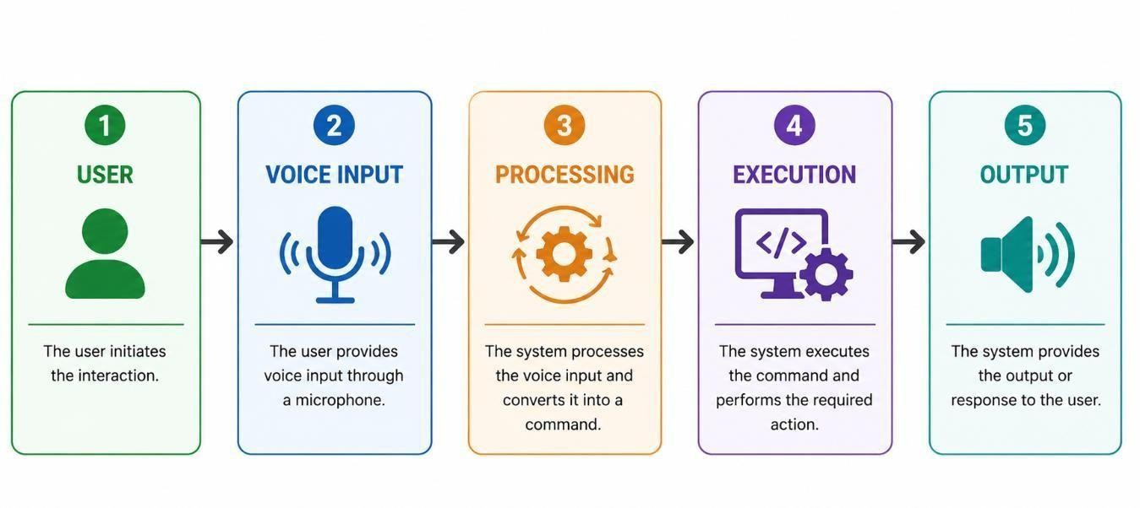
Fig 1.1: Scope and Working Overview of NEXUS System

Fig 1.1 illustrates the overall scope and working of the NEXUS system. It shows how user input is processed and converted into actions, resulting in output in the form of voice or text responses.

The project is mostly limited to desktop environments. The system has a lot of advanced features, but some of them only work when you have an internet connection, especially those that use external APIs. Also, the performance of some modules, like face recognition, may be affected by/

things like the amount of light in the room.

Future improvements could make the system more useful by adding advanced natural language processing, the ability to work offline, compatibility with multiple platforms, and the ability to work with IoT devices. These changes can make the assistant much more useful and functional.

The NEXUS system's main goal is to make it easier and more productive for people to use computers by making it easier for them to interact with them.

CHAPTER 2 LITERATURE REVIEW

INTRODUCTION TO LITERATURE REVIEW
The literature review is a crucial part of every research project, offering a comprehensive overview of the existing technologies, methodologies, and advancements in the relevant field. Many works have been done in the fields of artificial intelligence, natural language processing, speech recognition, computer vision and automation, in the case of intelligent virtual assistants [1].

The aim of this chapter is to analyze and evaluate the existing work related to virtual assistants and to identify their strengths, limitations and areas for improvement. As the previous systems were developed, studying them helps to understand how different technologies were applied and how they can be combined to develop a more efficient and advanced system.

Virtual assistants have improved human-computer interaction by allowing users to communicate with systems in a natural and intuitive way [3]. But, even with these advances, most current assistants are built for specific environments, such as mobile devices or smart home systems. This leaves a gap in the availability of intelligent assistants designed for the desktop environment.

This chapter presents a review of different kinds of virtual assistants, technologies involved in their development, and the limitations that have led to the development of the proposed NEXUS system.

EXISTING VIRTUAL ASSISTANTS
Virtual assistants are an integral part of modern technology that allow users to perform tasks through voice commands and automated processes [3]. The most popular virtual assistants like Google Assistant, Amazon Alexa and Apple Siri have revolutionized the way users interact with digital equipment.

Google Assistant is well known for its natural language processing capabilities and its integration with multiple Google services. It allows users to do things like search for

information, set reminders and control smart devices. Amazon Alexa is mainly used in smart home scenarios and supports a large number of third-party applications via its skill-based architecture. But Apple Siri is designed to work seamlessly within the Apple ecosystem, providing an easy-to-use interface for users of iPhones, iPads and Macs.
These assistants, powerful as they are, are essentially systems operating in the cloud. This means that user data is processed on remote servers, which brings up concerns about data privacy and security. These assistants also need a stable internet connection that limits their usability in offline environment.

They are also not tightly integrated with desktop systems. They can do general things, but they aren't built to do things that are specific to a desktop computer, such as managing files, controlling applications, or monitoring the system. This restriction points to the necessity of a more advanced assistant able to function inside desktop environments [9].

Several open-source and desktop-based assistant systems have been developed to overcome the limitations of commercial virtual assistants. They are trying to offer users more flexibility, customization and control of their data.

Mycroft AI is one of the most prominent open source assistants. It provides developers with the ability to develop custom functionalities and modify the system as per their needs. Mycroft has online and some offline capabilities, making it a strong alternative for users worried about privacy. But the setup can be complex and some features still depend on external services.

Besides Mycroft, a number of J.A.R.V.I.S.-like assistants have been created by researchers and developers. These systems are aimed at automating desktop tasks and enabling voice based interaction. They are often not scalable and do not combine multiple functionalities into one platform although they do demonstrate innovative features.

Most desktop assistants are designed for specific tasks, rather than providing a complete solution. Some systems are designed only for voice recognition, others for automation or system monitoring. This lack of integration reduces their effectiveness and usability.

OPEN-SOURCE AND DESKTOP-BASED ASSISTANTS
People aren’t always thrilled with commercial virtual assistants. They're often rigid, and don’t let users tweak or truly control their experience. So, a bunch of open-source and desktop-based assistants have popped up, offering more freedom. You get to customize things, and you’re not handing over your data to some big tech company.

Take Mycroft AI, for example. It’s probably the most famous open-source assistant out there. Developers can make it do pretty much anything they want, and even change the whole system if needed. You can use it online or offline—so privacy-conscious folks have options. The catch? Setting it up isn’t exactly a walk in the park, and some features still

need third-party services.

Then there’s this whole trend of J.A.R.V.I.S.-inspired assistants—yes, like in the movies. Researchers and hobbyists are behind these, and their goal is to automate desktop tasks and let you talk to your computer. They’re cool and show off some wild features, but most aren’t built to scale or pack everything under one roof.
Honestly, many desktop-based assistants just handle one thing. Some do voice recognition, some automate stuff, others keep an eye on your system. Because of that, they usually fall short when you want something all-in-one and seamless.

SPEECH RECOGNITION TECHNOLOGY

Speech recognition is basically the backbone of virtual assistants—it lets them turn your spoken words into text, so the system can figure out what you want and get things done for you [5].

These days, speech recognition relies a lot on machine learning and deep learning. The whole process is about analyzing your audio and picking up patterns in how people talk [1]. Libraries like Speech Recognition make it pretty easy to take voice input and work with it. And it’s impressive—they can handle different languages, accents, and ways of speaking. So you get a lot of flexibility.

But let’s be real, speech recognition isn’t perfect. It struggles with background noise, lousy microphones, and mumbled speech. If things get loud or your mic isn’t great, you’re probably going to see more mistakes—wrong commands, misunderstood words, all that stuff.

Even with those hiccups, speech recognition is essential. It’s what lets us interact naturally and hands-free with our devices.

COMPUTER VISION AND FACE RECOGNITION
Computer vision is all about teaching machines to 'see' and make sense of images and videos. Face recognition is a specialized part of that, focusing on identifying people by their faces.

OpenCV is a big player in this world [6]. It’s packed with tools for image processing, object detection, and face recognition. If you’ve ever heard of Haar cascade classifiers, they’re a classic choice for spotting faces in pictures or on your webcam.

Face recognition takes user experience up a notch—it helps virtual assistants recognize who you are and serve up responses just for you. But the results depend a lot on lighting, camera quality, and the uniqueness of your face. If the lighting’s bad or the camera

resolution is low, accuracy drops off fast.

Still, computer vision is a game-changer. It makes virtual assistants smarter and more interactive.

AUTOMATION AND SYSTEM CONTROL

Automation is a major selling point in virtual assistants today. It means you can get things done without fiddling around yourself—open apps, search the web, send messages, or take control of your whole system.

If you’re on a desktop, automation is a huge productivity booster. You just say what you want, and complex tasks happen almost instantly. Usually, this is powered by scripting languages and APIs that let the assistant talk to your computer and other services [2].

Here’s the catch: most virtual assistants aren’t great at full-on desktop automation. They’re built for basic stuff, not deep system-level actions like handling files or monitoring performance. So there’s still plenty of room for improvement.

LIMITATIONS OF EXISTING SYSTEMS
Virtual assistants have some pretty clear shortcomings. They lean heavily on cloud services, which raises privacy issues. They also need a constant internet connection just to function. When it comes to desktop-specific features, most of them fall short. Another problem—these systems rarely pull together different technologies into one place. And don’t get me started on how much they struggle in noisy settings or bad lighting.
All of this shows we need something better—a smarter, more reliable assistant that doesn’t trip over these hurdles.

COMPARATIVE ANALYSIS OF EXISTING SYSTEMS

When you look closely at virtual assistants, the big-name commercial ones are slick and pretty accurate. They come packed with features, but honestly, they don't let you tweak much or make things your own. Open-source assistants are way more flexible—you get control—but setting them up can be a headache, and they don't always play nice with other tools.

That’s where the NEXUS system steps in. It’s built to tackle those problems. Instead of scattering features around, NEXUS pulls them together in one platform [9]. Local processing keeps things fast and private, system-level automation handles tricky tasks, and

the modular design means you can adapt it to fit desktop setups. It’s basically a smarter, more customizable workspace for people who want something that actually fits their needs.

Feature | Google Assistant | Alexa | Siri | Mycroft AI | NEXUS
Platform | Mobile/Cloud | Smart Home | Apple Ecosystem | Open-source | Desktop
Internet Dependency | High | High | High | Medium | Low
System Control | Limited | Limited | Limited | Moderate | High
Customization | Low | Medium | Low | High | High
Privacy | Low | Low | Medium | Medium | High
Offline Capability | No | No | Limited | Partial | Partial
Automation | Moderate | Moderate | Moderate | Moderate | Advanced

Table 2.1: Comparative Analysis of Virtual Assistants

RESEARCH GAP
The literature shows that virtual assistants just don’t deliver everything desktop users need. Most of them stick to one or two features and never really offer the whole package.

What’s missing is a single system that brings together speech recognition, face recognition, automation, real-time data access, and system monitoring—all in one place. On top of that, it should be easy to use, protect privacy, and scale as needed.

That’s where NEXUS comes in. This new system is built to tackle all these gaps, offering a smart, multifunctional assistant made just for desktop users

SUMMARY
In this chapter, I took a close look at current virtual assistant technologies—both commercial options and open-source systems. I also broke down the main tech behind them, like speech recognition, computer vision, and automation [1][5][6].
While digging into these tools, I found some clear shortcomings. Honestly, the existing systems don’t quite cut it, and there’s a real need for something smarter and more connected.

CHAPTER 3 PROPOSED METHODOLOGY

INTRODUCTION

Here’s how we built the NEXUS virtual assistant: First, we mapped out what we needed the system to do and which technologies would actually work. NEXUS isn’t just slapped together—it’s designed to be modular and scalable, so every part fits together and can grow or change as needed. The real trick is making all these different pieces talk to each other smoothly.

We worked step by step. We started with requirement analysis, picked the right technologies, built separate modules, then brought everything together and tested it all to make sure things really functioned the way we wanted. Every phase mattered—if we missed something, the whole system would feel clumsy or incomplete.

NEXUS leans on AI, weaving in things like speech recognition and computer vision [1][5][6], and marries those with handy automation and system monitoring tools. That’s how it manages to respond naturally and keep everything running in the background, turning the virtual assistant into a responsive, intelligent experience instead of just another piece of software.

SYSTEM OVERVIEW

The NEXUS system is a multi-purpose desktop assistant consisting of various modules that performs the task of voice command execution, face recognition, system monitoring and real-time data fetching [9].

The system receives user input, processes it and executes the corresponding action. The input can be voice commands or visual data that are processed by machine learning and image processing techniques [1][6]. This processed data is then sent to the command execution module, where the required task is executed and feedback is provided to the user.

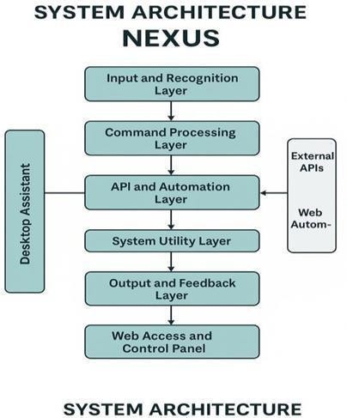
Fig 3.1: Overall System Architecture of NEXUS

The overall structure and working of the NEXUS system are illustrated in Fig 3.1, which shows the interaction between different modules and layers of the system.

The architecture shown in Fig 3.1 highlights the layered design of the system, where each layer is responsible for a specific function. This modular approach ensures flexibility, scalability, and ease of maintenance.

REQUIREMENT ANALYSIS

The design of NEXUS begins with the specification of system requirements. These requirements define the functionality that the system must provide and form the basis of the design and implementation process.

Functional Requirements

      - The system should be able to accept voice commands from the user

      - It should be able to correctly process and understand commands

      - It should be able to do things like open apps and search the web

      - It’ll provide live information like weather and news

      - It should recognize faces for a personalized interaction

      - It should monitor the system performance (CPU , memory , battery )

      - It should give feedback by audio and text

Non-Functional Requirements

      - The system should be efficient and responsive

      - It should ensure data privacy and security

      - It should be scalable and modular

      - It should have a user-friendly interface

      - It should operate with minimal resource consumption

TECHNOLOGY STACK

The development of NEXUS involves the use of various technologies and tools, each selected based on its functionality and compatibility.
- Programming Language: Python
- Speech Recognition: SpeechRecognition library [5]
- Text-to-Speech: pyttsx3

- Computer Vision: OpenCV [6]

- Web Framework: Flask

- Frontend: HTML, CSS, JavaScript

- APIs: Google APIs (weather, search, etc.) [5]

Python is chosen due to its simplicity, flexibility, and extensive support for AI and ML applications. The combination of these technologies enables the system to perform complex tasks efficiently.

MODULE-BASED SYSTEM DESIGN

The NEXUS system is divided into multiple modules [9], each responsible for a specific functionality. This modular design allows easy development, testing, and future enhancements

INPUT AND RECOGNITION MODULE

This module is responsible for capturing user input in the form of voice commands or visual data. The SpeechRecognition library is used to convert speech into text [5], while OpenCV is used for capturing and processing images for face recognition [6].

The module ensures accurate input capture and preprocessing, which is essential for the correct functioning of the system.

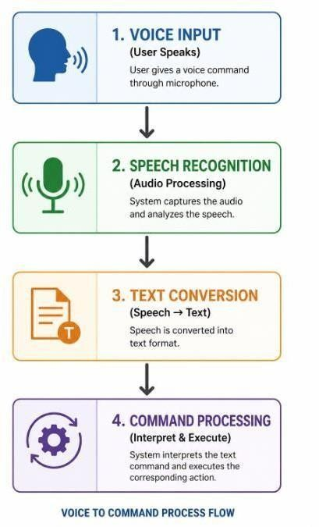

Fig 3.2: Voice Command Processing Workflow

COMMAND PROCESSING MODULE

This module is the brain of the system. It reads the text input and figures out what to do next. The module uses conditional logic and pattern matching to find commands and link them to certain tasks.

The modular design makes it easy to add new commands without breaking anything that already works.

AUTOMATION AND API INTEGRATION MODULE

This module is responsible for executing tasks such as opening applications, performing web searches, and retrieving real-time data. It interacts with external APIs to fetch information such as weather updates and news [5].
Automation scripts are used to perform system-level operations, enabling the assistant to execute tasks efficiently.

SYSTEM MONITORING MODULE

The system monitoring module tracks system performance parameters such as CPU usage, memory consumption, and battery status. It provides real-time updates to the user, helping in efficient system management.
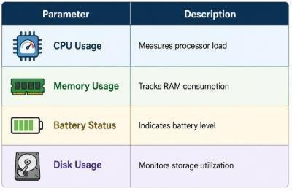
Table 3.1: System Monitoring Parameters

OUTPUT AND FEEDBACK MODULE
This module provides feedback to the user in both audio and text formats. The pyttsx3 library is used for text-to-speech conversion [5], enabling the system to respond verbally.
The feedback loop ensures smooth interaction between the user and the system.

WEB INTERFACE MODULE
The web interface allows users to interact with the assistant through a browser. It is developed using HTML, CSS, and JavaScript, with Flask serving as the backend [2].

This module enhances accessibility by enabling remote interaction with the system.
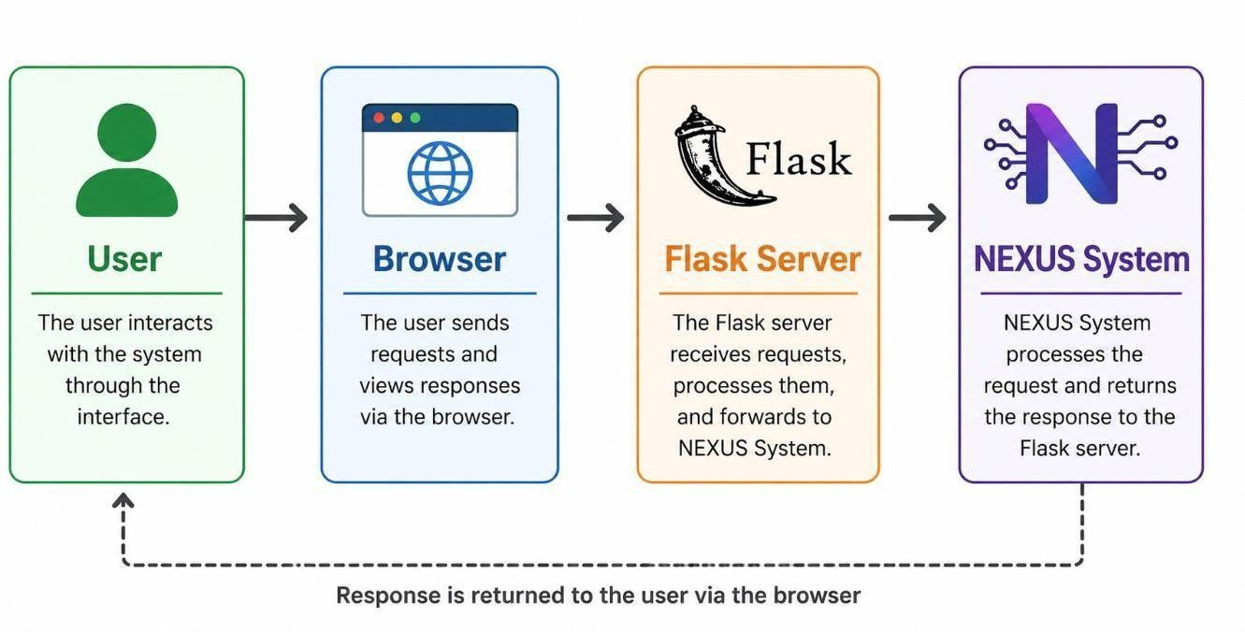

Fig 3.3: Web Interface Interaction Flow

SYSTEM INTEGRATION

All modules are integrated using a central controller that manages communication between different components. The controller ensures that data flows smoothly from input to output, enabling efficient execution of tasks.

The integration process involves combining individual modules and testing their interaction to ensure proper functionality.

WORKING OF THE SYSTEM
The working of NEXUS can be summarized in the following steps:

- User provides input (voice or visual)

- Input is processed and converted into text
- Command is interpreted
- Appropriate action is executed
- Output is generated and delivered to the user

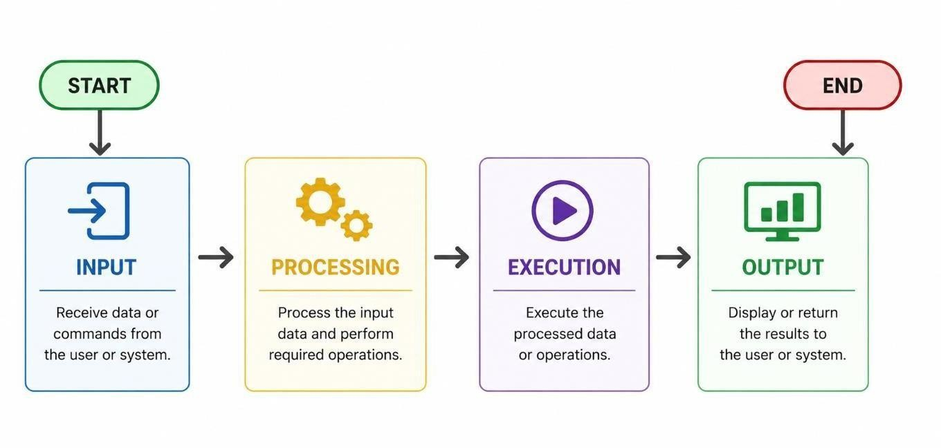

Fig 3.4: Overall System Workflow

TESTING AND OPTIMIZATION
The system is tested at both module and integration levels [9]. Different scenarios are used to evaluate performance, including voice recognition accuracy and system response time.
Optimization techniques are applied to reduce resource consumption and improve efficiency.

SUMMARY
This chapter outlined the suggested method for creating the NEXUS system. It went into great detail about the system's architecture, modules, and how they work together.

The modular design makes the system flexible and scalable, which means it can be changed in the future [2].
The following chapter will examine the outcomes and performance assessment of the system.

CHAPTER 4 RESULTS AND DISCUSSION

INTRODUCTION
This chapter is dedicated to the evaluation of the performance of the virtual assistant NEXUS developed in this project. The main aim is to assess the performance of the system in different scenarios and how it fulfils the desired requirements.

The assessment consists of functional testing and performance analysis. Functional testing is carried out to confirm that all the features of the system are working correctly and performance analysis is carried out to analyse parameters such as response time, accuracy and system resource utilisation.

To make sure the system is reliable, it is tested using both unit testing and integration testing approaches [2]. Unit testing verifies individual modules separately, whereas integration testing ensures smooth communication between all modules. The observations obtained from these tests help to understand the strengths and limitations of the system.

TESTING METHODOLOGY
The system is evaluated in a structured way, hence a systematic testing approach is followed [2]. The testing process is broken down into several stages to make sure that each component is properly analysed.

Unit Testing

At this stage each system module is tested independently. Some of the modules which are verified individually are voice recognition, face detection, automation, system monitoring. This step helps to catch errors early and ensures that each module is working correctly before integration.

Integration Testing

Modules are tested separately and then integrated into the overall system. Integration testing ensures that all the components work together, without any conflicts or communication problems between the modules.

System Testing

Finally, the entire system is tested in a real-world environment. Different conditions like normal use, heavy load and environmental variations are considered. This makes it possible to evaluate the general usability and stability of the system.

FUNCTIONAL VALIDATION
Every feature of the NEXUS assistant goes through solid operational checks to make sure it actually works the way it’s supposed to. The team puts each module through some tough tests so nothing slips by.

Voice Command Processing

We put the voice recognition module [1] through its paces, throwing both simple and complex commands at it. It handles things like opening apps, running searches, and pulling up information without any trouble. Under normal conditions, it works smoothly—no big hiccups.

    - Face Recognition Performance
To test the face recognition [5], we brought in different users and tried a range of lighting setups. When the light is good, the system has no problem picking up and identifying faces. In dimmer environments, its accuracy dips a bit, which isn’t surprising—most vision-based systems run into the same issue.
    - Automation Tasks
For automation [6], we had the system launch apps, open websites, and handle online searches. It finishes these tasks quickly and doesn’t need anyone to step in manually. That really highlights how handy it is for taking over those routine, repetitive jobs.
    - Real-Time Data Retrieval
When it comes to grabbing real-time info—like the latest weather or news—the assistant taps into external APIs and gets results back fast. The data is spot-on and arrives almost instantly, showing that API integration is working just right.
    - System Monitoring
The system monitoring module keeps users in the loop with steady updates on CPU load, memory usage, and battery life. It makes it easier for people to stay on top of performance

and keep their resources in check.

SYSTEM WORKING DEMONSTRATION
To demonstrate the practical implementation of the NEXUS virtual assistant, the system was executed in a real-time environment. This section presents the working of the system through actual screenshots of the code execution, user interface, and command processing.

Code Execution
The backend of the system is implemented using Python and Flask. The main application file contains the logic for voice processing, command execution, and system interaction.
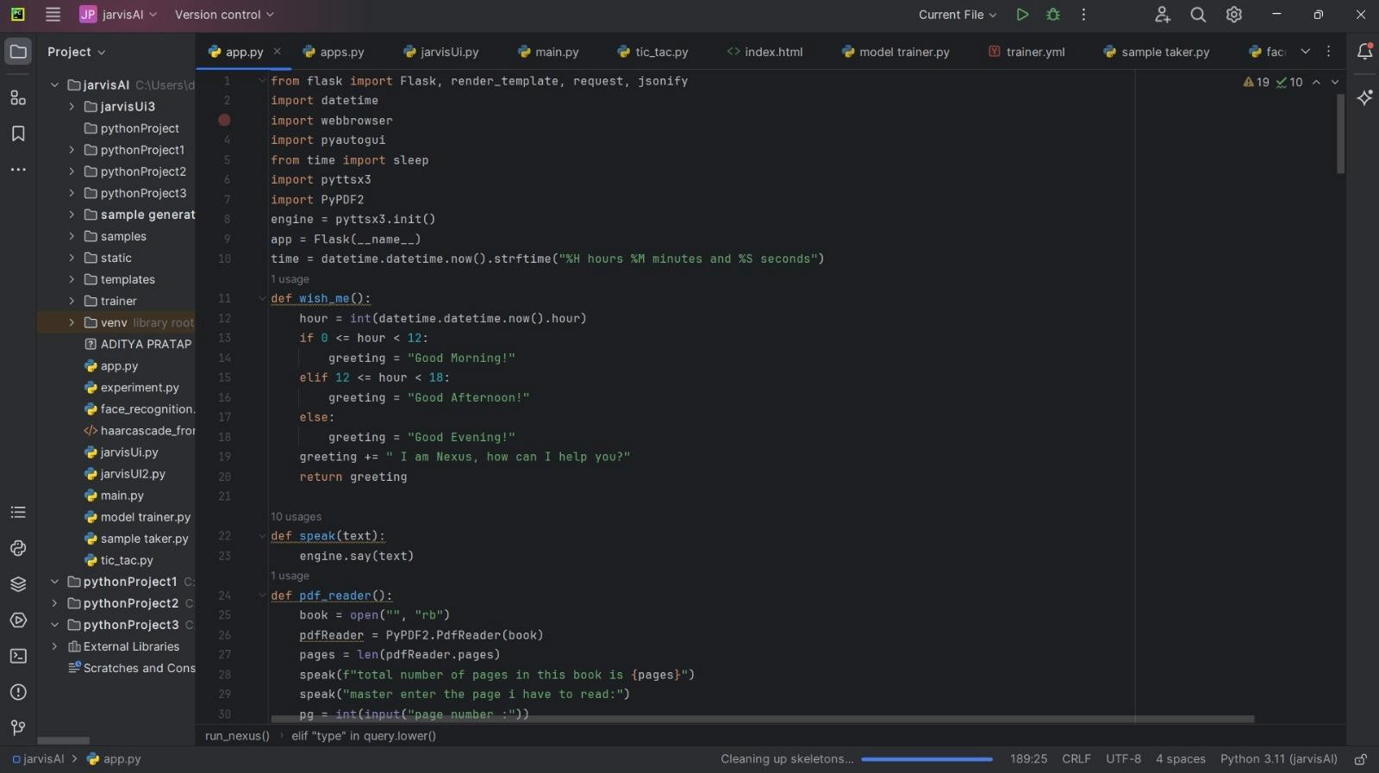

Fig 4.1: Backend Code Implementation of NEXUS System
The above figure shows the implementation of core functionalities such as speech processing, greeting generation, and command handling. The use of Python libraries enables efficient execution of tasks.

Homepage Interface
The system has a web-based interface through which the user can access the virtual assistant. This interface is the entry point of the system and is made with HTML, CSS and JavaScript while Flask is used for the backend operations [2]. The homepage is designed to provide a clean and attractive layout that enhances user engagement.
The interface has a navigation bar with various sections like Home, About, Features and FAQ to help users to explore different aspects of the system. The main part of the page presents the

goal of the assistant and provides a brief description of its functions. This gives users a preview of the system's functionality before they start using it [3].
The homepage also has interactive buttons such as “Launch Nexus” and “Watch Demo.” In fact the interaction is provided through the button “Launch Nexus” that redirect the user to the assistant interface. This systematic design helps in smooth navigation and improves the overall usability of the system.
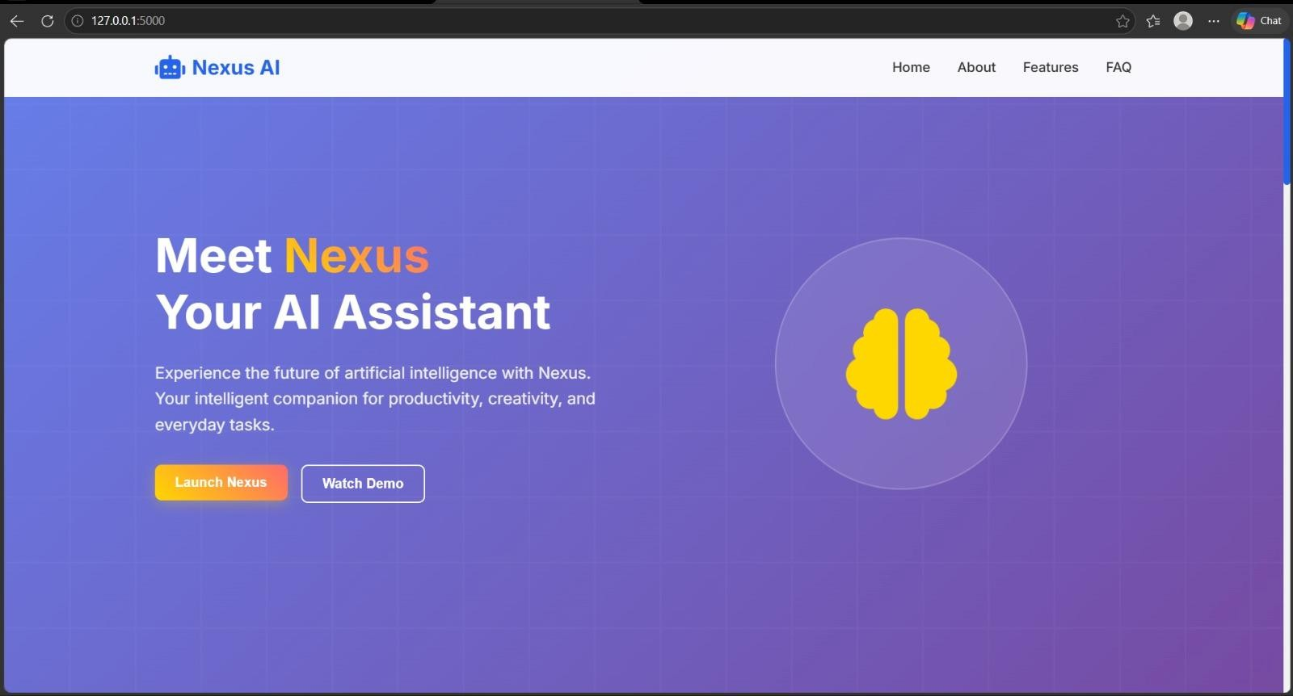
Fig 4.2: Homepage Interface of NEXUS System
Figure above shows the homepage of the NEXUS virtual assistant. It presents the system overview and the user can launch the assistant with the “Launch Nexus” option. The interface is meant to be simple and user-friendly.

Assistant Interaction Interface
The assistant interaction interface is the main screen for user direct interaction with the NEXUS system. The goal of this interface is to provide a fluid and interactive experience, enabling users to give commands by voice input rather than the traditional ways of input. Voice based interaction integration increases the usability of the system and reduces manual effort [3].
The interface shows the greeting message which is generated dynamically by taking into account the system time and makes the interaction more personalised. There is also a “Start Listening” button to turn on the speech recognition module. The system records the user’s voice, converts it to text and executes the command by using speech recognition methods after activation [5].

The interface also provides visual feedback, showing the recognized command and the system response. This dual feedback (audio and visual) helps the user to understand better and ensures that the communication is clear. The interface is simple and intuitive, so even if you’re not tech-savvy, you can easily interact with the assistant. Additionally, the design ensures smooth navigation between different states of interaction, allowing users to operate the system without confusion. The responsive behavior of the interface further enhances usability by providing immediate feedback to user actions, making the interaction more efficient and engaging.
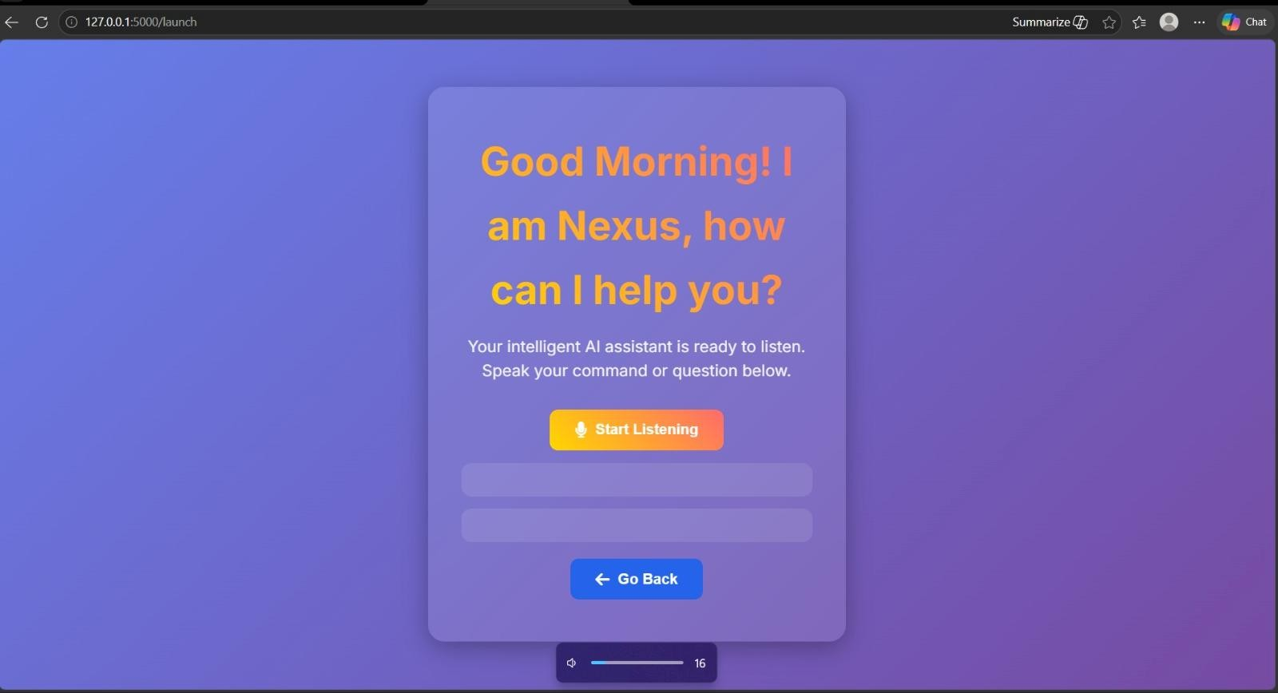

Fig 4.3: Assistant Interaction Interface
The figure shows the interaction screen where the assistant greets the user and asks for input. The “Start Listening” button allows the system to receive voice commands from the user and process them in real time.

Command Execution Output
The command execution phase is really where NEXUS comes to life. Here, user input gets translated into real actions. Once the assistant turns your voice into text, it uses a set of rules to figure out what you want and matches that to the right task. Automation techniques power this whole process [2].
NEXUS isn’t just listening—it can launch your apps, run system commands, or pull information from the internet. All of this happens automatically, so you don’t need to repeat the same boring tasks over and over. It saves you a lot of time and keeps things moving [2].
Every time you give a command, the system shows you what it understood and tells you what

it’s about to do. This keeps things clear and lets you double-check that NEXUS heard you right. Thanks to the mix of speech recognition and automation, the assistant responds fast and handles tasks right when you need them [5].
NEXUS also keeps things organized. It runs commands one after the other to prevent clashes between tasks. Its processing is built to handle all sorts of requests efficiently, always making sure it chooses the right action for every command. This keeps the assistant reliable and steady, even when you’re using it for long stretches [2].
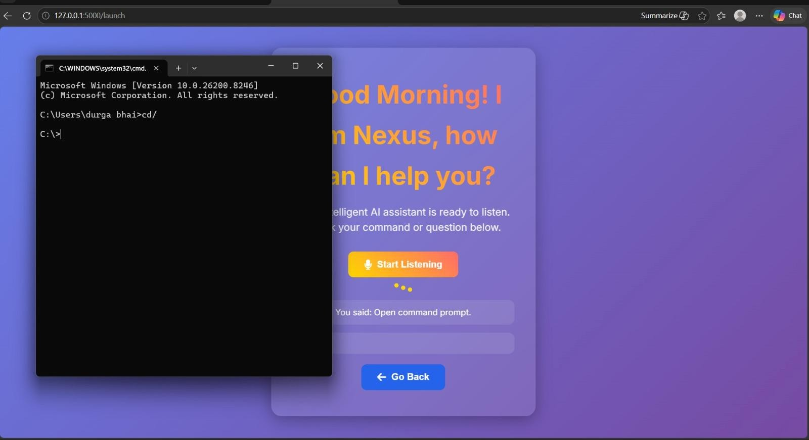

Fig 4.4: Command Execution using Voice Input
The figure above shows the execution of a user command. The assistant receives the voice input, processes it and performs the requested action successfully, e.g. the command prompt is opened, which confirms the correct working of the automation module.

Face Recognition Output
The face recognition module gives the NEXUS virtual assistant its edge when it comes to knowing who’s using it. It relies on computer vision to scan for faces in real time. Basically, the camera grabs an image, and the system uses image processing algorithms to pick out unique facial features [6].
After spotting a face, the system matches it against stored profiles. This lets NEXUS greet you by name or unlock special features, making it feel more personal. On top of that, face recognition helps keep things secure, making sure only authorized users get access. Tools like OpenCV make it pretty straightforward to build this kind of functionality [6].

The module runs smoothly as long as the lighting is decent. It reliably finds faces and gets the details right. Things like poor lighting or a bad camera can make it less accurate—that’s just a common hassle with these systems. Still, in most real-world situations, it holds up well.
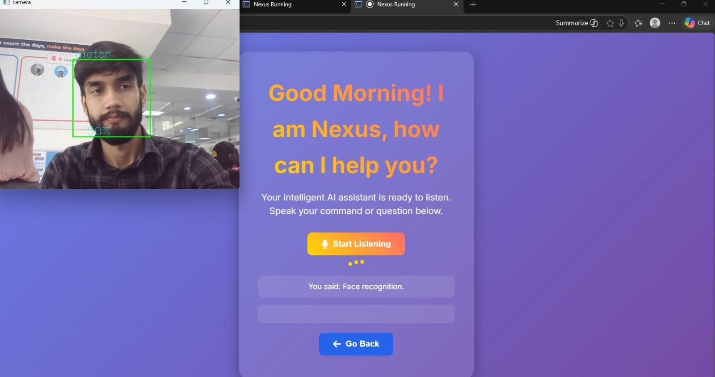

Fig 4.5: Face Recognition Detection Output
The image shows how the face recognition module catches the user’s face through the camera. You can see the system locking onto facial features and marking the person’s face, showing off exactly how the computer vision feature works.

PERFORMANCE EVALUATION
We measure how well the NEXUS virtual assistant works by looking at things like response time, how much memory and CPU it uses [2], and its overall efficiency. These factors show how smoothly the system runs during normal use.
Besides those parameters, the team checks how the system holds up in different real-world situations. They push the assistant through nonstop use and make it tackle several tasks at once, just to see if it keeps up and stays responsive. It's all about figuring out whether the system can handle the pressure without breaking down or slowing over time. A solid system needs to be fast, sure — but it also has to stay steady, even when it's hit with repetitive or demanding jobs.
Performance evaluation isn’t just about numbers—it’s about how it feels to actually use the system. People want quick responses from the assistant, not awkward pauses. Consistency counts, too. If the assistant acts the same every time and doesn’t stumble when handling tasks, that goes a long way. It shouldn’t hog resources, either. When everything runs smoothly and stays reliable, using the system feels easy, not frustrating. These factors decide if the system

can handle real-world, real-time use.
To get a clearer picture, we’ve put the results into a graph in Fig 4.6
Fig. 4.6: Performance Indicators of NEXUS
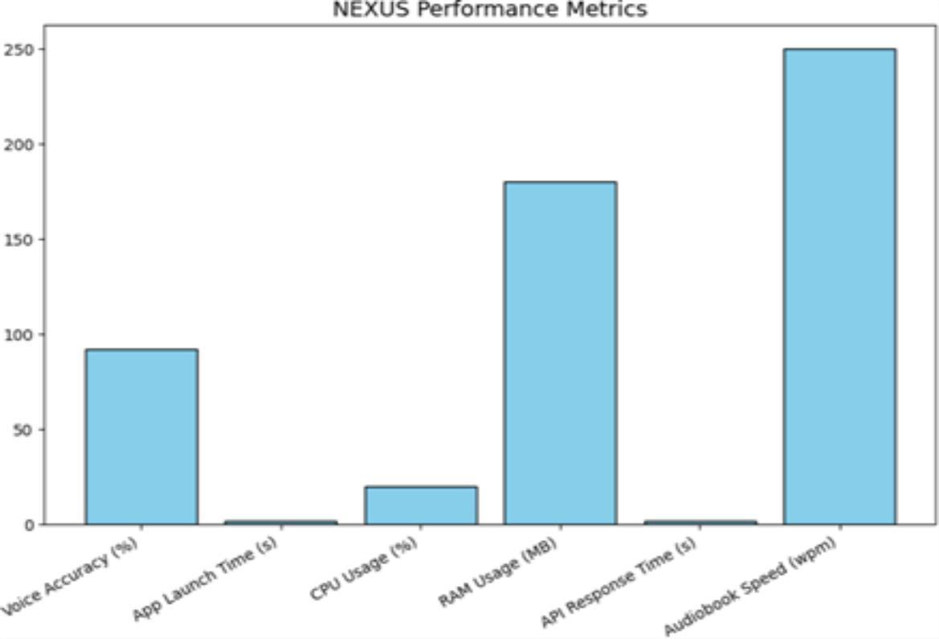

If you check out Fig 4.1, you’ll see NEXUS keeps response times quick—just between 1 and 2 seconds for most tasks. That’s fast enough for efficient processing.
On top of that, it uses memory wisely—sitting at about 180 MB—and it doesn’t hog the CPU, staying in a low to moderate range. You can run NEXUS with other programs and it won’t drag your system down.
All in all, the graph shows a good balance between speed and efficiency, making NEXUS a solid choice for everyday desktop use.

RESPONSE TIME ANALYSIS
Response time is basically how long the system takes to handle your command and send something back [2]. It’s a key part of how people feel when they use it.
With the NEXUS system, you usually get a response in about 1 to 2 seconds. That speed comes from how efficiently it processes tasks and how it runs commands locally, without

constantly relying on outside servers
The average response time observed for various operations is summarized in Table 4.1.

Operation | Response Time
Voice Command | 1.5 sec
Application Launched | 1 sec
Web Search | 2 sec
Data Retrieval | 1.8 sec
Table 4.1: Response Time Analysis
Table 4.1 makes it clear: the system handles user commands fast. Launching an application happens almost instantly—it runs locally, so there’s nothing holding it back. Web searches take a bit longer because they depend on the network to pull data from the internet. Same goes for things like weather updates or news queries; those need to reach out to external APIs, which slows things down just a touch.
Even with these small delays, response times stay reasonable. The system keeps up, performing smoothly—no frustrating waits. Overall, the results show the NEXUS system gets responses out quickly and efficiently, which is essential for real-time desktop work. Low response time keeps the experience fluid, making interactions feel natural and ensuring the system doesn’t get in the way.

RESOURCE UTILIZATION ANALYSIS
How a software system uses resources really affects how well it works[2]. It’s easy to overlook, but things like RAM, CPU, disk space, and bandwidth—all those make or break performance, especially if you’re running several applications at once. If a virtual assistant hogs resources, everything else slows down. Nobody wants that.
For NEXUS, the developers made low resource consumption a top priority. They tested it thoroughly, watching its behavior as it handled tasks and tracking how much of each resource it actually used. It’s not just about monitoring, though. They also evaluated NEXUS in various scenarios—keeping it running for long stretches and pushing it into multitasking environments. Even when several apps are going at once, NEXUS runs smoothly in the background. It doesn’t bog down the system or disrupt other programs. That’s a relief for anyone who relies on stable performance.
NEXUS’s architecture helps too. The modules only kick in when needed. If you’re not using features like speech recognition or face detection, those don’t sit there burning CPU cycles. This approach keeps things lightweight and efficient. Selective activation, rather than always-on, really pays off in terms of system speed.

There’s flexibility built in as well. NEXUS adapts to a range of hardware, performing reliably even on machines that aren’t packed with high-end specs. You don’t need a powerhouse PC to use it. Plus, it doesn’t gobble up network bandwidth—when it needs to grab data in real time, it does so without overwhelming your connection.
Resource utilization details are laid out in Table 4.2.

Resource | Usage
RAM | ~180 mb
CPU | Low to Moderate
Disk | Minimal
Network | Moderate
Table 4.2: Resource Utilization Analysis
Table 4.2 clearly illustrates how the NEXUS system runs efficiently while keeping resource use in check. RAM stays steady at about 180 MB—a modest footprint—so even computers with average specs can handle it with ease.
CPU usage shifts between low and moderate. It depends on what's happening at the moment. Intensive tasks like voice recognition or face detection push the processor a bit more, but any spikes settle down fast once those tasks wrap up.
As for disk usage, it barely registers, since NEXUS doesn’t need much local storage to function. Network activity sits at a reasonable level, mainly because the system fetches live data like weather and news through APIs.
All in all, these results show that the NEXUS assistant uses resources wisely. It avoids bogging down the system, runs well alongside other programs, and suits continuous, everyday use on desktop machines.

ACCURACY ANALYSIS
Accuracy plays a key role in judging how well a virtual assistant works [5]. It shows how reliably the system understands what users say and carries out their requests without making mistakes. When accuracy is high, users can trust the assistant to do what they want, which makes the experience smoother and more satisfying.
For the NEXUS virtual assistant, accuracy mainly hinges on how the voice recognition module performs and how efficiently it processes commands. To see how well the system handles real-world situations, we tested it in different environments, paying close attention to how accurately it caught and completed user commands Table 4.3 shows the system’s

accuracy results across these various test conditions

Condition | Accuracy
Quiet Environment | 92%
Moderate Noise | 88%
High Noise | 80%

Table 4.3: Accuracy Analysis
Table 4.3 makes it clear—the NEXUS system works best when things are quiet. Without much background noise, it easily picks up voice commands and responds right away.
Add a bit more noise, and accuracy dips. The system catches some interference, but it still gets the job done. In really noisy spots, though, accuracy takes a bigger hit. External sounds muddy the input and make it harder for NEXUS to follow commands. Even then, the system doesn't break down completely. It manages to process most instructions well enough.
All in all, the data shows the NEXUS assistant is reliable in everyday situations. It holds up decently even when the environment gets tricky. Still, there's room to grow; adding better noise reduction and advanced speech processing could boost performance in future updates.

USER EXPERIENCE ANALYSIS
User experience really shapes how effective and usable a virtual assistant can be[3]. When a system feels easy to use—when you barely have to think about what you’re doing—it's a sign of good design. The best experiences let you get things done quickly, with no frustration.
Take the NEXUS virtual assistant. Right from the start, it feels smooth and straightforward. You can just speak your commands, no need for a keyboard or mouse. This hands-free control isn't just convenient—it opens the door for all sorts of users, especially those who want speed and accessibility.
Responsiveness plays a huge role, too. NEXUS reacts fast. You don’t find yourself drumming your fingers on the desk, waiting for something to happen. Instead, commands go through quickly, and the assistant delivers accurate results. That’s what makes the interaction feel seamless.
Feedback matters as well. NEXUS speaks responses out loud and displays them on the screen. Users know the system heard them and took action. The text-to-speech feature and

visual cues work together, keeping things clear and reducing confusion.
You don’t need tech expertise, either. The interface avoids clutter and complexity. Whether you’re a beginner or just don’t care for technical details, you can still jump in and get things done.
Reliability ties all of this together. The system stays solid, even across long sessions. Features like automation, real-time data retrieval, and system monitoring work smoothly, combining to make the whole experience better.

In the end, NEXUS gets the essentials of user experience right. It feels reliable and approachable. With its balance of simplicity and performance, it actually delivers on the promise of a better way to interact with your desktop.

DISCUSSION OF RESULTS
Testing and implementing the NEXUS virtual assistant tells a clear story: the system handles itself well across a few key areas—response time, accuracy, and how much it eats up resources[2][5]. When you dig into these numbers, you get a sense of how reliable and capable the assistant really is.
For response time, NEXUS doesn’t keep you waiting. It usually processes commands in just a second or two, so using it feels smooth and natural. Local processing does the heavy lifting here, cutting down on lag—something that often bogs down cloud-based assistants.
Resource-wise, the assistant keeps things light. RAM stays low, and CPU usage doesn't push the limits. That means you can run NEXUS alongside other apps without worrying about your machine slowing to a crawl.
On accuracy, NEXUS holds up well in quiet settings, delivering high recognition rates. Noise is the usual culprit when accuracy drops—just like with most speech systems—but even then, it’s still passable. With better noise filters, there’s room to make things even sharper.
User experience backs all this up. The interface is straightforward, voice commands work without fuss, and responses come in real time. Juggling multiple tasks is no problem, which makes the assistant genuinely useful.
Still, there are gaps. Background noise can trip it up, and some features need an internet connection. Those are challenges, but also a chance to refine the system down the road.
All told, NEXUS hits its marks: it’s efficient, accurate, and easy to use—everything you want in a desktop assistant that’s built to do the job right.

LIMITATIONS OF THE SYSTEM

While the NEXUS virtual assistant works smoothly and gets the job done, it isn't perfect. Testing has brought some limitations to light—areas where the system could use a boost in future updates.
First, background noise throws off its voice recognition. Put NEXUS in a noisy environment and you'll notice its accuracy drops. The assistant struggles to pick out commands when there’s a lot going on in the background, often misinterpreting what the user says [5].
There’s also the matter of internet reliance. Features like weather reports or news updates depend on external APIs. Take away a steady internet connection and these services stop
When the room is dim or the camera feed is blurry, the face detection loses accuracy, sometimes missing or misidentifying faces altogether.
Then there’s offline functionality in general. The system manages simple tasks locally, but most advanced features require an internet connection or outside resources. This limits how useful NEXUS is when you don’t have access to the web.
Even with these constraints, NEXUS still performs well in typical settings. It lays down a strong foundation for making future editions smarter and more resilient.

SUMMARY
This chapter took a close look at how the NEXUS assistant performs. The evaluation covered speed, resource use, accuracy, and overall experience from the user’s side [1].
The results show NEXUS handles commands quickly and doesn’t hog system resources. It responds fast, hits the mark with command execution, and delivers a user experience that fits right in with real desktop applications.
Of course, the analysis surfaced some challenges—things like background noise and the need for internet connectivity. Those areas give clear direction for what to tackle next as the system evolves.
All things considered, NEXUS stands out as a capable and reliable tool for bridging the gap between people and their computers. Bringing multiple features together on one platform, it shows just how much potential intelligent assistants offer in desktop environments

CHAPTER 5 CONCLUSION AND FUTURE SCOPE

INTRODUCTION
Here’s where we wrap up the NEXUS virtual assistant project and think about what comes next. In this chapter, I’ll go over what we accomplished, what went well, and where we can take NEXUS in the future.
Building NEXUS was a chance to bring together a bunch of different technologies — speech recognition, computer vision, automation, and system monitoring — all in one place[1][5][6]. After running and testing the system, it’s clear NEXUS handles a lot of tasks smoothly and keeps things simple for users. It’s efficient and easy to use, but there’s definitely room to push it further.

CONCLUSION
“NEXUS: A Multifunctional AI-Based Virtual Assistant” hits its main goal: it builds a smart assistant for your desktop that uses voice commands and automation to handle a bunch of different tasks[3][5]. It pulls together some impressive technology to offer a smooth, interactive experience.
One of the standout wins here is the voice recognition. You can just talk to NEXUS, and it understands what you want — whether it’s opening apps, running web searches, or grabbing real-time info. You don’t have to click around, which definitely makes life easier.
There's also face recognition. It’s not about strict security, but more about making the assistant feel personal. NEXUS recognizes you and tailors the experience — it’s more engaging, more friendly.
When it comes to automation, NEXUS gets rid of boring, repetitive stuff. You tell it what to do, like managing system operations or handling web tasks, and it just does it. Plus, it can snag the latest weather and news on the spot.
The system monitoring part is handy too. It keeps an eye on things like CPU, memory, and battery, so you know how your device is running and can manage it better.

What really makes NEXUS flexible is its modular architecture. Each part works on its own but still communicates smoothly with the rest, so you can add new features without breaking anything.
It’s scalable and ready for growth.
Performance-wise, NEXUS delivers solid accuracy, quick response, and good resource management. It works reliably for everyday use and keeps things running smoothly.
There are a few drawbacks, though. It doesn’t pick up voices as well in noisy places, and some features need an internet connection. These are areas that could use a bit more work.
All in all, NEXUS shows what intelligent virtual assistants can do for desktop environments — making interactions easier and boosting productivity.

FUTURE SCOPE
The NEXUS system already covers a lot of ground with its features, but there’s still room to grow. Here’s where the system can get even better:

Offline Functionality
Right now, some key features, especially those tied to external APIs, need a steady internet connection. By adding offline speech recognition and local data retrieval, the system would work more reliably even when the internet’s spotty.

Advanced Natural Language Processing
The way things stand, NEXUS understands only basic commands. Upgrading to stronger NLP models helps it handle more natural, conversational language. You'd be able to talk to it like you would to another person—which just feels better[1].

Enhanced Face Recognition
Face recognition does its job, but pushing it with more robust machine learning algorithms would boost accuracy. It’s not just about picking out a face, either. Adding multi-user support, emotion detection, and reading facial expressions would make interactions smoother and smarter.

Cross-Platform Support
At the moment, NEXUS focuses on desktop use. Expanding to other platforms—like Linux and mobile—opens the door for more people to use and rely on it wherever they are.

Integration with IoT Devices

Connecting the system to smart home tech and IoT would be a game changer. Imagine controlling all your devices with one assistant—home automation gets way simpler and a lot more powerful.

Improved Security Features
Security always matters. By adding advanced ways to verify users, like voice biometrics and multi-factor authentication, NEXUS becomes more secure and ready for handling sensitive data.

Machine Learning for Personalization
With machine learning, NEXUS can pick up on your preferences and habits. Over time, it gets better at making suggestions and tailoring its responses to you, creating a more personal experience.

Mobile Application Integration
Building a mobile app means you’re not tied to your desk. You’d be able to control and check in with your assistant wherever you are, making the whole system far more flexible and convenient.

FINAL REMARKS
NEXUS isn’t just another virtual assistant—it’s a real leap toward smarter, more personalized desktop help. By bringing different technologies together on one platform, it shows how AI can actually make daily tasks easier and a little less annoying.
This project goes beyond just a cool demo. It’s a hands-on use of advanced tech that sets the stage for more innovation in intelligent systems. Down the line, with some solid updates and new features, NEXUS can grow into an even stronger tool that tackles all sorts of users’ needs.

REFERENCES

- Y. LeCun, Y. Bengio, and G. Hinton, “Deep learning,” Nature, vol. 521, no. 7553,
pp. 436 – 444, 2015.

- S. Russell and P. Norvig, Artificial Intelligence: A Modern Approach, 4th ed., Pearson, 2020.

- M. McTear, Z. Callejas, and D. Griol, The Conversational Interface: Talking to Smart Devices, Springer, 2016.

- P. Viola and M. Jones, “Rapid object detection using a boosted cascade of simple features,” IEEE CVPR, 2001.

- Google Developers, “Speech-to-Text API Documentation.” [Online].
Available: https://cloud.google.com/speech-to-text

- OpenCV.org, “OpenCV: Open Source Computer Vision Library.” [Online].
Available: https://opencv.org/

- R. Supe, S. Deshmukh, and A. Jadhav, “ARIA: An AI-powered desktop assistant,” IJCA, 2019.

- V. Kumar and N. Aggarwal, “Design of intelligent virtual assistant,” IJERT, 2020.

- A. K. Das and D. Bandyopadhyay, “Desktop-based personal assistants using Python,” IJAIA, 2021.

APPENDIX 1









NEXUS: A Multifunctional AI-based Virtual Assistant for Smart System Interaction
Ritiwesh Bhardwaj1,Neha Singh2, Manya Jain3, Gun Singhal4, Mani Dwivedi5
∗Department of Computer Science and Engineering, KIET Group of Institutions, Delhi-NCR, India
{neha.2226cse1197,ritiwesh.2226cse1178,manya.2226cse1048}@kiet.edu
{mani.dwivedi@kiet.edu,gun.2226cse1007@kiet.ed}

Abstract —
The need to have smart virtual assistants that can help in streamlining the process of human-computer interface has become extremely high in an age dominated by digital transformation. The study is a description of NEXUS, an all-in-one AI-based virtual assistant that deals with many smart operations including face recognition, voice commands, launching applications, and real-time updates of weather and news, as well as monitoring the system. Based on J.A.R.V.I.S. of the Marvel Universe, NEXUS is built with Python and it uses libraries and APIs, including OpenCV, Speech Recognition, pyttsx3, Google APIs, and web automation software. The paper will address the architecture of the system, the development approach, implementation issues, and its major functionalities. NEXUS will make people more productive and have a personal experience in using it and lead the way to further development of intelligent desktop companions.

Keywords —Virtual Assistant, Speech Recognition, Face Detection, Python, Automation, System Monitoring, Smart Interaction.
- Introduction

The use of virtual assistants has transformed the human-computer interaction by being an intelligent voice-controlled interface that eases the interaction of the user in the digital systems [1], [2]. Such assistants have reduced the use of traditional input interfaces like keyboards and touch screens so that they will find it easier to communicate in a more hand-free manner [3]. Companies such as Google Assistant, Siri, and Alexa have established the standards in this field and provide an easy-to-use integration with
mobile devices, smart homes, and IoT systems [3], [9]. Nonetheless, these solutions are great in mobile-centric and voice-activated smart home applications, but fail miserably when needed to provide desktop-based assistance, in particular in cases where localized processing, file system access or customizable automation are required [6], [7].

Having identified this technological gap, we had the idea of, and created NEXUS- a multi-purpose, AI-based virtual assistant, which was to be used in desktops. NEXUS is not only a command-response tool over but a holistic intelligent system that can be used to perform a broad range of functions such as face recognition based user interaction [8], voice command based interpretation and execution [11], auto application launching, web based task automation, real time information retrieval (weather, news, calendar update) [12] and performance monitoring of the system. The functions are designed to work together to give the user a smooth and responsive experience according to the desktop workflow.

The NEXUS is designed based on a compound of Artificial Intelligence (AI) and Machine Learning (ML) algorithms, which are applied in the creation of a system to communicate directly with the user in an understandable and smart way [9]. The system has been written in Python and uses popular libraries and API like OpenCV [12], SpeechRecognition [11], pyttsx3 and Google APIs [12] so that it is robust and modular.

In comparison to cloud-dependent voice assistants, NEXUS uses the internet to access some of its services

which can be a limitation when used in offline conditions. Nonetheless, being designed modularly and desktop oriented, it is highly responsive and flexible. Its compatibility with operating systems as well as its capability to operate on the system level make it distinctively superior to the current alternatives [6], [10].
Essentially, NEXUS will revolutionize desktop usage by making it a more reliable, customizable, and smart assistant that has the potential to improve productivity,
accessibility, and user interaction. NEXUS can be used as an intelligent digital companion, whether it is by the students managing academic assignments, developers in the process of automating code workflows, or professionals who just have to handle system utilities and the software is capable of adjusting to the various computing requirements [9], [10].

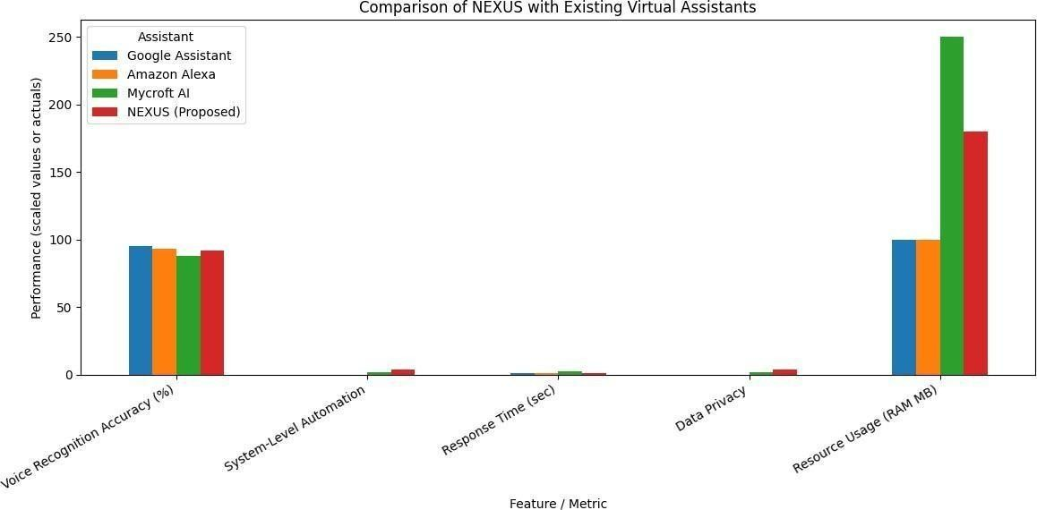

Fig 1: Comparison of NEXUS with existing virtual assistants

- Related Work

The use of intelligent virtual assistants (IVAs) has drastically improved human-computer interaction with such devices as Google Assistant, Amazon Alexa, and Apple Siri as they allow communicating with humans in a natural manner, using their voices, and also can just be easily integrated with devices, be they mobile or IoT-based [3], [9]. Although they have impressive abilities, they are largely cloud-based and thus endanger privacy and cannot be easily adapted to desktop-based environments [6], [10].
To close this divide, a variety of open-source initiatives, such as Mycroft AI and other J.A.R.V.I.S.-inspired platforms, have been created, which can be customized and supported by the community to be used on the desktop [6], [7]. Despite being more open-
minded and modular, these tools can be complex to set up, require reliance on remote servers, or even lack fundamental automation capabilities, like system monitoring and control of local applications [7], [10].

Natural Language Processing (NLP) and Computer Vision (CV) have recently created developments, leading to improved speech-based and vision-based interfaces [1], [2], [8], [11], [12]. Nevertheless, the majority of previous systems focus on single functionalities, such as speech recognition or facial recognition, with no way of integrating it into a single intelligent system [6], [9].
The proposed NEXUS assistant will touch upon these

drawbacks by integrating voice recognition, facial recognition, real-time data query and desktop

automation in a locally optimized system [6], [8], [10], [11], [12]. This combined design allows performing an operation efficiently and with privacy without using any external cloud services.

According to the comparative analysis in Figure 1, it is evident that NEXUS has a local accuracy of voice recognition of approximately 92 percent, which is very close to the cloud-based applications such as Alexa and Google Assistant. In contrast to the conventional IVAs that are not system-controlled, NEXUS supports launching of the application and desktop control entirely, which has real performance and user freedom advantages.
NEXUS performs at a notably lower efficiency of 1-2 second response times and 180 MB of RAM, which is far lower than Mycroft AI (250MB). These measurements reflect that the system manages to achieve a good balance between speed, reliability, and optimization of resources, and it is a strong option when the users want a smart, locally deployed virtual assistant.
- System Architecture

The design of the NEXUS architecture is created as a user-friendly, scalable and modular architecture, which helps in the intelligent communication between the user and the desktop environment. It incorporates speech processing, computer vision, automation, system monitoring and a special web interface into a unified assistant design. The architecture can be split into six major parts:

- Input and Recognition Layer.

The layer also allows multimodal user input, mainly voice commands. The system uses a SpeechRecognition library in order to record the speech of the user through a microphone and translate it into executable text commands. NEXUS, moreover, has facial recognition features based on OpenCV and Haar cascade classifiers [8], [12]. In contrast to rigid authentication systems, this option improves the level of user interaction and personalization without compulsory verification.

- Command Processing Layer

After the input of the user is translated into a textual format, it is then processed by a command processor
that transforms the input into existing tasks. This layer acts as the decision-making processor that directs commands to modules that are applicable like local system utilities, web-based queries, or API requests. Its modular design enables adding new commands with a minimum of reconfiguration enhancement of scalability.

- API and Automation Layer

This layer is concerned with performing automation and voice-based feedback. The system does not require any intermediaries to process commands and execute the necessary actions in case of browser-related tasks, including playback on YouTube, WhatsApp messaging, or Google searches. Pyttsx3 library brings out the speech output and therefore the assistant can relay the results and responses in real-time. This layer enables a seamless and interactive user experience because it can combine command execution and text-to-speech feedback.

- System Utility Layer

This layer handles the supervision of critical sites of system performance like CPU load, memory and battery status. It will help to prevent problems with managing the system proactively by giving real-time updates and notifying users about surpassing thresholds to make the system more reliable. This advantage is an added benefit compared to traditional assistants which can generally not integrate host-level diagnostics [10].

- Output and Feedback Layer

NEXUS provides feedback to the users in both audio and text form. Pyttsx3 library is used in the synthesis of text to speech, which is important to make assistant responses, status updates, and alerts sound as natural and hands-free. This is a continuous feedback loop which makes the interaction more intuitive.

- Web Access and Control Panel

A specialized NEXUS website is created to make it more user-friendly and convenient. It is an interactive gateway, which allows the user to invoke or to connect with the NEXUS virtual assistant as well as to directly give commands by the means of a web interface.The

most important functions of the web site are:

  - Giving a point of entry into NEXUS.
  - Providing general facts and application policies.
  - It enables the users to run the commands
directlythrough the embedded web interface.

The site has been written in HTML, CSS, and JavaScript and the back-end is using Flask API to enable communication between the browser and the assistant application. This solution does not use the conventional, static portals, but rather allows direct interaction so that the user can control NEXUS without any problems using the web interface.
The interactive design not only enhances deployment and usability but NEXUS can be deployed with only a single click and the user, in particular organizational or academic users, can adapt and use the assistant swiftly.

This multi-layered system architecture allows NEXUS to be a smart, secure, and multi-platform virtual assistant, which can be used to increase the productivity of desktops and provide remote access via its web interface.

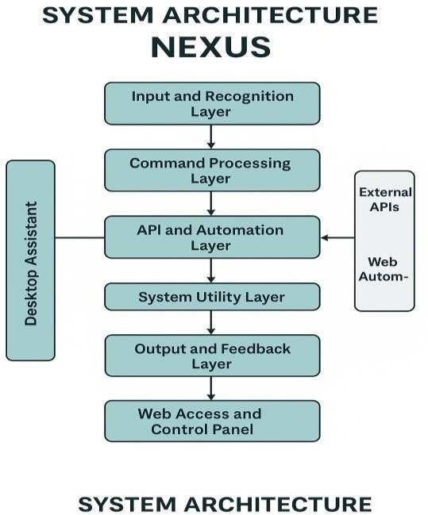

Fig. 2: System architecture of the NEXUS: A Multifunctional AI-based Virtual Assistant

- METHODOLOGY

NEXUS development was done in a structured and
modular manner to make it functional, scalable, and maintainable. The manner of conducting the research is broken down into major steps:

- Requirement Analysis
Assuming that the main functions of a smart virtual assistant needed on the desktop could be listed, the initial step was the identification of the essential features required in the project. Voice interaction, facial recognition, real-time updates, system monitoring, and accessibility were selected by previous studies as the key elements of an intelligent assistant [6], [7], [10].

- Technology Selection

Following technologies were chosen based on functionality, compatibility as well as developer support:

  - Core development Python, used in the field of AI research as a result of a strong ecosystem [2].

  - Voice input and voice output, Speech Recognition and pyttsx3, which is compliant with the best practices in speech-to-text and text-to-speech systems [9], [11].

  - OpenCV facial recognition, which is based on the existing computer vision techniques [8], [12].

  - Web automation web browser, used in virtual assistant research that is automation-based [7].

  - Web interface: HTML,CSS, JavaScript and Flask API, as well as a responsive and user-friendly gateway [6].

- Module Development

NEXUS features are added as modules each to enable easy debugging and subsequent upgrades:

  - Voice Command Module: Processes and captures spoken commands, which is a reflection of the NLP-driven interaction systems [1], [9].
  - Face Recognition Module: This is an OpenCV and Haar cascade module that recognizes and identifies faces, but it is not designed to be security-related [8], [12].

  - Task Automation Module: This runs commands such as application opening or web search as had been previously implemented in desktop assistants [6], [7].

  - API Integration Module: Allows the execution and interaction directly by the web interface with a Flask backend [10].

  - System Monitoring Module: Reports CPU, memory, battery status, enhancing the awareness of the user about the health of the device [10].

  - Web Interface Module: : The interface will enable users to start NEXUS and command it through a browser based interface that can be supported by Flask [6].

- Integration and Communication

Every module was incorporated into a single controller with Python classes and function calls. The inter-module communication was controlled by a central dispatcher to flow tasks across voice commands, the processing logic and output generation [2], [7].

- Testing and Optimization
Each of the modules was unit tested and then the entire system was integrated tested. The accuracy of voice recognition and reliability of face detection were tested in various conditions of the environmental factors, backed by the results of the study of the speech and vision systems [1], [3], [11]. To minimize the use of the system resources, performance tuning was done and the system operated smoothly even on the resource-constrained devices [6], [10].
- Results

The NEXUS assistant was put into trial in terms of performance, functionality and efficiency in a variety of use scenarios on various desktop environments. Testing involved the unit level and integrated testing of the assistant when it came to the key modules.

- Functional Validation

Each of the planned features was implemented and tested successfully, as other studies on intelligent assistants had demonstrated [6], [7], [10]:
  - Voice Command Implementation: Correctly carried out operations like opening applications, web searching and reading documents.

  - Face Recognition: The user faces were detected and identified with the Opencv Haar cascades [8], [12].

  - Real-Time Data Retrieval: Retrieved and displayed weather information, news, and calendar information using external APIs.

  - System Monitoring: Reported CPU, RAM and battery status successfully.

  - Web Interface: It was to have a responsive web site to initiate commands remotely.

- Performance Evaluation
The major indicators noted in the execution of the system are summarised below:
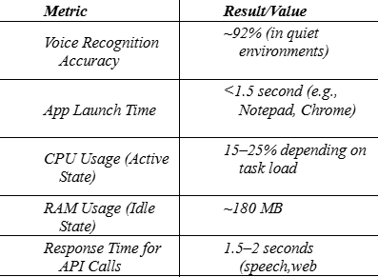

These findings are comparable to the benchmarks that can be found in other related studies of desktop-assistants and system responsiveness is verified in typical workloads [6], [10].

- System Compatibility

  - Tested Operating Systems: Windows 10, MacOS.
  - Python Versions: 3.8, 3.10
  - Browser Support: Chrome, Firefox.

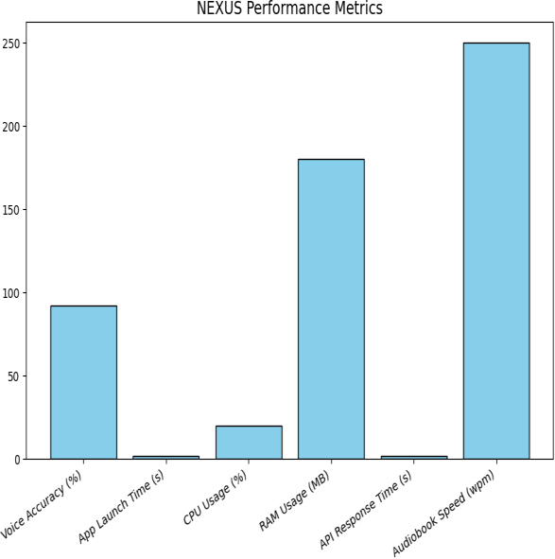

Fig 3: NEXUS performance indicators.

The findings are that NEXUS is a stable and multi functional assistant that provides value-stable performance and a smooth user experience in a normal use environment.

- Discussion

NEXUS design and simulation prove that the construction of a desktop-based multifunctional assistant was possible with the help of open-source frameworks and modular design principles [6], [7], [10]. The system illustrates that speech recognition, computer vision, tasks automation, and monitoring the system can be properly combined in order to make desktops productive.
The voice command was the most influential system as it made hands-free working and easy interaction possible. Although the accuracy was above 90 percent during quiet conditions, in noisy conditions the performance reduced, which is in line with the previous results regarding speech interfaces [1], [11]. It means that better noise reduction or offline ASR (automatic speech recognition) models should be used to be much better resistant.
Although face recognition was not used in authentication, it was able to provide increased personalization and user interaction. It was affected by the quality of lighting and cameras, which is also a limitation identified in other applications of the same computer vision [8], [12]. Although these limitations exist, it has had valuable interaction services as an additional module.
The API integration layer allowed automation of activities executed on the browser like playback of
videos on YouTube, chatting on WhatsApp, and searching Google. This was to provide dynamism in relation to interaction with online services and ensure modular extent.

The web access module gave a direct browser based interface that enabled a user to not only start NEXUS, but also to execute commands in a simple and easy to reach portal. It was built with HTML, CSS, JavaScript and Flask as a backend to expand the functionality of the assistant outside the desktop to enhance accessibility and user onboarding.
On the whole, these findings point to the fact that privacy-oriented, local-first assistants are both realistic and beneficial, especially in the context of academic and organizational work where data privacy is essential. Compared to the existing solutions, which are commercial depending on a cloud, NEXUS focuses on control and modularity that makes it a strong contender to alternative solutions.

- Conclusion

The given work introduced the design and development of NEXUS, a multifunctional AI-based desktop assistant that unites the voice interaction, face recognition, task automation, real-time data retrieval, system monitoring, etc., into a single platform. In contrast to traditional assistants which concentrate mostly on mobile and IoT ecosystems [3], [9], NEXUS proves how far it is possible to extend the intelligent assistant technology to desktop ecosystems with a high level of privacy and modularity [6], [7], [10].
The system was also integrated with open-source software, such as Python, OpenCV, Speech Recognition, pyttsx3 and Google APIs and thus makes it extendable and affordable. A companion site was also created that is lightweight to make the process of onboarding and interaction with users simple hence enhancing accessibility in academic and organizational contexts.

It was experimentally proven that NEXUS can work under regular desktop conditions and be highly accurate in speech recognition in acoustically favorable scenarios and respond to modules with acceptable response times. Shortcomings were seen in noisy settings and services that are dependent on APIs, which are in line with difficulties reported in previous literature [1], [11]. The latter problems indicate that better NLP pipelines, noise-resistant ASR models, and local caching mechanisms

are required in future iterations.

Altogether, NEXUS confirms the idea of a privacy-focused, desktop-friendly virtual assistant, which can be used by students, professionals, and developers to be more productive. As it continues to develop, with better context and multimodal emotion recognition, and increased remote control, it can transform into an all-encompassing intelligent assistant that fills the gap between commercial cloud-based IVAs and local-first solutions that a user can control.
- Future Work

The current version of NEXUS establishes a solid foundation as a desktop-based AI assistant; however, there remain opportunities to extend its intelligence, interactivity, and scalability in future iterations:

- Face Recognition for Attendance: Extending the facial recognition module to support automated attendance marking in academic and organizational environments. This feature could streamline record-keeping, reduce manual effort, and improve accuracy in user identification.
- Offline and Low-Resource Capabilities: Incorporating offline voice recognition and TTS models will reduce dependency on internet-based services, enhancing both privacy and usability in secure or remote environments [6], [10].
- Cross-Platform Support: Extending compatibility to macOS and Linux, in addition to Windows, will broaden adoption and benefit open-source and research communities.

- Emotion and Sentiment Recognition: Leveraging facial expression analysis and prosody-based speech models could allow NEXUS to adapt responses dynamically to user emotions, enabling more empathetic and human-like interaction [2], [8].

- Remote Device Synchronization: Mobile applications and cloud synchronization may be developed to enable remote control, task scheduling, and system monitoring across devices.

- Voice Biometrics for Authentication:
Combining voice biometrics with face
recognition would provide multi-factor, password-less authentication, increasing system security in sensitive environments.

- Machine Learning for Personalization: Behavioral modeling and reinforcement learning can be applied to anticipate user needs, recommend actions, and deliver adaptive, personalized experiences over time [3], [4].

References

- Y. LeCun, Y. Bengio, and G. Hinton, "Deep learning," Nature, vol. 521, no. 7553, pp. 436–444,
May 2015.

- S. Russell and P. Norvig, Artificial Intelligence: A Modern Approach, 4th ed. Hoboken, NJ, USA:
Pearson, 2020.

- A. Esteva, B. Kuprel, et al., "Dermatologist-level classification of skin cancer with deep neural networks,"Nature, vol. 542, no. 7639, pp.
115–118, Feb. 2017.

- D. Silver, A. Huang, et al., "Mastering the game of Go with deep neural networks and tree search," Nature, vol. 529, no. 7587, pp. 484–489, Jan. 2016.

- E. M. Bender, T. Gebru, et al., "On the dangers of stochastic parrots: Can language models be too
big?," in Proc. 2021 ACM Conf. Fairness, Accountability, and Transparency (FAccT), pp. 610–623, 2021.

- R. Supe, S. Deshmukh, and A. Jadhav, "ARIA: An AI-powered desktop virtual assistant," International Journal of Computer Applications, vol. 182, no. 35, pp.28–33, 2019.

- V. Kumar and N. Aggarwal, "Design and development of an intelligent virtual assistant for desktop automation," International Journal of Engineering Research & Technology (IJERT), vol. 9, no. 7, pp. 186–192, 2020.

- P. Viola and M. Jones, "Rapid object detection using a boosted cascade of simple features," in Proc. IEEE Conf. Computer Vision and Pattern Recognition (CVPR), vol. 1, pp. I–511–I–518, 2001.

- M. McTear, Z. Callejas, and D. Griol, The

Conversational Interface: Talking to Smart Devices, Springer, 2016.

- A. K. Das and D. Bandyopadhyay, "Developing desktop-based personal assistants using Python: Challenges and opportunities," International Journal of Artificial Intelligence & Applications (IJAIA), vol. 12, no. 4, pp. 45–57, Jul. 2021.
- Google Developers, "Speech-to-Text API Documentation,"[Online].Available: https://cloud.google.com/speech-to-text/docs. [Accessed: Aug. 10, 2025].

- OpenCV.org, "OpenCV: Open Source Computer VisionLibrary,"[Online].Available: https://opencv.org/. [Accessed: Aug. 10, 2025].

