Circuit Lab Test Place: ____

Central Regional, PA

Written By: Justin Keenan

Run By: State College High School

School Name: ________________________________

School Number: ________________________________

Students Name: ________________________________

________________________________

BOX ALL ANSWERS

This test is designed to be long and difficult, it is advisable to use all of your time.

The point value for each question is 2 points for each multiple choice answer or it will otherwise be marked.

Tiebreakers will be marked with (T1) for the first tiebreaker, (T2) for the second and so on.

You may detach the test; just reattach it at the end.

The test will be broken up into 2 sections, a lab section, and a general questions section.

In addition if you can identify the picture on the cover you will get extra credit, put your answer at the end in the designated spot

**Good luck!**

1. What is an Ampere in BASE SI units? (2 point)

Ampere is a Base SI unit

1. What is a mho? (2 point)

Unit of Conductance (reciprocal of resistance)

1. What is the resistance of a resistor with the colors (Green Brown Violet Gold)? (2 points)

51 Mega-Ohms +/- 5%

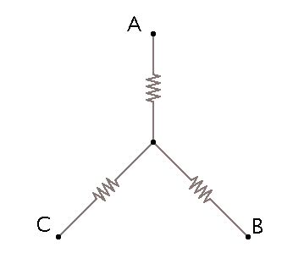

1. The circuit to the left is inside of a black box, you measure the resistance between AC, AB and BC and get: AC = 25 ohms. AB = 35 ohms and BC = 50 ohms. What is the value of each of the resistors? Name them Resistor A, Resistor B, and Resistor C according to their closest Node. (4 Points)

a = 5

b = 30

c = 20

4b) Redraw the circuit in 4 as a Delta configuration with the same nodes A,B,C and solve for the resistors. (4 points)

Rp = 5*30 + 5*20 + 20*30 = 850 ohms

R(AB) = 850 / 20 = 42.5 ohm

R(BC) = 850 / 5 = 170 ohm

R(AC) = 850 / 30 = 28.3 ohm

1. Are appliances in your house hooked up in series or parallel? Why? (3 Points)

Parallel – so that if one breaks, it doesn’t cut off power to the rest of the house

1. In the circuit below solve for the current through the resistor labeled. You may assume each resistor has a resistance of 100 Ohms and the battery has a Voltage of 10 Volts?(3 Point)

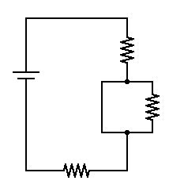

0 Amps – No current, it’s in parallel with a short

/7

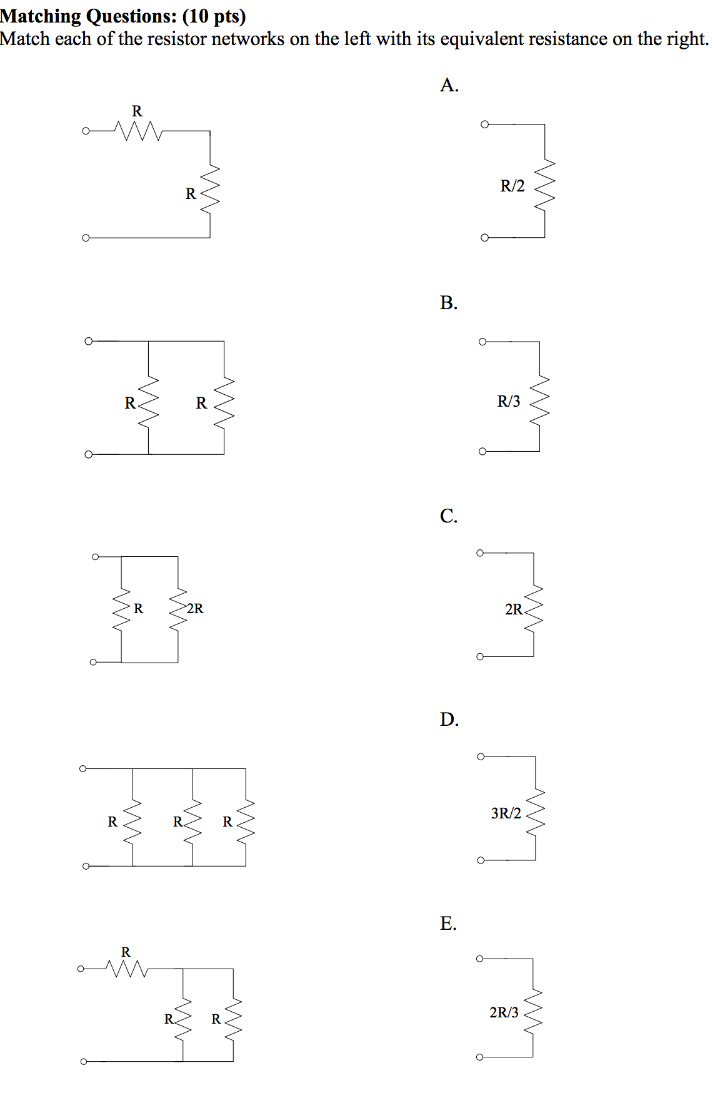

7)

C

8)

A

9)

E

10)

(1/2R*R)/(3/2R) = 1/3R – B

11)

D

12) Determine the equivalent resistance Req across terminals (a, b). – C 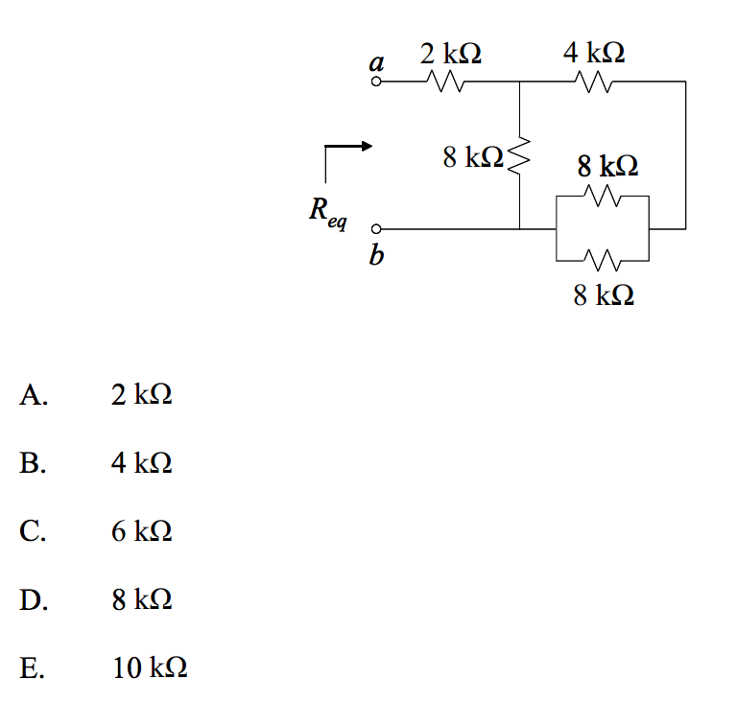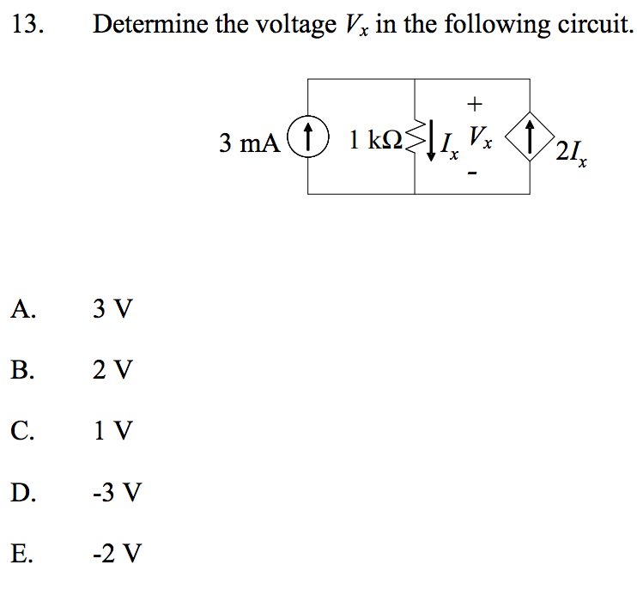

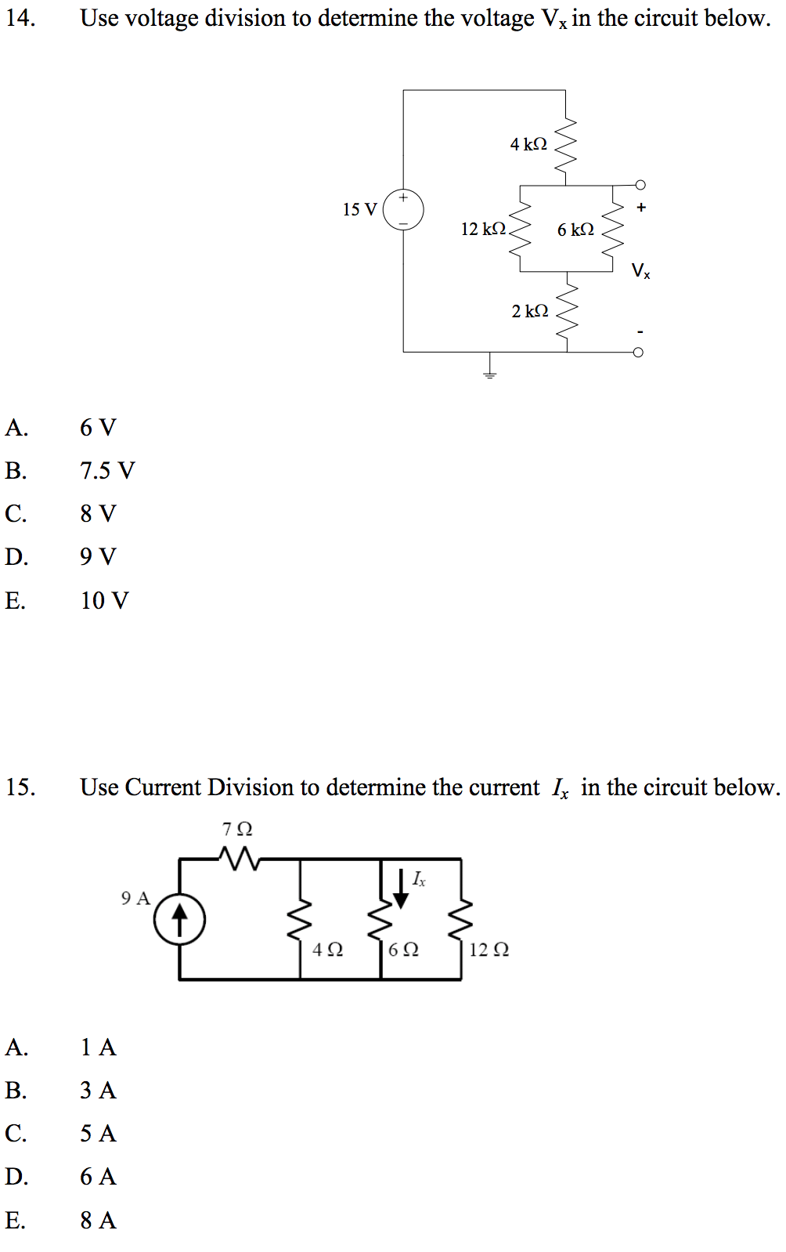

D

B

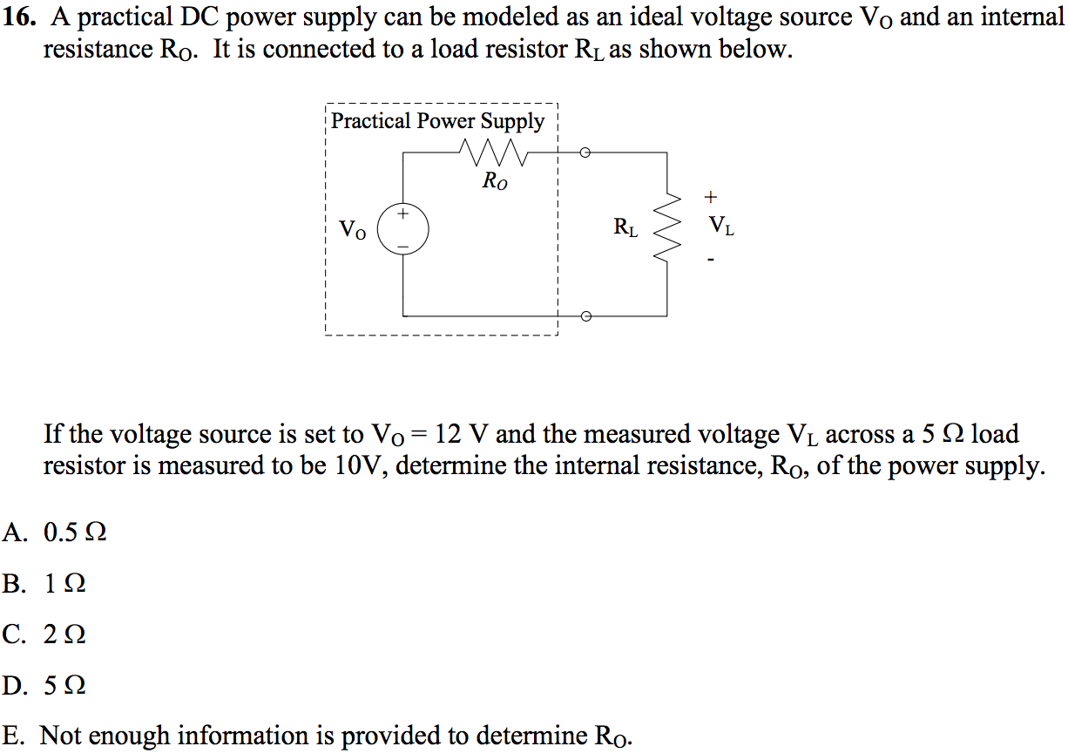

B

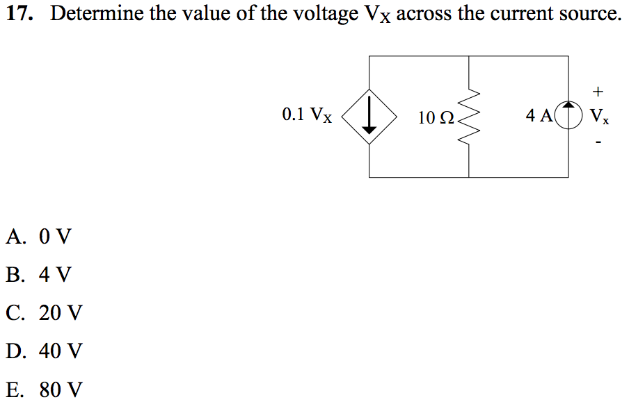

This Problem is worth 4 points and is (T1)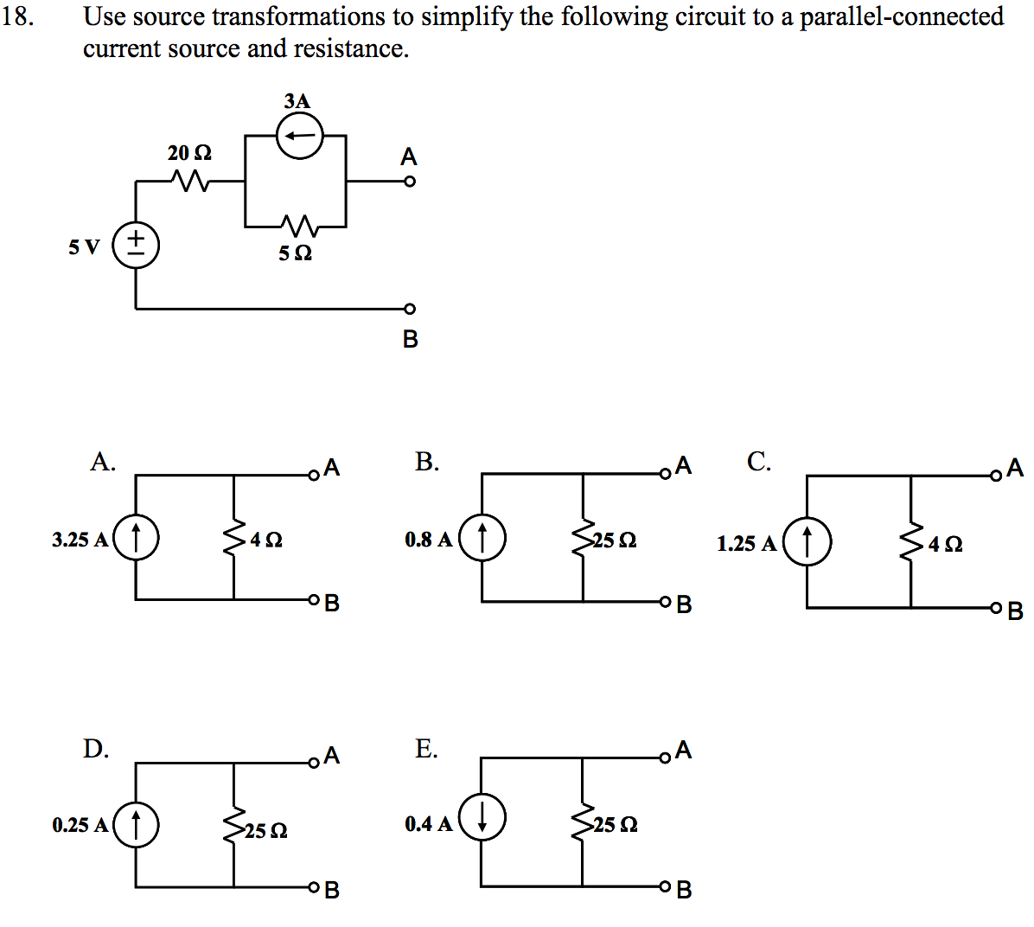

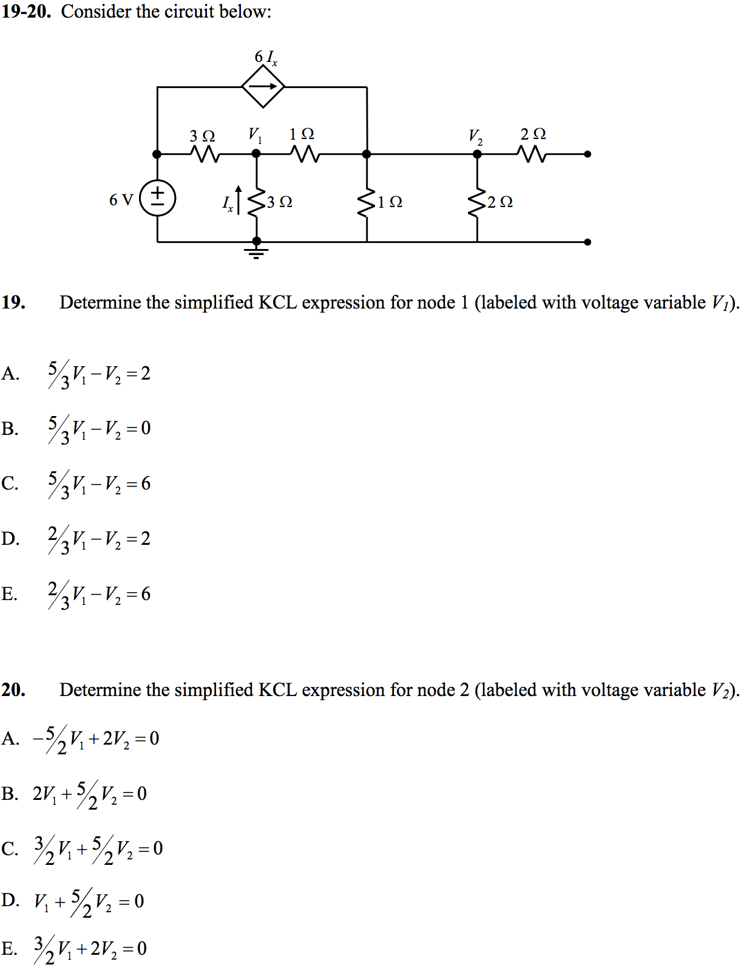

21) (T5) We have a galvanometer that has maximum deflection at 1mA, and resistance 250 Ohms.

Using this galvanometer and any resistor values needed, design and draw a voltmeter that has maximum deflection at 15V. What is the total resistance of this voltmeter? (5 points)

(T3) Using this galvanometer and any resistor values needed, design and draw an ammeter that has maximum deflection at 5A. What is the total resistance of this ammeter? (5 points)

22) (T4) Discharging capacitor problem: The Capacitor is not charged at time t = 0s.

At t = 0s switch S1 is closed.

At t = 5000s S1 is opened, and S2 is closed.

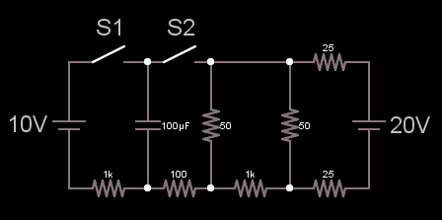

What is the Voltage across the Capacitor at t=0.2s? (2 points)

V = 10 V(1 – e^-(t/RC)) =

10V (1 – e^(-t/(100*10^-6 * 1000)) = 10V(1 – e^(0.2/0.1) = 10V(1 – e^(-2)) = 10 V (.864) = 8.64 V

Redraw the circuit at t = 5000s with a Thevenin Equivalent. (4 points)

VTHEV =

RTHEV =

What is the new time constant for this circuit? (2 point)

C*R(thev)

What is the voltage across the Capacitor at t = ∞? (2 point)

VTHEV

23) In the circuit below:

Voltage applied is = 15V. Ra = 20 Ohms, Rm = 2 kOhms, Rn = 6 kOhms.

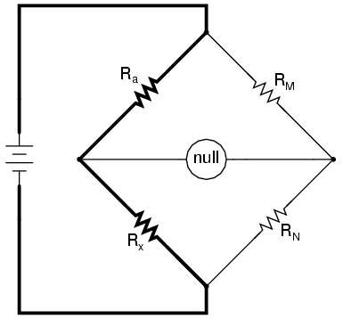

Find Rx such that the null detector measures null. (2 points)

Ra/Rx = RM/RN

Rx = RN/RM*Ra = 6000 / 2000 * 20 = 60 ohms

Replace the null detector with a load and calculate the Thevenin equivalent.

Use the value of Rx that you calculated above. (6 points)

Vthev =

Rthev =

(T1) Now set this load to a Voltage source with V = 100V. What is the current supplied by this voltage source? (2 points)

24) (T2) What is the Voltage at Va? (10 points)

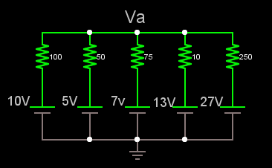

25) Calculate the Equalvalent Resistance of the circuit below. The Circuit repeats the same pattern an infinite amount of times (such that the section A-B is connected to B for a infinite amount of times). (10 points)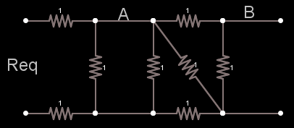

26) (T3) Write the logic formula for C and D (not Simplified). (6 points)

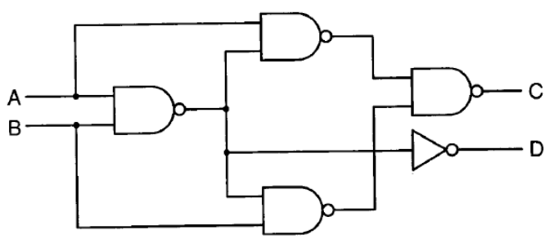

Write the Logic formula for C and D as simplified as possible. (4 points)

27) Create a OR gate using only NOT and AND gates. (4 points)

28) Create a AND gate using only NOR gates. (4 points)

29) Create a AND gate using only NAND gates. (2 points)