Reducing Stockouts and Order Hold Losses through Sales Analysis for a Fashion Jewellery Retailer
A Proposal report for the BDM capstone Project
Submitted by
Name: Ritoma Nandi
Roll number: 23f3001843


IITM Online BS Degree Program,
Indian Institute of Technology, Madras, Chennai
Tamil Nadu, India, 600036

Declaration Statement
I am working on a Project Title “Optimising Inventory Management and Sales Performance for Zane Lifestyle, Kolkata”. I extend my appreciation to Zane Lifestyle, for providing the necessary resources that enabled me to conduct my project.
I hereby assert that the data presented and assessed in this project report is genuine and precise to the utmost extent of my knowledge and capabilities. The data has been gathered through primary sources and carefully analysed to assure its reliability.
Additionally, I affirm that all procedures employed for the purpose of data collection and analysis have been duly explained in this report. The outcomes and inferences derived from the data are an accurate depiction of the findings acquired through thorough analytical procedures.
I am dedicated to adhering to the information of academic honesty and integrity, and I am receptive to any additional examination or validation of the data contained in this project report.
I understand that the execution of this project is intended for individual completion and is not to be undertaken collectively. I thus affirm that I am not engaged in any form of collaboration with other individuals, and that all the work undertaken has been solely conducted by me. In the event that plagiarism is detected in the report at any stage of the project’s completion, I am fully aware and prepared to accept disciplinary measures imposed by the relevant authority.
I agree that all the recommendations are business-specific and limited to this project exclusively, and cannot be utilized for any other purpose with an IIT Madras tag. I understand that IIT Madras does not endorse this.

Signature of Candidate:
Name: Ritoma Nandi
Date: June 1, 2026

Contents
1 Executive Summary 4
2 Organisation Background 4
3 Problem Statement 4
Problems Identified: 4
3.1 Objective 1: Sales and Inventory Performance Analysis 4
3.2 Objective 2: Unconfirmed Order Hold Management 5
4 Background of the Problem 5
5 Problem Solving Approach 5
5.1 Methods Used 5
Sales and Inventory Performance Analysis 5
Unconfirmed Order Hold Management 5
5.2 Intended Data 5
5.3 Tools for Analysis 6
6 Expected Timeline 6
6.1 Project Timeline and Milestones 6
6.2 Work Breakdown Structure (WBS) 7
6.3 Gantt Chart 7
7 Expected Outcome 7

1 Executive Summary
Zane Lifestyle is a fashion accessories and jewellery retailer for individual consumers founded two years back in Kolkata, West Bengal, specializing in anti-tarnish earrings, bracelets, necklaces, and rings for women aged 18-45. Zane Lifestyle uses both a brick-and-mortar shop and Social Media to sell their merchandise while delivering orders through Indian Post and DTDC. They sell under brand name Vanki.

The key business problems faced by the firm are the nonexistence of any inventory management systems digitally and lack of information on sales performance. Consequently, there is overstocking of underperformers and risks associated with out-of-stock items as fast movers. Further, it is impossible to predict how well the firm would perform in seasonal peaks such as Durga Puja and weddings without having such analytical information at hand. At present, all data about transactions are kept manually through invoices as well as Social Media chat conversations.

Issues will be resolved through analysing transaction data gathered for three months (March – May 2026) using MS Excel. Analysis will focus on methods like ABC classification based on product revenue contribution, sales velocity analysis to determine reorder points, and Pareto analysis to highlight the best-performing top 20% products accounting for 80% of the total revenue. Expected result will be a series of recommendations based on collected and processed data as well as a useful Excel dashboard for making future decisions.

2 Organisation Background
In Kolkata, West Bengal, where celebrations never cease, Zane Lifestyle was founded two years ago. The concept behind the company was simple enough; every lady requires affordable yet durable and elegant jewellery pieces.
Zane Lifestyle operates with a dual-channel approach in its retail operations, as it offers its products through the conventional way in their single physical outlet while also making use of Social Media for the same. Indian Post and DTDC ensure that the delivery services remain swift and seamless. The category of products available is fivefold; namely, earrings, bracelets/bangles, necklaces, rings, and ear cuffs. These products are made from anti-tarnish metals that can withstand time well.
The typical buyer persona for this brand includes working women aged between 25-40 years. They shop online as well as through physical visits, and make purchases worth Rs. 300-400 each visit. An average return rate of just 1-2% shows that their customers can trust the brand completely. Durga Puja and wedding seasons see the highest demands for these products.

3 Problem Statement

Problems Identified:
- Currently, all inventory decisions are intuition-based with no digital records, which causes overstocking of slow-moving items and stockouts of high-demand products during peak seasons like Durga Puja and weddings.
- No hold deadline exists, blocking inventory from other buyers and resulting in lost sales opportunities.

3.1 Objective 1: Sales and Inventory Performance Analysis
To identify fast and slow-moving products and seasonal demand patterns through structured sales data analysis.
Data Required: Product-wise sales quantity, opening/closing stock, buying and selling price, seasonal demand, and supplier lead time.

3.2 Objective 2: Unconfirmed Order Hold Management
To assess the financial impact of informal stock reservations caused by payment-unconfirmed orders.
Data Required: Number of unconfirmed orders, duration of stock held, value of inventory blocked, and lost sales instances.

4 Background of the Problem
Zane lifestyle is a micro enterprise in the informal sector that sells products of the lifestyle mostly via Social Media communication and along with informal customer networks in India. Over the past two years, as the product range and order volume have grown, which has led to informal working practices that are not efficient for effective small business management.
Two internal problems were identified during the initial consultation on 01 June 2026. First, the absence of digital inventory system leading to intuition-based purchasing decisions rather than data which results in overstocking of slow-moving items and stockouts of popular ones. Not maintaining sales records makes it impossible to anticipate demand spikes especially during high sales periods such as Durga Puja or wedding seasons. Second, customers keep products on hold cause of no payment deadlines resulting in tying up stock and restricting availability to other buyers.
Zane Lifestyle being an Indian micro enterprise faces the typical limitations of one including limited access to formal financial tools, unpredictable consumer demand, and reliance on social trust networks rather than contractual agreements. Research on small business management in developing economies shows that introducing ABC inventory classification and systematic sales trend analysis can substantially reduce overstocking costs in similar contexts.
This project applies that methodology to Zane Lifestyle's operations.

5 Problem Solving Approach
Zane Lifestyle faces operational inefficiencies that are limiting its growth and profitability. The following structured approach will be used to address the identified problems.

5.1 Methods Used

Sales and Inventory Performance Analysis
- ABC Analysis to classify all SKUs into three tiers: A (top ~70% revenue), B (next ~20%), and C (bottom ~10%) to prioritise restocking decisions.
- Sales velocity analysis to determine how frequently each product appears in orders and average quantity sold for reorder planning.
- Month-wise revenue aggregation plotted as a time-series line chart to identify seasonal demand peaks such as Durga Puja and wedding seasons.

Unconfirmed Order Hold Management
- Hold duration tracking by recording how long stock remains informally reserved per incident along with the corresponding value withheld, captured through discussion with the owner and validated against order records.
- Lost sales opportunity cost estimation to quantify the financial impact of informal reservations, forming the basis for recommending a formal hold deadline policy.

5.2 Intended Data
The primary data (invoice images) for this project has been collected directly from the business owner of Zane Lifestyle during an online meeting held on 01 June 2026. The dataset covers sales orders from March 2026 to May 2026 and includes the following fields: Order ID, Order Date, Number of Products per Order, Product Name, Product Category, Quantity, Unit Price, Total Order Amount, Payment Method, and Return Status.
The initial data collection had been carried out using paper invoices and Social Media records. This data has now been digitized in an Excel file format. Another meeting has been scheduled to confirm the dataset and capture any missing records. The following variables which have not yet been captured include Customer ID, Delivery Status, Supplier Details, and Processing Time.
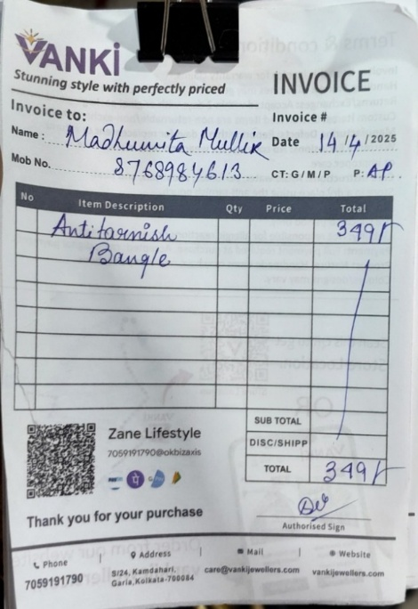
Figure 5.1: Collected Invoice

5.3 Tools for Analysis
Microsoft Excel will be the primary analysis tool for this project. The choice is justified on the grounds that Excel is accessible to the business owner and can be handed over as a usable, self-contained dashboard after the project concludes. Excel’s pivot tables, SUMIF/COUNTIF functions, and charting capabilities are well-matched to the dataset size (100 orders, approximately 150-line items). Specific tools to be used include:
- Pivot Tables – for category-wise and month-wise revenue and order frequency aggregation.
- Bar and Column Charts – for comparing category performance and payment method breakdown (shows frequency across different values).
- Line Charts – for monthly revenue trends (shows change over time).
- Pie Charts – for category revenue share as a proportion of total (shows part of a whole).
- Conditional Formatting – to highlight high-priority SKUs in the ABC classification.
- VLOOKUP and SUMIF functions – for data merging, validation, and aggregation during the cleaning phase.

6 Expected Timeline

6.1 Project Timeline and Milestones
- Business Meeting & Data Gathering: June 01, 2026
- Data Digitization and Cleaning: June 01 – June 04, 2026
- Submission of Proposal: June 11–13, 2026
- Exploration of Data through ABC Analysis: July 2026 (Mid-term Stage)
- Trend Analysis & Insights Generation: August 2026 (Final Stage)

6.2 Work Breakdown Structure (WBS)
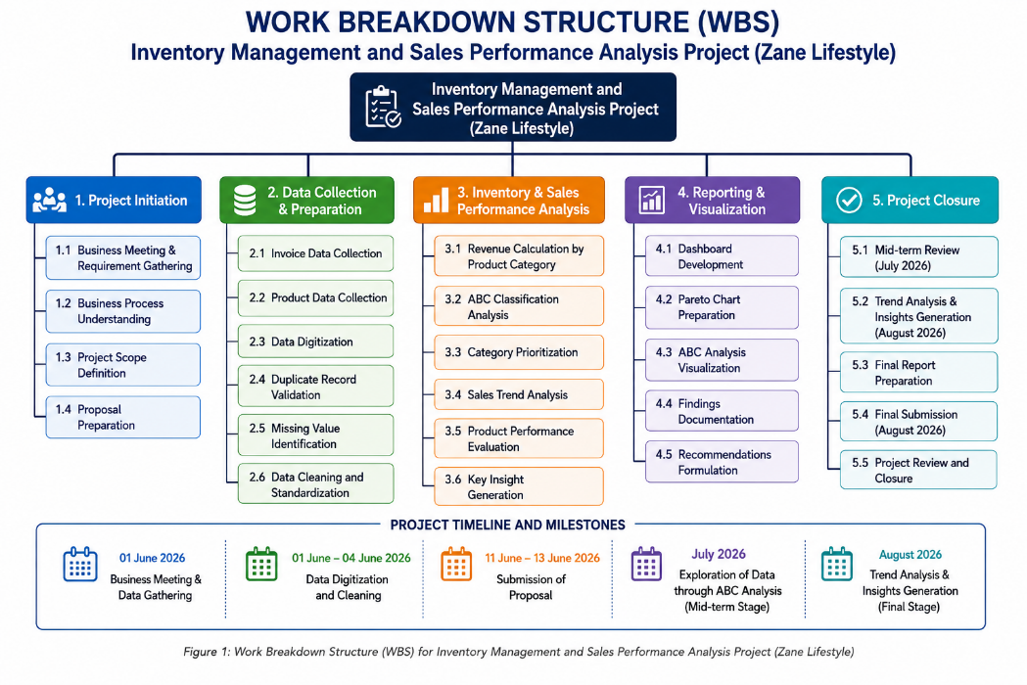
Figure 6.1: Work Breakdown Structure (WBS) for Inventory Management and Sales Performance Analysis Project

6.3 Gantt Chart

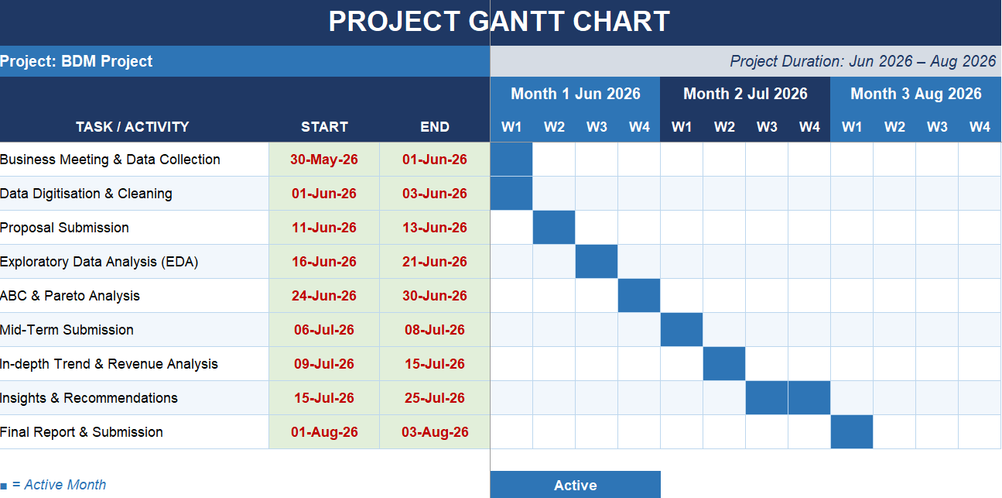
Figure 6.2: Gantt Chart for Inventory Management and Sales Performance Analysis Project

7 Expected Outcome
In undertaking this project, the intention is to put into practice the concepts covered during the Business Data Management theory course. This will be done by analysing actual business information in the hope of making conclusions and drawing actionable insights for Zane Lifestyle’s decision maker. After successfully completing this project, the following will have been achieved:
7.1 An ABC classification of all product SKUs and their respective categories for use by the owner in deciding on inventory management priorities.
7.2 A seasonal demand schedule for determining which months are high revenue months as well as lead times for stock up before the festive season.
7.3 Pricing strategies based on order values analysis and category wise performance analysis.
7.5 Creation of an easy-to-use Excel dashboard tool which will allow the owner to track sales and inventory on his own.

