File creation :

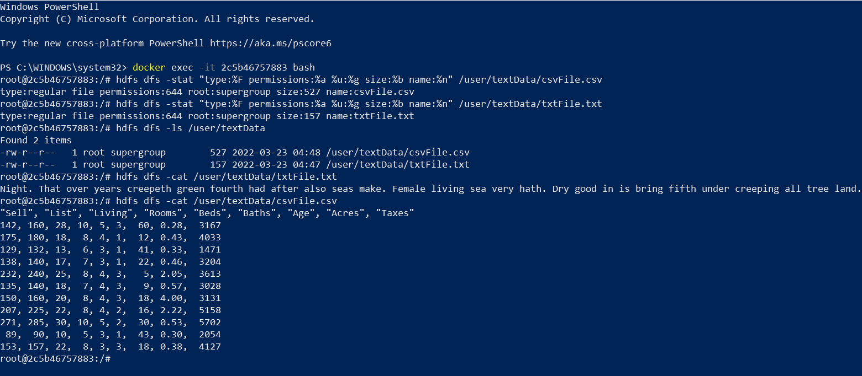

To move files from container to your local machine

