Since 1876
Rank 35 of 100
24,414 $M (2014)

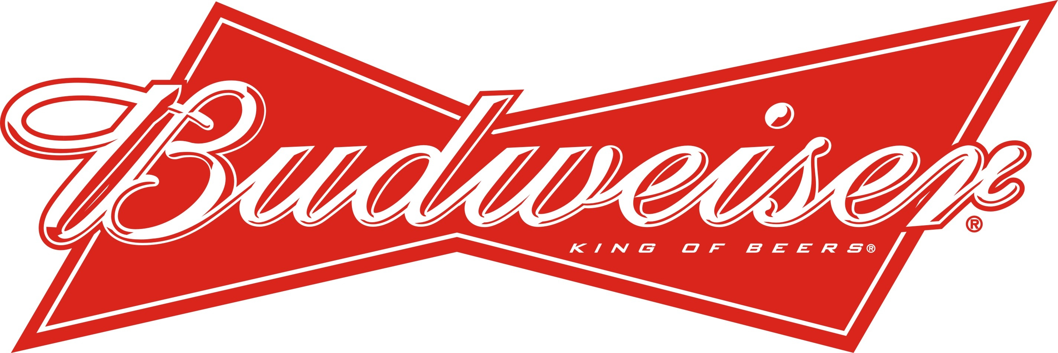

available in 80 markets
worldwide
12 breweries in
US

Budweiser
About
Budweiser is an lable of the American Brewery Anheuser–Busch InBev which was founded in 1876. It is one of the best selling beers in the US and also available in 80 other markets all over the world. Budweiser is Rank 35 of 100 most valuable brands in 2014. The value of Budweiser is 24,414 Million Dollar.
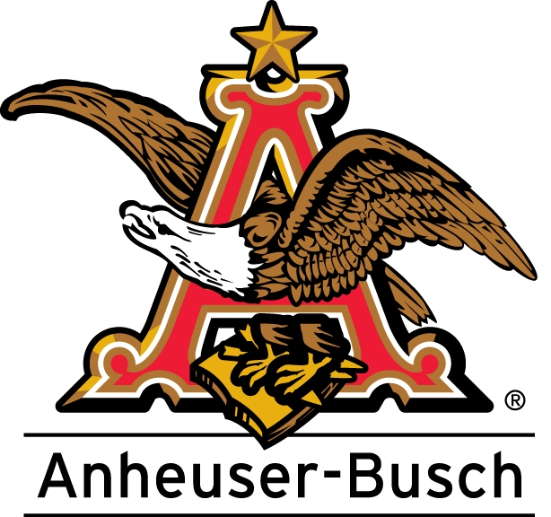
History
In 1857 a master brewer called Adolphus Busch left Germany and settled in St. Lois/USA. He soon married
Lilly Anheuser. Her father owned a small brewery and in 1864 Busch partnerd with his father in law,
Anheuser-Busch Company was born. 1870 Anheuser-Busch became the first American brewery which
implemented pasteurization. 1876 Budweiser was introduced as an brand of Anheuser-Busch, Budweiser
was a light Bohemian lager beer. 1920 they had to suspend brewing beer because of the bad financial
situation therefore they launched a range of non-alcoholic products. 1933 Anheuser-Busch began brewing
Budweiser again. 1936 Budweiser’s sales began to climb again which was caused of the introduction of
can-beer. August A. Busch Jr. became president of Anheuser-Busch in 1946 and from 1951 to 1976 nine
breweries opened. 2008 InBew bought the majority of Anheuser-Busch.

Products
- Budweiser King of Beers (lager beer, 5%)
- Black Crown (lager beer, 6%)
- Chelada (spiced lager beer, 5%)
- Select (light lager beer, 4,3%)

The Beer
Budweiser is brewed using barley malt, rice, water, hops and yeast. It is lagered with beechwood chips in the ageing vessel which, according to Anheuser-Busch, creates a smoother taste. The beer is light-bodied with faint sweet notes and negligible bitterness and the alcohol volume is about 5%. Budweiser remains one of the world's lowest rated beers on notable rating sites, even Adolphus Busch didn't like it. But based upon sales, it is the second most popular American brewed pale lager among North American beer consumers. Budweiser and Bud Light are advertised as vegan beers, in that their ingredients and conditioning do not use animal by-products.

Trademark dispute
Anheuser–Busch has been involved in a trademark dispute with European beer companies, in particular Budweiser Budvar Brewery, over the trademark rights to the name "Budweiser". This dispute had the result that in most European countries American Budweiser is now not labelled as Budweiser but as Bud. the name Budweiser refers to the original Czech beer, Budweiser Budvar, except for Sweden, Ireland and the United Kingdom, where both beers are sold as Budweiser.

