Leave Management – Responsive UI & Functional Requirements
This document explains the responsive UI improvements and functional changes required for the Leave Management module screens.

1. Team History Tab – Responsive Design Requirement
The Leave Management module currently contains multiple tabs in a single row. When the screen width becomes smaller or additional tabs are added, the UI becomes compressed and affects the screen layout. To avoid screen collapse, the tab section should support horizontal (X-axis) scrolling.

Current Issues
- Too many tabs are displayed in a single row.
- Tabs shrink and compress the screen layout.
- UI becomes difficult to use on smaller screens.
- Users cannot clearly access all tabs.
- Screen should not collapse when more tabs are added.

Expected Behavior
- Tabs should support horizontal scrolling (X-axis scroll).
- Only the tab section should scroll horizontally.
- Main screen layout should remain fixed.
- Tabs should not wrap to the next line.
- Responsive design should work properly on desktop, laptop, and tablet screens.

Suggested Technical Implementation
- Use overflow-x: auto for the tab container.
- Use white-space: nowrap to keep tabs in a single line.
- Prevent screen collapse when tabs exceed available width.
- Maintain proper spacing and minimum width for tabs.
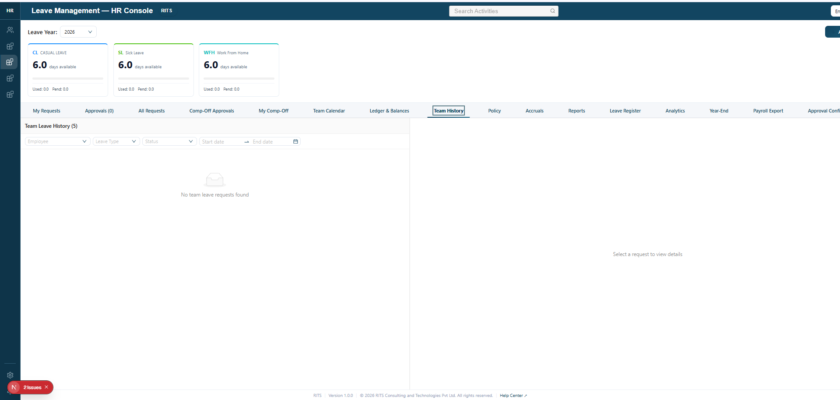
Figure 1: Team History screen with multiple tabs.

2. Backdated Leave Request Message Handling
Currently, when users apply leave for previous dates within the current month, a warning message is displayed. This warning message should be removed from the UI.

Current Behavior
- System displays a warning message for backdated leave requests.
- Message appears when leave is applied for past dates.
- Message states that the request will be routed to HR approval.

Required Change
- Remove the backdated leave warning message from the screen.
- Leave request submission should continue normally.
- HR approval workflow should work in the backend without displaying warning text.
- UI should remain clean without unnecessary warning popups/messages.
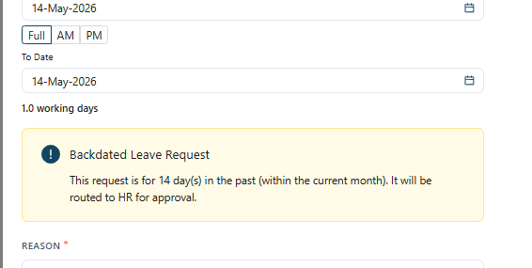
Figure 2: Existing backdated leave warning message.

3. Leave Tile Visibility Requirement
Leave tiles should be displayed only when leave balances or pending values are available. If leave count is zero and pending count is also zero, the corresponding leave tile should not be displayed.

Current Issue
- Leave tiles are displayed even when leave balance is 0.
- Pending count also remains 0 but tiles are still visible.
- Empty leave tiles create unnecessary UI space usage.

Expected Behavior
- Hide leave tile when available leave count is 0.
- Hide leave tile when pending leave count is also 0.
- Only active leave types with valid values should be displayed.
- UI should dynamically render leave tiles based on actual data.

Image Reload Requirement
- Image preview section should reload properly after data refresh.
- Updated leave tiles should render automatically after API response.
- Removed tiles should not remain cached in the UI.
- UI should refresh dynamically without manual page reload.
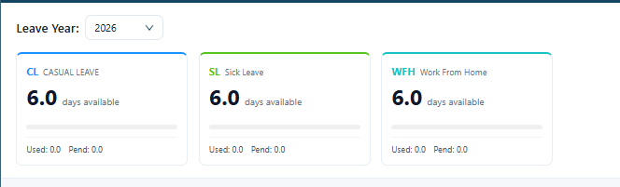
Figure 3: Leave tiles screen.

Final Summary
The Leave Management module requires responsive UI improvements and cleanup changes to provide a better user experience. Tabs should support horizontal scrolling, backdated warning messages should be removed from the UI, and leave tiles should only be displayed when valid leave data exists.

4. Issue:
After uploading a document, the View option is only visible after reloading the page. This behavior should be avoided.
Required Changes:
- Once the document is uploaded successfully, the View and Download options should be displayed immediately without requiring a page reload.
- Currently, the View and Download options are appearing only after clicking Save or after refreshing the page.
- Need to update the UI state dynamically after upload completion so the uploaded document is instantly available for viewing and downloading.
- Ensure proper frontend refresh/state handling after successful upload response.

