Write Up for music.txt

!! Warning !!

Here be spoilers, this is your final warning

Note

The intention of these write ups is to provide an insight into the intended strategy for solving the challenge. If you used a differing method to solve the challenge, feel free to message @1cysw0rdk0 or @Simon on slack. Write ups may not be provided or complete for all challenges, and may or may not include scripts used to create or solve the challenge.

Step 1: Opening the music.txt file presents us with some pretty nasty stuff.

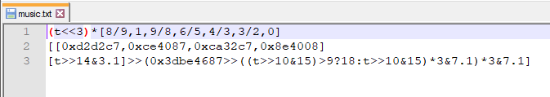

Looking at this text, we see only one “variable”, t. Incrementing this t value gives us outputs which form a pattern. When these 8 bit integers are used as a raw 8-bit audio track, a familiar song is played. Several applications, both online and standalone apps, will allow audio to be played in this format. The flag is simply the title of the song.

RS{never_gonna_give_you_up}