

INDRAPRASTHA INSTITUTE *of*

INFORMATION TECHNOLOGY

DELHI

Department

of

Electronics & Communication Engineering

ECE111|Digital Circuits

**Dr. Sudhanshu Shekhar Jamuar**

Lab_1:

Student Name RITICK CHAUDHARY

Roll No. 2020460

Date 20/01/2021

Aim: **To design the logic circuit of AND gate and verify its truth table.**

Components/ICs Used: **Breadboard, LED, Quad AND gate IC 74HC08, Slide switches(2), 1kohm resistor and connecting wires.**

Link of TINKERCAD Workspace:

<https://www.tinkercad.com/things/6U5Hyz6JYUp-and-gate/editel?sharecode=mnrH7MQgTGvSfbQK8mcvPGsOkTWGV0IkS1Q3XMxVuQ4>

Pin Diagram of the IC (If Applicable):

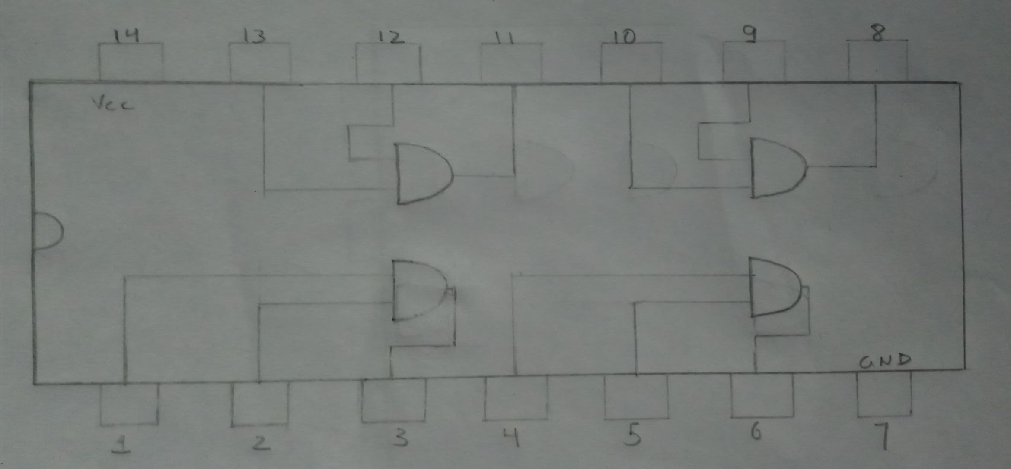

PIN DIAGRAM OF Quad AND gate IC

Circuit Diagram:

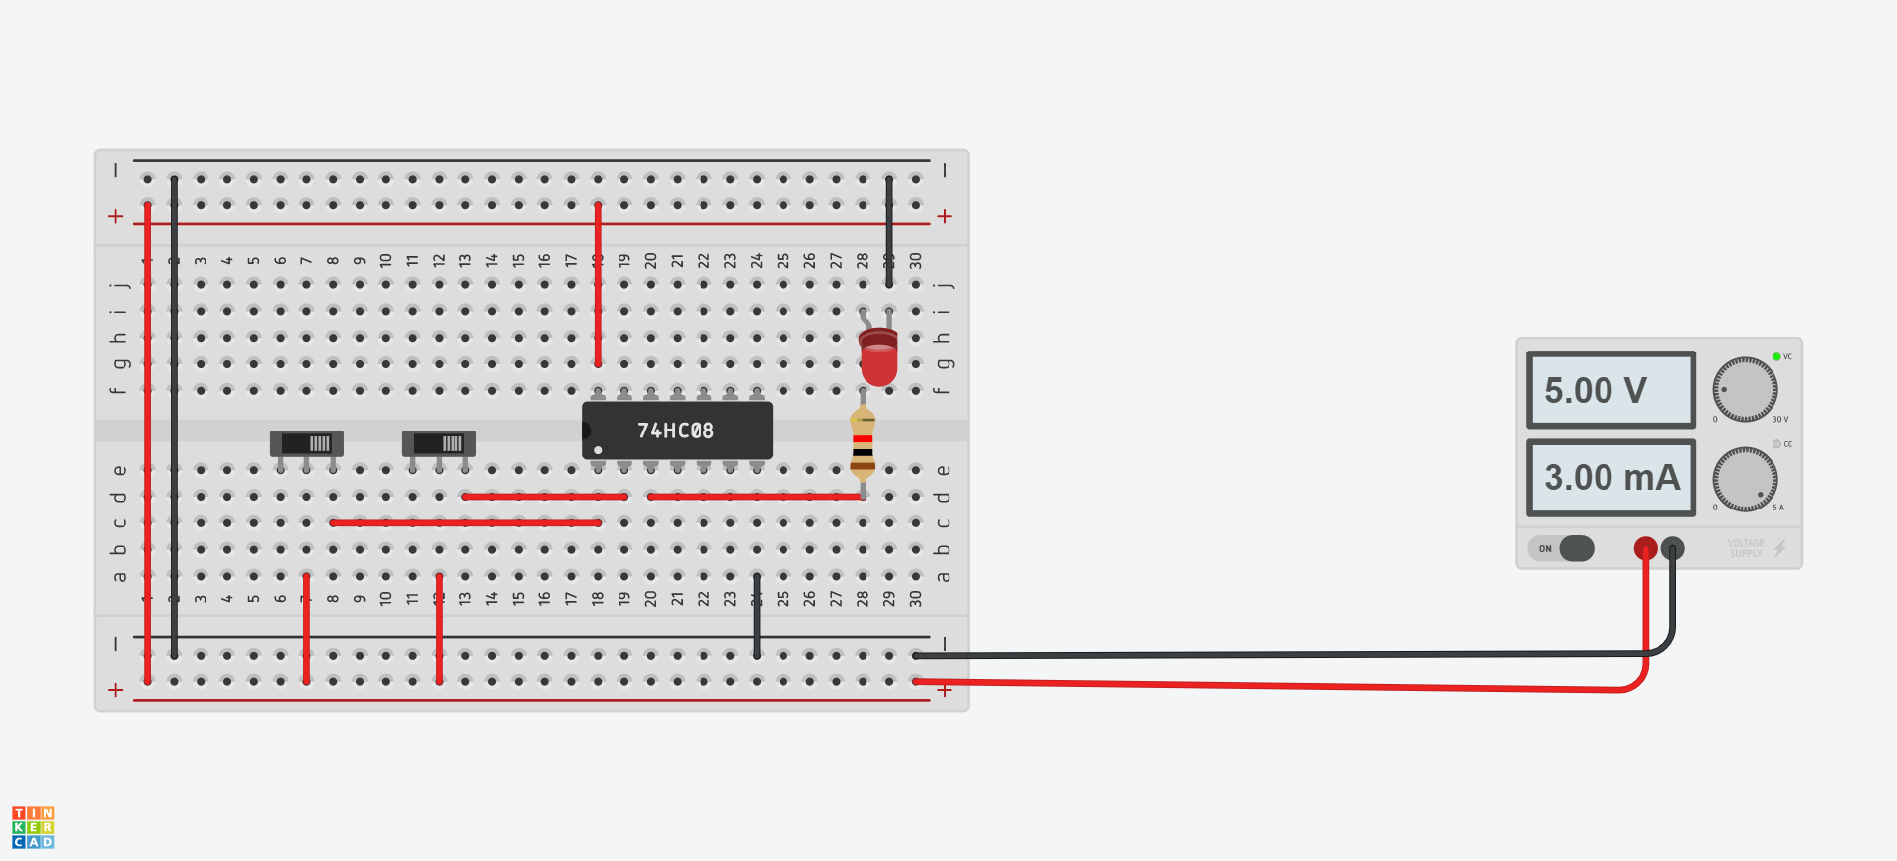

Truth Table:

|  |  |  |
| --- | --- | --- |
| **A** | **B** | **A.B** |
| **0** | **0** | **0** |
| **0** | **1** | **0** |
| **1** | **0** | **0** |
| **1** | **1** | **1** |

**TRUTH TABLE FOR AND GATE**

K maps (If Applicable):NA

Observations/Results: **It is observed that LED glows if and only if both the inputs are high. The results observed verify the truth table of AND gate.**

Aim: **To design the logic circuit of OR gate and verify its truth table.**

Components/ICs Used: **Breadboard, LED, Quad OR gate IC 74HC32, Slide switches(2), 1kohm resistor and connecting wires.**

Link of TINKERCAD Workspace:

<https://www.tinkercad.com/things/czcbX61kGhC-or-gate/editel?sharecode=CbVT3jvVzD8Rjiel9D1CicgZVdscbCjjvH9w9CaqwYw>

Pin Diagram of the IC (If Applicable):

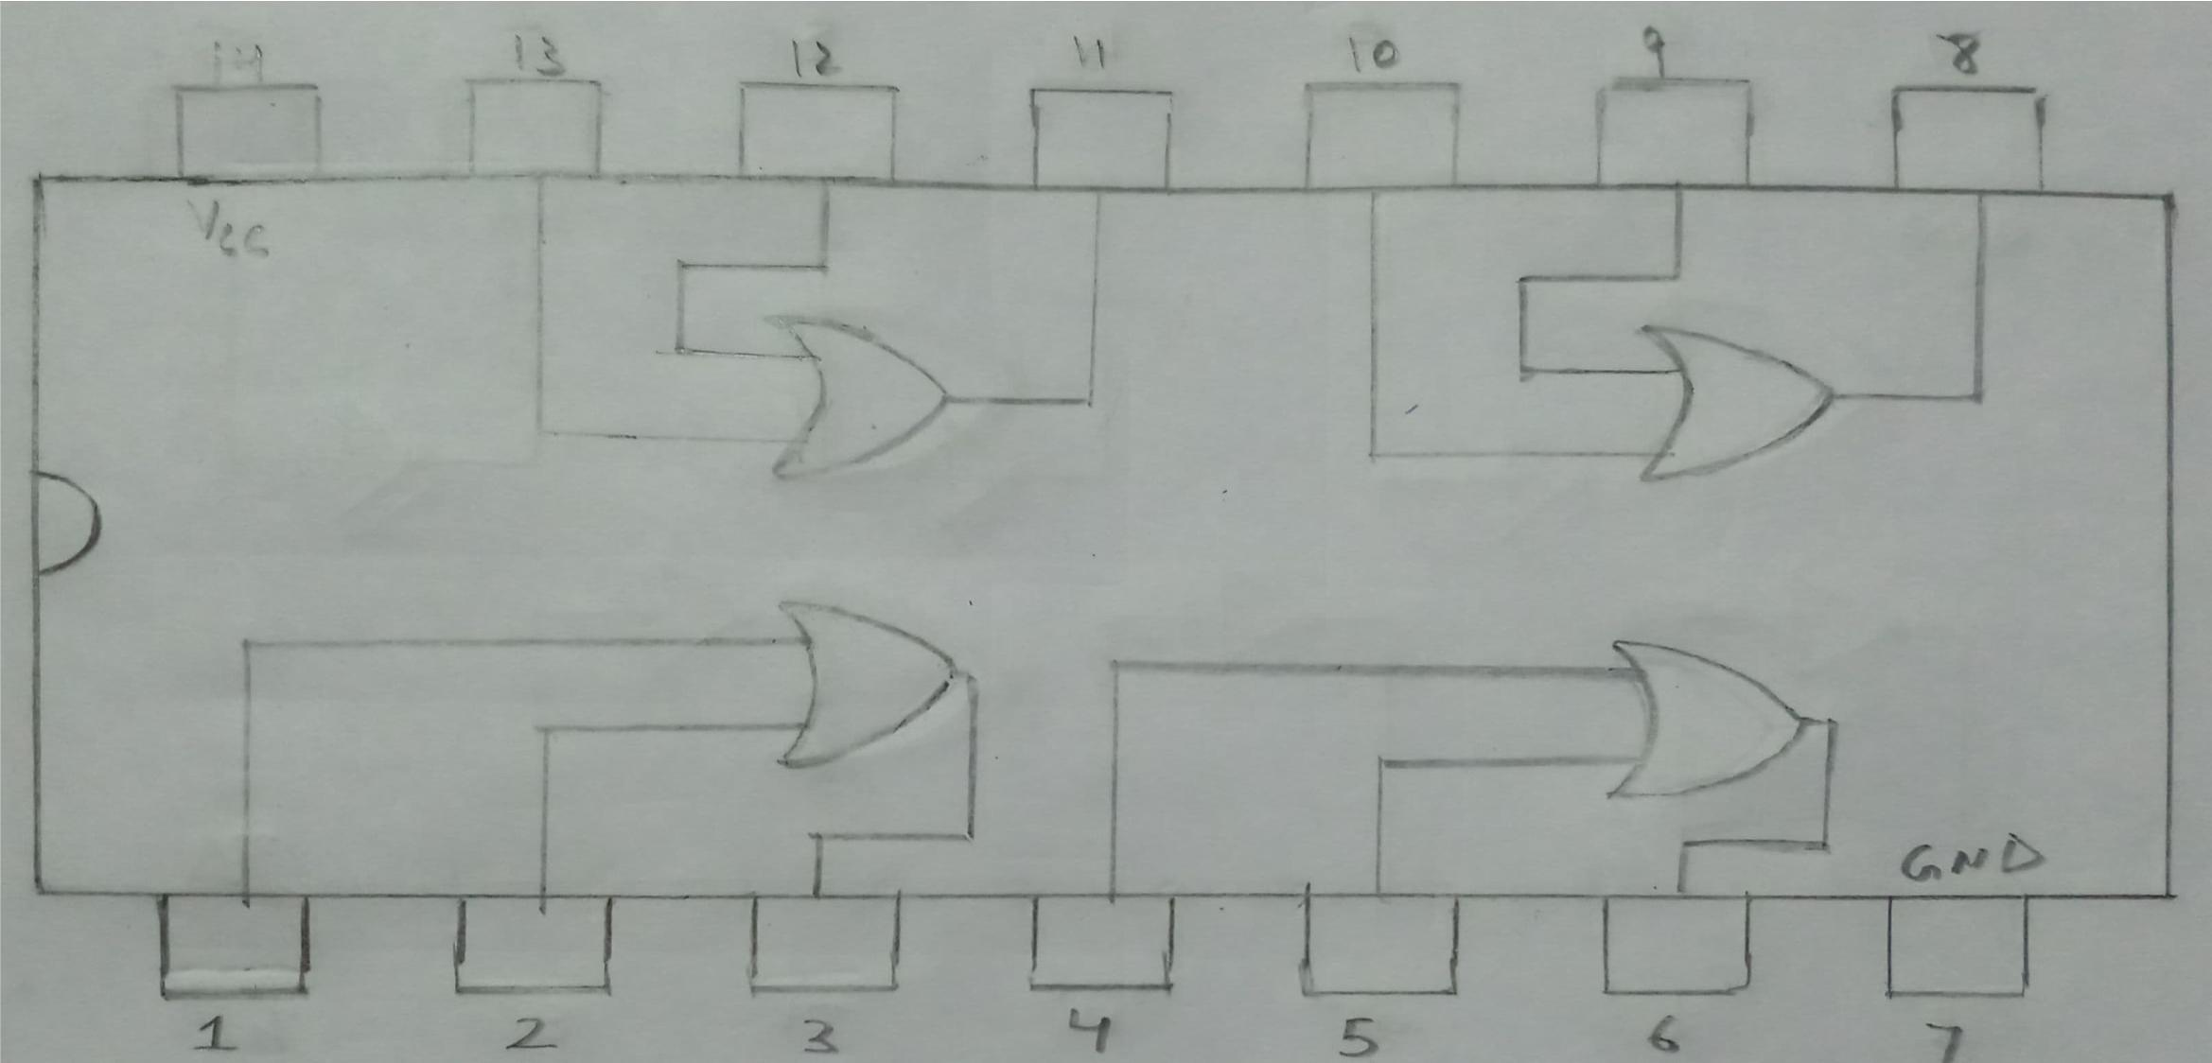

PIN DIAGRAM OF Quad OR gate IC

Circuit_Diagram: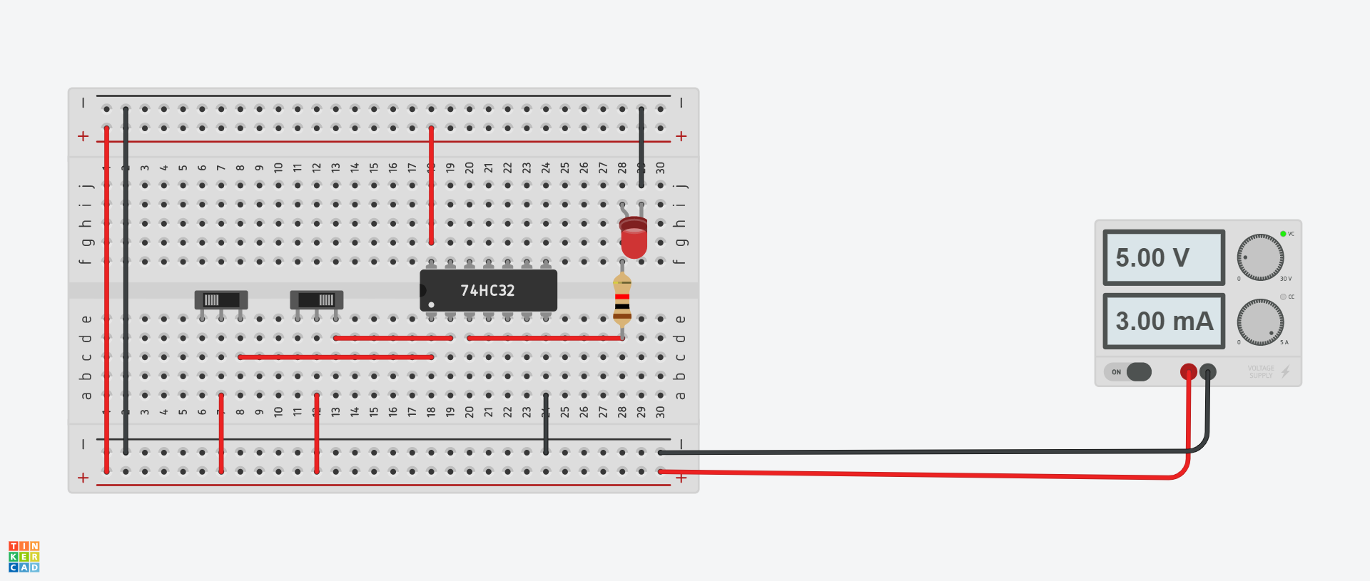

Truth Table:

|  |  |  |
| --- | --- | --- |
| **A** | **B** | **A+B** |
| **0** | **0** | **0** |
| **0** | **1** | **1** |
| **1** | **0** | **1** |
| **1** | **1** | **1** |

**TRUTH TABLE FOR OR GATE**

K maps (If Applicable):NA

Observations/Results: **It is observed that LED glows if any one or both of the inputs is high. The results observed verify the truth table of OR gate.**

Aim: **To design the logic circuit of NOT gate and verify its truth table.**

Components/ICs Used: **Breadboard, LED, Hex Inverter IC 74HC04, Slide switch, 1kohm resistor and connecting wires.**

Link of TINKERCAD Workspace:

<https://www.tinkercad.com/things/8XmR0836sSm-not-gate/editel?sharecode=ATyIGDiMSE84p1i8i-jewA1jfpfYRf-CIm9LAoz7pME>

Pin Diagram of the IC (If Applicable):

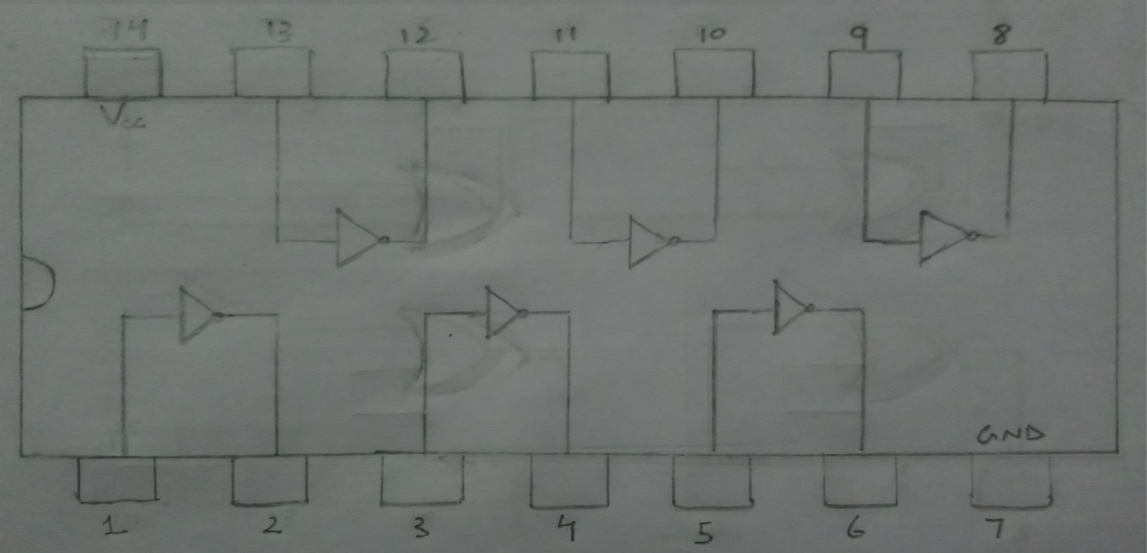

PIN DIAGRAM OF Hex Inverter

Circuit Diagram:

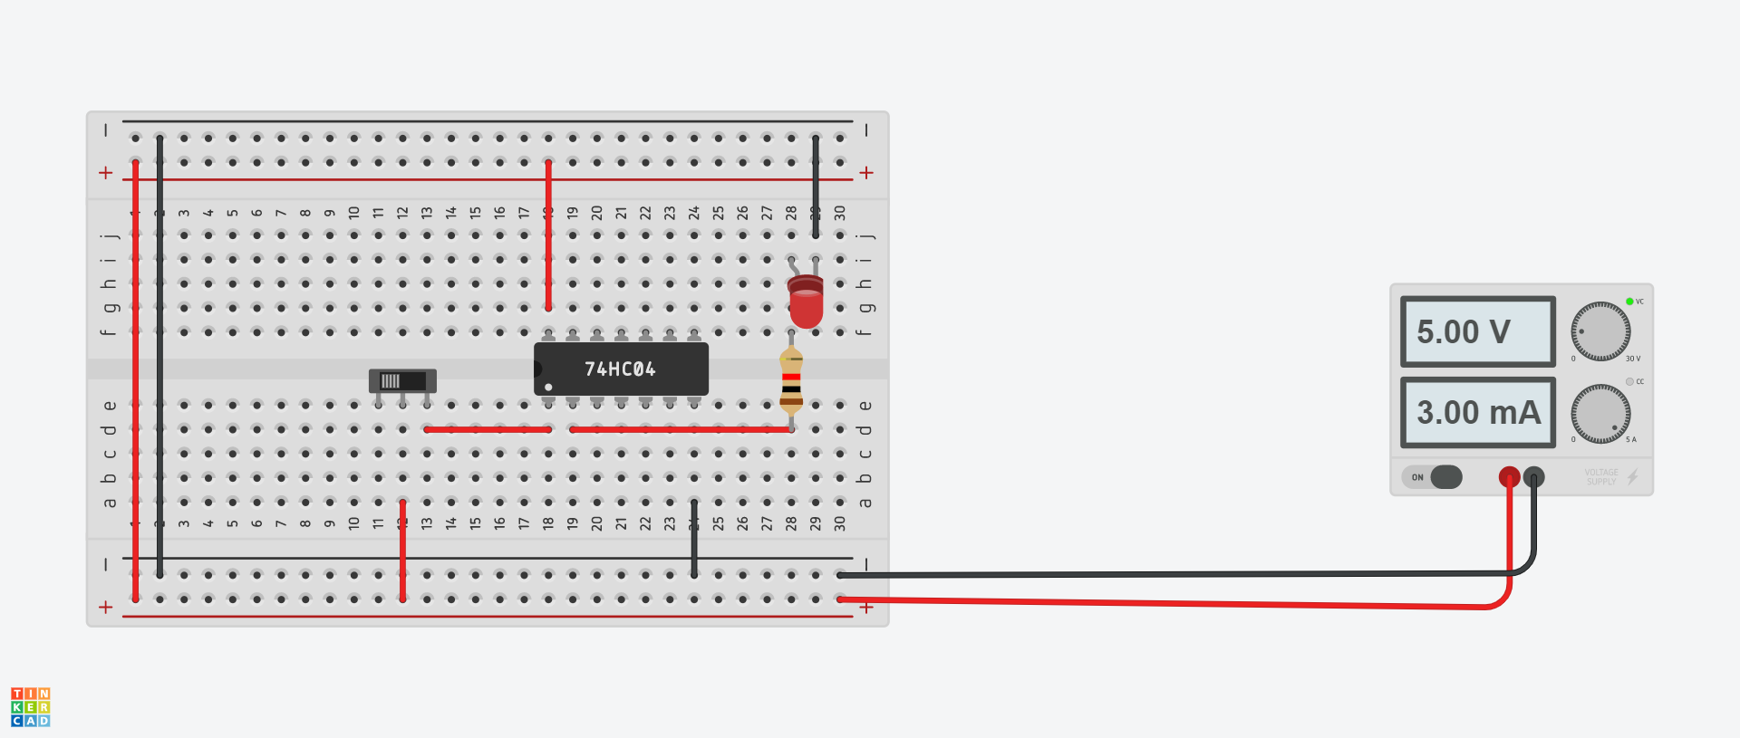

|  |  |
| --- | --- |
| A | A’ |
| 0 | 1 |
| 1 | 0 |

**TRUTH TABLE FOR NOT GATE**

K maps (If Applicable):NA

Observations/Results: **It is observed that LED glows if input is low and vice versa. The results observed verify the truth table of NOT gate.**

Aim: **To design the logic circuit of XOR gate and verify its truth table.**

Components/ICs Used: **Breadboard, LED, Quad XOR gate IC 74HC86, Slide switches(2), 1kohm resistor and connecting wires.**

Link of TINKERCAD Workspace:

<https://www.tinkercad.com/things/7QLBjJXfmED-xor-gate/editel?sharecode=SO7qWsypbc7wMO81xWgFJ35bhl2mdzwl0LwDXbf4t1Y>

Pin Diagram of the IC (If Applicable):

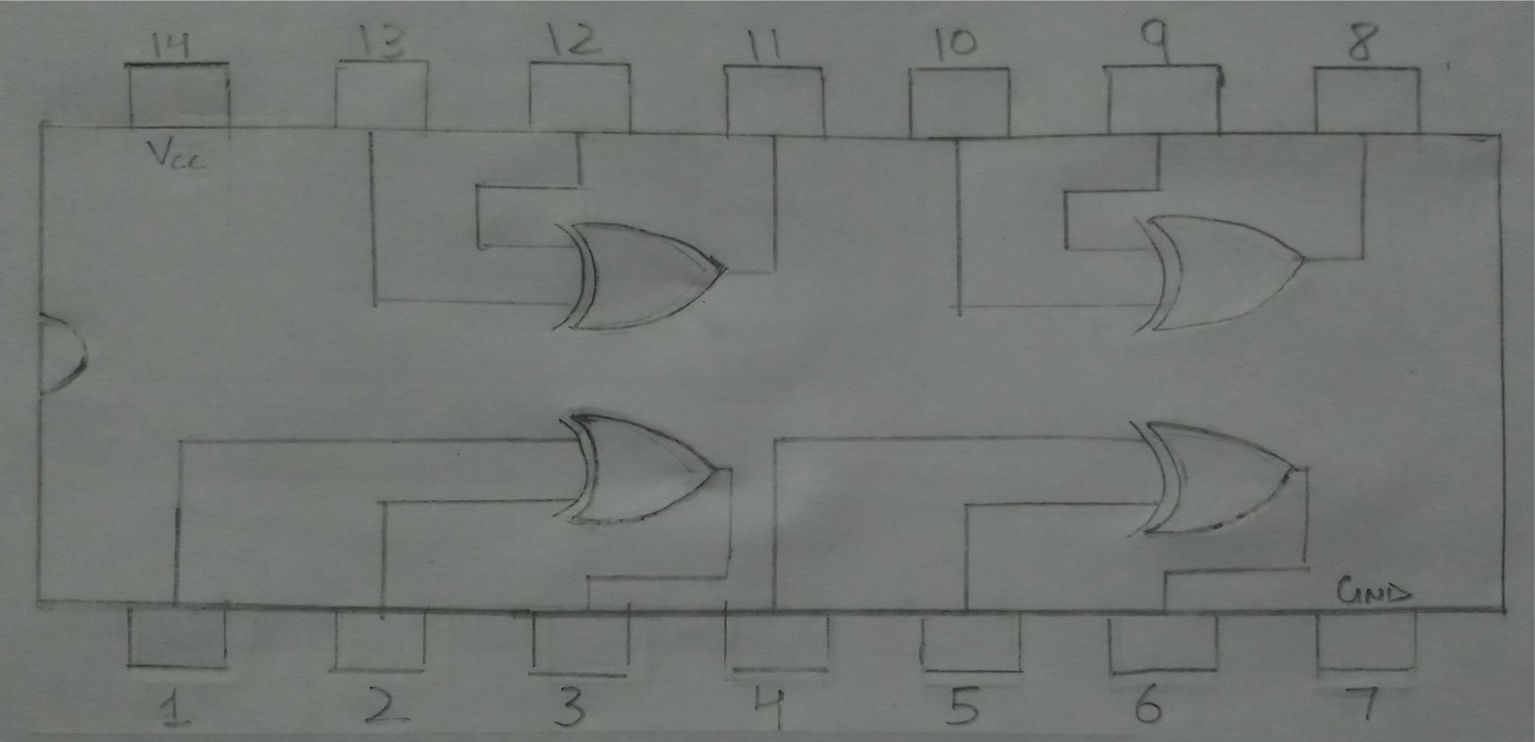

PIN DIAGRAM OF Quad XOR gate IC

Circuit Diagram:

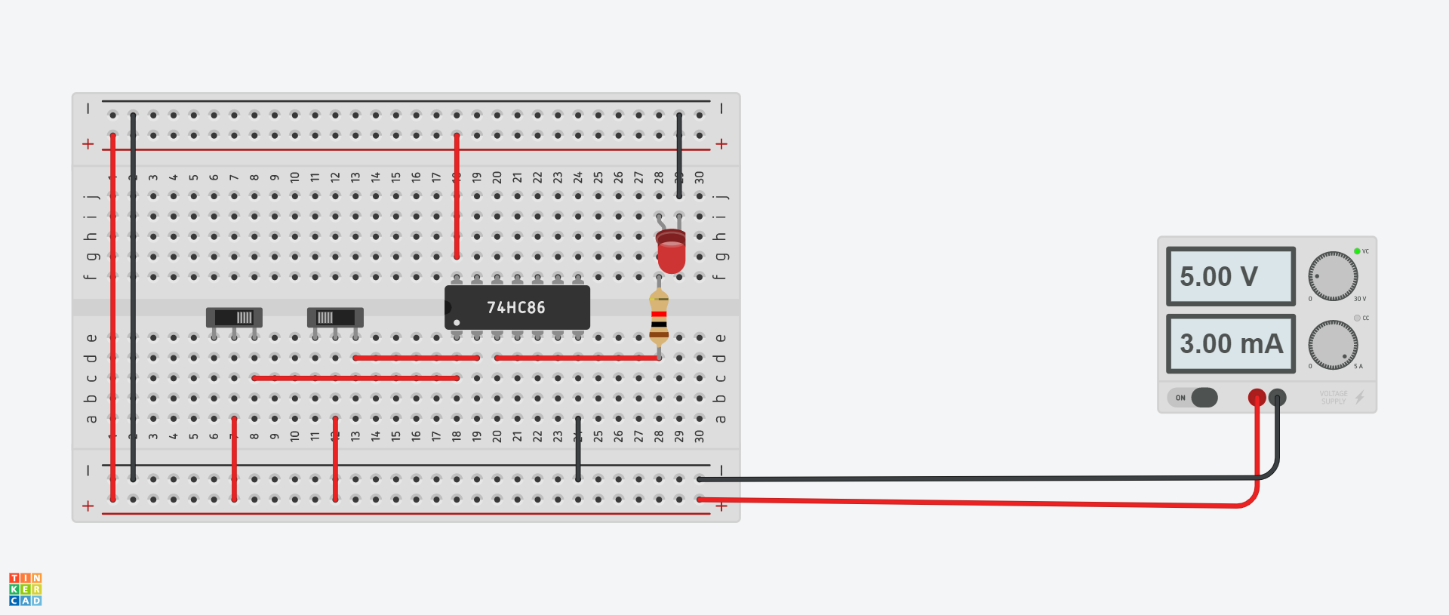

Truth Table:

|  |  |  |
| --- | --- | --- |
| **A** | **B** | **A XOR B** |
| **0** | **0** | **0** |
| **0** | **1** | **1** |
| **1** | **0** | **1** |
| **1** | **1** | **0** |

**TRUTH TABLE FOR XOR GATE**

K maps (If Applicable):NA

Observations/Results: **It is observed that LED glows if exactly one of the input is high while other is low. The results observed verify the truth table of XOR gate.**

Aim: **To design the logic circuit of NAND gate and verify its truth table.**

Components/ICs Used: **Breadboard, LED, Quad NAND gate IC 74HC00, Slide switches(2), 1kohm resistor and connecting wires.**

Link of TINKERCAD Workspace:

<https://www.tinkercad.com/things/39xcH2D15Zt-nand-gate/editel?sharecode=G8jwjSJS8PUTd41LzFEPJSgPz7N2OyYs4z5hfhS9SfI>

Pin Diagram of the IC (If Applicable):

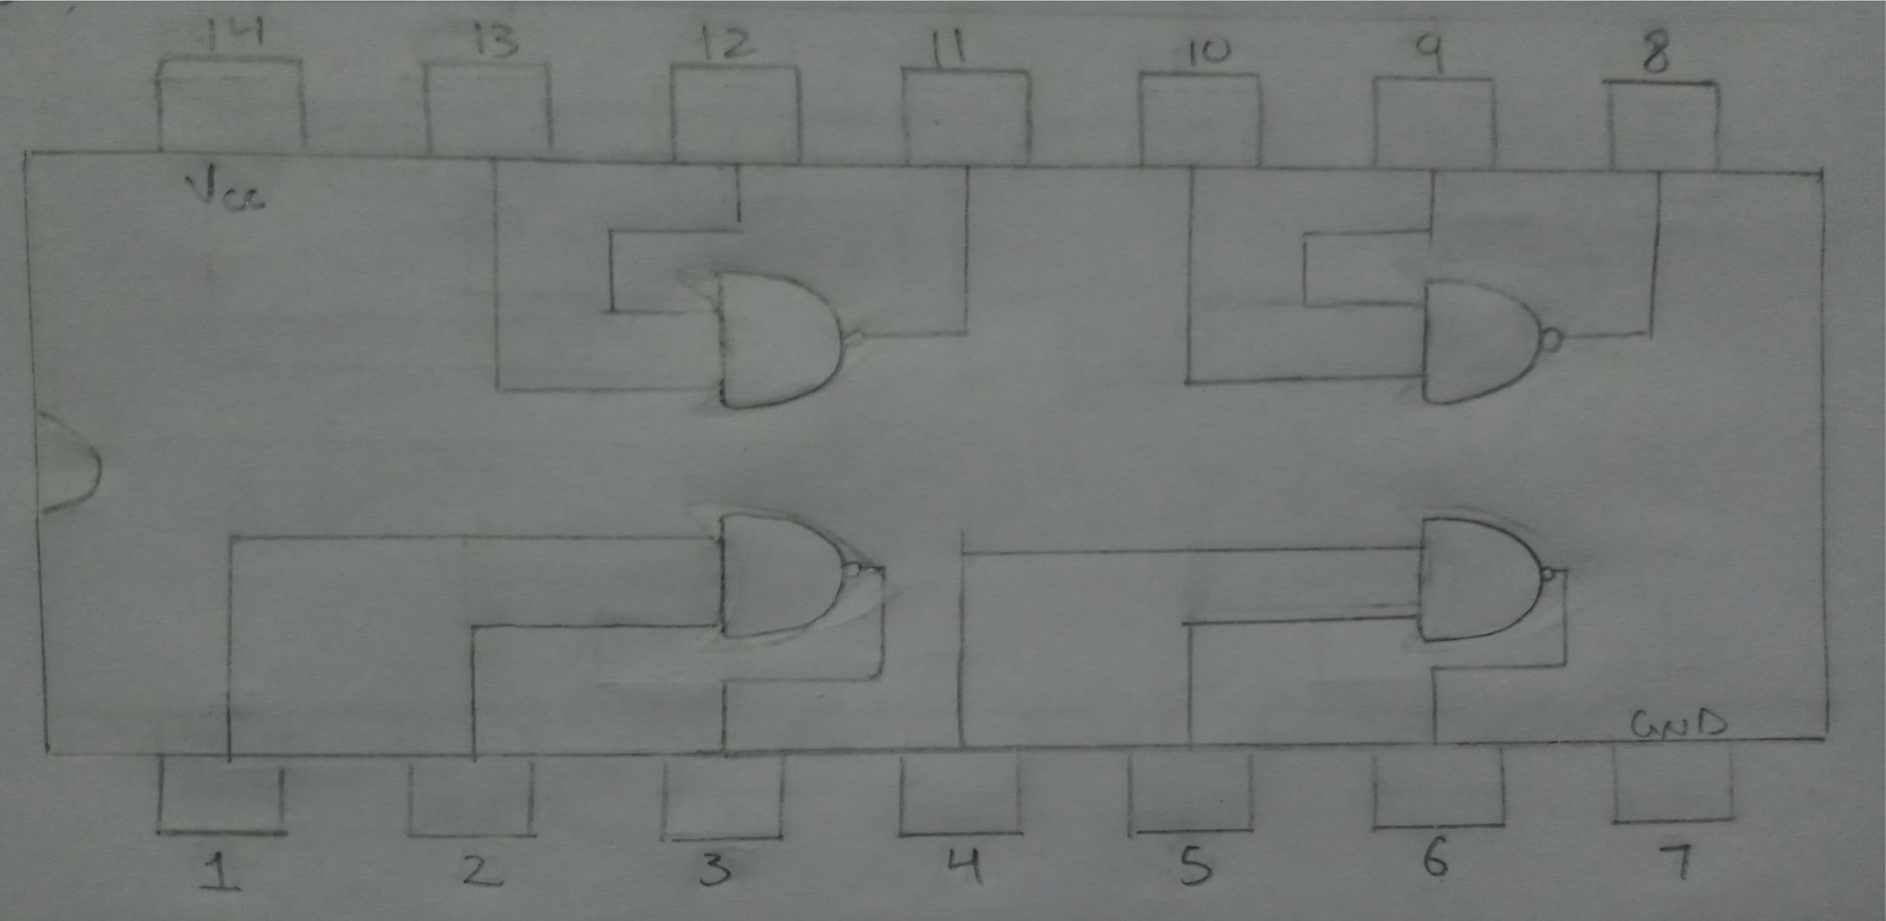

PIN DIAGRAM OF Quad NAND gate IC

Circuit Diagram:

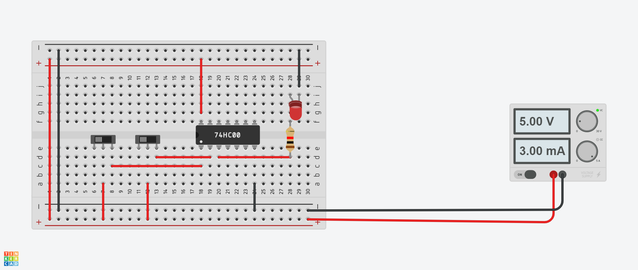

Truth Table:

|  |  |  |
| --- | --- | --- |
| **A** | **B** | **(A.B)’= A’+B’** |
| **0** | **0** | **1** |
| **0** | **1** | **1** |
| **1** | **0** | **1** |
| **1** | **1** | **0** |

**TRUTH TABLE FOR NAND GATE**

K maps (If Applicable):NA

Observations/Results: **It is observed that LED glows if both inputs are low or exactly one of the inputs is high.It does not glow when both the inputs are high. The results observed verify the truth table of NAND gate.**

Aim: **To design the logic circuit of NOR gate and verify its truth table.**

Components/ICs Used: **Breadboard, LED, Quad NOR gate IC 74HC02, Slide switches(2), 1kohm resistor and connecting wires.**

Link of TINKERCAD Workspace:

<https://www.tinkercad.com/things/fAFKLeQLp8U-nor-gate/editel?sharecode=Ibql-HH8hEzEZy8AcqiQfjP4B0V8bpEjsqoFbCEtHlw>

Pin Diagram of the IC (If Applicable):

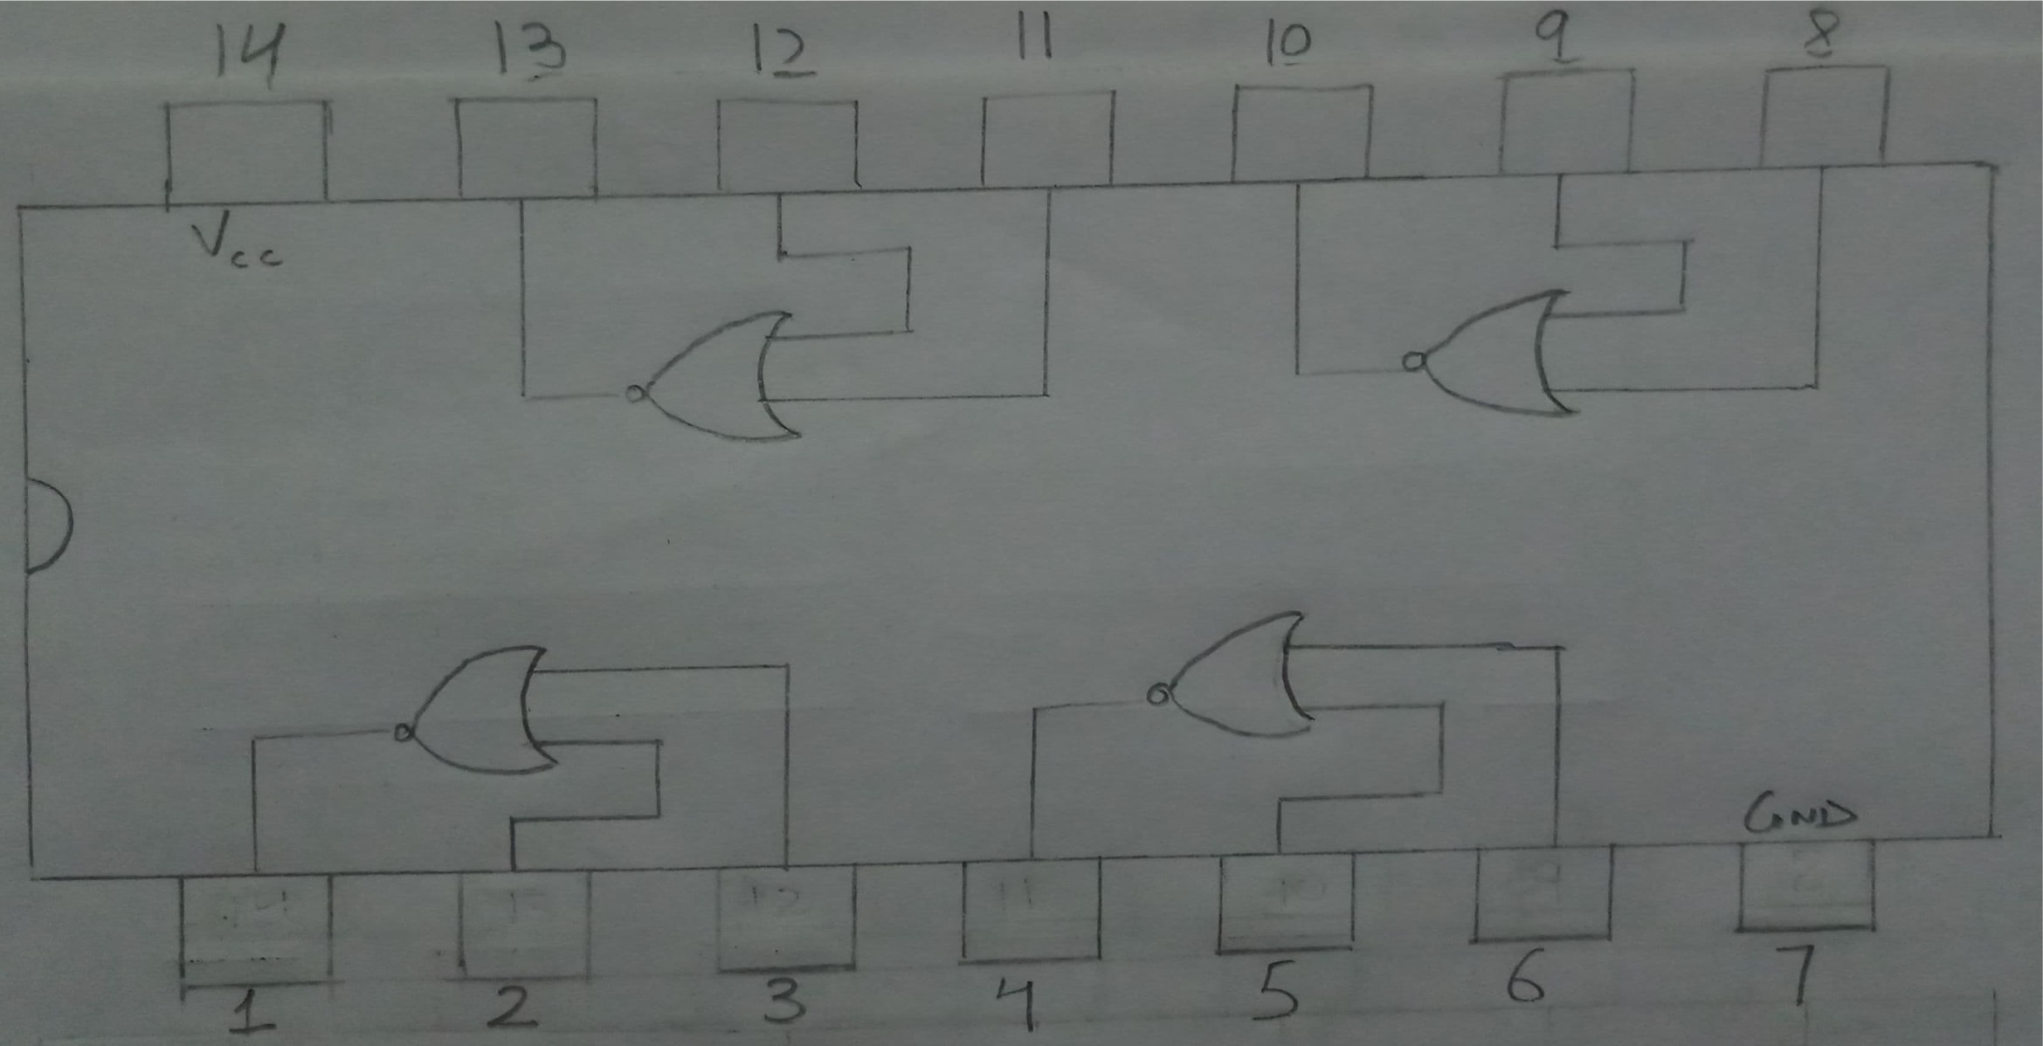

Circuit Diagram:

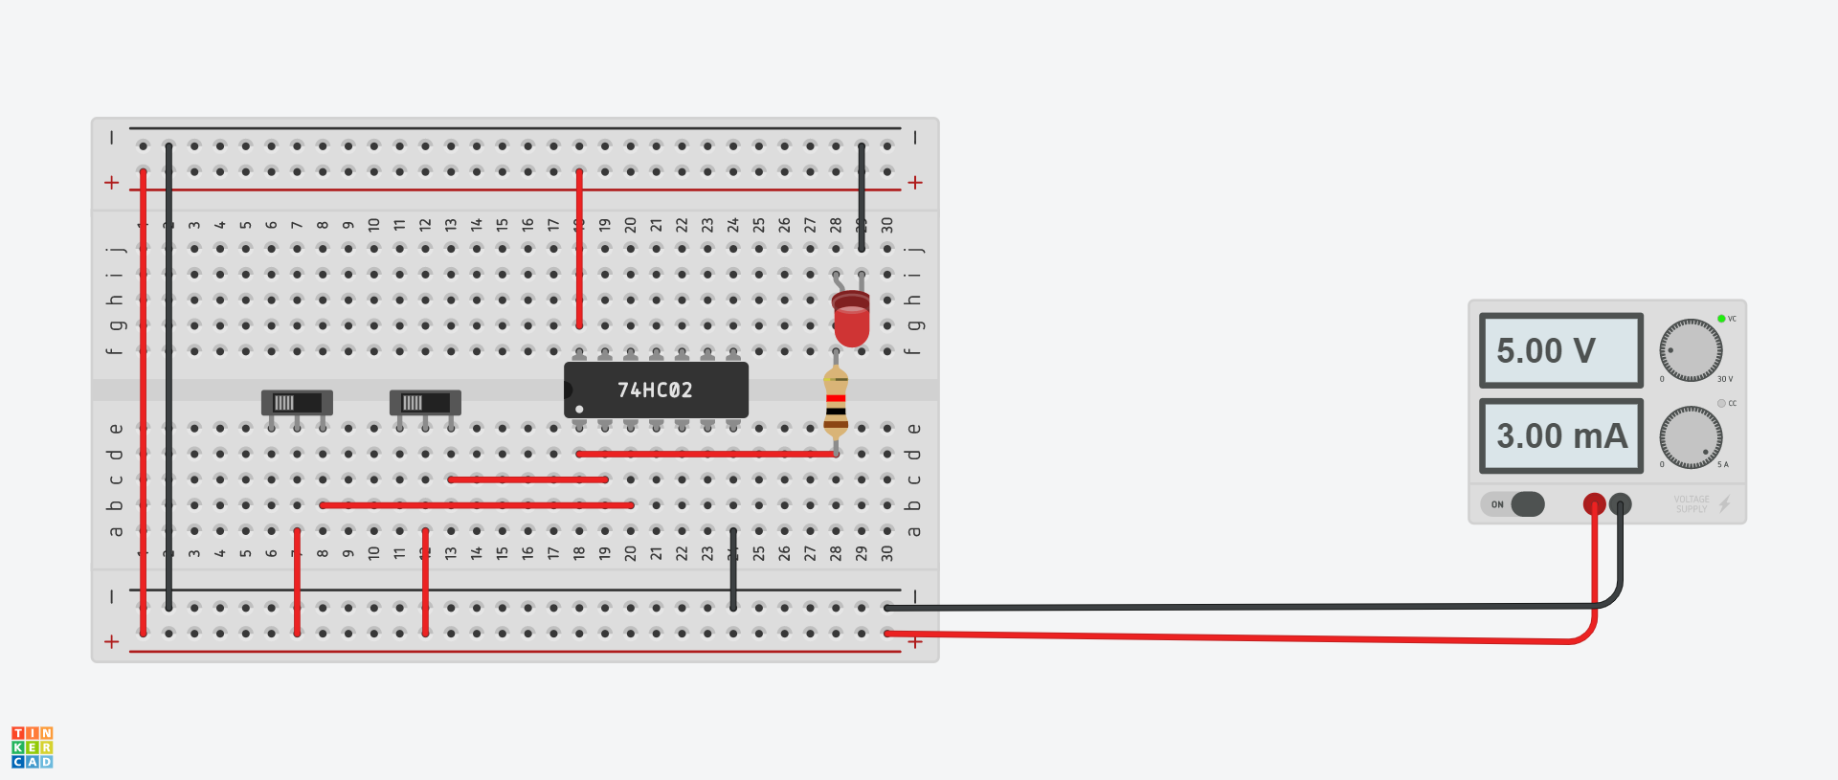

Truth Table:

|  |  |  |
| --- | --- | --- |
| **A** | **B** | **(A+B)’= A’.B’** |
| **0** | **0** | **1** |
| **0** | **1** | **0** |
| **1** | **0** | **0** |
| **1** | **1** | **0** |

**TRUTH TABLE FOR NOR GATE**

K maps (If Applicable):NA

Observations/Results: **It is observed that LED glows if and only if both the inputs are low. The results observed verify the truth table of NOR gate.**