A

SI: Nizek odtočni potencial. Zemljina ima tudi, če je nasičena, visoko stopnjo infiltracije. Globoke, dobro drenirane zemljine z zmerno teksturo (pesek, globoka rečna naplavina). Stopnja izgub za skupino zemljine je med 7,5 in 11,5 mm/h.

EN: Low drainage potential. Even if saturated, the soil has a high rate of infiltration. Deep, well-drained soil of moderate texture (sand, deep river bed). The loss rate for the soil group is between 7,5 and 11,5 mm / h.

B

SI: Povprečni do nizek odtočni potencial. Zemljina ima, če je nasičena, povprečno stopnjo infiltracije vode. Plitve rečne naplavine, peščena ilovica z zmerno prepustnostjo. Stopnja izgub za skupino zemljine je med 3,85 in 7,5 mm/h.

EN: Average to low drain potential. The earth, if saturated, has an average rate of water infiltration. Shallow river beds, sandy loam with moderate permeability. The loss rate for the soil group is between 3,85 and 7,5 mm / h.

C

SI: Visok do zmeren odtočni potencial. Zemljina ima, če je nasičena, nizko stopnjo infiltracije vode. Glinena ilovica, plitva peščena ilovica, zemljine z nizko vsebnostjo organskih snovi in zemljine z običajno visoko vsebnostjo gline. Stopnja izgub za skupino zemljine je med 1,3 in 3,85 mm/h.

EN: High to moderate drainage potential. Soil, if saturated, has a low water infiltration rate. Clay loam, shallow sandy loam, soil with low organic matter content and soil with typically high clay content. The loss rate for the soil group is between 1,3 and 3,85 mm / h.

D

SI: Visok odtočni potencial. Zemljina ima, če je nasičena, zelo nizko stopnjo infiltracije vode. Zemljine z visoko gladino talne vode, z glinastim slojem ali neprepustnim slojem na površini ali tik pod površino, zaslanjena zemljišča ipd. Zemljine imajo zelo nizko stopnjo prepustnosti. Stopnja izgub za skupino zemljine je med 3,85 in 7,5 mm/h.

EN: High drainage potential. The earth, if saturated, has a very low water infiltration rate. Lands with a high surface water level, with a clay layer or an impermeable layer on the surface or just below the surface, covered land, etc. Soil has a very low throughput. The loss rate for the soil group is between 0,00 and 1,3 mm / h.

Explanation:

SI: Ker ravno v urbanih območjih tipi zemljine niso dovolj natančno specificirani in so razlike od območja do območ ja se izbor tipa zemljine prepusti uporabniku aplikacije. Prvi izračun se nanaša na tip zemljine B – s povprečno stopnjo infiltracije.

EN: Because in urban areas land types are not sufficiently specified and there are differences from area to area, the choice of land type is left to the user of the application. The first calculation refers to the type of soil B – an average infiltration rate.

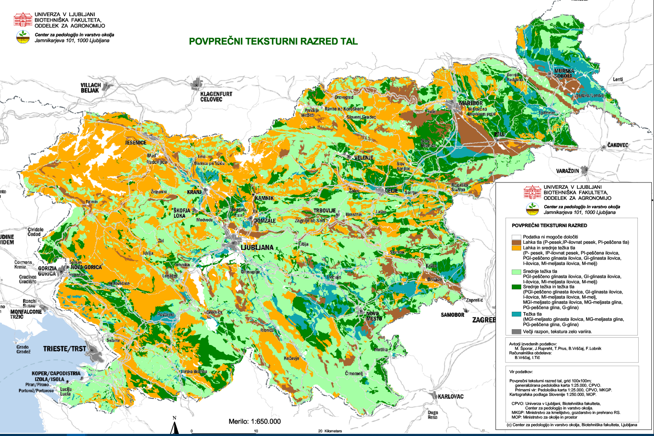

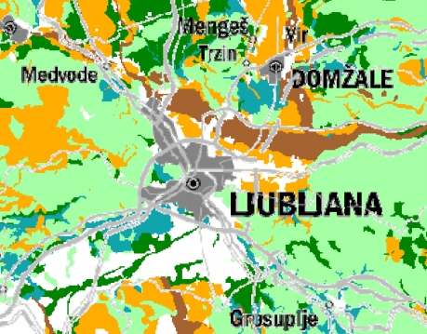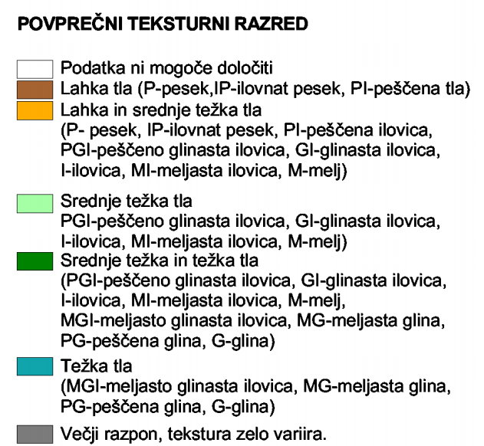

Source: <http://www.bf.uni-lj.si/fileadmin/groups/2701/tematskakarta_TRZ.pdf>